**Project Proposal Brief:**

**Title – “**MLB Teams Attendance vs their Wins/Losses from 2009-2019”

**Mission –** We like Baseball and as fans wanted to see if the fans have an effect on their teams wins and loss. Specifically, we want to see if there are any correlations between a game attendance and wins and loss ratios over time for MLB teams over the past 10 years (2009-2019).

Key Q = Do you teams with higher attendance rates win more over time?

**Inspiration (visuals/links) -**

**Vision (sketch)-**

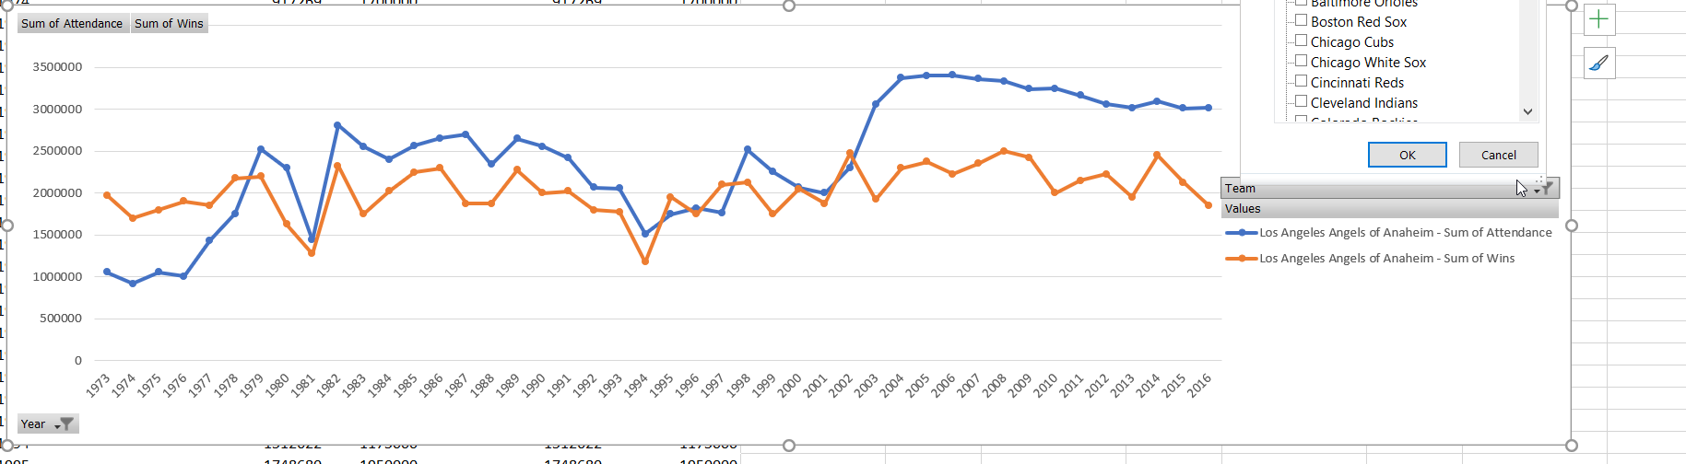

**Resources (datasets) -**

* MLB API - [http://lookup-service-prod.mlb.com](http://lookup-service-prod.mlb.com/)
* Kaggle dataset - kaggle.com/timschutzyang/dataset1#baseballdata.csv
* <https://developer.sportradar.com/io-docs>

**Github repo. link** -

https://github.com/dante-m/Project-2---Team-MSJD.git