Architecture Sketch
Weather Flags gates a Flutter weather dashboard with an on-device feature-flag platform. Config is loaded from bundled JSON (swappable to a remote Retrofit endpoint); weather from Open-Meteo; flags evaluated locally by a pure-Dart FlagEvaluator.

Layer diagram
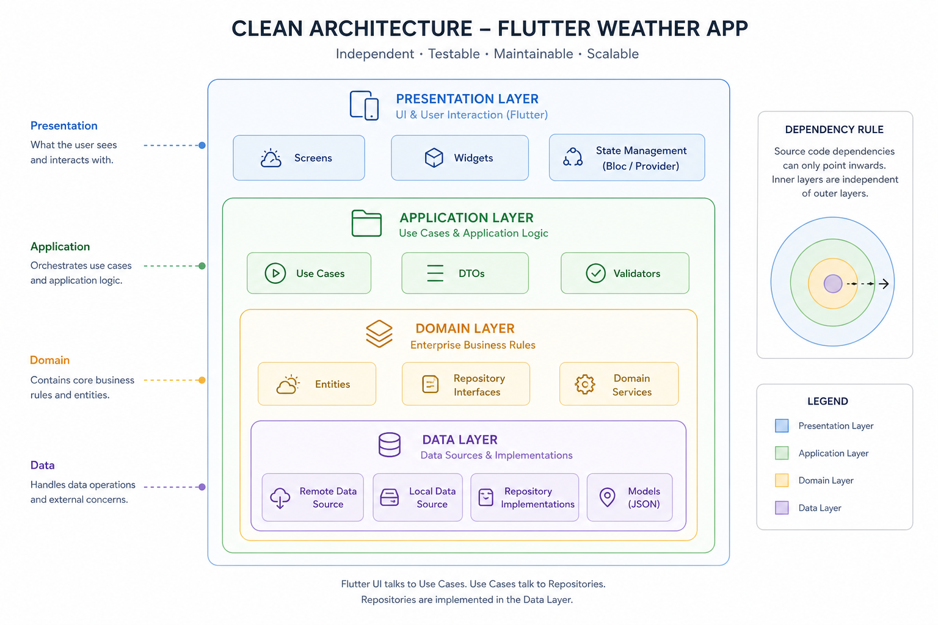
┌──────────────────────────────────────────────────────────────────────────┐
│ PRESENTATION │
│ WeatherDashboardPage, FeatureGate, ConfigDebugPanel, GoRouter │
│ lib/features/*/presentation/ + lib/core/widgets/ │
└───────────────────────────────┬──────────────────────────────────────────┘
│ reads Bloc state / dispatches events
┌───────────────────────────────▼──────────────────────────────────────────┐
│ APPLICATION │
│ RemoteConfigBloc, WeatherBloc → use cases (GetRemoteConfig, etc.) │
└───────────────────────────────┬──────────────────────────────────────────┘
│ calls
┌───────────────────────────────▼──────────────────────────────────────────┐
│ DOMAIN │
│ RemoteConfig, FeatureFlag, FlagEvaluation, WeatherBundle │
│ FlagEvaluator (pure Dart) | repository interfaces │
└───────────────────────────────▲──────────────────────────────────────────┘
│ implements
┌───────────────────────────────┴──────────────────────────────────────────┐
│ DATA │
│ RemoteConfigRepositoryImpl (in-memory + broadcast stream) │
│ WeatherRepositoryImpl (Retrofit → Open-Meteo) │
│ DTOs, mappers, assets/config/*.json │
└────────────────────────────────────────────────────────────────────────────┘

core/ — GetIt DI, GoRouter, theme, Failure, location
Dependency rule: presentation → application → domain ← data. Domain has no Flutter, DTO, or Bloc imports.
Layer | Responsibility
**Presentation** | UI; `FeatureGate` / `FlagVariant` read `RemoteConfigBloc` evaluations
**Application** | Blocs orchestrate use cases; propagate `Either<Failure, T>`
**Domain** | Entities, `FlagEvaluator`, repository contracts
**Data** | JSON assets, Retrofit clients, repository implementations

Flag evaluation pipeline
Config JSON ──► RemoteConfigRepository ──► broadcast stream
│
▼
RemoteConfigBloc (userId + active config)
│
┌───────────────┴───────────────┐
▼ ▼
FeatureGate widget GoRouter redirect
│ │
└───────────► FlagEvaluator.evaluate(flag, userId)
│
┌─────────────────┼─────────────────┐
▼ ▼ ▼
kill-switch? enabled? bucket < rollout%?
(strict first) (second) (third)
│ │ │
└─────────────────┴─────────────────┘
▼
FlagEvaluation
(result, bucket, reason, variant)

Single user + flag (sequence)
userId="user_87", flagKey="air_quality_card", config_a (30% rollout)

1. hash input = "user_87:air_quality_card"
2. FNV-1a 32-bit → integer hash
3. bucket = hash % 100 (e.g. 17)
4. killSwitch? → no → continue
5. enabled? → yes → continue
6. 17 < 30? → yes → result = true, reason = "bucket 17 < 30%, included"
7. FeatureGate renders child; evaluation table shows bucket 17
Same inputs always produce the same bucket (tested: 1 000 repeated calls). No network at evaluation time.

Key decisions
- On-device evaluation — explainability and offline resilience; no per-widget network call. Trade-off: no instant global override without a config push (mitigated by kill-switch + config stream).
- Mocked config with a real Retrofit seam — assets/config/*.json today; RemoteConfigRemoteSource is a one-line DI swap to a real endpoint. Presentation and FlagEvaluator unchanged.
- Deterministic FNV-1a bucketing — hash(userId:flagKey) % 100, not random. Stable across restarts and devices; testable without a backend assignment service. Per-flag salt via flagKey avoids one bucket deciding all flags.
- Strict kill-switch precedence — evaluated before enabled and rollout %. Prevents a mis-set rollout from exposing a flag that ops has killed (incident guardrail).
- FeatureGate as the single gating primitive — adding a feature is a config entry + one widget wrap (+ optional route redirect). Inverse cleanup path when a flag graduates.
- Four-layer Clean Architecture — application/ holds Blocs separate from presentation/ so domain rules and orchestration stay testable without widget trees.
- Fake repository at the DI boundary — FakeWeatherRepository returns canned WeatherBundle fixtures so UI is runnable before Open-Meteo; swap to WeatherRepositoryImpl in GetIt without touching widgets.
- Either<Failure, T> — repositories return fpdart Either; failures are typed (NetworkFailure, locationPermissionDenied, etc.) and mapped in the data layer, not thrown across boundaries.
See CONVENTIONS.md for package and naming standards.

