Group Members: Joshua Malmberg, Samira Pulatova, Tim Lykov, Dante Barr
CMPT 354 Project: Formal Specifications
Description
We are developing a database system and website to gamify the online martial arts experience and make it more engaging for kids.
The domain of this database is a martial arts school. The school hosts several classes, each with instructor(s), students, and parents/guardians. The database will model the classes, students and their guardians, instructors. In addition, the database will model online activities, allowing students to engage with each other remotely while studying martial arts.
Our database system will work in combination with a website to facilitate remote learning for martial arts students. Our website will allow instructors and administrators to create several classes and enroll students in the classes. For each class, instructors will create a list of activities for the students to complete. For each activity, one and only one instructor or student will upload a demonstration video. The rest of the students will then upload reply videos of themselves emulating the demonstration video.
Each activity will have a deadline. After the deadline passes, the students will vote for the best reply video. The student whose reply video receives the most votes will be declared as the winner of that activity and receive points. The instructor will also be able to pick his favourite reply video, providing bonus points to the corresponding student. Finally, every student who participated in the session will also be awarded points.
A leaderboard will be implemented to show which students have the most points. Points Breakdown: 10 for first video uploaded for each activity type.
- 5 for uploading the following videos.
- 1 additional point for each best video vote.
- 5 for instructor’s favorite video vote.
The demonstration and reply videos will be hosted using YouTube. Students will upload their videos to YouTube, and post the video to our website by providing a link to the YouTube video. This link will be stored by the database and will be used to embed the video within a webpage.
Updated E/R Diagram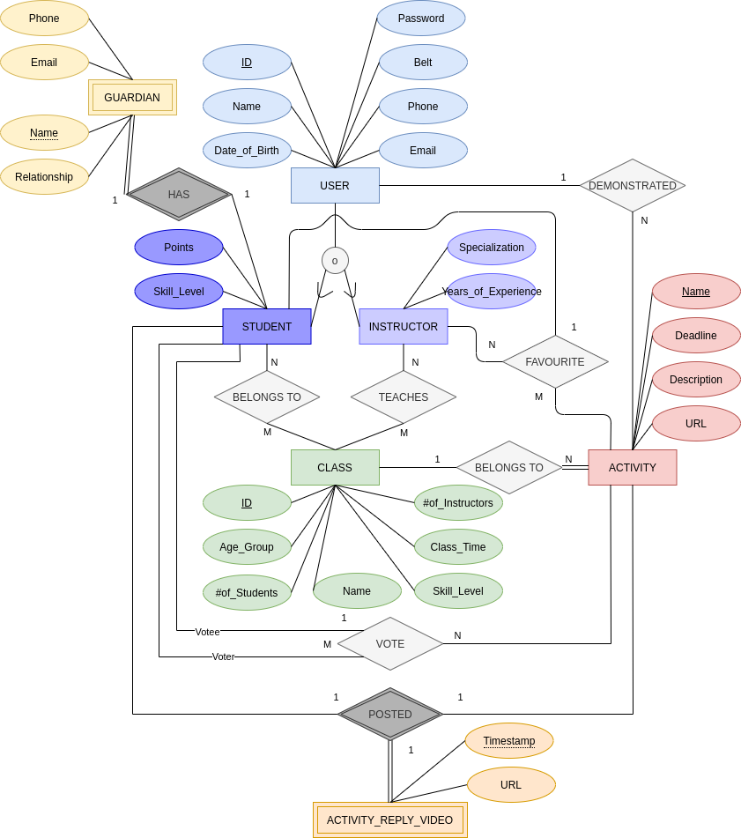Schema
Relations:
User [ID: INTEGER, name: VARCHAR(20), dob: DATE, phone: CHAR(10), email: VARCHAR(50), belt: CHAR(6), password: VARCHAR(100)]
Instructor [ID: INTEGER, specialization: VARCHAR(20), years_experience: INTEGER]
Student [ID: INTEGER, points: INTEGER, skill_level: ENUM(“low”, “medium”, “high”)]
Guardian [student_ID: INTEGER, name: VARCHAR(20), phone: CHAR(10), email: VARCHAR(50), relationship: VARCHAR(15)]
Activity [name: VARCHAR(20), deadline: DATE, description: VARCHAR(200), url: VARCHAR(2048), user_ID: INTEGER, class_ID: INTEGER]
Class [ID: INTEGER, name: VARCHAR(100), age_group: CHAR(5), skill_level: ENUM(“low”, “medium”, “high”), time: INTEGER, num_students: INTEGER, num_instructors: INTEGER]
ActivityVideo [activity_name: VARCHAR(20), student_ID: INTEGER, timestamp: INTEGER, url: VARCHAR(2048)]
BelongsTo [student_ID: INTEGER, class_ID: INTEGER]
Teaches [instructor_ID: INTEGER, class_ID: INTEGER]
Favourite [instructor_ID: INTEGER, activity_name: VARCHAR(20), student_ID: INTEGER]
Vote [voter_ID: INTEGER, activity_name: VARCHAR(20), votee_ID: INTEGER]

Foreign Keys:
Instructor.ID references User.ID
Student.ID references User.ID
Guardian.student_ID references Student.ID
Activity.user_ID references User.ID
Activity.class_ID references Class.ID
ActivityVideo.activity_name references Activity.name
ActivityVideo.student_ID references Student.ID
BelongsTo.student_ID references Student.ID
BelongsTo.class_ID references Class.ID
Teaches.instructor_ID references Instructor.ID
Teaches.class_ID references Class.ID
Favourite.instructor_ID references Instructor.ID
Favourite.activity_name references Activity.name
Favourite.student_ID references Student.ID
Vote.voter_ID references Student.ID
Vote.activity_name references Activity.name
Vote.votee_ID references Student.ID

SQL Dump
Please refer to the file create_db.sql included in the same .zip as this document.

Query Demonstration

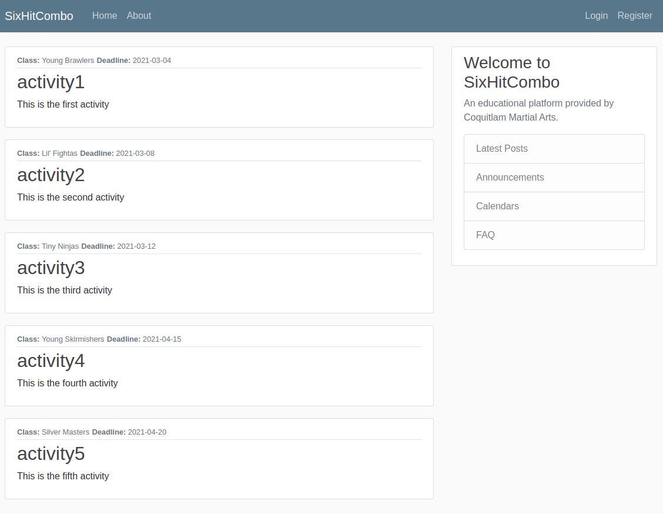

This webpage shows the list of all activities stored in the database. It is produced using the database query:

SELECT Activity.name AS ActivityName, deadline, description, class_ID, Class.name AS ClassName FROM Activity JOIN Class ON Activity.class_ID = Class.ID

Each entry in the webpage represents an activity and provides the following information:
- “Class” indicates the name of the class that the activity belongs to
- “Deadline” indicates the deadline of the activity
- The bold title in the center indicates the activity name
- The line at the bottom of the entry provides the activity description.

A webpage similar to this will be a core component of the website in the final release and will be used by students and instructors to see the activities available for them to participate in.

