**­Design**

* **Overall Plan**
  + This is a hierarchy chart displaying the whole program solution. When the program starts, check_file() starts after main_menu() is run and the user can choose either get_order_input(), editing_main_menu() finalize_order() or options(). The subprograms that the user can choose all return information that is used with the other subprograms to work properly. Without this information the program will not work and information will not be passed around. These subprograms run and when the user decides to exit those sub programs they will be brought back to the main menu unless they choose to exit. This is a basic abstraction of how the overall program’s subprograms work together.

**Pseudo Code on next page.**

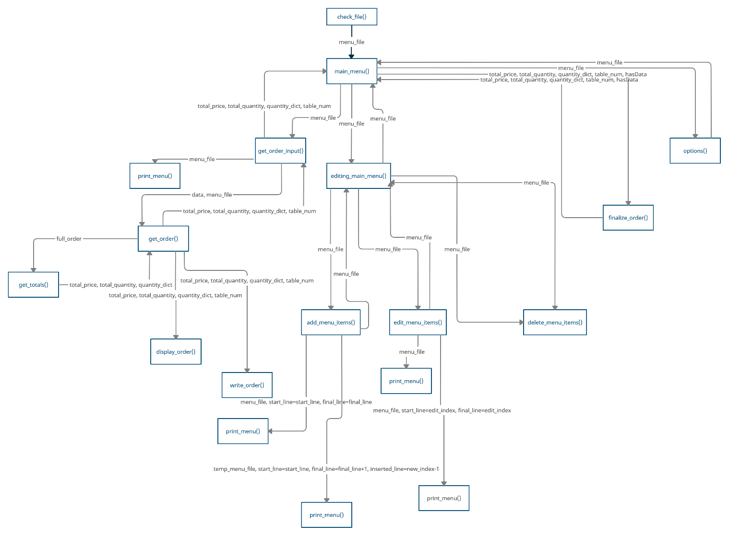

* **Individual subroutine plans**
  + Check “Pseudo Code.txt” for **FULL** Individual Subroutine plans in pseudo code
* **Subroutine Descriptions:**
  + ***finalize_order()***– takes all the totals and data from what the user has entered as their order and then displays it for printing.
  + ***options()***– displays an options menu for the user so that they can choose if they want to manually reset the menu back to defaults
  + ***delete_menu_items()***– allows the user to delete existing menu items that are stored in the menu that will be eventually written to: “menu.txt”
  + ***write_menu()***– takes the menu then, creates menu.txt and writes to it from menu_file that is passed into it as an parameter
  + ***edit_menu_items()***– allows the user to take an existing menu item and edit it’s index, name, price or category and saves changes to the menu
  + ***add_menu_items()***– allows the user to add menu items to the menu. When adding an item, the user can decide it’s price, name, index number and category
  + ***editing_main_menu(****)* – Provides the menu interface for the user to choose to Add, edit or delete menu items in the menu. Exiting this menu takes the user to the main_menu()
  + ***write*_order()** – Takes the user’s order totals such as total price and total quantity and writes it to “running_totals.txt”
  + ***display_order()***– displays the current order with the quantities of each menu item ordered
  + ***get_quantity()***– Generates a dictionary of how many of each item has been ordered in a simple dictionary format for display_order()
  + ***get_totals()*** – Calculates quantity and cost totals for display_order()
  + ***get_order()***– Checks order with menu in “menu.txt” and generates the variable: “full_order”
  + ***print_menu()***– Takes menu.txt from the “menu_file” variable and prints it to the user when so that the user can see a clear view of the current menu with index numbers, prices, names and the category that it is in
  + ***get_order_input()***– Takes the user’s input for their order and validates it and formats it properly so that it can be used later in the program by other subroutines
  + ***main_menu()***– The Main Menu of the program, it’s the first menu that the user sees. The user can choose to Input order data, edit menu items, finalize order, change options or quit to desktop.
  + ***check_file()***– Checks for the menu.txt and creates menu.txt it if it doesn’t exist using the tuple: DEFAULT_MENU
* **Test table for carrying out tests in the program:**
  + Each color in the “Test No.” column represents a different module/subroutine
    - The module/subprogram is written in ***BOLD*** in the *“Purpose of Test”*
  + Each shade of that colour represents a single input with three different types of data: *Errorneous, Boundary and Normal*
  + There are 20 different input statements that the user can interact with in the program according to this table

|  |  |  |
| --- | --- | --- |
| |  |  | | --- | --- | | **Stage 2 – Initial Test Plan** | **Stage 3 and 4 – Test Table** | |
| |  |  |  |  |  |  |  | | --- | --- | --- | --- | --- | --- | --- | | **Test No.** | **Type of Data** | **Purpose of Test** | **Test Data** | **Expected Result** | **Actual Result** | **Action Needed/Comments** | | **1** | Erroneous | Check that menu index is only an integer ***main_menu()*** | abc123.!@#!!|})(*#& | “Invalid Index” | “Invalid Index” | No action needed | | **2** | Boundary | Check that menu index is in range ***main_menu()*** | 0 | “Out of range try again!” | “Out of range try again!” | No action needed | | **3** | Normal | Check that menu index is in range ***main_menu()*** | 1 | “E.g. \"6,4,4,7,8,10,10  Would be an order from Table 6 for 2 Burgers, 1 Fries, 1 Salad and 2 Soft Drinks” | “E.g. \"6,4,4,7,8,10,10  Would be an order from Table 6 for 2 Burgers, 1 Fries, 1 Salad and 2 Soft Drinks” |  | | **4** | Normal | Check that input order formats correctly ***get_order_input()*** | 6, 1, 8, 5,4 ,2, 3, 6 | *Shows correct output with items listed* | *Shows correct output with items listed* | No action needed | | **5** | Boundary | Check if user can’t input a table number or menu index number higher than what is already accepted ***get_order_input()*** | 100,1,1,1,1000,200 | “We only have 10 tables! Table number must be lower than 10, please try again.” | “We only have 10 tables! Table number must be lower than 10, please try again.” | No action needed | | **6** | Erroneous | Check if user can’t input table order with characters that aren’t integers ***get_order_input()*** | A, b ,c $, 1, _”:<AD>>{_+ “:< | “Your order has invalid characters, please try again.” | “Your order has invalid characters, please try again.” |  | | **7** | Normal | Check that menu index is only an integer ***editing_main_menu()*** | abc123.!@#!!|})(*#& | “Invalid index” | “Invalid index” | No action needed | | **8** | Boundary | Check that menu index is in range ***editing_main_menu()*** | 0 | “Out of range try again!” | “Out of range try again!” | No action needed | | **9** | Erroneous | Check that menu index is in range ***editing_main_menu()*** | 1 | *Shows correct output with items listed* | *Shows correct output with items listed* | No action needed | | **10** | Normal | Check that category in user input is a valid option ***add_menu_items()*** | mains | “Please choose the name of your new menu item.” | “Please choose the name of your new menu item.” | No action needed | | **11** | Boundary | Check that category in user input is a valid option ***add_menu_items()*** | deserts | “Please enter a valid category, try again” | “Please enter a valid category, try again” |  | | **12** | Erroneous | Check that category in user input is a valid option ***add_menu_items()*** | abc123.!@#!!|})(*#& | “Please enter a valid category, try again” | “Please enter a valid category, try again” |  | | **13** | Normal | Check that name in user input is a valid option ***add_menu_items()*** | Double Cheeseburger |  |  |  | | **14** | Boundary | Check that name in user input is a valid option ***add_menu_items()*** | 123 Burger 123 | “Name must contain alphabetic characters only, try again.” | “Name must contain alphabetic characters only, try again.” |  | | **15** | Erroneous | Check that name in user input is a valid option ***add_menu_items()*** | abc123.!@#!!|})(*#& | “Name must contain alphabetic characters only, try again.” | “Name must contain alphabetic characters only, try again.” |  | | **16** | Normal | Check if the price in the user input is a valid option ***add_menu_items()*** | 100 | *Shows correct output with menu items listed in the specified category* | *Shows correct output with menu items listed in the specified category* |  | | **17** | Boundary | Check if the price in the user input is a valid option ***add_menu_items()*** | 0.01 | *Shows correct output with menu items listed in the specified category* | *Shows correct output with menu items listed in the specified category* |  | | **18** | Erroneous | Check if the price in the user input is a valid option ***add_menu_items()*** | abc123.!@#!!|})(*#& | Please input numeric characters only, try again. | Please input numeric characters only, try again. |  | | **19** | Normal | Check if the new menu index entered is valid ***add_menu_items()*** | 4 | *Shows correct output with the new menu item inserted into the menu with a arrow pointing at it.* | *Shows correct output with the new menu item inserted into the menu with a arrow pointing at it.* |  | | **20** | Boundary | Check if the new menu index entered is valid ***add_menu_items()*** | 7 | Please enter a value between 3 and 6. | Please enter a value between 3 and 6. |  | | **21** | Erroneous | Check if the new menu index entered is valid ***add_menu_items()*** | abc123.!@#!!|})(*#& | Your index must contain only numeric characters only, try again. | Your index must contain only numeric characters only, try again. |  | | **22** | Normal | Check if the input for if deciding whether to save changes, retry, add another item or discard changes is valid ***add_menu_items()*** | “S” ***OR*** “s” ***OR*** “R” ***OR*** “r” ***OR*** “A” ***OR*** “a” ***OR*** “D” ***OR*** “d” | *Returns user to Edit Menu Items menu and Shows correct output* | *Returns user to Edit Menu Items menu and Shows correct output* |  | | **23** | Boundary | Check if the input for if deciding whether to save changes, retry, add another item or discard changes is valid ***add_menu_items()*** | B | Please enter either:"S" to save,  "R" to retry,  "A" to add another item  "D" to discard changes and exit | Please enter either:"S" to save,  "R" to retry,  "A" to add another item  "D" to discard changes and exit |  | | **24** | Erroneous | Check if the input for if deciding whether to save changes, retry, add another item or discard changes is valid ***add_menu_items()*** | abc123.!@#!!|})(*#& | Please enter either:"S" to save,  "R" to retry,  "A" to add another item  "D" to discard changes and exit | Please enter either:"S" to save,  "R" to retry,  "A" to add another item  "D" to discard changes and exit |  | | **25** | Normal | Check if menu index chosen by the user is valid ***edit_menu_items()*** | 4 | Enter a letter from below to choose what to edit of Burger:  (I)ndex # of item  (N)ame of item  (P)rice  (C)ategory  Enter "E" to (E)xit and choose another item edit or exit. | Enter a letter from below to choose what to edit of Burger:  (I)ndex # of item  (N)ame of item  (P)rice  (C)ategory  Enter "E" to (E)xit and choose another item edit or exit. |  | | **26** | Boundary | Check if menu index chosen by the user is valid ***edit_menu_items()*** | 13 | Your index must be between: 1 and 12  Please try again... | Your index must be between: 1 and 12  Please try again... |  | | **27** | Erroneous | Check if menu index chosen by the user is valid ***edit_menu_items()*** | abc123.!@#!!|})(*#& | Please enter numeric characters only, try again. | Please enter numeric characters only, try again. |  | | **28** | Normal | Check if the choice made by the user when selecting what to edit of the menu item is a valid selection ***edit_menu_items()*** | “I” ***OR*** “i” ***OR*** “N” ***OR*** “n” ***OR*** “P” ***OR*** “p” ***OR*** “C” ***OR*** “c” | Choose the menu item index number that you  want it to change to:  Index Number: | Choose the menu item index number that you  want it to change to:  Index Number: |  | | **29** | Boundary | Check if the choice made by the user when selecting what to edit of the menu item is a valid selection ***edit_menu_items()*** | A | Your input must be either: "I", "N", "P" or "C". Try again! | Your input must be either: "I", "N", "P" or "C". Try again! |  | | **30** | Erroneous | Check if the choice made by the user when selecting what to edit of the menu item is a valid selection ***edit_menu_items()*** | abc123.!@#!!|})(*#& | Your input must be either: "I", "N", "P" or "C". Try again! | Your input must be either: "I", "N", "P" or "C". Try again! |  | | **31** | Normal | Check if the menu item index number that the user wants to change the menu item to is valid ***edit_menu_items()*** | 10 | *Shows the valid input with the menu item’s index number changed.* | *Shows the valid input with the menu item’s*  *index number changed.* |  | | **32** | Boundary | Check if the menu item index number that the user wants to change the menu item to is valid ***edit_menu_items()*** | “0” ***OR “***13” | Your index must be between: 1 and 12  Please try again… | Your index must be between: 1 and 12  Please try again... |  | | **33** | Erroneous | Check if the menu item index number that the user wants to change the menu item to is valid ***edit_menu_items()*** | abc123.!@#!!|})(*#& | Please enter numeric characters only, try again. | Please enter numeric characters only, try again. |  | | **34** | Normal | Check if the name entered by the user when editing the name of the menu item is valid ***edit_menu_items()*** | Double Mega Burger | *Shows the menu item with the new name* | *Shows the menu item with the new name* |  | | **35** | Boundary | Check if the name entered by the user when editing the name of the menu item is valid ***edit_menu_items()*** | Name123 | Name must contain alphabetic characters only, try again. | Name must contain alphabetic characters only, try again. |  | | **36** | Erroneous | Check if the name entered by the user when editing the name of the menu item is valid ***edit_menu_items()*** | abc123.!@#!!|})(*#& | Name must contain alphabetic characters only, try again. | Name must contain alphabetic characters only, try again. |  | | **37** | Normal | Check if the price entered by the user is valid ***edit_menu_items()*** | 40 | *Shows the new menu item with the price entered by the user.* | *Shows the new menu item with the price entered by the user.* |  | | **38** | Boundary | Check if the price entered by the user is valid ***edit_menu_items()*** | 10000 | *Shows the new menu item with the price entered by the user.* | *Shows the new menu item with the price entered by the user.* |  | | **39** | Erroneous | Check if the price entered by the user is valid ***edit_menu_items()*** | abc123.!@#!!|})(*#& | Please input numeric characters only, try again. | Please input numeric characters only, try again. |  | | **40** | Normal | Check if the category entered by the user when editing the category is a valid category ***edit_menu_items()*** | Drinks | *Shows the menu with only the drinks showing and asks the user to input a menu index on where to insert the new menu item in the specified category* | *Shows the menu with only the drinks showing and asks*  *the user to input a menu index on where to insert the*  *new menu item in the specified category* |  | | **41** | Boundary | Check if the category entered by the user when editing the category is a valid category ***edit_menu_items()*** | Desserts | Please enter a valid category, try again. | Please enter a valid category, try again. |  | | **42** | Erroneous | Check if the category entered by the user when editing the category is a valid category ***edit_menu_items()*** | abc123.!@#!!|})(*#& | Please enter a valid category, try again. | Please enter a valid category, try again. |  | | **43** | Normal | Check if the new menu index that the user wants to select when chanigng the menu item’s category is correct. ***edit_menu_items()*** | 12 | *Shows the menu item with the menu item index that the user specified where choosing where to insert the menu item into the category.* | *Shows the menu item with the menu item index that the user specified where choosing where to insert the menu item into the category.* |  | | **44** | Boundary | Check if the new menu index that the user wants to select when chanigng the menu item’s category is correct. ***edit_menu_items()*** | 13 | Please enter a value between 9 and 12. | Please enter a value between 9 and 12. |  | | **45** | Erroneous | Check if the new menu index that the user wants to select when chanigng the menu item’s category is correct. ***edit_menu_items()*** | abc123.!@#!!|})(*#& | Your index must contain only numeric characters only, try again. | Your index must contain only numeric characters only, try again. |  | | **46** | Normal | Check if the menu item index input is valid when the user is trying to delete a menu item. ***delete_menu_items()*** | 5 | Are you sure you want to delete Sparkling water?  - Enter "Y" to Confirm Menu Item Deletion  - Enter "N" to Discard Changes and Exit to Edit Menu | Are you sure you want to delete Sparkling water?  - Enter "Y" to Confirm Menu Item Deletion  - Enter "N" to Discard Changes and Exit to Edit Menu |  | | **47** | Boundary | Check if the menu item index input is valid when the user is trying to delete a menu item. ***delete_menu_items()*** | 14 | Your delete index must be between: 1 and 13  Please try again... | Your delete index must be between: 1 and 13  Please try again... |  | | **48** | Erroneous | Check if the menu item index input is valid when the user is trying to delete a menu item. ***delete_menu_items()*** | abc123.!@#!!|})(*#& | Please enter numeric characters only, try again | Please enter numeric characters only, try again |  | | **49** | Normal | Check if the user input when confirming to delete the menu item is valid ***delete_menu_items()*** | “Y” ***OR “***y” “0” ***OR “***N” ***OR*** “n” | *Shows the new menu wth the selected menu item deleted and all the menu items in the correct order.* | *Shows the new menu wth the selected menu item deleted and all the menu items in the correct order.* |  | | **50** | Boundary | Check if the user input when confirming to delete the menu item is valid ***delete_menu_items()*** | abcdefg | Please enter "y" or "n" as your choice, try again. | Please enter "y" or "n" as your choice, try again. |  | | **51** | Erroneous | Check if the user input when confirming to delete the menu item is valid ***delete_menu_items()*** | abc123.!@#!!|})(*#& | Please enter "y" or "n" as your choice, try again. | Please enter "y" or "n" as your choice, try again. |  | | **52** | Erroneous | Check if the user trying to finalize order before having entered an order gives out an error ***finalize_order()*** | 3 | No current order! Go back and Input an order. | No current order! Go back and Input an order. |  | | **53** | Normal | Check if the user’s input when choosing whether to “*Exit and enter another order”, “exit and keep current order”* or to *“quit the program”*  is valid ***finalize_order()*** | “Y” ***OR “***y” “0” ***OR “***N” ***OR*** “n” ***OR “***Q” ***OR “***q” | *- Choosing “y” would exit and reset the order made by the user*  *- Choosing “n” would exit and keep the current order that the user has made*  *- Choosing “q” would quit the program as expected* | *- Choosing “y” would exit and reset the order made by*  *the user*  *- Choosing “n” would exit and keep the current order*  *that the user has made*  *- Choosing “q” would quit the program as expected* |  | | **54** | Boundary | Check if the user’s input when choosing whether to “*Exit and enter another order”, “exit and keep current order”* or to *“quit the program”*  is valid ***finalize_order()*** | abc | Please enter "y", "n" or "q"as your choice, try again.  - Enter "Y" to Exit and enter another order  - Enter "N" to Exit and keep current order  - Enter "Q" to Quit the program | Please enter "y", "n" or "q"as your choice, try again.  - Enter "Y" to Exit and enter another order  - Enter "N" to Exit and keep current order  - Enter "Q" to Quit the program |  | | **55** | Erroneous | Check if the user’s input when choosing whether to “*Exit and enter another order”, “exit and keep current order”* or to *“quit the program”*  is valid ***finalize_order()*** | abc123.!@#!!|})(*#& | Please enter "y" or "n" as your choice, try again.  - Enter "Y" to Exit and enter another order  - Enter "N" to Exit and keep current order  - Enter "Q" to Quit the program | Please enter "y", "n" or "q"as your choice, try again.  - Enter "Y" to Exit and enter another order  - Enter "N" to Exit and keep current order  - Enter "Q" to Quit the program |  | | **56** | Normal | Check if the choice index for choosing whether to Reset Menu Items File or to Exit to Main Menu is valid ***options()*** | 1 | Are you sure you want to reset the Menu Items File? (menu.txt)?  This will erase all saved changes to the file and reset it to  defaults.  - Enter "Y" to CONFIRM MENU RESET  - Enter "N" to DISCARD CHANGES AND EXIT | Are you sure you want to reset the Menu Items File? (menu.txt)?  This will erase all saved changes to the file and reset it to  defaults.  - Enter "Y" to CONFIRM MENU RESET  - Enter "N" to DISCARD CHANGES AND EXIT |  | | **57** | Boundary | Check if the choice index for choosing whether to Reset Menu Items File or to Exit to Main Menu is valid ***options()*** | “3” ***OR “***0” | Please enter 1 or 2 as your choice. | Please enter 1 or 2 as your choice. |  | | **68** | Erroneous | Check if the choice index for choosing whether to Reset Menu Items File or to Exit to Main Menu is valid ***options()*** | abc123.!@#!!|})(*#& | Please enter numeric characters only, try again. | Please enter numeric characters only, try again. |  | | **69** | Normal | Check if the deletion confirmation message is valid ***options()*** | “N” ***OR*** “n” ***OR*** “Y” ***OR*** “y” | *Selecting “Y” displays: “File reset!” then returns the user to the main menu.*  *Selecting “N” displays: “Exiting...” then returns the user to the main menu.* | *Selecting “Y” displays: “File reset!” then returns*  *the user to the main menu.*  *Selecting “N” displays: “Exiting...” then returns*  *the user to the main menu.* |  | | **70** | Boundary | Check if the deletion confirmation message is valid ***options()*** | a | Please enter "y" or "n" as your choice, try again. | Please enter "y" or "n" as your choice, try again. |  | | **71** | Erroneous | Check if the deletion confirmation message is valid ***options()*** | abc123.!@#!!|})(*#& | Please enter "y" or "n" as your choice, try again. | Please enter "y" or "n" as your choice, try again. |  | |