**­Debugging**

* **Fixing Order Input Validation**
  + 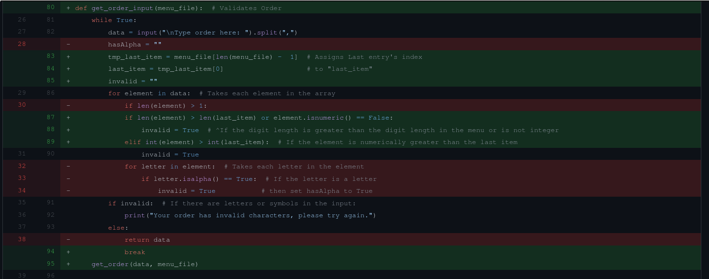dksj xcxcxc thi