DAN TREVOR MATOVU

Kiira, Kyaliwajjala, Eden Road, Kampala, Uganda
Email: dantetrevordrex@gmail.com | Phone: +256745315809
LinkedIn: https://www.linkedin.com/in/dantetrevordrex
GitHub: https://www.github.com/danteindrex

PROFESSIONAL SUMMARY

Results-driven Backend Developer and AI Specialist with expertise in Python (Django), automation, API integrations, and AI-driven systems. Passionate about workflow automation, business intelligence, and scalable software development. Experienced in AI-driven automation, cloud-based integrations, and full-stack development.

TECHNICAL SKILLS

Programming Languages: Python (Django), Dart (Flutter), Rust, COBOL,SQL,

Backend Development: RESTful APIs, System Automation, Database Management (PostgreSQL, MySQL)
Automation & AI: AI-driven business automation, Workflow optimization, Business Intelligence Dashboards.
Cloud & DevOps: Firebase, CI/CD (GitHub Actions), API Integration, Cloud-based automation
Frontend Technologies: JavaScript (React), flutter
Expertise: Development of AI based solutions with Deep learning.

Project Management: Agile (Scrum), Jira, Trello

WORK EXPERIENCE
AI Projects | Hackathon Contributor | 2025
- Built Deep_Jobs, an AI-powered job search tool that analyzes developer portfolios (GitHub, resumes) to match with job openings using CrewAI and Perplexity API.
- Created E‑Govt WhatsApp Helpdesk, a multi-agent virtual assistant deployed on WhatsApp that guides citizens through accessing government services using ADK and LLMs.

Software Developer | Taste and Tasty Restaurant | March 2023 – Present

Developed and deployed an AI-powered restaurant ordering system using Flutter and Firebase, reducing manual processing time by 50%.
Designed automated order tracking workflows, ensuring real-time data synchronization between customers and kitchen staff.
Integrated secure API connections to streamline payment processing and customer management.
Collaborated with designers and stakeholders to optimize user experience and system efficiency.

IBM Granite AI Hackathon Participant | 2024

Developed System GPT, an AI-powered business management system that automates workflows, customer interactions, and business intelligence tasks.

Designed and implemented AI-driven automation for system monitoring, optimizing operational efficiency.

Integrated RESTful APIs and cloud-based services for real-time data processing.

Project available on GitHub: https://www.github.com/danteindrex/systemgpt

NASA Space Apps Challenge Participant | 2024

Led a team in developing a real-time crop monitoring app using NASA satellite imagery to assist farmers with AI-driven insights.

Designed an automated data pipeline for satellite image processing, improving accuracy in agricultural predictions.

Implemented backend services in Python (Django) to handle data ingestion and analysis.

Assistant Consultant Intern | Hak Computers, Kampala | June 2020 – July 2021

Provided IT support and troubleshooting for system networks, improving operational efficiency.

Assisted in automation of system maintenance tasks, reducing downtime by 20%.

Managed system integrations for print jobs and networked devices, optimizing resource utilization.

EDUCATION & CERTIFICATIONS

Diploma in Computer Science | Uganda Institute of Information and Communication Technology (UICT)

CS50 Python Certificate | Harvard University

Certificate in Business Communication | HP Life

Certificate in Video Editing with After Effects | LinkedIn Learning

ACHIEVEMENTS & IMPACT
- Developed Deep_Jobs, an AI-based career discovery tool that deeply analyzes GitHub and resume content to recommend jobs and auto-apply.
- Built E‑Govt WhatsApp Helpdesk, a live government-support chatbot system deployed for non-tech users on WhatsApp using Google's ADK.

Developed an AI-powered automation system that streamlined restaurant order processing.

Designed an API-driven data pipeline for real-time crop monitoring using NASA imagery.

Built System GPT, an AI-based business management automation tool, optimizing operational workflows.

Optimized system automation to reduce manual business operations and enhance efficiency.

REFERENCES

Mr. Rodney – software engineer, Makerere university. | +256 785 336891
Mrs. Joy – Data scientist | +256 726 242350
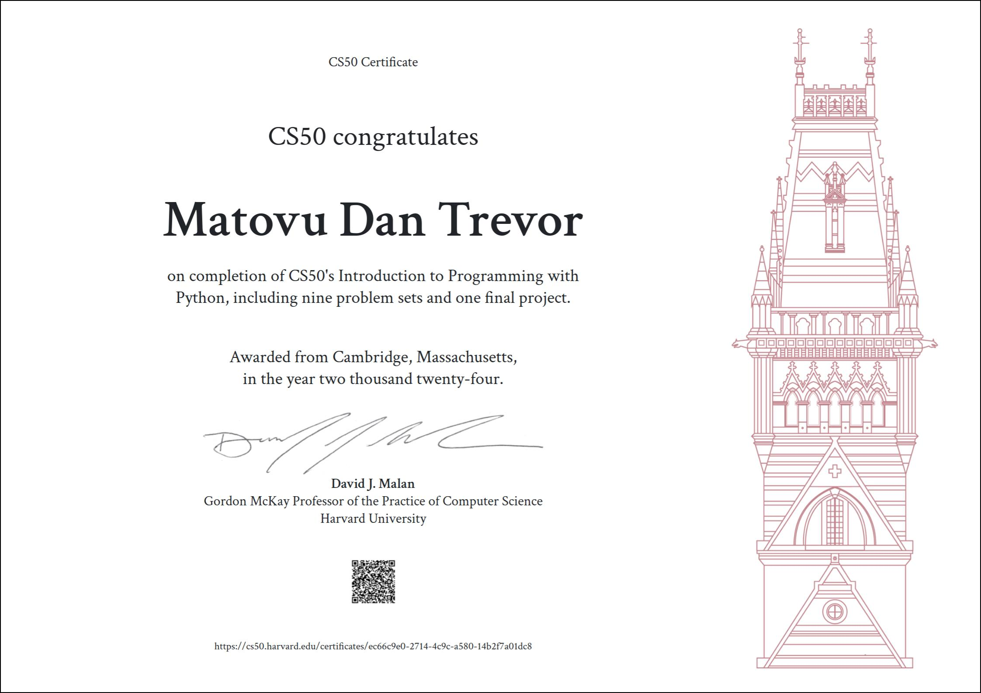

PROJECTS

Devpost AI Agent Hackathon | Developer & Research Lead | 2025
Project: Deep_Jobs (https://devpost.com/software/deep_jobs)
- Led the development of an AI-driven job recommendation engine that analyzes GitHub projects and resumes to match candidates with relevant opportunities.
- Integrated CrewAI, Perplexity’s deep research API, and Gemini Vision API to power multi-agent job search and application automation.
- Designed agent workflows for market analysis, resume parsing, and beta auto-application functionality.
- Engineered FastAPI MCP endpoints for scalable job discovery and AI-driven application workflows.

Google ADK Hackathon | Backend Developer | 2025
Project: E‑Govt WhatsApp Helpdesk (https://devpost.com/software/e-govt-whatsapp-helpdesk)
- Developed a multi-agent conversational chatbot on WhatsApp to answer government service questions using Google’s ADK and WhatsApp Cloud API.
- Implemented agent hierarchy with LlmAgent, SequentialAgent, and ParallelAgent workflows to handle diverse citizen requests.
- Used Vertex AI and Perplexity LLMs for real-time Q&A, document lookup, and intent recognition.
- Deployed the system on Google Cloud Run and validated response accuracy through ADK's eval suite.

