Data Analysis for TechPointX Xbot Digital Assistant

Dante Razo

10/20/2018

# Abstract

I’ve been tasked with analyzing app store data to assess its current state and predict the success of TechPointX’s upcoming $Xbot$ digital assistant. Due to the popularity of the company’s OSXtern operating system, expectations are high for the app. I observed trends in the app store to help the team make the launch as impactful as possible. I used $RMarkdown$, $RStudio$, and the $DataExplorer$ library for R to create this report.

## Importing Data & Packages

First, I imported the data. The $.csv$ has headers and entries are separated by commas, so I used $read.csv()$’s default settings.

require(DataExplorer) # package that provides additional visualization tools for data analysis

## Loading required package: DataExplorer

appStore <- read.csv(file = "AppStoreAssessmentDataScience.csv")  
appStore.og <- appStore # store copy of the original before preprocessing

## Data Preprocessing

Before any preprocessing is done, we can observe that $appStore$ contains 7197 objects of 9-dimensions. There are no missing values, so imputation is not necessary.

dim(appStore)

## [1] 7197 9

sum(is.na(appStore)) # no missing values in dataset

## [1] 0

The first column of $appStore$ is in numerical order, but only the first 18 entries match the column number. It’s unknown why numbers are skipped over. This vector has a 99% correlation with column numbers, so I removed it from the dataset. It is stored under a new name in case it can be used later.

sum(appStore[1] == seq(1, nrow(appStore))) # checks if entry equals row number; 18 matches

## [1] 18

cor(appStore$X, seq(1, nrow(appStore))) # computes correlation between two vectors

## [1] 0.9936812

appStore.V1 <- appStore[1] # save first column as new variable  
appStore <- appStore[, 2:9] # remove first column from dataset

The $app_content_rating$ column contains integers with a “+” character appended to the end. I removed the pluses and converted the resulting strings to integers. This will allow me to take averages and analyze this vector if I need to.

appStore$app_content_rating <- as.numeric(gsub("\\+", "", appStore$app_content_rating))

It was at this point that I remembered to check for other types of missing values (such as zeroes where they don’t make sense). Using the $summary()$ function revealed that the last column of the dataset ($app_total_supported_langs$) contained 0’s. It doesn’t make sense for an app to have 0 supported languages, so these are effectively missing values. Due to the small number of affected entries, I elected to simply remove them.

summary(appStore$app_total_supported_langs)

## Min. 1st Qu. Median Mean 3rd Qu. Max.   
## 0.000 1.000 1.000 5.435 8.000 75.000

sum(appStore$app_total_supported_langs == 0)

## [1] 41

appStore$app_total_supported_langs[appStore$app_total_supported_langs == 0] <- NA # replace 0's  
appStore <- na.omit(appStore)

## Data Analysis

Now that the data has been processed, I can begin to make sense of it. I began by making density plots of every column in the dataset. The $DataExplorer$ library makes it easy to view all plots at once.

plot_density(appStore) # function from DataExplorer library

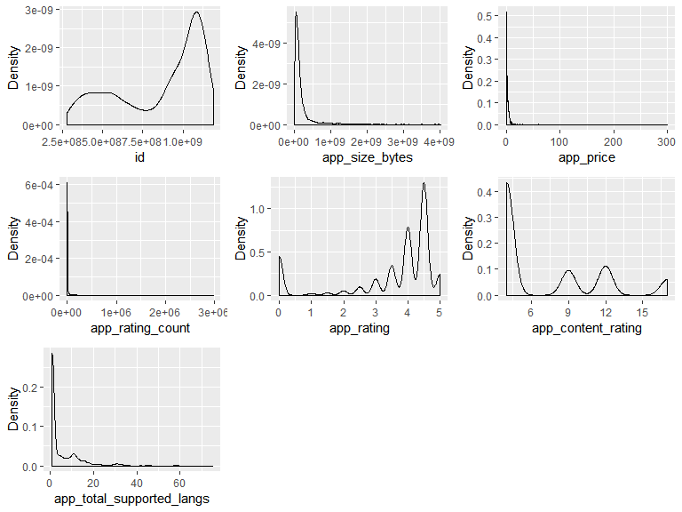 I immediately noticed that $appStore\$id$ is a a left-skewed bimodal distribution. The ID is simply a number and won’t be useful in identifying trends in the App Store, so I moved on to other columns. The majority of apps on the market are less than 1000MB ( ${10}^{9}=1,000,000,000$ bytes). Depending on how OSXtern and other supported platforms defines a gigabyte, you could say that most apps are less than 1GB as well.

plot_correlation(appStore[, 2:ncol(appStore)], maxcat = 24) # function from DataExplorer library

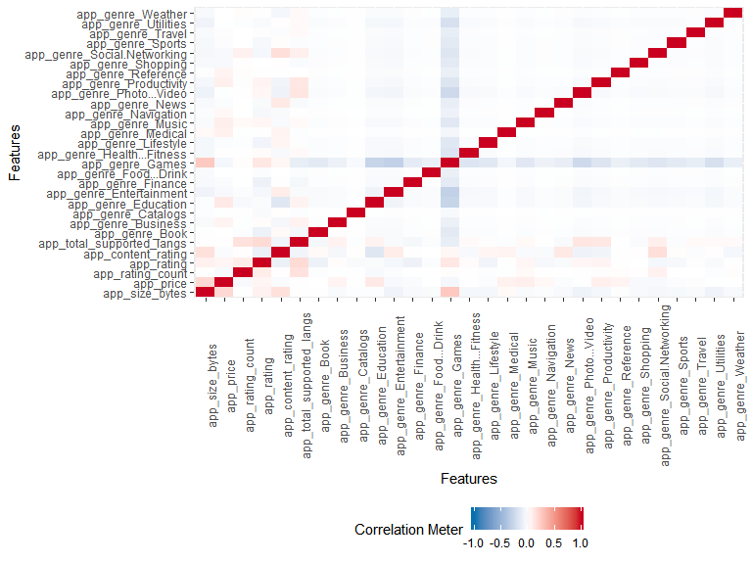

$DataExplorer$’s $plot_correlation()$ function produced a nice correlation graph of every feature. I didn’t learn anything new from it, but it confirmed that no high-correlation vector pairs remained. The only feature not pictured is $app_genre$ because each entry is a string. It contains nominal data; usually, I’d assign numbers to each value before working with them, but $DataExplorer$ has a visualization solution that negates the need to first quantify the genres.

Surprisingly, app price and size have a somewhat strong correlation with a correlation coefficient ($r$) of 0.18. $r^{2}=0.0324$, which means that only 3.24% of the variation is explained by $r$. Another strange observation is that $r=0.14$ for $app_content_rating$ and $app_size_bytes$. Less surprising and somewhat strong correlations include: $app_rating_count$ vs. $app_total_supported_langs$ (0.14) and $app_rating$ vs. $app_total_supported_langs$ (0.17). Finally, games tend to be bigger in size (bytes) and have higher ratings than other apps.

plot_bar(appStore$app_genre, title = "Frequency of App Genres in the App Store")

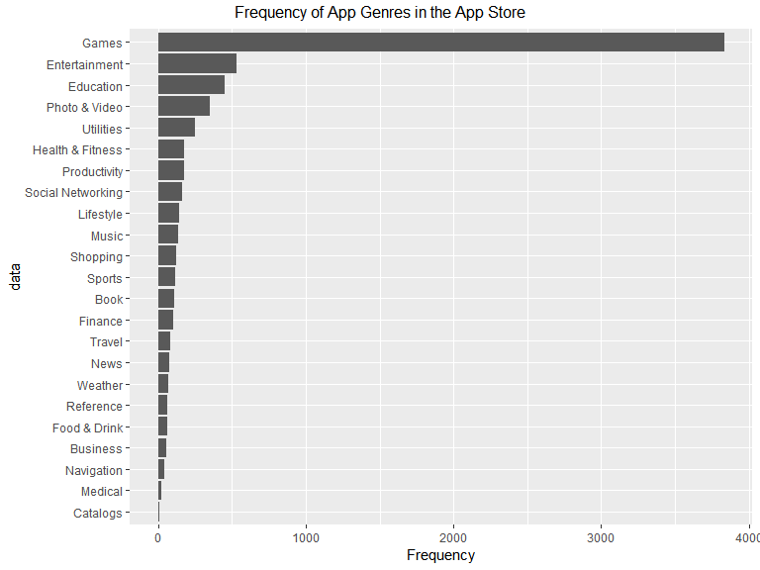

The ‘Games’ category stands out as an outlier. The number of ‘Games’ apps (3832) is over 7 times greater than the number of ‘Entertainment’ apps (534). I created a separate dataset that contains everything but apps labeled ‘Games’ in case the outlier affects future observations.

numGames <- sum(grepl("Games", appStore$app_genre)) # most common genre  
numEntertainment <- sum(grepl("Entertainment", appStore$app_genre)) # second most common genre  
numGames/numEntertainment # ratio (7x increase)

## [1] 7.17603

appStore.noGames <- appStore # create copy of dataset  
appStore.noGames$app_genre[grepl("Games", appStore.noGames$app_genre)] <- NA # replace games with NA  
appStore.noGames <- na.omit(appStore) # remove games (now NA)

$Xbot$ is an assistant, so it’d best fit in the ‘Utilities’ category. I compared this category to its nearest competitors below:

numPhoto <- sum(grepl("Photo & Video", appStore$app_genre))  
numUtil <- sum(grepl("Utilities", appStore$app_genre))  
numHealth <- sum(grepl("Health & Fitness", appStore$app_genre))  
  
numUtil # number of utility apps

## [1] 248

numPhoto - numUtil # distance to upper neighbor

## [1] 100

numUtil - numHealth # distance to lower neighbor

## [1] 68

Unlike ‘Games’, ‘Utilities’ is reasonably close to its neighbors. It’s a popular yet less-saturated genre with only 248 apps. $Xbot$ has a higher chance of success than any new game that comes to the app store because it has less competition. If advertised properly, it could very easily top the charts.

Next, I focused on the price of the apps in the dataset ($appStore\$app_price$). Unsurprisingly, the majority (56%) were free. I must admit that I’m unsure what to make of this; the naive answer would be to make $Xbot$ a free app too to achieve the same accessibility and popularity as the others. People are more likely to download and try a free app than pay for an app they may not enjoy using.

sum(appStore$app_price == 0)/nrow(appStore) # 56% of apps are free

## [1] 0.5627446

appStore.prices <- as.data.frame(table(appStore$app_price)) # store prices in new dataframe  
names(appStore.prices)[1] <- "Price" # rename first dataframe vector  
plot(appStore.prices) # plot distribution of prices

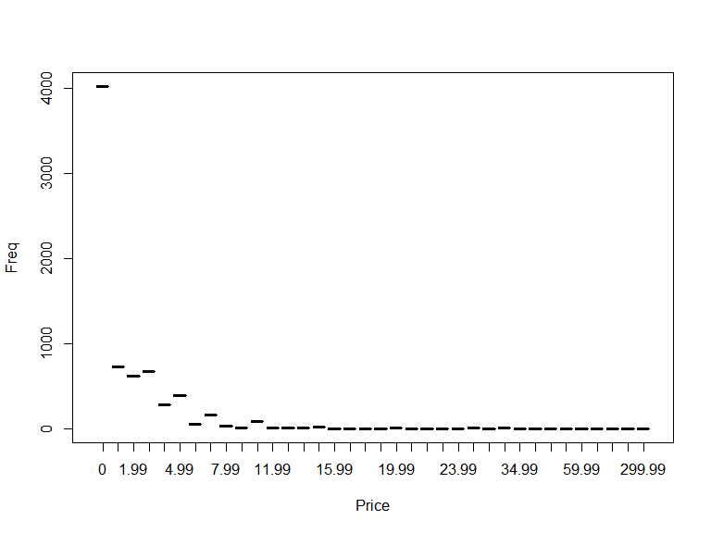

# Conclusion

To make $Xbot$ a success, TechPointX needs to list the app as a “Utility” and consider making the app free to incite downloads. App size and rating are positively correlated, but making an app less than 1GB is common and undoutebly expected by consumers. $Xbot$ needs to have the lowest app content rating possible to increase the number of potential users. It would be beneficial to hire a localization team to ensure everyone can use the app no matter the locale. The more languages an app supports, the higher the rating according to the dataset.