Windows 11 Virtual Machine Deployment Lab
Windows 11 Virtual Machine Deployment Lab

Author: Dante Walker
Date Completed: June 2026

Objective: The purpose of this lab was to install and configure Microsoft Windows 11 within Oracle VirtualBox. This project was completed to gain hands-on experience with virtualization technologies, operating system deployment, system verification, and basic networking.

Tools Used
- Oracle VirtualBox
- Microsoft Windows 11 ISO
- Windows 11 Host System

System Configuration

Virtual Machine Name: Virtual Machine Windows Install

Allocated Resources:

- RAM: 8 GB
- CPU Cores: 2
- Virtual Disk: 64 GB

Step 1: Windows 11 Installation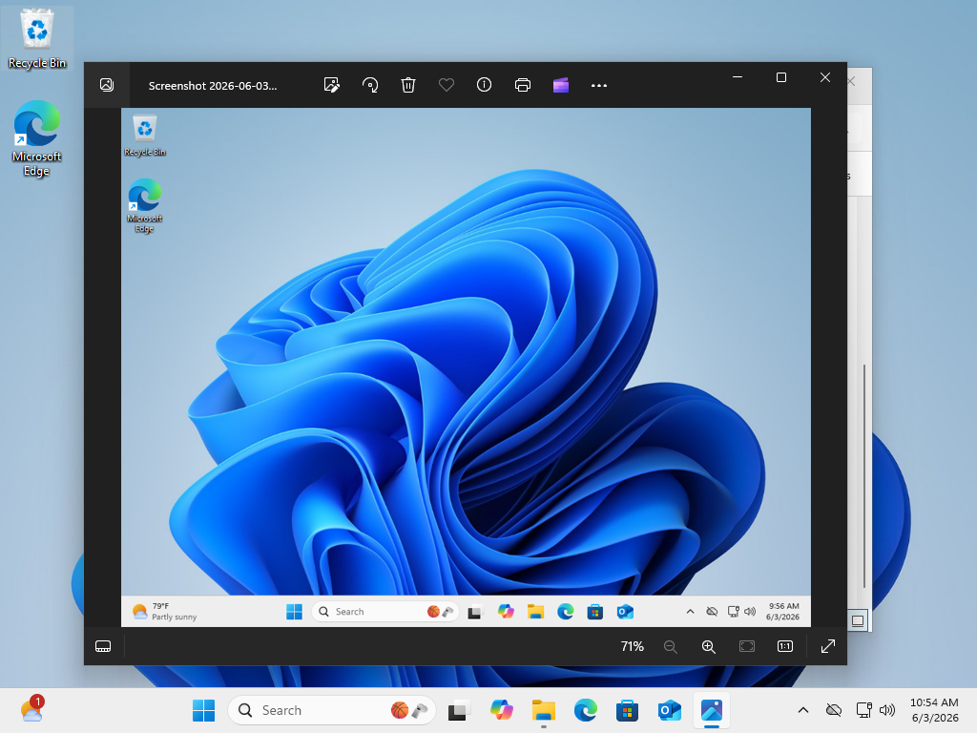

Description: Windows 11 was successfully installed and booted within the virtual machine. The operating system reached the desktop environment without errors.

Step 2: System Verification
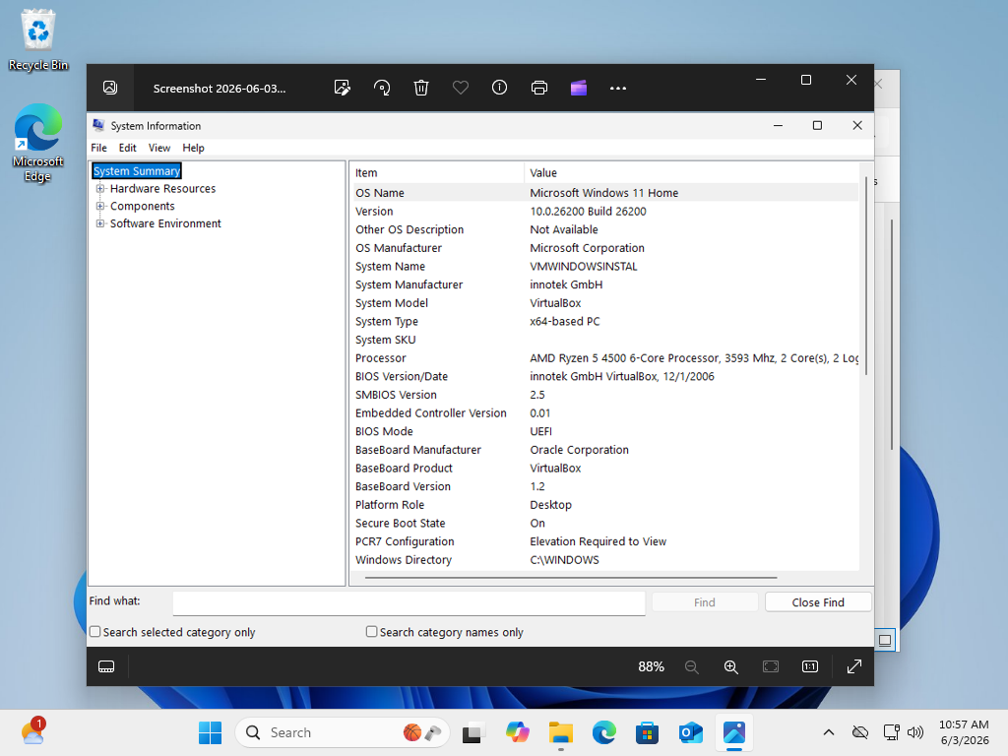

Description: System Information was reviewed to confirm the operating system version, processor configuration, BIOS mode, and hardware detection.

Step 3: Device Specifications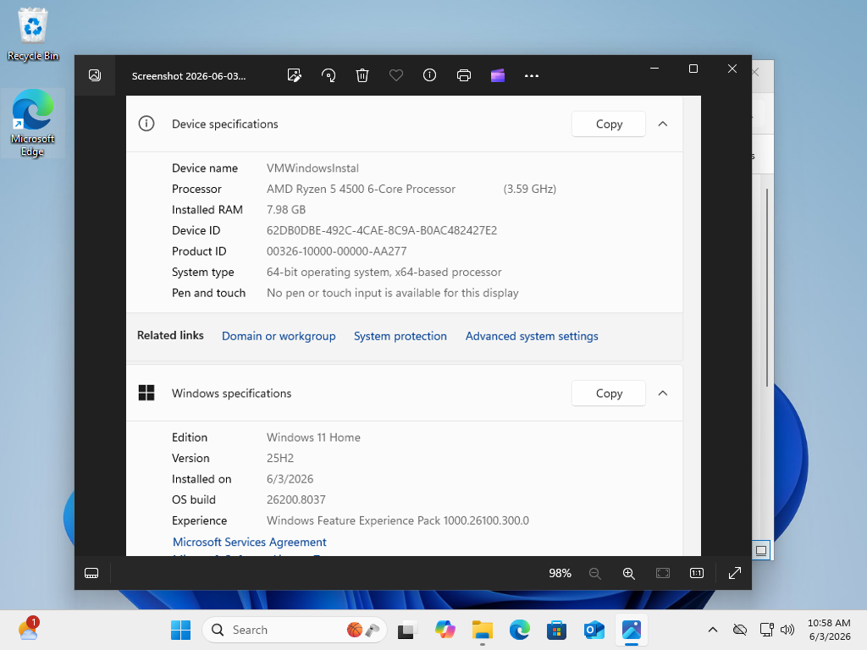

Description: Device specifications were reviewed to verify processor allocation, installed memory, and operating system architecture.

Step 4: Disk Management Verification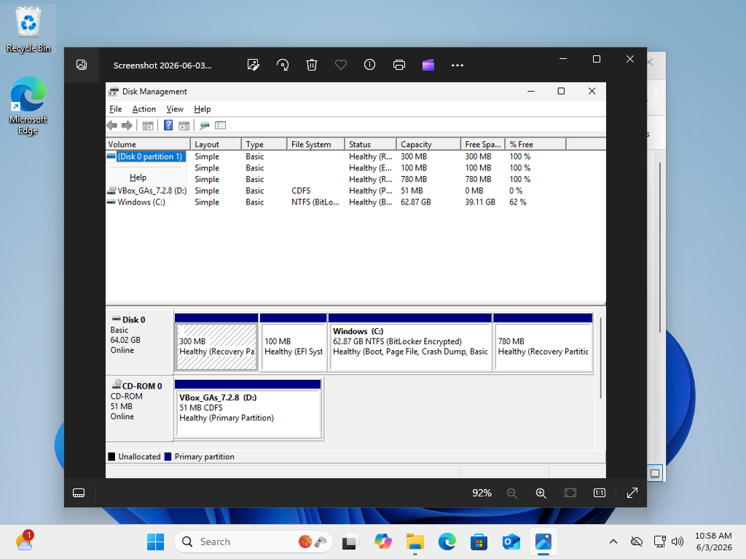
Description: Disk Management was used to verify partition creation and storage allocation. Windows correctly recognized the virtual hard disk and system partitions.

Step 5: VirtualBox Guest Additions
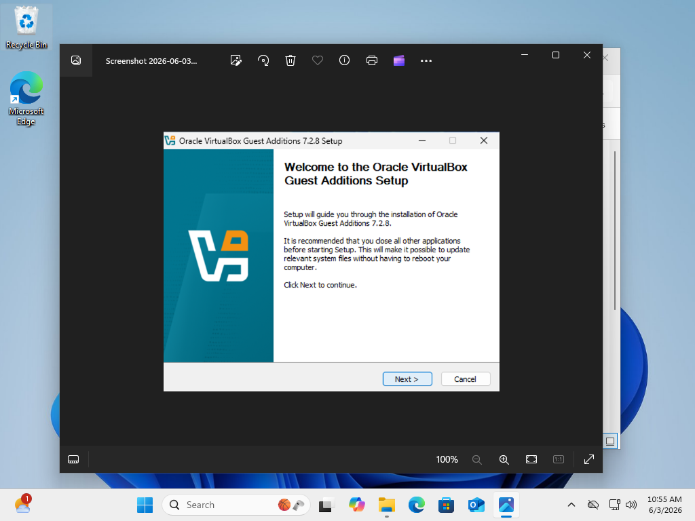
Description: Oracle VirtualBox Guest Additions were installed to improve display support, mouse integration, and overall virtual machine usability.

Step 6: Network Connectivity Verification
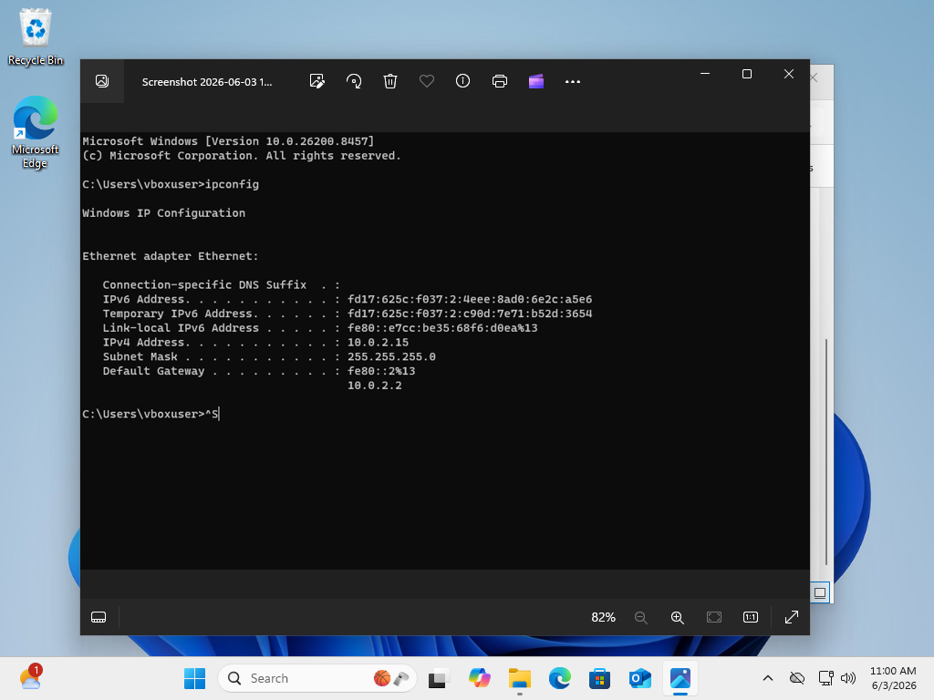

Description:The ipconfig command was executed to verify successful network connectivity. The virtual machine received an IPv4 address and gateway configuration through VirtualBox networking.

Troubleshooting
Issue: Virtual machine initially displayed an "Aborted" status during startup.

Resolution: Verified virtualization settings and restarted the virtual machine. The issue was resolved and Windows 11 installed successfully.

Skills Demonstrated

• Virtualization
• Windows 11 Deployment
• System Configuration
• Storage Management
• Network Verification
• Technical Documentation
• Basic Troubleshooting
• Oracle VirtualBox Administration

---

Conclusion

The Windows 11 virtual machine was successfully deployed and configured within Oracle VirtualBox. System functionality, networking, storage configuration, and VirtualBox integration were verified through testing and documentation. This project provided practical experience with virtualization technologies commonly used in IT support and system administration environments.

