Dante Reynaldo Montaño Lelarge
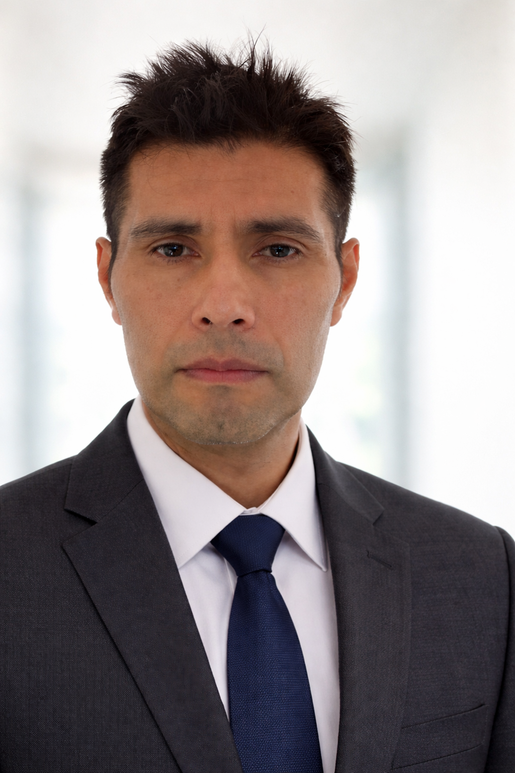

AI-Enhanced Virtual Assistant

Professional Profile
Remote professional with experience in digital management, content creation, automation and AI-assisted productivity tools. Skilled in supporting businesses through efficient workflows, research, and digital organization.

Contact
Location: La Paz, Bolivia
Email: montainreynaldex@gmail.com
Phone: +591 60114365
LinkedIn: https://www.linkedin.com/in/reynaldo-montano-68254b360/

Experience
Freelance Virtual Assistant & Web Support (2022–Present)
- Email and task management
- Content creation with AI assistance
- Research and documentation
- Workflow automation using Make and n8n

Education
Systems Engineering – Universidad Privada Domingo Savio (UPDS), Bolivia
6th Semester – Currently taking Web Technology I

Key Skills
AI Tools (ChatGPT, automation workflows), Content Creation, Task Management, WordPress, Customer Support, Productivity Optimization, Portuguese (Fluent)

