Dante Reynaldo Montaño Lelarge
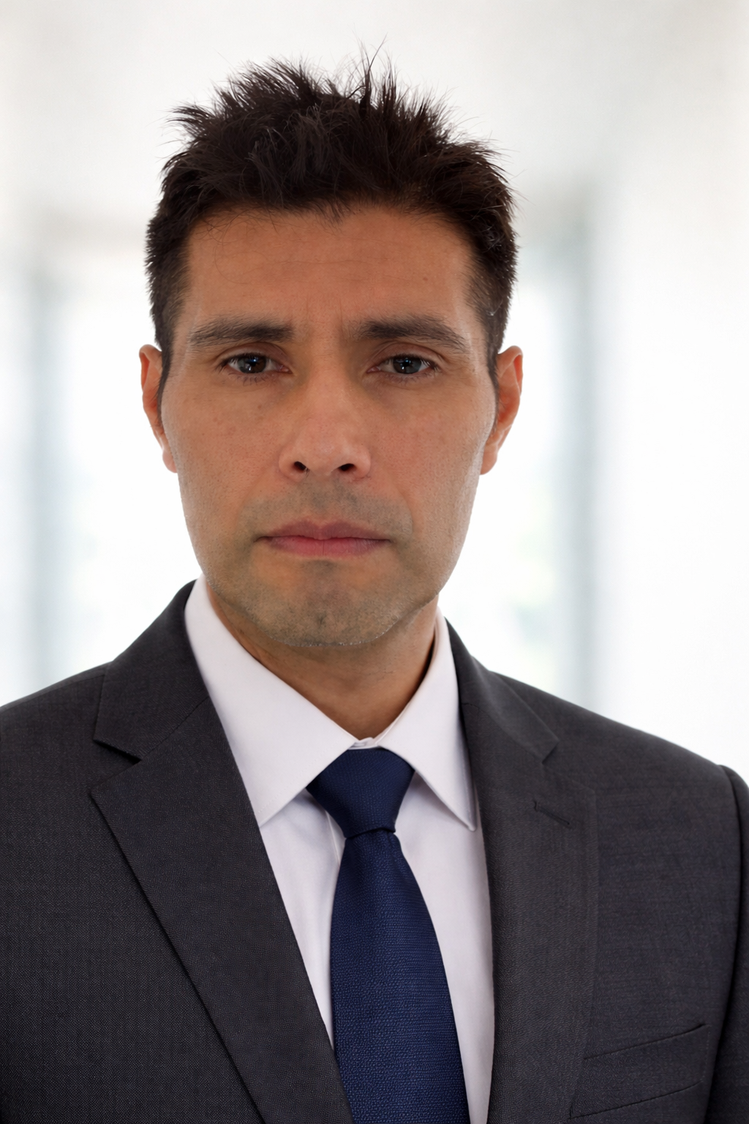

Automation & No-Code Specialist (AI-Driven)

Professional Profile
Automation-focused remote professional using AI and no-code tools to streamline processes, reduce manual tasks and improve operational efficiency.

Contact
Location: La Paz, Bolivia
Email: montainreynaldex@gmail.com
Phone: +591 60114365
LinkedIn: https://www.linkedin.com/in/reynaldo-montano-68254b360/

Experience
Automation Freelancer (2022–Present)
- Workflow automation with Make and n8n
- API integrations
- Process optimization using AI
- Digital system structuring for small businesses

Education
Systems Engineering – Universidad Privada Domingo Savio (UPDS), Bolivia
6th Semester – Currently taking Web Technology I

Key Skills
Make, n8n, API Integration, Process Automation, AI Productivity Tools, Workflow Design, Analytical Thinking

