PCB Block
ECE 44x
Last Revision: 02/27/17

Daniel Eisenbach
Electrical and Computer Engineering
Oregon State University
Corvallis, OR
eisenbad@oregonstate.edu

Abstract—The purpose of this document is to outline the functionality and design of the PCB block for the OCR Speed Sign Detection project to fourth-year electrical engineering students, and the project’s stakeholders. This document includes an overview, verification process, design, and validation for the PCB block.
Keywords—OCR, BLE, PCB, AVRISP, MCU, LCD, EasyEDA

Introduction
The PCB block, which contains the physical components of the MCU and LCD blocks, functions to create a portable Bluetooth Low Energy (BLE) LCD device small enough to fit in one’s hand. The BLE LCD receives and displays the detected sign data from the OCR app running on a connected Android device via the BLE Transmitter block. The BLE LCD demonstrates how the OCR Speed Sign Detection system could offload data to external ECUs in a truck using the BLE protocol.

Block Overview
As is outlined in Fig. 1 below, the PCB contains the MCU and LCD blocks. The BLE Transmitter block sends data to the MCU block, which passes the data on to the LCD block to be displayed. The code block represents the program stored onto the MCU through the AVRISP protocol. The PCB also contains the following components:
- SPST power switch
- 6-pin shrouded header connected to the MCU’s SPI pins for in-system programming using the AVRISP protocol
- 10K potentiometer to adjust the contrast ratio of the LCD
- 47 Ohm resistor to limit the LCD backlight’s current draw to less than 50mA
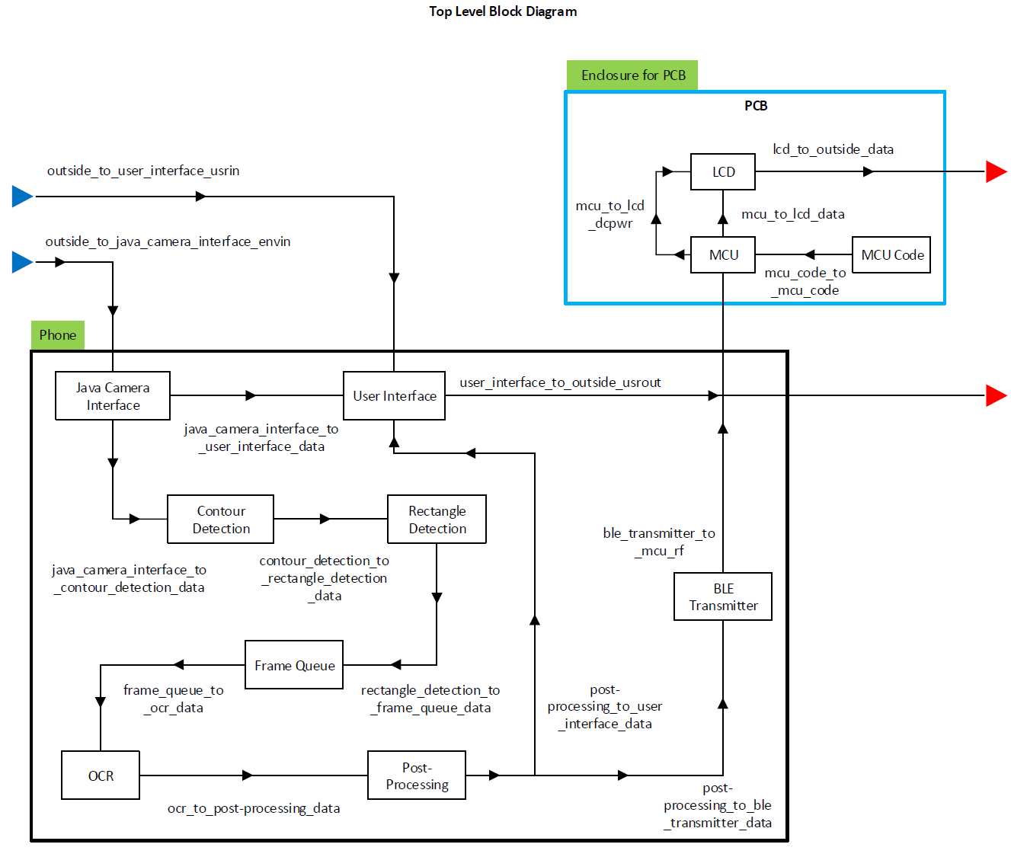
- Top level block diagram for the OCR system, with the PCB block highlighted in blue.

Verification
To verify the PCB block’s interface properties, the below test will be carried out over five trials. This test will prove that all the PCB connections are correct and functional.

Test Steps:
- Power Bluetooth LCD PCB with a 1S LiPo Battery (~3.7V)
- Verify LCD shows “NO CONNECTION”
- Verify the output voltage from the 5V Step-Up board to the LCD1602 module is a nominal 5V DC
- Connect BLE device to MCU
- Verify LCD shows “DETECTED SIGN:”
- Send string “25” to the MCU block via a connected Bluetooth device
- Verify LCD shows “25 MPH” within one second of sending the string from the connected BLE device
- Wait 10 seconds
- Verify LCD still shows “25 MPH”
- Send string “50” to the MCU block via a connected Bluetooth device
- Verify LCD shows “50 MPH” within one second of sending the string from the connected BLE device
- Wait 10 seconds
- Verify LCD still shows “50 MPH”

Test Pass Condition:
If all the emboldened verification steps pass in four out of five trials of the above test, then all the block is ready for inclusion into the system.

Link to video demonstrating interface property tests: PCB Block Tests

Design

Schematic
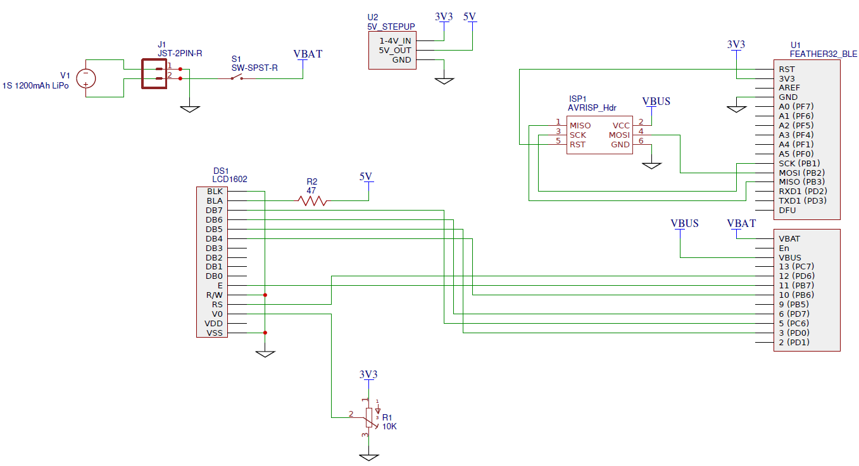
- Schematic for the PCB block.

PCB Layout
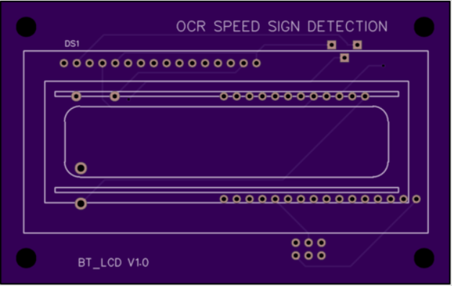
- Top-view of PCB Layout and silkscreen.
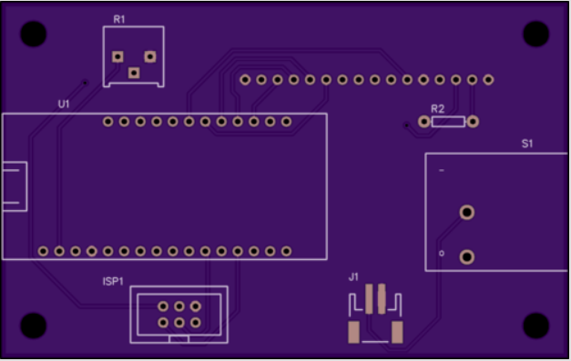
- Bottom-view of PCB Layout and silkscreen.
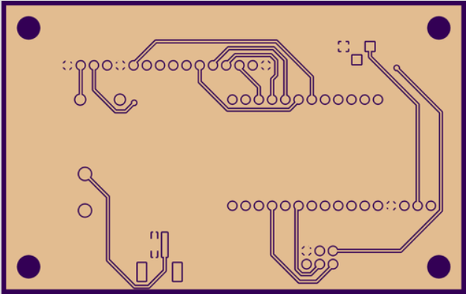
- View of ground plane on bottom of PCB.
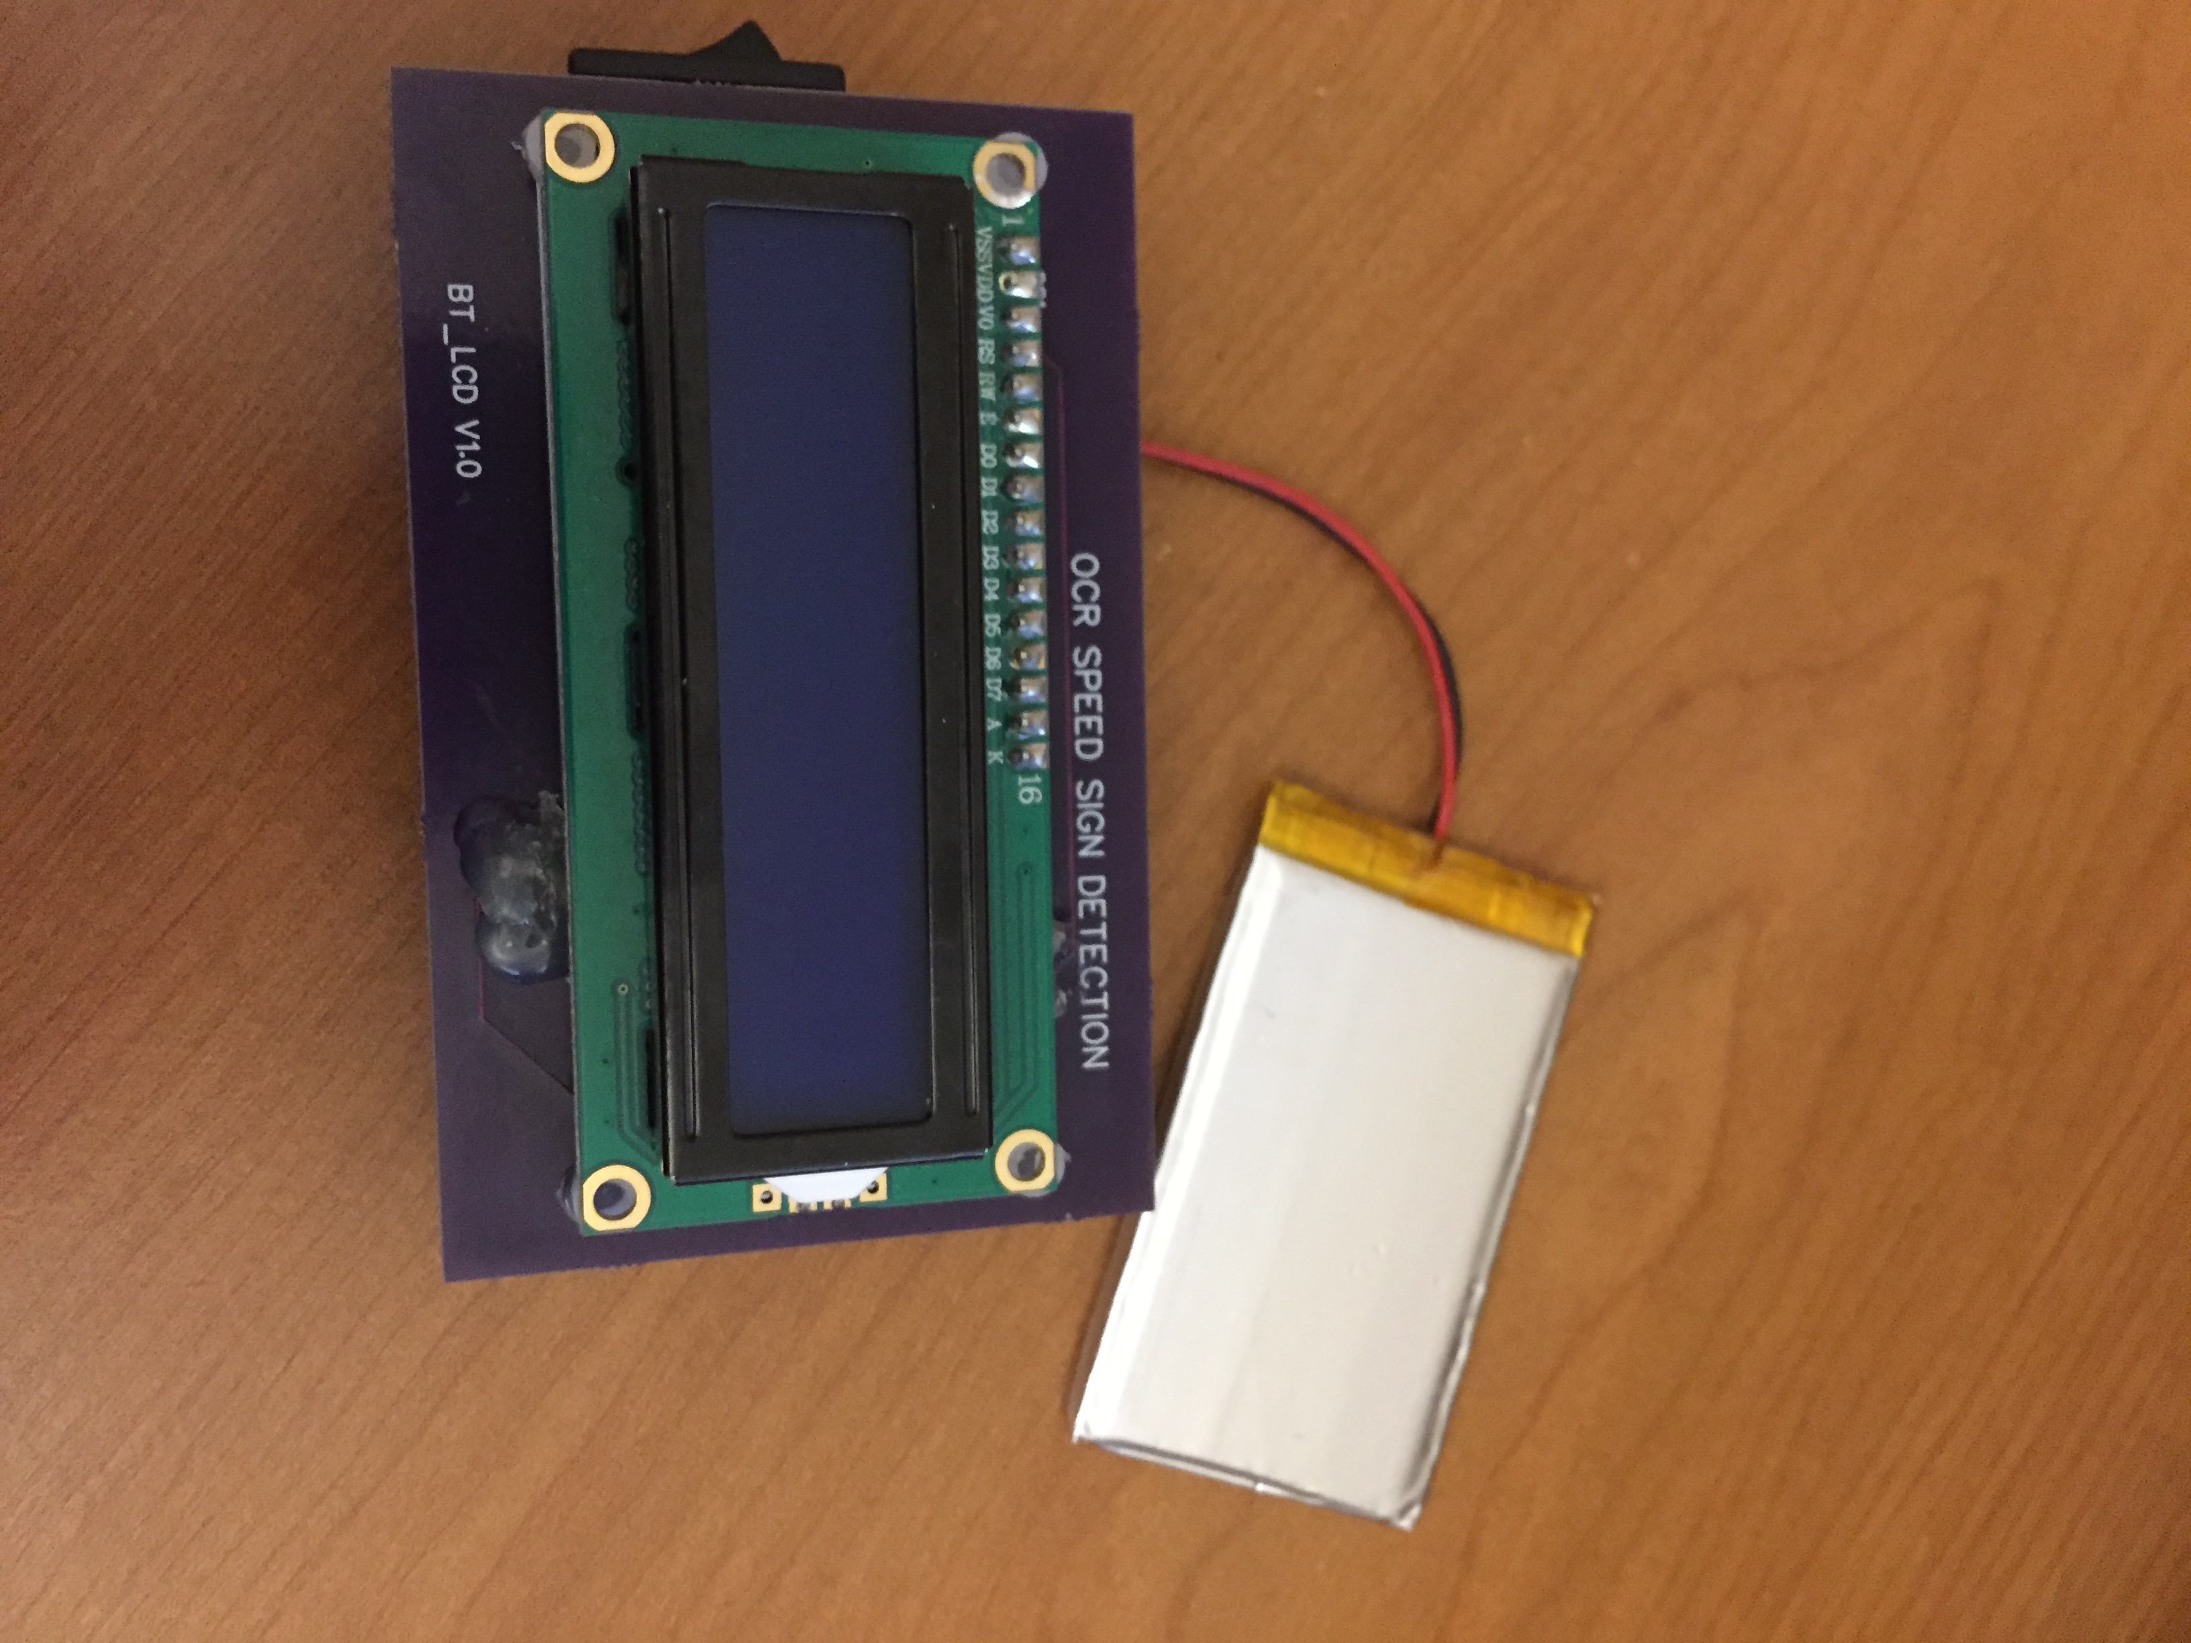
- Top-view of populated PCB.
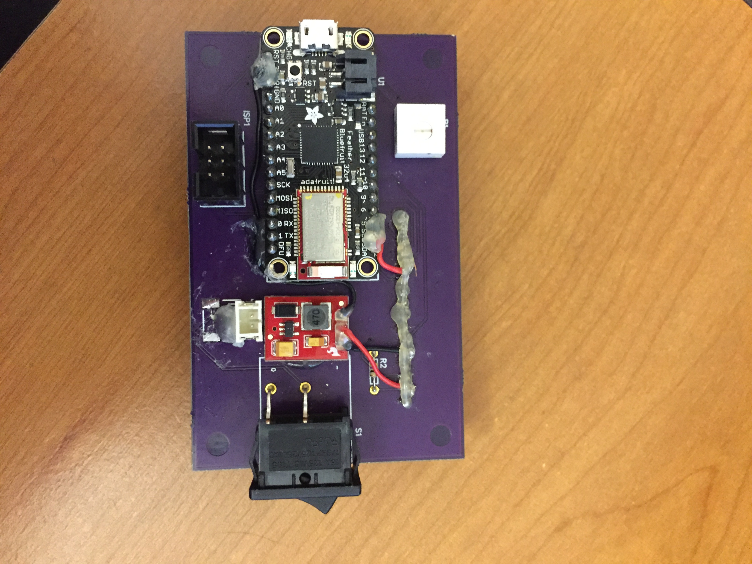
- Bottom-view of populated PCB.

BOM
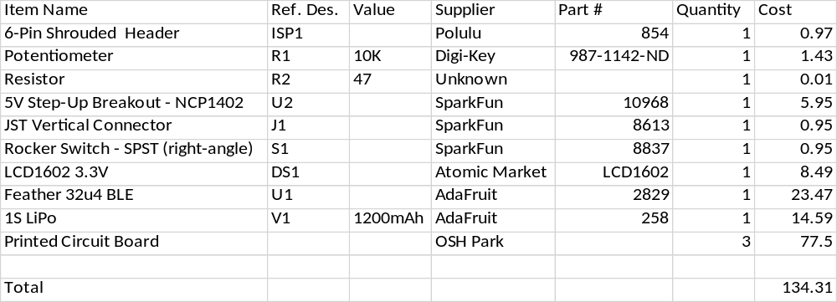
- BOM for BLE LCD PCB.

Design Validation
The 2-layer PCB was designed using EasyEDA, and printed through OSH Park. As can be seen in Fig. 3 and Fig. 4 above, silk screens were designed for all of the components with reference designators to ensure that components would be placed and oriented correctly when soldered to the PCB. As can be seen in Fig. 5 above, the PCB contains a ground plane layer to minimize signal noise between the MCU and LCD.
EasyEDA contains a built in DRC that can be adjusted. The design rules listed below in Table 1 were used for the PCB layout. A 0.254mm trace width was chosen to provide a large headroom for current capacity, and to prevent heat damage when soldering the components to the PCB. A 0.254mm trace width can handle more than 3A of current, which can easily support the BLE LCD peak system draw of less than 200mA [1]. The BLE LCD draws less than 200mA per the design of the MCU and LCD blocks, and can be observed by measuring the current draw from the 1S LiPo powering the system. 0.254mm was chosen for the track-to-track, track-to-pad, pad-to-pad, and hole-to-hole buffers to ensure the EasyEDA auto-routing tool created a trace layout that had no 90-degree bends, and that best utilized the free space on the PCB. These buffers allow for easier modification of the PCB in case edits are needed.
Fig. 6 and Fig. 7 above show PCB the built with the components listed in the BOM. Hot glue was used on the component pins to prevent shorting.
- Design Rule Settings
Item | Value
Track Width | 0.254mm
Track to Track | 0.254mm
Track to Pad | 0.254mm
Pad to Pad | 0.254mm
Hole to Hole | 0.254mm
Via Hole Size | 0.305mm
- PCB design rules.

Terms

AVRISP: AVR in-system programming
BLE: Bluetooth Low Energy
DRC: design rule check
ECU: electronic control unit
LCD: liquid crystal display
MCU: microcontroller unit
OCR: optical character recognition
PCB: printed circuit board
SPST: single pull single throw (switch)

References

- Suppanz, Brad. (2007). Trace Width Website Calculator. Retrieved February 24, 2017, from http://www.4pcb.com/trace-width-calculator.html

