How can children’s opinions about climate change be better heard?

14-aug

How to collect the opinions/voices of the children:

* Schools: Educate the children on the topic and then interviewing them at their schools for their point of view.
* Smartphones: Give the children smartphones and teach them how to film themselves. (con: not every kid goes to school.)
* Find the “black spots” and prioritize these zones.

Outreach:

* The whole world?

- Begin with a “black spot”, then expand

* Start in the western world. there are more resources, and therefore more opportunities to influence more people.

How to reach out:

* Influencers

- YouTubers, bloggers, athletes etc.

- Create kind of an “event” online. Create hype around the “QR-code”

* #SocialMedia

Thursday 15.aug

How to get the interviews/opinions:

* Emissary from Redd Barna goes down and films.
* Send down phones and they can film themselves. Collect the data on a schedule (every monday, or each month etc.)
* Phones can go missing.
* Send down people to teach them how to use the phone, and also do the interviews.
* Depends on long- or short-term plan.

Representatives visit the targeted villages, gives the villagers phones and knowledge on how to use them, also some education on how the climate change will affect the villagers. The villagers then film themselves and once a week, the representatives return to collect the films.

How to Spread the message globally:

* Influencers, such as celebrities, YouTubers, Bloggers, Athletes etc.

Create Hype around the QR-code, then when the code is released, people who scan the QR will be directed to a short film, after the film, they get the option to explore a page with more videos of children explaining their opinions on climate change, and some info about the project.

-------------------------------------------------------------------------------------------------------------------------

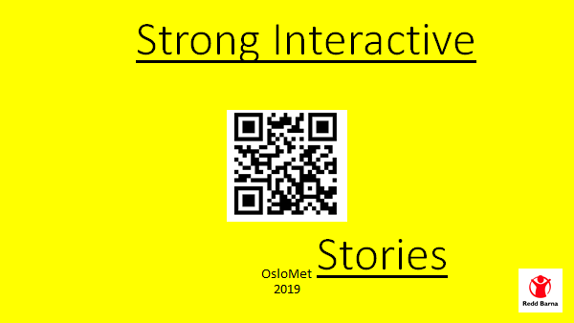

Our idea to help the children getting heard, is to send a representative from Redd Barna to villages collecting different opinions, videos, and quotes weekly. This information will be posted on a webpage dedicated to share children’s opinions about climate change. To promote the webpage, we have taken inspiration from the marketing techniques of Fyre Festival. This consists of creating a hype around a QR-code with a countdown. Fyre festival had celebrities and influencers share a blank, bright orange photo without any other information to it, mystifying the whole project. This made a lot of people question the photo and what the reason behind the photo was, causing a major viral hype. The reason why we have chosen to use this advertisement, is to get a lot of people talking about “what’s going to happen when the timer reaches zero?”. You can see an example of the photo we want to share, the QR-code on the current photo sends you to reddbarna.no, but it is only an example to showcase how it would look and be used.

When the timer does reach zero, there will be a captivating short video that summarizes the great opinions the children have about climate change. After that video, the user will get the opportunity to explore a page with more in-depth videos and information about the project, villages and more, including information on how to help save the environment.

After the webpage have been released, a long-term plan could be to introduce adverts on YouTube, Instagram, Facebook and other social media platforms. This will help keep the attention for the web page alive.

Skallkode:

Countdown som teller ned fra f.eks 10 sek, når den når 0 blir man redirigert til den aktuelle siden.

Forside med tittel og et stort bakgrunnsbilde av «et eller annet relevant for prosjektet»

Navbar med knappene: «om prosjektet», «kontakt oss», «Videoer», «donèr»

-om prosjektet: info (ipsum lorum, fyller inn fra teksten over i dette dokumentet),

-kontakt oss: kontaktinfo til Redd barna, donasjonsknapp?

-videoer: selve intervjuene (legg inn noen gifs eller random videoer), litt bakgrunnsinfo til hver film.