**ENSF-381**: **Full Stack Web Development Laboratory**

**Lab01**

**Section:**

**Group information:**

Jason Nguyen (30209015)

Daniel Rey (30216790)

**Exercise 1 Output:**

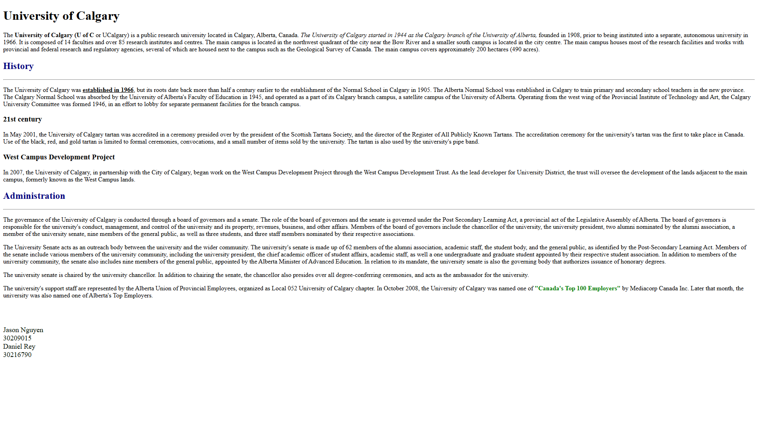

**Exercise 2 Answer:**

1. **The HTML element used for “Faculties” is:_____<h3>______**
2. **Screenshot:** A screen shot of a computer program

   Description automatically generated