**ENSF-381**: **Full Stack Web Development Laboratory**

**Lab03**

**Section:**

**Group information:**

Daniel Rey (30216790)

Jason Nguyen (30209015)

**GitHub Link:**

[**https://github.com/danthemanr/ENSF381_Group44**](https://github.com/danthemanr/ENSF381_Group44)

**Exercise 1 Output:**



**Exercise 2 Output:**

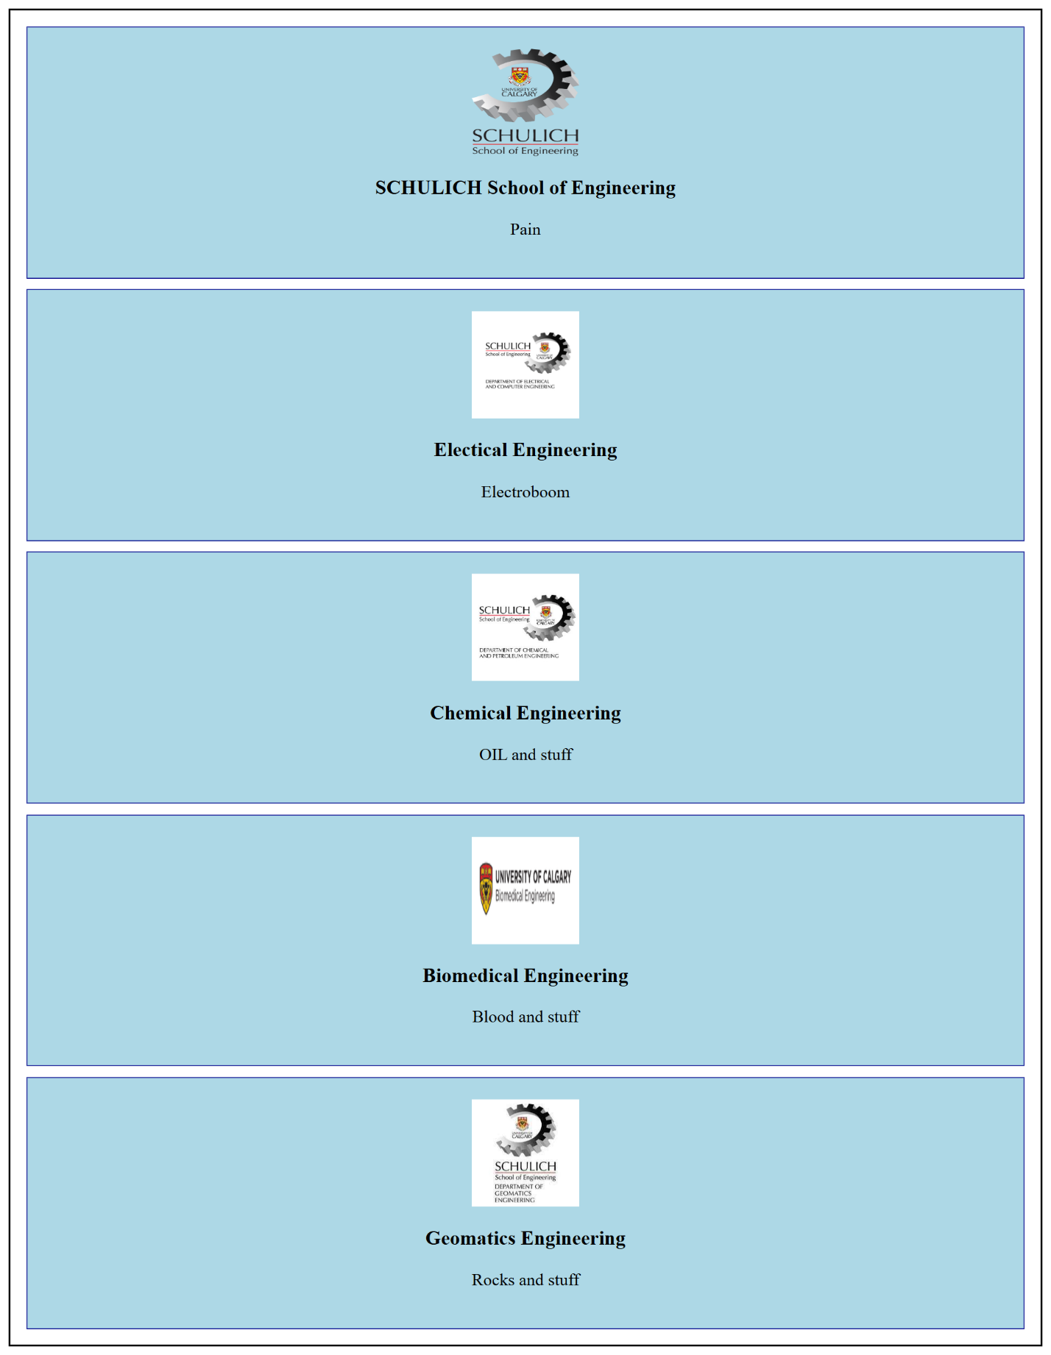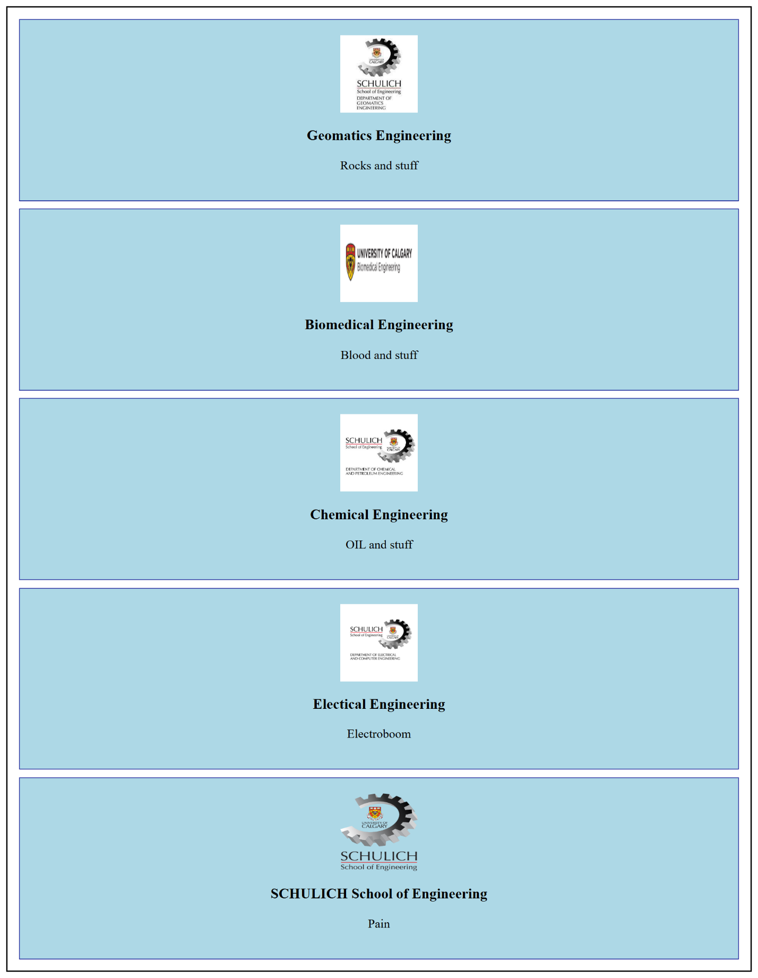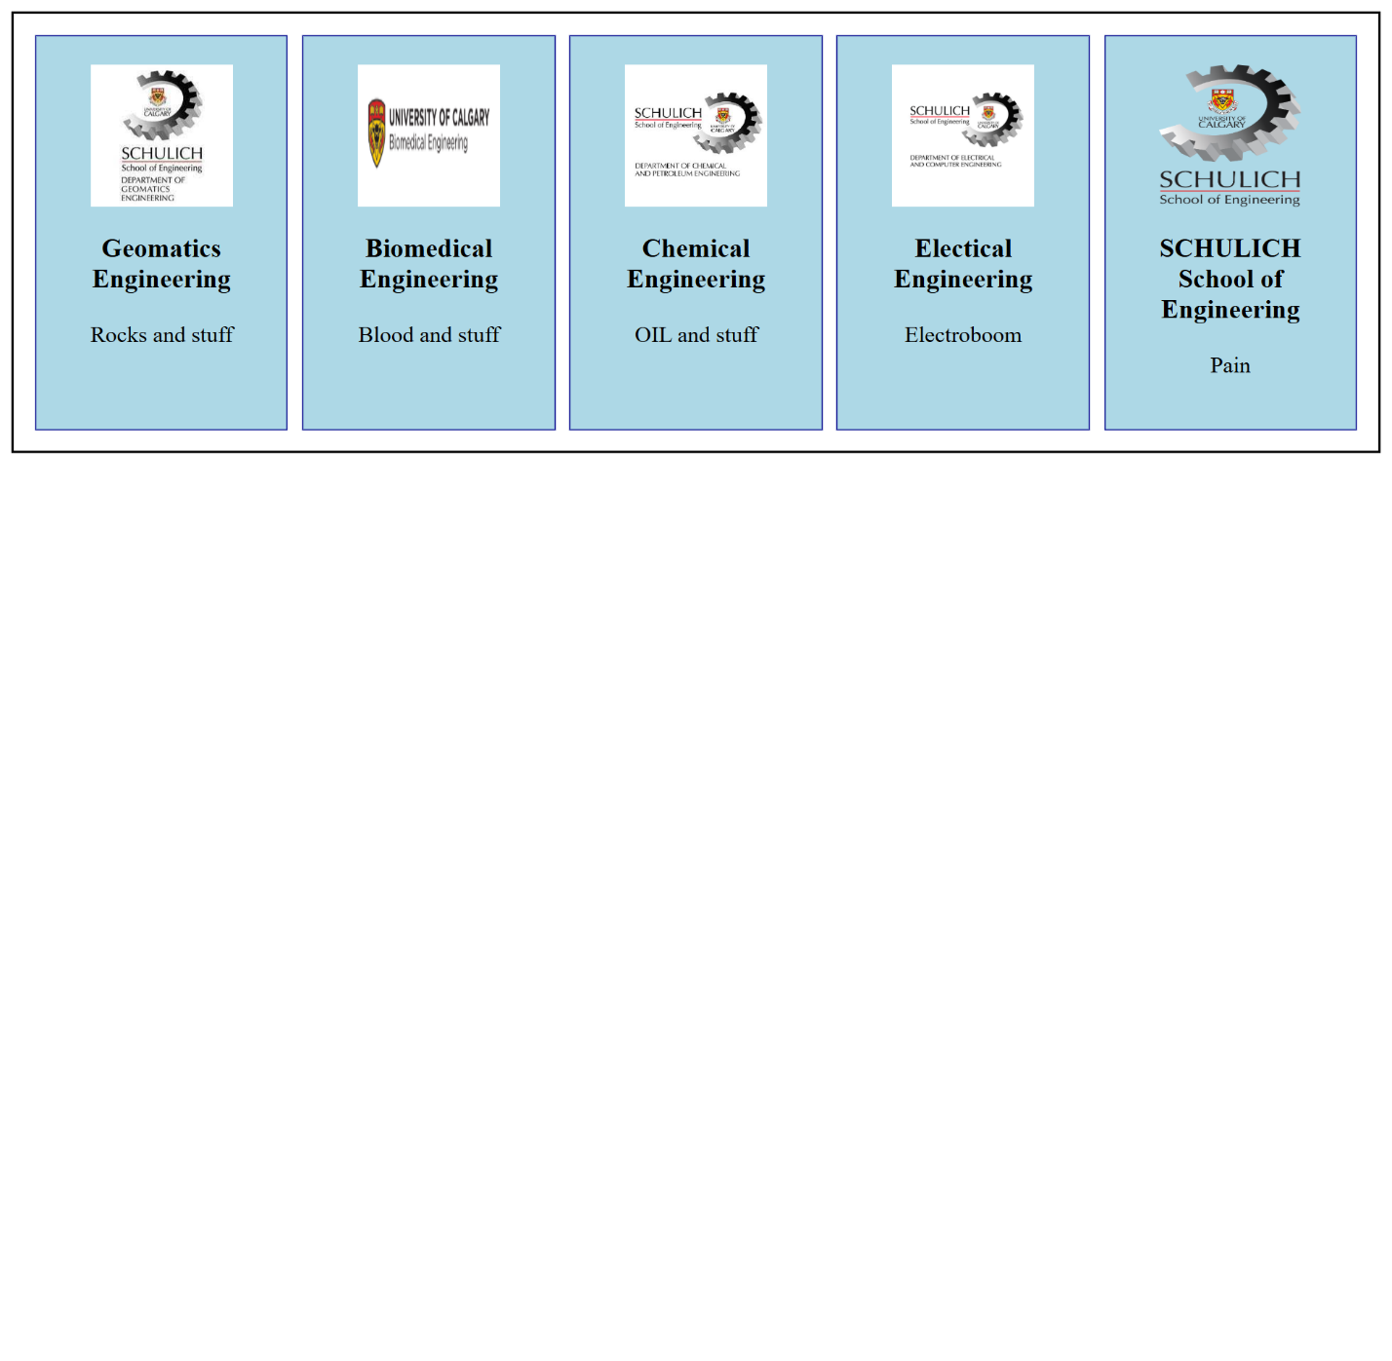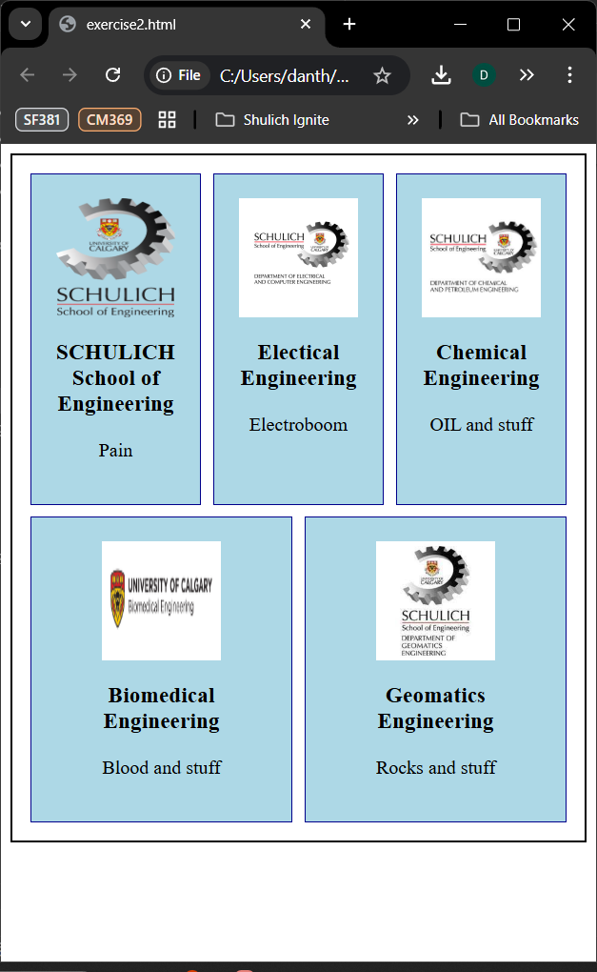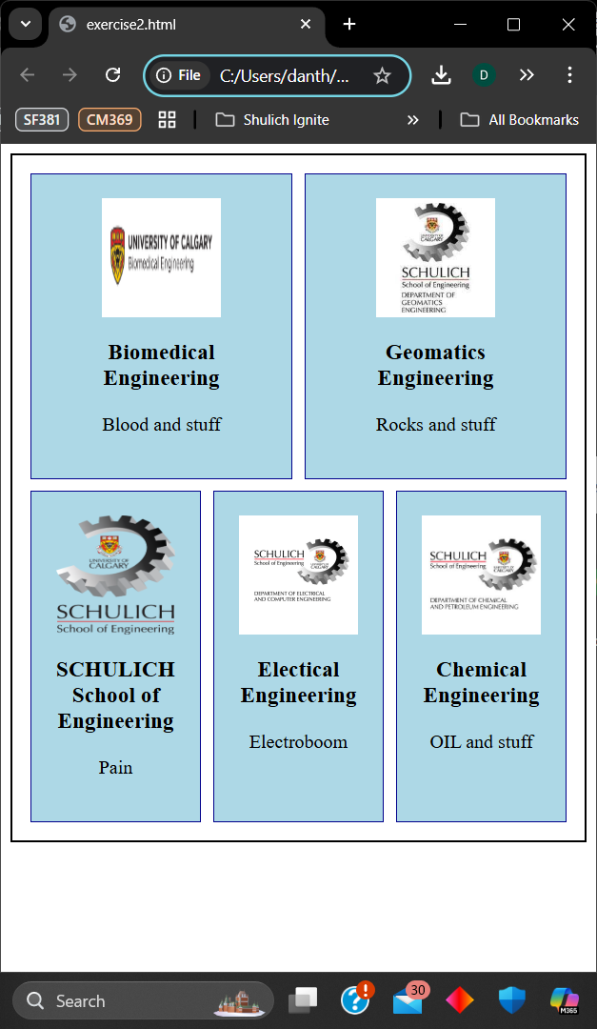

**Exercise 3 Output:**

