1. Introduction
Digital forensics is defined as the science of employing rigorous scientific methods to manage digital evidence for law enforcement to effectively reconstruct possible criminal events and anticipate potential unlawful actions. That evidence should be preserved, analysed, and presented from validated methodologies (Gary, 2001). As the foundation of digital forensics, Chain of Custody (CoC) serves as a fundamental yet powerful method for maintaining the integrity and security of digital artifacts during the forensic lifecycle (Nath et al., 2024).

1.1 Research Background
The traditional CoC practices employed a straightforward way of using paper or electronic forms, which is cost-efficient and easily integrated into the legal process. However, the explosive development of information technology, such as storage capacity, cloud computing, and the increasing number of digital devices, poses huge challenges to the traditional way of conducting digital forensics and CoC (Quick & Choo, 2014). Consequently, many forensic software were created to reduce the burden of manual record-imputing and enhance security and admissibility, including FTK (Forensic Toolkit), EnCase, and Autopsy for digital forensics, ERIN7 and EvidenceOnQ for CoC. Due to commercial and technical considerations, there are no official APIs to support software interconnection and data interoperability. This fragmented state of systems presents two critical challenges. First, the immutability of digital evidence could be compromised because of diverse systems employed at different stages of the investigation. Second, independent systems will lead to a higher maintenance cost compared to the traditional paper-based method (Nath et al., 2024).
With the mature application of emerging technologies across various industries, scholars have gradually shifted their attention to the integration of digital forensics and blockchain in the last decade (Igonor et al., 2025). Being a decentralised, transparent, and immutable database, blockchain seems to perfectly align with the requirements of digital forensics and CoC. There have been many studies focusing on this area in recent years (Atlam et al., 2024). However, blockchain applications in the field of digital forensics are still at an early stage of industry implementation. Compared with traditional digital forensic tools and methods, the number of mature and widely adopted implementations is still limited (Atlam et al., 2024). One important reason is that forensic guidelines and best practices, which represent validated methodologies as Gary (2001) emphasised, have not received sufficient attention, making it difficult for most designs to be implemented in real-world legal environments. To bridge the gap, it is necessary to combine blockchain with validated practices in digital forensics, so that in-depth research and evaluation of its application and performance could be meaningful.
Autopsy is a widely used digital forensic analysis platform and is trusted by law enforcement, government agencies, and academic institutions worldwide. It supports established digital forensics standards and best practices, including ISO/IEC 27037 and NIST SP 800-86 (Parker, 2026), making it a professionally recognized and court-acceptable forensic tool. As an open-source and highly modular platform, Autopsy is also well-suited for research-oriented digital forensics studies. Its extensible plugin architecture allows researchers to instrument and monitor forensic workflows without altering core analysis functionality. As a result, Autopsy provides an effective testbed for evaluating the technical feasibility and limitations of applying blockchain technologies to digital forensics.

1.2 Research Motivation
Although scholars have conducted various research on the application of blockchain in digital forensics, most of them focus on the management of on-chain data and the CoC process, with little attention paid to the preceding evidence analysis and anchoring data to the chain. For example, while Atlam et al. (2024) provide a comprehensive summary of the blockchain forensics lifecycle based on contemporary research, there is no mention of the data sources or the initial chain entry. Driven by the CoC requirement for evidential lifecycle management and considering the inherent unpredictability that could happen during software integration development, significant performance discrepancies could arise between the theoretical blockchain framework and its practical implementation when integrated with different digital forensic systems. Such differences introduce challenges to the practicality of the proposed research. To address these challenges, this study proposed an end-to-end model that starts from data generation and transmission to on-chain preservation and subsequent verification. Autopsy was selected as the only data source for practicality concerns. This holistic design ensures that both data and processes can be operated and analysed in a highly controlled and verifiable manner.
On the other hand, despite the popularity in the industry, the open-source nature of Autopsy introduces many security risks. Specifically, Autopsy is developed upon the NetBeans platform (Basis Technology, 2020), which allows developers to construct complex applications in a highly modular framework. However, while this flexibility accelerates the development process, it also leads to a series of security flaws(The Apache Software Foundation, 2026). First, all modules in NetBeans are running in a unified Java Virtual Machine (JVM) environment without any mandatory isolation mechanism to prevent possible malicious attacks from any modules. Second, the lack of robust access control for local file systems and networks facilitates unauthorized data access and a significant risk of data exposure. Consequently, Autopsy, being developed on this platform, naturally inherits these structural vulnerabilities. Operationally, Autopsy relies on unencrypted files in local storage (Devin, 2026), using structured databases such as SQLite or PostgreSQL without proper access control mechanisms. This deficiency exposes Autopsy to significant data exfiltration and tampering. Furthermore, the lack of effective data segregation not only leads to unauthorized inter-case access but also creates a pathway for malicious exploits from third-party modules, compromising the CoC in the end.
As a decentralised, immutable, and traceable ledger technology, blockchain can effectively provide security for evidential artifacts and operational logs (Tsai, 2021), offering a viable method to mitigate the cybersecurity risks of Autopsy:
- Unencrypted local storage issue: The blockchain architecture utilises consensus and immutable ledgers to safeguard the integrity of on-chain data. Even local data suffers from unauthorised intrusion and modification, the on-chain records still keep their original state, ensuring a tamper-proof record for the evidence.
- CoC protection: The entire evidential lifecycle in Autopsy could be stored on-chain, including acquisition, transmission, analysis, and access. With timestamp and operator identities, a non-repudiable audit trail can be established for precise accountability.
- Modular risk management: By introducing a mechanism to record all the modular operations on-chain, any abnormal behaviours can be rapidly localised and analysed via history records, preventing malicious modules from compromising the forensic process.
Despite all the security flaws of Autopsy, the ubiquity of this tool in the forensic industry stems from its prioritization of functionality and efficiency over rigorous security controls. Its open-source nature and modular design significantly lower the barrier for installation and application, making it ideal for testing theoretical possibilities. The objective of this research is to enhance system security without sacrificing the performance advantages of Autopsy. By integrating a blockchain design to address critical security needs, the proposed model avoids deep-level modification to the software and high computational costs. Although this approach still introduces some performance overhead, the gains in evidential integrity and CoC protection can be significant.

1.3 Research Questions
After reviewing contemporary literature and the Autopsy open-source community, there are no existing studies of functional products that integrate Autopsy with blockchain technology. Consequently, this research is a novel attempt to bridge the gap in the digital forensic domain. The following questions and sub-questions this research tries to answer are:
1. How to develop a blockchain-based Chain of Custody plugin for Autopsy to ensure the immutability and auditability of digital evidence during the analysis and reporting phases?
1.1 What kind of blockchain fits the requirements of this study the most?
1.2 To what extent is it technically feasible to manage on-chain and off-chain storage within the Autopsy framework while maintaining data integrity?
1.3 What is the most effective way to collect runtime data, and at what level of granularity can the data be obtained?
2. What are the performance trade-offs when integrating blockchain-based audit trails into the Autopsy workflow, and how can they be minimized?
2.1 How can blockchain data transmission and synchronization processes be properly integrated into Autopsy’s evidence analysis workflow while ensuring the correctness and integrity of data transmission?
2.2 What impact will on-chain and off-chain interactions have on Autopsy in terms of performance?
2.3 What impact will the security mechanisms of blockchain have on Autopsy in terms of performance?

1.4 Research Structure
The research consists of six chapters. Chapter 1 provides an overview of the research background, underlying motivations, and core goals. Chapter 2 presents a deep literature review, critically analysing representative academic studies for identifying existing research gaps. Due to the interdisciplinary nature of this study, this chapter will also establish fundamental concepts and frameworks in digital forensics, information security, and blockchain. Chapter 3 explains the research methods in detail, beginning with how the two main research questions arise from identified gaps. It further outlines the system development cycle, including functional requirements, architectural design, and testing methods to validate the research hypotheses. This chapter ends with the description of the hardware and software environment for development. Chapter 4 presents the findings, showing the system performance and important test data to prove the feasibility and significance of the design. Chapter 5 synthesises the research findings, evaluating how the implementation fulfils the initial design expectation. Meanwhile, the inherent limitations of this research should be discussed, and future improvement directions should be proposed.

2. Literature Review
With the development of the Internet of Things (IoT), an unprecedented surge in the number and variety of digital devices is reshaping the landscape of human society (Rose et al., 2015). When more and more devices and resident data are involved in legal proceedings, digital forensics gradually becomes the fundamental technical means to support legal investigations and judicial rulings, with a core objective of ensuring the standardised acquisition, analysis, and explanation of digital evidence to achieve authenticity, accuracy, and admissibility (Leroux, 2004). Nonetheless, unlike traditional physical evidence, digital artifacts are easily replicated and tampered with, making protecting their traceability and integrity a paramount challenge in digital forensics (Sachowski, 2019).
To deal with such issues, CoC is widely used in the working flow of digital forensics to record the evidence management trace covering acquisition, transmission, analysis, and reporting (Main et al., 2025). Classical CoC methods rely on centralised logging systems, vulnerable to high risks of being tampered with, lack of transparency, and auditing difficulties in complex digital environments (Giova, 2011). These problems not only compromise the admissibility of the forensic process but also weaken the reliability of digital evidence in judicial practice. Therefore, exploring new evidence management mechanisms that are more secure, transparent, and verifiable has become a major focus of recent research.
In recent years, blockchain technology has been widely considered an innovative solution for contemporary forensic challenges due to its decentralized, immutable, and traceable features (Dasaklis et al., 2021). Numerous studies have made efforts to introduce blockchain in the design of CoC by storing the hash values, timestamps, and operation logs of evidence on-chain to enhance security and transparency (G. & S., 2023; M. Li et al., 2023; Pourvahab & Ekbatanifard, 2019). However, many studies are still in the stage of theoretical design or concept verification, not fully complying with current international standards, such as ISO 27037 (Lavin Perrino et al., 2025). Consequently, their operational viability in real-world investigations is still limited.
Meanwhile, as one of the most accepted open source digital forensic platforms, Autopsy has established mature working flows that comply with industrial best practices (Parker, 2026). However, there is no research found on the integration of blockchain technology into Autopsy after searching major research databases, reflecting gaps between previous academic studies and actual applications. Accordingly, it is necessary to explore how blockchain can be seamlessly combined with real forensic tools and further analyse its performance.
This chapter aims to build the theoretical foundation for this study with a systematic literature review and to justify the necessity and rationality of the proposed questions. Digital forensics is an interdisciplinary field of law and technology, where the admissibility of evidence depends not only on the technical rigor of the investigation process but also on compliance with the legal requirements of the management method within its lifecycle. Recognising this dual standard is essential to assess whether a technological design actually fits forensic scenarios.
The following sections are organised as follows: 2.1 will clarify the core objective of digital forensics with the legal requirements for evidence integrity; 2.2 will discuss the concept of CoC and the structural disadvantages of traditional methods; 2.3 will elaborate the fundamental features of blockchain and assess its suitability as well as its limits to forensics; 2.4 will introduce the latest trends in blockchain forensics and critically review its identified challenges from two perspectives: technological feasibility and operational practicality; 2.5 focuses on the Autopsy platform, evaluating its main functions, regulatory compliance, and the contemporary gap in blockchain integration; 2.6 will synthesise two distinct dimensions of research gaps identified in this review and how they collectively provide the foundation and motivation for proposed questions.

2.1 The Core Objectives and Legal Requirements for Digital Forensics
Digital Forensics is usually considered the identification, preservation, analysis, and presentation of data residing on computers, network devices, mobile devices, and other digital equipment, with the aim of providing verifiable information for event reconstruction and conflict resolution (Casey, 2011). The research roadmap released at the Digital Forensic Research Workshop (DFRWS) by Palmer (2001) emphasized that evidence handling, tool reliability, and analysis repeatability should be incorporated into the systematic research agenda to build a shared foundation for elevating forensic activities from technical operations to standardised repeatable procedures. Different from conventional ‘data restoration’ or ‘troubleshooting’, digital forensics focuses on dealing with digital artifacts with possible evidential value in judicial or regulatory contexts; International Organization for Standardization (2012) decomposed the forensic tasks into continuous steps including identification, collection, acquisition, and preservation, with risk control requirements at each step. In NIST SP 800-86, the forensic operations of security-related incidents are further summarised as identifying and protecting pertinent data, processing and extracting information, conducting analysis and forming judgements, and producing reports (Kent et al., 2006). Although this framework focuses more on the secure operation of organisations, it still complies with the “collection–extraction–analysis–reporting” lifecycle from the academic community. From the forensic readiness standpoint, Sachowski (2019) observes that agencies restricted to the post-incident response (Reactive) stage usually struggle to prove the procedural legitimacy of the evidence handling process. Institutional documentation and upstream capability are needed to make critical steps visible and auditable. In sum, the basic workflow of digital forensics is both a technical chain and a methodology constraint for legal admissibility.
Based on a legal perspective, the admissibility and probative value of digital evidence frequently depend on whether it can withstand scrutiny regarding authenticity, integrity, and reliability, and such scrutiny should be supported by verifiable facts (Leroux, 2004). The research on the admissibility of evidence indicates that controversies are usually caused by whether data were reliably generated, remained free from unauthorised alteration, and can be presented appropriately. The judges and parties therefore pay more attention to the procedural protection and proof chain integrity, not merely to the technology itself. According to International Organization for Standardization (2012), authenticity relies on the consistency between evidence and its claimed source; Integrity emphasizes safeguarding the evidential tamper-proof nature during the whole forensic process, and should be justified with means of hash verification, bit-stream imaging, access controls, and audit logs; Reliability further encompasses the repeatability of the method, the justifiability of tools and parameters, and the traceability of analytical process, which influences the fact-finders’ judgement on the expert opinions or technical conclusions (Argy & Mason, 2007). Although rules differ across jurisdictions, the requirement of documenting where the evidence comes from, how it has been processed, and who is responsible in a traceable and auditable way shares commonalities in different systems (Nath et al., 2024).
Compared to traditional physical evidence examination, digital evidence showcases characteristics of bit-level replicability, volatility, and data volume growing, making the “original-copy” relationship, the scene boundaries, and temporal anchoring more complicated (Casey, 2011). In the research of Quick and Choo (2014), they highlight that the growing storage capacity, aggregation of heterogeneous multi-source data, and elongated examination cycles will deteriorate the human–machine resource bottleneck situation further, raising the error rate of data processing as well as the risk of documentation missing. Especailly in cloud and virtualised environments, evidence will be distributed in the infrastructure layers (IaaS), where data control planes and tenant responsibilities become increasingly vague and difficult to verify. The IaaS forensic framework of Pourvahab and Ekbatanifard (2019) indicates that remote hosting and multi-party collaboration data processing are challenging the traditional local-device-centric evidence preservation model, signifying the importance of provenance preservation and process logging. By contrast, physical evidence forensics relies on physical sealing, packaging, and handover records to keep traceability, whereas digital forensics typically requires extra mechanisms—write protection, forensic imaging, hash chains, time synchronisation, and similar artefacts—to transform continuous data changes into understandable models in law (International Organization for Standardization, 2012). Accordingly, the key to digital forensics lies not only in successful extraction but also in procedural accountability from detailed activity logging in rapidly changing digital environments.
To address these challenges, the international community has developed technical guidelines, represented by the ISO/IEC family of standards, to provide a unified framework ensuring that digital forensics and incident investigations are rigorous and auditable. ISO/IEC 27037:2012 addresses the lifecycle of digital evidence; ISO/IEC 27041:2015 provides systematic guidance for estimating whether the investigation methodology is fit for purpose; ISO/IEC 27042:2015 focuses on the analysis and explanation of digital artifacts; ISO/IEC 27043:2015 supplies structural constraints for investigation principles and procedures (International Organization for Standardization, 2012, 2015a, 2015b, 2015c). The NIST SP 800-86 (Kent et al., 2006) incorporates multiple sources data extraction, analysis, and documentation into the incident response procedure in a way that emphasizes actual practice. At the application level, Parker (2026) discusses how Autopsy aligns with ISO/IEC 27037 and NIST SP 800-86 standards, which proves the industry uses these documents as references to assess whether the workflow covers the whole forensic lifecycle. By doing so, theoretical forensic models are not merely abstract principles but are translated into concrete checklists for professional practice. Collectively, international standards and national guidelines mentioned above provide transnational technical references and a baseline of good practice for establishing digital forensic capabilities, setting up standard operating procedures (SOP), and estimating tools.
To sum up, digital forensics, at the intersection of law and technology, is a process that converts digital material into admissible and auditable evidence. On its legal side, the key is to build a defendable foundation around authenticity, integrity, and reliability. On the technical side, it emphasises how to mitigate the risk of data alteration and loss in highly replicable and dynamic digital landscapes (Leroux, 2004). For embedding procedural requirements into practical investigations, the crux of the matter is the continuous documentation and verification mechanism for evidence custody and movement. Giova (2011) highlights that traditional CoC is inefficient within the digital context because it struggles to adequately prove whether the authorisation operation, copy generation, and processing steps in the examination software comply with legal provisions. In recent years, the discussion around improving CoC with new technologies has expanded (Lavin Perrino et al., 2025; Main et al., 2025). However, no matter what technology is chosen, the goal is still to provide an auditable trace that supports data integrity and the legitimacy of handling for courts and regulators (Nath et al., 2024). In other words, CoC is still the critical nexus linking standard operation, technical tools, and admissible proof.

2.2 Mechanisms and Limitations of the Traditional Chain of Custody
In the context of digital forensics, CoC is defined as the process of recording the entire sequence of possession and handling that evidence goes from its discovery to presentation at trial, so any party can verify and trace “Who, When, and How the evidence has been processed” (Damascena et al., 2022). This institution comes from the original physical evidence management practice. In the classic narrative of crime scene investigation from Lee et al. (2001), the basic framework of CoC includes evidence labelling, packaging, sequential sign-off, and custodial environment control, which aims to eliminate any substitution, contamination, or loss possibilities on the physical level and to prove to the court that what is presented is what was collected at the scene. When the forensic subjects extend from touchable media to electronic data, the scope of CoC accordingly expands to include forensic images, hash values, log files, and exported analytical artefacts, with the recording object shifting from evidence-bag serial numbers to tool versions, acquisition parameters, operational timestamps, and verification results (Carrier & Spafford, 2004). The event-based forensic framework proposed by Carrier and Spafford (2004) emphasises the importance of identifying every state change of digital evidence as a necessary event that should be recorded. It implies that the ideal state of CoC within the digital context should be a machine-readable event log covering all critical operations. However, according to the industry practice in the following years, this ideal remains some distance from reality because the two major CoC mechanisms-paper forms and centralised digital logs-have their own shortcomings.
In traditional CoC practices, the first method is paper records: investigators fill the recipient, the transferor, the date and time, the location, and the purpose on a form attached to the evidence bag or case file, after which the form is signed and transferred with the evidence; The second method is centralised digital log: the investigating agencies or forensic laboratories maintain, process, and transfer evidence records in their case management systems or databases. Kohn et al. (2013) outline a forensic process model to divide the whole investigation into different steps, defining the linkage of input-output between steps as connection points. They demonstrate when such points are not synchronously recorded or they are incompatible across phases, a fracture of “technical operations have been completed but there is no procedural evidence to verify who and when did it” will appear. Yudi and Imam (2018) further describe the digital forensics workflow with a framework of people, evidence, and process, highlighting that CoC effectively serves to link discrete operations into a causal chain. Once a certain step or record is missing or not verifiable, all subsequent analysis and conclusions could be questioned. In terms of practical use, paper-based and centralised ledgers can keep a basic evidential traceability in simple investigations with limited participants, consistent evidence formats, and restricted data sizes. The inherent vulnerabilities of such mechanisms will start to show when the investigation scope goes beyond these prerequisites.
These vulnerabilities manifest in three levels. First is the single point of failure. Al-Khateeb et al. (2019) point out that centralised systems are more vulnerable to denial-of-service attacks and integrity attacks, and paper records could be missing, destroyed, or expired due to improper management. Such single-point dependency is particularly dangerous for digital forensics because a disruption in evidence logging is not merely temporary system unavailability but will lead to the break of CoC, unverifiable transferring processes, and unclear responsibility for handling evidence. Traditional CoC could continue to function at the operational level, its fragility will be magnified when facing legal disputes or adversarial scrutiny. Second is the tampering issue. Lone and Mir (2019) argue that it is difficult for traditional CoC to achieve integrity, transparency, authenticity, and auditability at the same time. Al-Khateeb et al. (2019) further prove that even the digitalised CoC provides more convenience than paper records, it still suffers from integrity attacks more easily. The root of the problem is that although centralised systems can capture a lot of operational logs, they lack the inherent capability to prove that those records have not been altered. Furthermore, paper records struggle to provide continuous, fine-grained, and real-time verification functions. Consequently, traditional CoC can usually prove the existence of records but not the consistent credibility of evidence. Third is auditing difficulty and limited non-repudiation. Auditability is considered the core requirement of CoC, with the meaning of detecting irregularities during the custody process (Batista et al., 2023). When contemporary forensic systems operate in an environment involving heterogeneous devices, cloud platforms, or cross-border stakeholders, they always suffer from insufficient transparency on evidence handling, which is caused by the lack of a unified and transparent view of forensic handling in traditional forensics (Kumar et al., 2021). Similarly, Khanji et al. (2022) observe that the effectiveness of existing forensic tools and methods degrades significantly when handling distributed digital environments where the collection and processing of evidence is increasingly sophisticated. For CoC, this means that it becomes more and more difficult to build a complete, trustworthy, and non-repudiable custody trail once the evidence has been handled through multiple departments, systems, or jurisdictions.
For the reasons mentioned above, the critique to traditional CoC in this literature review is not for pointing out that the mechanism it uses to record is not modernised, but to identify the fundamental flaws, which is high dependency on central control, struggling to prevent post-event modification, and limited transparency and auditability. The increasing evidence scale and data complexity pose a huge challenge. It is precisely this mismatch between technology and industry development that drives scholars to seek alternative or supplementary mechanisms. Al-Khateeb et al. (2019) proposed a design to reshape CoC into a decentralised ledger by introducing blockchain to address traditional flaws. Researchers believe that decentralisation, immutability, and transparent auditability of blockchain show a significant match to the need for contemporary CoC (Al-Khateeb et al., 2019; Lone & Mir, 2019; Yan et al., 2020). However, new issues like whether this technology can truly bridge the gaps or whether it will lead to new performance and governance costs can be answered after a deep analysis of blockchain's core properties.

2.3 Suitability Analysis of Blockchain Technology
At a technical level, blockchain is a decentralised data structure that is comprised of cryptographic hash chains, distributed ledgers, and smart contracts (Habib et al., 2022). Every block on the chain contains a hash pointer to its predecessor, a group of verified records, and timestamps, forming an append-only, non-retroactively-modifiable ordered sequence of blocks. The distributed ledger means every node in the network maintains its own copy of the data, ensuring only data that has been through consensus confirmation by most of the nodes can be considered valid (Zhou et al., 2023). On this basis, smart contracts provide an automatic mechanism of "code-is-rule", where predefined logic will be run by the network once the trigger has been fulfilled. Authorisation check, state update, and logging will be achieved without the interference of administrators (S. N. Khan et al., 2021). Together, these mechanisms become the four major properties of blockchain: immutability, consensus, timestamp transparency, and automated execution, and they happen to respond to the key demands of CoC (Igonor et al., 2025).
The first and most frequently emphasised property is immutability. Once the digital fingerprint, transfer metadata, and critical handling events are written to the ledger, any subsequent modifications to the history records are not merely modifying a local log, but are under the constraints of multiple nodes in a chain. Both Lone and Mir (2019) and Atlam et al. (2024) argue that it is this tamper-resistant capability that makes blockchain the ideal technology for improving the integrity and authenticity of digital evidence CoC. Therefore, blockchain can transform the state of evidence from simple existence into resistance to silent alteration, filling a critical gap in the traditional centralised logging systems.
The second is the decentralised verification capability from the consensus mechanism. Traditional CoC concentrates recording and verifying authority in a single organisation or management node, whereas blockchain uses the consensus mechanism to update the ledger on a multi-party agreement basis (Ferdous et al., 2021). For CoC, its significance does not lie in decentralisation itself, but it enables an institutionalised and repeatable validation mechanism to support the authenticity of evidence. Kumar et al. (2021) emphasises that such distributed verification facilitates reducing the reliance on a single management party or system in a multi-party forensic environment, mitigating the single node trust issue in traditional CoC. However, recent studies also prove that this advantage does not justify the suitability of all blockchain types for forensic use. On the contrary, the design of consensus mechanism directly affects performance, governance model, and legal practicality, which necessitate a selection based on the actual jurisdiction environment.
The third is the transparency of the timing sequence and verifiable traceability. Transaction records on the chain are organised according to block height and chronological order, enabling auditors to easily reconstruct event order and confirm whether a record has already existed at a specified time (Atlam et al., 2024). This is critical for CoC because the core of CoC is not whether a single operation has happened, but whether the sequence of operations, responsibility transition, and context continuity can be established. Batista et al. (2023) indicate provenance and auditability as the fundamental requirement for CoC, and Tsai (2021) points out that one of the values of blockchain-based custody records is providing the management history in a chronological and traceable way. Blockchain converts evidence registration, transfers, access events, and verification actions into transaction records on chain, elevating the temporal transparency and post event reviewability of CoC. Hence, more and more forensic studies treat blockchain as a suitable technology for building audit trail, not for storing evidence files.
The fourth is the automation capability of smart contracts. S. N. Khan et al. (2021) demonstrate that smart contracts can deploy predefined conditions, permissions, and triggering logic on chain so that specific business rules can run automatically when fulfilling requirements. In terms of CoC, this means core controls like access authorisation, transfer confirmation, role verification, log registration, and even multi-signature approval can be implemented automatically through programs, not relying on manual forms or retrospective log compilation. The research both from Tsai (2021) and Kumar et al. (2021) suggest that the consistency and verifiability in CoC can be greatly improved by embedding the confirmation, audit, and responsibility into evidence-handling workflows. Although such automatic potentials show strength in reducing omission, improving consistency, and clarifying accountability boundaries, it also depends on the correct design of the contract. If the authorisation model, trigger condition, or irregularity handling logic are poorly configured, the flaws of smart contracts can also be exacerbated automatically.
Although the specialties of blockchain mentioned above correspond to CoC needs, not all types of blockchain fit forensic scenarios. The public chains, such as Ethereum, can provide top level decentralised and censorship resistant performance but their low transaction throughput, long verification latency, and Gas fee for each transaction cannot fulfil the need for low latency and high frequency writes in forensic workflow (Habib et al., 2022). On the other hand, private chains feature in single organisation deployment and management. Despite the performance and privacy advantages, the centralised governance characteristic introduces the “single administrator” issue that CoC seeks to eliminate (Wüst & Gervais, 2018). The decision framework by Wüst and Gervais (2018) also demonstrates that when multiple mutually mistrusting entities participate in forensic workflows, and the data integrity requirement is strict, a consortium or permissioned chain is a more suitable choice. It exactly corresponds to the real-world jurisdiction landscape, where law-enforcement agencies, forensic laboratories, prosecution services, and defence counsel coexist. Consortium chains (like Hyperledger Fabric) offer a balanced design on access control, consensus efficiency, and privacy channels, with limited nodes covering multiple agencies and controlled consensus latency (Yao et al., 2021). Consequently, most studies on blockchain forensics choose consortium chains as their basic framework.
At the same time, the inherent limitations of blockchain should not be overlooked since they frequently become the bottleneck affecting the efficiency of forensic practice. From a performance perspective, multi-round information exchange and cryptographic verification within the consensus process introduce transaction latency. Even in a consensus protocol that is optimised for permissioned settings (e.g., PBFT), the communication complexity rises dramatically with the increasing of nodes (Zhou et al., 2023). In terms of storage limitations, the full-node replication mode of blockchain requires each participating node to keep a copy of the whole ledger. Wei et al. (2022) indicate that by the increase of the ledger, synchronization time, query efficiency, and storage costs all deteriorate, and frequent writing hashes and metadata in data integrity protection applications (typically forensic scenarios) accelerates this process. With respect to latency problems, a transaction has to go through a consensus cycle from submission to final verification, which brings the risk of transaction backlog or even record loss if the transaction is generated at a faster speed than block production (Malakhov et al., 2023). Furthermore, Zhang et al. (2020) highlight the tension between the public transparency of on-chain data and the confidentiality requirements for sensitive information (like forensic data) can be mitigated by design additional encryption layer or privacy channels. These limitations imply that a balance between the immutability advantage and performance, storage, and privacy cost should be achieved, instead of assuming the blockchain technology can solve all traditional CoC deficiencies unconditionally.
In summary, the core properties of blockchain closely match the fundamental needs of CoC, capable of responding to the issues in section 2.2 from a technical standpoint. When consortium chains are considered as a promising basic framework for forensic scenarios, inherent limitations of blockchain inevitably become engineering constraints. As a result, scholars made great progress in translating these properties into actual systems, with some gaps still unsolved.

2.4 Current Studies of Blockchain on Digital Forensics
Existing studies have proposed a wide range of solutions around evidential integrity protection, on-chain/off-chain storage design, privacy control, and specific forensic scenario adaptation. However, significant differences are exhibited between these solutions in objectives, assumptions, and realisation depth. In the systematic review of Atlam et al. (2024), they suggest that although the number of research on this topic has been increasing rapidly, the landscape still suffers from fragmented scenarios, heterogeneous implementations, and inconsistent evaluation criteria. Such current state requires answering two questions when analysing these studies: first, what is actually addressed? Second, what gaps has been left behind? Four major categories of research can be grouped according to contemporary academic hot spots.

2.4.1 Protecting CoC Integrity and Immutability
Current studies have expanded along with two pathways on this fundamental question. The first approach is on-chain hash anchoring: writing the hash digest of the evidence file onto the blockchain and providing an anchoring reference for the data state based on the immutability of the on-chain records. The evidence management framework designed by Rao et al. (2020) exemplifies this principle by calculating the hash value of the evidence immediately after extraction. Lone and Mir (2019) further combine the hash attestation with the smart contracts of Hyperledger Composer in the forensic chain, enabling every evidence state transition, such as handover, analysis, and export, to be automatically documented as a on-chain transaction. This proves the possibility of an automatic CoC on a conceptual level. Liu et al. (2021) propose an analytical mathematical approach to improve collision resistance and verification granularity by multiple hash functions. Mahrous et al. (2021) introduce the fuzzy hash to improve the on-chain algorithm to deal with the possible minor, non-malicious data change in current IoT environments. The second approach is combining hash attestation with encryption and access control mechanisms. Yan et al. (2020) design a framework that introduces a revocation mechanism of ciphertext-policy ABE (CP-ABE) and BLS signature, achieving fine-grained access control and signature verification. Also, Li et al. (2021) adopt randomised signatures for anonymous witness verification and protect juror privacy by designing a secure voting protocol, extending the scope of evidence management from investigation to courtroom deliberation.
Taken together, studies above have proven how blockchain improves the efficiency of CoC, but several limitations have also been exhibited. Many designs are based on the assumption that on-chain hash records are equal to evidence integrity. From an operational perspective, however, on-chain hash can only justify the consistency between digital fingerprints at a specific point in time with the current object, but cannot solve pre-extraction possible contamination, off-chain data alteration, or the semantic correspondence between evidence and operators. More importantly, many studies suffer from legal admissibility. Take the plan of Li et al. (2021) as an example. Although it intends to improve the system efficiency with a more lightweight approach, its voting and verification logic focus more on technical feasibility, not legal requirements. The 50% consensus threshold in its design means on-chain records can be tampered with if half of the nodes have been compromised. This security assumption could be incompatible with the ‘proof beyond a reasonable doubt’ principle in criminal proceedings. In another words, achieving technical consensus is not equal to legal admissibility. Furthermore, many solutions, including the Forensic-chain (Lone & Mir, 2019), are still at their proof of concept stage, without verified capabilities to deal with large-scale, multi-source, high-concurrency evidence in real law-enforcement environments.

2.4.2 Hybrid Architecture for On-chain/Off-chain Evidence Storage
Evidence files in digital forensics (disc images, video footage, and network-traffic captures) frequently reach tens of gigabytes or even terabytes, making it impossible to upload them on-chain because of throughput, storage, and cost concerns. Therefore, scholars widely turn to the “metadata/hash on-chain and original files off-chain” hybrid mode. The BlockIPFS (Interplanetary File System) of Nyaletey et al. (2019) represents an early realisation of this design, leveraging the content-addressing and distributed-storage capabilities of IPFS to store evidence files while anchoring their IPFS hash on-chain to guarantee traceability and immutability. The MF-Ledger by Khan et al. (2021) chooses Hyperledger Sawtooth as the foundation of the permissioned-chain, hosting multimedia files on the decentralised storage layer and managing the access control and audit of the evidence lifecycle with smart contracts. Rana et al. (2023) introduce Layer 2 Polygon into forensic applications, seeking to address the network throughput and costs bottleneck with the Ethereum Layer 2 scaling solution. Recent research further refined this foundation: Fu et al. (2024) proposed a lightweight storage solution for Hyperledger Fabric, aiming to slow down the growth of the ledger by trimming redundant data structures. Rani et al. (2024) apply the IPFS-based blockchain design in the IoT environment for end-to-end evidence preservation and permission verification using smart contracts.
Taken as a whole, hybrid architecture has become the primary engineering paradigm in blockchain forensics because it balances on-chain verifiability and off-chain storage capacity. However, this field is also the focal point where gaps are frequently exposed. First, on-chain/off-chain design does not eliminate trust issues, instead, it redistributes them. Although on-chain records ensure that metadata is hard to tamper with, the access control and persistence of off-chain objects still rely on external mechanisms. A typical problem in the design of Nyaletey et al. (2019): Even hashes and references are securely stored on-chain, the system will possibly lose control of the file transmission path if legitimate users redistribute access identifiers. Second, overly idealised premises are introduced for some access control risk studies. Rana et al. (2023) mandate a single user access to the evidence files at any time points for better exclusive control, but such design does not align with actual legal investigation procedures where parallel review, supervised sharing, and multi-role verification are often necessary. Third, when many hybrid architectures feature a decentralised style, their authorisation design retains super-admin roles, concentrated permission authority, or master nodes in practice (Li et al., 2021; Nyaletey et al., 2019; Rana et al., 2023). The governance logic fails to truly diverge from the traditional centralised mode. Hence, even though the hybrid mode is a viable technical path, the core challenge is not just where to place the data but also achieving a balance among capacity, access control, availability, and governance structure.

2.4.3 Specialised Designs for Specific Forensic Scenarios
Another kind of research focuses on building blockchain-based solutions in particular legal domains, seeking to decrease the design complexity by narrowing down the research scope. The CoC design for forensic medicine by Lusetti et al. (2020) uploads the hashes and operational logs of pathological-section photographs, examination reports, and other medico-legal files on the blockchain to provide an auditable trace for evidence custody in medical examinations. Li et al. (2021) extend the scope of evidence collection to courtroom voting, which is a rare endeavor to cover the procedural requirements of the trial phase by randomising witnesses’ signatures and secure voting protocol. Cebe et al. (2018) proposed a lightweight blockchain framework for connected vehicles, uploading real-time accident evidence by creating dynamic case and node management. Xiao et al. (2024) outline a combined forensic framework of blockchain and edge computing for alleviating the dual challenges of restricted resources and evidence volatility in IoT scenarios.
To sum up, it is increasingly recognized within the scholarly community that blockchain-based CoC in digital forensics is not a purely abstract technical concept, but is closely coupled with industrial standards, participants’ needs, and privacy constraints. Such constructive progress means research is going through conceptual models to institutional adaptation. However, new issues also arise at the same time: Tailored designs always require specialised assumptions for local effectiveness, which will weaken their generalizability. Medical evidence, vehicular evidence, IoT ecosystems, or court-participant privacy scenarios all have their own needs where only certain authorisation structures, node distributions, or auditing logic are valid, meaning that it could be difficult to transfer them into the mainstream forensic environment. Consequently, although current specialised designs enrich the possible applications of blockchain in digital forensics, the issue of how established platforms can transform them into empirical applications still remains unresolved. Dedicated tools always represent a higher threshold and increased costs.

2.4.4 Limitations of Current Studies: Feasibility and Usability
Moving forward to a more holistic perspective, several recent systematic reviews have synthesised and reflected the landscape in this field. In view of Igonor et al. (2025), they summarised the common limitations of current studies into two categories:
First is the feasibility challenge. Limitations, including computational cost and latency from consensus mechanisms, on-chain storage scalability bottleneck, and the on-chain record formatting issues when mapping fine-grained data from complex evidence, create barriers for many prototypes moving from laboratory environments to real-world investigation workflow. Atlam et al. (2024) further demonstrated that scalability and real-time processing compatibility are the most frequently mentioned bottlenecks after analysing 46 related papers. More importantly, contemporary frameworks have not provided effective solutions addressing the gap between the immutability of blockchain and legal requirements for correcting errors.
Second is the usability challenge. The majority of studies lack concrete integration with mainstream forensic tools, where many independent designs are proposed without explaining how investigators can use them with common forensic software like Autopsy, FTK, or EnCase. What is more, although security mechanisms including RBAC, CP-ABE, and multi-signature are introduced, the authorisation or access control model is specified for dedicated scenarios. A standardised cross-institutional interoperable paradigm is needed. Beyond these technical considerations, it is imperative to note the insufficient alignment with real judicial processes. Igonor et al. (2025) argue that legal requirements like evidence disclosure/discovery, the right of the defence to independent verification, and evidence-access rules during trial have not been considered in most systems. Batista et al. (2023) further point out that significant gaps remain at the intersection of legal and technical interfaces in blockchain solutions that is developed from the physical-evidence CoC.
Synthesising the preceding analysis, current studies have demonstrated the feasibility of enhancing digital CoC using blockchain on a theoretical level, accumulating various design patterns in areas like hash attestation, encrypted access control, and hybrid on-chain/off-chain storage. However, there are significant disconnects between theoretical design and legal application: limited prototype validation, lack of integration with mainstream tools, non-standardised security mechanisms, and weak alignment with jurisdictional procedures. These gaps provide the rationale for focusing on the forensic platform Autopsy that will be discussed in the next section.

2.5 Autopsy: Capability Boundaries and Extensibility
The critical review in 2.4 has demonstrated that the primary usability challenge of blockchain-based digital forensics is the lack of integration with recognised forensic tools. To fill this gap, one question should be answered: why is a widely adopted tool necessary for becoming the target environment of blockchain CoC integration? In this study, Autopsy is chosen not only because it is open-source but also because it combines industry recognition, a platform-oriented architecture, and module extensibility. Such feature makes it an ideal platform to research how blockchain-integrated CoC can function in mainstream forensic workflow.
Autopsy, developed by the Sleuth Kit Labs (former Basis Technology), is one of the most popular open source digital forensic software worldwide. According to its official website, tens of thousands of law-enforcement and corporate cyber investigators in the globe rely on Autopsy (Sleuth Kit Labs, 2026). In an official document in 2017, the Science and Technology Directorate of the U.S. Department of Homeland Security (DHS) confirmed that the weekly average downloads of Autopsy since its release reached 4,000, and it is continuously funded by the DHS Cyber Security Division (CSD) under the Cyber Security Forensics project, with users spanning across federal, state, and local law-enforcement agencies. Autopsy has been incorporated into the curriculum of all four of DHS's Federal Law Enforcement Training Centers (FLETCs), and has become the main forensic tool for many agencies (U.S. Department of Homeland Security, 2017). In contrast to standalone applications developed from the start, the wide industrial adoption of Autopsy empowers its built-in function to reach various users and agencies at a far more rapid pace and broader scale.
The compliance foundation of Autopsy is the critical prerequisite for its wide acceptance in law enforcement scenarios. The NIST Computer Forensics Tool Testing (CFTT) programme, jointly operated by DHS and the National Institute of Justice (NIJ), has conducted several tests on Autopsy: the 2018 test focused on assessing the string search capability of Autopsy version v.4.6.0 (NIJ & DHS, 2018), and the 2024 test paid attention to the graphic file carving capabilities of Autopsy v.4.21.0 (NIJ & DHS, 2024). Repeated evaluations under the DHS/NIJ CFTT framework significantly strengthen Autopsy’s compliance feature. In the discussion on the alignment of Autopsy with International standards, Parker (2026) demonstrated that the collecting, analysing, and reporting workflow of Autopsy matches the core forensic procedures in both ISO/IEC 27037:2012 and NIST SP 800-86. This compliance foundation empowers Autopsy with the admissibility in courtroom contexts, making it an ideal testbed for blockchain-based CoC solutions.
The extensible architecture is the foundation for supporting integration with blockchain in Autopsy. This platform is developed on Java and NetBeans and exposes four categories of plug-in extension points through a multi-layer structure: the Ingest Module is the major analytical extension entry, which runs in parallel when a data source is added to a case; The Content Viewer Module can exhibit the content of the file in various ways; The Report Module generates custom-format reports after analysis is completed; The Add-on Viewer can show complex data with independent visualisation panels (Sleuth Kit Labs, 2026). In addition to Java modules, Autopsy also supports Python scripts with Jython (JVM of Python 2.7) so that developers can easily utilise core Java services of the platform. The officially operated third-party module repository (sleuthkit/autopsy_addon_modules) aggregates various addons from the community, including video triage, golden-image comparison, SQLite parsing, hash analysis, and network forensics (Sleuth Kit Labs, 2024). Such modular structure indicates that new functionalities like blockchain can be developed without modifying the core code of Autopsy. Following the developing and deploying guidelines of the Plugin SDK specification, the blockchain log writing, hash attestation, and access-control logic can be embedded into the Autopsy workflow in a non-invasive way. From an engineering realisation perspective, the Ingest Module of Autopsy allows developers to intercept and process critical events during the data source analysis phase, which can serve as a natural interface for CoC records uploading on-chain.
In terms of security and auditing capabilities, several mechanisms for evidence integrity protection have been incorporated in Autopsy, but they still show significant vulnerabilities concerning CoC support. Autopsy ensures immutability of original evidence within the analytical process by mandatory read-only mode, bit-stream forensic imaging, and multi-algorithm hash verification (MD5, SHA-1, and SHA-256), and stores operational logs, annotations, and hash results in a local SQLite database (Cyberly, 2025a). Nevertheless, Autopsy does not provide any encryption protection for local case files or SQLite database with all the files, indices, and logs in the case directory stored in plaintext. In other words, the security of the software relies on the operating system or external encryption mechanisms (Cyberly, 2025b). With respect to CoC traceability, the operational log in Autopsy covers high-level information like “who collected evidence” and “what analysis has been conducted”, but there is no independent third-party log to verify those fine-grained handling steps in the analytical process like the generation and export records of evidence copies (Cyberly, 2025a). Current implementation of CoC in Autopsy relies on the maintenance of the local database by honest operation personnel, without an external and tamper-resistant audit trail. Once the local system is compromised or records are maliciously modified, current platform cannot provide a non-repudiable and complete operational history.
Given the existing capabilities and limitations in Autopsy, a distinct gap is the absence of blockchain modules in the official Autopsy module repository and its open source community. This phenomenon is not coincidental because most of the contemporary studies are built on independent frameworks and have not tried to integrate with the Ingest Module, core database, or report system of Autopsy. Although the academic community has conducted a wide range of studies on using blockchain to improve CoC, the engineering practice on the most popular open source forensic platform is almost a total blank. Collectively, this blank and the limitations of blockchain studies in section 2.4 constitute the core area of this research, which will be discussed in the next section.

2.6 Current Gaps
According to the literature review from sections 2.1 to 2.5, a clear research trajectory linking digital forensics, CoC, and blockchain has been established. The fundamental objective of digital forensics is not only data recovery but also keeping the authenticity, integrity, and auditability of the evidence in a way that is recognised by law, making them explainable, challengeable, and admissible in formal proceedings. Although CoC has long been functioning as the key support for digital forensics, the single-point dependency, possible after hoc modification, and insufficient transparency issues exposed in digital environments struggle to deal with the highly frequent and multi-node evidence flow challenge. The blockchain technology provides theoretical measures for these needs, including immutability, consensus-driven distributed verification, chronological traceable records, and automatic procedures by smart contracts. Existing studies have proposed a wide range of prototypes and solutions, where significant gaps remain.
In the landscape of current literature, the question of whether blockchain can be applied to digital forensics has been answered, whereas the question of how blockchain-based forensic solutions can function in a way recognised by law enforcement still needs a systematic resolution. In other words, the key challenge has transformed from technological feasibility to real-world compatibility. Based on the previous review, three related gaps can be organised.
First is an engineering implementation gap. Existing studies have demonstrated the capabilities of blockchain in improving evidence integrity, traceability, and auditability, and have proposed on-chain/off-chain hybrid storage, access control, and automated smart contract solutions for CoC management. However, these achievements mostly stay in a conceptual framework, prototype system, or specific experiment stage. Detached from popular forensic platforms, they always operate independently, such as the lack of blockchain addons in Autopsy.
Second, there is a compliance gap between the workflow and legal requirements. Integrity protection, transparency, and decentralization have been highly emphasised, but the discussion on how to align technical mechanisms with legal procedures, organisational structure, and evidence handling accountabilities is far from sufficient. Actually, CoC within a forensic environment does not run in an absolutely open or symmetrical network, but in an environment with clear role-based responsibilities, authorisation levels, audit accountability, and reporting duty. The application of blockchain technology to CoC is not a purely technical issue, but more of an institutional embedding problem. Contemporary researchers still need to answer the question: under the existing legal logic, how should blockchain be designed to be an improved evidence custody mechanism that aligns with legal workflow?
Third is the gap in the feasibility assessment of system performance. Many studies have acknowledged the additional computing, storage, and latency costs introduced by blockchain and accepted the on-chain/off-chain hybrid structure. Nonetheless, a systematic assessment study on how blockchain solutions actually affect investigation efficiency, which steps are most vulnerable to bottlenecks, and how to minimise cost influence. Especially when these solutions are integrated into real forensic workflows, transaction verification latency, on-chain writing frequency, off-chain synchronisation logic, etc, all affect the case handling. Hence, current studies lack a clear understanding of the actual cost of blockchain integration into forensic workflows.
Based on the gap analysis above, the position of this study becomes clear. Instead of proposing an abstract conceptual model, this study should focus on how to integrate blockchain into mainstream digital forensic platforms while ensuring that the design complies with legal requirements. The performance assessment should also be conducted in the meantime. Along with this direction, this study can facilitate the development of automatic evidence custody, auditable verification, and enhanced security mechanisms in digital forensics, further narrowing the distance between theoretical design and the industry ecosystem. The next chapter will present how this study responds to these gaps and the research questions.

3. Research Design

3.1 Introduction
Chapter 2 conducted a systematic review on the development of digital forensics, CoC, and the application of blockchain technology in them, with several critical gaps being identified. Although current studies recognise the potential of blockchain in protecting CoC integrity, traceable records, and immutable storage, most works are still in the conceptual model, partial prototype, or experimental framework stage, gaps were left relative to real digital forensic workflow. Hence, this study should focus on systematic design, not pure technical possibilities, exploring whether blockchain-facilitated CoC and verification mechanisms can be embedded further into actual forensic practices.
Based on this background, this chapter aims to illustrate how this study responds to those gaps identified in Chapter 2 and the overall design in terms of methods and system-level. Contrary to a purely conceptual discussion, this study, adopting prototype-based and evaluation-oriented methods, will not only propose a conceptual judgement on whether CoC can be improved by blockchain, but also develop a blockchain-based CoC and an evidence integrity verification system. In this design, Autopsy functions as the front-end forensic platform and FISCO BCOS (H. Li et al., 2023) operates as the underlying permissioned blockchain platform, also called a blockchain adaptation layer, to organise the evidence generation, hash anchoring, subsequent verification and supervised modification into related research objects. In essence, this study emphasises how to establish the connection between technical feasibility, workflow compatibility, and legal application logic.
Therefore, this chapter first formulates the research questions based on gaps mentioned above and explains the overall research path. It next discusses the technology stack chosen for this study to prove that the selection of particular platforms and APIs are not only for engineering reasons but also for the research objects, scenarios, and assessment goals of this study. On this basis, this chapter will analyse the proposed architecture, showcasing the responsibilities and data flow logic between Autopsy addon layer, blockchain adaptation layer, FISCO BCOS consensus layer, and off-chain storage. It further illustrates the core design features, including event-driven operational log capture, a structured CoC report supported using aggregate hashes, an encrypted on-chain mode, an authorised modification protocol, and real-time integrity verification. In the end, the implementation model, evaluation method, and development environment will be explained, providing the basis for the results in Chapter 4.

3.2 Research Questions
Based on the identified gaps in Chapter 2, this study will narrow its focus to two fundamental problems. The intention is to focus on a more specific and meaningful scenario: how to achieve a blockchain-based CoC mechanism on a mainstream open source digital forensic platform, while exploring the technical feasibility and operational acceptance. Existing studies have demonstrated the potential of blockchain in protecting the integrity of digital evidence and traceability of CoC, but critical issues, including platform selection, workflow integration, data management, and performance trade-off, remain stagnant (Al-Khateeb et al., 2019; Atlam et al., 2024; Igonor et al., 2025).
This study aims to solve two research questions. The first question focuses on system development, which is how to develop a blockchain-based Chain of Custody plugin for Autopsy to ensure the immutability and auditability of digital evidence during the analysis and reporting phases. The core of this question is not only whether the data can be uploaded onto the chain, but also further exploring the compatibility of the chosen blockchain platform, the feasibility of the data management plan, and the operational mode of the designed system in the existing Autopsy workflow.
The second question focuses on the actual costs and implementation requirements of the integrated system, which is what the performance trade-offs are when integrating blockchain-based audit trails into the Autopsy workflow, and how they can be minimised. Compared to the first question, it emphasises more on the practical usability, workflow compatibility, and forensic rationality of the design.
To respond and analyse these two questions more specifically, they are broken down into sub-questions:
Under question one, the first issue is to decide which type of blockchain best fits the requirements of this research. The selection of the blockchain platform is important because it will influence subsequent authorisation control, confirmation latency, integration complexity, and storage strategy. Especially in digital forensic scenarios, permissioned blockchains are often more compatible with multi-organisation participation, low latency, and controlled governance requirements than public chains are (Wüst & Gervais, 2018). Second, exploring whether an on-chain and off-chain storage management plan is achievable for Autopsy. This question directly responds to the transparency and confidentiality tension mentioned in Chapter 2 and points to the most common implementation difficulty in hybrid mode. Third, analysing the influence of on-chain/off-chain interaction on the performance of Autopsy. Even the design stands on the theory level, if the writing, querying, or verification processes dramatically slow down the forensic workflow, the applicability of the system would be strictly limited.
Under question two, sub-questions concern the correctness and security constraints of the workflow after integration. First, how can blockchain data transmission and synchronization processes be properly integrated into Autopsy’s evidence analysis workflow while ensuring the correctness and integrity of data transmission? This issue reflects that the integration of digital forensic systems is not simply adding technological layers, but configuring the logic between plugin trigger, data extraction, on-chain writing, and subsequent verification. Second, how can a mechanism be established to link operational processes to personnel (e.g., via signatures) and to protect local evidence from tampering? Existing studies have considered accountability the core component of CoC. Only by a mechanism that relates the operational processes to specific actors, and a continuous protection of original evidence in local storage, can the immutability claim of on-chain storage be more complete and meaningful (Lone & Mir, 2019). Consequently, question two takes into consideration not only the balance between performance and security but also the overall acceptance of the binding and operational procedure.
In general, the above research questions and their sub-questions constitute the analytical framework of this study. They together transform the gaps identified in Chapter 2 into research objectives that can be designed, implemented, and assessed. Meanwhile, they also serve as guidance for following technology stack selection, overall structure design, critical function decision, and experiment evaluation. In other words, this study is organised around the research questions and progressively conducts system design and verification, ensuring that every structural element and mechanism can be understood and evaluated within the context of these questions.

3.3 Technology Stack Selection and Justification
For a hybrid forensic platform that is comprised of a forensic client, a blockchain backend, an authentication gateway, and a judicial display dashboard, the selection of different technologies is not independent, but should be a comprehensive one that influences data integration, access control, on-chain anchoring, results display, and subsequent verification. Specifically speaking, the technology stack must support the various coupling mechanisms between those core system function layers: the forensic client generates structured JASON files as the bridge to the API server; The REST interface is exposed by the API server to abstract away differences between blockchain platforms; The judicial display dashboard exclusively accesses the hash value on-chain through the API server's query interface, never touching the SDK of blockchain; Only the write-to-chain and hash query interaction paths are exposed by the blockchain. Such a layered decoupling design ensures that each component can be developed independently and integrated incrementally. More crucially, the change of blockchain platform (like from a private chain to a public chain) does not affect the application logic of the upper layers. This section will elaborate on the technology selection used in each layer.

3.3.1 Polyglot Programming Landscape
The platform of this study spans across three distinct runtime environments, each with its own justification:
Autopsy plugin and blockchain client: Java
Autopsy's current version of 4.22.1 requires Java 17 runtime, so the compilation target version of the plugin must align with it (The Sleuth Kit, 2026). The blockchain client requires Java 11. In the official FISCO BCOS Java SDK 2.9.2 guide, it is claimed that Java 8-11 are supported, and higher versions of JDK might encounter reflective-access restrictions imposed by the Java Platform Module System when the SDK invokes its underlying cryptographic libraries (FISCO BCOS, 2026). The twos independently maintains its own build configuration: the plug-in side is orchestrated by an Apache Ant script, and the blockchain module uses Apache Maven dependencies and multiple entry-point executions.
API Server: Node.js
The event-driven and non-blocking I/O model of Node.js matches the request feature of this platform (Node.js, 2026): each on-chain request has to be verified by the blockchain consensus mechanism; Each query reads the ledger state. Both operations are I/O-intensive rather than CPU-intensive, which can support high concurrent throughput by its asynchronous processing model, without increasing the thread overhead. Furthermore, the native JSON support of Node.js (object to string serialisation is a built-in operation not a library dependency) highly matches the design of using JSON as the data carrier across all layers in this system, eliminating the need for additional serialisation adapters when building on-chain transaction payload or parsing query response.
Display Dashboard: Python
The key function of the display board is to present on-chain query results and report generation. For such none real-time computation tasks, the Python ecosystem, including its libraries such as pandas for data processing and Matplotlib for visualisation, provides a cost-effective and efficient solution. Meanwhile, because the dashboard never invokes the blockchain SDK directly when communicating with the HTTP interface of the API server, the language choice is fully independent of the Java and Node.js components, introducing no conflict while integrating.

3.3.2 Autopsy Integration Stack
Autopsy and Sleuth Kit Data Model
Autopsy 4.22.1 is one of the most widely used open source digital forensic tools, which adopts the Sleuth Kit (TSK) data model as its underlying storage layer (The Sleuth Kit, 2026). TSK offers a unified API (sleuthkit-4.14.0.jar) covering core data types such as SleuthkitCase, AbstractFile, Image, and Content, enabling developers to traverse the evidence file tree and query file metadata and hash values with one unified API without touching the I/O of the original disk. The importance of this abstraction to this research is: the plugins only communicate with TSK API, not concerning the differences in evidence image format (E01, RAW, AFF, etc.), which will be handled transparently by Autopsy. By doing so, this research can focus on the organisation of on-chain data and the semantics of integrity verification, not on the details of image format parsing.
Integration Modules
Autopsy is built on the NetBeans rich-client platform (OpenIDE), providing multiple modules-ingest modules, report modules, viewer modules, and user-interface components-for developers to expand existing workflows (The Sleuth Kit, 2026). At the level of implementation language and expansion strategy: GeneralReportModule generates structured CoC reports; An event-listening mechanism continuously captures the operational log of the case; TopComponent and Action components of NetBeans display status and interact with interfaces. The workflow of Autopsy allocates distinct operational roles to specialised modules, which offers multiple entries for plugin development in this study and aligns more naturally to the actual forensic execution order of investigators.
In this study, the GeneralReportModule is chosen as the trigger entry for writing data into the blockchain for three reasons: first, the data generated from the GeneralReportModule is well processed and structured reports by the investigators. On the contrary, if the trigger is configured in the ingest modules, it generates a lot of raw records, most of which fail to constitute meaningful evidence; Second, the on-chain write can be displayed in a visible way of the report wizard in GeneralReportModule, making the operation perceptible and interruptible for the analyst and enhancing the workflow efficiency by making the pipeline manageable and predictable; Third, once the plugin is loaded, the module is developed to persist each forensic operation into local JSON files for long-term storage, whereas the original Autopsy mechanism only record the current state of operation, lossing all the previous state information. This design improves the evidential traceability and integrity of the system.

3.3.3 Blockchain Platform Stack
This study adopts the FISCO BCOS as the core blockchain platform with independent Java interfaces for chain connectivity, hash writing, query verification, and record management. The official source (FISCO BCOS, 2026) defines this platform as an open-source blockchain infrastructure for consortium scenarios, emphasising security, reliability, performance, and industrial usability. It offers components like Java SDK, console, and WeBase. The obvious advantage of this technology stack is its consistency of development language and invoking method with the existing Java plugin framework in Autopsy, making the blockchain API modules easily incorporated into the proposed system as independent Java sub-modules.
From a structural perspective, the FISCO BCOS can be divided into three layers. The first layer is the underlying blockchain FISCO BCOS for permissioned governance, consensus, and on-chain recording capability. The second layer is the Java SDK API for node connectivity, transaction submission, and query. The third layer consists of business-level interface modules around research objectives, including CaseDataBlockchainClient, HashOnlyWriteService, HashOnlyQueryService, IntegrityVerifier, and ModificationApprovalService. Meanwhile, this study adopts a hash-only on-chain mode with only index hashes and record hashes stored in the chain, positioning blockchain as the verifiable anchor role, rather than a case data storage.
The reason for selecting FISCO BCOS is its compliance with the management logic of CoC. Although existing studies have proven the value of blockchain in digital forensics mainly lying in immutable records, traceable custody, and integrity verification, many of them adapt more in an environment with controlled participants, clear authorisation, and explicit governance than in an open scenario (Al-Khateeb et al., 2019; Batista et al., 2023). The adoption of this blockchain integration stack is not for platform complexity, but to assign a clear and constrained role to the blockchain technology in this study, which is restricted to structured CoC records, on-chain anchoring, and verification support.

3.3.4 Deployment and Supporting Tools
In addition to the main platform and core modules, this research also adopts a group of supporting technology stacks for build coordination, configuration management, blockchain observability, and system support.
First, the system uses a dual-build structure, not a single one. The Autopsy plugin is built on Ant (Apache Software Foundation, 2026a) due to its reliance on the modular NetBeans/Autopsy building logic. The blockchain interface adopts Maven (Apache Software Foundation, 2026b) to fit the standard Java SDK management model.
Second, this study mainly uses two lightweight data structures of JSON and TOML for data exchange and configuration. JSON is for case reports, off-chain records, and integrity-verification objects because it naturally fits hierarchical structures, list data, and cross-module exchange. TOML is for the connection configuration of the blockchain API module because it offers a clear structure and readability.
Third, the WeBASE in the FISCO BCOS platform is used for chain-side visualisation and management aid. From a general system point of view, the mail-service component, lightweight script-based utilities, and cache-clearing and installation-support tools together form the supporting toolchain for the platform.

3.4 Overall System Architecture

3.4.1 Design Principles
Based on the review in Chapter 2, the system in this study focuses on three issues. First, although current blockchain-based digital forensics studies frequently emphasise improved evidence integrity and traceability, integration with mainstream forensic tools is still limited. Hence, this study selects Autopsy as the forensic client to prevent the theoretical design detaching from the real workflow at conceptual level. Second, limited efforts has been made to deeply analyse the difference in responsibility, authority, and interaction between investigators and judicial verifiers, which could introduce potential security issues. Two clear data paths are designed in this system for respective personnel. Third, introducing blockchain into Autopsy is not only for uploading data on-chain and securely storing, but also for leveraging this technology to effectively orchestrate the system to support integrity proof, access control, and audit processes. Consequently, this system does not expose blockchain to all participants; it, instead, designs a middle-layer server to handle all the interaction and exchange operations. The intent is to develop a modular architecture where each component is assigned explicit functional responsibilities.

3.4.2 Three-Layer Design
The system is divided into three layers as in XXXXX. A clear function has been defined for each layer by minimising the interface between layers to ensure the preservation of decoupling and platform substitutability.
Three-layer diagram
Layer 1: Autopsy Plugin Layer
As the only component running in Autopsy processes, it is responsible for collecting data from Autopsy’s workflow. The output of this layer will subsequently be anchored on-chain or for verification use, including case metadata, file information, and corresponding hash values. The key mission of this layer is to ensure that the blockchain-based CoC mechanism is built on the workflow within Autopsy, not on data sources independent from the real workflow. Therefore, the module is configured to run in the backgound collecting and passing data while investigators analyse evidence following Autopsy’s procedure in the foreground.
Layer 2: Blockchain Adaptation Layer
This layer is located in the middle of the plugin layer and consensus layer as the privacy boundary and communication hub, responsible for hash processing, request forwarding, authentication checks, and result return. It incorporates the functions including unified authentication, API gateway functions, and part of the result-organisation, which means it bears both the technology adaptation and the process-coordination roles. This layer handles two critical issues for this study. The first one is technical decoupling. It needs to abstract all the technical complexities of the other two layers when transmitting data between them. By doing so, this system can easily migrate to alternative blockchain platforms or other forensic tools. The other important issue is security concerns. This layer must handle role separation, authorisation validation, write interfaces, and query interfaces properly to prevent plaintext from reaching the shared ledger or being exposed.
Layer 3: Consensus Layer
The layer mainly consists of on-chain data structures, consensus nodes, and the distributed ledger. It is responsible for solidifying the incoming evidence digests, timing information, and state changes, and returning on-chain records or transaction references for subsequent queries. The key in this layer is to offer an immutable record independent of Autopsy local log or database. The PBFT permission chain is introduced to eliminate the dependency on any single administrator's honesty, where each transaction can only be added to the ledger after multiple nodes' consensus has been reached. Committted records are immutable and indisputable.

3.4.3 Core Modules and Functions
As in the system architecture diagram, the system contains four core modules: the Autopsy client module, the central gateway module, the blockchain backend module, and the data presentation dashboard module. They are not independent, but logically organised along the investigator’s write path and the judge’s query path.
Autopsy Client Module
The key function of this module is to support image analysis, file information extraction, and investigator-initiated blockchain operations to generate and update on-chain evidence digests. As the initial point in the data flow, it must ensure that the input data is from real forensic processes, serving as a trusted input-generation point while also acting as the investigator's operational terminal for blockchain-facing actions. Hence, it continuously monitors and records case lifecycle events in Autopsy, collecting data from the real workflow for data authenticity.
Central Gateway Module
Built on Node.js/Express, the module exposes a unified REST interface to other modules and serves as the trust boundary of the system. It acts as the trust hub for the system, responsible for the unified login entry point, role identification, authorisation token generation, email delivery, upload-request reception, and query-request reception. By placing the investigator’s write request and the judge’s verification request into one authorisation and routing framework, it ensures that each role faces different access paths and function boundaries when entering the system. This design prevents coupling identity verification, permission judgment, and request control into Autopsy or a blockchain platform.
Blockchain Backend Module
Being the basis for the immutability of this system, the module records evidence hashes permanently by a distributed consensus mechanism and exposes interfaces to authorised queriers. It contains the distributed ledger, on-chain storage structure, and smart contract that automatically enforces rules that won’t be bypassed at the application level. Internally, the dashboard can be organised into three judicial function areas: evidence query, judicial review, and audit-trail inspection. When it receives a legal request from the gateway, evidence-related data will be recorded on-chain. Considering the need for possible record correction in real legal procedures, the system designs a two-party approval mechanism within which record modification is possible after approval from both parties. Furthermore, any change to the evidence leaves a valid audit trail of both parties, satisfying the procedural requirements of CoC that every amendment of the evidential record should be related to an authoritative party.
Data Presentation Dashboard Module
This dashboard serves judges and auditors as a technical translator, offering an evidence query interface, verification display, audit-trail display, and verification reports. It is developed using Python and Streamlit, communicating with the gateway through HTTP access without directly contacting the blockchain SDK. As a technical translator, it transforms complex technical processes and results into a lightweight, understandable webpage. Although it is not mandatory from a technical standpoint, it is crucial for enhancing system usability and results acceptance.

3.5 System Features
This section introduces the key design decisions and functional features. Although the technology stack selection and system architecture define the general technological direction, the high-level decisions are still insufficient to address the identified gaps or research questions of this study. In order to transform conceptual designs into operational and verifiable solutions, it is vital to implement fine-grained function features. Therefore, these features should not be a mechanical copy and paste of existing technology, but should be tailored to the specific needs of digital forensics and aligned with the research objectives of this study.

3.5.1 Event-Driven Operation Log Capture
Section 2.2 explains traditional CoC’s dependency on manual input, which frequently leads to inevitable omissions and delays in practice. Igonor et al. (2025) also identify automation of operation recording and minimising human intervention as key challenges of digital forensics. Section 2.5 further reveals that the internal SQLite database of Autopsy cannot provide independent and verifiable logs. Any accidental overwriting or migration can result in permanent data loss. Hence, a persistent data record independent from Aytopusy is necessary.
In the design of this study, an event listener will be registered once the plugin is loaded in Autopsy, automatically capturing major events in a case lifecycle, including case creation and closure, data source mounting and removal, file tagging and un-tagging, and report generation. Together with the event type, a UTC timestamp, and the examiner identifier, all records will be appended to a persistent JSON file. The whole process is running silently in the background without consuming the analysis thread.
The key innovation of this design is non-intrusive data collection, monitoring through the open Case event bus while no modification is made to the analysis modules or data structures in Autopsy. More importantly, each event record is automatically associated with the examiner's identity. The strong bond between operation, personnel, and time stamp is achieved without additional authorisation steps, which embeds the traceability compliance obligation into the workflow, not on top of it.

3.5.2 Structured CoC Report with Aggregate Hash
The admissibility of evidence relies on its integrity and accuracy (Batista et al., 2023), which means any file modification, record deletion, or metadata change will lead to verification failure. However, section 2.4.4 has illustrated that blockchain is a performance-restricted platform. If every field or file digest is uploaded on-chain, the write frequency and storage cost will grow linearly with case size, affecting the efficiency and experience of the whole platform. Further, too many files uploaded on-chain causes a fragmented records situation, which is difficult to reconstruct the whole crime scene. This study adopts a structured manner to compress the digests of all evidence artifacts into one hash to address the two issues above. First, aggregate hash significantly improves the verification efficiency because any modification can be discovered with one hash check instead of checking every file hash. Second, it decouples the evidence file size from blockchain preformance. Predictable and fixed overhead (index_hash and record_hash) offers huge advantages for theoretical design to become engineered applications.
To achieve this goal, after the report module is loaded, it will read the collected operational log from the persistent JSON file and traverse all the file lists in local Autopusy database (including path, file size, MIME type, and the MD5 and SHA-256 hashes). Together with the case metadata (case name, ID, creation time, responsible examiner), all three types of data will be combined into a structured JSON report. An aggregate hash will be calculated based on this report to become the only cryptographic digest for the whole case file.

3.5.3 On-Chain Confidentiality Protection
The tension between the sensitivity of case data and the transparency of the distributed ledger in blockchain has been explained in section 2.3, which drives this study to adopt a hash-only on-chain model. Under this design, the ledger only stores an immutable proof for a structured record at a certain time, while the actual content stays off-chain. However, a gap still exists in offering evidence usability by far. This study further expands the design to incorporate a verification step, closing the loop for real judicial implementation.
There are two hashes stored on-chain, among which index_hash is the unique identifier of a case for fast case-indexed and record_hash is for integrity verification. The computational irreversibility of the hash algorithm ensures that the reconstruction of the case content is infeasible. In the verification workflow, a hash is calculated from the file uploaded by anyone. It will then be compared to the record on-chain through the ReadEvidence contract, after which a PDF court verification report can be generated for legal use. This report is guaranteed by the consensus mechanism of the blockchain platform, independent of the judgment of any single institution.
The core feature of this design is to resolve the conflict between forensic compliance and data confidentiality through structural decoupling, not by adding a new encryption complexity that would introduce additional security requirements, more performance overhead and attack surfaces. The independent verification model eliminates the dependency on any centralised service provider, perfectly matching the independent credibility requirement for CoC in judicial proceedings.

3.5.4 Two-Party Modification Protocol
Al-Khateeb et al. (2019) explains the inevitability and importance of legal alteration to evidence files in the contemporary digital forensic landscape. The key issue is to keep the traceability of all operation records to provide an audit trail for the court. The two-party logic in this study aims to fulfil these requirements. The submission party can initiate a modification request, but it is valid only after the approval of the supervisory judicial side. This design not only makes the blockchain flexible but also integrates the supervised correction into the immutable model.
In the designed workflow, the law enforcement party first initiates the modification request, submits the new record hash, and labels the status as PENDING. The judicial authority will then review the proposal based on legal regulations and approve or reject it. In the last step, when the status is marked as APPROVED, system automatically completes the technical update to the master table. This design leverages the automatic enforcement capability of the smart contract to decouple approval from execution without any additional development workload, which reflects the legal meaning of an approved amendment becoming effective after authorisation. All proposal and review steps are recorded on-chain for future audit.
A significant difference in record modification between blockchain and other traditional management platforms is the permanent residency of historical records. When a modification proposal is approved in this system, the existing records will not be updated, but will remain on-chain untouched. A new record will be added to the distributed ledger instead. This mechanism leverages the natural features of the blockchain technology to effectively enhance the CoC integrity without introducing additional logic or performance overhead.

3.5.5 Token-Based Authentication Framework
As the entry point of the system, an appropriate security mechanism for access control and authentication is necessary. The design principle in this study comes from the simulation of real judicial systems, where the investigators cannot conduct forensic activities concerning a case without a valid authorisation credential issued by a supervising authority. The token design in this system technically simulates the authentication process. Furthermore, a role-based authorisation mechanism is also realised with this design. Tokens assigned to investigators and judges decide the write or read-only access for each role, corresponding to the investigative and oversight authority of different legal institutions.
Two authentication paths are configured for investigators and judges/auditors in this system. For the former, a time-limited random OTP token is generated and sent after the initial portal login. Every subsequent transaction from the Autopusy plugin will carry this token to authenticate itself at the API gateway. Once the token expires, it cannot be reused. For the latter, a similar token logic with read-only authorisation is implemented, and no write interface will be exposed to this type of user.
The security design of this research considers basic security requirements as the goal, trying to balance cryptographic complexity and platform performance. Advanced mechanisms, such as asymmetric encryption, can be introduced in production deployment if needed. Nevertheless, the additional security improvements will not substantially influence the research questions in this study.

3.5.6 Case File Integrity Verification
In the current Autopsy workflow, the data source hash is only calculated once when it is imported. In the following analysis process, there is no automatic examination mechanism to verify if the source has been tampered with. Li et al. (2019) argues that protecting continuous integrity should be a system-level objective of digital forensics.
In this design, every time an investigator opens a case in Autopsy, the plugin recalculates the SHA-256 hash of the case image (.dd, .E01, and other formats) in an independent background thread. The computed hash will then be compared with the latest hash in the JSON file, after which the result is displayed graphically in the StatusWindow. Any hash mismatch will produce a warning sign to remind the analyst. The independent thread design enables the uninterrupted performance of Autopsy during the hashing process of large image files.
This mechanism liberates investigators from inefficient manual hash verification to autonomous system operations. The records on-chain focus on what was previously recorded. Conversely, this design links the current state to historical records, offering historical auditability and continuous tampering detection for CoC.

3.6 Security Design
For CoC in digital forensics, security is not an optional choice, but a mandatory requirement to protect sensitive evidence. Especially for this study, the system not only needs to answer whether the records have been modified, but also needs to prove who is qualified to modify or to verify, if the procedural rule can be bypassed, and if an independent audit can be conducted in case of a dispute arising. As a result, an isolated or fragmented security framework is insufficient. This study adopts the defence-in-depth as its security principle. It does not represent conducting repetitive examinations on the same target. Instead, it emphasises establishing defensive mechanisms according to the different nature of threats.

3.6.1 Security Environment Analysis
The research subject of this study is not a traditional enterprise information system. Rather, it includes both the workflow within Autopsy and the underlying blockchain CoC platform that serves digital forensic processing. Contrary to the conventional security environment, where data is in a relatively isolated and closed state and preventing data leakage is always the major goal, the data protection requirements of digital forensics in this system exhibit fundamental differences. The evidence data and CoC not only face external threats and unauthorised access but also must keep integrity and verifiability during the internal workflow. Therefore, security models that focus mainly on segmented protection, such as those for forensic tools, blockchain platforms, or API gateway components, failed to adapt to this hybrid security environment. A unified framework that combines internal and external security control while protecting data integrity during the CoC lifecycle is needed.
The security objective of this system cannot be simplified as the traditional CIA goals (confidentiality, integrity, and availability), but needs to incorporate the institutional requirements of forensic scenarios into the overall design. A layered framework that assigns security responsibility according to the nature of the risk is adopted. The design of each layer addressing one major type of threat reflects the implementation of the digital forensic workflow in this study. The four major modules with distinct roles can introduce diverse threats and a single point of failure. On one hand, concentrating system-level security on any module can lead to fundamental risks. On the other hand, the immutability nature of the blockchain can not safeguard evidential integrity in the extraction, transmission, or processing phase. The layered approach in this study provides architectural support for identity, role path, privilege, rule, and audit, enforcing different controls on various security boundaries to achieve end-to-end protection of evidence data.

3.6.2 Five-Layer Security Design
The security design of this study is illustrated in Figure XXXX, where this framework divides security into five lines of defence according to threats:
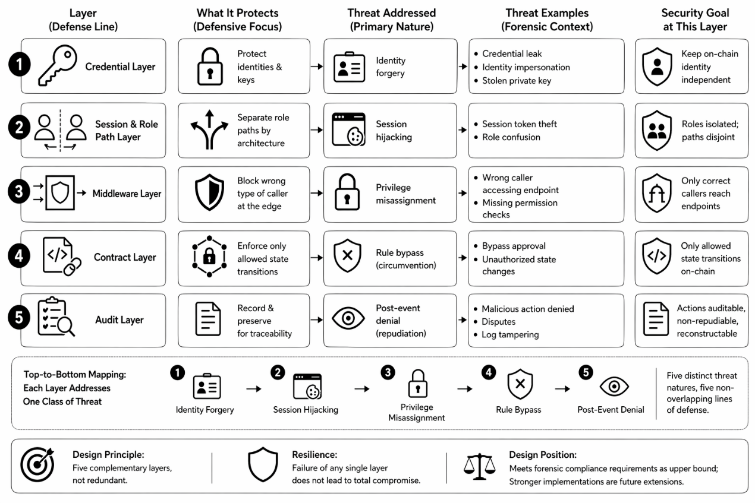
Credential Layer
The security objects of this layer are identities and key materials, where identity forgery risks like credential leak, identity impersonation, and stolen private key can happen. In digital forensics, if the system can not verify who initiated the operations in the workflow, the foundation for subsequent authorisation, modification, and audit will be lost. The core purpose of the credential layer is not to simply strengthen the overall authentication level but to preserve a stable and traceable relationship between on-chain behaviours and according actors, answering the question of who did this.
Session Layer
The main types of risk for this layer to handle are session hijacking and role confusion, with the focus on separating the operational model of different roles by establishing dedicated processing channels for them. In the configuration of this system, investigators are responsible for proposing and modifying case files when judges or auditors conduct verification and examination. In case of these two types of roles sharing the same access path, APIs, or session logic, the probability of overreach and role confusion will still significantly increase, even if the underlying access control has been deployed. Therefore, the security objective of this layer is to separate the paths of write and verification, naturally dividing the capability boundaries of different roles with systematic logic, not post-incident remedies.
Middleware Layer
This layer handles privilege misassignment by censoring the consistency between the caller and the invoked operation. The session layer configures dedicated paths for different roles, whereas the middleware layer further validates if the entity entering a certain path has the correct authorisation. In other words, this layer achieves the least privilege principle at the request boundary to prevent mismatches between callers and operations. This design is critical for the CoC requirement because any unauthorised writes or modifications to the CoC will inevitably compromise the evidential integrity.
Contract Layer
By transforming critical institutional CoC procedures into on-chain state-transition conditions, this layer leverages the mandatory enforcement from the consensus mechanism to handle rules bypass risk. Any modification to the CoC must follow a non-bypassable procedure that is also auditable and traceable. The two-party modification protocol in this study reflects this principle by translating proposal, approval, and update into rule constraint to ensure procedual requirement cannot be bypassed under any circumstances. The consensus mechanism and automatic execution of the blockchain offer technical implementation support.
Audit Layer
This player handles post-event denial by focusing on the protection and organisation of critical events, transaction identifications, and operational traces for subsequent reconstruction. The threats to digital forensic systems include not only improper action itself but also the following disputes over attribution and procedural legitimacy. The system must provide clear and systematic operational traces for persuasive evidence in legal proceedings. Hence, the security objective of this layer is to ensure critical CoC operations are auditable, immutable, and reconstructable by any independent party.
The security design directly responds to research question 2 of this study, the security trade-off of integrating blockchain into the CoC workflow. It provides a top-level threat-defence-research question alignment diagram, based on which this study elevates the blockchain-based CoC solution from a group of isolated functions into an interconnected system with clear security boundaries.

3.7 Development and Experimental Environment

3.7.1 Experimental Environment
A mixed deployment of Windows and Linux is adopted in this study because this design contains a desktop forensic application, a Java blockchain API module, and a local permissioned blockchain network. Autopsy is running on the Windows side for case analysis, plugins functioning, and report generation, while WSL Ubuntu is the running environment of the blockchain network.
Type | Name | Purpose | Version
Operating System | Windows | Main workstation environment for Autopsy | Windows 11
Linux Runtime | WSL 2 with Ubuntu | Provides a Linux environment for running FISCO BCOS nodes | 20.04
Digital Forensics Platform | Autopsy | Main forensic platform | 4.22.1
Programming Language | Java | Core language used for the Autopsy plugin and the blockchain interface module | Java17 for plugin; Java 11 for blockchain module
Plugin Build Tool | Apache Ant | Builds the Autopsy-side plugin | 1.10.17
Blockchain Module Build Tool | Apache Maven | Manages blockchain interface | 3.6+
Blockchain Platform | FISCO BCOS | Local permissioned blockchain | FISCO BCOS 2.1 test network
Blockchain SDK | FISCO BCOS Java SDK | Provides Java connectivity to the blockchain network | 2.9.2
Blockchain Network Topology | Four-node local chain | Local permissioned consensus environment | 4 nodes, local deployment
Blockchain Management Tool | WeBASE | Web-based observation and management of the FISCO BCOS network | WeBASE 1.5.1
Smart Contract | Solidity | Contract development | 0.5.10
Data Format | JSON | Stores structured CoC data | UTF-8 JSON
Configuration Format | TOML | Stores blockchain connection configuration | 1.1.0
API Gateway | Node.js | Middleware authentication | 24.15.0
Email Service | Nodemailer | Delivering tokens | 8.0.5
Presentation Dashboard | Streamlit | Dashboard layer | 1.56.0

3.7.2 Test Dataset
This research uses simulated forensic images from the “Digital Forensics Tools and Techniques” course as the experimental input. These images are pre-built disk image files in .dd format, containing digital evidence simulated for real crime scenes. The content includes metadata of system files, debris of deleted files, timestamp records and other forensics-related file formats (documents, images, and executables). Because the real digital forensics data is hard to get due to its confidentiality and sensitivity, adopting scholarly datasets becomes a viable method for this study.

4. System Implementation and Results

4.1 Introduction
Based on the current research gap identified in Chapter 2, Chapter 3 establishes the research foundation and system framework of this study. The central objective of this system is not to prove whether evidence digests can be stored using blockchain technology, but to integrate the CoC mechanism into a blockchain-based digital forensic workflow. Therefore, this study aims to design a unified processing platform that covers the CoC lifecycle while ensuring the integrity, traceability, and measurability of the evidence. According to the design in Chapter 3, Autopsy is positioned as the evidence generation frontend, API gateway is responsible for authorisation and communication control, the FISCO BCOS deals with blockchain-based integrity and modification control, and the dedicated judicial dashboard handles and displays evidence verification.
This chapter presents the system realisation and experimental results. It explains how the designed components can be interconnected to form a prototype platform. Furthermore, the measurable data from this system will also be collected to answer the research questions in this study. The material showcased in this chapter includes the structured CoC report from Autopsy, key operational records, upload and proposal receipts, gateway running records, blockchain transaction information, audit information, and verification outputs from the judge dashboard.
This chapter is organised as follows. Section 4.2 presents the system formation and data flow. From section 4.3 to 4.6, the implementation of major components will be illustrated and displayed. Section 4.7 explains the experimental process to establish a framework for subsequent tests. The function outcomes, security test results, actual workflow, and key performance results are reported in 4.8 to 4.11. Section 4.12 summarises the whole chapter and prepares transitions to the following discussion.

4.2 System Overview
Because this study focuses on how to effectively integrate blockchain into the analysis and report phase of Autopsy in terms of a CoC workflow, this system needs to reflect three interconnected relationships: first, how to collect evidence data from Autopsy workflow and organise them as verifiable records? Second, how to separate off-chain evidence records with on-chain hash transactions while keeping a strong correspondence between them for subsequent verification? Third, how to organise all the component functions and actor operations in the system to jointly form an auditable CoC history trace.

4.2.1 Overall Architecture of the Implemented System
The architecture of the system is shown in Figure XXXXX, within which the Autopsy plugins are the evidence data collection entry, the API gateway is the control centre and a data exchange hub, the FISCO BCOS is the blockchain-based integrity anchoring and modification-control layer, and the web dashboard serves as the audit and display platform for judges and auditors. Autopsy does not communicate with the FISCO BCOS directly. Instead, the forensic client, on-chain service, and verification interface are connected through the gateway. This star topology supports the independent running of each component while concentrating all middleware services into the gateway, minimising performance interference among core functional modules.
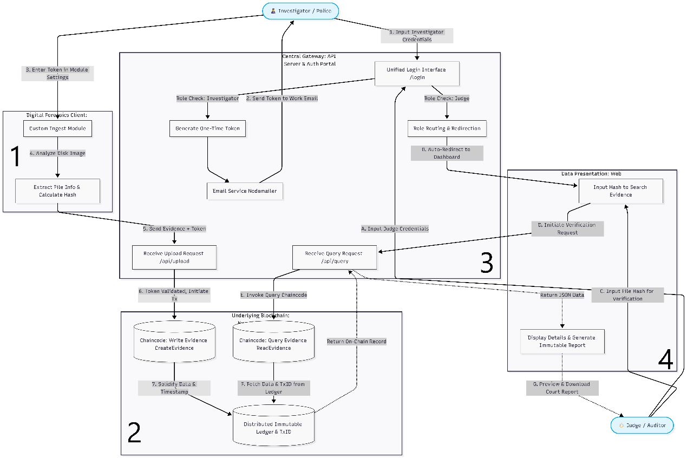
Figure XXXX
In terms of actual implementation, Autopsy plugins generate original forensic records, including case metadata, data source hashes, file-level hashes, operation events, and a report-level aggregate hash. The API gateway positions between Autopsy and the blockchain platform, handling request entry, OTP(One-Time Password) examination, role routing, report integrity verification, chain-side hash calculation, and transaction routing. The FISCO BCOS blockchain and smart contracts do not store the actual evidence or CoC content, but record the hash commitment (evidence digest) for off-chain verification, modification status, and contract events. The judge dashboard initiates a query or approval process through the gateway so it does not directly access the blockchain SDK or off-chain storage directory. The detailed modular function and outputs are illustrated in Table XXX. The system is therefore divided into four areas of forensic generation, controlled transmission, immutable anchoring, and judicial verification.
Component | Position | Responsibility | Main output
Autopsy plugin | Examiner Workstation | Capture case events, generate CoC report, initiate upload or modification | case_data_extract.json, operation log,  image integrity status, upload/proposal receipt
API gateway | Middleware | Authenticate users, verify hash, enforce role-based routes, , transmit blockchain requests | API response, timing fields, audit log, chain transaction metadata
FISCO BCOS / Smart Contract | Blockchain integrity | Anchor hash commitments, manage proposal and contract events | txHash, block number, proposal state, event record
Private off-chain store | Local evidence record | Store complete case record | Full JSON record used for later verification
Judge-web dashboard | Verification and review | Query case records, verify hash values, approve/reject proposals, present audit trail | Verification result, approval/rejection outcome, exportable review report
Table
The implemented architecture becomes a controlled evidence pipeline that reflects the requirements of CoC management: Autopsy provides a structured case data source; Gateway functions as a verification and transmission point; FISCO BCOS offers references for record integrity and immutability; The dashboard is an independent audit interface for on-chain and off-chain comparison. This sequential relationship among modules corresponds closely to the five-layer security design in Chapter 3, where credential and seesion decide who can enter the pipeline, middleware examines the authorisation of certain roles, contract logic restricts how the upload and modification proposal proceed, and audit records can be used for the reconstruction of events and operations.

4.2.2 Implemented System Functionalities
This system has achieved the management of the CoC workflow in the analysis and report stage using blockchain technology. Detailed functionalities are shown in Table:
Capability | Observable Output | Analytical Meaning
Case data extraction | Case metadata, data source information, file-level hash values | Establishes the off-chain evidence record to be protected
Operation event capture | case_extract_events.json, operation entries in report | Provides procedural context for CoC reconstruction
CoC report generation | case_data_extract.json, aggregateHash | Creates a report-level object whose integrity can be verified
Image integrity | Computed image hash | Adds a source-level integrity check outside the final report alone
Authorised blockchain upload | upload_receipt.json, indexHash, recordHash, txHash | Demonstrates controlled transmission from Autopsy to blockchain
Modification proposal | proposal_receipt.json, proposal ID, proposal state | Represents post-submission changes as reviewable requests
Judicial approval/ rejection | Approval/rejection transaction, updated proposal status | Introduces independent review into the modification workflow
Automatic execution | Executed proposal state, updated record hash | Separates approval from final state update while preserving auditability
Verification query | Hash comparison result, record integrity flags | Shows whether the off-chain record still matches the chain commitment
Tamper-difference presentation | Mismatch indicators and changed-field presentation | Makes integrity failure visible to a reviewer
Audit trail display | Contract events and enriched gateway audit records | Supports reconstruction of upload, proposal, and approval actions
Timing records | Client round-trip time, gateway timing fields, chain timing fields | Provides empirical data for performance assessment
Table
This system not only supports a simple upload or query mode but also supports the initial evidence registration path, the later modification path, the independent verification path, and the audit path. These paths reflect different scenarios in the workflow of blockchain-based CoC in this study. The initial registration focuses on the first on-chain anchoring of the report generated by Autopsy. The modification path deals with how to update or correct existing records. The verification path compares the readable off-chain record with its on-chain commitment (transaction). The audit path forms and displays the operational history of each record. The implementation as a whole is sufficient to support the observation and evaluation of system feasibility, integrity preservation, auditability, and performance.

4.2.3 Implemented Data Flow
The end-to-end data flow and data objects are illustrated in Figure XX and Table XX. The system divides forensic operations into write flow (investigator) and read flow (judge). The former represents how the investigator generates forensic reports from Autopsy and writes hash commitment onto the blockchain. The latter showcases how the judge or auditor queries case records and verifies authenticity and integrity using a dedicated dashboard. In terms of CoC management, the configuration of data flow should not only focus on the data route, but also on how to keep the data consistency when they travel across different modules. Meanwhile, potential security risk points on the routes should also be identified according to the integrity needs and access control.
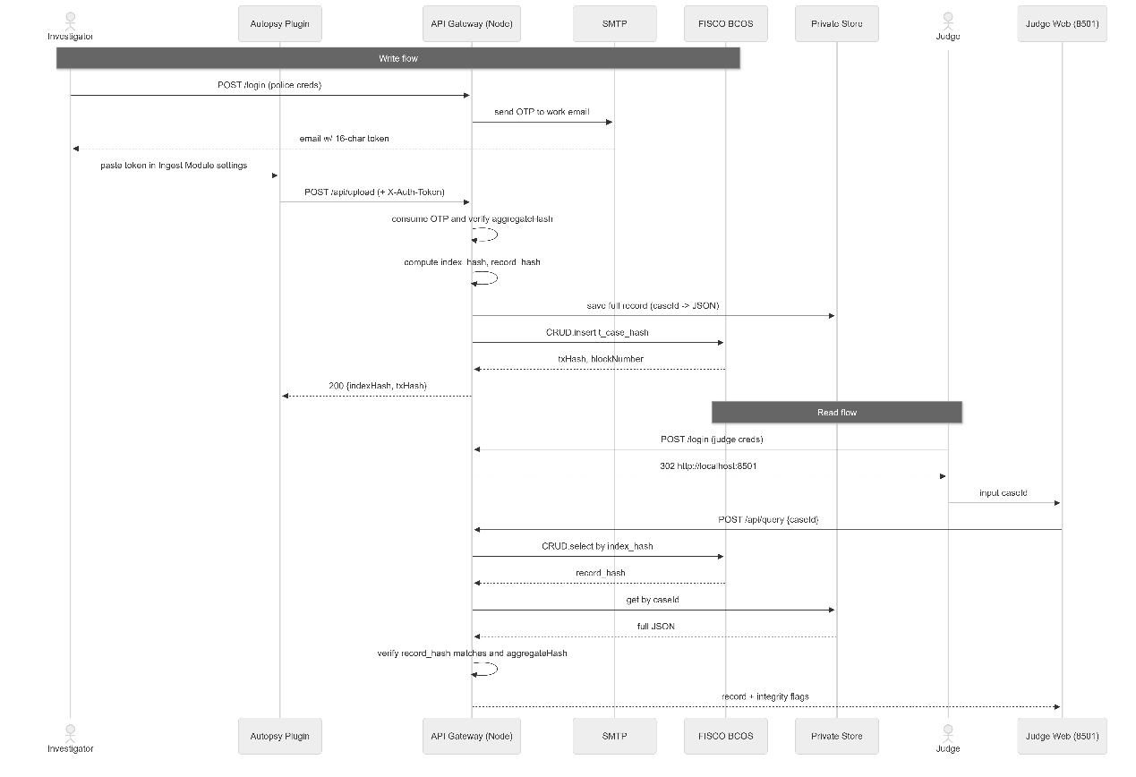
Figure: XXXX
Write Flow
The investigator first logs into the system via the API gateway and receives a one-time token that will be sent to the API gateway with the structured JSON report from the Autopsy plugin. The gateway consumes the token to verify the aggregate hash of the CoC report content and computes the indexHash for on-chain anchoring and recordHash for verifiability. The complete JSON record is stored off-chain while the hash commitment is recorded on-chain for query and integrity verification. The txHash(transaction hash) from the blockchain platform and block number are organised by the gateway into an upload receipt that will be sent back to Autopsy.
Data object | Generation Position | Store Position | Purpose
Operation log | Autopsy plugin | Case directory / report JSON | CoC operations
File and data source hashes | Autopsy plugin | Report JSON | Integrity state of evidence objects
Case report JSON | Autopsy plugin | Off-chain private store | Readable case record
aggregateHash | Autopsy plugin | Report JSON / gateway verification result | Hash of the report body
indexHash | API gateway | On-chain | Case lookup
recordHash | API gateway | On-chain | Integrity commitment
Upload receipt | API gateway | Report output directory | Result of submission
Proposal receipt | API gateway | Report output directory | Result of modification proposal
Audit event | Contract/gateway | Audit log/event response | Review of workflow actions
Table XXX
Read Flow
The judge(auditor) uses the case ID to initiate a query after logging in. The dashboard does not access on-chain nodes, but sends the query to the gateway that computes and searches the corresponding index based on the case ID. The index is used to retrieve the on-chain recordHash and JSON record from off-chain storage. The gateway will then recalculate the recordHash according to the JSON file and compare to the on-chain commitment. If the two values match, the consistent state between off-chain and on-chain will be displayed on the dashboard. If not, a warning of integrity risk and tampering will be displayed. All verification results can be downloaded and exported into a PDF or JSON format report for further use.
Hash Consistency Issue
A key feature of this system is the multiple hash calculations at different points in the data flow. Autopsy plugins calculate file-level hash, data source hash, and report-level aggregate hash. The gateway validates the report-level hash and derives indexHash and recordHash. The blockchain layer stores and returns the hash commitment on-chain for subsequent comparison. Because of the fundamental importance of preserving integrity in the lifecycle of CoC, the consistency of the file hash must be maintained in the data flow. However, even an intact report is transmitted between modules and a same hash algorithm is implemented(SHA-256 for file verification in this study), subtle differences in different computing points, such as hash input boundary, JSON serialisation, field ordering, character encoding, line endings, null handling, excluded fields, timestamp format, or hexadecimal casing, can still lead to substantial differences in the resulting hashes, causing a mismatch on a valid record. Furthermore, if one system component conducts hash computation on a data scope that is comparatively narrower than that in other components, some modifications could fall outside the integrity check. In other words, cross-language and cross-runtime hash consistency is a critical challenge for this system. Detailed implementation policy and method will be explained in the following sections.
Security Analysis
There are mainly four potential vulnerabilities in the data flow from a security perspective. First is the investigator’s login portal at the gateway because the security mechanism deployed at this access point decides whether unauthorised users can submit upload or modification requests. Second is the gateway’s entry for Autopsy uploads because incomplete, replayed, forged, or modified reports can enter the system. Third is the off-chain private store because unauthorised modifications can happen and compromise subsequent verification results. The last is the judge-side query and approval path, where verification results are exposed and decide whether on-chain records can be updated. The layered security design in Chapter 3 is built on these vulnerabilities. Following sections will illustrate how each layer of the security mechanism is deployed in different modules.

4.2.4 Evidence Submission and Modification Approval Flows
The authenticity of digital evidence depends not only on the consistency of the hash value but also on whether the handling process is valid and can be audited independently. In addition to the data flow, this system also defines two business flows: initial submission and later modification. The former emphasises the efficient and controlled registration, while the latter focuses on the judicial review and contract constraints of existing on-chain records.
Initial submission
The process is illustrated in Figure XXX. The gateway conducts a procedural gatekeeping on the investigator’s submission based on the identity credential, OTP, aggregate hash and on-chain submission result. The Autopsy report that has passed this verification is stored off-chain with its hash commitment on-chain. Failed requests are rejected before chain registration occurs.
The core design feature of the initial submission is integrating the operation logic into Autopsy by providing an operational interface directly in the Autopsy plugin. Without independent tools or external scripts, investigators can therefore finish all necessary operations in a familiar working environment, which reduces the burden of switching between different systems. Igonor et al. (2025) indicate that one major challenge of integrating blockchain technology into digital forensics is the great effort and workload for seamless interoperability, which is also the technical feasibility in research question 1 of this study. The Autopsy plugin design offers a viable solution for this problem.
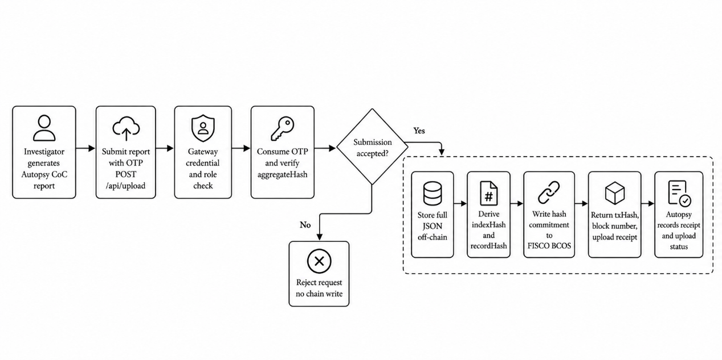
Figure Initial Submission
Modification Process
This process shares a similar integrity logic with the initial submission but adds an explicit judicial review stage, as shown in Figure XXXX. When a modification is needed, Autopsy updates the case report and submits a modification proposal to the gateway. The case will be set to a pending state after the credential check and integrity verification have passed at the gateway. The judge examines and makes decisions upon those proposals. Because of the immutability nature of the blockchain, modifications are added on-chain, not overwriting existing records, creating an auditable workflow.
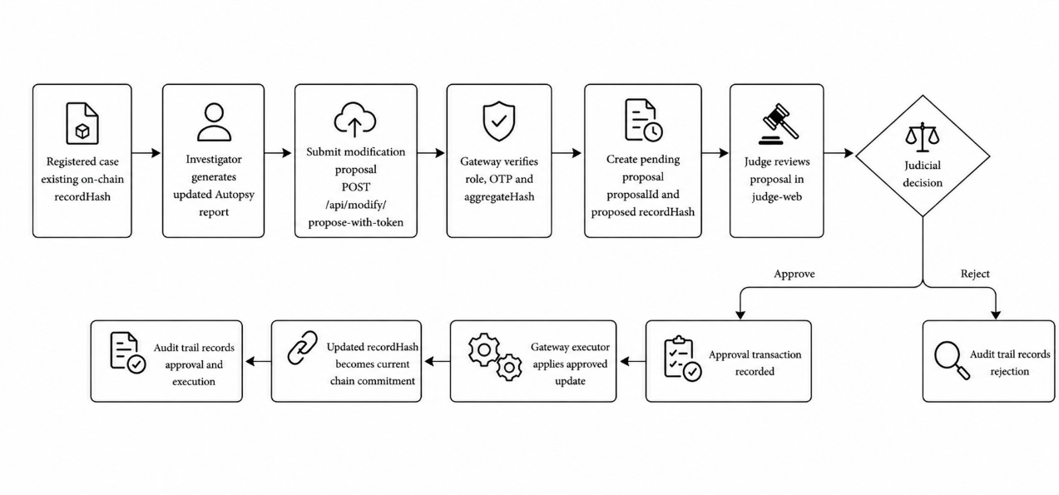
Figure Modification Process
Atlam et al. (2024) point out that although immutability makes records on-chain tamper-proof, it also introduces challenges for alteration and deletion if stored evidence is fraudulent. The modification process in this system directly responds to this issue. Another feature in this process is the automated execution after the judge’s approval. The gateway invokes the smart contract execution immediately when it detects a state change from pending to approval. This automation eliminates human-introduced difference between approval content and final execution result, because the execution logic is fixed in the contract code, without depending on any personal judgment or operation.

4.3 Autopsy Plugins Implementation
Autopsy plugins are positioned as the environment for digital evidence analysis, report generation, and evidence submission. The four plugins developed in this study are case event capture, structured report generation, image integrity verification, and police upload/proposal panel. The core mission is to export evidence data, file hash, operational events, and reports within the CoC analysis stage into verifiable CoC artefacts for subsequent submission onto the blockchain. Before displaying actual functions, the integration issues that occurred need to be analysed. As one of the most critical discoveries in this study, it directly determines the success of this system.

4.3.1 Integration Constraints and Core JAR Patch Deployment
The initial assumption of this study is that Autopsy plugins can be developed using the NetBeans platform's modular methods. In the official development guide of Autopsy 4.22.1 (The Sleuth Kit, 2026), third-party Java modules are published as the NBM(NetBeans Module) format and installed through the Plugins function in Autopsy. Consequently, the CoC report module, window component, and menu entry are packaged into NBM files at the beginning of the development, which has been proven to be an infeasible deployment approach. The reason for this issue is not from the design and development of those modules, but from the way the Autopsy distribution customises, trims, and caches parts of the NetBeans Platform.
Diagnose Process
First, a compatibility problem occurred during the installation phase of the standard NBM packages, where the java.lang.IllegalArgumentException: No enum constant and org.netbeans.updater.ModuleInfo.ELEMENTS.licenses exception was raised by Autopsy. It indicates that the AutoupdateInfoParser embedded in Autopsy does not function as the parser in the standard NetBeans distribution, causing necessary XML elements such as <licenses> or <module-dependencies> to be ignored by the parser in Autopsy 4.22.1. As a result, plugin packages were rejected before entering the module registration step.
After the failure above, this study further tried to put the compiled plugin JAR directly into Autopsy's module directory and manually add necessary configuration files to simulate the standard NetBeans module registration structure. It also failed because Autopsy cannot recognise these plugins after loading. The phenomenon proves that the AutoupdateInfoParser in Autopsy only loads those modules that have been identified by the platform. The physical existence of JAR files in the directory does not represent that they have been added in the internal module registry of NetBeans RCP.
The last problem is caused by the caching mechanism of the NetBeans platform. During the development process, a situation occurred where files had been replaced and configuration entries had been added but Autopsy appeared to have no response. The reason is that the binary metadata caches maintained by Autopsy were not synchronised with the file updates, so the platform kept the state of old modules. This issue is difficult to diagnose because it is not exposed in an explicit way by Autopsy.
Implementation of Solution
After deeply analysing the official development guidelines of NetBeans (NetBeans, 2026) and Oracle (Oracle, 2026), a method of preserving the module manifest and merging layer/service registrations into the existing core module successfully creates a path for loading the developed plugins into Autopsy. In actual implementation, the plugin Java source files are first compiled with Autopsy's bundled JDK and the dependency JARs, and then injected into the original system core org-sleuthkit-autopsy-core.jar to build a patch. The original core JAR file in Autopsy is then replaced with this patch, with NetBeans cache cleaned so that metadata can be rebuilt on the next startup. At last, all plugins are correctly loaded and function as planned.
The resolution of this issue carries two meanings. From the implementation perspective, it guarantees that the designed plugins can function in the latest version of Autopsy, providing case data for the following steps. On the integration feasibility side, it showcases the potential difficulties when modifying existing forensic tools to integrate with other platforms. The feasibility of the integration in this study not only relies on the academic design but also on these easily overlooked engineering details.

4.3.2 Case Event Capture and Operation Log
Among the Autopsy plugins, CaseEventRecorder is the basic module that connects Autopsy real-time events to the following structured report. It does not record user operations after the report generation, but adopts an event-driven manner to continuously capture key state changes. Its operations are illustrated in Figure XX: the recorder is created after the plugins are loaded. It then registers a PropertyChangeListener towards the Case event system in Autopsy, monitoring key operational events. Every time an event is triggered, the recorder encapsulates the event time, event type, operator, and event detail into an OperationEntry and persists it as the case_extract_events.json in the current case directory. The following report module will read case-level events in this file and write to the report.
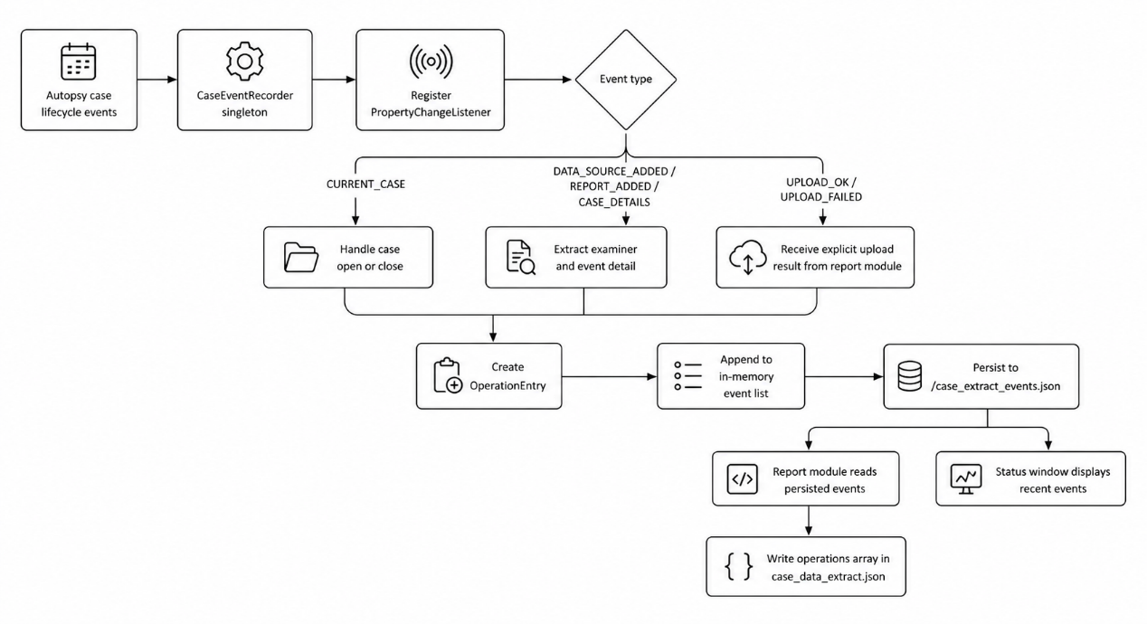
Figure XXXX
The granularity selection of captured events in this study is a balanced decision between logging detail and system performance. Current capturing points are positioned at the case model, report module, and gateway submission outcome. All recorded event types are shown in Table XXX.
Event type | Captured information | Design purpose
CASE OPENED | Case name, examiner, OS user, timestamp | Establish the starting point of operation history
CASE_CLOSED | Case name, examiner, timestamp | Mark the end of an active case session
ADDING_  DATA_SOURCE | Examiner, data source/import status detail | Record the beginning of a data source intake action
DATA_SOURCE  _ADDED | Data source name or content detail, examiner, timestamp | Link evidence intake to the case report and hash records
ADDING_DATA_  SOURCE_FAILED | Failure-related detail and examiner | Preserve failed intake attempts
REPORT_ADDED | Report-related event detail and examiner | Record when report generation is added to the case history
CASE_DETAILS | Metadata change detail and examiner | Capture changes that affect case-level context
UPLOAD_OK | Case ID, transaction hash, request ID, round-trip time | Connect local report generation with external submission
UPLOAD_FAILED | Error kind, HTTP status, operator message, round-trip time | Preserve failed transmission attempts for later diagnosis
INTEGRITY_FAIL | Expected and actual hash prefixes, image name | Record detected mismatch between image file and stored reference
Table XXX
This module embeds the CoC audit requirement of “who performed what action on the case and when” into the forensic tool itself. The automatic, objective, and non-omissible way of operational log generation eliminates the inherent flaws of traditional manual recording, such as potential omissions, insufficient logging granularity, and decoupling from actual operations. The event-driven mechanism enables a record at the time the event occurs, minimising the time difference between events and reports. Furthermore, event omission becomes almost impossible because each qualifying operation will invoke the callback in this module to record. Moreover, the file persistence strategy ensures that logs of all executed operations have been written to the disk in case Autopsy crashes during the analysis process.

4.3.3 Structured Case Data Report Generation
After event capture, the next core implementation is the structured report, which is generated by the CaseDataExtractReportModule and registered as one of the GeneralReportModule in the report wizard in Autopsy, as shown in Figure XXX. It does not aim to replace the original report export function in Autopsy, but to produce an evidence record file that can be independently verified. Specifically, the structured reports should exhibit the CoC characteristics mentioned in NIST SP 800-86 standard (Kent et al., 2006). First, the record should cover case-related analytical data to reduce the risk of potential omission. Second, the record itself should be able to prove that it has not been modified after generation. Third, the third party with the same tool and input should be able to recompute and verify the record content. Fourth, the record format must be correctly identified by the gateway for the following comparison and presentation. Hence, when the traditional file-list export can only prove what has been recorded, this module further answers the questions on integrity and immutability.
The report is built with five layers as shown in Figure XXX:
Layer 1: Case Metadata
It includes fields from the Autopsy case model, including caseId, caseDisplayName, examiner, and createdDate. CoC should record basic case information in these fields to link the report to a specific operator for subsequent review, approval, and accountability.
Layer 2: Operations
Instead of resubscribing to runtime events at the time of report generation, this module reads operational logs continuously accumulated in case_extract_events.json. Because the operation log is a growing record during the case handling process and report generation is a one-time snapshot, this design ensures that all operations are recorded without omission.
Layer 3: Data Source
This module obtains the data source of the current case in Autopsy, extracting its physical paths and hash values in the Autopsy database (MD5 and SHA256). The information in this layer records the original identity of the case file and forms the foundation for the integrity verification in next module. Notably, the hashes obtained at this layer are the ones calculated by Autopsy when the case file is imported, which represents the initial state of the evidence possessing significant forensic value.

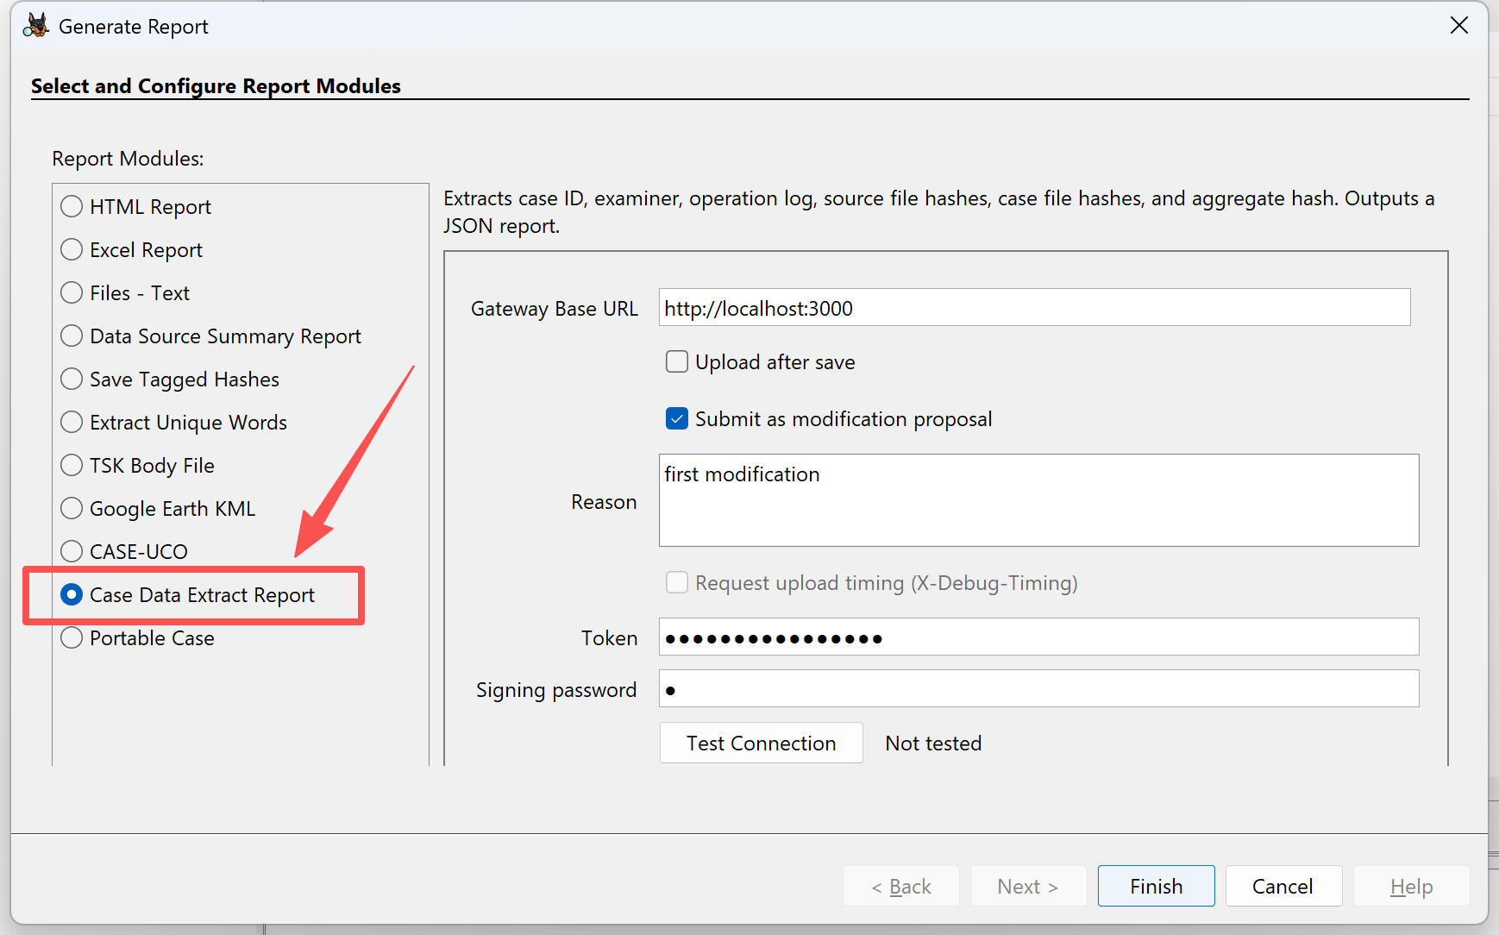
Figure XXX
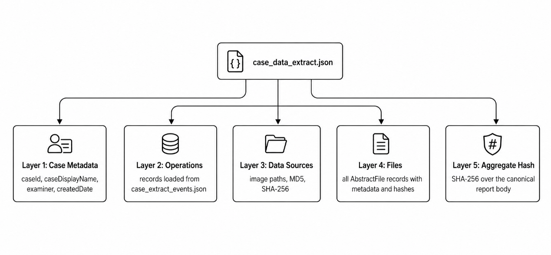
Figure XXX
Layer 4: Files
The complete file inventory of the case file (files array) is recorded at this layer with significant fields shown in Table XXX. Because of the potential metadata structure (including file path) lost risk from certain deleted files (The Sleuth Kit, 2020), this module queries the Sleuth Kit case database file records directly and returns all available resulting rows, without the file path restrictions of the tree traversal method. The risk of deleted files not being properly identified in the report is therefore significantly decreased.
Field category | Fields | Forensic significance
Identity | name, path | Locates a file object in the case database
Physical attribute | size | Provides a basis for possible size changes
Timestamp | created, modified,  accessed, changed | Timeline analysis and event reconstruction
Existence state | deleted, allocated | Distinguishes allocated files, deleted files, and unallocated records
Classification | known, mimeType | Distinguishes file type
Integrity values | md5, sha256 | Mathematical fingerprints
Table: XXXX
Layer 5: Aggregate hash
Based on the main body of the report upon the four layers above, a structural integrity-commitment field- aggregateHash -is calculated and written back into the report. It proves that the exported report is not only a data record but also a structured evidence artifact that can be recalculated and verified.
After the five-layer assembling process, this module generates the structured report case_data_extract.json and stores it in the directory designated by Autopsy. The content of case_data_extract.json is shown in Table XXX.
Field name | Main content | Verification significance
caseId | Case number | Case Identifier for following operations
caseDisplayName | Case name | Local case context
examiner | Examiner name | Links the report to the operator
createdDate | Case creation date | Case-level metadata
operations | Time, action, operator | Runtime operation history
dataSources | Source name, paths, MD5, SHA-256 | Evidence source identity and baseline hashes
files | File metadata, status, type, and hashes | Complete evidence content inventory
aggregateHash | SHA-256 over the canonical report body | Report-level integrity commitment
Table XXXX

4.3.4 Image Integrity Verification
The evidential value of digital forensic work depends on the critical fact that the evidence file has not been modified in an unauthorised or undocumented way. However, Giova (2011) has highlighted that digital evidence is complex, diffuse, and volatile, which makes it vulnerable to improper alteration. To handle this issue, the conventional digital forensic workflow requires investigators to manually trigger the hash calculation of the case image and record it. It introduces two potential limitations. First, the verification process entirely depends on the investigator’s expertise and sense of responsibility. Second, the verification results could be excluded from the operation log or subsequent reports, even if the process has been carried out.
The core intention of developing this module is to transform the integrity verification of the evidence data source (image file) process from a spontaneous manual action into an automatically triggered, displayed, and recorded system mechanism after each Autopsy case opening. In this study, a dedicated interface embedded in Autospy is developed to show the verification result as in Figure XXX.
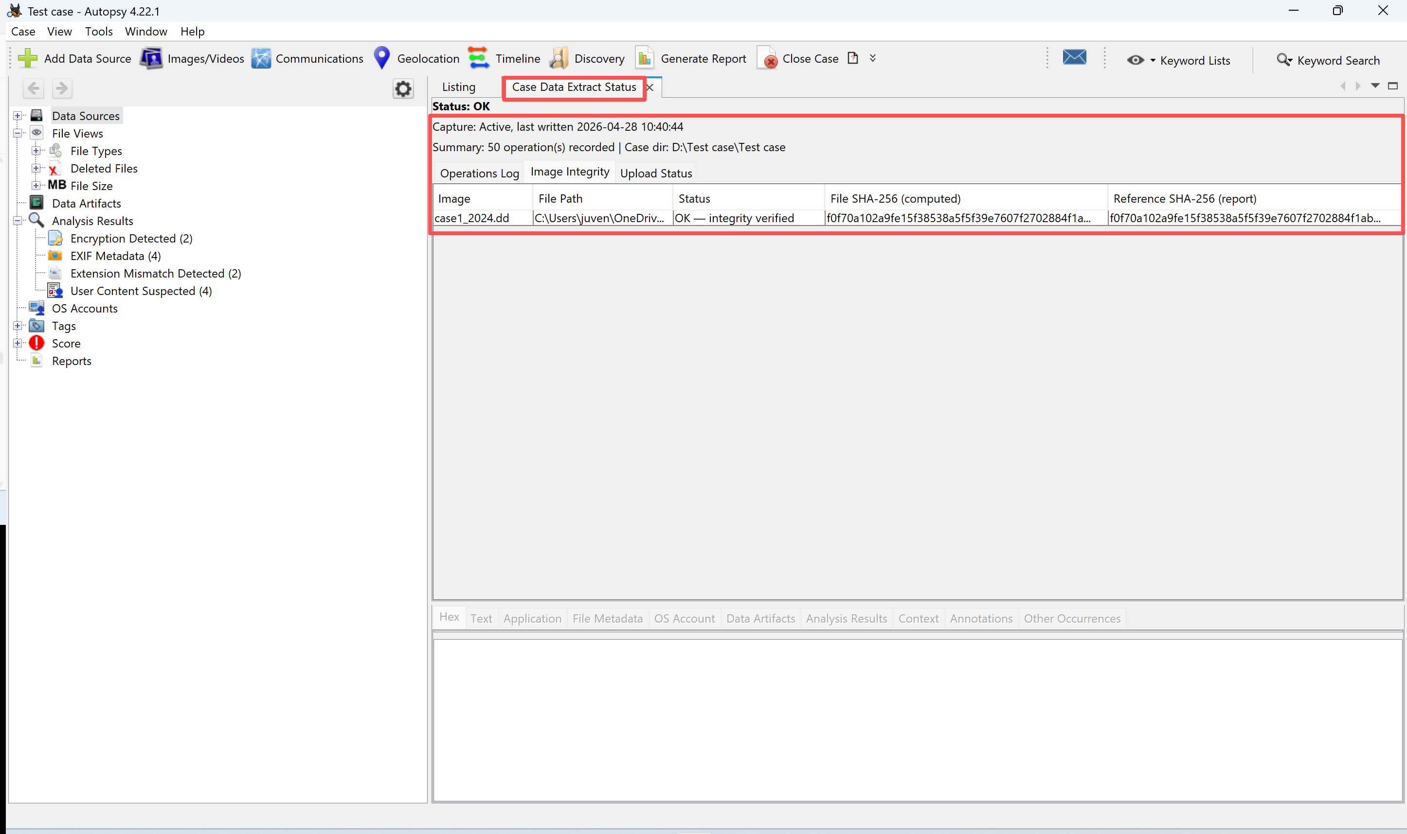
Figure XXXX
Functioning Mechanism
The operation process of this module is not a simple hash calculation and comparison, but a closed loop from data analysis to operation audit in terms of the CoC lifecycle. After a case is opened in Autopsy, the module first tries to retrieve the data source SHA-256 as the comparison reference from the latest version of the locally stored structured report (case_data_extract.json). It then reads the physical image bytes to recalculate the SHA-256. The result is then compared to the reference hash and displayed in the integrity tab. The whole process is recorded by the event capture module and further protected by the aggregate hash in the structured report. Under the joint effort of modules, events of case opening, evidence recalculation, integrity verification, and result recording are connected to become an auditable procedure.
Key Implementation Decisions
First is the reference hash selection. After a case is established in Autopsy, both the local Autopsy database and the structured report save the hash result calculated by Autopsy. In this implementation, a report-first with database fallback strategy is adopted, where the database is accessed only when no available reference can be retrieved from the report. The cause for this strategy is that the structured report is the defined CoC artefact in this study under the protection of the report-level aggregate hash, whereas the local database is stored in plaintext without any security measures, making it vulnerable to various risks.
Second is the background hashing execution. Forensic images frequently reach the size of tens of gigabytes or several terabytes, where sequential reading and computing SHA-256 can take a substantial amount of time. If this operation occurs in the Autopsy UI threads after case opening, the software becomes completely unavailable. Therefore, this module creates a daemon thread that does not interfere with the running of Autopsy. Further, a progress display in the monitor window is implemented to inform the investigator of the operation status. The daemon thread mechanism decouples verification from the user interface, preventing the newly introduced security measure from degrading system usability.
After the verification, the module use three conditions to express different evidential meanings as shown in Table XXX.
State | Display | Forensic meaning
Match | OK - integrity verified | The physical image file matches the reference SHA-256
Mismatch | TAMPERED - Image file may have been modified. | The current physical file differs from the reference and requires investigation
No reference | No reference hash | The system cannot verify integrity because no baseline is available
Table XXX

References
Al-Khateeb, H., Epiphaniou, G., & Daly, H. (2019). Blockchain for Modern Digital Forensics: The Chain-of-Custody as a Distributed Ledger. Blockchain and Clinical Trial. https://doi.org/10.1007/978-3-030-11289-9_7

Apache Software Foundation. (2026a). Apache Ant. https://ant.apache.org/

Apache Software Foundation. (2026b). Apache Maven. https://maven.apache.org/

Argy, P., & Mason, S. (2007). Electronic evidence: disclosure, discovery and admissibility. LexisNexis Butterworths.

Atlam, H. F., Ekuri, N., Azad, M. A., Lallie, H. S., Atlam, H. F., Ekuri, N., Azad, M. A., & Lallie, H. S. (2024). Blockchain Forensics: A Systematic Literature Review of Techniques, Applications, Challenges, and Future Directions. Electronics 2024, Vol. 13,, 13(17). https://doi.org/10.3390/electronics13173568

Basis Technology. (2020). Autopsy Forensic Browser Developer's Guide and API Reference. https://sleuthkit.org/autopsy/docs/api-docs/4.14.0/

Batista, D., Mangeth, A. L., Frajhof, I., Alves, P. H., Nasser, R., Robichez, G., Silva, G. M., Miranda, F. P. d., Batista, D., Mangeth, A. L., Frajhof, I., Alves, P. H., Nasser, R., Robichez, G., Silva, G. M., & Miranda, F. P. d. (2023). Exploring Blockchain Technology for Chain of Custody Control in Physical Evidence: A Systematic Literature Review. Journal of Risk and Financial Management 2023, Vol. 16,, 16(8). https://doi.org/10.3390/jrfm16080360

Carrier, B., & Spafford, E. (2004). An event-based digital forensic investigation framework. Digital Investigation.

Casey, E. (2011). Digital evidence and computer crime: Forensic science, computers, and the internet. Academic press.

Cebe, M., Erdin, E., Akkaya, K., Aksu, H., & Uluagac, S. (2018). Block4Forensic: An Integrated Lightweight Blockchain Framework for Forensics Applications of Connected Vehicles. IEEE Communications Magazine, 56(10). https://doi.org/10.1109/MCOM.2018.1800137

Cyberly. (2025a). How Does Autopsy Ensure Data Integrity During Investigations? https://www.cyberly.org/en/how-does-autopsy-ensure-data-integrity-during-investigations/index.html

Cyberly. (2025b). Limitations of Autopsy. https://www.cyberly.org/en/what-are-the-limitations-of-autopsy/index.html

Damascena, N. P., Calmon Silva, M., Deitos, A. R., Baldasso, R. P., Ferreira, R. C. G., Kotinda Júnior, C., & Palhares Machado, C. E. (2022). Recommendations for Procedures Related to the Evidence Chain of Custody in Forensic Anthropology in Brazil. Forensic Sciences Research, 7(4). https://doi.org/10.1080/20961790.2022.2076984

Dasaklis, T. K., Casino, F., & Patsakis, C. (2021). SoK: Blockchain Solutions for Forensics. Security Informatics and Law Enforcement. https://doi.org/10.1007/978-3-030-69460-9_2

Devin. (2026). DeepWiki sleuthkit/autopsy. https://deepwiki.com/sleuthkit/autopsy

Ferdous, M. S., Chowdhury, M. J. M., & Hoque, M. A. (2021). A survey of consensus algorithms in public blockchain systems for crypto-currencies. Journal of Network and Computer Applications, 182. https://doi.org/10.1016/j.jnca.2021.103035

FISCO BCOS. (2026). FISCO BCOS Documentation. https://fisco-bcos-documentation.readthedocs.io/en/latest/

Fu, X., Ma, H., Ding, B., Wang, H., & Shi, P. (2024). Subtraction of Hyperledger Fabric: A blockchain-based lightweight storage mechanism for digital evidences. Journal of Systems Architecture, 153. https://doi.org/10.1016/j.sysarc.2024.103182

G., R., & S., R. (2023). A blockchain-based cloud forensics architecture for privacy leakage prediction with cloud. Healthcare Analytics, 4. https://doi.org/10.1016/j.health.2023.100220

Gary, P. (2001). A road map for digital forensic research. Digital Forensics Research Workshop,

Giova, G. (2011). Improving Chain of Custody in Forensic Investigation of Electronic Digital Systems.

Habib, G., Sharma, S., Ibrahim, S., Ahmad, I., Qureshi, S., Ishfaq, M., Habib, G., Sharma, S., Ibrahim, S., Ahmad, I., Qureshi, S., & Ishfaq, M. (2022). Blockchain Technology: Benefits, Challenges, Applications, and Integration of Blockchain Technology with Cloud Computing. Future Internet 2022, Vol. 14,, 14(11). https://doi.org/10.3390/fi14110341

Igonor, O. S., Amin, M. B., Garg, S., Igonor, O. S., Amin, M. B., & Garg, S. (2025). The Application of Blockchain Technology in the Field of Digital Forensics: A Literature Review. Blockchains 2025, Vol. 3, Page 5, 3(1). https://doi.org/10.3390/blockchains3010005

International Organization for Standardization. (2012). ISO/IEC 27037:2012. https://www.iso.org/standard/44381.html

International Organization for Standardization. (2015a). ISO/IEC 27041:2015. https://www.iso.org/standard/44405.html

International Organization for Standardization. (2015b). ISO/IEC 27042:2015. https://www.iso.org/standard/44406.html

International Organization for Standardization. (2015c). ISO/IEC 27043:2015. https://www.iso.org/standard/44407.html

Kent, K., Chevalier, S., Grance, T., & Dang, H. (2006). NIST Special Publication (SP) 800-86, Guide to Integrating Forensic Techniques into Incident Response. https://doi.org/10.6028/NIST.SP.800-86

Khan, Uddin, M., Shaikh, A. A., Laghari, A. A., & Rajput, A. E. (2021). MF-Ledger: Blockchain Hyperledger Sawtooth-Enabled Novel and Secure Multimedia Chain of Custody Forensic Investigation Architecture. https://doi.org/10.1109/ACCESS.2021.3099037

Khan, S. N., Loukil, F., Ghedira-Guegan, C., Benkhelifa, E., Bani-Hani, A., Khan, S. N., Loukil, F., Ghedira-Guegan, C., Benkhelifa, E., & Bani-Hani, A. (2021). Blockchain smart contracts: Applications, challenges, and future trends. Peer-to-Peer Networking and Applications 2021 14:5, 14(5). https://doi.org/10.1007/s12083-021-01127-0

Khanji, S., Alfandi, O., Ahmad, L., Kakkengal, L., & Al-kfairy, M. (2022). A systematic analysis on the readiness of Blockchain integration in IoT forensics. Forensic Science International: Digital Investigation, 42-43. https://doi.org/10.1016/j.fsidi.2022.301472

Kohn, M. D., Eloff, M. M., & Eloff, J. H. (2013). Integrated digital forensic process model. Computers & Security, 38, 103-115.

Kumar, G., Saha, R., Lal, C., & Conti, M. (2021). Internet-of-Forensic (IoF): A blockchain based digital forensics framework for IoT applications. Future Generation Computer Systems, 120. https://doi.org/10.1016/j.future.2021.02.016

Lavin Perrino, I., Llanos Ferraris, D. R., Lavin Perrino, I., & Llanos Ferraris, D. R. (2025). An Analysis of Blockchain Solutions for Digital Evidence Chain of Custody. https://doi.org/10.5281/zenodo.15430154

Lee, H. C., Palmbach, T., & Miller, M. T. (2001). Henry Lee's crime scene handbook. Academic Press.

Leroux, O. (2004). Legal admissibility of electronic evidence. International Review of Law, Computers & Technology, 18(2). https://doi.org/10.1080/1360086042000223508

Li, H., Chen, Y., Shi, X., Bai, X., Mo, N., Li, W., Guo, R., Wang, Z., & Sun, Y. (2023). FISCO-BCOS: An Enterprise-grade Permissioned Blockchain System with High-performance | Proceedings of the International Conference for High Performance Computing, Networking, Storage and Analysis. Proceedings of the International Conference for High Performance Computing, Networking, Storage and Analysis. https://doi.org/10.1145/3581784.3607053

Li, M., Chen, Y., Lal, C., Conti, M., Alazab, M., & Hu, D. (2023). Eunomia: Anonymous and Secure Vehicular Digital Forensics Based on Blockchain. IEEE Transactions on Dependable and Secure Computing, 20(1). https://doi.org/10.1109/TDSC.2021.3130583

Li, M., Lal, C., Conti, M., & Hu, D. (2021). LEChain: A blockchain-based lawful evidence management scheme for digital forensics. Future Generation Computer Systems, 115. https://doi.org/10.1016/j.future.2020.09.038

Li, S., Qin, T., & Min, G. (2019). Blockchain-Based Digital Forensics Investigation Framework in the Internet of Things and Social Systems. IEEE Transactions on Computational Social Systems, 6(6). https://doi.org/10.1109/TCSS.2019.2927431

Liu, G., He, J., & Xuan, X. (2021). A Data Preservation Method Based on Blockchain and Multidimensional Hash for Digital Forensics. Complexity, 2021(1). https://doi.org/10.1155/2021/5536326

Lone, A. H., & Mir, R. N. (2019). Forensic-chain: Blockchain based digital forensics chain of custody with PoC in Hyperledger Composer. Digital Investigation, 28. https://doi.org/10.1016/j.diin.2019.01.002

Lusetti, M., Salsi, L., & Dallatana, A. (2020). A blockchain based solution for the custody of digital files in forensic medicine. Forensic Science International: Digital Investigation, 35. https://doi.org/10.1016/j.fsidi.2020.301017

Mahrous, W. A., Farouk, M., & Darwish, S. M. (2021). An Enhanced Blockchain-Based IoT Digital Forensics Architecture Using Fuzzy Hash. IEEE Access, 9. https://doi.org/10.1109/ACCESS.2021.3126715

Main, A., Khedekar, R., & Jogale, V. (2025). Maintaining Chain of Custody Using Blockchain. SSRN Electronic Journal. https://doi.org/10.2139/ssrn.5297079

Malakhov, I., Marin, A., & Rossi, S. (2023). Analysis of the confirmation time in proof-of-work blockchains. Future Generation Computer Systems, 147. https://doi.org/10.1016/j.future.2023.04.016

Nath, S., Summers, K., Baek, J., & Ahn, G.-J. (2024). Digital Evidence Chain of Custody: Navigating New Realities of Digital Forensics. 2024 IEEE 6th International Conference on Trust, Privacy and Security in Intelligent Systems, and Applications (TPS-ISA). https://doi.org/10.1109/TPS-ISA62245.2024.00012

NetBeans. (2026). Javadoc of NetBeans. https://bits.netbeans.org/9.0/javadoc/org-openide-modules/org/openide/modules/doc-files/api.html

NIJ, & DHS. (2018). Autopsy Version 4.6.0 Test Results for String Search Tool. https://www.dhs.gov/sites/default/files/publications/Test%20Report_NIST_String%20Searching%20Autopsy%20v.4.6.0_November%202018.pdf

NIJ, & DHS. (2024). Test Results for File Carving Tool: Autopsy Version 4.21.0. https://www.dhs.gov/sites/default/files/2024-09/24_0919_st_test_results_for_graphic_file_carving_tool_autopsy_4.21.0_0.pdf

Node.js. (2026). Run JavaScript Everywhere. https://nodejs.org/en

Nyaletey, E., Parizi, R. M., Zhang, Q., & Choo, K.-K. R. (2019). BlockIPFS - Blockchain-Enabled Interplanetary File System for Forensic and Trusted Data Traceability. 2019 IEEE International Conference on Blockchain (Blockchain). https://doi.org/10.1109/Blockchain.2019.00012

Oracle. (2026). NetBeans Developing Applications with NetBeans IDE. https://docs.oracle.com/netbeans/nb81/netbeans/develop/nbeans_modules.htm#NBDAG3056

Palmer, G. (2001). A road map for digital forensic research. First digital forensic research workshop, utica, newwork,

Parker, J. W. S. (2026). Is Autopsy Compliant With Legal And Regulatory Standards? https://www.cyberly.org/en/is-autopsy-compliant-with-legal-and-regulatory-standards/index.html

Pourvahab, M., & Ekbatanifard, G. (2019). Digital Forensics Architecture for Evidence Collection and Provenance Preservation in IaaS Cloud Environment Using SDN and Blockchain Technology. IEEE Access, 7. https://doi.org/10.1109/ACCESS.2019.2946978

Quick, D., & Choo, K.-K. R. (2014). Impacts of increasing volume of digital forensic data: A survey and future research challenges. Digital Investigation, 11(4). https://doi.org/10.1016/j.diin.2014.09.002

Rana, S. K., Rana, A. K., Rana, S. K., Sharma, V., Lilhore, U. K., & Khalaf, O. I. (2023). Decentralized Model to Protect Digital Evidence via Smart Contracts Using Layer 2 Polygon Blockchain. IEEE Access, 11. https://doi.org/10.1109/ACCESS.2023.3302771

Rani, D., Gill, N. S., Gulia, P., Yahya, M., Ahanger, T. A., Hassan, M. M., Abdallah, F. B., Shukla, P. K., Rani, D., Gill, N. S., Gulia, P., Yahya, M., Ahanger, T. A., Hassan, M. M., Abdallah, F. B., & Shukla, P. K. (2024). A secure digital evidence preservation system for an iot-enabled smart environment using ipfs, blockchain, and smart contracts. Peer-to-Peer Networking and Applications 2024 18:2, 18(2). https://doi.org/10.1007/s12083-024-01855-z

Rao, S., Fernandes, S., Raorane, S., & Syed, S. (2020). A Novel Approach for Digital Evidence Management Using Blockchain. SSRN Electronic Journal. https://doi.org/10.2139/ssrn.3683280

Rose, K., Eldridge, S., & Chapin, L. (2015). The internet of things: An overview. The internet society (ISOC), 80(15), 1-53.

Sachowski, J. (2019). Implementing digital forensic readiness: From reactive to proactive process. CRC Press.

Sleuth Kit Labs. (2024). Official Autopsy Addon GitHub. https://github.com/sleuthkit/autopsy_addon_modules

Sleuth Kit Labs. (2026). Autopsy: Digital forensics. https://www.autopsy.com/

The Apache Software Foundation. (2026). Apache NetBeans 29. https://netbeans.apache.org/front/main/help/

The Sleuth Kit. (2020). File Systems. https://www.sleuthkit.org/sleuthkit/docs/api-docs/4.9.0/fspage.html

The Sleuth Kit. (2026). Autopsy Java Development Setup. https://sleuthkit.org/autopsy/docs/api-docs/4.22.1/

Tsai, F.-C. (2021). The Application of Blockchain of Custody in Criminal Investigation Process. Procedia Computer Science, 192. https://doi.org/10.1016/j.procs.2021.09.048

U.S. Department of Homeland Security. (2017). Snapshot: S&T is Enhancing the Autopsy Digital Forensics Tool. https://www.dhs.gov/archive/science-and-technology/news/2017/12/12/snapshot-st-enhancing-autopsy-digital-forensics-tool

Wei, Q., Li, B., Chang, W. l., Jia, Z. p., Shen, Z. y., & Shao, Z. l. (2022). A Survey of Blockchain Data Management Systems. ACM Transactions on Embedded Computing Systems (TECS), 21(3). https://doi.org/10.1145/3502741

Wüst, K., & Gervais, A. (2018). Do you Need a Blockchain? 2018 Crypto Valley Conference on Blockchain Technology (CVCBT). https://doi.org/10.1109/CVCBT.2018.00011

Xiao, N., Wang, Z., Sun, X., & Miao, J. (2024). A novel blockchain-based digital forensics framework for preserving evidence and enabling investigation in industrial Internet of Things. Alexandria Engineering Journal, 86. https://doi.org/10.1016/j.aej.2023.12.021

Yan, W., Shen, J., Cao, Z., & Dong, X. (2020). Blockchain Based Digital Evidence Chain of Custody. Proceedings of the 2020 2nd International Conference on Blockchain Technology. https://doi.org/10.1145/3390566.3391690

Yao, W., Ye, J., Murimi, R., & Wang, G. (2021). A survey on consortium blockchain consensus mechanisms. arXiv preprint arXiv:2102.12058. https://www.academia.edu/download/78726641/2102.12058v2.pdf

Yudi, P., & Imam, R. (2018). Digital Forensics Workflow as A Mapping Model for People, Evidence, and Process in Digital Investigation. International Journal of Cyber-Security and Digital Forensics, 7(3), 294-305. https://go.gale.com/ps/i.do?id=GALE%7CA570819767&sid=googleScholar&v=2.1&it=r&linkaccess=abs&issn=23050012&sw=w&p=AONE&userGroupName=anon%7E4bb76b51&aty=open-web-entry

Zhang, R., Xue, R., & Liu, L. (2020). Security and Privacy on Blockchain. ACM Computing Surveys, 52(3). https://doi.org/10.1145/3316481

Zhou, S., Li, K., Xiao, L., Cai, J., Liang, W., Castiglione, A., Zhou, S., Li, K., Xiao, L., Cai, J., Liang, W., & Castiglione, A. (2023). A Systematic Review of Consensus Mechanisms in Blockchain. Mathematics 2023, Vol. 11,, 11(10). https://doi.org/10.3390/math11102248

