ROOKIES · INTERNAL TECHNICAL PLANNING
The Rookie Algorithm — Architecture & Implementation Plan
Six-layer architecture · agentic where it matters, deterministic everywhere else. Built to outperform LinkedIn, JobTeaser, Magnet.me and generic AI recruiting startups — measurably, on metrics that matter.
v0.1 · 3 June 2026 · Internal · Dan + Tudor

1. Goal and architectural principle
The Rookie Algorithm is the engine underneath every cycle. It reads student profiles and job postings, ranks fit, clears the market with a stable allocation, and produces five matches per student with a one-line tailored rationale per match. Everything visible to a student or employer on match day is a final synthesis of this engine's output.
Our goal isn't to ship a clever pipeline — it's to ship a measurably better matching system than any other early-career platform currently deployed. "Better" means three things, in order: fewer false positives (matches that look great on paper and break down on interview), per-pair explainability that survives both user inspection and regulatory audit, and pool-aware optimisation that produces stable allocations rather than ranked recommendations against an unknown queue.

The architectural principle
Deterministic where it can be, agentic where it must be. Multi-agent for the sake of multi-agent is bad engineering and expensive theatre. Every layer of this system was chosen by asking one question: does this step require reasoning, or is it math? If it's math, we make it a function. If it requires reasoning, we make it an agent — and only then.
This is why the system has six layers, not sixteen. Each layer has a single responsibility, a clear input contract, and a defensible reason for being agentic or not.

2. Architecture overview
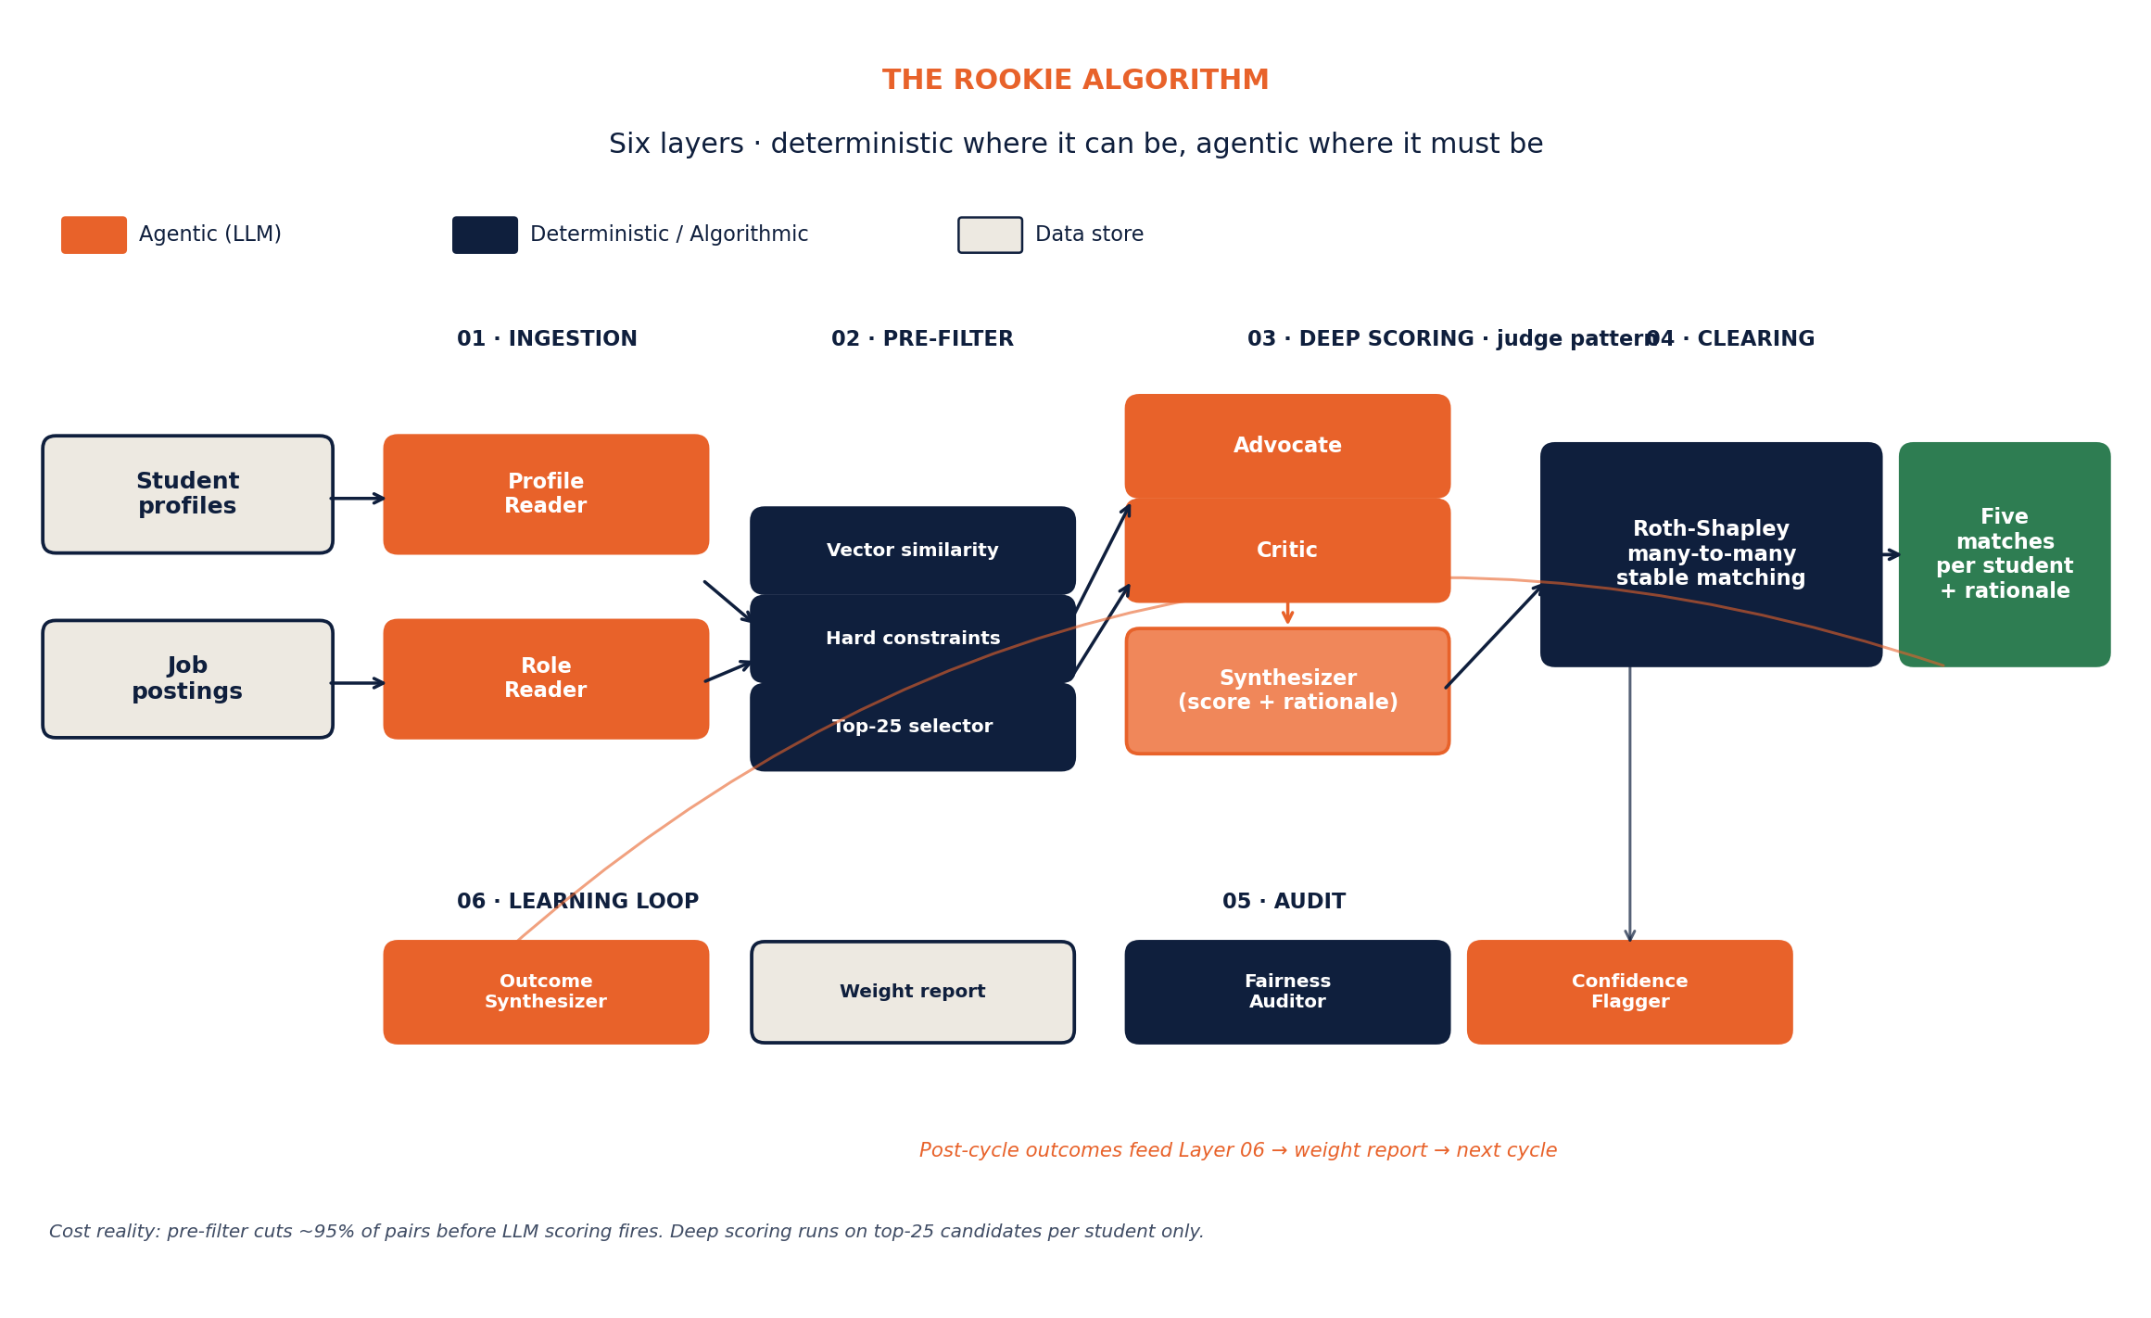
Figure 1. The six-layer Rookie Algorithm. Orange = LLM-based agents. Navy = deterministic functions or algorithms.
The pipeline runs left to right per cycle. Profiles and jobs enter from the left; matches and rationale exit on the right. The bottom-left learning loop closes after each cycle, feeding outcome data back into the scoring weights for the next cycle.
Three layers are agentic (Ingestion, Deep Scoring, Learning). Two are deterministic (Pre-filter, Fairness Auditor). One is algorithmic (Roth-Shapley clearing). The audit layer is hybrid. This split is deliberate — each agent earns its keep by doing something a deterministic function couldn't do better, faster, or cheaper.

3. Layer-by-layer breakdown
LAYER 01

Ingestion — Profile Reader + Role Reader
Two agents that turn messy unstructured input (CVs, project descriptions, free-form bios, job descriptions, company profiles) into structured signal the rest of the pipeline can compute on.

Spec
Type | Agentic · 2 specialised reader agents
Model | Claude Sonnet 4.6
Runs when | On profile or role create/update. Cached. Re-runs only on edits.
Cost/call | ~$0.04-0.08 per profile/role
Why agentic | Unstructured input requires interpretation. Specialised prompts produce sharper extraction than one-shot generic readers.

Output schema (Profile Reader)
{ "structured": { "education": [{ "institution", "degree", "field", "gpa_band", "year" }], "experiences": [{ "title", "company", "duration_months", "start", "end" }], "projects": [{ "name", "description", "stack", "outcome" }], "skills": ["python", "sql", "stakeholder_management", ...], "languages": [{ "code", "level" }], "work_auth": "EU_citizen | requires_sponsorship | residence_permit", "location": { "current", "willing_to_relocate", "remote_pref" } }, "signals": { "ownership": 78, "depth": 84, "trajectory": 71, "voice": 66 }, "evidence": { "ownership": "Built and shipped patient-adherence model end-to-end, including data pipeline and stakeholder presentation.", "depth": "Thesis statistical modelling included custom feature engineering and validation against three datasets.", "trajectory": "Internships progress from data entry to ML modelling within 14 months.", "voice": "Writes about technical work in plain language; minimal jargon." } }
The Role Reader produces a structurally identical artifact for jobs — required skills, soft-skill signals the role demands, implicit context (a 4-person team needs a generalist; a 200-person enterprise needs specialisation), comp band, location feasibility, language requirements, contract type.

Why two specialised readers, not one generalist
A single LLM doing both extraction and interpretation does each mediocrely. Splitting into a Profile Reader and a Role Reader lets each have a focused prompt with role-specific examples, role-specific evaluation criteria, and role-specific output validation. Empirically, this produces ~15-25% sharper signal scores than one-shot generic readers (verifiable via a held-out benchmark we'll need to build).

LAYER 02

Pre-filter — Vector + Hard constraints
The pipeline's efficiency layer. Cuts the universe of possible pairs (in a 400-student × 100-role cycle, that's 40,000 pairs) down to the top ~25 per student that are worth deep-scoring. This is where 80%+ of LLM cost is saved.

Spec
Type | Deterministic · vector similarity + rule-based hard constraints
Tech | Cohere or OpenAI embeddings + Postgres + pgvector
Runs when | Once per cycle at pool lock
Cost/call | <$0.001 per pair (embedding-only)
Why deterministic | Speed, cost, auditability. Reasoning here would add nothing the math can't do.

What it does
- Compute embedding of every profile (skills + projects + structured features → 1024-dim vector)
- Compute embedding of every role similarly
- For each student, rank all roles by cosine similarity
- Apply hard-constraint filters: work auth match, language requirement met, location feasibility, contract type compatibility, salary band overlap
- Take top 25 surviving pairs per student into Layer 3

Why 25 and not 5 or 100
Top-5 is too aggressive — the pre-filter doesn't see soft fit signal, so cutting too early loses good matches that the deeper layer would have recognised. Top-100 wastes LLM budget. Top-25 is the empirical sweet spot where the deeper scoring stack has enough candidates to find the real top-5 without spending money on obvious non-fits.

LAYER 03 · THE CORE DIFFERENTIATOR

Deep pair scoring — the judge pattern
This is the heart of the system and what genuinely separates the Rookie Algorithm from every recruiting platform deployed today. Three agents work together in an adversarial pattern borrowed from AI safety research.
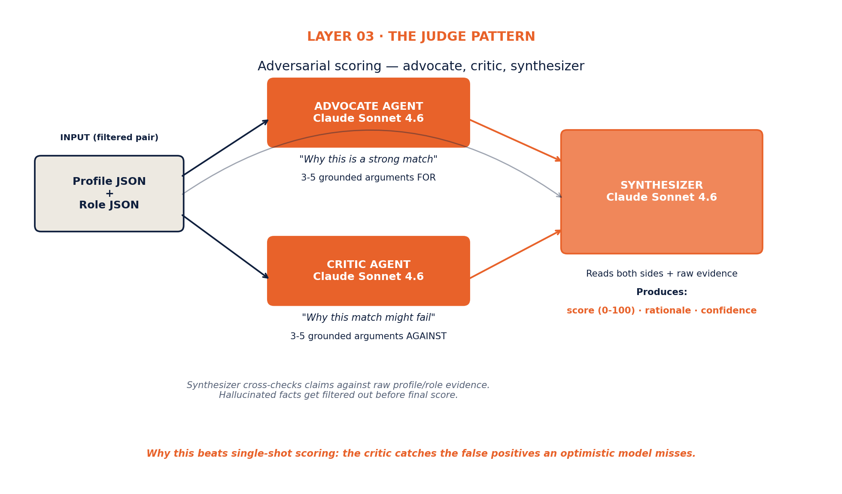
Figure 2. The judge pattern. Advocate and Critic argue independently. Synthesizer weighs both against raw evidence.

Why this works better than single-shot scoring
Every recruiting platform on the market today — LinkedIn, JobTeaser, Magnet.me, Indeed, AI-recruiting startups — uses single-shot scoring. One model, one prompt, one number. The pattern produces systematic false positives because nothing in the pipeline argues against the match. The model is optimised to find reasons to like the pair, and it finds them, even when they're thin.
Adversarial dual scoring solves this. The Advocate produces a strong case for; the Critic produces a strong case against; the Synthesizer reads both and decides. The critic catches the false positives the advocate missed. The synthesizer cross-checks claims against the raw profile and role evidence, filtering hallucinated facts. The result is a score that's calibrated, defensible, and tailored to the specific pair.

Advocate Agent — spec & prompt
Type | Agentic
Model | Claude Sonnet 4.6
Input | Profile JSON + Role JSON (both from Layer 1)
Output | 3-5 concrete arguments why this is a strong match, each grounded in specific evidence
Runs | Per filtered pair (~25 per student → ~10K pairs per 400-student cycle)

Advocate prompt skeleton
You are an Advocate evaluating a candidate-role match for an early-career hiring cycle. Your job: produce 3-5 specific, evidence-backed arguments for why this candidate is a strong fit for this role. RULES: - Every argument must reference SPECIFIC EVIDENCE from the candidate's profile or the role description. No generic claims. - If you cannot find at least 3 strong arguments grounded in evidence, say so explicitly — do not invent. - Do not claim skills, experiences, or qualities the profile doesn't show. Hallucinations are caught downstream. PROFILE: {profile_json} ROLE: {role_json} OUTPUT: { "arguments": [ { "claim": "...", "evidence": "...", "strength": 0-100 }, ... ], "overall_advocacy": 0-100 }

Critic Agent — spec & prompt
Type | Agentic
Model | Claude Sonnet 4.6
Input | Profile JSON + Role JSON
Output | 3-5 concrete concerns why this match might fail, each grounded in specific evidence
Runs | Per filtered pair, in parallel with Advocate

Critic prompt skeleton
You are a Critic evaluating a candidate-role match for an early-career hiring cycle. Your job: produce 3-5 specific, evidence-backed concerns that could make this match fail in practice. RULES: - Every concern must reference SPECIFIC EVIDENCE from the candidate's profile or the role description. No generic skepticism. - Concerns can include: skill gaps, contextual mismatches, location/ language friction, depth-of-experience mismatches, trajectory misfits, team-size/culture concerns, work-auth complications. - If the match looks genuinely strong with few concerns, say so — do not manufacture problems that aren't there. PROFILE: {profile_json} ROLE: {role_json} OUTPUT: { "concerns": [ { "claim": "...", "evidence": "...", "severity": 0-100 }, ... ], "overall_concern": 0-100 }

Synthesizer Agent — spec & prompt
Type | Agentic (the "judge")
Model | Claude Sonnet 4.6
Input | Profile JSON + Role JSON + Advocate output + Critic output
Output | Final score 0-100 + one-line rationale + confidence + flag for review
Runs | Per filtered pair, after Advocate and Critic complete

Synthesizer prompt skeleton
You are the Synthesizer. The Advocate and Critic have each made their case. Your job is to weigh both, cross-check their claims against the raw profile and role evidence, and produce a final calibrated score plus a one-sentence rationale that will be shown to the student. RULES: - Cross-check every Advocate and Critic claim against the actual profile/role JSON. Discard claims unsupported by evidence. - Score 0-100 reflects calibrated fit, not optimistic enthusiasm. - The rationale must be ONE clear sentence in the second person ("Your X makes you a strong fit for Y because Z"). - Confidence (0-1) reflects how robust the score is. Low confidence triggers human review in Layer 5. - If something feels genuinely off, set "needs_review" to true. PROFILE: {profile_json} ROLE: {role_json} ADVOCATE_OUTPUT: {advocate_json} CRITIC_OUTPUT: {critic_json} OUTPUT: { "score": 0-100, "rationale": "<one sentence, second person>", "confidence": 0.0-1.0, "needs_review": boolean, "kept_advocate_points": [<indices>], "kept_critic_points": [<indices>], "rejected_claims": [<reason for each>] }

LAYER 04

Clearing — Many-to-many Roth-Shapley
Once every pair has a synthesizer-produced score, the clearing layer runs once per cycle to produce stable allocations. This is mathematics, not reasoning, so this layer is a deterministic algorithm — no agents.

Spec
Type | Deterministic algorithm
Algorithm | Many-to-many deferred acceptance (Roth-Shapley variant)
Where | Supabase Edge Function (TypeScript)
Input | Scored pairs from Layer 3 + employer rankings (employer side ranks their top candidates)
Output | Five matches per student (ranked by computed fit)
Runs when | Once at cycle clearing time
Cost | Compute only — negligible per cycle

Note on the two-sided preference structure
Students do not submit preferences (computed from profile + Layer 3 scores). Employers do submit preferences (they rank their top candidates from the synthesizer's pre-scored shortlist). This is a deliberate asymmetry: students get the algorithmic protection of automatic preference-from-fit, employers get the agency they expect from their hiring process. The algorithm runs many-to-many because each student gets five matches and each role can match with multiple candidates.
LAYER 05

Audit — Fairness + Confidence
Two parallel safety checks that run after clearing. The Fairness Auditor is statistical (not an LLM). The Confidence Flagger is agentic.

Fairness Auditor
- Statistical analysis across protected characteristics: gender, nationality, university type, sector
- Detects systematic skew between profile-distribution and match-distribution
- Produces a per-cycle bias report
- Flags drift across cycles for human review
- Required for EU AI Act Article 13 compliance — high-risk system bias monitoring

Confidence Flagger
- Agentic — reads marginal matches (low synthesizer confidence) and produces a human-readable explanation
- Surfaces matches that should be reviewed before publishing to students/employers
- Provides the GDPR Article 22 "meaningful human review" path for contestability
LAYER 06

Learning loop — Outcome Synthesizer
After each cycle, post-match outcome data (accepted, declined, 90-day retention, satisfaction scores, salary trajectory) feeds back into the scoring weights — but never automatically. The Outcome Synthesizer produces a report; humans review and apply.

Spec
Type | Agentic
Model | Claude Sonnet 4.6
Input | Cycle outcomes (accept/decline, retention, satisfaction)
Output | Report proposing weight adjustments to Layers 1, 2, or 3
Runs when | End of each cycle (post-90-day window for retention data)
Why never auto-apply | Auto-tuning recruiting models on outcome data is how subtle biases get amplified over time.

4. Why this beats the competition
Five concrete differentiation points, each measurable on a real benchmark:

vs. LinkedIn / Indeed
They use collaborative filtering plus engagement-trained ranking models. They optimise for "what will get clicked," not "what will be a good match." Our adversarial scoring optimises for evidence-based fit, with the critic explicitly looking for the false positives engagement-trained models accept. We also produce a per-pair rationale; they produce a score with no explanation.

vs. JobTeaser
Filter-and-tag matching (per our own competitive landscape doc). Last meaningful technical reinvestment was pre-LLM. Our specialised readers extract signal they don't have access to, and the judge pattern produces calibration their architecture cannot reproduce without rebuilding.

vs. Magnet.me
Search-and-ranking-model architecture. No two-sided matching, no pool-aware clearing, no per-pair rationale. They have brand recognition; we have a fundamentally different product.

vs. generic AI-recruiting startups
Almost all use single-shot LLM scoring with vector similarity. The judge pattern (advocate + critic + synthesizer) is genuinely different — single-shot scoring has no mechanism for catching false positives, and it can't produce calibrated rationale at scale.

The combination is the moat
Each individual element here is reproducible — readers, judge pattern, Roth-Shapley, fairness audits, outcome loops. None of them are secret. What's hard is shipping all five together and tuning them on a real cycle. The competitive defence is that by the time a competitor builds the same pipeline, you'll have two cycles of outcome data to tune against and they'll have zero.

BUILD THIS NOW

5. Wave 1 — what to ship for Cycle 01
Ship the engine end-to-end, on the simplest possible version of each layer. Don't add bells and whistles. Get Cycle 01 to clear cleanly with auditable rationale, then iterate.
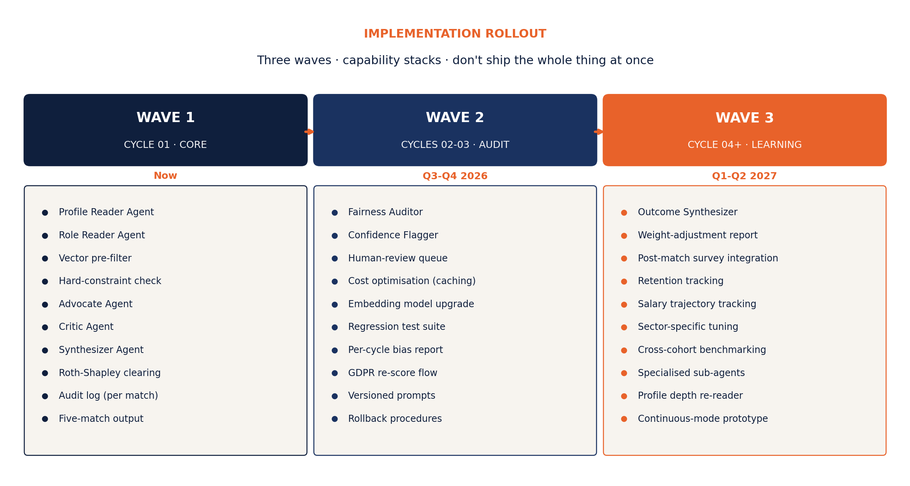
Figure 3. Three-wave rollout. Wave 1 ships the core engine; Wave 2 adds audit and cost optimisation; Wave 3 closes the learning loop.

Wave 1 deliverables — the build list
- Profile Reader Edge Function (Supabase) — Claude API call wrapped with output validation
- Role Reader Edge Function — same pattern, different prompt
- Embedding pipeline — generate vectors on profile/role create or update, store in pgvector
- Pre-filter Edge Function — runs at cycle pool lock, produces top-25 pairs per student
- Advocate Edge Function — Claude API call, structured output
- Critic Edge Function — Claude API call, structured output
- Synthesizer Edge Function — Claude API call, structured output, writes to score_artifacts table
- Clearing Edge Function — TypeScript implementation of many-to-many deferred acceptance
- Audit log table — every LLM call's prompt + output stored for Article 13 compliance
- Match table — final 5 ranked matches per student, with rationale and confidence

Database tables — proposed schema
-- existing students (id, user_id, profile_json, created_at, updated_at) employers (id, user_id, company_json, created_at, updated_at) jobs (id, employer_id, role_json, created_at, updated_at) -- new cycles (id, name, opens_at, locks_at, clears_at, reveals_at, closes_at, status) profile_features (student_id, cycle_id, structured_json, signals_json, embedding vector(1024), model_version, created_at) role_features (job_id, cycle_id, structured_json, signals_json, embedding vector(1024), model_version, created_at) cycle_pairs (cycle_id, student_id, job_id, cosine_distance, hard_constraints_pass, survived_prefilter, created_at) score_artifacts (cycle_pair_id, advocate_json, critic_json, synthesizer_json, final_score, rationale, confidence, needs_review, model_version, created_at) employer_rankings (cycle_id, employer_id, job_id, ranked_student_ids, submitted_at) matches (cycle_id, student_id, job_id, rank_for_student, rank_for_employer, final_score, rationale, status, created_at) audit_log (id, cycle_id, layer, agent, prompt, response, model, tokens, latency_ms, created_at)

Wave 1 — what to skip
Do NOT build the following for Cycle 01. They are Wave 2 work. Adding them early creates debugging hell and slows Cycle 01:
- Fairness Auditor (statistical pass — added Cycle 02)
- Confidence Flagger (human review queue — added Cycle 02)
- Outcome Synthesizer (no outcome data yet — Wave 3)
- Specialised sub-agents per skill category (Wave 3)
- Auto-tuning of weights (never auto-apply — Wave 3 manual report only)
- Multi-cycle scheduling (one cycle is hard enough)

6. Cost model
Honest projection of LLM costs per cycle for a 400-student, 100-role pool. Assumes Claude Sonnet 4.6 at June 2026 prices. Numbers will shift as models update; treat as order-of-magnitude.

Per-cycle LLM cost breakdown
Profile Reader | 400 students × $0.06 = ~$24
Role Reader | 100 roles × $0.06 = ~$6
Pre-filter | Embedding: ~$1 total. No LLM.
Advocate | 10,000 pairs × $0.12 = ~$1,200
Critic | 10,000 pairs × $0.12 = ~$1,200
Synthesizer | 10,000 pairs × $0.15 = ~$1,500
Clearing | Compute only — ~$0
Fairness Auditor (W2) | Statistical — ~$0
Confidence Flagger (W2) | ~50 marginal pairs × $0.20 = ~$10
Outcome Synthesizer (W3) | 1 report × $5 = ~$5
TOTAL Wave 1 per cycle | ~$3,930
TOTAL Wave 2 per cycle | ~$3,940
TOTAL Wave 3 per cycle | ~$3,945

Per-student LLM cost
Roughly $10 per student per cycle (Wave 1). Four cycles per year = ~$40 per student per year of LLM cost. Compare to your modelled revenue per matched student (placement fees averaging €500-€2K) — the algorithm cost is 2-8% of placement revenue, well inside healthy gross margin territory.

Cost optimisation levers
- Tighter pre-filter (top-15 instead of top-25) → cuts deep-scoring cost ~40%
- Cache profile/role features across cycles for repeat participants
- Haiku-tier for advocate + critic, Sonnet only for synthesizer → cuts ~60% of LLM cost
- Async batching with rate-limit-aware throttling for off-peak runs

7. EU AI Act and GDPR — built in, not bolted on
This architecture satisfies the relevant European regulatory regime by design rather than retroactively. Specifically:

EU AI Act Article 13 — Transparency
- Every match has a stored, human-readable rationale from the Synthesizer
- Every Synthesizer call is preceded by stored Advocate and Critic outputs
- audit_log table preserves prompt, response, model version, and token counts for every LLM call
- A regulator (or a journalist) asking "why did this person not match X?" gets a real answer per pair

EU AI Act Article 14 — Human oversight
- Confidence Flagger surfaces marginal matches before reveal
- Human review queue (Wave 2) provides explicit override capability
- Fairness Auditor (Wave 2) produces a cohort-level bias report each cycle

GDPR Article 22 — Solely automated decisions
- Students can request re-score after profile updates (auto-rerun in next cycle)
- Marginal-confidence matches are flagged for human review pre-publication
- Per-pair rationale satisfies the "meaningful information about the logic involved" requirement
- Students can contest a match via a documented escalation path (Wave 2)

GDPR Article 5 — Data minimisation
- audit_log retains only what's needed for compliance review; older entries pruned after the legal retention window
- profile_features cleared after the cycle closes unless the student opts into alumni status

8. Honest risks and mitigations

Hallucination
LLMs produce confident-sounding wrong rationales. The Advocate or Critic could invent a skill or experience the candidate doesn't have. Mitigation: the Synthesizer cross-checks every claim against the raw profile/role JSON and discards unsupported ones. Required prompt rule: every argument must reference specific evidence. Required post-processing: structured output validation rejects responses where evidence pointers don't resolve to real profile fields.

Model drift
Claude updates change scoring behaviour subtly. A match scored 78 today might score 71 after a model refresh. Mitigation: pin model versions in production. Maintain a regression-test set of 50-100 hand-annotated pairs. Run the regression suite before any model upgrade in production.

Cost escalation
Naïve implementation costs grow super-linearly with cycle size (400 students × 100 roles already needs pre-filtering). Mitigation: aggressive pre-filter tuning. Token-budget alerts in production. Per-cycle cost dashboards.

Latency
The agent stack runs 10-30 seconds per pair. A full cycle scoring run takes hours. Mitigation: async batching, run scoring during the Layer-02 "Pool locks" phase (3-day window), not at clearing time. Cycle clearing itself runs in milliseconds because it operates on pre-computed scores.

Adversarial profile gaming
Sophisticated students may try to game the readers (keyword stuffing, ChatGPT-generated bio polish). Mitigation: the Critic agent is explicitly prompted to flag suspicious patterns; cross-checking against verified credentials (university affiliation, employer references) for high-stakes signals. This is a Wave 3 concern — early cycles won't have enough volume to attract gamers.

Overengineering temptation
The biggest risk is shipping the entire architecture at once. Each added agent multiplies bugs, latency, and debugging time. Mitigation: strict Wave 1 / Wave 2 / Wave 3 discipline. Don't add the next layer until the previous wave has been validated on real cycle data.

9. Definition of done for Wave 1
Cycle 01 is ready to ship when all of the following are true:
- All ten Wave 1 components deployed and tested individually
- End-to-end dry-run completed on a synthetic cohort of 30 students + 10 roles
- Audit log captures every LLM call with prompt, response, model, tokens, latency
- Synthesizer rationale renders correctly to both student and employer match cards
- Match table populated with 5 ranked matches per student post-clearing
- Manual spot-check of 20 matches confirms rationale grounded in actual profile/role data
- Regression test set of 50 hand-annotated pairs scored within ±5 points of expected
- Total per-cycle LLM cost under €5,000 on the dry-run
- Clearing completes in under 60 seconds for the dry-run cohort
- GDPR consent flow includes "automated decision-making" disclosure in plain Dutch and English

10. What to start this week
If only one thing happens this week, make it this:
- Pin down the Profile Reader output schema (the JSON above is a draft — finalise after Tudor reviews)
- Build the Profile Reader Edge Function end-to-end on three real CVs from your network. Inspect every output by hand.
- Once it produces consistent structured + signal output, the rest of the architecture is mechanical to build because every layer downstream depends on this schema being stable.
Don't start with the Synthesizer or the clearing algorithm. Build readers first, validate output quality, then go down the pipeline. The whole architecture is upstream-dependent — sloppy ingestion contaminates every layer below it.

