ROOKIES · INTERNAL PLANNING
Feature Roadmap — Hybrid Matchmaking Model
Persistent surface + periodic match clearing. Capability-based phasing.
v0.1 · 26 May 2026 · Internal

Context
This document captures the feature scope for the version of Rookies that pivots from "ranked job board with AI rationale" to a hybrid product: a persistent platform layer that runs continuously, with periodic matchmaking cycles layered on top. The cycle layer is what operationalises the Roth-Shapley mechanism design the pitch memo describes. The persistent layer is what gives SMEs and students reasons to use Rookies between cycles, and what keeps the product usable without a confirmed university partner.
Phasing below is capability-based, not partner-conditional. The MVP can ship as an open-market launch; cycle infrastructure goes live as soon as supply on both sides is credible, whether that supply comes from a university partner or organic acquisition. The hardest decision in this plan is when to run the first cycle — too early and it looks dead, too late and the IP narrative stays hypothetical.

Architecture overview
Two layers, one product. The persistent layer is always on — profiles, jobs, directories, recruiter tooling, analytics. The cycle layer activates periodically: registration window, preference submission, Gale-Shapley clearing, results reveal, accept/decline. The persistent layer feeds the cycle (the pool of registered students and roles); the cycle writes back into the persistent layer (match outcomes, alumni state, longitudinal data for analytics).
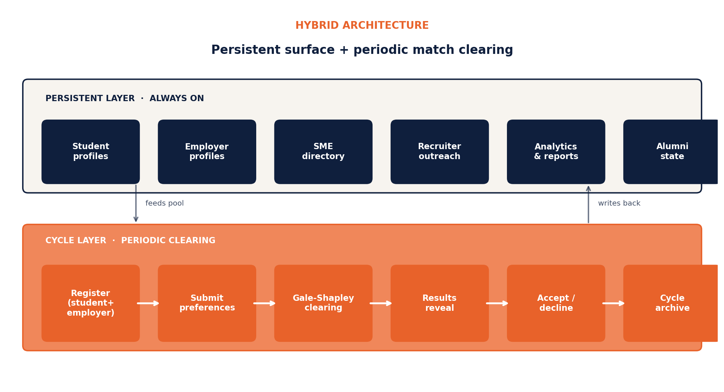
Figure 1. Hybrid architecture. Persistent and cycle layers share data continuously.

PHASE 0 / 1

MVP — Foundation
Goal of this phase: ship the smallest product that lets us run one credible matchmaking cycle end-to-end, with audit-grade explainability from day one. No payments, no multi-cycle scheduling, no recruiter outreach product yet. Build the engine, prove the mechanism, generate the first cohort artefacts.

Feature set
Identity & roles | • Three role types: student, employer recruiter, career officer  • Supabase Auth, role on profile row  • Email-domain verification for university association  • KvK lookup for employers (NL)
Student profile | • Structured CV: education, experiences, projects, skills, languages  • CV upload with LLM parsing fallback  • Work authorization + location + mobility preferences  • Soft-skill self-assessment (anti-gaming guardrails)  • Profile completeness score that gates cycle entry
Employer + jobs | • Company profile (brand, sector, size, culture tags)  • Recruiter seats per company  • Job CRUD with structured fields (role type, skills, language, work auth, location, comp band)
Matching engine | • Layer 1: quantitative scoring (linear optimisation over structured features)  • Layer 2: Claude Sonnet 4.6 rationale layer per pair  • Layer 3: Gale-Shapley runner with two-sided preferences  • Per-match rationale stored permanently for audit
Cycle infrastructure | • Single cycle, hand-scheduled (no automation yet)  • State machine: scheduled → open → preferences → clearing → published → closed  • Cap configuration (max students, max roles, max apps per role)  • Eligibility check before cycle entry  • Preference submission UI for both sides
Results experience | • Embargoed clearing → coordinated reveal at release time  • Match page with rationale rendered to both sides  • Accept / decline workflow with deadline  • Unmatched-role recovery (released back to pool)
Compliance | • GDPR consent flows, data export, deletion  • EU AI Act Article 13: per-match rationale, audit log, model card  • Demographic outcome monitoring (drift detection)  • Terms of service versioning per cycle
Career Officer Console v1 | • Cohort registration tracking (who's in / not in)  • Push reminders to register  • Basic outcome dashboard (post-cycle)
Comms | • Transactional email: cycle open, preferences reminder, results, accept/decline  • In-app notifications

PHASE 2

Cycle activation
Goal of this phase: turn the working cycle into a repeatable product. Multi-cycle scheduling, between-cycle utility, recruiter tooling, payment rails, and the analytics depth career offices will actually pay for. This is where Rookies stops being a working prototype and starts being a business.

Feature set
Multi-cycle scheduling | • Cycle calendar with overlapping windows allowed  • Sector-specific or track-specific sub-cycles  • Cohort-aligned cadence (semester anchored)  • Cycle templating + automation
Commitment mechanism | • Refundable deposits at cycle entry (€10 student / €100–500 employer)  • Stripe-held escrow with automated refund on participation  • No-show forfeit logic
Recruiter outreach product | • Pre-scored shortlist view with rationale  • One-click messaging with rationale-aware templates  • Pipeline view: matched → interview → offer → accepted  • Response tracking, notes, tagging  • Calendar/scheduling link integration
Between-cycle surface | • SME and startup directory (always browseable)  • Save / follow companies  • Compatibility hints between cycles (preview-grade scoring)  • Career prep content & resources
Featured content | • Sponsored employer profiles (paid, never inside match results)  • Sector spotlights  • Video features & employee testimonials
Career Officer Console v2 | • Longitudinal multi-year cohort view  • Skills-gap report (employer demand vs cohort supply)  • Cycle ops view: liquidity monitoring, registration pace  • Faculty / board-ready PDF exports
Monetisation rails | • Stripe integration  • Tiered SaaS for employers (Free / SME / Mid / Enterprise)  • Per-seat recruiter licensing  • University license invoicing  • Sponsorship slot management
Match guarantee | • Re-match credit logic for paid employers when a match doesn't convert  • Adjacent placement-fee tracking (opt-in for SMEs)
Cohort identity | • Match badges ("Matched: Spring 2026")  • Shareable match cards  • Cohort-wide stats page per cycle

PHASE 3

Scale & moat
Goal of this phase: turn the system into infrastructure. Multi-university orchestration, alumni community, data products, and the kind of integrations that lock Rookies into the early-career hiring stack across Europe. This is also where the community moat described in section 6.4 of the pitch memo finally has data to compound on.

Feature set
Multi-university orchestration | • Cross-institution cycle calendar  • Per-university branding & co-marketed events  • Cross-cohort analytics & benchmarking (anonymised)  • Localisation per market (NL → EU)
Integrations | • ATS connectors: Greenhouse, Personio, Workable  • Calendar integrations (Google, Outlook)  • SSO for university accounts  • Webhook framework for employers
Sponsored cycles | • Title sponsorship of named cycles  • Sector cycles co-branded with industry partners  • Sponsor positioning never inside match results
Alumni & community | • Alumni profile state post-graduation  • 30 / 60 / 90-day post-match check-ins  • Cohort spaces (per university, per cycle)  • Referral system  • Alumni-only employer tier
Data products | • Anonymised longitudinal dataset  • Sector & regional labour-market reports  • Government / CBS data partnerships  • Skills-gap intelligence as a paid product
API / engine licensing | • Matching engine as B2B API  • Bootcamp / alt-credential partner programme  • Cross-EU pilot infrastructure
Advanced compliance | • Per-cycle bias auditing dashboards  • Automated AI Act conformity reporting  • Granular per-region data residency

Roadmap summary
Each phase stacks on the previous. The persistent layer keeps growing in capability; the cycle layer becomes increasingly automated and instrumented. The phase boundaries are capability checkpoints, not calendar dates — Phase 2 begins when MVP has run at least one cycle end-to-end and produced a clean cohort outcome dataset; Phase 3 begins when the system has supported at least two universities in parallel.
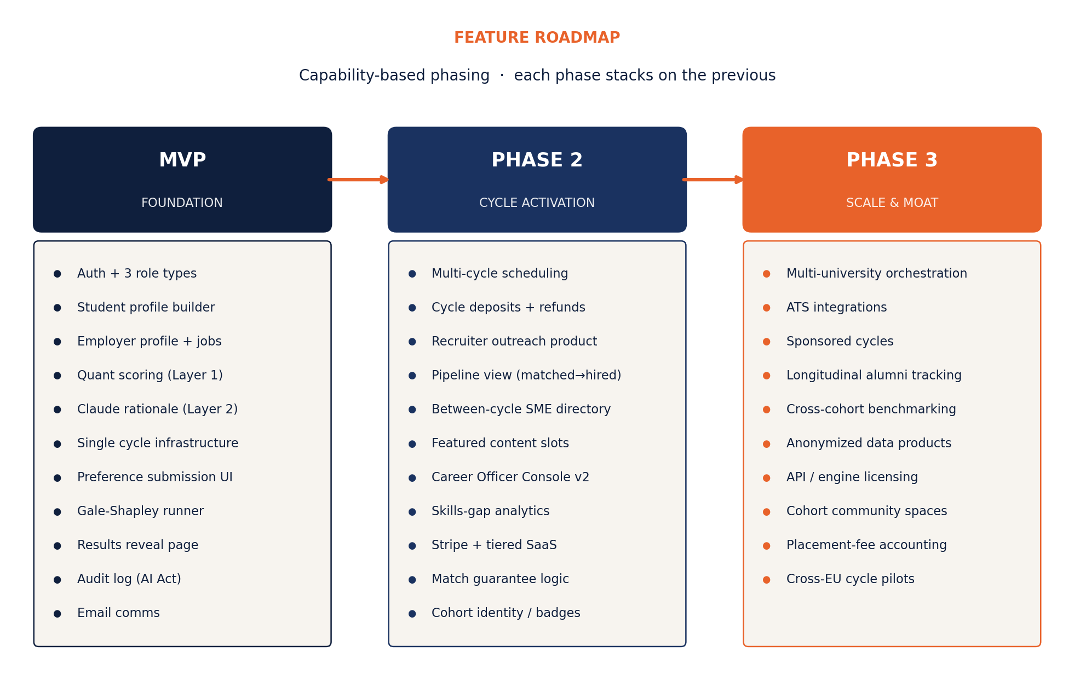
Figure 2. Feature stack by phase. Each column builds on the previous.

Cycle lifecycle
Every cycle moves through the same six states. The transitions are the hooks where compliance, comms, and analytics fire. Timing labels below assume a four-to-five-week cycle; faster or slower cadences scale proportionally.
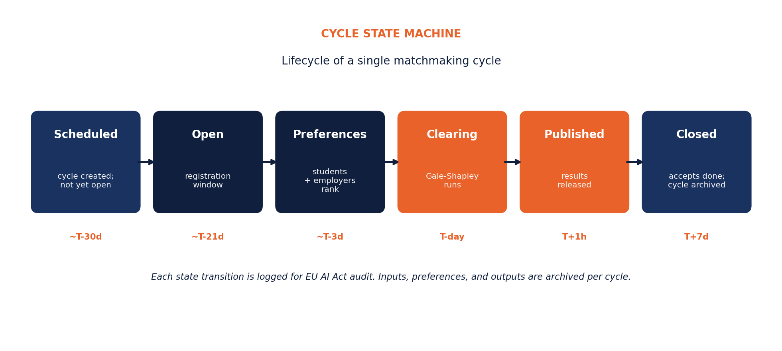
Figure 3. State machine for a single cycle. Each transition produces an audit record.

Dependencies & risks

What MVP depends on
- LLM scoring engine (score-match Edge Function) producing stable, defensible per-pair rationale. This is already in active build and is the technical critical path for MVP.
- Enough supply on both sides to run a credible first cycle. Without a university partner, this means organic acquisition or sector-specific seeding. A first cycle of 50 students and 15 employers is a defensible minimum; below that the optics suffer.
- Audit log + per-match rationale storage being built from day one, not retrofitted. EU AI Act compliance is non-negotiable and twice as expensive to add later.

Where the engineering hours actually go
- The Gale-Shapley runner is one weekend. The audit, dispute, and explainability infrastructure around it is months.
- The cycle state machine multiplies edge cases fast: missed preference deadlines, cancelled cycles, declined matches, mid-cycle slot changes, no-shows.
- The preference submission UI is harder than it looks — it has to give students enough signal to rank with confidence without revealing absolute scores.
- Career Officer Console deepening from "exists" to "a Dean will pay €100K for it" is its own multi-month track.

Risks worth naming
- First-cycle liquidity. The biggest single risk to the hybrid model is a thin first cycle. Mitigation: pre-commit a minimum threshold below which the cycle is delayed rather than run, and seed both sides actively before launch.
- Mechanism integrity. The product story collapses if Rookies ever sells ranking inside the match. Every monetisation lever in Phase 2 must respect the firewall between revenue and rank.
- University dependency. Without a confirmed institutional partner, the early revenue picture loses its largest single contract. Build the product to work without one; treat any partner that does land as upside, not foundation.
- Compliance scope creep. AI Act and GDPR demands will keep growing. Treat compliance infrastructure as core product, not overhead — it is the moat that LinkedIn and Magnet.me cannot easily replicate at NL scale.

Build sequencing — recommended
- Months 1–2: identity, profiles, jobs, scoring engine integration.
- Months 2–3: cycle state machine, preference UI, Gale-Shapley runner, audit log.
- Months 3–4: results experience, accept/decline, Career Officer Console v1, comms.
- Month 4: dry-run cycle with synthetic or seed users, validate end-to-end.
- Month 5+: first real cycle, then begin Phase 2 work informed by what actually happened.

