# TITLE

#### NAME

#### April 15, 2016

# Description

This set of scripts help convert the output of Rmd files to docx files. It is done by creating a clean html file, then opening, converting, and saving the html to docx using [Applescript and Microsoft Word](https://www.dropbox.com/s/4bwwsgod27w1fjo/word-2004-applescript-reference.pdf?dl=0).

The workhorse script is a makefile. Just change the variables to convert any Rmd to docx. However, only clean (not standalone) html files will fully convert. There are some caveats (outlined below) if you want to keep a standalone html file.

In this repo, the makefile converts example.Rmd to example.docx.

## The output files

* example.html
* example.docx

## The main support file

* html2docx.sh

The makefile automatically downloads the html2docx.sh conversion script using wget if it’s missing. (Requires unix command-line tool wget to download if missing.)

## Optional support files

* chicago-author-date.csl
* bibliography.bib

These files are listed to show that folks can cite references (useful for academics). To learn more about these RMarkdown yaml options, see this [RStudio post](http://rmarkdown.rstudio.com/authoring_bibliographies_and_citations.html).

# Requirements

1. Microsoft Word for Mac in your Applications folder. This has been built and testing using Microsoft Word for Mac, Version 15.20.
2. R with packages rmarkdown and knitr.
3. An understanding of how to use GNU Make and terminal commands.

# How to Use

There are two options for going from Rmd to docx. The first make option is all and the second is alt. But before anything, make sure the makefile variables are set up accordingly. Simply change the RMD_NAME variable to suite your needs:

RMD_NAME = example.Rmd

In this case, the Rmd file of interest is example.Rmd.

## Option 1: all

Simply run

make all

Although one can knit an html file from a Rmd file—letting knitr run the pandoc step—there is a caveat.

output options self_contained **must** be FALSE. Otherwise, Microsoft Word will crash during the html to docx conversion. Keep in mind that this is the default option for rmarkdown. But I force it to be true in the makefile.

## Option 2: alt

You cannot convert a self contained (aka standalone) html file to a docx. (At least I’ve found that it always crashes.) If you want the option to have a standalone html file, then then we use option alt.

Simply run

make alt

This will produce a clean (not self contained) html, create a docx file, then replace the clean html file with a standalone file.

It’s a little hackish, but it allows you to create a docx AND keep a standalone html file.

# First Run, Word will ask for permission

When you first run the script, do not worry if Word asks for permissions. Once you give Word access to the folder and files, it should run just fine and without asking again every time after.

# Shortcomings

## Footnotes

Footnotes, not matter what, go to the bottom of the page. Just how html files work.

# Thanks

A special thanks to [Andrew Heiss](http://github.com/andrewheiss), from whom I’ve learned almost all I know about makefiles and converting markdown files to docx files.

Here is some random stuff just to show you that the conversion script works.

# A random citation

Tidy data is important. See (Wickham 2014).

# Some Plots and Tables

I stole these from Yihui Xie.

Figures and tables with captions will be placed in figure and table environments, respectively.

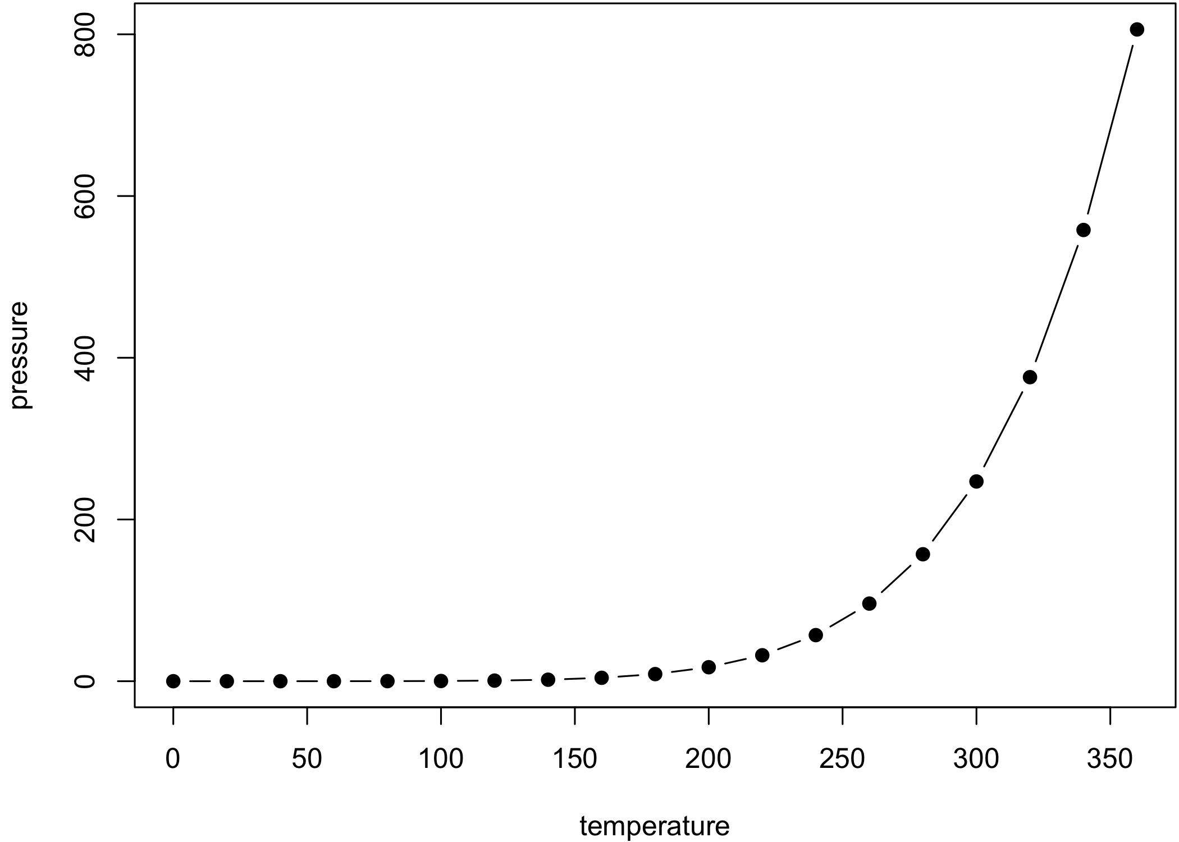

Here is a nice figure!

| Here is a nice table! | | | | |
| --- | --- | --- | --- | --- |
| **Sepal.Length** | **Sepal.Width** | **Petal.Length** | **Petal.Width** | **Species** |
| 5.1 | 3.5 | 1.4 | 0.2 | setosa |
| 4.9 | 3.0 | 1.4 | 0.2 | setosa |
| 4.7 | 3.2 | 1.3 | 0.2 | setosa |
| 4.6 | 3.1 | 1.5 | 0.2 | setosa |
| 5.0 | 3.6 | 1.4 | 0.2 | setosa |
| 5.4 | 3.9 | 1.7 | 0.4 | setosa |
| 4.6 | 3.4 | 1.4 | 0.3 | setosa |
| 5.0 | 3.4 | 1.5 | 0.2 | setosa |
| 4.4 | 2.9 | 1.4 | 0.2 | setosa |
| 4.9 | 3.1 | 1.5 | 0.1 | setosa |
| 5.4 | 3.7 | 1.5 | 0.2 | setosa |
| 4.8 | 3.4 | 1.6 | 0.2 | setosa |
| 4.8 | 3.0 | 1.4 | 0.1 | setosa |
| 4.3 | 3.0 | 1.1 | 0.1 | setosa |
| 5.8 | 4.0 | 1.2 | 0.2 | setosa |
| 5.7 | 4.4 | 1.5 | 0.4 | setosa |
| 5.4 | 3.9 | 1.3 | 0.4 | setosa |
| 5.1 | 3.5 | 1.4 | 0.3 | setosa |
| 5.7 | 3.8 | 1.7 | 0.3 | setosa |
| 5.1 | 3.8 | 1.5 | 0.3 | setosa |

# References

Wickham, Hadley. 2014. “Tidy Data.” Journal of Statistical Software 59 (1): 1–23. doi:[10.18637/jss.v059.i10](https://doi.org/10.18637/jss.v059.i10).