# Daniel Robertson 54940486

## Question 1

### 1.1

Project portfolio management provides a the full spectrum of all the projects that an organization is considering or plans to execute. It then prioritizes it based on resource capacity and allocation, and decides which projects are to be implemented and which are to be scraped.

Functions of project portfolio management are as follows:

* Identify the projects that are considered worth implementing
* Assessing the potential risk of a project
* How to allocate limited resources in the form of staff and finances to the project
* Understanding and being aware of interdependencies between projects, especially in instances of where multiple projects need to be complete

Three keys aspects

1. Project portfolio definition
   * Organization need to record in a single repository all of the details of current projects
   * Decisions are required to about weather all projects types are going to be included
   * NPD(new product development) projects are often more frequent, where as renewal projects are riskier as they are less frequent and therefore less experience
   * When both projects use the same resource pool, including the resources, the argument for common portfolio is strengthened
2. Project portfolio management
   * Once a portfolio is a established, costing breakdown can be recorded
   * The expected value of the project can also be recorded based on manager discretion
   * Actual performance can be tracked based on performance indicators
   * This information can be used in the future for better screening of new projects
3. Project portfolio optimization
   * High-level managers can track performance of the portfolio on regular basis
   * By doing this a better balance of portfolio can be achieved
   * The portfolio needs to be carefully though-out as to balance high risk very profitable projects vs more moderate lower risk

## Question 2

### 2.1

Project 1 net profit = -110 000+10 000+5 000+20 000+15 000+16 000+55 000=R**11 000.00**

Project 2 net profit=-450 000+50 000+50 000+100 000+120 000+10 000+135 000=R**15 000.00**

Project 3 net profit=-300 000+22 000+30 000+4 000+14 000+130 000+122 000=R**22 000.00**

### 2.2

Project 3, project 3 has the highest net profit

### 2.3

ROI=(Average annual profit)/total Investment x 100

Project 1 ROI=((11 000/6)/110 000) x 100 = 0.016666667 x 100=**1.666666667%**

Project 2 ROI=((15 000/6)/450 000) x 100=0.005555556 x 100=**0.555555556%**

Project 3 ROI=((22 000/6)/300 000) x 100=0.012222222 x 100=**1.222222222%**

### 2.4

Project 1 has the highest ROI

### 2.5

On the 6th year 44 000 of the 55 000 is required to break even, hence the payback period is the 5th year and 0.8 of the 6h year

Project 1 payback period = 5 + (44 000/55 000)=**5.8 years**

On the 6th year 120 000 of the 135 000 is required to break even, hence the payback period is the 5th year and 0.88888 of the 6h year

Project 2 payback period= 5 + (120 000/135 000)=**5.88888 years**

On the 6th year 100 000 of the 122 000 is required to break even, hence the payback period is the 5th year and 0.8196 of the 6th year

Project 3 payback period= 5+ (100 000/122 000)=**5.8196 years**

### 2.6

Net present value= value in year t/(1+r)^t

Project 1

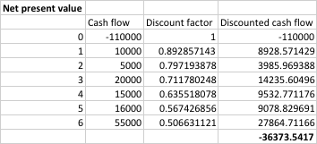

Project 1 Net present value **= R-36 373.54**

Project 2

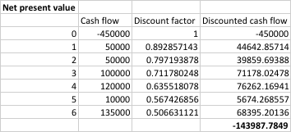

Project 2 net present value = **R-143987.78**

Project 3

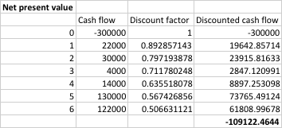

Project 3 net present value = **R-109122.46**