PERANCANGAN BASIS DATA
RELASIONAL MENGGUNAKAN ORACLE SQL DEVELOPER DATA MODELER DAN IMPLEMENTASI
DDL PADA POSTGRESQL
Laporan ini disusun untuk memenuhi tugas UTS mata kuliah Sistem Basis Data yang diampu oleh Bapak Rizal Broer Bahaweres, M.Kom.



Disusun Oleh:
Danuardi Saputro | 1251420128

PROGRAM STUDI TEKNIK INFORMATIKA
FAKULTAS SAINS DAN TEKNOLOGI
UIN SYARIF HIDAYATULLAH JAKARTA
2026
Nama : Danuardi Saputro
NIM : 1251420128
Kelas : 3D
Mata Kuliah : Sistem Basis Data
Dosen : Pak Rizal Broer, M.Kom
GitHub Repo : https://github.com/dnnuuyzzo/UTS_SBD_Danuardi-Saputro_3D
- SOAL 3.21: U.S. HOUSE OF REPRESENTATIVES VOTING DATABASE
  - Deskripsi Singkat
Mencatat informasi voting anggota DPR AS selama sesi kongres 2 tahunan:
- STATE: Nama negara bagian unik dan region (Northeast, Midwest, dll.).
- CONGRESS_PERSON: Anggota kongres, distrik, start date, dan partai politik.
- BILL: RUU yang diajukan, tanggal voting, status lulus (Yes/No).
- SPONSORS: Relasi M:N anggota kongres yang mensponsori RUU.
- VOTE: Relasi voting mencatat pilihan suara (Yes, No, Abstain, Absent).
  - Skrip DDL
- DROP TABLE IF EXISTS vote CASCADE;
- DROP TABLE IF EXISTS bill_sponsor CASCADE;
- DROP TABLE IF EXISTS bill CASCADE;
- DROP TABLE IF EXISTS congress_person CASCADE;
- DROP TABLE IF EXISTS state CASCADE;

- CREATE TABLE state (
- state_name VARCHAR(50) PRIMARY KEY,
- region VARCHAR(20) NOT NULL,
- CONSTRAINT chk_state_region CHECK (region IN ('Northeast', 'Midwest', 'Southeast', 'Southwest', 'West'))
- );

- CREATE TABLE congress_person (
- congress_person_id SERIAL PRIMARY KEY,
- name VARCHAR(100) NOT NULL,
- state_name VARCHAR(50) NOT NULL,
- district INT NOT NULL,
- start_date DATE NOT NULL,
- party VARCHAR(20) NOT NULL,
- CONSTRAINT fk_cp_state FOREIGN KEY (state_name) REFERENCES state (state_name) ON UPDATE CASCADE ON DELETE RESTRICT,
- CONSTRAINT chk_cp_party CHECK (party IN ('Republican', 'Democrat', 'Independent', 'Other'))
- );

- CREATE TABLE bill (
- bill_id SERIAL PRIMARY KEY,
- bill_name VARCHAR(150) NOT NULL UNIQUE,
- date_of_vote DATE NOT NULL,
- passed_or_failed VARCHAR(5) NOT NULL,
- CONSTRAINT chk_bill_passed CHECK (passed_or_failed IN ('Yes', 'No'))
- );

- CREATE TABLE bill_sponsor (
- bill_id INT NOT NULL,
- congress_person_id INT NOT NULL,
- PRIMARY KEY (bill_id, congress_person_id),
- CONSTRAINT fk_bs_bill FOREIGN KEY (bill_id) REFERENCES bill (bill_id) ON DELETE CASCADE,
- CONSTRAINT fk_bs_cp FOREIGN KEY (congress_person_id) REFERENCES congress_person (congress_person_id) ON DELETE CASCADE
- );

- CREATE TABLE vote (
- congress_person_id INT NOT NULL,
- bill_id INT NOT NULL,
- vote_cast VARCHAR(10) NOT NULL,
- PRIMARY KEY (congress_person_id, bill_id),
- CONSTRAINT fk_vote_cp FOREIGN KEY (congress_person_id) REFERENCES congress_person (congress_person_id) ON DELETE CASCADE,
- CONSTRAINT fk_vote_bill FOREIGN KEY (bill_id) REFERENCES bill (bill_id) ON DELETE CASCADE,
- CONSTRAINT chk_vote_cast CHECK (vote_cast IN ('Yes', 'No', 'Abstain', 'Absent'))
- );

- INSERT INTO state (state_name, region) VALUES
- ('California', 'West'),
- ('Texas', 'Southwest'),
- ('New York', 'Northeast');

- INSERT INTO congress_person (name, state_name, district, start_date, party) VALUES
- ('Nancy Pelosi', 'California', 11, '1987-06-02', 'Democrat'),
- ('Kevin McCarthy', 'California', 20, '2007-01-03', 'Republican'),
- ('Ted Cruz', 'Texas', 1, '2013-01-03', 'Republican');

- INSERT INTO bill (bill_name, date_of_vote, passed_or_failed) VALUES
- ('Infrastructure Investment and Jobs Act', '2021-11-05', 'Yes'),
- ('Clean Energy Development Bill', '2022-03-15', 'No');

- INSERT INTO bill_sponsor (bill_id, congress_person_id) VALUES
- (1, 1),
- (2, 1);

- INSERT INTO vote (congress_person_id, bill_id, vote_cast) VALUES
- (1, 1, 'Yes'),
- (2, 1, 'No'),
- (3, 1, 'No'),
- (1, 2, 'Yes'),
- (2, 2, 'No'),
- (3, 2, 'Abstain');
- Dokumentasi
- Logical Model:
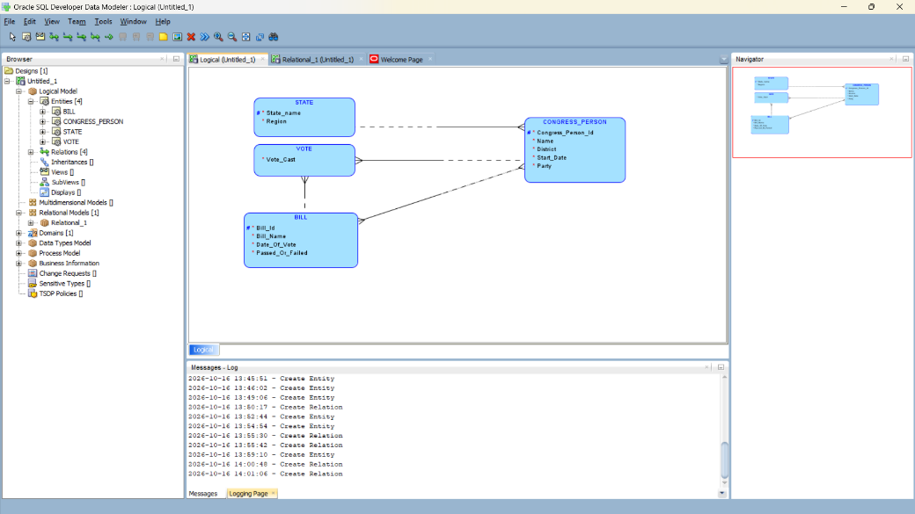
- Relational Physical Model:
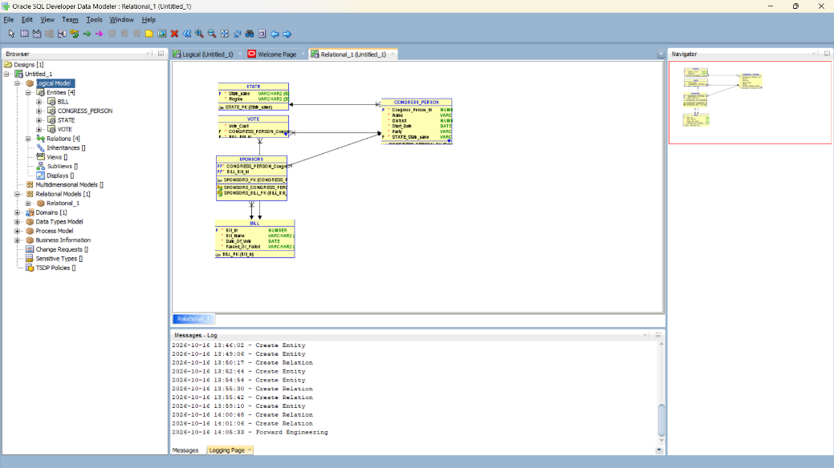
- Generate DDL:
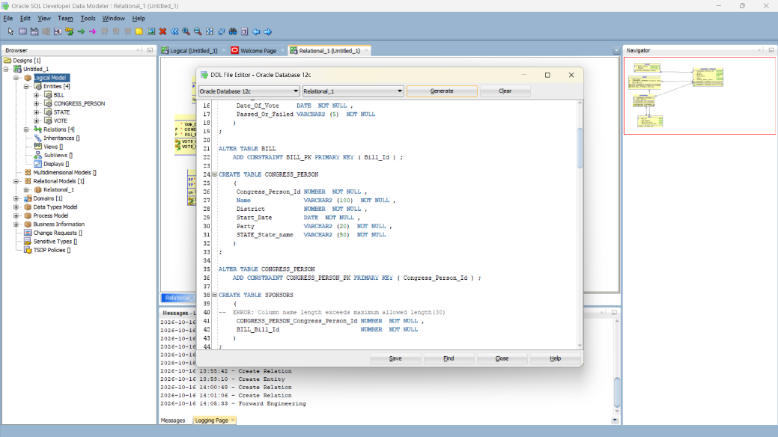
- Hasil Eksekusi di SQL:
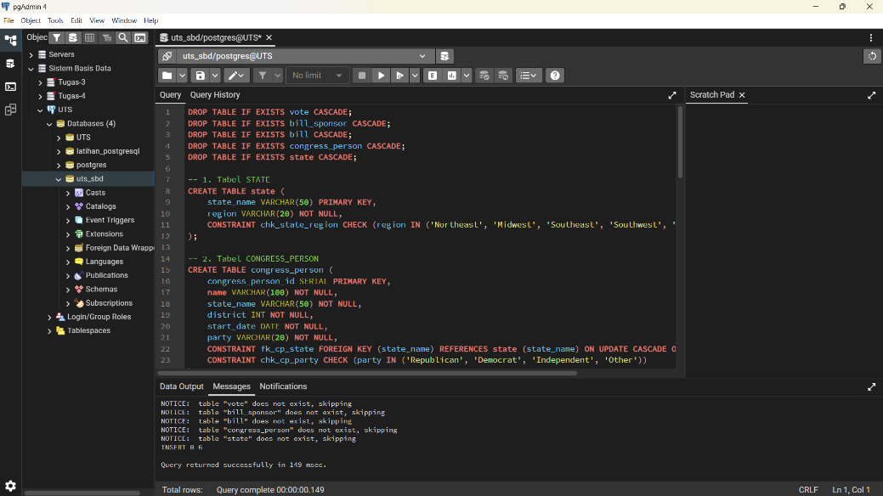

- SOAL 3.34: CONFERENCE REVIEW DATABASE
  - Deskripsi Singkat
Sistem peninjauan karya ilmiah pada konferensi:
- AUTHOR: Penulis paper dengan email unik. Satu author sebagai Contact Author.
- PAPER: Judul, abstrak, file name, dan contact author.
- WRITES (PAPER_AUTHOR): Relasi M:N antara paper dan penulis.
- REVIEWER: Data peninjau dan tabel REVIEWER_TOPIC untuk topik minat.
- REVIEW_ASSIGNMENT: Penugasan reviewer pada paper dengan 4 nilai skala 1-10 (technical merit, readability, originality, relevance), rekomendasi akhir, serta komentar untuk panitia dan feedback untuk penulis.
  - Skrip DDL
- DROP TABLE IF EXISTS review_assignment CASCADE;
- DROP TABLE IF EXISTS reviewer_topic CASCADE;
- DROP TABLE IF EXISTS reviewer CASCADE;
- DROP TABLE IF EXISTS paper_author CASCADE;
- DROP TABLE IF EXISTS paper CASCADE;
- DROP TABLE IF EXISTS author CASCADE;

- CREATE TABLE author (
- author_email VARCHAR(100) PRIMARY KEY,
- first_name VARCHAR(50) NOT NULL,
- last_name VARCHAR(50) NOT NULL
- );

- CREATE TABLE paper (
- paper_id SERIAL PRIMARY KEY,
- title VARCHAR(255) NOT NULL,
- abstract TEXT NOT NULL,
- file_name VARCHAR(255) NOT NULL,
- contact_author_email VARCHAR(100) NOT NULL,
- CONSTRAINT fk_paper_contact_author FOREIGN KEY (contact_author_email)
- REFERENCES author (author_email) ON UPDATE CASCADE ON DELETE RESTRICT
- );

- CREATE TABLE paper_author (
- paper_id INT NOT NULL,
- author_email VARCHAR(100) NOT NULL,
- author_order INT NOT NULL DEFAULT 1,
- PRIMARY KEY (paper_id, author_email),
- CONSTRAINT fk_pa_paper FOREIGN KEY (paper_id) REFERENCES paper (paper_id) ON DELETE CASCADE,
- CONSTRAINT fk_pa_author FOREIGN KEY (author_email) REFERENCES author (author_email) ON DELETE CASCADE
- );

- CREATE TABLE reviewer (
- reviewer_email VARCHAR(100) PRIMARY KEY,
- first_name VARCHAR(50) NOT NULL,
- last_name VARCHAR(50) NOT NULL,
- phone_number VARCHAR(30),
- affiliation VARCHAR(100)
- );

- CREATE TABLE reviewer_topic (
- reviewer_email VARCHAR(100) NOT NULL,
- topic VARCHAR(100) NOT NULL,
- PRIMARY KEY (reviewer_email, topic),
- CONSTRAINT fk_rt_reviewer FOREIGN KEY (reviewer_email) REFERENCES reviewer (reviewer_email) ON DELETE CASCADE
- );

- CREATE TABLE review_assignment (
- paper_id INT NOT NULL,
- reviewer_email VARCHAR(100) NOT NULL,
- technical_merit INT NOT NULL,
- readability INT NOT NULL,
- originality INT NOT NULL,
- relevance INT NOT NULL,
- overall_recommendation VARCHAR(30) NOT NULL,
- committee_comments TEXT,
- author_feedback TEXT,
- PRIMARY KEY (paper_id, reviewer_email),
- CONSTRAINT fk_ra_paper FOREIGN KEY (paper_id) REFERENCES paper (paper_id) ON DELETE CASCADE,
- CONSTRAINT fk_ra_reviewer FOREIGN KEY (reviewer_email) REFERENCES reviewer (reviewer_email) ON DELETE CASCADE,
- CONSTRAINT chk_tech_merit CHECK (technical_merit BETWEEN 1 AND 10),
- CONSTRAINT chk_readability CHECK (readability BETWEEN 1 AND 10),
- CONSTRAINT chk_originality CHECK (originality BETWEEN 1 AND 10),
- CONSTRAINT chk_relevance CHECK (relevance BETWEEN 1 AND 10),
- CONSTRAINT chk_recommendation CHECK (overall_recommendation IN ('Strong Accept', 'Accept', 'Weak Accept', 'Borderline', 'Weak Reject', 'Reject', 'Strong Reject'))
- );

- INSERT INTO author (author_email, first_name, last_name) VALUES
- ('alice@acm.org', 'Alice', 'Smith'),
- ('bob@ieee.org', 'Bob', 'Jones'),
- ('charlie@mit.edu', 'Charlie', 'Brown');

- INSERT INTO paper (title, abstract, file_name, contact_author_email) VALUES
- ('Optimizing Query Plans in Distributed DB', 'This paper explores query optimization...', 'paper1_opt.pdf', 'alice@acm.org'),
- ('Deep Learning for Database Tuning', 'Automated indexing using RL...', 'paper2_tune.pdf', 'charlie@mit.edu');

- INSERT INTO paper_author (paper_id, author_email, author_order) VALUES
- (1, 'alice@acm.org', 1),
- (1, 'bob@ieee.org', 2),
- (2, 'charlie@mit.edu', 1);

- INSERT INTO reviewer (reviewer_email, first_name, last_name, phone_number, affiliation) VALUES
- ('rev1@stanford.edu', 'David', 'Clark', '+1-555-0101', 'Stanford University'),
- ('rev2@oxford.ac.uk', 'Elena', 'Rostova', '+44-20-7946-0958', 'Oxford University'),
- ('rev3@ntu.edu.sg', 'Feng', 'Wei', '+65-6790-5152', 'NTU Singapore');

- INSERT INTO reviewer_topic (reviewer_email, topic) VALUES
- ('rev1@stanford.edu', 'Query Optimization'),
- ('rev1@stanford.edu', 'Relational Databases'),
- ('rev2@oxford.ac.uk', 'Machine Learning'),
- ('rev3@ntu.edu.sg', 'Distributed Systems');

- INSERT INTO review_assignment (paper_id, reviewer_email, technical_merit, readability, originality, relevance, overall_recommendation, committee_comments, author_feedback) VALUES
- (1, 'rev1@stanford.edu', 8, 9, 8, 9, 'Accept', 'Solid paper, good contribution.', 'Well-written paper with strong empirical validation.'),
- (1, 'rev3@ntu.edu.sg', 7, 8, 7, 8, 'Accept', 'Interesting results for distributed scale.', 'Please expand the benchmark section.'),
- (2, 'rev2@oxford.ac.uk', 9, 9, 9, 10, 'Strong Accept', 'Very novel approach to index tuning.', 'Excellent novelty and presentation.');

- TABLE IF EXISTS review_assignment CASCADE;
- DROP TABLE IF EXISTS review_assignment CASCADE;
- Dokumentasi
- Logical Model:
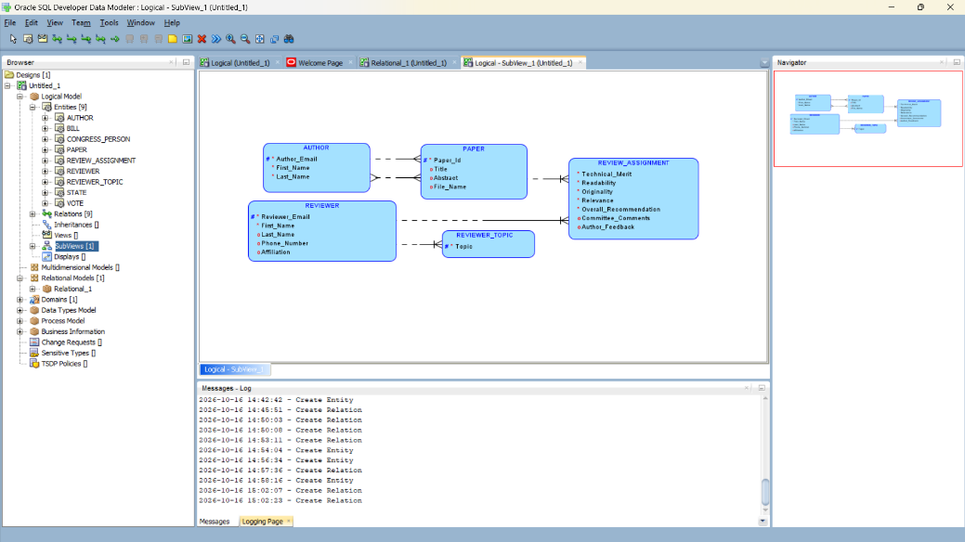
- Relational Physical Model:
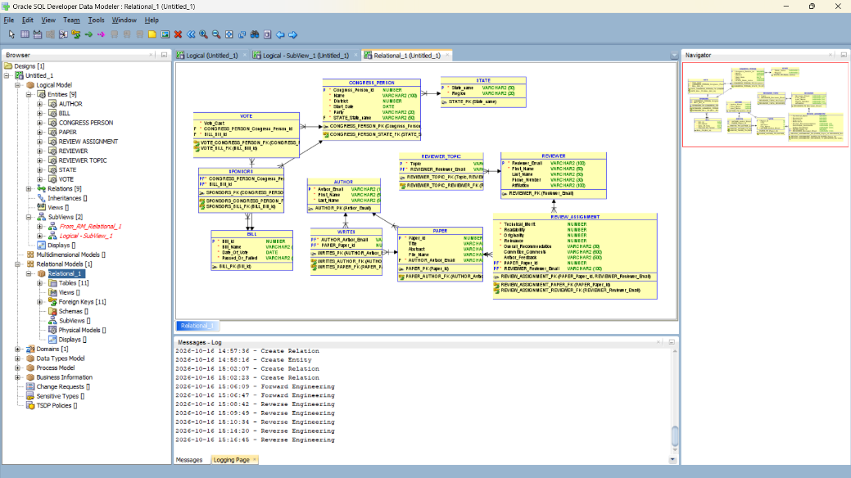
- Generate DDL:
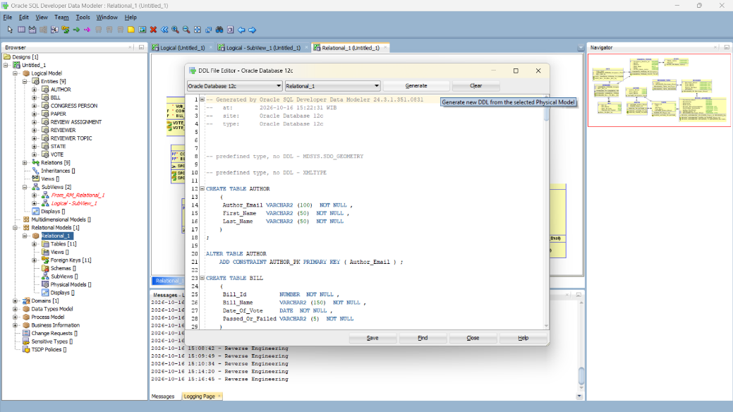
- Hasil Eksekusi di SQL:
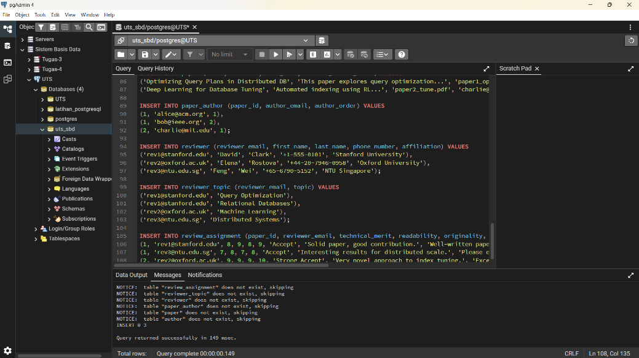

- SOAL 3.35: AIRLINE DATABASE SYSTEM
  - Deskripsi Singkat
Implementasi skema basis data penerbangan komersial:
- AIRPORT & AIRPLANE_TYPE: Bandara dan tipe pesawat beserta relasi CAN_LAND (M:N).
- AIRPLANE: Pesawat fisik dari masing-masing tipe pesawat.
- FLIGHT & FARE: Nomor penerbangan dan pilihan tarif harga tiket.
- FLIGHT_LEG: Segmen rute dengan bandara keberangkatan dan kedatangan.
- LEG_INSTANCE: Penerbangan nyata segmen pada tanggal tertentu dengan pesawat terkait.SEAT_RESERVATION: Reservasi kursi penumpang pada instance penerbangan.
  - Skrip DDL
DROP TABLE IF EXISTS flight_leg CASCADE;
DROP TABLE IF EXISTS fare CASCADE;
DROP TABLE IF EXISTS flight CASCADE;
DROP TABLE IF EXISTS airplane CASCADE;
DROP TABLE IF EXISTS can_land CASCADE;
DROP TABLE IF EXISTS airplane_type CASCADE;
DROP TABLE IF EXISTS airport CASCADE;

CREATE TABLE airport (
airport_code VARCHAR(10) PRIMARY KEY,
name VARCHAR(100) NOT NULL,
city VARCHAR(50) NOT NULL,
state VARCHAR(50) NOT NULL
);

CREATE TABLE airplane_type (
type_name VARCHAR(50) PRIMARY KEY,
max_seats INT NOT NULL,
company VARCHAR(50) NOT NULL
);

CREATE TABLE can_land (
type_name VARCHAR(50) NOT NULL,
airport_code VARCHAR(10) NOT NULL,
PRIMARY KEY (type_name, airport_code),
CONSTRAINT fk_cl_type FOREIGN KEY (type_name) REFERENCES airplane_type (type_name) ON DELETE CASCADE,
CONSTRAINT fk_cl_airport FOREIGN KEY (airport_code) REFERENCES airport (airport_code) ON DELETE CASCADE
);

CREATE TABLE airplane (
airplane_id INT PRIMARY KEY,
total_no_of_seats INT NOT NULL,
type_name VARCHAR(50) NOT NULL,
CONSTRAINT fk_plane_type FOREIGN KEY (type_name) REFERENCES airplane_type (type_name) ON UPDATE CASCADE ON DELETE RESTRICT
);

CREATE TABLE flight (
flight_number VARCHAR(20) PRIMARY KEY,
airline VARCHAR(50) NOT NULL,
weekdays VARCHAR(50) NOT NULL
);

CREATE TABLE fare (
flight_number VARCHAR(20) NOT NULL,
fare_code VARCHAR(20) NOT NULL,
amount NUMERIC(10, 2) NOT NULL,
restrictions VARCHAR(255),
PRIMARY KEY (flight_number, fare_code),
CONSTRAINT fk_fare_flight FOREIGN KEY (flight_number) REFERENCES flight (flight_number) ON DELETE CASCADE
);

CREATE TABLE flight_leg (
flight_number VARCHAR(20) NOT NULL,
leg_no INT NOT NULL,
departure_airport_code VARCHAR(10) NOT NULL,
arrival_airport_code VARCHAR(10) NOT NULL,
scheduled_dep_time TIME NOT NULL,
scheduled_arr_time TIME NOT NULL,
PRIMARY KEY (flight_number, leg_no),
CONSTRAINT fk_fl_flight FOREIGN KEY (flight_number) REFERENCES flight (flight_number) ON DELETE CASCADE,
CONSTRAINT fk_fl_dep_airport FOREIGN KEY (departure_airport_code) REFERENCES airport (airport_code),
CONSTRAINT fk_fl_arr_airport FOREIGN KEY (arrival_airport_code) REFERENCES airport (airport_code)
);

CREATE TABLE leg_instance (
flight_number VARCHAR(20) NOT NULL,
leg_no INT NOT NULL,
flight_date DATE NOT NULL,
airplane_id INT,
departure_airport_code VARCHAR(10) NOT NULL,
arrival_airport_code VARCHAR(10) NOT NULL,
dep_time TIME,
arr_time TIME,
no_of_avail_seats INT NOT NULL,
PRIMARY KEY (flight_number, leg_no, flight_date),
CONSTRAINT fk_li_leg FOREIGN KEY (flight_number, leg_no)
REFERENCES flight_leg (flight_number, leg_no) ON DELETE CASCADE,
CONSTRAINT fk_li_plane FOREIGN KEY (airplane_id) REFERENCES airplane (airplane_id),
CONSTRAINT fk_li_dep_airport FOREIGN KEY (departure_airport_code) REFERENCES airport (airport_code),
CONSTRAINT fk_li_arr_airport FOREIGN KEY (arrival_airport_code) REFERENCES airport (airport_code)
);

CREATE TABLE seat_reservation (
flight_number VARCHAR(20) NOT NULL,
leg_no INT NOT NULL,
flight_date DATE NOT NULL,
seat_no VARCHAR(10) NOT NULL,
customer_name VARCHAR(100) NOT NULL,
customer_phone VARCHAR(30),
PRIMARY KEY (flight_number, leg_no, flight_date, seat_no),
CONSTRAINT fk_sr_instance FOREIGN KEY (flight_number, leg_no, flight_date)
REFERENCES leg_instance (flight_number, leg_no, flight_date) ON DELETE CASCADE
);

INSERT INTO airport (airport_code, name, city, state) VALUES
('CGK', 'Soekarno-Hatta International Airport', 'Tangerang', 'Banten'),
('DPS', 'I Gusti Ngurah Rai International Airport', 'Denpasar', 'Bali'),
('SUB', 'Juanda International Airport', 'Surabaya', 'Jawa Timur');

INSERT INTO airplane_type (type_name, max_seats, company) VALUES
('Boeing 737-800', 189, 'Boeing'),
('Airbus A320-200', 180, 'Airbus');

INSERT INTO can_land (type_name, airport_code) VALUES
('Boeing 737-800', 'CGK'),
('Boeing 737-800', 'DPS'),
('Airbus A320-200', 'CGK'),
('Airbus A320-200', 'DPS'),
('Airbus A320-200', 'SUB');

INSERT INTO airplane (airplane_id, total_no_of_seats, type_name) VALUES
(101, 180, 'Airbus A320-200'),
(102, 189, 'Boeing 737-800');

INSERT INTO flight (flight_number, airline, weekdays) VALUES
('GA-402', 'Garuda Indonesia', 'Mon,Tue,Wed,Thu,Fri,Sat,Sun'),
('QZ-7510', 'AirAsia Indonesia', 'Mon,Wed,Fri,Sun');

INSERT INTO fare (flight_number, fare_code, amount, restrictions) VALUES
('GA-402', 'ECONOMY', 1500000.00, 'Non-refundable'),
('GA-402', 'BUSINESS', 3500000.00, 'Free reschedule'),
('QZ-7510', 'PROMO', 850000.00, 'Cabin baggage only');

INSERT INTO flight_leg (flight_number, leg_no, departure_airport_code, arrival_airport_code, scheduled_dep_time, scheduled_arr_time) VALUES
('GA-402', 1, 'CGK', 'DPS', '07:30:00', '10:20:00'),
('QZ-7510', 1, 'CGK', 'SUB', '09:00:00', '10:30:00');

INSERT INTO leg_instance (flight_number, leg_no, flight_date, airplane_id, departure_airport_code, arrival_airport_code, dep_time, arr_time, no_of_avail_seats) VALUES
('GA-402', 1, '2026-11-01', 101, 'CGK', 'DPS', '07:35:00', '10:25:00', 178),
('QZ-7510', 1, '2026-11-01', 102, 'CGK', 'SUB', '09:00:00', '10:30:00', 187);

INSERT INTO seat_reservation (flight_number, leg_no, flight_date, seat_no, customer_name, customer_phone) VALUES
('GA-402', 1, '2026-11-01', '12A', 'Danuardi Saputro', '081234567890'),
('GA-402', 1, '2026-11-01', '12B', 'Rizal Broer', '081298765432');
- Dokumentasi
- Logical Model:
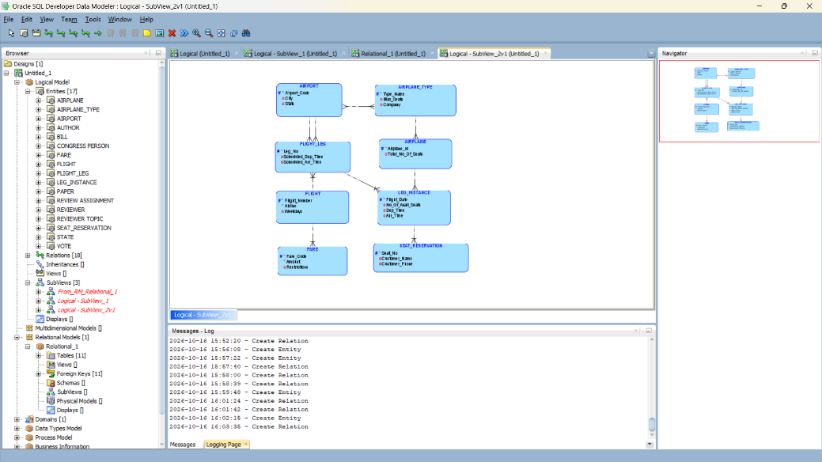
- Relational Physical Model:
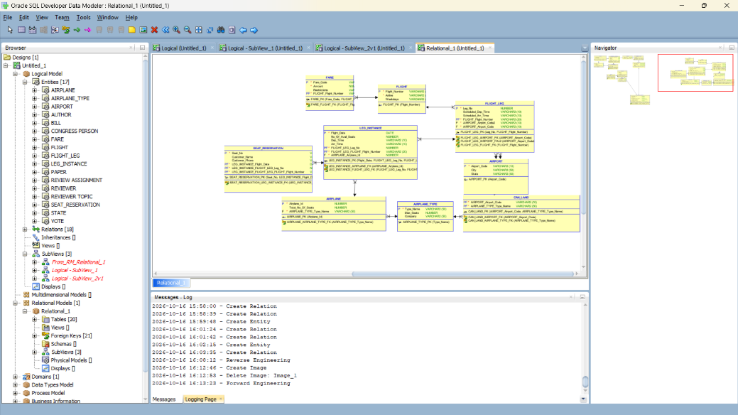
- Generate DDL:
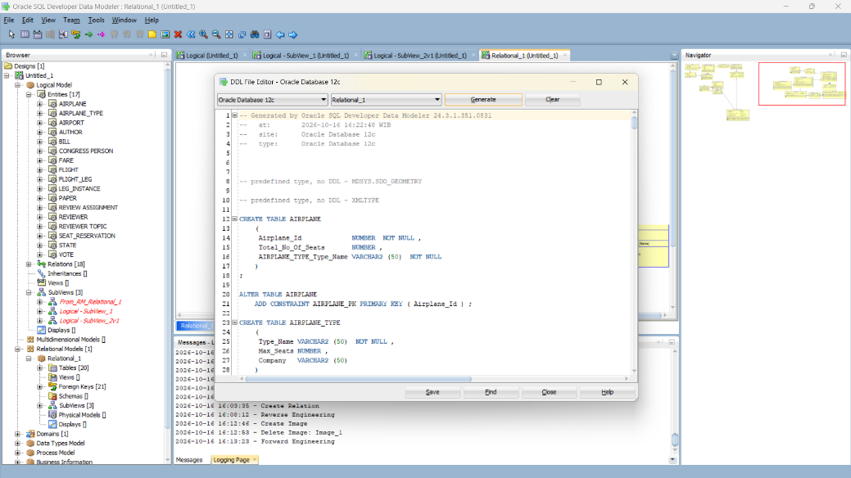
- Hasil Eksekusi di SQL:
