|  |
| --- |
| Module CI869 |
| Wetlands Website |
| Software Design and Development |

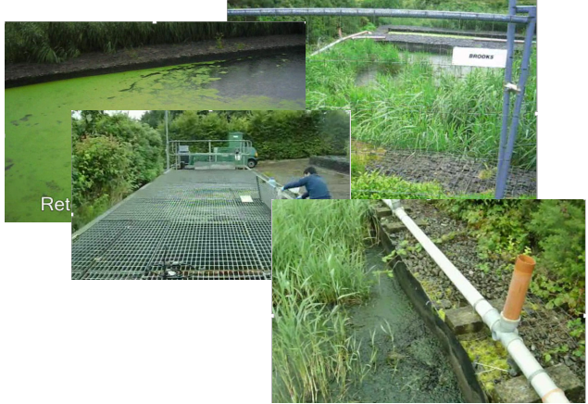

Contents

1 Introduction 4

1.1 Purpose 4

1.2 Participants 4

1.3 Timeline 5

1.4 Report Outline 5

2. Project Definition 6

2.1 Initial Brief 6

2.2 Business Driver from Project 6

2.3 Glossary 7

2.4 Problem Domain 7

2.5 Research into Wetland Data 9

2.6 Project Requirements 11

3. Project Management 12

3.1 Programming and Responsibilities 12

3.2 Risk Analysis 13

4. System Analysis and Design 14

4.1 Research of similar systems 14

4.2 Requirements 14

4.3 Business Rules 14

4.4 Use cases 15

4.5 Data Modelling 16

4.6 Interaction Modelling 16

4.7 Project Architecture 17

4.8 Selecting Technologies and Tools 17

5. Implementation 20

5.1 Database Structure 20

5.2 Code Structure 20

5.3 Components 20

5.4 Security 20

5.5 Phased development, next step 20

6. Testing 21

6.1 Unit Testing 21

6.2 System Testing 21

6.3 Interface User Experience Testing 21

7. Conclusion 22

7.1 Unit Testing 22

7.2 System Testing 22

7.3 Interface User Experience Testing 22

References 22

APPENDIX A Preparing for Interviews 23

# 1 **Introduction**

This document contains the requirements analysis and structural modelling for the Wetlands Database Management System being proposed for the storing site sample data and providing a website so that sample data can be made available online.

## Purpose

Create a constructed wetland performance database which would allow users to query the database to find and download data that matches particular search criteria.

Provide a user-friendly interface to allow interested parties to 'interrogate' the data (e.g. the end user may wish to examine the performance of wetlands, in a particular size category, in treating a specific water quality parameter, for example).

Increase awareness of the work done by The Geo-Environmental Engineering (GENE) research group, based at NUI Galway.

* Examine the material that needs to be modelled for the system. Gain an understanding of the problem domain and evolve a clear perspective on the essential requirements.
* Work with our client to develop a solution that is effective and achievable with in our limits of time and resources.
* Develop and practice group working skills that support good software development practices and encourage productivity from each team member.
* Maintain regular communications with team members, supervisor and client. Providing updates on progress.
* Produce a working demo model for the presentation.

## Participants

The development team throughout this project, 3 student from the HDip Software Design and development Course:

Ciaran Severn

Catherine Gaughan-Smith

Sean Lydon

Senior Technical advisor : Joe O’Connell

Project supervisor : Josephine Griffith.  
  
Module co-ordinator : Finlay Smith.  
  
Stakeholders:

|  |  |
| --- | --- |
| Owner | Dr. **Mark G. Healy** (room ENG-1038).  BE, MEngSc, PhD, Eur Ing, CEng, FIEI, Chartered Engineer,  Senior Lecturer in Civil Engineering |
| Administrator /  Wetlands Researcher | **Collette J Mulkeen** College of Engineering and Informatics |
| Expert User | Dr. Brian Donlon, EPA Research Manager ,  Environmental Protection Agency |

## Timeline

The key dates for the project are as follows:

Project Allocation – October 2014

First Presentation – November 2014

Phase 1 Report – November 2014

Project Demo – March 2015

Final Project Report – March 2015

## Report Outline

{Todo}

# **Project Definition**

## Initial Brief

A recent EPA-funded study is seeking to address this knowledge gap.

As part of the study, we are collecting performance data from wetlands in Ireland. However, we need a user‐friendly interface to allow interested parties to ‘interrogate’ the data (e.g. the end user may wish to examine the

performance of wetlands, in a particular size category, in treating a specific water quality parameter, for example).

No such database exists in Europe, and this would be a unique opportunity to advance the state-of-the-art in wetland analysis.

What we require:

• A constructed wetland performance database similar to an existing one in the USA (http://firehole.humboldt.edu/wetland/twdb.html), which would allow users to query the database to find and download data that matches particular search criteria.

• The data would be returned to the end user in tabular format.

• The database would need to be designed such that it may be continuously updated by the research group. Ideally, it may also be possible for County Council technicians to upload data onto the portal, using a login password.

• Ideally this database would be housed on our research group’s webpage

(http://www.nuigalway.ie/gene/)

## Business Driver from Project

The Geo-Environmental Engineering (GENE) research group, based at NUI Galway, investigates the fate of **phosphorus** and **nitrogen in soil-plant-water systems** and the effects of agricultural management on soil and water quality. GENE has helped develop decision-making tools to target management alternatives and remedial measures that have reduced the risk of nutrient loss from farms. Currently, GENE’s main research interests are:

(1)   resource recovery and resource efficacy – use of materials for wastewater and water treatment; waste materials and chemicals as phosphorus and nitrogen adsorbents and soil amendments; waste as energy sources and slow-release fertilisers

(2)   forestry – protection of water courses from forestry activities, greenhouse gas emissions

(3)   soil physics – modelling of water movement through soil and management impacts for farmers



## Glossary

|  |  |
| --- | --- |
| **EPA** | **Environmental Protection Agency** |
| Flow rate | Total effluent volume discharged over the 24-hour period in which the composite sample is collected shall be recorded. |
| BOD | BOD 5 day Biochemical Oxygen Demand (without nitrification suppression). |
| cBOD | 5 day Carbonaceous Biochemical Oxygen Demand (with nitrification  suppression). |
| COD | Chemical Oxygen Demand |
| DO | Dissolved Oxygen |
| **RBC** | **Rotating Biological** **Contactor,** for example in Hollymount, Fenagh and Newtowngore. |

## Problem Domain

|  |
| --- |
| **Fig. 18.11A** Raw sewage moves from the grit chamber to primary treatment, where sludge is removed and the clarified water then proceeds to secondary treatment (here shown as activated sludge treatment).    From <<http://apesnature.homestead.com/chapter17.html>> |
| **Fig. 18.11B** In primary treatment sludge is removed and the clarified water then proceeds to secondary treatment. Raw sewage moves from the grit chamber to primary treatment, where sludge is removed and the clarified water then proceeds to secondary treatment.    From <<http://apesnature.homestead.com/chapter17.html>> |
| **Fig. 18.11C** Raw sewage moves from the grit chamber to primary treatment, where sludge is removed and the clarified water then proceeds to secondary treatment (here shown as activated sludge treatment).    From <<http://apesnature.homestead.com/chapter17.html>> |
| **Fig. 18.13** The secondary treatment, activated sludge process may be modified to remove nitrogen and phosphate while at the same time breaking down organic matter.    From <<http://apesnature.homestead.com/chapter17.html>> |

## Research into Wetland Data

|  |  |  |  |
| --- | --- | --- | --- |
| Wetlands | Identification: Wetland name (for example - Moycullen, Galway) Location: GPS coordinates,  Type: Bog, fens, cutover and cutaway bog areas.   |  |  | | --- | --- | | Wetland location   * latitude and longitude * city * state * EPA region * EPA facility ID * USGS watershed ID | Wetland owner, operator, designer, and regulator contact information   * name * addresses * phone numbers * email * web page entries |  * Design characteristics descriptors   + include population of the service community   + scale of the operation (bench, pilot, or full-scale)   + source of wastewater   + period and type of hydraulic loading   + type of pre-treatment   + type of pre disinfection   + objectives and beneficial uses of the wetland system   + dates of start-up and full operation   + capital costs   + O/M costs   + hydraulic type and loading rate   + total wetland footprint area |
| Site Source Type | Municipal,  Agricultural,  Industrial |
| Types of Pre-treatment | Primary,  Secondary |
| sample points | The sample points data table contains a description of all sample point locations where data is collected for the wetland systems included in the database. Each entry in this table contains   * identification number of the associated wetland * name and description of the point * cell in the wetland (if any) where the sample point is located * indication whether this sample point is a treatment system influent or effluent point |
| constituent measured | The samples data table contains the actual measured wetland descriptive or performance data. Each entry in this table contains   * identification number of the associated wetland * date the data was collected * identification number of the constituent measured * observed value of the constituent or sample variable * text comment associated with the sample |
| Meteorological characteristics | * monthly average precipitation * monthly minimum temperature * monthly maximum temperature * monthly evapotranspiration * annual average temperature, precipitation, and evapotranspiration * average first day of ice cover * average number of ice cover days |

## Project Requirements

#### Negotiate Scope

{Discuss}

#### Identify Tasks

{Discuss}

#### Estimate Task Durations

{Discuss}

#### Specify Inter-task Dependencies

{Discuss}

#### Assign Resources

{Discuss}

#### Direct the Team Effort

{Discuss}

#### Assess Project Results and Experiences

{Discuss}

# **Project Management**

This document

## Programming and Responsibilities

Our approach to managing the project development was to break it down into components. Through out the development we re-evaluated which components were more essential and then assigned the development of components to each team member. When the work was completed and tested, we went through a process if merging changes into the repository and then did some integration testing the confirm that the components still worked individually and also as part of the system.

The Product Breakdown Structure (PBS) is a hierarchical structure of things that the project will make or outcomes that it will deliver.

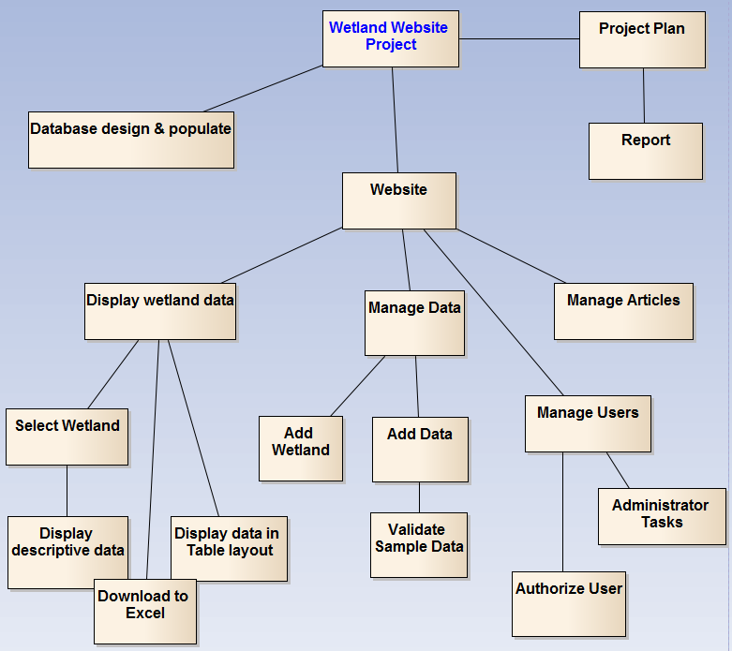

Figure . Product Breakdown Structure

## Risk Analysis

{Todo}

# **System Analysis and Design**

This document

## Research of similar systems

{Todo}

## Requirements

{Todo}

1. **Scope of Functions**
   * 1.1. The system will record ….
   * 1.2 The system will allow ...
   * 1.3 The system will generate ….
   * 1.4 The system will keep track of .. .
   * Design the interface to target people with scientific background.
   * Database can be updated without having specialized skills.
   * Database can only be updated by registered users.
   * Display data on specific wetland sites.
   * Be able to download data to an excel spreadsheet
   * Display links to publications and literature on wetlands sites.
2. **Operational**
   * 2.1 The system will run on any Web browser and on the intranet.
3. **Performance**
   * 3.1 Download speeds.
4. **Security**
   * 4.1 Information

## Business Rules

{Todo}

## Use cases

{Describe}

Register User

Authorize User

Download Data

Query Data

Submit For Review

Upload Data



## Data Modelling

{Todo}

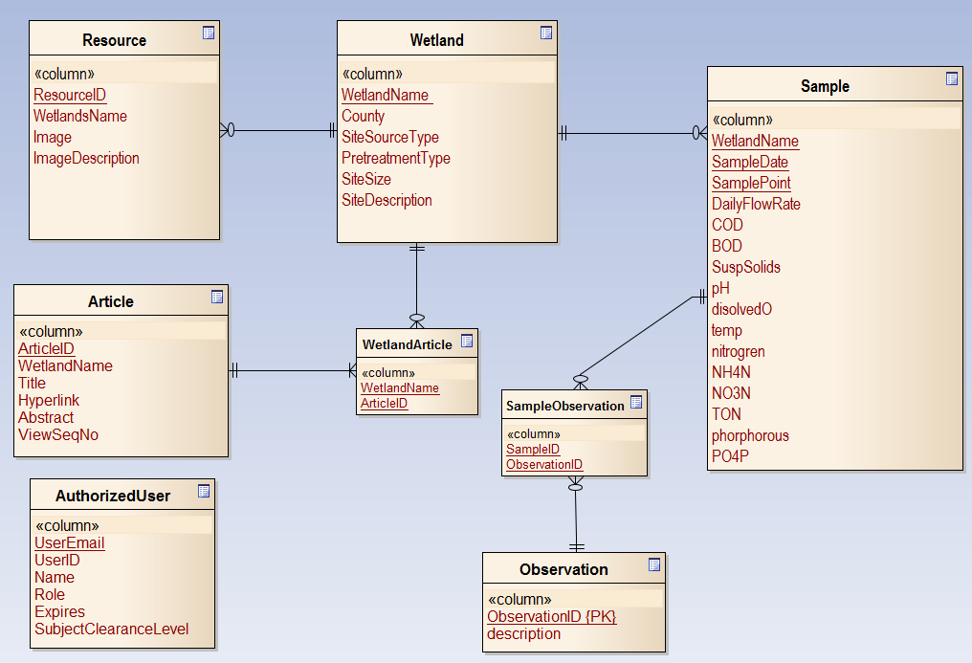

## Interaction Modelling

{Todo}



## Project Architecture

{ Discuss }

## Selecting Technologies and Tools

{Discuss}

* Twitter bootstrap
* My SQL
* PHP
* Java script

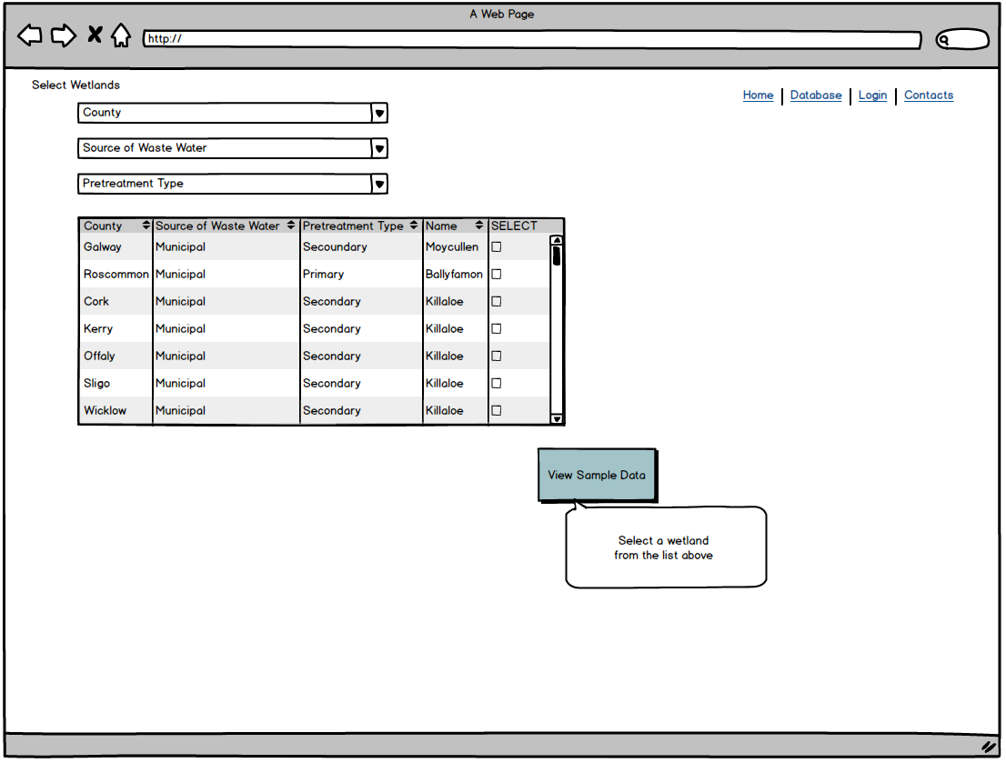

# **Implementation**

This document

## Database Structure

Todo

## Code Structure

### Object oriented PHP

##### classes folder : helper functions

**Config.php:** provides a static getter function for global variables which can traverse a path through nested array elements :  **Cookie.php** uses static functions for getters / setters on cookies.  
**DB.php** is a wrapper class for PDO access to database. It provides helper methods to simplify queries and I/O on the data  
**Hash.php** uses a secure hash algorithm to protect passwords and cookies.

**Input.php** for accessing super global GET / POST values  
**Redirect.php:** provides a static function which wraps the php header redirect command.  
**Session.php:** uses static functions for getters / setters on sessions.

**Token.php**: provides cross site request forgery protection, matches the current uses session token when a form is submitted.

**User.php:** controller class for **User** entity, logging in and checking permissions.

**Validate.php**: provides user input validation, boundary class.

##### core Folder : autoload classes

**init.php**: functionality to include on each page: start session so people can log in, access global configuration settings for the database, cookies and session token, and autoload classes so that classes are loaded efficiently (when they are required) offering dependency injection with php function spl_autoload_register. This will replace the list of all the required_once functions on each page for a single point of reference.

##### functions Folder : sanitize functions

**Sanitize.php**: function that uses html encoding to sanitize input / output.

##### includes Folder: Error Handling 404

errors folder : **404**.**php** standard message

### Static Helper Files

### Static Helper Files

Validation Helpers : Input is automatically sanitized  
config.php : Single location for configuration values

### Login / Permissions

Functionality:   
User Validation, User Session (Remember me option), Manage profiles, Update passwords, Ability to Register

Groups : permissions holds a JSON string of different permissions a user can have.

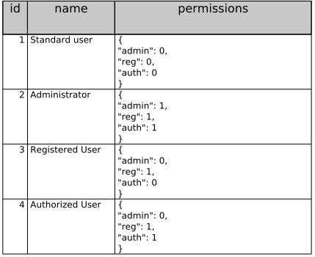

Figure . Table Groups, showing different roles

User_Session : Holds session hashes of people who have asked to be remembered when they logged in. Stores a hash that corresponds to a user ID and if this matches a cookie hash then that user will be logged in.

## Components

Todo

## Security

Todo

## Phased development, next step

Todo

# **Testing**

This document

## Unit Testing

Todo

## System Testing

Todo

## Interface User Experience Testing

Todo

# **Conclusion**

This document

## Unit Testing

Todo

## System Testing

Todo

## Interface User Experience Testing

Todo

=============================================================================

## References

***Environmental Science****.* (2014, 11 30). Retrieved from Dolores Gende's AP Sciences Website: http://apesnature.homestead.com/

***Geo-Environmental Engineering Research Group*** <http://www.nuigalway.ie/gene/>

# APPENDIX A Preparing for Interviews

Questions Interview 1

22 October 2014

11:52

|  |  |
| --- | --- |
| Describe the Users | County Council technicians |
| Describe the key concerns that the system should address for each user | Who will be using the web site ?   What types of user would be accessing and using this system ?  For each type of user, what aspects of the data would they be concerned with? |
| Describe how the data is collected - samples onsite, sent to labs |  |
|  | What information would be most important to the users? |
| Understand the Data involved | Sources/ Sinks of information ?    What external systems need to be interfaced to? |
| Submit Data | What is the process for submitting data?    How is it collected? By whom?  What form does the data come in? |
| Wetland Performance | What are the performance indicators that need to be calculated? |
| Understand the processes involved | What typical searches would be essential to be made available on the website?  What services does the application need to provide |

Questions for interview 2

05 November 2014

11:56

|  |  |
| --- | --- |
| Concern with size of spreadsheet - how it will grow and how that can be uploaded | There will be approx 140 sheets - how will that be uploaded  How much would that grow with samples for each month |
| Identify stakeholders / roles | ACTORs 1 - general public ACTORs 2 - Engineer , Environmental Scientist,   Students, Local Interest Groups |
| How users will use the website | If they saw the tabulated form would that make sense to them?    What sort of questions would they have in mind when they come to the website    Would they be comparing wetlands?  What would they expect to see?   Can you describe the scenario where actor 1 / actor 2 visits the web site. |
| GET TERMINOLOGY - glossary | Clarify the 8 important properties …. Would we be inputing the same statistics - or different element(sample components) |
| Graphical Representation | What graphs do you have on the spreadsheet?  Is that something that would be useful to show on line? |