HearDesk
  - End-to-End UI Test Report
Browser workflows • Recorded results • Screenshots
Website feedback. Ready for your team.
A personal full-stack engineering project
Prepared by Muhammad Danu Susyanto
Version 1.0 • 14 October 2026
Portfolio edition describing the implemented app, with test examples and dated results.

Contents
Contents 2
1. Purpose and recorded version 3
2. Test environment 3
3. How the tests were run 3
4. Features covered by the browser tests 4
5. UI test UC-01: send feedback and save tracking access 4
6. UI test UC-02: read team replies without seeing internal notes 4
7. UI test UC-03: dialogs, loading and screen sizes 5
8. Test results 6
9. Screenshot: landing page 7
10. Screenshot: team inbox 8
11. Screenshot: visitor widget 9
12. What the results establish 9
13. How to maintain this report 10
14. Test source references 11

1. Purpose and recorded version
This document explains the HearDesk features and code reviewed for this portfolio. The results describe the recorded version and test environment. They do not represent a customer contract, independent certification or measured business results.
End-to-End UI testing means using a real browser to follow a user workflow through the running application. Playwright performs actions such as filling the feedback form and checking the result on screen. These tests used a production build, meaning the compiled application intended for deployment, in a separate local test environment.
The run recorded here started on 13 October 2026 at 04:14:49.928 UTC. It tested Git commit afb4f54a83eafcd0f10232adbbeeae92292c293a. The result is historical evidence, not a new test execution caused by a wording update to this document.
The scenario table comes from the Playwright result file. A scenario is one named test and can contain several steps and checks. A check in test code is called an assertion.

2. Test environment
Table 1. Test environment
Item | Configuration and meaning
Test tool | Playwright 1.63.0 with Chrome on Windows. Headless means the browser ran without a visible desktop window.
Application | Next.js production build with E2E_PRODUCTION=true, served locally on port 3100.
Example website | A local website on port 3200 that embeds the widget.
Database | ureport_test, checked by the runner before data cleanup. The application database was not used.
Execution order | One worker runs tests sequentially. Some scenarios depend on records created by earlier scenarios.
Saved evidence | Structured result file, selected screenshots and failure traces when a test fails.
Email | A local test mailbox. No real email delivery is tested.
Source version | afb4f54a83eafcd0f10232adbbeeae92292c293a

3. How the tests were run
The application was built in .next-sonar, a separate build directory. The test runner checked its database target, applied test-database migrations, cleared previous test records and started both the application and example website. Tests used sample accounts and reports, not customer data.
Recorded command: HEARDESK_BUILD_DIR=.next-sonar E2E_PRODUCTION=true npm run test:e2e -- --reporter=json. On Windows, these environment variables are set before running npm. The JSON option saves results in a structured format that can be checked automatically.
Successful process exit codes and scenario results are separate checks. Log warnings also need review. A test fixture means the sample accounts, websites and reports created for the tests.

4. Features covered by the browser tests
Table 2. Features covered by the browser tests
Group | FSD IDs | What the tests check
Sign-in and setup | FR-01, FR-02 | Create or verify a test account, open the right workspace and reject a session that has been revoked.
Visitor widget | FR-04 to FR-08 | Open the embedded form, submit a report, attach an image, save tracking access and retry without a second report.
Inbox and settings | FR-03, FR-09 to FR-11 | Search reports, use filters, save website settings, update status and add internal notes.
Private tracking | FR-12, FR-13 | Open the private tracking page, read team replies and refresh status without exposing internal notes.
Company separation | FR-02, FR-06 | Reject requests for another Company's reports, notes and screenshots without the required membership.
Reporting | FR-14 | Compare the monthly chart and Excel output with stored report totals.
Platform management | FR-15 | Use the separate service-management console and check records of supported administrative actions.
Screen behavior | FR-17 | Check loading placeholders, errors, dialogs, reduced motion and layouts at different screen widths.

5. UI test UC-01: send feedback and save tracking access
Starting state: a registered test website belongs to an active Company. The visitor does not have a login session.
Steps: open the example website and its feedback widget. Enter a message, optionally attach a screenshot, and submit. Read the success message and save the private tracking link and code.
Expected result: one report is saved and the code has 48 hexadecimal characters. The link opens /track#code=… without requiring visitor login. Retrying the same identified request with unchanged content does not create a second report.
Related rejection checks cover changed content under a reused request identity, unsupported files and too many requests. The recorded scenario outcomes appear in the results table.

6. UI test UC-02: read team replies without seeing internal notes
Starting state: a tracked report exists and a test team account can update it.
Steps: send a reply to the visitor, add a separate internal note and set the report to REVIEWING. Open the tracking link in a visitor browser context, which has no team login. Check the reply and status, then set DONE in the team view and refresh the visitor page.
Expected result: the visitor sees the team reply and updated status, but cannot see the internal note. The link also opens in a new tab from the widget. An unknown code shows an error, and entering the correct code restores the report view.
The scenario checks page width on phone-sized and desktop screens. It uses separate team and visitor contexts so a team login cannot accidentally make the anonymous flow pass.
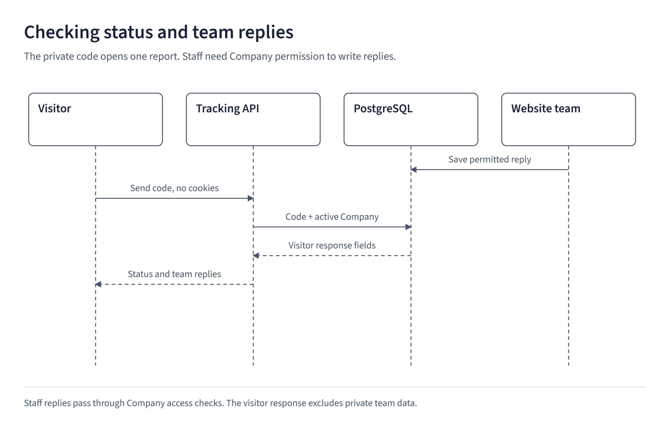
Figure 1. UI test UC-02: read team replies without seeing internal notes

7. UI test UC-03: dialogs, loading and screen sizes
Landing tests open and close the demo, press Escape, click outside the dialog and use the interactive preview. They also check that animations finish correctly after resizing and that reduced-motion preferences are respected.
Inbox tests check filters, website settings and loading placeholders. A skeleton is a temporary placeholder shown while a request is loading. The tests check that placeholders disappear when results or errors arrive.
Screenshots show appearance, while assertions check behavior. Passing in this Chrome environment does not establish full compatibility with every other browser or assistive technology.

8. Test results
All 19 scenarios passed. A scenario is marked Passed when all checks in its automated test succeed. No scenarios failed unexpectedly or were skipped, and none passed only after a retry.
Table 3 summarizes the workflows and application behavior checked during this run. Section 14 lists the original test names and source files using the same scenario IDs.
Run started: 13 October 2026 at 04:14:49.928 UTC.
Total duration: 113.0 seconds.
Table 3. Test results
ID | Scenario | Result / duration
E2E-01 | Account setup remains complete if automatic sign-in fails. The user is not asked to create the account again. | Passed  0.7 s
E2E-02 | Users can complete setup, access the admin workspace, submit anonymous feedback with an image attachment, and sign out. | Passed  11.7 s
E2E-03 | Retrying an unchanged submission does not create a duplicate report. Reusing its ID with changed content, uploading an invalid image, or exceeding request limits is rejected. | Passed  2.3 s
E2E-04 | Landing page animations finish correctly after rapid interaction and follow reduced-motion settings. | Passed  1.9 s
E2E-05 | Completed opening animations stay in their final position when the window is resized or motion preferences change. | Passed  2.3 s
E2E-06 | The example widget illustration on the landing page fits within its container at widths between mobile and desktop layouts. | Passed  0.4 s
E2E-07 | The landing page demo works on mobile and does not send or save real feedback. | Passed  2.7 s
E2E-08 | The website list and add-website form appear side by side on desktop and stack vertically on mobile. | Passed  1.5 s
E2E-09 | The workspace fits desktop and mobile screens without content overflowing the layout. | Passed  2.6 s
E2E-10 | Search and category/status filters show matching reports or an empty state. The saved website name, button label, and button position remain after reload and appear in the visitor widget. | Passed  10.5 s
E2E-11 | Replacing a widget key requires confirmation. The previous key stops working, while existing reports are retained. | Passed  5.1 s
E2E-12 | Company APIs and older endpoints block access to another Company's reports, notes, and attachments. Platform-level permissions alone do not grant access. | Passed  5.9 s
E2E-13 | The Company's monthly chart loads. Annual, monthly, and all-time Excel exports match the report totals and row counts returned for each period. | Passed  5.8 s
E2E-14 | Opening the filter panel does not move the table. Applying a filter keeps the selected page size in the URL. | Passed  2.7 s
E2E-15 | The Platform Owner has a separate console with activity charts, Company records, and account controls. Company suspension, reactivation, and website-limit changes work, and the saved limit change appears in the audit log. | Passed  16.1 s
E2E-16 | The landing and login pages recognize an active Platform Owner session. Reusing its cookies after sign-out does not restore access. | Passed  2.9 s
E2E-17 | Loading placeholders remain visible while requests are pending, disappear after success or an error, and follow reduced-motion settings. | Passed  7.4 s
E2E-18 | Visitors can track an anonymous report and read public team replies. Internal notes remain hidden. | Passed  6.2 s
E2E-19 | A new user can verify their email through the local test mailbox, create a Company, add a website, and reset their password. | Passed  12.5 s

9. Screenshot: landing page
Captured during the recorded browser run. The reports shown in the landing preview are examples, not customer submissions.
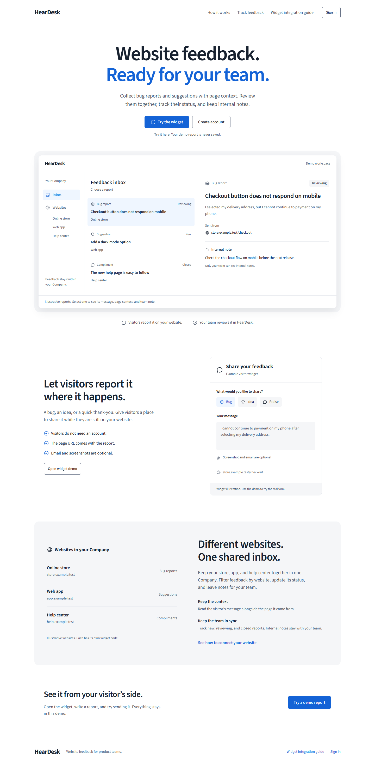
Figure 2. Test environment screenshot: landing page

10. Screenshot: team inbox
The inbox contains test reports in a separate test environment. It shows the screen used to review feedback and does not represent real customer activity.
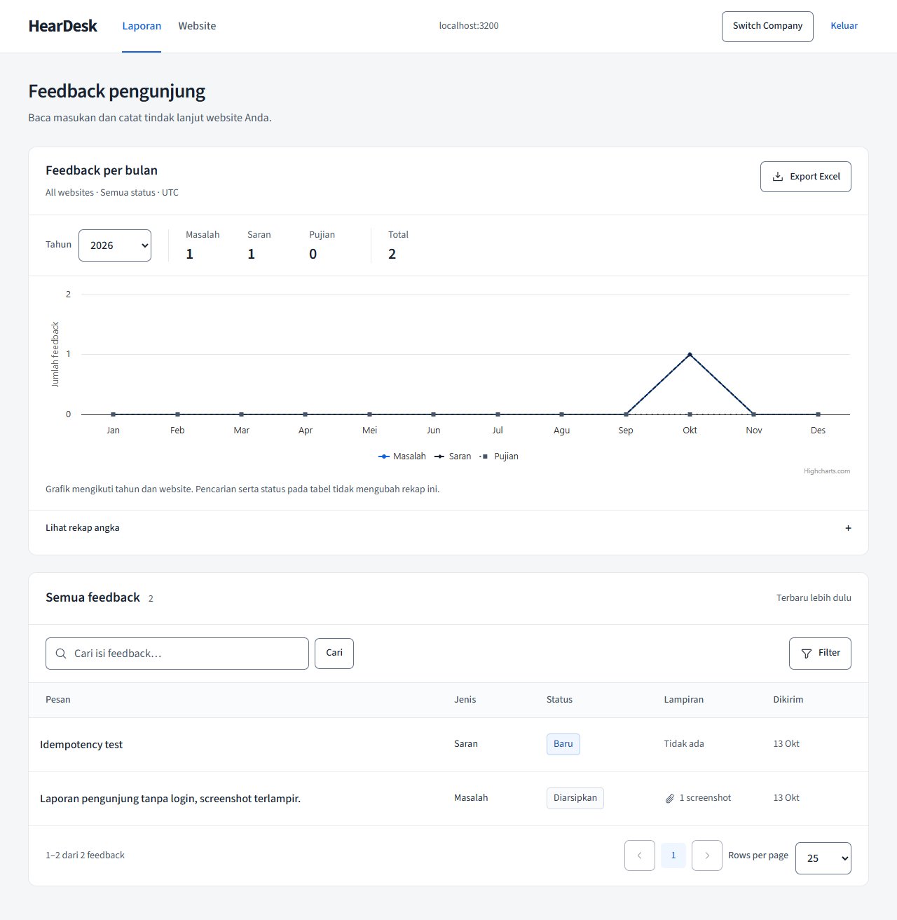
Figure 3. Test environment screenshot: team inbox

11. Screenshot: visitor widget
The registered test website displays the feedback form at a phone-sized screen width. The selected screenshot does not display a live private tracking code or a password.
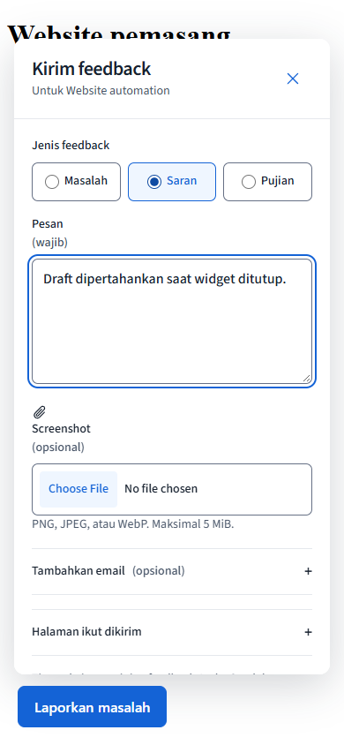
Figure 4. Test environment screenshot: visitor widget

12. What the results establish
All recorded scenarios passed on the stated version and environment. This verifies those workflows, not every possible use of the app. It does not measure heavy-load performance, prove that all vulnerabilities are absent, or establish production availability.
Earlier test logs contained warnings about concurrent pg queries and Vite configuration compatibility. A warning is different from a failed assertion and should still be reviewed. Some tests need the records produced by earlier tests, so running a single file may require additional setup.
Separate recorded checks passed 269 unit/component tests and 90 integration tests on 13 October 2026. Those counts are supporting evidence and are not included in the 19 browser scenarios.

13. How to maintain this report
Keep the test date, Git commit, browser, result file and screenshots together. When a feature changes, update its FSD requirement and test assertions before recording new results. Traces can include form data and are not automatically published.
Source files: tests/e2e/application.spec.ts, landing.spec.ts, visual.spec.ts, zz-company-isolation.spec.ts, zz-feedback-reporting.spec.ts, zz-filter-ui.spec.ts, zz-platform.spec.ts, zz-skeleton.spec.ts, zz-session-navigation.spec.ts, zz-tracking.spec.ts and zzz-onboarding.spec.ts.

14. Test source references
The original automated test names are listed here for readers who want to locate the checks in the code. The source files are in tests/e2e. Each ID matches the plain-language description in Table 3. File names and line numbers refer to the recorded source version.
Table 4. Test source references
ID / source file | Original automated test name
E2E-01  application.spec.ts:6 | successful setup with failed auto-login does not ask to create account again
E2E-02  application.spec.ts:40 | setup, private admin, anonymous widget, attachments and logout
E2E-03  application.spec.ts:194 | anonymous retries, conflicting payloads, invalid files and request limits
E2E-04  landing.spec.ts:4 | landing motion settles after rapid interaction and respects reduced motion
E2E-05  landing.spec.ts:52 | completed entrances remain settled across resizing and preference changes
E2E-06  landing.spec.ts:94 | widget illustration contents fit at intermediate widths
E2E-07  landing.spec.ts:111 | public landing demo never writes feedback and works on mobile
E2E-08  visual.spec.ts:6 | website list and add form align side-by-side on desktop and stack on mobile
E2E-09  visual.spec.ts:28 | desktop and mobile workspace render without overflow
E2E-10  visual.spec.ts:62 | search, filters, settings persistence and public widget configuration
E2E-11  visual.spec.ts:145 | widget key rotation requires confirmation and retires old key without deleting reports
E2E-12  zz-company-isolation.spec.ts:9 | Company API and legacy routes reject foreign reports, notes, attachments and platform-only access
E2E-13  zz-feedback-reporting.spec.ts:5 | Company monthly line chart and three Excel periods match aggregate data
E2E-14  zz-filter-ui.spec.ts:3 | filter popover floats without shifting table and preserves URL context
E2E-15  zz-platform.spec.ts:3 | platform owner has separate console, real metadata and audited Company management
E2E-16  zz-session-navigation.spec.ts:3 | landing and login recognize current owner session and revoked cookies
E2E-17  zz-skeleton.spec.ts:3 | data skeletons remain until response, disappear on success/error and respect reduced motion
E2E-18  zz-tracking.spec.ts:8 | visitor tracks an anonymous report and sees public replies but never internal notes
E2E-19  zzz-onboarding.spec.ts:8 | local client verifies email, creates Company, connects website and resets password

