Door and window detection results
Method: each photo was processed in two steps. First, Grounding DINO (open-vocabulary detector) located doors and windows from the text prompt "door. window.". Then each detected box was passed to SAM (Segment Anything), which produced a precise mask. In the result images, coloured overlays mark the segmented masks and red rectangles show the detected boxes with their label and confidence score. Images with no overlay had no detection above the thresholds (box 0.35, text 0.25).

20240819_100055.jpg
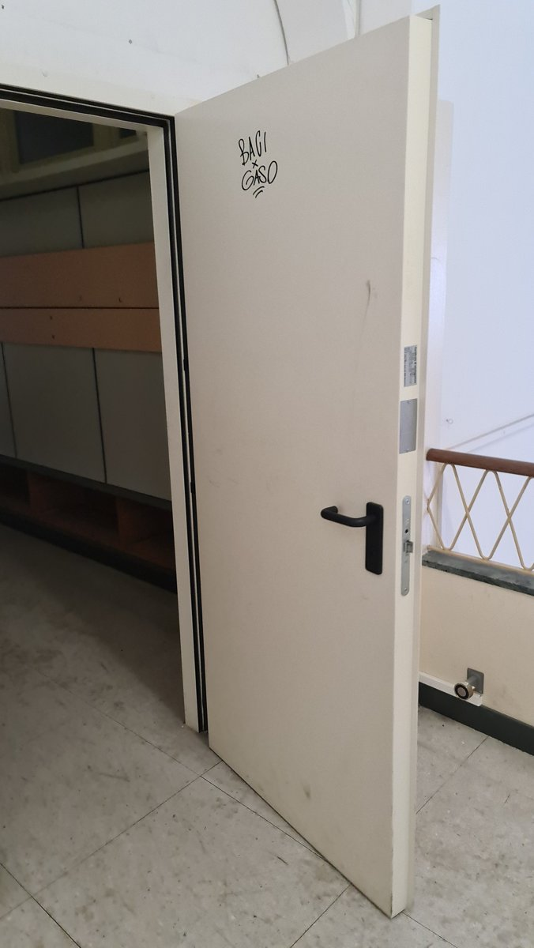  Original | 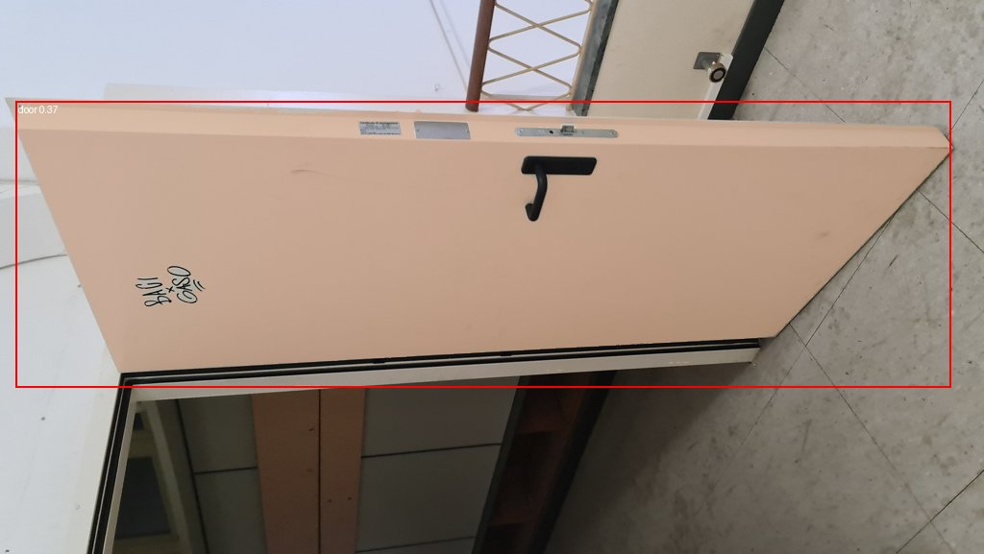  Detection result (doors and windows)

20240819_100836.jpg
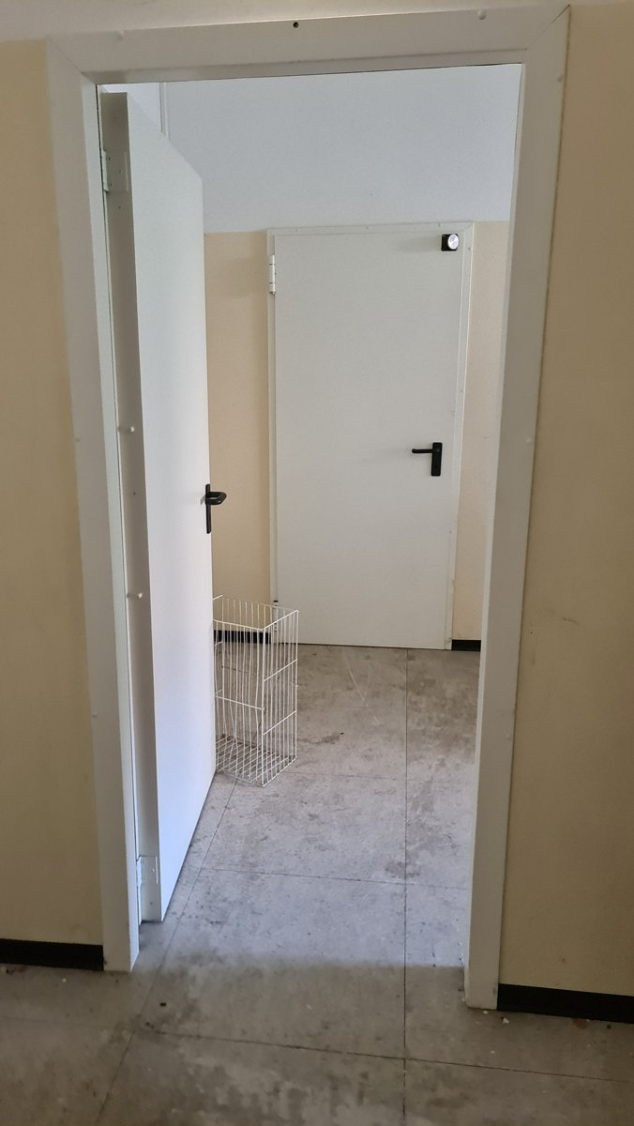  Original | 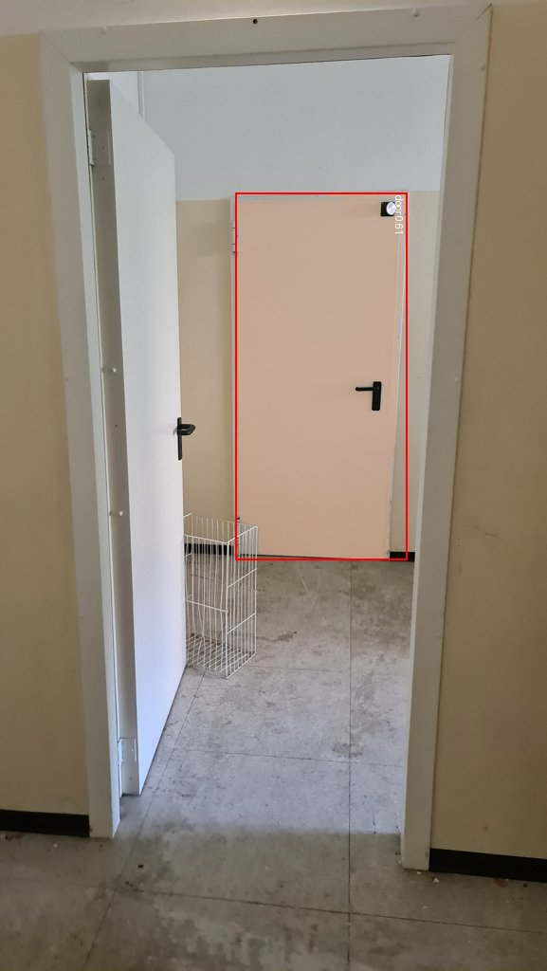  Detection result (doors and windows)

20240824_110946.jpg
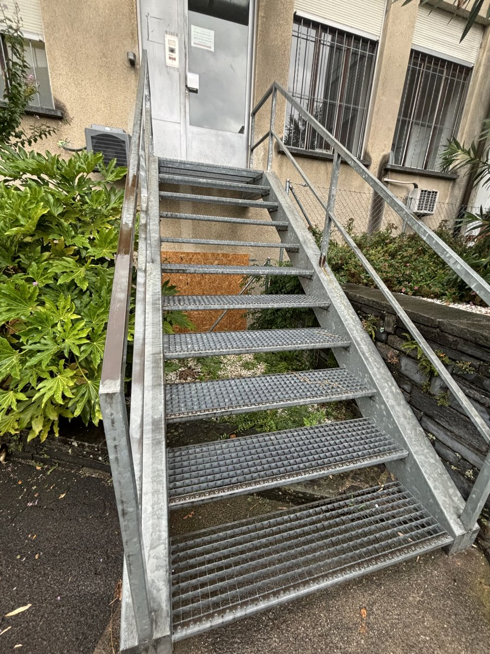  Original | 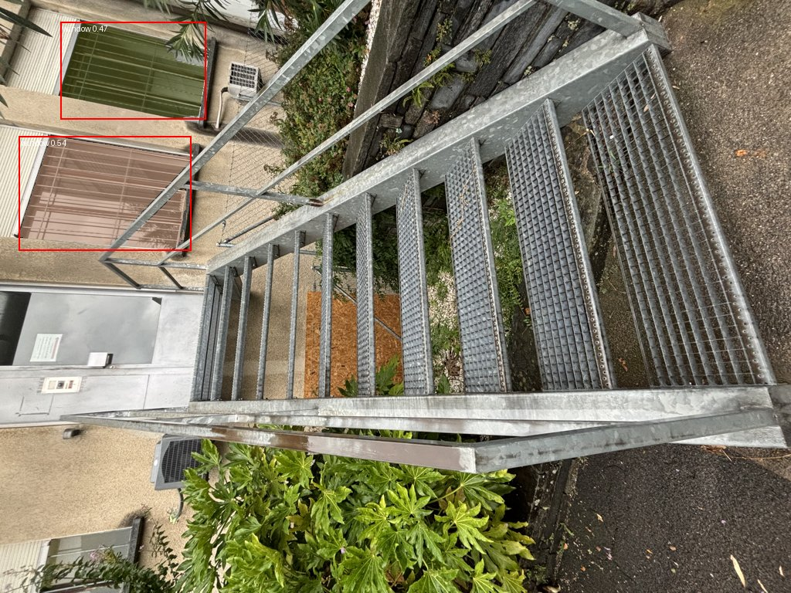  Detection result (doors and windows)

20240826_095451.jpg
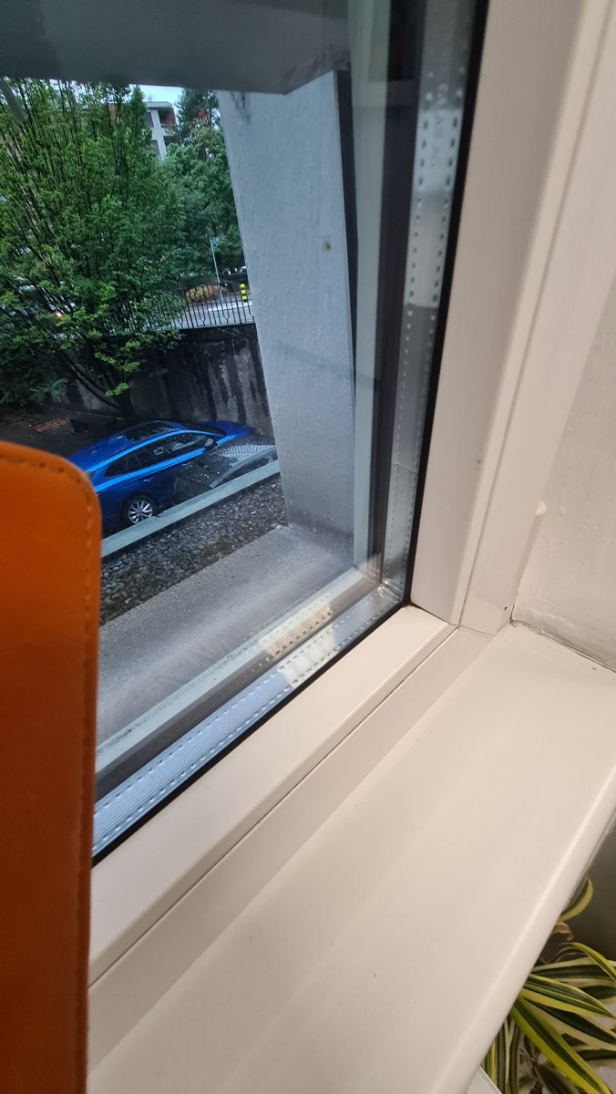  Original | 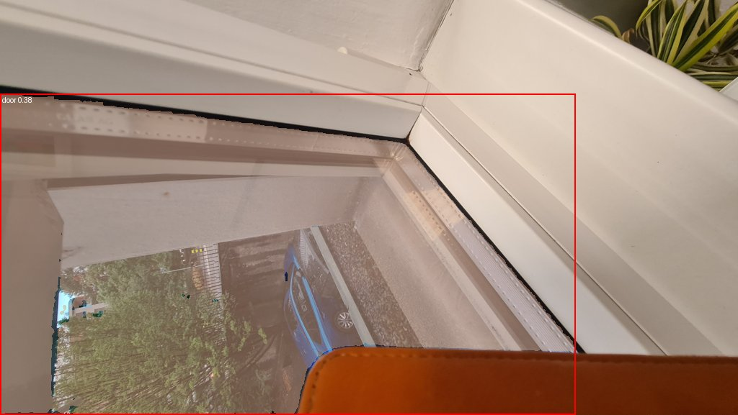  Detection result (doors and windows)

20240826_104603.jpg
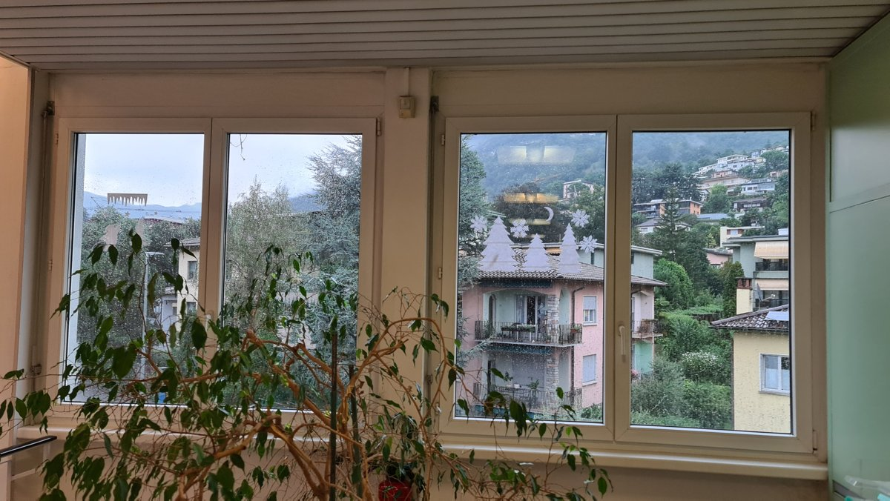  Original | 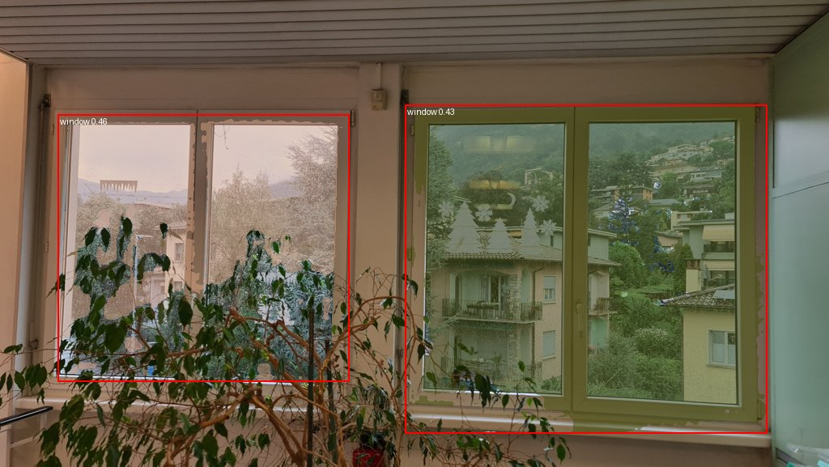  Detection result (doors and windows)

20260205_144908.jpg
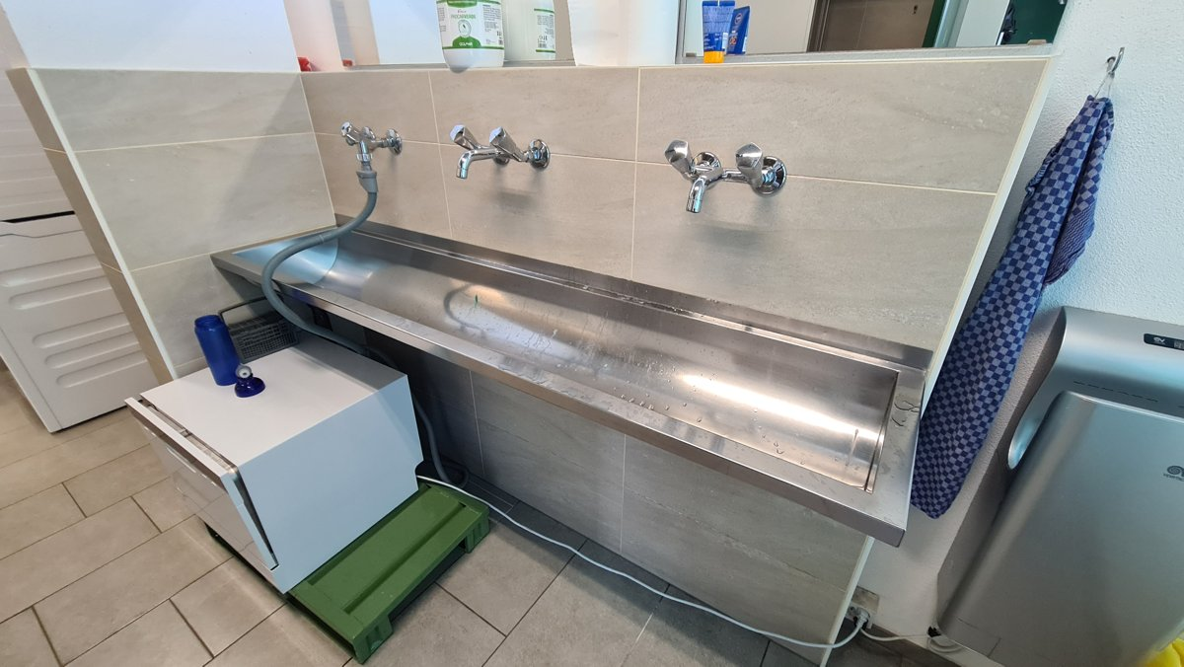  Original | 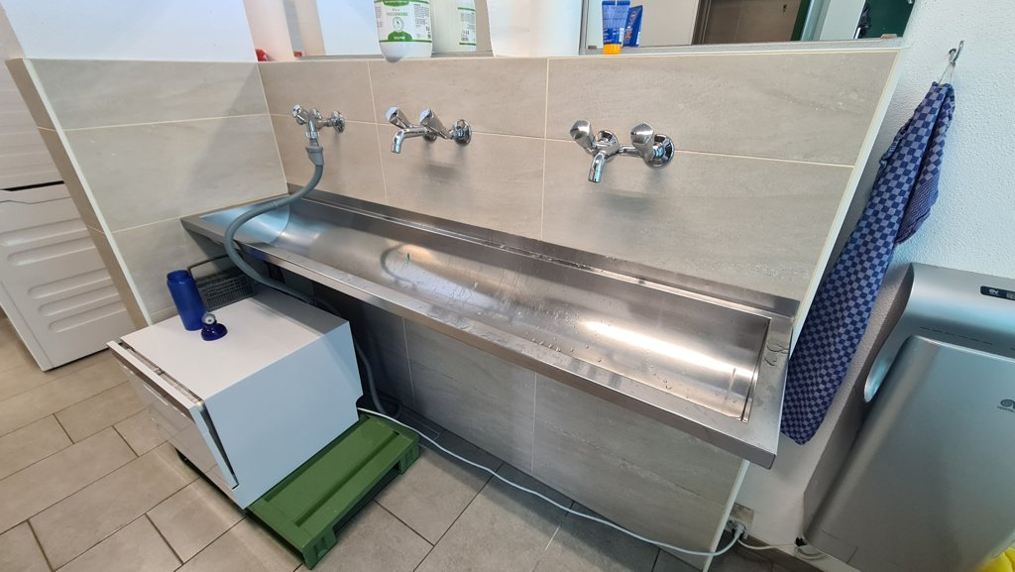  Detection result (doors and windows)

20260504_101951.jpg
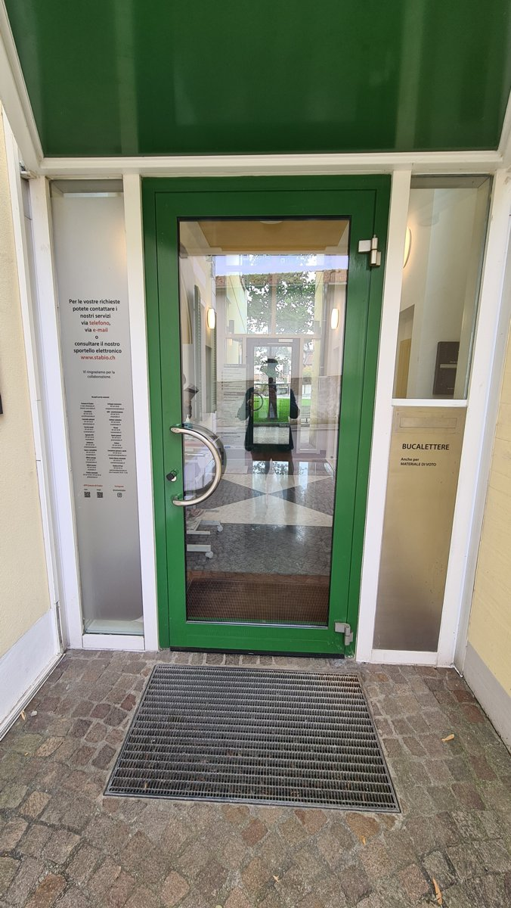  Original | 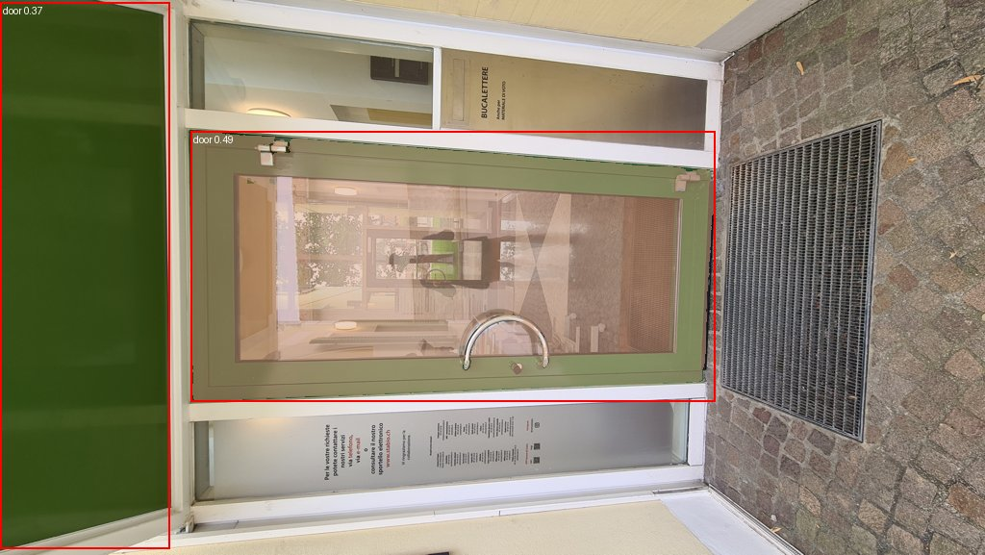  Detection result (doors and windows)

20260504_102000.jpg
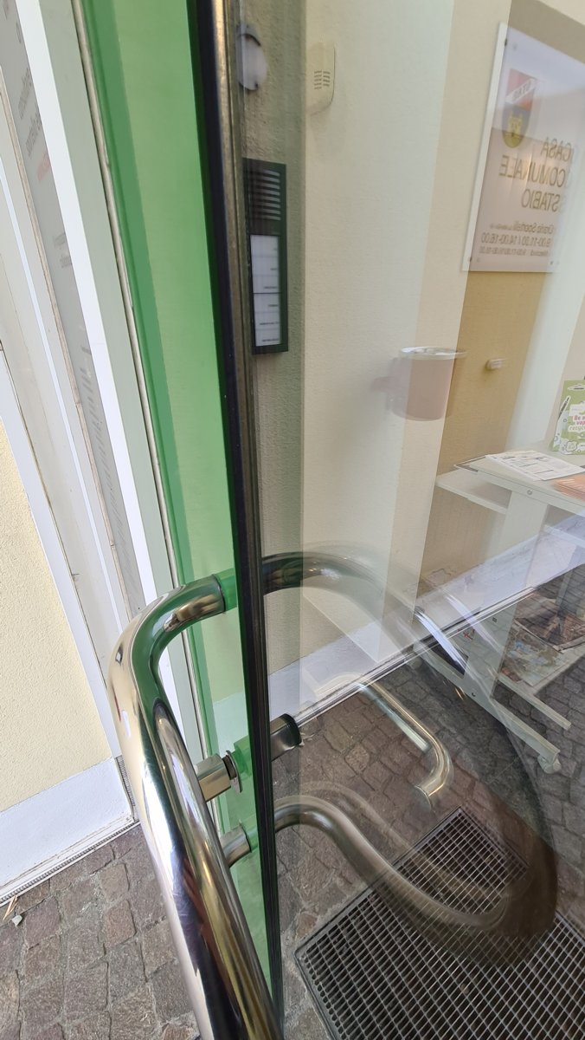  Original | 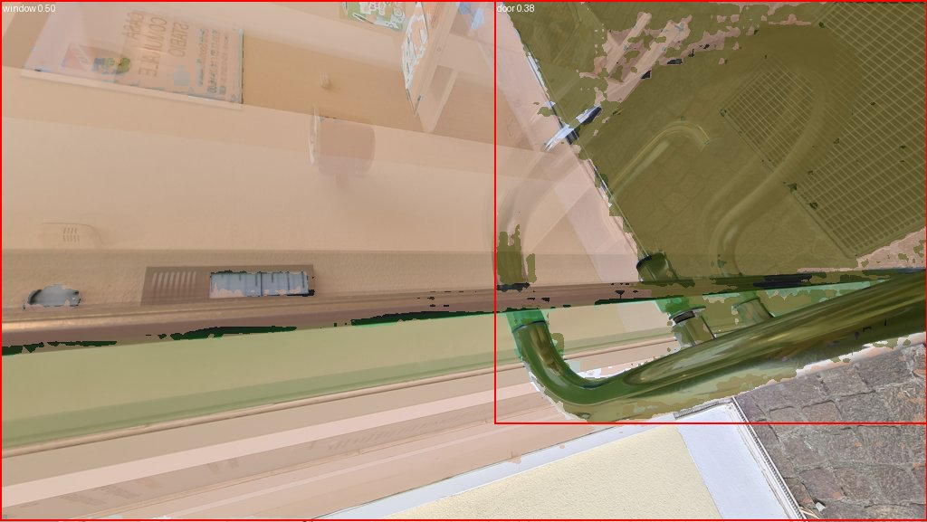  Detection result (doors and windows)

20260504_103344.jpg
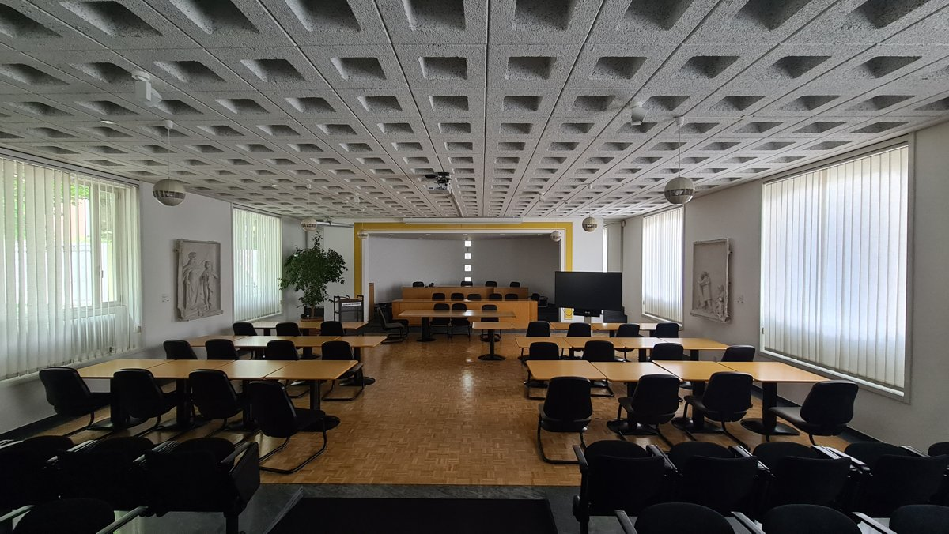  Original | 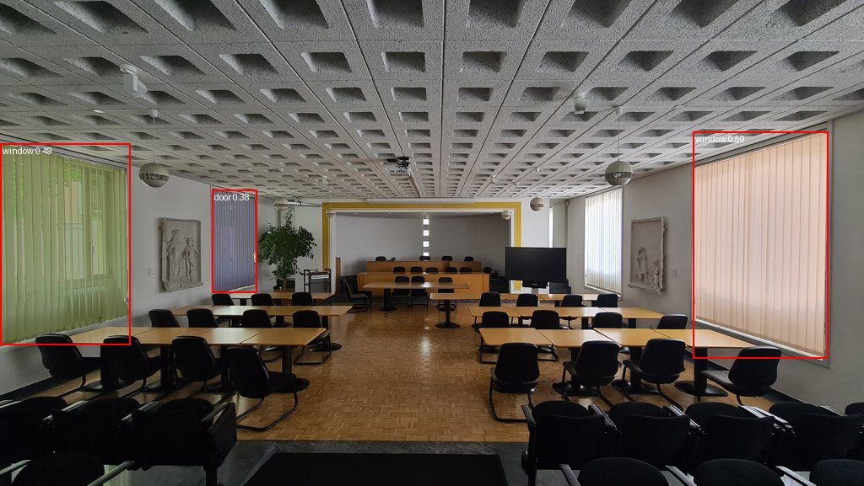  Detection result (doors and windows)

20260504_103346.jpg
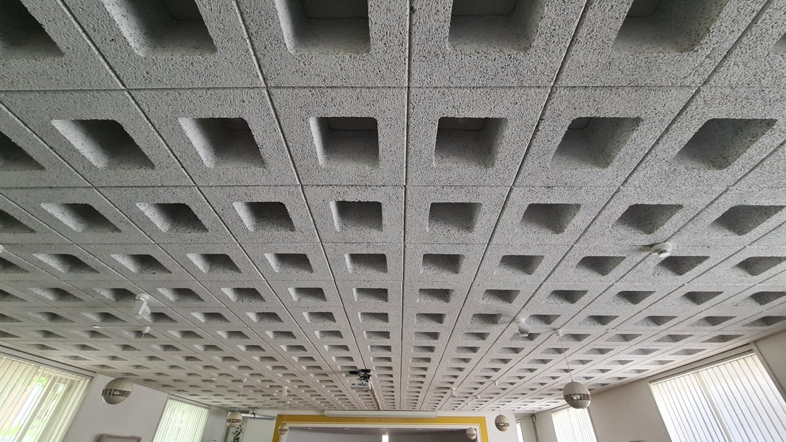  Original | 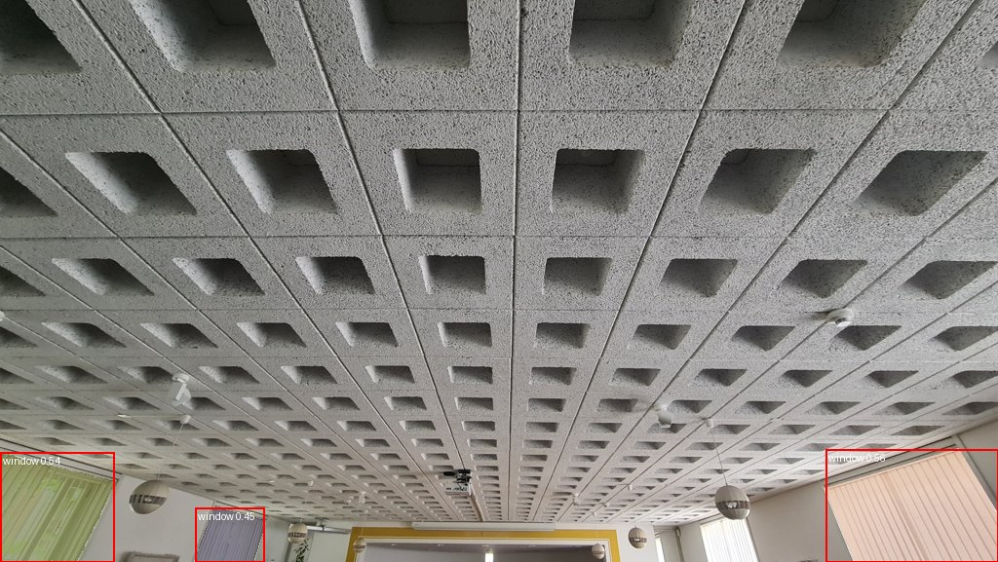  Detection result (doors and windows)

20260504_105544.jpg
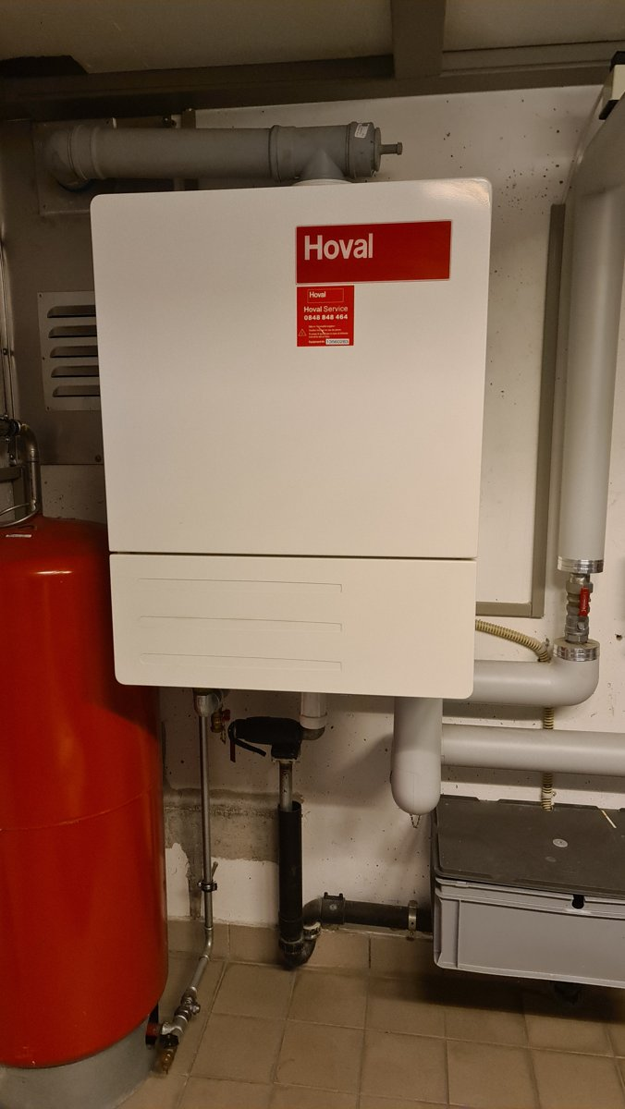  Original | 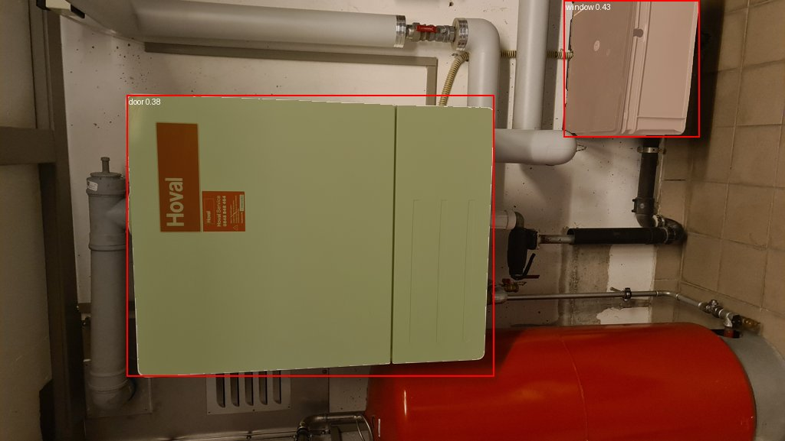  Detection result (doors and windows)

20260504_105610.jpg
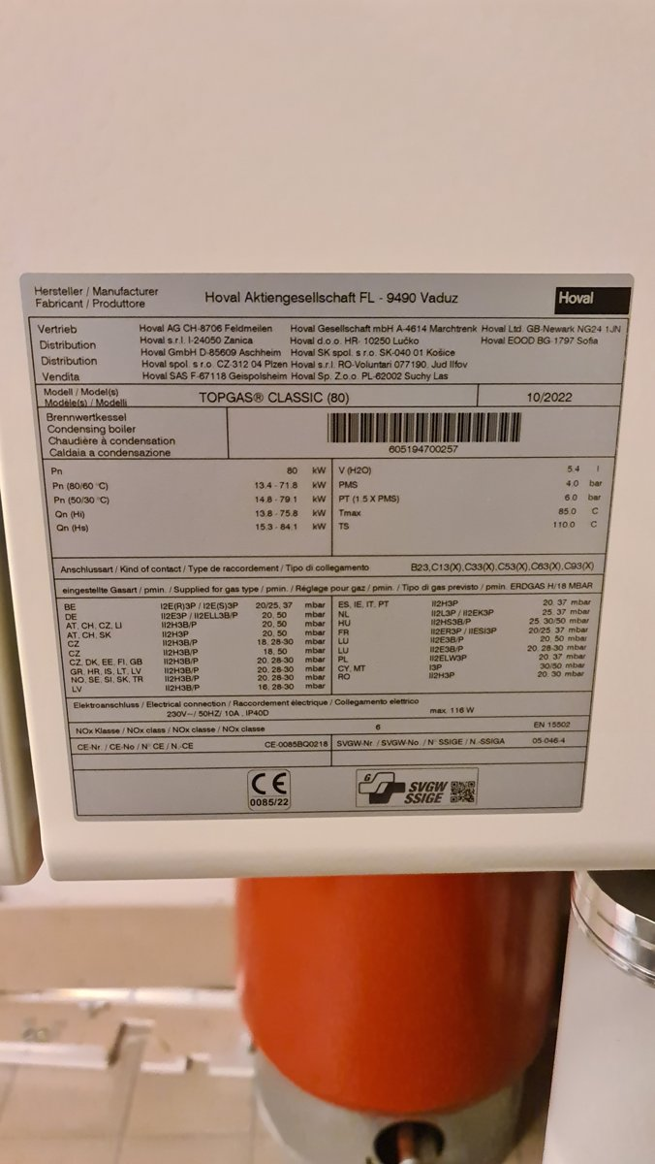  Original | 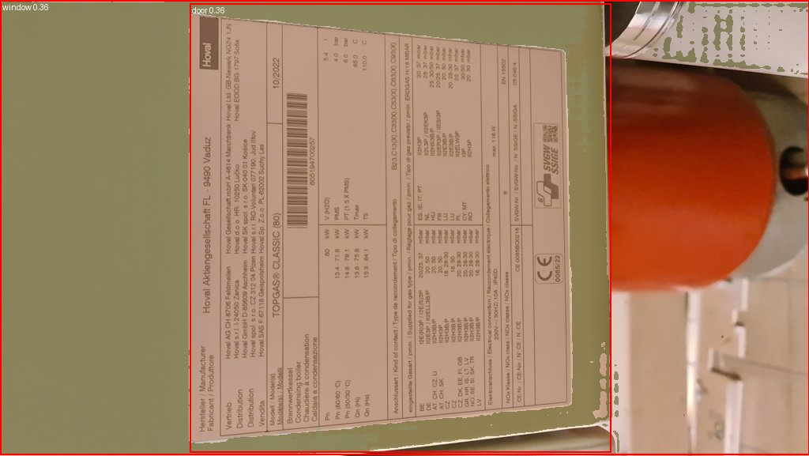  Detection result (doors and windows)

DSC_0038.JPG
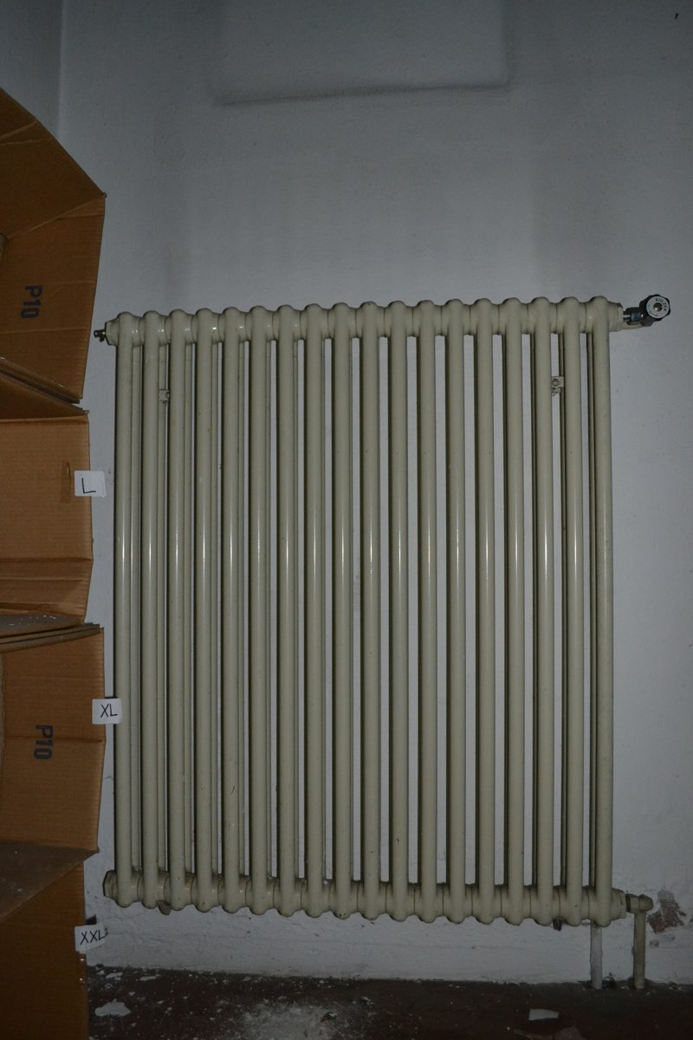  Original | 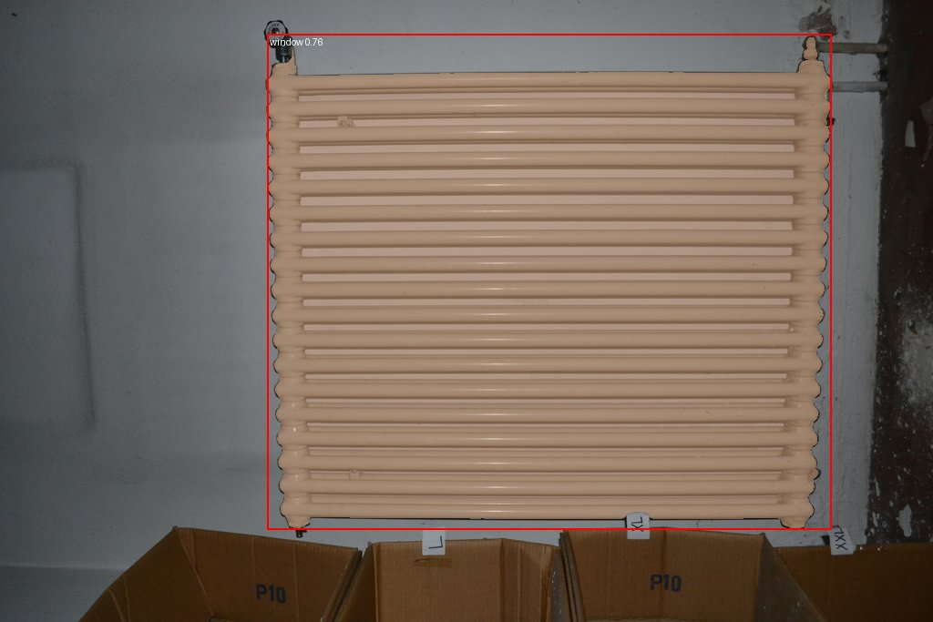  Detection result (doors and windows)

DSC_0758.JPG
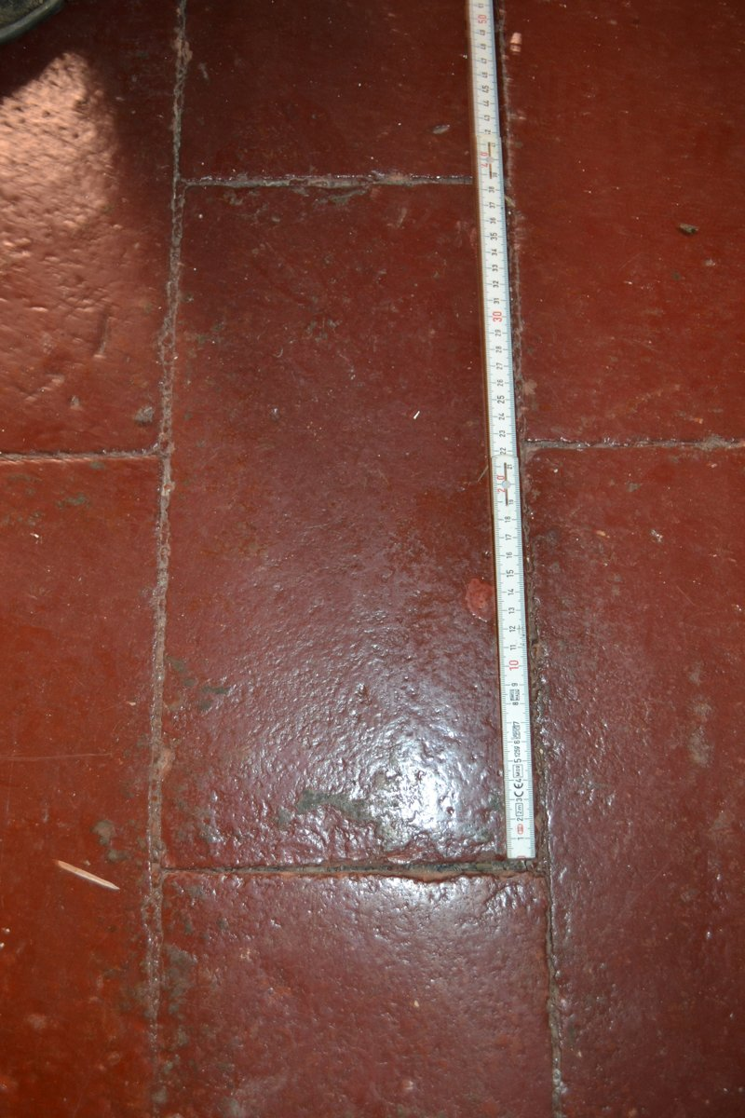  Original | 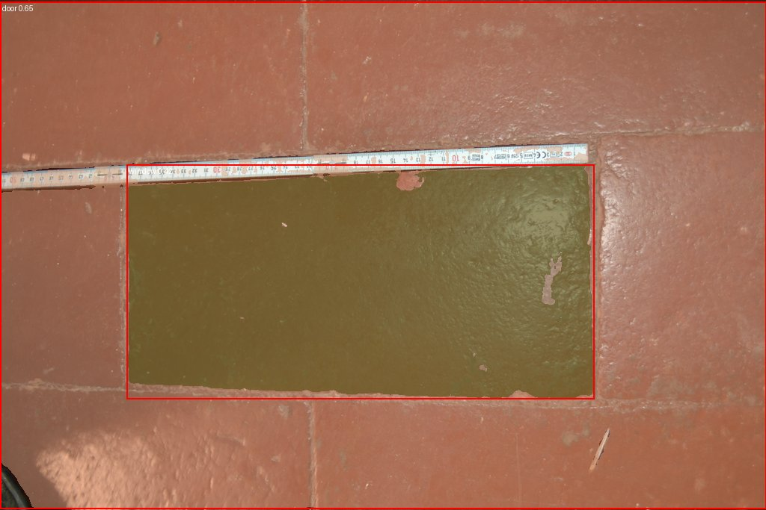  Detection result (doors and windows)

IMG_2761.HEIC
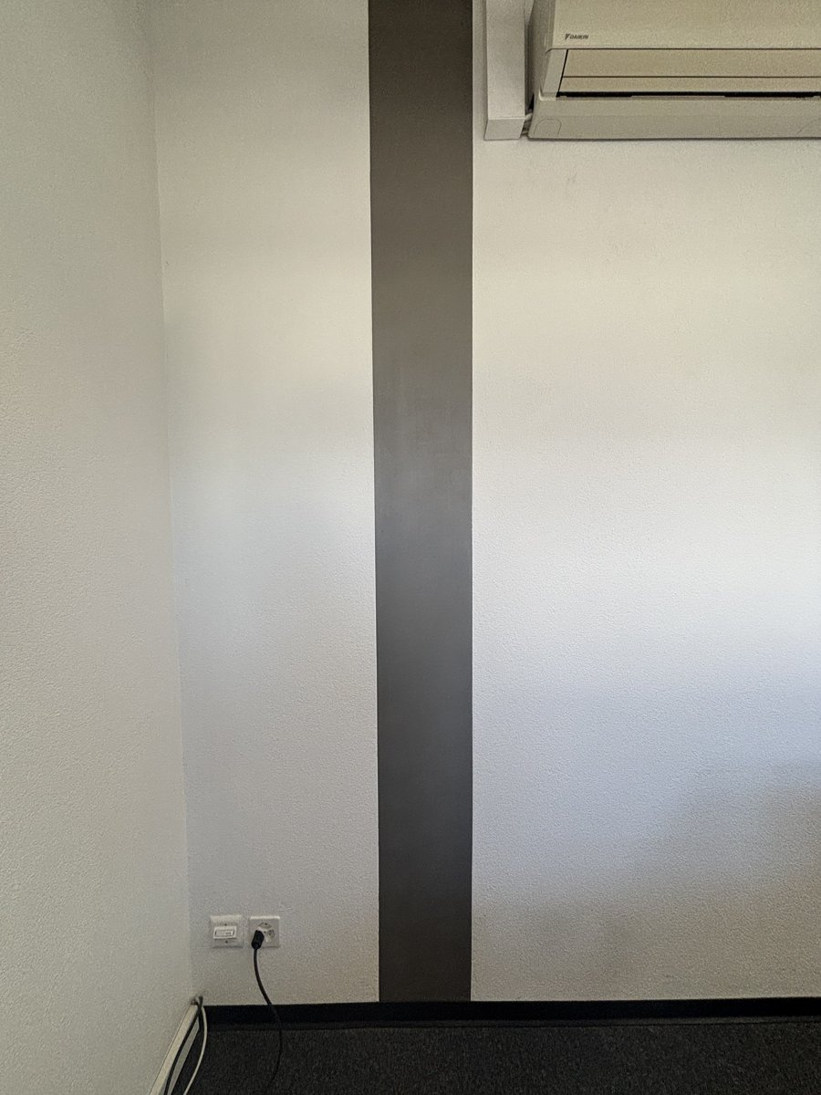  Original | 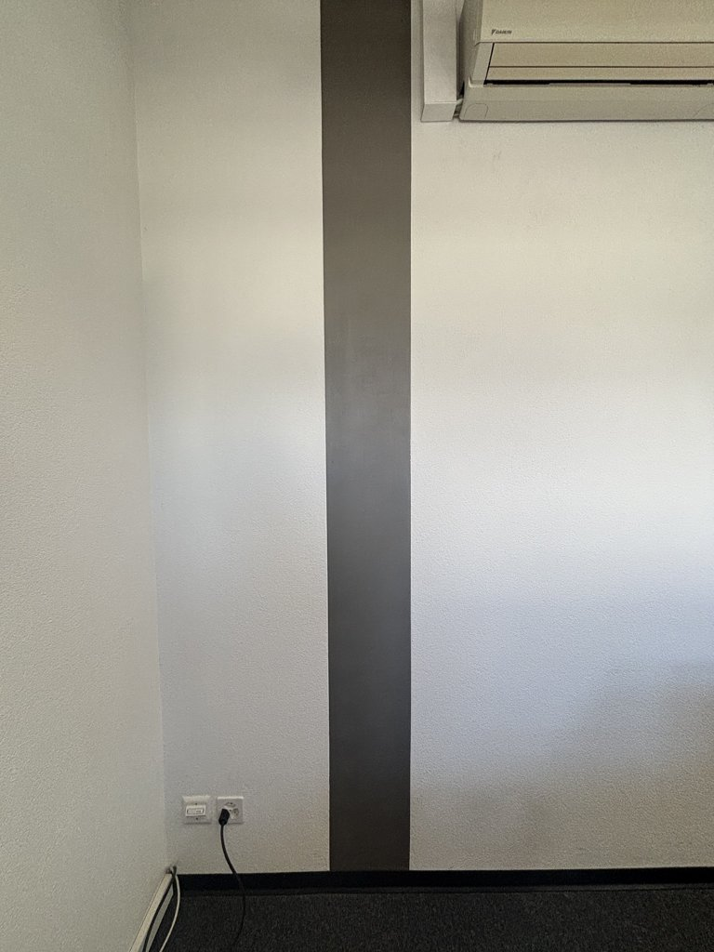  Detection result (doors and windows)

IMG_2765.jpg
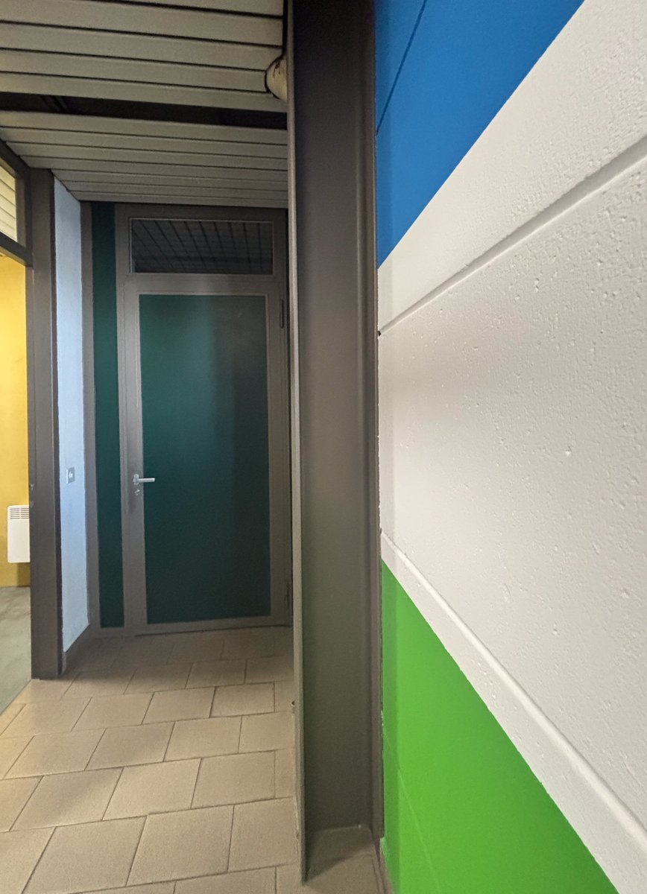  Original | 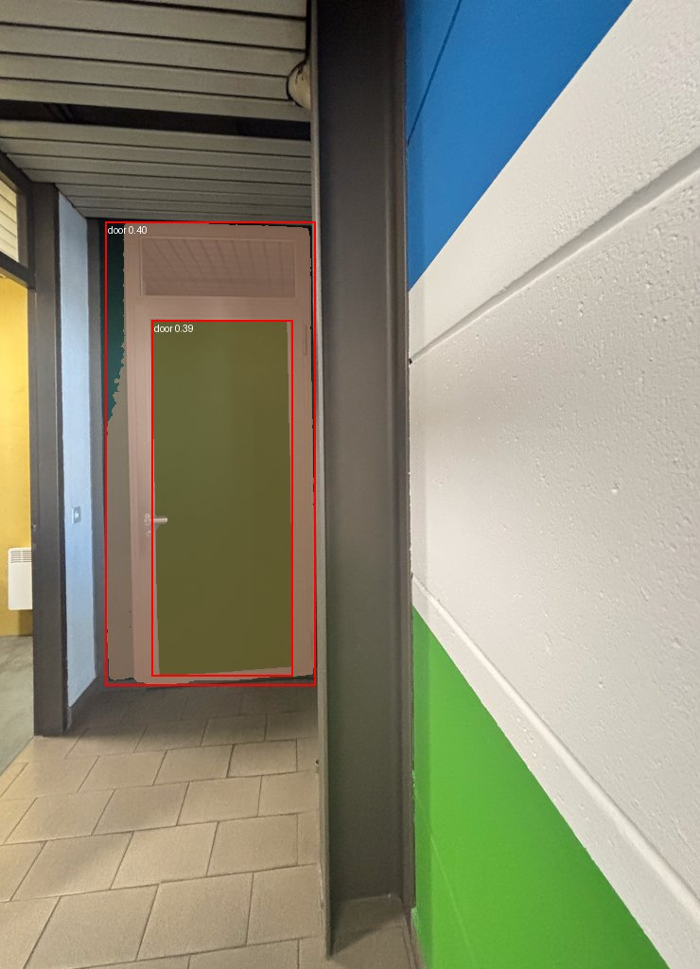  Detection result (doors and windows)

IMG_2768.jpg
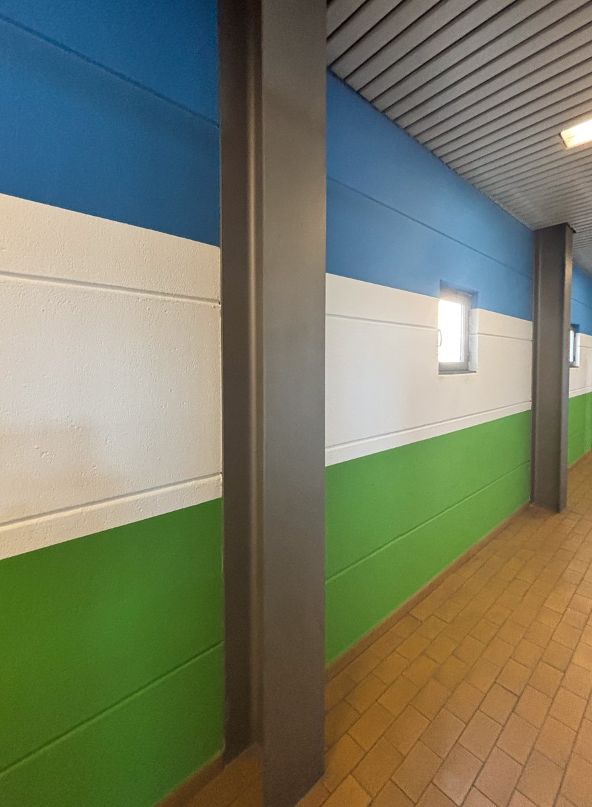  Original | 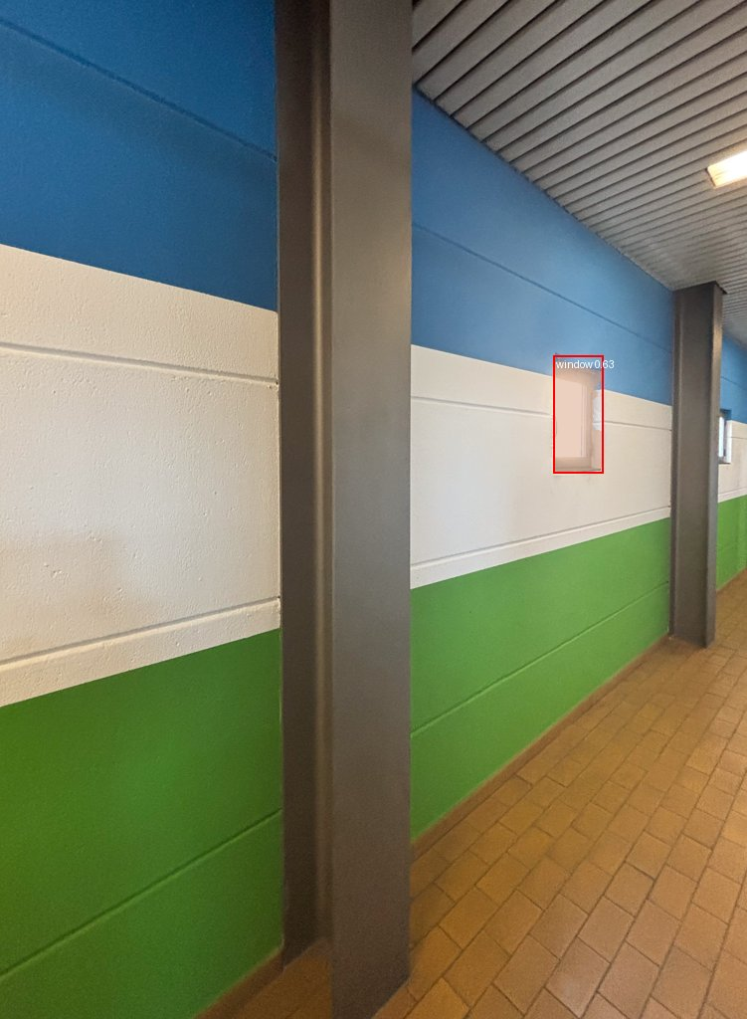  Detection result (doors and windows)

