Deconstruction audit - vLLM analysis

20240819_100055.jpg
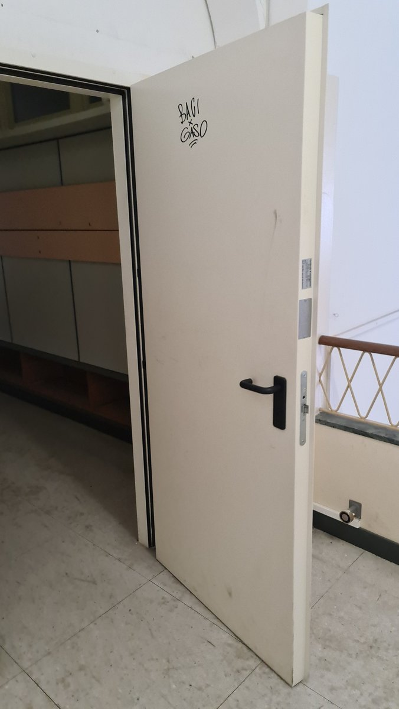 | Space type: circulation corridor  Overall condition: Fair  comp_01 - flush steel fire-rated door leaf  Category: Doors & Portals  Materials: carbon steel, mineral core, paint coating  Salvage tier: refurbish_reuse  Hardware: black lever handle, mortise lock, strike plate, door closer (partially visible)  Markings: Graffiti: 'BAGI CASO' in black marker; two silver certification/label plates on edge (partially obscured, likely fire rating or manufacturer ID)  Connection: hinged  Deconstruction notes: Remove hinges and hardware first. Inspect core for moisture or degradation. Door may require sanding and repainting. Check for lead-based paint if pre-1978. Handle with care to avoid denting.  Bounding box [ymin, xmin, ymax, xmax] (0-1000): 312, 6, 825, 968  Hazard and diagnostic flags  - Verify fire rating label content and core material (possible legacy asbestos-containing core in older buildings).  - Test for lead-based paint on door surface and hardware due to age and graffiti.  - Inspect door frame for mastic or sealant residue that may require hazardous waste handling.

20240819_100836.jpg
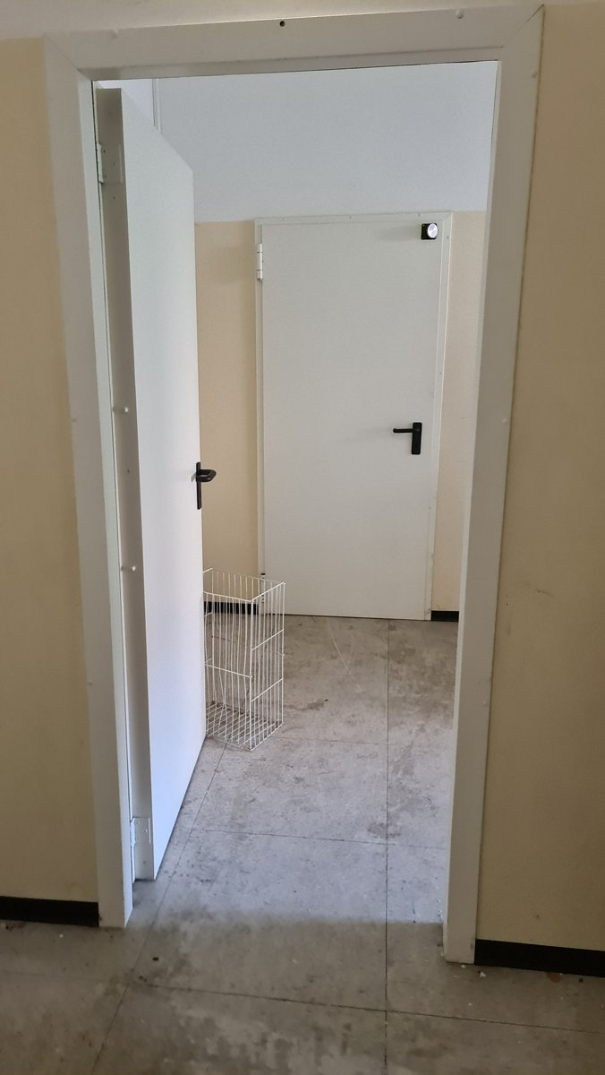 | Space type: circulation corridor  Overall condition: Fair  comp_01 - flush steel door leaf with fire-rated core  Category: Doors & Portals  Materials: cold-rolled steel, mineral wool core, paint coating  Salvage tier: refurbish_reuse  Hardware: black lever handle, mortise lock, strike plate, surface-mounted hinges  Markings: No visible manufacturer labels or certification badges; small black circular device near top right corner may be a fire alarm or smoke detector sensor.  Connection: hinged  Deconstruction notes: Remove hinges first, then carefully detach door from frame. Inspect core for moisture or degradation. Core may contain asbestos if pre-1980s; test if uncertain. Clean surface and repaint for reuse.  Bounding box [ymin, xmin, ymax, xmax] (0-1000): 152, 78, 345, 825  comp_02 - flush steel door leaf with fire-rated core  Category: Doors & Portals  Materials: cold-rolled steel, mineral wool core, paint coating  Salvage tier: refurbish_reuse  Hardware: black lever handle, mortise lock, strike plate, surface-mounted hinges  Markings: No visible manufacturer labels or certification badges; small black circular device near top right corner may be a fire alarm or smoke detector sensor.  Connection: hinged  Deconstruction notes: Remove hinges first, then carefully detach door from frame. Inspect core for moisture or degradation. Core may contain asbestos if pre-1980s; test if uncertain. Clean surface and repaint for reuse.  Bounding box [ymin, xmin, ymax, xmax] (0-1000): 415, 198, 745, 578  comp_03 - wire mesh storage basket  Category: Finishes & Coverings  Materials: galvanized steel wire  Salvage tier: direct_reuse  Markings: No visible markings or labels.  Connection: self-standing  Deconstruction notes: Lift out manually; no disassembly required. Clean with wire brush and mild detergent. Suitable for reuse in storage or utility areas.  Bounding box [ymin, xmin, ymax, xmax] (0-1000): 333, 525, 475, 698  Hazard and diagnostic flags  - Core material of steel doors may contain legacy asbestos insulation; verify via sampling if building predates 1980.  - Black baseboard trim may contain lead-based paint; test if building predates 1978.  - Mastic or sealant at door frame joints may contain VOCs or hazardous adhesives; inspect and test if necessary.

20240824_110946.jpg
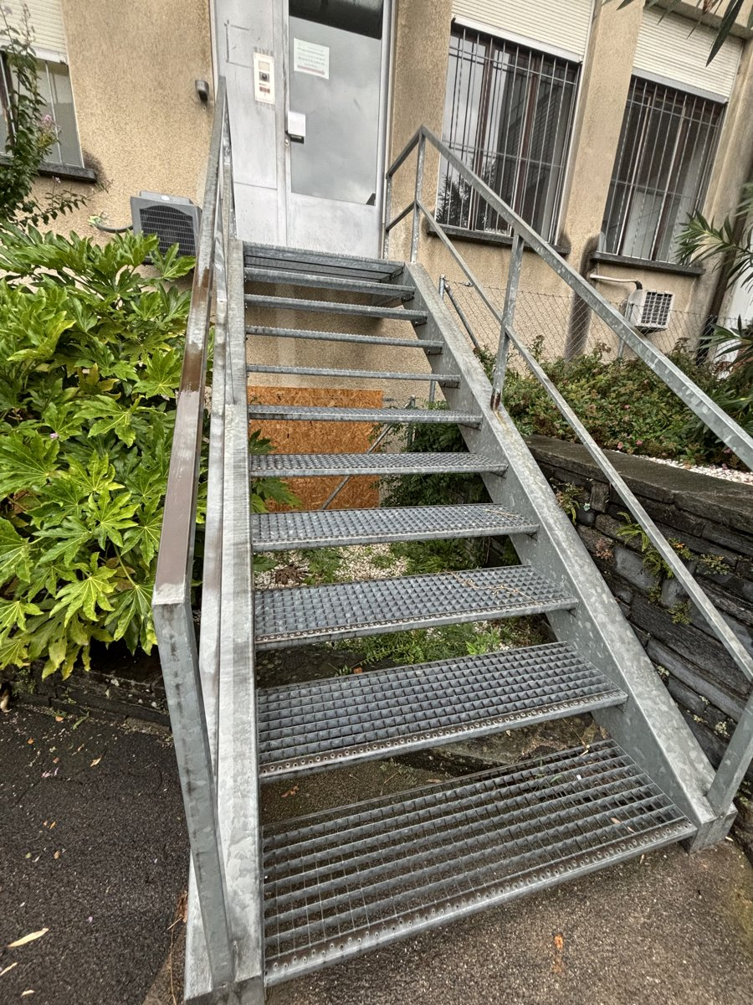 | Space type: exterior stairwell  Overall condition: Fair  comp_01 - galvanized steel handrail and guardrail assembly  Category: Railings & Guards  Materials: galvanized steel  Salvage tier: direct_reuse  Markings: No visible labels or markings  Connection: welded to stair stringers and anchored to concrete base  Deconstruction notes: Disassemble by cutting welds at stringer connections; inspect for corrosion at base anchors; remove with care to avoid bending or kinking tubular sections.  Bounding box [ymin, xmin, ymax, xmax] (0-1000): 198, 78, 999, 999  comp_02 - galvanized steel stair treads with diamond plate surface  Category: Railings & Guards  Materials: galvanized steel  Salvage tier: direct_reuse  Markings: No visible labels or markings  Connection: welded to steel stringers  Deconstruction notes: Cut welds at stringer connections; inspect for localized corrosion or pitting; treads may be reused as industrial flooring or platform decking.  Bounding box [ymin, xmin, ymax, xmax] (0-1000): 312, 238, 935, 985  comp_03 - steel door with intercom and signage  Category: Doors & Portals  Materials: steel, glass, plastic  Salvage tier: refurbish_reuse  Hardware: intercom panel, door handle, lock mechanism, strike plate  Markings: White paper signage with text; no visible manufacturer markings  Connection: hinged, surface-mounted  Deconstruction notes: Remove door hinges and disconnect intercom wiring; inspect door leaf for denting or warping; clean and repaint for reuse in industrial or commercial applications.  Bounding box [ymin, xmin, ymax, xmax] (0-1000): 278, 0, 525, 258  Hazard and diagnostic flags  - Inspect galvanized steel for lead-based paint or zinc-rich coatings; test for presence of hazardous mastic or sealants at base anchors.  - Verify condition of concrete base and embedded anchors for structural integrity prior to removal.

20240826_095451.jpg
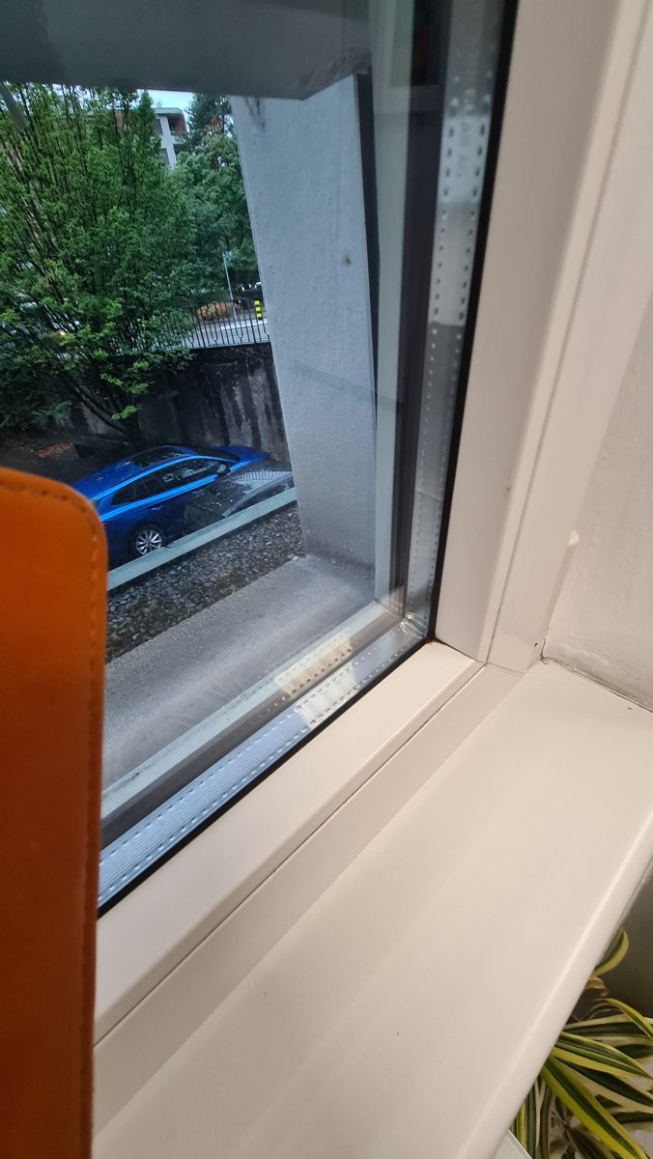 | Space type: interior window opening / room corner  Overall condition: Good  comp_01 - interior window sill and frame assembly  Category: Finishes & Coverings  Materials: polyvinyl chloride (PVC) or painted aluminum, glass  Salvage tier: refurbish_reuse  Markings: No visible manufacturer labels or certification badges; surface shows minor paint chipping and dirt accumulation.  Connection: dry-bolted or snap-fit to structural frame  Deconstruction notes: Remove by detaching from structural frame using screwdriver or pry tool; inspect for sealant or adhesive residue; clean and repaint for reuse in similar applications.  Bounding box [ymin, xmin, ymax, xmax] (0-1000): 142, 550, 999, 999  comp_02 - fixed glass window unit  Category: Doors & Portals  Materials: tempered or laminated glass, aluminum or PVC frame  Salvage tier: direct_reuse  Markings: No visible labels; glass appears to be double-glazed with visible spacer bar and desiccant beads.  Connection: glazed into frame with gasket or sealant  Deconstruction notes: Carefully remove glass unit by releasing gasket or sealant; inspect for cracks or delamination; suitable for reuse in non-load-bearing applications.  Bounding box [ymin, xmin, ymax, xmax] (0-1000): 0, 0, 789, 792  Hazard and diagnostic flags  - Verify presence of lead-based paint on window frame or sill prior to sanding or removal; test sealant for VOCs or asbestos if building predates 1980.  - Inspect glass for laminated safety film or interlayer; if present, handle with care to avoid shattering during removal.

20240826_104603.jpg
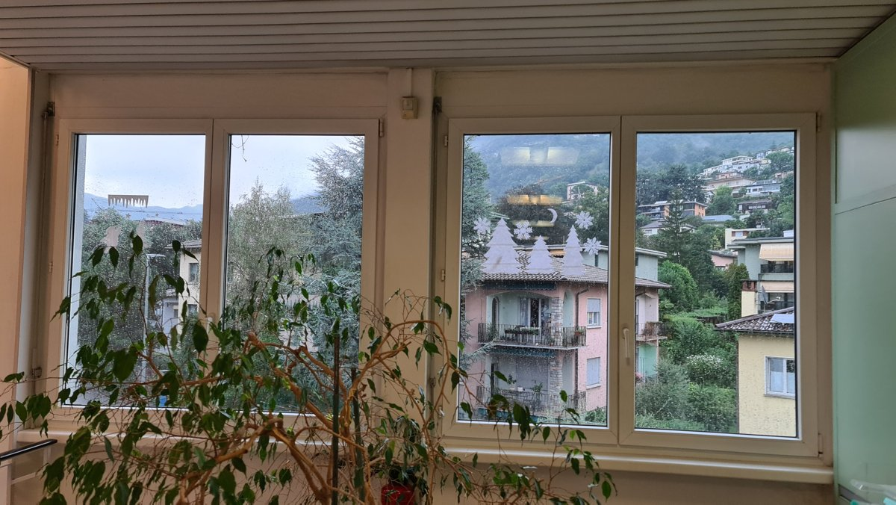 | Space type: interior window bay / balcony access area  Overall condition: Good  comp_01 - double-glazed casement window unit (two-leaf configuration)  Category: Doors & Portals  Materials: PVC-U (polyvinyl chloride), tempered glass, aluminum reinforcement, EPDM seals  Salvage tier: direct_reuse  Hardware: white plastic tilt-and-turn handle, internal locking mechanism, hinge pins (likely steel)  Markings: no visible manufacturer labels or certification badges; window glass has decorative snowflake decals (non-structural)  Connection: hinged, surface-mounted to window frame with concealed hinge pins  Deconstruction notes: Remove by disengaging locking mechanism, releasing hinges, and carefully lifting out. Check for sealant or mastic at frame-to-wall interface; may require gentle prying with flat bar. Glass panes are likely laminated or double-glazed—handle with care to avoid breakage.  Bounding box [ymin, xmin, ymax, xmax] (0-1000): 48, 135, 925, 920  comp_02 - interior window sill (likely PVC or painted wood)  Category: Finishes & Coverings  Materials: PVC-U or painted MDF/wood composite  Salvage tier: refurbish_reuse  Markings: no visible markings  Connection: adhered or dry-fitted to window frame  Deconstruction notes: Remove by gently prying from frame; may be glued with silicone or acrylic sealant. Clean and sand for refinishing if surface is intact.  Bounding box [ymin, xmin, ymax, xmax] (0-1000): 48, 820, 925, 950  comp_03 - ceiling soffit with horizontal slats (likely PVC or painted wood)  Category: Finishes & Coverings  Materials: PVC-U or painted wood  Salvage tier: refurbish_reuse  Markings: no visible markings  Connection: screwed or nailed to ceiling joists  Deconstruction notes: Remove by unscrewing or prying slats from backing; check for moisture damage or mold at joints.  Bounding box [ymin, xmin, ymax, xmax] (0-1000): 0, 0, 999, 140  Hazard and diagnostic flags  - Verify presence of legacy sealants or adhesives at window frame-to-wall interface—may contain VOCs or formaldehyde; test if necessary.  - Inspect window glass for laminated safety glazing (PVB interlayer) or low-emissivity coatings—may affect recycling value.  - Check for hidden insulation or mastic behind window frame—potential for asbestos or CFC-based foams in older builds (though this unit appears modern).

20260205_144908.jpg
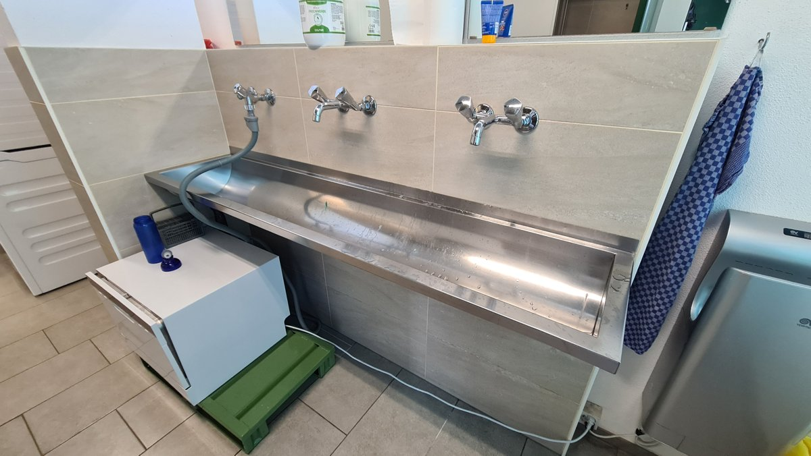 | Space type: locker room or utility washroom  Overall condition: Good  comp_01 - stainless steel trough sink with integrated backsplash  Category: Casework & Millwork  Materials: stainless steel (likely 304 or 316 grade)  Salvage tier: direct_reuse  Hardware: three chrome-plated wall-mounted faucets with lever handles, flexible grey supply hose  Markings: no visible manufacturer labels or certification badges; surface appears clean and unmarked  Connection: surface-mounted to tiled wall, likely bolted or welded at back edge  Deconstruction notes: Remove by disconnecting supply lines and unscrewing mounting brackets from wall. Ensure no hidden welds or adhesives at junctions. Use care to avoid scratching stainless surface.  Bounding box [ymin, xmin, ymax, xmax] (0-1000): 175, 162, 885, 825  comp_02 - large-format ceramic wall tiles  Category: Finishes & Coverings  Materials: ceramic tile, cementitious thin-set adhesive, grout  Salvage tier: refurbish_reuse  Markings: no visible manufacturer markings; uniform beige/cream color with subtle veining  Connection: thin-set adhesive with grouted joints  Deconstruction notes: Tiles can be removed with tile removal tools; may require scoring and prying. Check for moisture damage or delamination. Grout may need cleaning or replacement for reuse.  Bounding box [ymin, xmin, ymax, xmax] (0-1000): 17, 95, 885, 575  comp_03 - floor tiles  Category: Finishes & Coverings  Materials: ceramic or porcelain tile, cementitious adhesive, grout  Salvage tier: refurbish_reuse  Markings: no visible markings; uniform light beige square tiles  Connection: thin-set adhesive with grouted joints  Deconstruction notes: Remove using tile removal tools; inspect for cracks or chipping. Grout may need reapplication for reuse.  Bounding box [ymin, xmin, ymax, xmax] (0-1000): 0, 575, 725, 1000  comp_04 - chrome-plated wall-mounted faucets  Category: Hardware & Fixtures  Materials: brass or chrome-plated metal, rubber washers, plastic fittings  Salvage tier: refurbish_reuse  Hardware: lever handles, flexible supply hose (one visible)  Markings: no visible brand or model markings  Connection: threaded wall mount with compression fittings  Deconstruction notes: Disconnect supply lines and unscrew from wall. Clean and inspect for corrosion or mineral buildup. Reuse with new washers if needed.  Bounding box [ymin, xmin, ymax, xmax] (0-1000): 280, 175, 665, 325  comp_05 - white compact utility cabinet  Category: Casework & Millwork  Materials: particleboard or MDF, melamine laminate, steel frame or hinges  Salvage tier: material_recycling  Hardware: hinges, drawer slide (partially visible)  Markings: no visible labels; white finish with slight wear  Connection: surface-mounted or freestanding  Deconstruction notes: Disassemble by removing doors and drawers. Separate metal components from wood composites. Check for adhesives or laminates.  Bounding box [ymin, xmin, ymax, xmax] (0-1000): 100, 500, 350, 890  comp_06 - green plastic step stool  Category: Casework & Millwork  Materials: recycled HDPE or polypropylene  Salvage tier: direct_reuse  Markings: no visible markings  Connection: freestanding  Deconstruction notes: Clean and inspect for cracks or deformation. Suitable for reuse in utility or storage areas.  Bounding box [ymin, xmin, ymax, xmax] (0-1000): 235, 715, 415, 990  Hazard and diagnostic flags  - Verify presence of lead-based paint or hazardous adhesives on wall tiles or cabinet surfaces prior to removal.  - Inspect behind sink for legacy insulation or mastic that may contain asbestos or formaldehyde-based binders.  - Check electrical outlet near sink for proper grounding and moisture protection; verify no exposed wiring.

20260504_101951.jpg
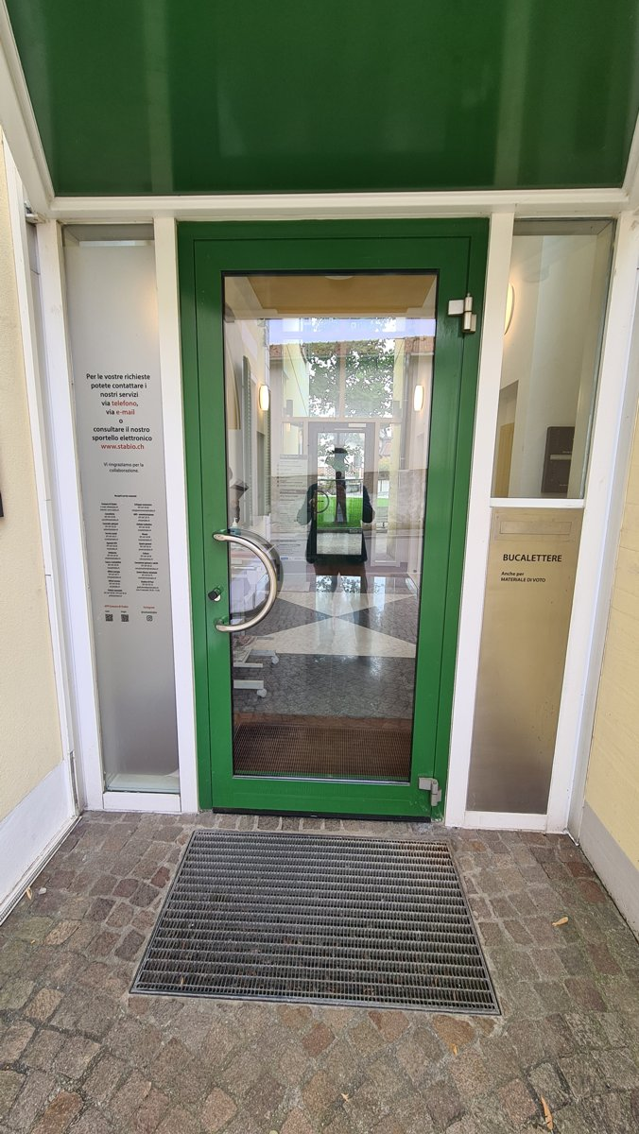 | Space type: entrance portal  Overall condition: Good  comp_01 - green-painted steel door leaf with glazed panel  Category: Doors & Portals  Materials: carbon steel, tempered glass, paint coating  Salvage tier: direct_reuse  Hardware: chrome-plated D-shaped pull handle, surface-mounted latch, strike plate, door closer (not visible but implied by function)  Markings: No visible manufacturer markings or certification badges; text on adjacent panels is informational (contact details, 'BUCALETTERE')  Connection: hinged  Deconstruction notes: Remove hinges carefully to preserve door leaf integrity. Check for sealant or gasket at frame interface; may require gentle prying. Door appears to be in good condition with no visible warping or damage.  Bounding box [ymin, xmin, ymax, xmax] (0-1000): 285, 194, 765, 722  comp_02 - metal grating entrance mat  Category: Finishes & Coverings  Materials: galvanized steel  Salvage tier: direct_reuse  Markings: No visible markings  Connection: surface-laid  Deconstruction notes: Lift out manually; no fasteners. Clean and inspect for corrosion before reuse.  Bounding box [ymin, xmin, ymax, xmax] (0-1000): 198, 728, 788, 897  comp_03 - side panel with frosted glass and letterbox  Category: Casework & Millwork  Materials: aluminum or steel frame, frosted glass, metal letterbox insert  Salvage tier: refurbish_reuse  Hardware: letterbox slot, label plate with text 'BUCALETTERE'  Markings: Text: 'BUCALETTERE', 'Anche per MATERIALE DI VOTO'  Connection: surface-mounted  Deconstruction notes: Remove by detaching from frame or wall. Clean glass and frame; inspect for paint adhesion or corrosion.  Bounding box [ymin, xmin, ymax, xmax] (0-1000): 715, 194, 965, 728  comp_04 - side panel with informational signage  Category: Casework & Millwork  Materials: aluminum or steel frame, frosted glass, printed vinyl or adhesive label  Salvage tier: refurbish_reuse  Markings: Text: 'Per le vostre richieste potete contattare i nostri servizi via telefono, via e-mail o consultare il nostro sportello elettronico www.stabio.ch'  Connection: surface-mounted  Deconstruction notes: Remove by detaching from frame or wall. Peel off adhesive labels if needed; frame may be reused.  Bounding box [ymin, xmin, ymax, xmax] (0-1000): 95, 194, 285, 728  Hazard and diagnostic flags  - Verify presence of sealant or mastic at door frame-to-wall interface; may contain legacy VOCs or asbestos if original construction predates 1980.  - Inspect door core for potential mineral wool or foam insulation; if present, test for hazardous fibers or chemical degradation before handling.

20260504_102000.jpg
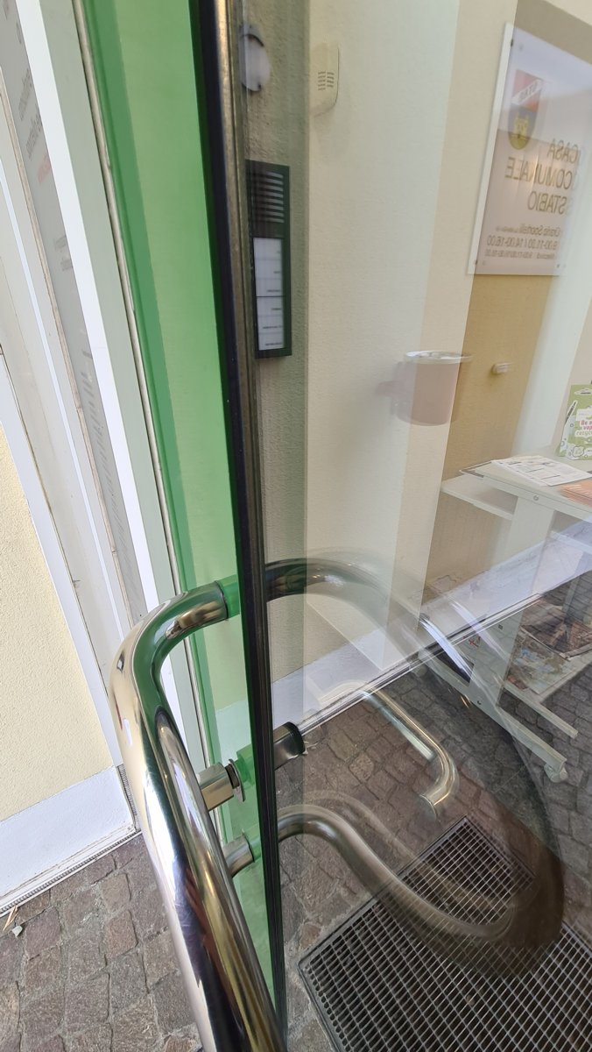 | Space type: circulation corridor  Overall condition: Good  comp_01 - stainless steel handrail with curved profile  Category: Railings & Guards  Materials: stainless steel  Salvage tier: direct_reuse  Hardware: surface-mounted brackets, welded joints  Markings: no visible labels or markings  Connection: surface-mounted with bracketed supports  Deconstruction notes: Remove by unscrewing or unbolting mounting brackets; inspect for weld integrity and surface corrosion; clean with mild detergent and stainless steel polish for reuse.  Bounding box [ymin, xmin, ymax, xmax] (0-1000): 178, 527, 782, 998  comp_02 - frameless glass door with metal edge trim  Category: Doors & Portals  Materials: tempered glass, aluminum or stainless steel trim  Salvage tier: direct_reuse  Hardware: door handle (not visible), door closer (not visible), glass-to-frame gasket  Markings: no visible labels or markings  Connection: edge-mounted with gasketed frame  Deconstruction notes: Carefully remove glass panel by releasing gaskets and lifting vertically; inspect for edge chipping or scratches; store flat to prevent stress fractures.  Bounding box [ymin, xmin, ymax, xmax] (0-1000): 112, 0, 488, 998  comp_03 - paved stone flooring with metal grating  Category: Finishes & Coverings  Materials: natural stone pavers, galvanized steel grating  Salvage tier: material_recycling  Hardware: grating fasteners (not visible)  Markings: no visible labels or markings  Connection: mortared or bedded in sand, grating secured with clips or welds  Deconstruction notes: Remove grating by cutting or prying fasteners; stone pavers can be lifted with pry bar and reused if intact; separate metal and stone for recycling.  Bounding box [ymin, xmin, ymax, xmax] (0-1000): 0, 600, 998, 998  comp_04 - white metal display stand with glass top  Category: Casework & Millwork  Materials: steel frame, tempered glass, powder-coated finish  Salvage tier: refurbish_reuse  Hardware: adjustable shelf brackets, foot levelers  Markings: no visible labels or markings  Connection: bolted assembly  Deconstruction notes: Disassemble by removing bolts; inspect for coating damage; sand and repaint if needed; glass top can be reused if undamaged.  Bounding box [ymin, xmin, ymax, xmax] (0-1000): 732, 425, 998, 745  Hazard and diagnostic flags  - Verify presence of lead-based paint on metal components prior to sanding or cutting; test for VOCs in adhesives or sealants used in glass gaskets; inspect grating for galvanic corrosion if in contact with dissimilar metals.

20260504_103344.jpg
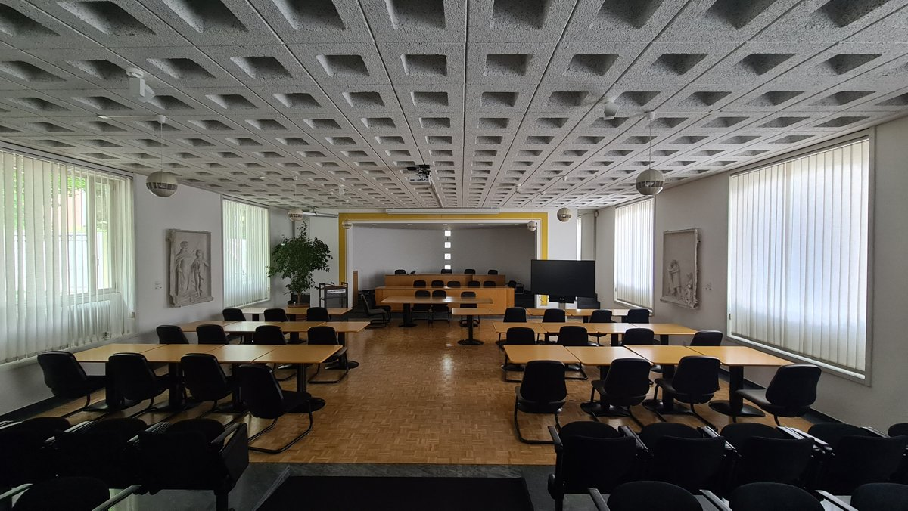 | Space type: lecture hall / classroom  Overall condition: Good  comp_01 - acoustic ceiling tile grid system  Category: Finishes & Coverings  Materials: concrete, aggregate, cementitious matrix  Salvage tier: material_recycling  Hardware: suspended grid hangers, metal cross-tees  Markings: no visible manufacturer markings; uniform gray finish with geometric voids  Connection: suspended grid system with wire hangers  Deconstruction notes: Remove tiles carefully to avoid dust; grid system may be reused if structurally sound; test for asbestos if pre-1980s construction  Bounding box [ymin, xmin, ymax, xmax] (0-1000): 0, 0, 999, 412  comp_02 - wooden classroom tables (rectangular, pedestal base)  Category: Casework & Millwork  Materials: laminate-faced particleboard, steel pedestal, powder-coated steel base  Salvage tier: refurbish_reuse  Hardware: steel pedestal legs, adjustable foot glides, table top edge banding  Markings: no visible labels; uniform light wood veneer finish  Connection: bolted pedestal to tabletop  Deconstruction notes: Disassemble by removing bolts from pedestal; inspect for warping or delamination; clean and refinish for reuse  Bounding box [ymin, xmin, ymax, xmax] (0-1000): 0, 580, 999, 900  comp_03 - black office chairs (stackable, metal frame)  Category: Casework & Millwork  Materials: steel frame, polypropylene shell, fabric upholstery  Salvage tier: refurbish_reuse  Hardware: casters, gas lift mechanism, adjustable backrest, armrests  Markings: no visible branding; standard institutional design  Connection: welded frame, bolted components  Deconstruction notes: Inspect for broken casters or gas lift; clean upholstery; replace if damaged; stack for transport  Bounding box [ymin, xmin, ymax, xmax] (0-1000): 0, 580, 999, 999  comp_04 - parquet flooring (herringbone pattern)  Category: Finishes & Coverings  Materials: hardwood, varnish finish  Salvage tier: direct_reuse  Hardware: tongue-and-groove joints, subfloor fasteners  Markings: no visible labels; consistent grain and finish  Connection: nail-down or glue-down to subfloor  Deconstruction notes: Carefully pry up planks using a floor scraper; avoid chipping; sand and refinish for reuse  Bounding box [ymin, xmin, ymax, xmax] (0-1000): 0, 580, 999, 900  comp_05 - spherical pendant lights (Bauhaus-style)  Category: Lighting & Fixtures  Materials: aluminum, glass diffuser, electrical wiring  Salvage tier: direct_reuse  Hardware: ceiling canopy, suspension cable, socket base  Markings: no visible labels; minimalist design  Connection: suspended via cable from ceiling grid  Deconstruction notes: Disconnect electrical supply; remove canopy and cable; inspect for corrosion or damage  Bounding box [ymin, xmin, ymax, xmax] (0-1000): 158, 215, 732, 412  comp_06 - vertical blinds (window coverings)  Category: Partitions & Enclosures  Materials: PVC or aluminum slats, fabric or vinyl tape, metal headrail  Salvage tier: refurbish_reuse  Hardware: headrail brackets, cord system, slat connectors  Markings: no visible branding; white finish  Connection: surface-mounted to window frame  Deconstruction notes: Remove from headrail; clean slats; inspect for warping or discoloration; replace cords if frayed  Bounding box [ymin, xmin, ymax, xmax] (0-1000): 0, 280, 965, 730  comp_07 - relief sculptures (wall-mounted, plaster or stone)  Category: Art & Decorative Elements  Materials: plaster, gypsum, concrete  Salvage tier: direct_reuse  Hardware: wall anchors, mounting brackets  Markings: no visible labels; classical figures depicted  Connection: surface-mounted with mechanical fasteners  Deconstruction notes: Carefully remove with support; inspect for cracks or flaking; clean and restore if needed  Bounding box [ymin, xmin, ymax, xmax] (0-1000): 180, 445, 235, 600  comp_08 - lectern or teacher's desk (wooden, elevated platform)  Category: Casework & Millwork  Materials: solid wood, steel support frame  Salvage tier: refurbish_reuse  Hardware: drawer pulls, metal legs, adjustable feet  Markings: no visible labels; light wood finish  Connection: bolted frame to tabletop  Deconstruction notes: Disassemble by removing bolts; inspect for wood rot or moisture damage; sand and refinish  Bounding box [ymin, xmin, ymax, xmax] (0-1000): 410, 525, 565, 610  Hazard and diagnostic flags  - Verify presence of asbestos in ceiling tiles (pre-1980s construction common); test if necessary  - Inspect adhesive or mastic used in flooring installation for VOCs or hazardous compounds  - Check for lead-based paint on wall-mounted fixtures or sculptures if pre-1978 building  - Assess electrical wiring in pendant lights for insulation degradation or fire risk

20260504_103346.jpg
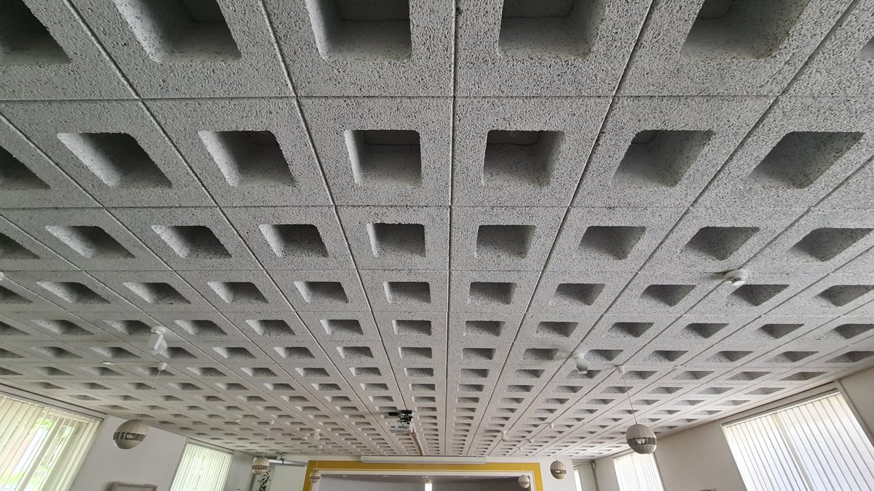 | Space type: interior circulation or open-plan space  Overall condition: Good  comp_01 - precast concrete coffered ceiling panel system  Category: Finishes & Coverings  Materials: lightweight aggregate concrete, cementitious matrix  Salvage tier: direct_reuse  Markings: No visible manufacturer markings or certification badges; surface appears unmarked.  Connection: dry-bolted or grouted at joints; likely modular grid system with interlocking or keyed edges  Deconstruction notes: Remove panels carefully by lifting from perimeter to avoid cracking; inspect for embedded fasteners or concealed wiring; avoid impact to preserve integrity of voids and surface texture.  Bounding box [ymin, xmin, ymax, xmax] (0-1000): 0, 0, 999, 940  comp_02 - spherical pendant light fixtures  Category: Lighting & Fixtures  Materials: polished metal (likely aluminum or stainless steel), glass or acrylic diffuser  Salvage tier: refurbish_reuse  Hardware: suspension rods, ceiling canopy, electrical junction box  Markings: No visible labels; fixtures appear to be standard commercial design.  Connection: suspended via threaded rods or cables from ceiling grid  Deconstruction notes: Disconnect electrical supply before removal; inspect for corrosion or damage to suspension hardware; clean and repaint if needed for reuse.  Bounding box [ymin, xmin, ymax, xmax] (0-1000): 125, 650, 750, 999  Hazard and diagnostic flags  - Verify presence of concealed wiring or conduit within ceiling voids before panel removal.  - Test for presence of legacy fireproofing or sealants in joint areas; potential for asbestos-containing materials if building predates 1980s.  - Inspect for moisture intrusion or efflorescence in concrete panels, which may indicate long-term water exposure.

20260504_105544.jpg
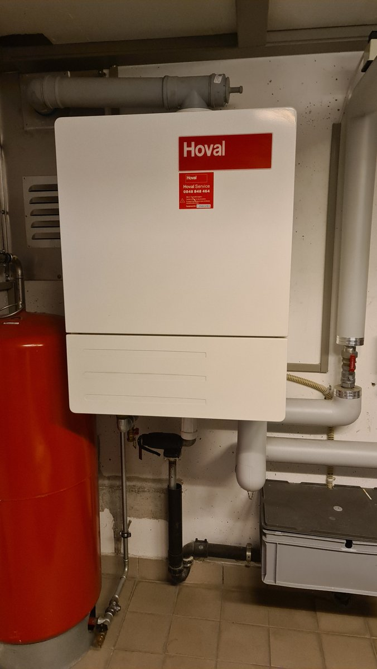 | Space type: mechanical room  Overall condition: Good  comp_01 - Hoval brand wall-mounted boiler unit  Category: Mechanical & Plumbing Fixtures  Materials: galvanized steel, insulated composite panel, plastic casing  Salvage tier: refurbish_reuse  Hardware: service access panel, pressure relief valve, gas inlet connection, drain valve  Markings: Hoval logo, Hoval Service label with phone number 0848 848 464, equipment ID 13000283, warning triangle symbol  Connection: wall-mounted with bolted flange, piped connections via threaded and compression fittings  Deconstruction notes: Disconnect gas, water, and electrical supply before removal. Remove mounting bolts and carefully lower unit to avoid damage to casing. Inspect for internal corrosion or heat damage prior to refurbishment.  Bounding box [ymin, xmin, ymax, xmax] (0-1000): 142, 158, 792, 632  comp_02 - red expansion tank (likely for heating system)  Category: Mechanical & Plumbing Fixtures  Materials: steel, polyester coating, rubber diaphragm  Salvage tier: refurbish_reuse  Hardware: pressure gauge, valve, bracket mounting  Markings: No visible labels; standard industrial red finish  Connection: bolted to wall bracket, threaded pipe connection  Deconstruction notes: Drain and depressurize before removal. Check for internal corrosion or diaphragm degradation. Reuse only if pressure-tested and functional.  Bounding box [ymin, xmin, ymax, xmax] (0-1000): 0, 465, 273, 999  comp_03 - gray plastic expansion tank or buffer tank  Category: Mechanical & Plumbing Fixtures  Materials: polypropylene, steel end caps  Salvage tier: material_recycling  Hardware: valve, pressure gauge, bracket mounting  Markings: No visible labels  Connection: bolted to wall bracket, threaded pipe connection  Deconstruction notes: Remove from mounting bracket. Separate metal end caps from plastic body for material sorting.  Bounding box [ymin, xmin, ymax, xmax] (0-1000): 688, 712, 999, 900  comp_04 - gray PVC or CPVC piping system  Category: Plumbing & Piping Systems  Materials: PVC, CPVC, brass fittings  Salvage tier: material_recycling  Hardware: elbows, tees, valves, compression fittings  Markings: No visible labels; standard gray coloration  Connection: solvent-welded joints, threaded connections  Deconstruction notes: Cut pipes at joints to separate fittings. Sort by material type (PVC/CPVC) and metal fittings for recycling.  Bounding box [ymin, xmin, ymax, xmax] (0-1000): 62, 105, 999, 735  comp_05 - ceramic tile flooring  Category: Finishes & Coverings  Materials: ceramic tile, cementitious mortar, epoxy grout  Salvage tier: material_recycling  Hardware: none  Markings: none  Connection: adhered to concrete subfloor  Deconstruction notes: Remove using tile puller or chisel. Separate tiles from mortar for recycling. Test grout for hazardous additives if unknown.  Bounding box [ymin, xmin, ymax, xmax] (0-1000): 192, 835, 999, 999  Hazard and diagnostic flags  - Verify presence of asbestos in joint compounds or insulation around pipes prior to dismantling.  - Test for lead-based paint on metal components if building predates 1978.  - Inspect boiler casing for internal corrosion or heat damage before reuse.  - Check for mastic or adhesive residues on pipe joints that may require hazardous waste handling.

20260504_105610.jpg
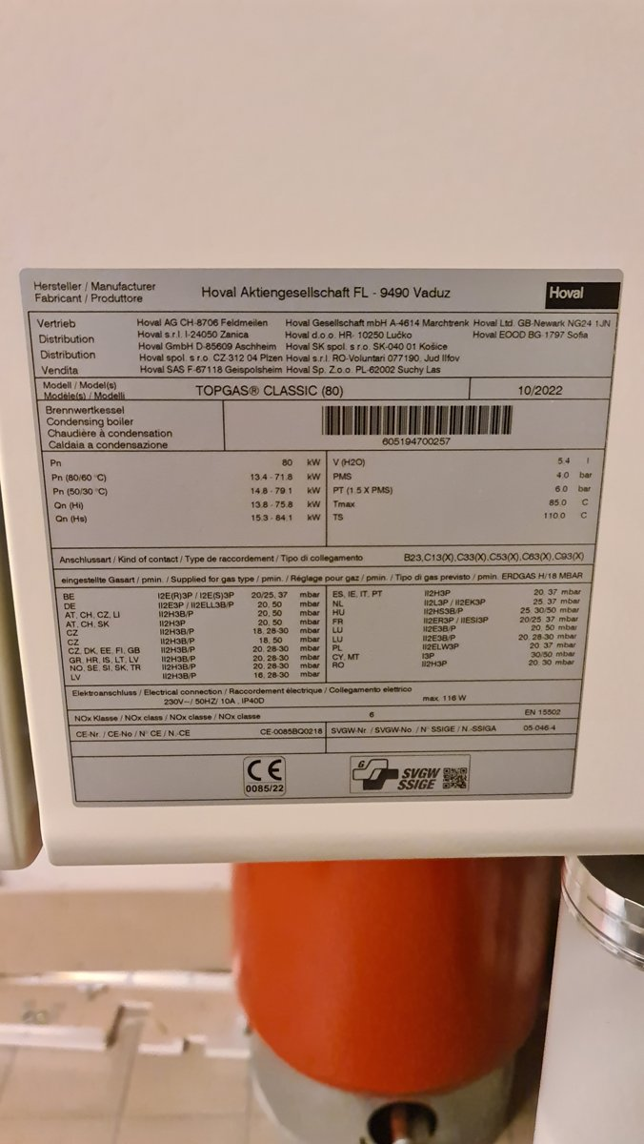 | Space type: mechanical room or utility closet  Overall condition: Good  comp_01 - Hoval TOPGAS® CLASSIC (80) condensing boiler  Category: Mechanical & Plumbing Equipment  Materials: stainless steel, galvanized steel, plastic casing, copper tubing, insulation (mineral wool or polyisocyanurate)  Salvage tier: direct_reuse  Hardware: pressure relief valve, gas inlet connection, electrical terminal block, drain valve, temperature sensor ports  Markings: Manufacturer: Hoval Aktiengesellschaft FL - 9490 Vaduz; Model: TOPGAS® CLASSIC (80); Date: 10/2022; CE Mark: 0085/22; SVGW SSIGE certification; Gas type: ERDGAS H/18 MBAR; Electrical: 230V~/50HZ/10A, IP40D; NOx Class: 6; Serial: 605194700257; Multiple regional gas supply codes (e.g., I2E(R)3P, I2H3B/P); Fire rating: Not applicable; DIN/EN standards: EN 15502  Connection: flanged or threaded gas connections, electrical conduit entry, drain pipe connection, water inlet/outlet ports  Deconstruction notes: Disconnect gas, water, and electrical supply lines before removal. Remove mounting brackets. Inspect for corrosion on flue and heat exchanger. Verify integrity of insulation before handling. Use lifting equipment for safe removal due to weight.  Bounding box [ymin, xmin, ymax, xmax] (0-1000): 34, 232, 975, 705  Hazard and diagnostic flags  - Verify presence of legacy insulation materials (e.g., asbestos-containing mineral wool) in boiler casing or flue; test if necessary.  - Check for residual gas or water in internal piping before dismantling; depressurize and drain system.  - Inspect for mastic or sealant residues on connections; may require chemical removal if contaminated.

DSC_0038.JPG
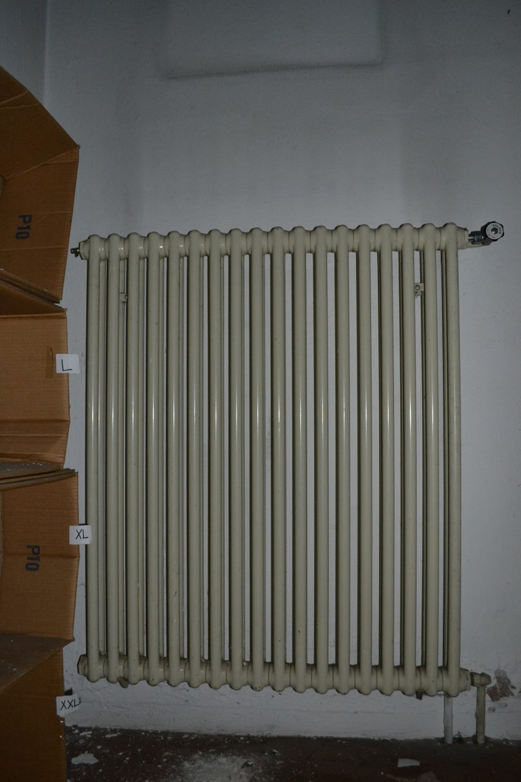 | Space type: circulation corridor  Overall condition: Fair  comp_01 - cast iron column radiator  Category: MEP Fixtures & Components  Materials: cast iron, enamel paint coating, brass valve  Salvage tier: direct_reuse  Hardware: thermostatic valve (right end), air vent (left end), bracket mounting hardware  Markings: no visible manufacturer markings or certification badges; valve has small circular label with indistinct text  Connection: threaded pipe connections, wall-mounted via brackets  Deconstruction notes: Remove by disconnecting supply/return pipes using pipe wrench; ensure system is drained and depressurized. Lift radiator carefully to avoid damaging enamel coating. Inspect for internal corrosion via valve access if reuse is intended.  Bounding box [ymin, xmin, ymax, xmax] (0-1000): 132, 280, 968, 900  Hazard and diagnostic flags  - Verify presence of lead-based paint on radiator surface prior to handling or sanding; test for lead if refurbishment is planned.  - Inspect wall behind radiator for potential asbestos-containing insulation or mastic, especially near baseboard area where discoloration is visible.

DSC_0758.JPG
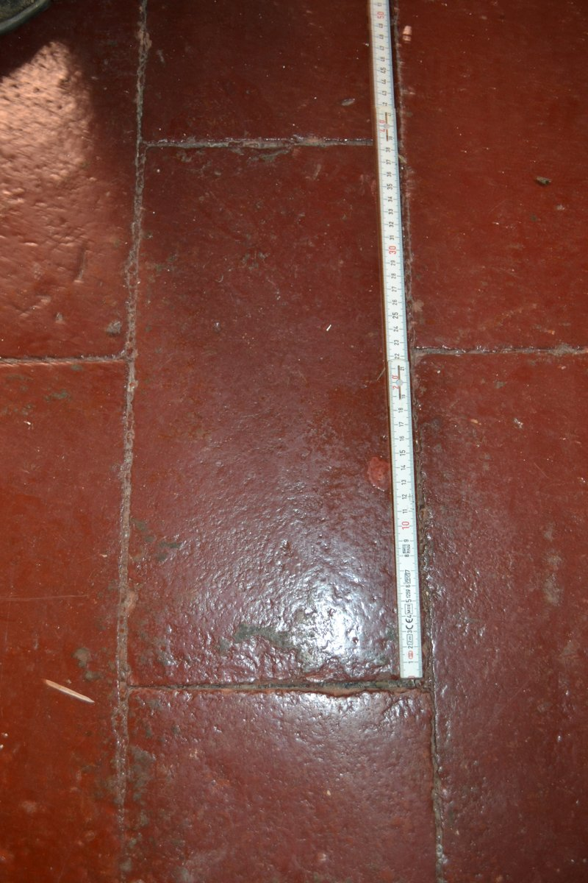 | Space type: circulation corridor  Overall condition: Fair  comp_01 - rectangular terracotta floor tile  Category: Finishes & Coverings  Materials: terracotta clay, mineral aggregate, glaze  Salvage tier: direct_reuse  Markings: No visible labels or markings; surface shows minor wear and darkened grout lines.  Connection: mortared  Deconstruction notes: Tiles can be removed intact using a tile removal tool or chisel with care to avoid cracking. Grout joints should be scored first. Use dust suppression. Check for underlying subfloor condition before removal.  Bounding box [ymin, xmin, ymax, xmax] (0-1000): 0, 0, 1000, 1000  Hazard and diagnostic flags  - Verify grout composition for potential asbestos or Portland cement-based mastic; test if necessary before removal.  - Inspect tile edges for hidden lead-based paint or sealant residues, especially if building predates 1978.

IMG_2761.HEIC
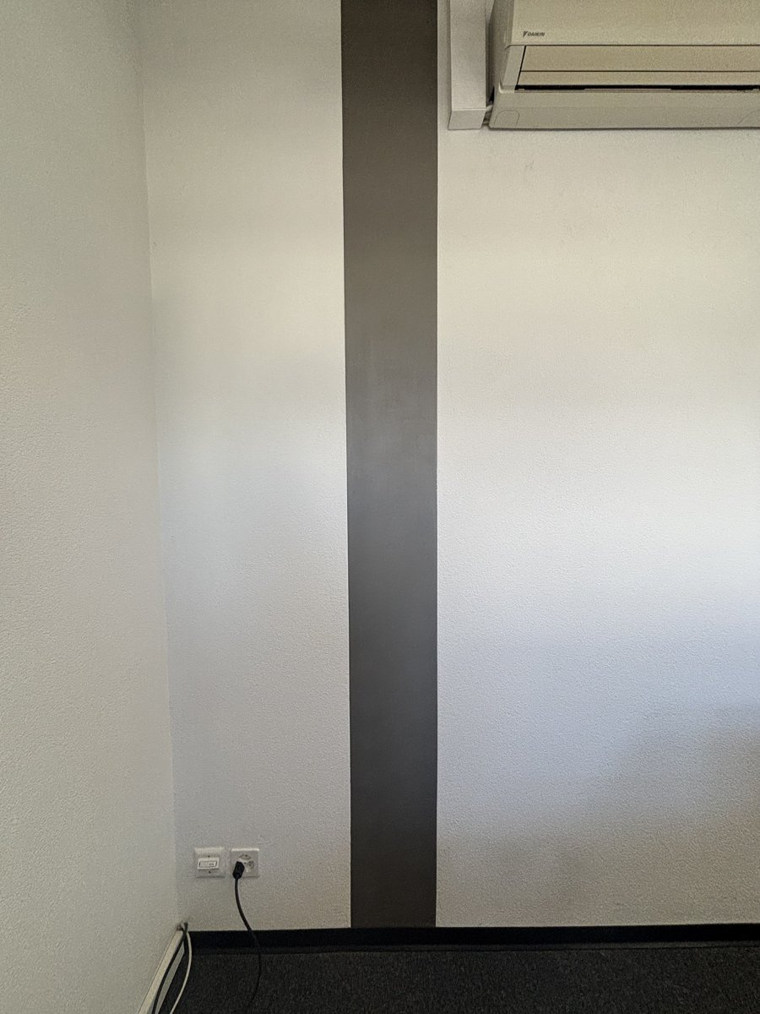 | Space type: interior corridor or office partition zone  Overall condition: Good  comp_01 - textured white wall finish (likely painted gypsum board or plaster)  Category: Finishes & Coverings  Materials: gypsum, plaster, acrylic paint  Salvage tier: material_recycling  Connection: adhered to structural frame  Deconstruction notes: Remove drywall or plasterboard carefully to avoid dust; separate metal studs from gypsum core for recycling; inspect for hidden wiring or plumbing before cutting.  Bounding box [ymin, xmin, ymax, xmax] (0-1000): 0, 0, 999, 920  comp_02 - wall-mounted electrical outlet (Schuko-type, 230V, 16A)  Category: MEP Fittings  Materials: polycarbonate, brass, copper  Salvage tier: refurbish_reuse  Hardware: screwed faceplate, internal terminal screws  Markings: standard European Schuko socket marking; no visible brand or certification badge  Connection: surface-mounted, screwed to wall  Deconstruction notes: Disconnect power supply before removal; inspect for corrosion or damage to internal contacts; clean and test for continuity before reuse.  Bounding box [ymin, xmin, ymax, xmax] (0-1000): 248, 830, 345, 865  comp_03 - split-type air conditioning indoor unit (Daikin brand)  Category: MEP Fittings  Materials: galvanized steel, plastic, copper tubing, refrigerant (R410A or similar)  Salvage tier: refurbish_reuse  Hardware: mounting brackets, screws, drain pipe connection, power cord  Markings: Daikin logo visible; model number not legible; likely includes energy efficiency rating sticker (not visible)  Connection: surface-mounted, bolted to wall  Deconstruction notes: Must be professionally decommissioned by licensed HVAC technician to recover refrigerant; remove mounting brackets and inspect for wall damage; unit may require cleaning and performance testing for reuse.  Bounding box [ymin, xmin, ymax, xmax] (0-1000): 585, 0, 999, 130  comp_04 - dark gray vertical accent strip (possibly metal or vinyl panel)  Category: Finishes & Coverings  Materials: aluminum, PVC, steel  Salvage tier: direct_reuse  Connection: adhered or mechanically fastened to wall  Deconstruction notes: Carefully remove to preserve surface; check for adhesive residue; may be reusable as decorative panel or partition accent.  Bounding box [ymin, xmin, ymax, xmax] (0-1000): 450, 0, 575, 920  comp_05 - black baseboard or skirting board  Category: Finishes & Coverings  Materials: PVC, MDF, vinyl  Salvage tier: refurbish_reuse  Hardware: screws or nails  Connection: nail/screwed to wall  Deconstruction notes: Remove with pry bar; inspect for warping or moisture damage; sand and repaint if necessary for reuse.  Bounding box [ymin, xmin, ymax, xmax] (0-1000): 0, 910, 999, 935  comp_06 - dark carpet flooring  Category: Finishes & Coverings  Materials: nylon, polypropylene, rubber or latex backing  Salvage tier: material_recycling  Connection: glued or mechanically fastened to subfloor  Deconstruction notes: Remove using carpet knife; separate backing from fiber; check for contamination; send to specialized carpet recycling facility.  Bounding box [ymin, xmin, ymax, xmax] (0-1000): 0, 920, 999, 999  Hazard and diagnostic flags  - Verify presence of asbestos in older wall finishes or insulation behind drywall; test for lead-based paint if building predates 1978; inspect electrical wiring for damage or outdated insulation; confirm refrigerant type and pressure in AC unit before dismantling.

IMG_2765.jpg
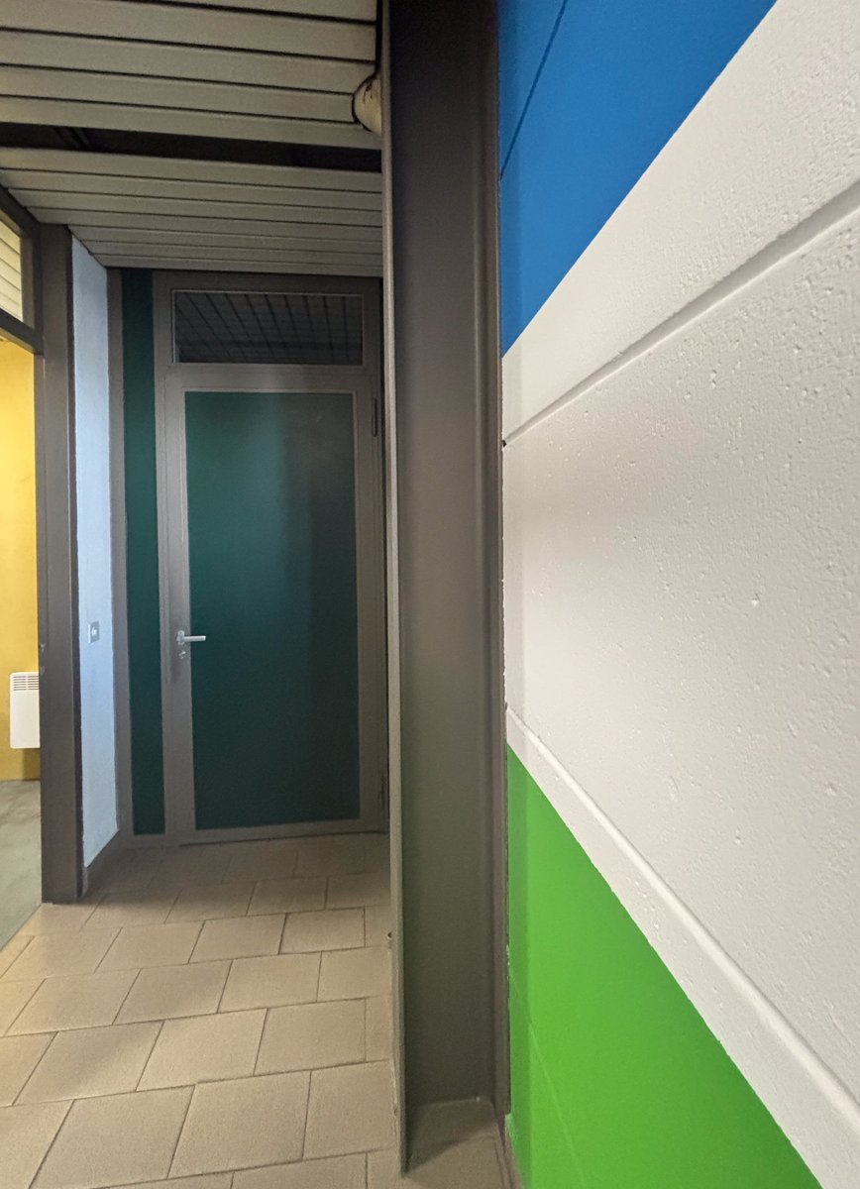 | Space type: circulation corridor  Overall condition: Good  comp_01 - flush steel door with transom window  Category: Doors & Portals  Materials: carbon steel, mineral core, polycarbonate or acrylic glazing  Salvage tier: refurbish_reuse  Hardware: silver lever handle, mortise lock, strike plate, door closer (not visible but likely present)  Markings: No visible manufacturer labels or certification badges; door frame appears to have standard industrial finish.  Connection: hinged with concealed hinges (likely surface-mounted or mortised)  Deconstruction notes: Remove door leaf by disengaging hinges; inspect core for moisture or degradation. Transom glazing may be secured with silicone or gasket—use caution to avoid breakage. Door frame may be anchored with screws or bolts; check for concealed fasteners.  Bounding box [ymin, xmin, ymax, xmax] (0-1000): 142, 225, 450, 710  comp_02 - painted concrete block wall with color bands  Category: Finishes & Coverings  Materials: concrete masonry units (CMU), acrylic or epoxy paint  Salvage tier: material_recycling  Markings: No visible labels; color bands (blue, white, green) suggest functional zoning or safety marking.  Connection: mortared masonry  Deconstruction notes: Demolition requires mechanical breaking; paint may be lead-free based on modern standards, but testing recommended. CMU blocks are recyclable as aggregate.  Bounding box [ymin, xmin, ymax, xmax] (0-1000): 575, 0, 999, 999  comp_03 - ceramic tile flooring  Category: Finishes & Coverings  Materials: ceramic tile, cementitious thinset, concrete substrate  Salvage tier: material_recycling  Markings: No visible markings; uniform tile pattern suggests standard commercial installation.  Connection: adhered with thinset mortar  Deconstruction notes: Tiles can be removed with chisel and hammer; however, due to size and condition, likely not suitable for reuse. Recycle as construction aggregate or landfill if contaminated.  Bounding box [ymin, xmin, ymax, xmax] (0-1000): 0, 695, 460, 999  comp_04 - steel column or portal frame  Category: Structural & Enclosure  Materials: structural steel, paint coating  Salvage tier: direct_reuse  Markings: No visible markings; likely standard structural steel section.  Connection: welded or bolted to foundation (not visible)  Deconstruction notes: Remove with torch or bolt-cutting; inspect for corrosion. Steel is high-value recyclable; if intact, can be reused in new construction.  Bounding box [ymin, xmin, ymax, xmax] (0-1000): 450, 0, 595, 999  Hazard and diagnostic flags  - Verify paint composition on CMU walls for lead content (especially if pre-1978 building).  - Inspect door core for moisture or mold; legacy mineral cores may contain asbestos if pre-1980s.  - Test adhesives and sealants used in door transom and tile installation for VOCs or hazardous content.

IMG_2768.jpg
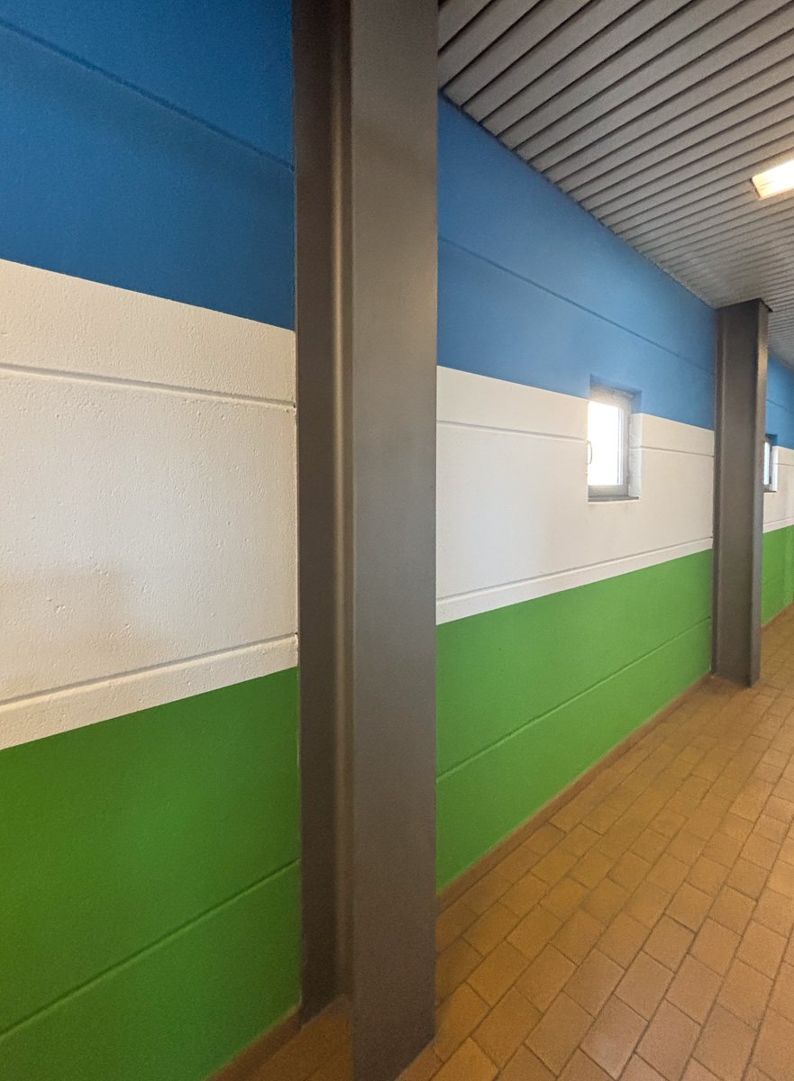 | Space type: circulation corridor  Overall condition: Good  comp_01 - painted concrete block wall panels (blue, white, green)  Category: Finishes & Coverings  Materials: concrete, paint (acrylic or latex)  Salvage tier: material_recycling  Markings: No visible labels or markings; painted surfaces show no manufacturer badges or certification stickers.  Connection: monolithic (cast-in-place or masonry laid with mortar)  Deconstruction notes: Walls are structural and not designed for disassembly; removal requires mechanical demolition. Painted surfaces may contain lead-based paint if pre-1978; testing recommended. Avoid dust generation during demolition.  Bounding box [ymin, xmin, ymax, xmax] (0-1000): 0, 0, 999, 999  comp_02 - steel structural columns  Category: Structural Elements  Materials: carbon steel  Salvage tier: direct_reuse  Markings: No visible markings or tags; surface appears painted or coated, possibly with industrial enamel.  Connection: welded or bolted to foundation and beam system (not visible in image)  Deconstruction notes: Columns are likely bolted or welded to base plates; require structural assessment before removal. Use magnetic particle inspection if reuse is intended. Remove with crane or lifting equipment.  Bounding box [ymin, xmin, ymax, xmax] (0-1000): 365, 0, 550, 999  comp_03 - ceiling tile system (linear metal or composite panels)  Category: Finishes & Coverings  Materials: galvanized steel, mineral fiber, paint  Salvage tier: material_recycling  Markings: No visible labels; panels appear uniform with no manufacturer badges.  Connection: suspended grid system (not visible), likely clipped or snapped into place  Deconstruction notes: Ceiling panels can be removed manually with minimal tools. Check for asbestos in older buildings; if pre-1980, testing required. Recycle metal and fiber components separately.  Bounding box [ymin, xmin, ymax, xmax] (0-1000): 545, 0, 999, 290  comp_04 - terrazzo or ceramic tile flooring (herringbone pattern)  Category: Finishes & Coverings  Materials: ceramic tile, grout, adhesive  Salvage tier: material_recycling  Markings: No visible labels or manufacturer markings on tiles.  Connection: adhered to concrete or mortar bed  Deconstruction notes: Tiles are likely bonded with mastic or thin-set; removal requires chipping or grinding. Test adhesive for VOCs or hazardous content. Recycle ceramic as aggregate or raw material.  Bounding box [ymin, xmin, ymax, xmax] (0-1000): 250, 550, 999, 999  comp_05 - small fixed window (likely for ventilation or light)  Category: Windows & Openings  Materials: glass, metal frame (aluminum or steel), paint  Salvage tier: refurbish_reuse  Hardware: small handle or latch visible on frame  Markings: No visible labels or certification badges.  Connection: set into concrete block wall, likely with mortar or sealant  Deconstruction notes: Window can be carefully removed with pry bar and hammer; check for lead paint on frame. Clean glass and frame; replace sealant if needed. Reuse in low-load applications.  Bounding box [ymin, xmin, ymax, xmax] (0-1000): 730, 345, 805, 465  Hazard and diagnostic flags  - Paint on concrete blocks may contain lead; testing recommended before demolition.  - Ceiling panels may contain asbestos if building predates 1980; sample for analysis.  - Flooring adhesive may contain VOCs or hazardous mastic; test prior to removal.  - Structural steel columns may have coating degradation or corrosion; inspect for pitting or rust before reuse.

