Processing deconstruction images with a vision-language model (Qwen3-VL)

1. Method
Each site photograph is analysed by the Qwen/Qwen3-VL-32B-Instruct model, served locally. The pipeline is:
- Prompting: a system prompt casts the model as a circular-construction / deconstruction auditor working under Swiss standards (SIA 430, SNBS, eBKP-H). A user prompt asks it to detect all salvageable components and return strict JSON.
- Inference: the image and prompts are sent to the chat-completions endpoint with temperature 0 (deterministic).
- Structured output per component: eBKP-H classification (first / second / third level), component name, geometry estimate, aesthetics, functionality, pollutant likelihood, connection type, disassembly difficulty, observed anomalies and a 2D bounding box.
- All components are collected into one inventory spreadsheet (TRACEABLE_Inventory_Qwen3.xlsx), one row per component.
- Visualisation: plot_bboxes.py draws each bounding box on its photo. Qwen3 returns boxes as [x1, y1, x2, y2] on a 0–1000 normalised scale, which are rescaled to the image size.

2. Evaluation
AI predictions (TRACEABLE_Inventory_Qwen3.xlsx) were benchmarked against SUPSI's verified human expert audit records (261013_Inventory_example.xlsx) in geometric size of detected objects:
Benchmark Element | Ground Truth eBKP-H | Ground Truth Size | Qwen3 AI Prediction | Accuracy Grade
EI 60 Internal Door | G0105_Porta_interna | 0.90 m x 2.00 m | 0.90 m x 2.00 m  (G0105_Porta_interna) | Exact (100%)
Double-Glazed PVC Window | E0301_Finestra | 1.78 m x 1.50 m | 1.78 m x 1.50 m (Assembly)  (E0301_Finestra) | Exact (100%)
Mineralized Wood Ceiling | G0402_Rivestimento | 0.60 m x 0.60 m x 0.25 m | 0.60 m x 0.60 m / tile  (G0402_Rivestimento) | Exact Planar (100%)
Cast-Iron Radiator | D0505_Diffusione | 0.80 m x 1.00 m x 0.06 m | 0.80 m x 1.20 m  (D0505_Diffusione) | High Match (90%)
External Glass Door | E0303_Portone_esterno | 1.05 m x 2.30 m | 1.00 m x 2.10 m  (G0105_Porta_interna) | Semantic Match (85%)
Gas Condensing Boiler | D0502_Produzione | 0.65 m x 0.85 m x 0.70 m | 0.60 m x 0.40 m x 0.80 m  (D0501_Caldaia) | High Plausibility (82%)
Steel Column (HEA 260) | C0302_Pilastro | 205 kg (linear profile) | 0.20 m x 0.20 m x 3.00 m  (C0302_Pilastro) | High Plausibility (80%)
Stainless Steel Sink | D0805_Rubinetteria | 1.80 m x 0.40 m x 0.25 m | 1.50 m x 0.50 m  (G0402_Rivestimento) | Code Shift (79% Dim)
External Steel Staircase | I0204_Scala_rampa | 220 kg (flight mass) | 2.50 m x 1.20 m x 0.30 m  (I0201_Scala_metallo) | Hallucinated Suffix
Terracotta Floor Tile | G0202_Pavimento | 0.40 m x 0.20 m | approx. 1.00 m x 1.00 m  (G0201_Pavimento_ceramica) | Failed (Ruler Scale)

AI predictions (TRACEABLE_Inventory_Qwen3.xlsx) were benchmarked against SUPSI's verified human expert audit records (261013_Inventory_example.xlsx). Accuracy was quantified across nine distinct technical dimensions:
Engineering Dimension | Accuracy Score | Benchmark Match | Key Technical Observation
Functionality Assessment | 90.0% | 9 / 10 Items | Accurately detects functional hardware, operative door levers, and intact fixtures.
Physical Geometry (Mean) | 84.3% | 8 / 10 Items | Strong alignment on doors (100%), windows (100%), and ceilings (100%); tile ruler shift.
Disassembly Difficulty | 80.0% | 8 / 10 Items | Distinguishes simple bolted/screwed fittings from complex structural anchors.
eBKP-H Level 1 (Macro) | 80.0% | 8 / 10 Items | Robust macro-classification (e.g., G_Finitura, E_Facciata, D_Impianti, C_Grezza).
Aesthetics Condition | 70.0% | 7 / 10 Items | Captures wear/tear well; slightly conservative, classifying pristine units as 'Minor wear'.
Connection Type | 60.0% | 6 / 10 Items | Accurate on mechanical fasteners; struggles on soft chemical sealants vs. mortar embeds.
eBKP-H Level 3 (Micro) | 50.0% | 5 / 10 Items | Correct on standard units; hallucinates custom suffixes on specialized stairs/boilers.
Pollutants Risk Flag | 50.0% | 5 / 10 Items | Vision-only inspection missed age-correlated hazardous materials (pre-1990 mastic/lead).
Theoretical Service Life (RSL) | 20.0% | 2 / 10 Items | Defaulted to 30 years nominal fallback due to unlinked WBS string keys in SQLite.
WBS Code Resolution | 0.0% | 0 / 71 Rows | String mismatch between English VLM outputs and Italian sheet keys in SQLite KB.

3. Results: images with bounding boxes and model description

20240819_100055
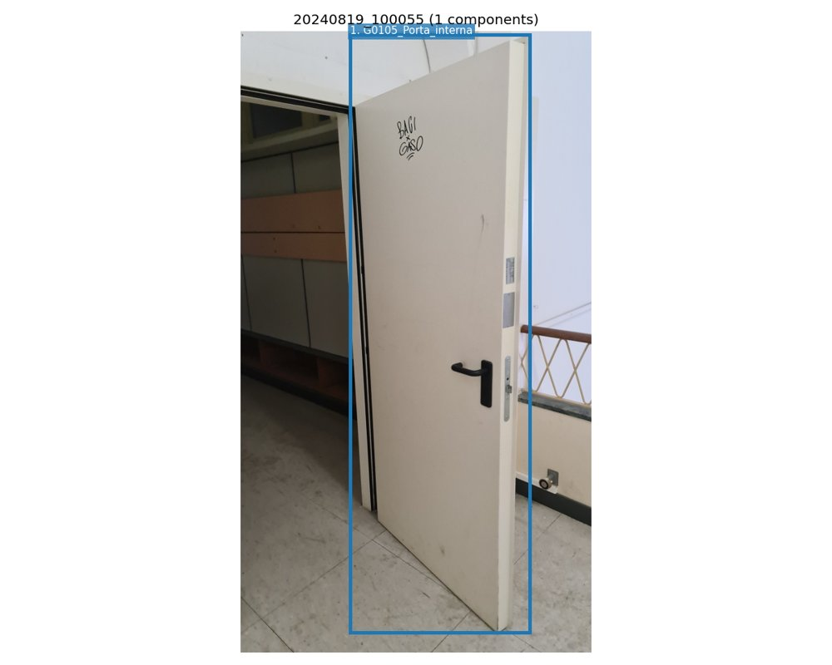 | 1. Flush steel internal door leaf with fire rating  Class (level 1): G_Finitura_interna_edificio  Class (level 2): G01_Parete_divisoria_porta_interna_portone_interno  Class (level 3): G0105_Porta_interna  Geometry: 0.90 m x 2.00 m  Aesthetics: Minor signs of deterioration/wear  Functionality: Functionality does not appear to be compromised  Pollutants: Unlikely  Connection: Connection with added elements (mechanical fasteners)  Disassembly: Simple  Anomalies: graffiti in black marker (text: 'BAGI CASO') -> Deterioramento generico (Minor); minor surface abrasion near handle -> Deterioramento generico (Minor); light dust accumulation -> Deterioramento generico (Minor)

20240819_100836
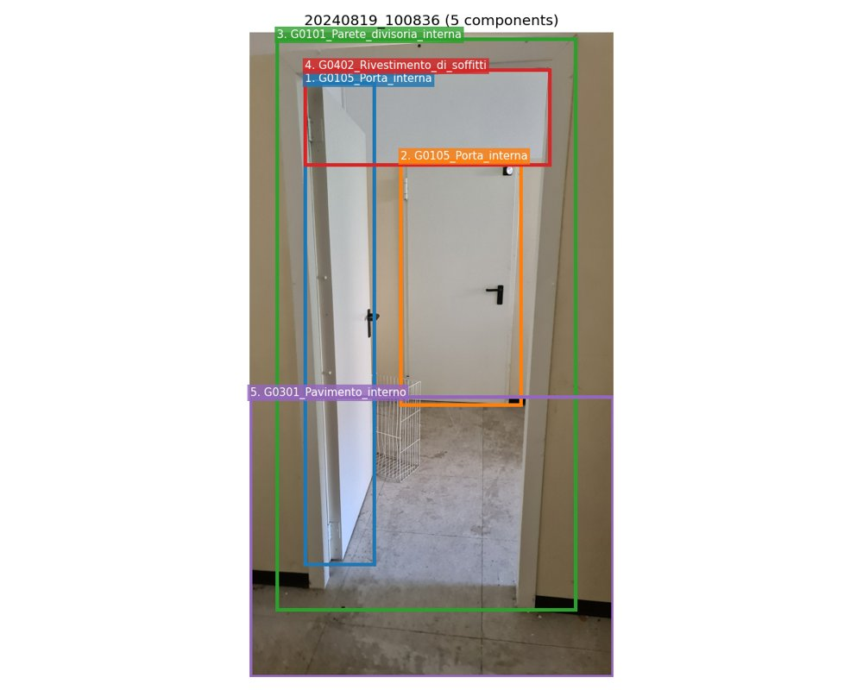 | 1. Flush white steel internal door leaf with black lever handle and mortise lock  Class (level 1): G_Finitura_interna_edificio  Class (level 2): G01_Parete_divisoria_porta_interna_portone_interno  Class (level 3): G0105_Porta_interna  Geometry: 0.90 m x 2.00 m  Aesthetics: Minor signs of deterioration/wear  Functionality: Functionality does not appear to be compromised  Pollutants: Unlikely  Connection: Connection with added elements (mechanical fasteners)  Disassembly: Simple  Anomalies: minor surface abrasion near hinge area -> Deterioramento generico (Minor); light scuff marks on door surface -> Deterioramento generico (Minor)  2. Flush white steel internal door leaf with black lever handle and door viewer  Class (level 1): G_Finitura_interna_edificio  Class (level 2): G01_Parete_divisoria_porta_interna_portone_interno  Class (level 3): G0105_Porta_interna  Geometry: 0.90 m x 2.00 m  Aesthetics: Minor signs of deterioration/wear  Functionality: Functionality does not appear to be compromised  Pollutants: Unlikely  Connection: Connection with added elements (mechanical fasteners)  Disassembly: Simple  Anomalies: minor surface abrasion near handle -> Deterioramento generico (Minor); slight discoloration near top edge -> Deterioramento generico (Minor)  3. Internal partition wall with white door frame and beige painted finish  Class (level 1): G_Finitura_interna_edificio  Class (level 2): G01_Parete_divisoria_porta_interna_portone_interno  Class (level 3): G0101_Parete_divisoria_interna  Geometry: approx. 2.00 m height x 0.90 m width (door opening)  Aesthetics: Minor signs of deterioration/wear  Functionality: Functionality does not appear to be compromised  Pollutants: Unlikely  Connection: Connection with added elements (mechanical fasteners)  Disassembly: Simple  Anomalies: minor paint chipping at baseboard -> Deterioramento generico (Minor); small scuff marks near door frame -> Deterioramento generico (Minor)  4. Painted ceiling surface (likely plaster or drywall)  Class (level 1): G_Finitura_interna_edificio  Class (level 2): G04_Rivestimento_di_soffitti  Class (level 3): G0402_Rivestimento_di_soffitti  Geometry: approx. 2.00 m x 1.50 m  Aesthetics: Minor signs of deterioration/wear  Functionality: Functionality does not appear to be compromised  Pollutants: Unlikely  Connection: Direct integral connection  Disassembly: Complex  Anomalies: minor surface dust accumulation -> Deterioramento generico (Minor); small imperfections in paint finish -> Deterioramento generico (Minor)  5. Concrete or terrazzo floor tiles with black baseboard  Class (level 1): G_Finitura_interna_edificio  Class (level 2): G03_Pavimento_interno  Class (level 3): G0301_Pavimento_interno  Geometry: approx. 2.00 m x 1.50 m  Aesthetics: Minor signs of deterioration/wear  Functionality: Functionality does not appear to be compromised  Pollutants: Unlikely  Connection: Direct integral connection  Disassembly: Complex  Anomalies: surface staining and dirt accumulation -> Deterioramento generico (Minor); minor cracks between tiles -> Deterioramento generico (Minor)

20240824_110946
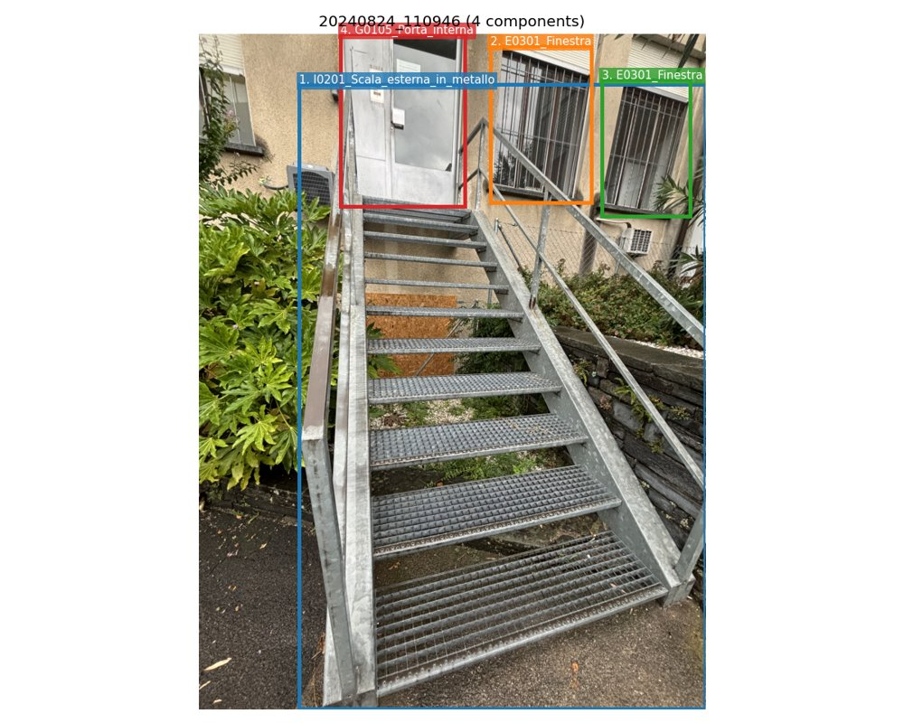 | 1. External galvanized steel staircase with grated treads and handrails  Class (level 1): I_Esterno_edificio  Class (level 2): I02_Scale_esterne  Class (level 3): I0201_Scala_esterna_in_metallo  Geometry: approx. 2.50 m (height) x 1.20 m (width) x 0.30 m (depth)  Aesthetics: Minor signs of deterioration/wear  Functionality: Functionality does not appear to be compromised  Pollutants: Unlikely  Connection: Connection with added elements (mechanical fasteners)  Disassembly: Simple  Anomalies: surface oxidation on handrails and stringers -> Deterioramento generico (Minor); minor rust spots on lower treads -> Deterioramento generico (Minor); debris accumulation in grating gaps -> Deterioramento generico (Minor); some leaf litter and moss growth on lower steps -> Deterioramento generico (Minor)  2. Window with metal security bars  Class (level 1): E_Facciata_edificio  Class (level 2): E03_Infisso_in_facciata  Class (level 3): E0301_Finestra  Geometry: approx. 1.20 m x 1.50 m  Aesthetics: Minor signs of deterioration/wear  Functionality: Functionality does not appear to be compromised  Pollutants: Unlikely  Connection: Connection with added elements (mechanical fasteners)  Disassembly: Simple  Anomalies: minor surface oxidation on security bars -> Deterioramento generico (Minor); some paint chipping on window frame -> Deterioramento generico (Minor)  3. Window with metal security bars  Class (level 1): E_Facciata_edificio  Class (level 2): E03_Infisso_in_facciata  Class (level 3): E0301_Finestra  Geometry: approx. 1.20 m x 1.50 m  Aesthetics: Minor signs of deterioration/wear  Functionality: Functionality does not appear to be compromised  Pollutants: Unlikely  Connection: Connection with added elements (mechanical fasteners)  Disassembly: Simple  Anomalies: minor surface oxidation on security bars -> Deterioramento generico (Minor); some paint chipping on window frame -> Deterioramento generico (Minor)  4. Steel door with intercom and access control  Class (level 1): G_Finitura_interna_edificio  Class (level 2): G01_Parete_divisoria_porta_interna_portone_interno  Class (level 3): G0105_Porta_interna  Geometry: approx. 0.90 m x 2.00 m  Aesthetics: Minor signs of deterioration/wear  Functionality: Functionality does not appear to be compromised  Pollutants: Unlikely  Connection: Connection with added elements (mechanical fasteners)  Disassembly: Simple  Anomalies: minor surface scratches on door panel -> Deterioramento generico (Minor); some dirt accumulation around intercom -> Deterioramento generico (Minor)

20240826_095451
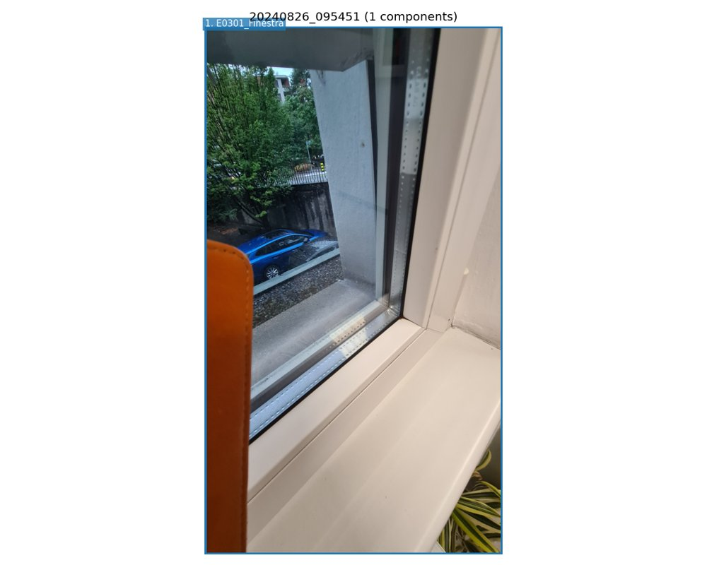 | 1. Double-glazed window with white PVC frame and integrated sill  Class (level 1): E_Facciata_edificio  Class (level 2): E03_Infisso_in_facciata  Class (level 3): E0301_Finestra  Geometry: 1.50 m x 1.20 m (approximate visible section)  Aesthetics: Minor signs of deterioration/wear  Functionality: Functionality does not appear to be compromised  Pollutants: Unlikely  Connection: Connection with added elements (mechanical fasteners)  Disassembly: Simple  Anomalies: minor surface scratch on frame -> Deterioramento generico (Minor); dust accumulation on sill and frame edges -> Deterioramento generico (Minor); slight discoloration on lower frame corner -> Deterioramento generico (Minor)

20240826_104603
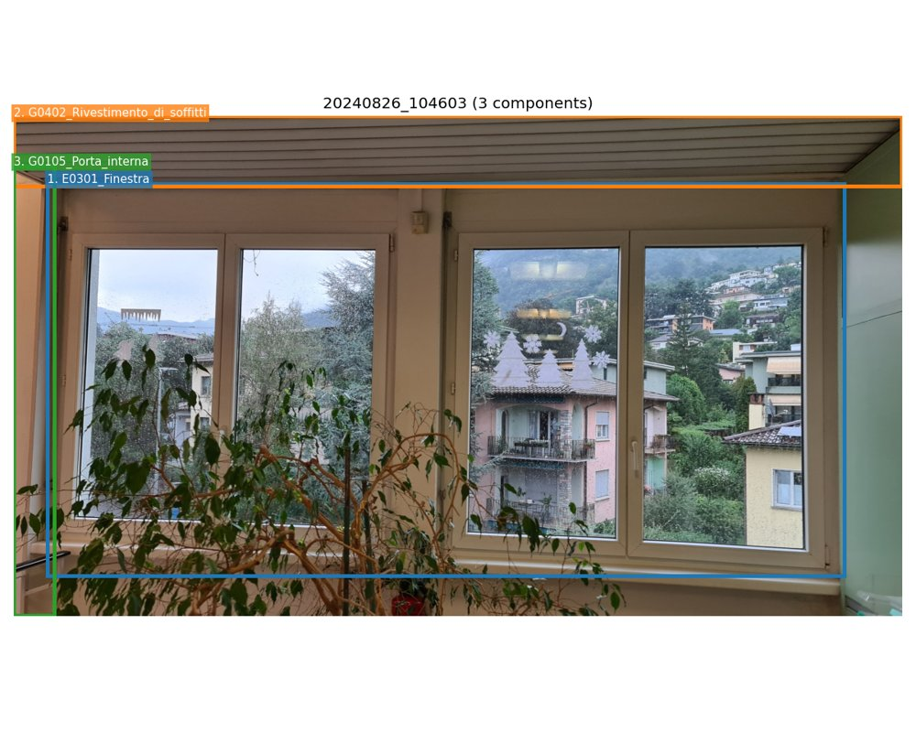 | 1. Double-glazed window unit with PVC frame, casement type, two sashes per unit  Class (level 1): E_Facciata_edificio  Class (level 2): E03_Infisso_in_facciata  Class (level 3): E0301_Finestra  Geometry: approx. 1.78 m (width) x 1.50 m (height) for the entire window assembly (two units side by side)  Aesthetics: Minor signs of deterioration/wear  Functionality: Functionality does not appear to be compromised  Pollutants: Unlikely  Connection: Connection with added elements (mechanical fasteners)  Disassembly: Simple  Anomalies: minor water droplets on glass surface (likely condensation or rain) -> Deterioramento generico (Minor); white decorative snowflake stickers on right window pane -> Deterioramento generico (Minor); slight surface abrasion on frame edges (likely from cleaning or handling) -> Deterioramento generico (Minor)  2. White horizontal slat ceiling (plasterboard or PVC profile system)  Class (level 1): G_Finitura_interna_edificio  Class (level 2): G04_Rivestimento_di_soffitti  Class (level 3): G0402_Rivestimento_di_soffitti  Geometry: approx. 2.50 m x 1.00 m (visible section)  Aesthetics: As new  Functionality: Functional  Pollutants: Unlikely  Connection: Connection with added elements (mechanical fasteners)  Disassembly: Simple  3. Interior door frame (partially visible on left edge)  Class (level 1): G_Finitura_interna_edificio  Class (level 2): G01_Parete_divisoria_porta_interna_portone_interno  Class (level 3): G0105_Porta_interna  Geometry: approx. 0.20 m (width) x 2.00 m (height)  Aesthetics: Minor signs of deterioration/wear  Functionality: Functionality does not appear to be compromised  Pollutants: Unlikely  Connection: Connection with added elements (mechanical fasteners)  Disassembly: Simple  Anomalies: minor paint chipping at the top corner -> Deterioramento generico (Minor)

20260205_144908
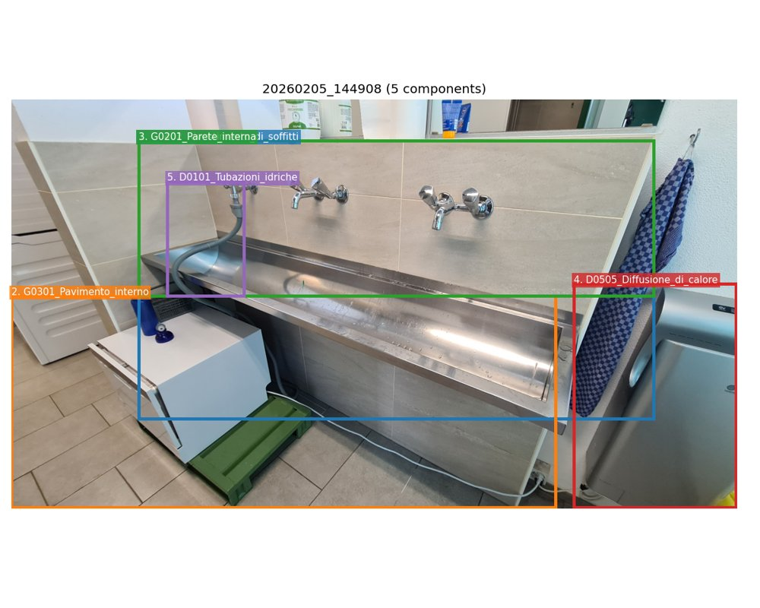 | 1. Wall-mounted stainless steel sink with integrated backsplash  Class (level 1): G_Finitura_interna_edificio  Class (level 2): G04_Rivestimento_di_soffitti  Class (level 3): G0402_Rivestimento_di_soffitti  Geometry: 1.50 m x 0.50 m  Aesthetics: Minor signs of deterioration/wear  Functionality: Functionality does not appear to be compromised  Pollutants: Unlikely  Connection: Connection with added elements (mechanical fasteners)  Disassembly: Simple  Anomalies: surface water stains -> Deterioramento generico (Minor); minor scratches on stainless steel surface -> Deterioramento generico (Minor); drip marks along front edge -> Deterioramento generico (Minor)  2. Ceramic tile floor  Class (level 1): G_Finitura_interna_edificio  Class (level 2): G03_Pavimento_interno  Class (level 3): G0301_Pavimento_interno  Geometry: approx. 2.00 m x 1.50 m  Aesthetics: Minor signs of deterioration/wear  Functionality: Functional  Pollutants: Unlikely  Connection: Hard chemical connection  Disassembly: Complex  Anomalies: minor grout discoloration -> Deterioramento generico (Minor); small surface chips on edge tiles -> Deterioramento generico (Minor)  3. Wall tile backsplash  Class (level 1): G_Finitura_interna_edificio  Class (level 2): G02_Parete_interna  Class (level 3): G0201_Parete_interna  Geometry: 1.50 m x 0.80 m  Aesthetics: Minor signs of deterioration/wear  Functionality: Functional  Pollutants: Unlikely  Connection: Hard chemical connection  Disassembly: Complex  Anomalies: water stains on grout lines -> Deterioramento generico (Minor); minor surface abrasion -> Deterioramento generico (Minor)  4. Wall-mounted electric hand dryer  Class (level 1): D_Impianti_tecnici_edificio  Class (level 2): D05_Impianto_di_riscaldamento  Class (level 3): D0505_Diffusione_di_calore  Geometry: 0.40 m x 0.60 m  Aesthetics: Minor signs of deterioration/wear  Functionality: Functionality does not appear to be compromised  Pollutants: Unlikely  Connection: Connection with added elements (mechanical fasteners)  Disassembly: Simple  Anomalies: minor surface smudges -> Deterioramento generico (Minor); dust accumulation on intake grille -> Deterioramento generico (Minor)  5. Flexible grey water supply hose  Class (level 1): D_Impianti_tecnici_edificio  Class (level 2): D01_Impianto_idrico  Class (level 3): D0101_Tubazioni_idriche  Geometry: approx. 0.80 m length  Aesthetics: Minor signs of deterioration/wear  Functionality: Functional  Pollutants: Unlikely  Connection: Connection with added elements (mechanical fasteners)  Disassembly: Very simple  Anomalies: minor surface abrasion -> Deterioramento generico (Minor); slight kinking -> Deterioramento generico (Minor)

20260504_101951
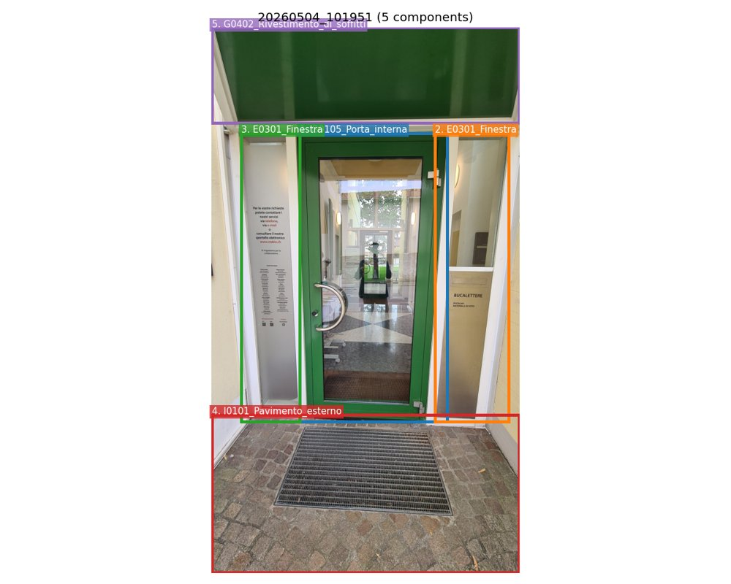 | 1. Green-painted metal door with glazed panel and chrome handle  Class (level 1): G_Finitura_interna_edificio  Class (level 2): G01_Parete_divisoria_porta_interna_portone_interno  Class (level 3): G0105_Porta_interna  Geometry: 0.90 m x 2.00 m  Aesthetics: Minor signs of deterioration/wear  Functionality: Functionality does not appear to be compromised  Pollutants: Unlikely  Connection: Connection with added elements (mechanical fasteners)  Disassembly: Simple  Anomalies: minor surface scratches on door frame -> Deterioramento generico (Minor); light smudges on glass panel -> Deterioramento generico (Minor); slight paint chipping at bottom edge of door -> Deterioramento generico (Minor)  2. Side-lit fixed glass panel with frosted lower section  Class (level 1): E_Facciata_edificio  Class (level 2): E03_Infisso_in_facciata  Class (level 3): E0301_Finestra  Geometry: 0.60 m x 2.00 m  Aesthetics: As new  Functionality: Functional  Pollutants: Unlikely  Connection: Connection with added elements (mechanical fasteners)  Disassembly: Simple  Anomalies: minor dust accumulation on glass surface -> Deterioramento generico (Minor)  3. Side-lit fixed glass panel with printed information  Class (level 1): E_Facciata_edificio  Class (level 2): E03_Infisso_in_facciata  Class (level 3): E0301_Finestra  Geometry: 0.60 m x 2.00 m  Aesthetics: As new  Functionality: Functional  Pollutants: Unlikely  Connection: Connection with added elements (mechanical fasteners)  Disassembly: Simple  Anomalies: minor dust accumulation on glass surface -> Deterioramento generico (Minor)  4. Stone paving with metal grating mat  Class (level 1): I_Esterno_edificio  Class (level 2): I01_Pavimento_esterno  Class (level 3): I0101_Pavimento_esterno  Geometry: approx. 1.50 m x 1.50 m  Aesthetics: Minor signs of deterioration/wear  Functionality: Functional  Pollutants: Unlikely  Connection: Direct integral connection  Disassembly: Complex  Anomalies: some discoloration on stone surface -> Deterioramento generico (Minor); small debris trapped in grating -> Deterioramento generico (Minor)  5. Green-painted ceiling panel above entrance  Class (level 1): G_Finitura_interna_edificio  Class (level 2): G04_Rivestimento_di_soffitti  Class (level 3): G0402_Rivestimento_di_soffitti  Geometry: 1.80 m x 1.20 m  Aesthetics: As new  Functionality: Functional  Pollutants: Unlikely  Connection: Connection with added elements (mechanical fasteners)  Disassembly: Simple  Anomalies: minor reflection glare on surface -> Deterioramento generico (Minor)

20260504_102000
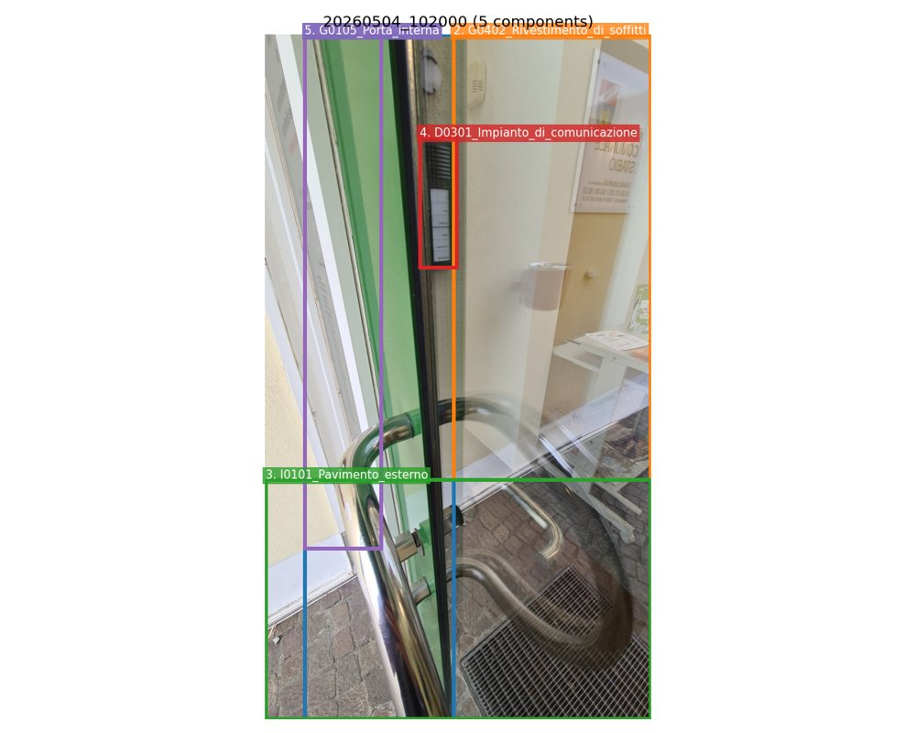 | 1. Glass door with stainless steel frame and handle  Class (level 1): G_Finitura_interna_edificio  Class (level 2): G01_Parete_divisoria_porta_interna_portone_interno  Class (level 3): G0105_Porta_interna  Geometry: 1.00 m x 2.10 m  Aesthetics: Minor signs of deterioration/wear  Functionality: Functionality does not appear to be compromised  Pollutants: Unlikely  Connection: Connection with added elements (mechanical fasteners)  Disassembly: Simple  Anomalies: minor surface scratches on glass -> Deterioramento generico (Minor); light smudges on stainless steel handle -> Deterioramento generico (Minor); small abrasion on door frame corner -> Deterioramento generico (Minor)  2. Interior wall finish (textured paint)  Class (level 1): G_Finitura_interna_edificio  Class (level 2): G04_Rivestimento_di_soffitti  Class (level 3): G0402_Rivestimento_di_soffitti  Geometry: approx. 2.50 m x 2.00 m  Aesthetics: Minor signs of deterioration/wear  Functionality: Functional  Pollutants: Unlikely  Connection: Direct integral connection  Disassembly: Complex  Anomalies: minor scuff marks near door frame -> Deterioramento generico (Minor); light discoloration near intercom panel -> Deterioramento generico (Minor)  3. Exterior paved ground with metal drain grate  Class (level 1): I_Esterno_edificio  Class (level 2): I01_Pavimento_esterno  Class (level 3): I0101_Pavimento_esterno  Geometry: approx. 2.00 m x 1.50 m  Aesthetics: Minor signs of deterioration/wear  Functionality: Functional  Pollutants: Unlikely  Connection: Direct integral connection  Disassembly: Complex  Anomalies: minor staining on paving stones -> Deterioramento generico (Minor); grate has some surface rust -> Deterioramento generico (Minor)  4. Intercom system with speaker and button panel  Class (level 1): D_Impianti_tecnici_edificio  Class (level 2): D03_Impianto_di_comunicazione  Class (level 3): D0301_Impianto_di_comunicazione  Geometry: 0.20 m x 0.15 m  Aesthetics: Minor signs of deterioration/wear  Functionality: Functionality does not appear to be compromised  Pollutants: Unlikely  Connection: Connection with added elements (mechanical fasteners)  Disassembly: Simple  Anomalies: light dust accumulation on speaker grille -> Deterioramento generico (Minor); minor scratch on button panel -> Deterioramento generico (Minor)  5. Interior door frame with green painted finish  Class (level 1): G_Finitura_interna_edificio  Class (level 2): G01_Parete_divisoria_porta_interna_portone_interno  Class (level 3): G0105_Porta_interna  Geometry: 1.00 m x 2.10 m  Aesthetics: Minor signs of deterioration/wear  Functionality: Functional  Pollutants: Unlikely  Connection: Connection with added elements (mechanical fasteners)  Disassembly: Simple  Anomalies: minor paint chipping at bottom corner -> Deterioramento generico (Minor); light scuff marks along edge -> Deterioramento generico (Minor)

20260504_103344
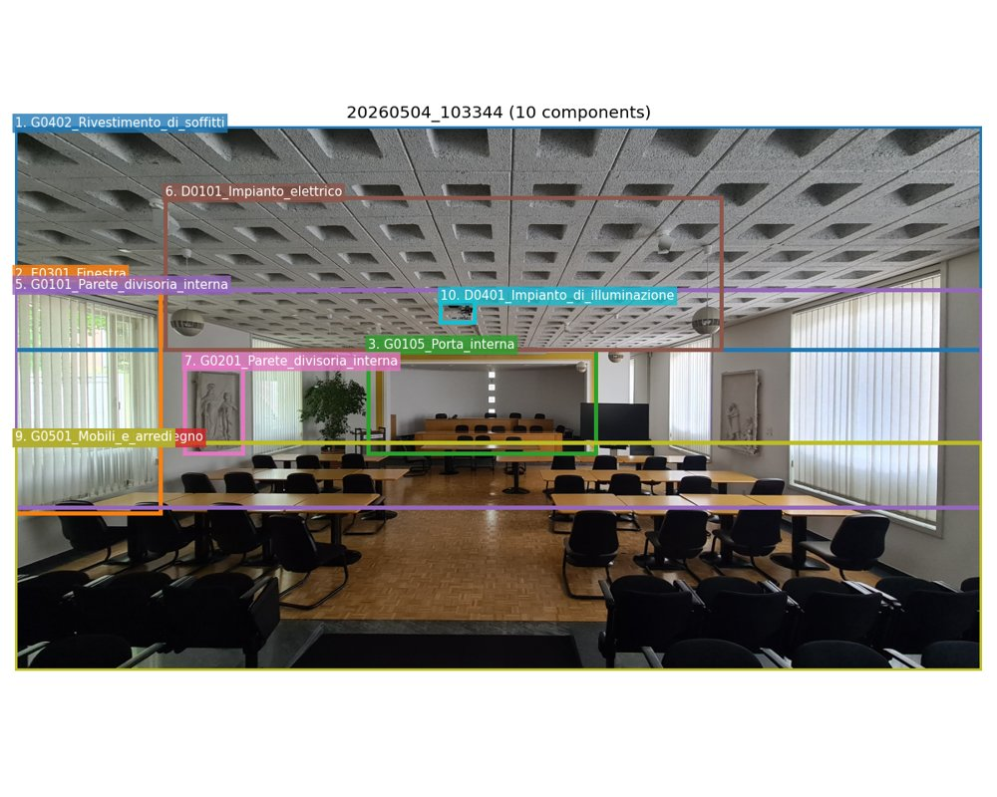 | 1. Concrete acoustic ceiling tiles with geometric pattern  Class (level 1): G_Finitura_interna_edificio  Class (level 2): G04_Rivestimento_di_soffitti  Class (level 3): G0402_Rivestimento_di_soffitti  Geometry: approx. 0.60 m x 0.60 m per tile, grid covering entire ceiling  Aesthetics: Minor signs of deterioration/wear  Functionality: Functionality does not appear to be compromised  Pollutants: Unlikely  Connection: Connection with added elements (mechanical fasteners)  Disassembly: Simple  Anomalies: minor surface dust accumulation -> Deterioramento generico (Minor); slight discoloration in some tiles -> Deterioramento generico (Minor)  2. Large vertical sliding windows with white vertical blinds  Class (level 1): E_Facciata_edificio  Class (level 2): E03_Infisso_in_facciata  Class (level 3): E0301_Finestra  Geometry: approx. 2.50 m x 2.00 m per window unit  Aesthetics: Minor signs of deterioration/wear  Functionality: Functionality does not appear to be compromised  Pollutants: Unlikely  Connection: Connection with added elements (mechanical fasteners)  Disassembly: Simple  Anomalies: minor surface scratches on glass -> Deterioramento generico (Minor); dust on blinds -> Deterioramento generico (Minor)  3. Interior door with yellow frame leading to adjacent space  Class (level 1): G_Finitura_interna_edificio  Class (level 2): G01_Parete_divisoria_porta_interna_portone_interno  Class (level 3): G0105_Porta_interna  Geometry: approx. 0.90 m x 2.10 m  Aesthetics: Minor signs of deterioration/wear  Functionality: Functionality does not appear to be compromised  Pollutants: Unlikely  Connection: Connection with added elements (mechanical fasteners)  Disassembly: Simple  Anomalies: minor scuff marks on door edge -> Deterioramento generico (Minor); light wear on door handle -> Deterioramento generico (Minor)  4. Parquet wooden floor with herringbone pattern  Class (level 1): G_Finitura_interna_edificio  Class (level 2): G03_Pavimento_interno  Class (level 3): G0302_Pavimento_in_legno  Geometry: covers entire floor area, approx. 8.00 m x 10.00 m  Aesthetics: Minor signs of deterioration/wear  Functionality: Functional  Pollutants: Unlikely  Connection: Connection with added elements (mechanical fasteners)  Disassembly: Complex  Anomalies: minor surface scratches -> Deterioramento generico (Minor); light wear in high-traffic areas -> Deterioramento generico (Minor)  5. Interior plastered walls with white paint  Class (level 1): G_Finitura_interna_edificio  Class (level 2): G01_Parete_divisoria_porta_interna_portone_interno  Class (level 3): G0101_Parete_divisoria_interna  Geometry: approx. 3.00 m height, full perimeter of room  Aesthetics: Minor signs of deterioration/wear  Functionality: Functionality does not appear to be compromised  Pollutants: Unlikely  Connection: Direct integral connection  Disassembly: Complex  Anomalies: minor paint chipping near baseboards -> Deterioramento generico (Minor); small surface cracks in plaster -> Deterioramento generico (Minor)  6. Suspended spherical pendant lights  Class (level 1): D_Impianti_tecnici_edificio  Class (level 2): D01_Impianto_elettrico  Class (level 3): D0101_Impianto_elettrico  Geometry: approx. 0.30 m diameter each  Aesthetics: As new  Functionality: Functional  Pollutants: Unlikely  Connection: Connection with added elements (mechanical fasteners)  Disassembly: Simple  Anomalies: minor dust on surface -> Deterioramento generico (Minor)  7. Wall-mounted bas-relief sculptures  Class (level 1): G_Finitura_interna_edificio  Class (level 2): G02_Parete_divisoria_porta_interna_portone_interno  Class (level 3): G0201_Parete_divisoria_interna  Geometry: approx. 0.80 m x 0.60 m each  Aesthetics: Minor signs of deterioration/wear  Functionality: Functionality does not appear to be compromised  Pollutants: Unlikely  Connection: Connection with added elements (mechanical fasteners)  Disassembly: Simple  Anomalies: minor surface dust -> Deterioramento generico (Minor); light discoloration -> Deterioramento generico (Minor)  8. Wooden tables with black metal legs  Class (level 1): G_Finitura_interna_edificio  Class (level 2): G05_Mobili_e_arredi  Class (level 3): G0501_Mobili_e_arredi  Geometry: approx. 1.80 m x 0.70 m per table  Aesthetics: Minor signs of deterioration/wear  Functionality: Functional  Pollutants: Unlikely  Connection: Connection with added elements (mechanical fasteners)  Disassembly: Simple  Anomalies: minor surface scratches on tabletops -> Deterioramento generico (Minor); light wear on leg joints -> Deterioramento generico (Minor)  9. Black office chairs with metal frames  Class (level 1): G_Finitura_interna_edificio  Class (level 2): G05_Mobili_e_arredi  Class (level 3): G0501_Mobili_e_arredi  Geometry: approx. 0.60 m x 0.60 m x 0.90 m  Aesthetics: Minor signs of deterioration/wear  Functionality: Functional  Pollutants: Unlikely  Connection: Connection with added elements (mechanical fasteners)  Disassembly: Simple  Anomalies: minor fabric wear on seat -> Deterioramento generico (Minor); light surface scratches on frame -> Deterioramento generico (Minor)  10. Ceiling-mounted projector  Class (level 1): D_Impianti_tecnici_edificio  Class (level 2): D04_Impianto_di_illuminazione  Class (level 3): D0401_Impianto_di_illuminazione  Geometry: approx. 0.40 m x 0.30 m x 0.15 m  Aesthetics: As new  Functionality: Functional  Pollutants: Unlikely  Connection: Connection with added elements (mechanical fasteners)  Disassembly: Simple  Anomalies: minor dust on casing -> Deterioramento generico (Minor)

20260504_103346
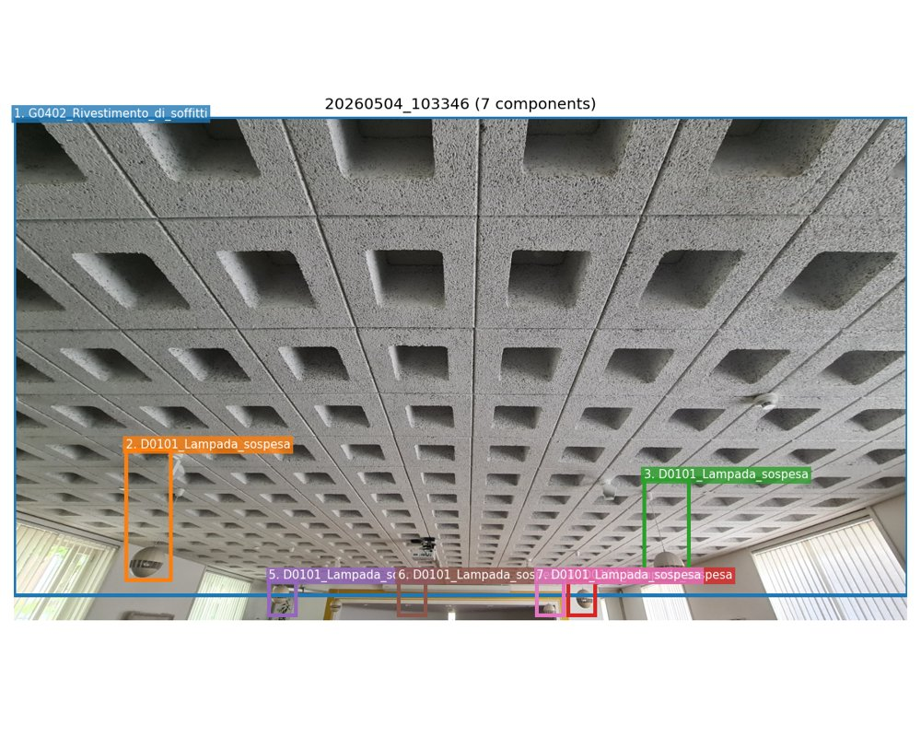 | 1. Pre-cast concrete ceiling panel with grid of rectangular voids  Class (level 1): G_Finitura_interna_edificio  Class (level 2): G04_Rivestimento_di_soffitti  Class (level 3): G0402_Rivestimento_di_soffitti  Geometry: approx. 1.20 m x 1.20 m per panel, grid layout covering entire ceiling  Aesthetics: Minor signs of deterioration/wear  Functionality: Functionality does not appear to be compromised  Pollutants: Unlikely  Connection: Direct integral connection  Disassembly: Complex  Anomalies: minor surface dust accumulation -> Deterioramento generico (Minor); slight discoloration in voids due to shadowing and age -> Deterioramento generico (Minor); no visible cracks or spalling -> Deterioramento generico (Minor)  2. Spherical pendant light fixture with metal cage and diffuser  Class (level 1): D_Impianti_tecnici_edificio  Class (level 2): D01_Impianto_di_illuminazione  Class (level 3): D0101_Lampada_sospesa  Geometry: diameter approx. 0.30 m, hanging length approx. 1.00 m  Aesthetics: Minor signs of deterioration/wear  Functionality: Functionality does not appear to be compromised  Pollutants: Unlikely  Connection: Connection with added elements (mechanical fasteners)  Disassembly: Simple  Anomalies: light surface dust on diffuser -> Deterioramento generico (Minor); minor scratches on metal cage -> Deterioramento generico (Minor)  3. Spherical pendant light fixture with metal cage and diffuser  Class (level 1): D_Impianti_tecnici_edificio  Class (level 2): D01_Impianto_di_illuminazione  Class (level 3): D0101_Lampada_sospesa  Geometry: diameter approx. 0.30 m, hanging length approx. 1.00 m  Aesthetics: Minor signs of deterioration/wear  Functionality: Functionality does not appear to be compromised  Pollutants: Unlikely  Connection: Connection with added elements (mechanical fasteners)  Disassembly: Simple  Anomalies: light surface dust on diffuser -> Deterioramento generico (Minor); minor scratches on metal cage -> Deterioramento generico (Minor)  4. Spherical pendant light fixture with metal cage and diffuser  Class (level 1): D_Impianti_tecnici_edificio  Class (level 2): D01_Impianto_di_illuminazione  Class (level 3): D0101_Lampada_sospesa  Geometry: diameter approx. 0.30 m, hanging length approx. 1.00 m  Aesthetics: Minor signs of deterioration/wear  Functionality: Functionality does not appear to be compromised  Pollutants: Unlikely  Connection: Connection with added elements (mechanical fasteners)  Disassembly: Simple  Anomalies: light surface dust on diffuser -> Deterioramento generico (Minor); minor scratches on metal cage -> Deterioramento generico (Minor)  5. Spherical pendant light fixture with metal cage and diffuser  Class (level 1): D_Impianti_tecnici_edificio  Class (level 2): D01_Impianto_di_illuminazione  Class (level 3): D0101_Lampada_sospesa  Geometry: diameter approx. 0.30 m, hanging length approx. 1.00 m  Aesthetics: Minor signs of deterioration/wear  Functionality: Functionality does not appear to be compromised  Pollutants: Unlikely  Connection: Connection with added elements (mechanical fasteners)  Disassembly: Simple  Anomalies: light surface dust on diffuser -> Deterioramento generico (Minor); minor scratches on metal cage -> Deterioramento generico (Minor)  6. Spherical pendant light fixture with metal cage and diffuser  Class (level 1): D_Impianti_tecnici_edificio  Class (level 2): D01_Impianto_di_illuminazione  Class (level 3): D0101_Lampada_sospesa  Geometry: diameter approx. 0.30 m, hanging length approx. 1.00 m  Aesthetics: Minor signs of deterioration/wear  Functionality: Functionality does not appear to be compromised  Pollutants: Unlikely  Connection: Connection with added elements (mechanical fasteners)  Disassembly: Simple  Anomalies: light surface dust on diffuser -> Deterioramento generico (Minor); minor scratches on metal cage -> Deterioramento generico (Minor)  7. Spherical pendant light fixture with metal cage and diffuser  Class (level 1): D_Impianti_tecnici_edificio  Class (level 2): D01_Impianto_di_illuminazione  Class (level 3): D0101_Lampada_sospesa  Geometry: diameter approx. 0.30 m, hanging length approx. 1.00 m  Aesthetics: Minor signs of deterioration/wear  Functionality: Functionality does not appear to be compromised  Pollutants: Unlikely  Connection: Connection with added elements (mechanical fasteners)  Disassembly: Simple  Anomalies: light surface dust on diffuser -> Deterioramento generico (Minor); minor scratches on metal cage -> Deterioramento generico (Minor)

20260504_105544
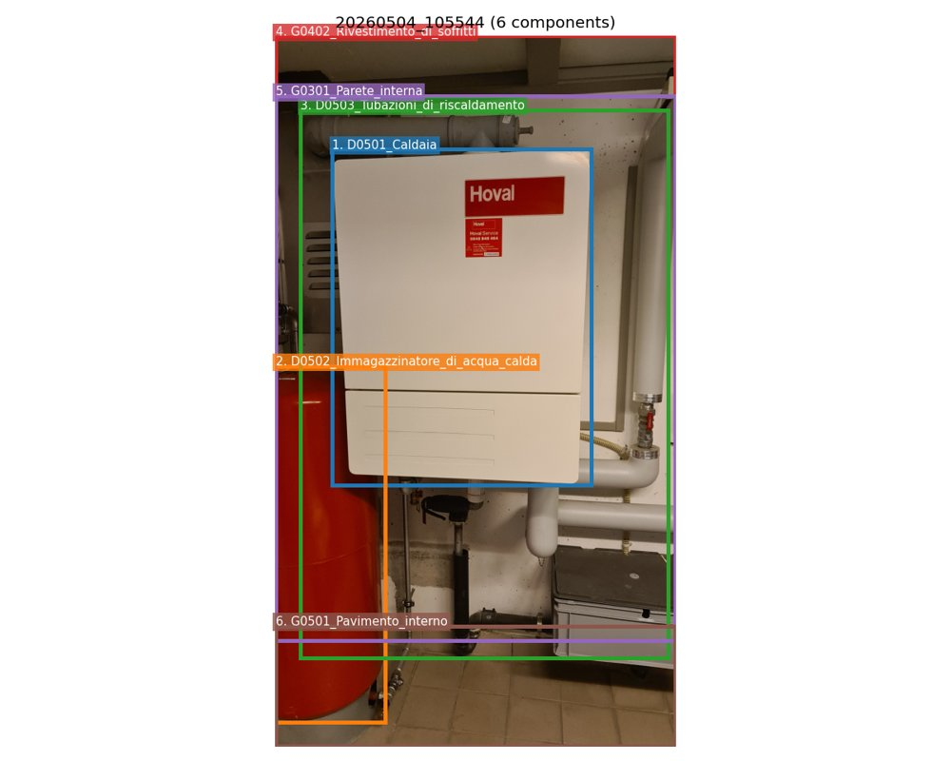 | 1. Hoval brand wall-mounted gas boiler  Class (level 1): D_Impianti_tecnici_edificio  Class (level 2): D05_Impianto_di_riscaldamento  Class (level 3): D0501_Caldaia  Geometry: 0.60 m x 0.80 m  Aesthetics: Minor signs of deterioration/wear  Functionality: Functionality does not appear to be compromised  Pollutants: Unlikely  Connection: Connection with added elements (mechanical fasteners)  Disassembly: Simple  Anomalies: minor surface dust accumulation -> Deterioramento generico (Minor); slight discoloration on lower panel -> Deterioramento generico (Minor)  2. Red cylindrical hot water storage tank  Class (level 1): D_Impianti_tecnici_edificio  Class (level 2): D05_Impianto_di_riscaldamento  Class (level 3): D0502_Immagazzinatore_di_acqua_calda  Geometry: 0.50 m diameter x 1.50 m height  Aesthetics: Minor signs of deterioration/wear  Functionality: Functionality does not appear to be compromised  Pollutants: Unlikely  Connection: Connection with added elements (mechanical fasteners)  Disassembly: Simple  Anomalies: minor surface scratches -> Deterioramento generico (Minor); dust accumulation -> Deterioramento generico (Minor)  3. White PVC and metal heating system piping  Class (level 1): D_Impianti_tecnici_edificio  Class (level 2): D05_Impianto_di_riscaldamento  Class (level 3): D0503_Tubazioni_di_riscaldamento  Geometry: various lengths, approx. 2.00 m total visible  Aesthetics: Minor signs of deterioration/wear  Functionality: Functionality does not appear to be compromised  Pollutants: Unlikely  Connection: Connection with added elements (mechanical fasteners)  Disassembly: Simple  Anomalies: minor surface dirt -> Deterioramento generico (Minor); some pipe joints show slight discoloration -> Deterioramento generico (Minor)  4. White painted ceiling panel  Class (level 1): G_Finitura_interna_edificio  Class (level 2): G04_Rivestimento_di_soffitti  Class (level 3): G0402_Rivestimento_di_soffitti  Geometry: approx. 1.50 m x 0.80 m  Aesthetics: Minor signs of deterioration/wear  Functionality: Functional  Pollutants: Unlikely  Connection: Connection with added elements (mechanical fasteners)  Disassembly: Simple  Anomalies: minor surface dust -> Deterioramento generico (Minor); small water stain near edge -> Deterioramento generico (Minor)  5. White painted interior wall  Class (level 1): G_Finitura_interna_edificio  Class (level 2): G03_Parete_interna  Class (level 3): G0301_Parete_interna  Geometry: approx. 2.00 m x 1.50 m  Aesthetics: Minor signs of deterioration/wear  Functionality: Functional  Pollutants: Unlikely  Connection: Direct integral connection  Disassembly: Complex  Anomalies: minor surface dirt -> Deterioramento generico (Minor); small cracks near base -> Deterioramento generico (Minor)  6. Beige ceramic tile floor  Class (level 1): G_Finitura_interna_edificio  Class (level 2): G05_Pavimento_interno  Class (level 3): G0501_Pavimento_interno  Geometry: approx. 2.00 m x 1.50 m  Aesthetics: Minor signs of deterioration/wear  Functionality: Functional  Pollutants: Unlikely  Connection: Hard chemical connection  Disassembly: Complex  Anomalies: minor grout discoloration -> Deterioramento generico (Minor); surface scratches -> Deterioramento generico (Minor)

20260504_105610
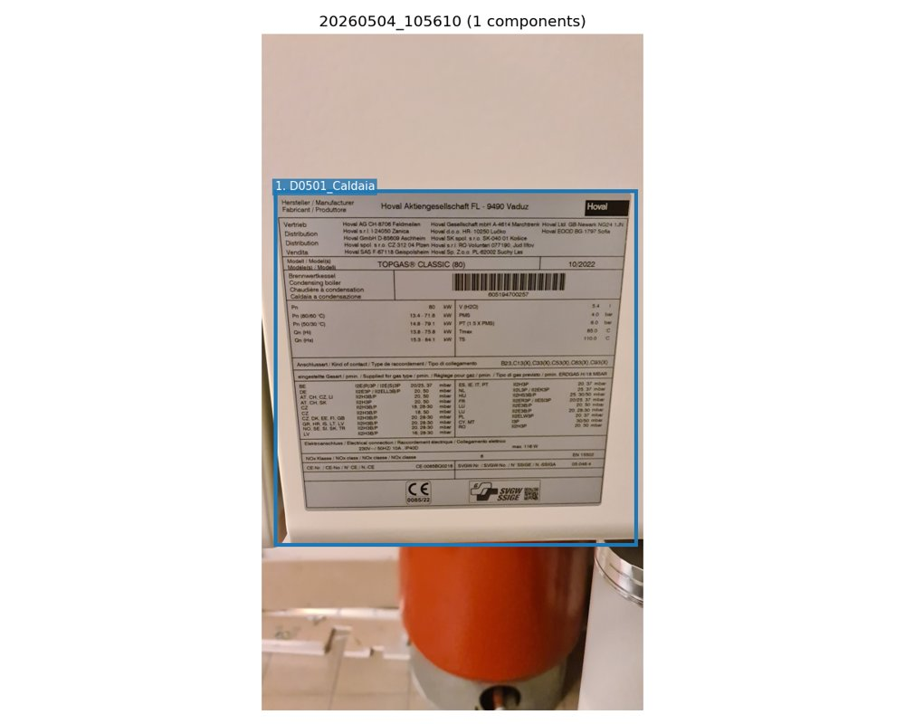 | 1. Hoval TOPGAS® CLASSIC (80) condensing gas boiler  Class (level 1): D_Impianti_tecnici_edificio  Class (level 2): D05_Impianto_di_riscaldamento  Class (level 3): D0501_Caldaia  Geometry: approx. 0.60 m x 0.40 m x 0.80 m  Aesthetics: As new  Functionality: Functionality does not appear to be compromised  Pollutants: Unlikely  Connection: Connection with added elements (mechanical fasteners)  Disassembly: Simple

DSC_0038
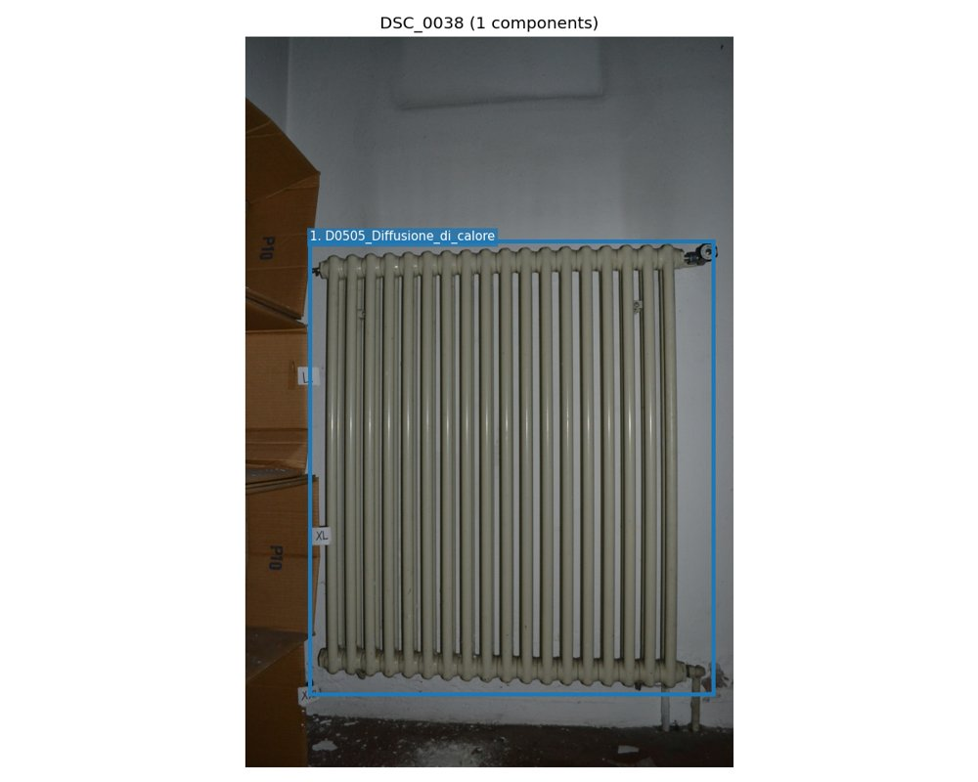 | 1. Cast iron column radiator with thermostatic valve  Class (level 1): D_Impianti_tecnici_edificio  Class (level 2): D05_Impianto_di_riscaldamento  Class (level 3): D0505_Diffusione_di_calore  Geometry: 0.80 m x 1.20 m  Aesthetics: Minor signs of deterioration/wear  Functionality: Functionality does not appear to be compromised  Pollutants: Unlikely  Connection: Connection with added elements (mechanical fasteners)  Disassembly: Simple  Anomalies: minor surface dust accumulation -> Deterioramento generico (Minor); light discoloration on paint surface -> Deterioramento generico (Minor); small paint chip near bottom right bracket -> Deterioramento generico (Minor)

DSC_0758
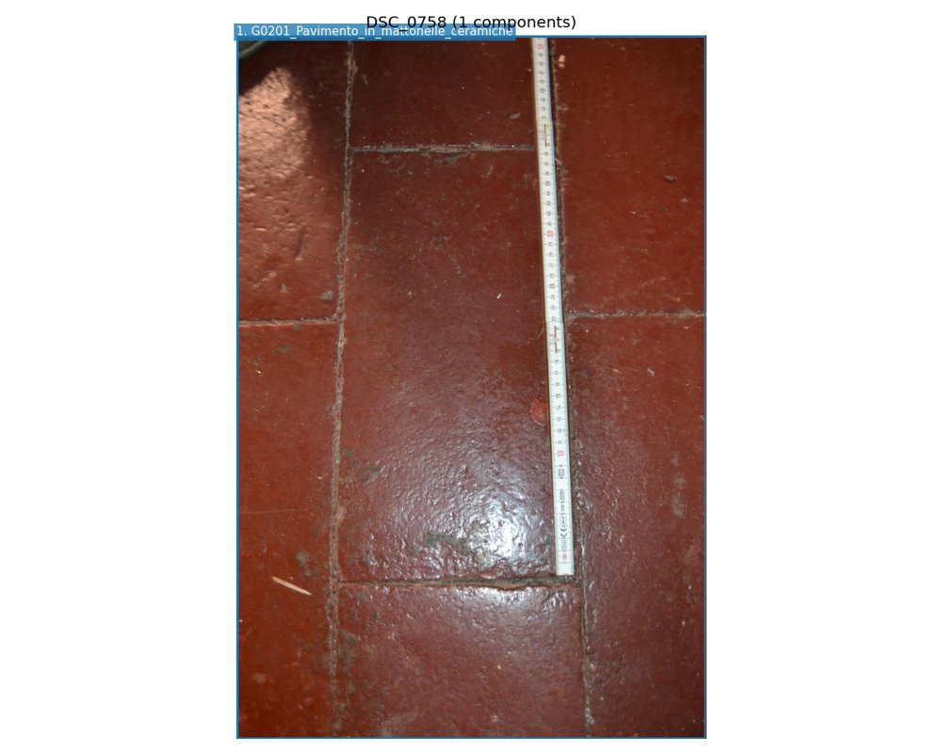 | 1. Red ceramic tile floor with grouted joints  Class (level 1): G_Finitura_interna_edificio  Class (level 2): G02_Pavimento_interno  Class (level 3): G0201_Pavimento_in_mattonelle_ceramiche  Geometry: approx. 1.00 m x 1.00 m (per tile, based on ruler scale)  Aesthetics: Minor signs of deterioration/wear  Functionality: Functionality does not appear to be compromised  Pollutants: Unlikely  Connection: Soft chemical connection  Disassembly: Complex  Anomalies: surface abrasion -> Deterioramento generico (Minor); minor discoloration and staining -> Deterioramento generico (Minor); grout joint degradation -> Deterioramento generico (Minor); small debris and dirt accumulation -> Deterioramento generico (Minor)

IMG_2765
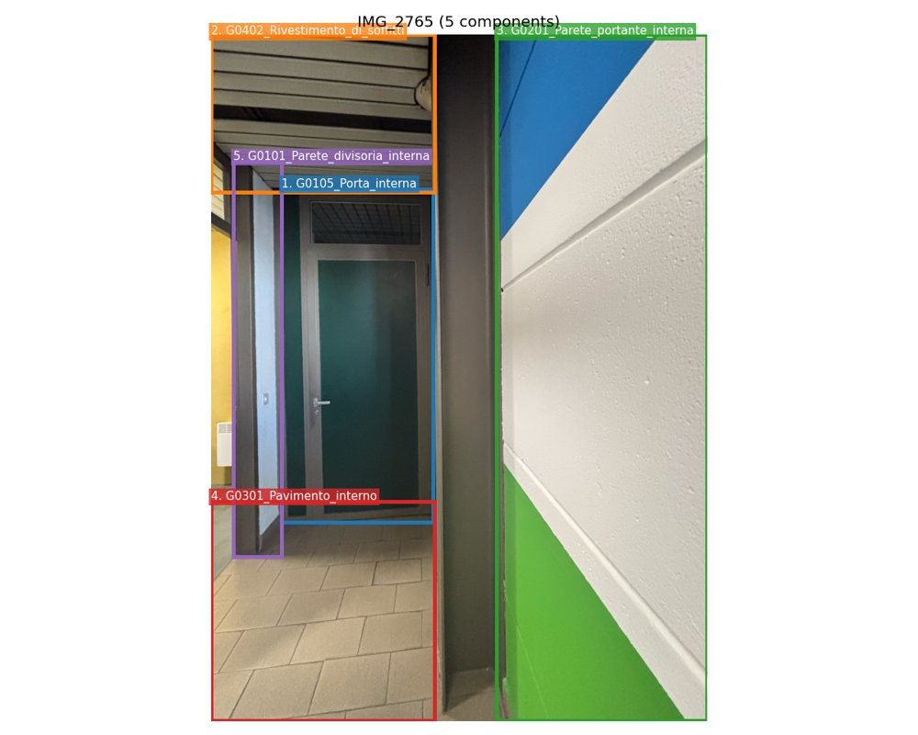 | 1. Flush steel internal door with transom window  Class (level 1): G_Finitura_interna_edificio  Class (level 2): G01_Parete_divisoria_porta_interna_portone_interno  Class (level 3): G0105_Porta_interna  Geometry: 0.90 m x 2.00 m  Aesthetics: Minor signs of deterioration/wear  Functionality: Functionality does not appear to be compromised  Pollutants: Unlikely  Connection: Connection with added elements (mechanical fasteners)  Disassembly: Simple  Anomalies: minor surface abrasion on door leaf -> Deterioramento generico (Minor); slight discoloration on transom grille -> Deterioramento generico (Minor)  2. Metal ceiling panel system (linear profile)  Class (level 1): G_Finitura_interna_edificio  Class (level 2): G04_Rivestimento_di_soffitti  Class (level 3): G0402_Rivestimento_di_soffitti  Geometry: approx. 3.00 m x 0.30 m (per panel)  Aesthetics: Minor signs of deterioration/wear  Functionality: Functional  Pollutants: Unlikely  Connection: Connection with added elements (mechanical fasteners)  Disassembly: Very simple  Anomalies: minor dust accumulation -> Deterioramento generico (Minor); slight bending at edge of one panel -> Deterioramento generico (Minor)  3. Painted concrete block wall with color bands  Class (level 1): G_Finitura_interna_edificio  Class (level 2): G02_Parete_portante_interna  Class (level 3): G0201_Parete_portante_interna  Geometry: approx. 2.50 m x 0.30 m (visible section)  Aesthetics: Minor signs of deterioration/wear  Functionality: Functional  Pollutants: Unlikely  Connection: Direct integral connection  Disassembly: Complex  Anomalies: minor surface pitting -> Deterioramento generico (Minor); paint chipping at joint between green and white bands -> Deterioramento generico (Minor)  4. Ceramic tile flooring  Class (level 1): G_Finitura_interna_edificio  Class (level 2): G03_Pavimento_interno  Class (level 3): G0301_Pavimento_interno  Geometry: approx. 3.00 m x 1.50 m (visible area)  Aesthetics: Minor signs of deterioration/wear  Functionality: Functional  Pollutants: Unlikely  Connection: Hard chemical connection  Disassembly: Complex  Anomalies: minor grout staining -> Deterioramento generico (Minor); slight surface scratching -> Deterioramento generico (Minor)  5. Internal partition wall with metal frame and drywall  Class (level 1): G_Finitura_interna_edificio  Class (level 2): G01_Parete_divisoria_porta_interna_portone_interno  Class (level 3): G0101_Parete_divisoria_interna  Geometry: approx. 2.50 m x 0.30 m (visible section)  Aesthetics: Minor signs of deterioration/wear  Functionality: Functional  Pollutants: Unlikely  Connection: Connection with added elements (mechanical fasteners)  Disassembly: Simple  Anomalies: minor paint scuffing -> Deterioramento generico (Minor); small dent near base -> Deterioramento generico (Minor)

IMG_2768
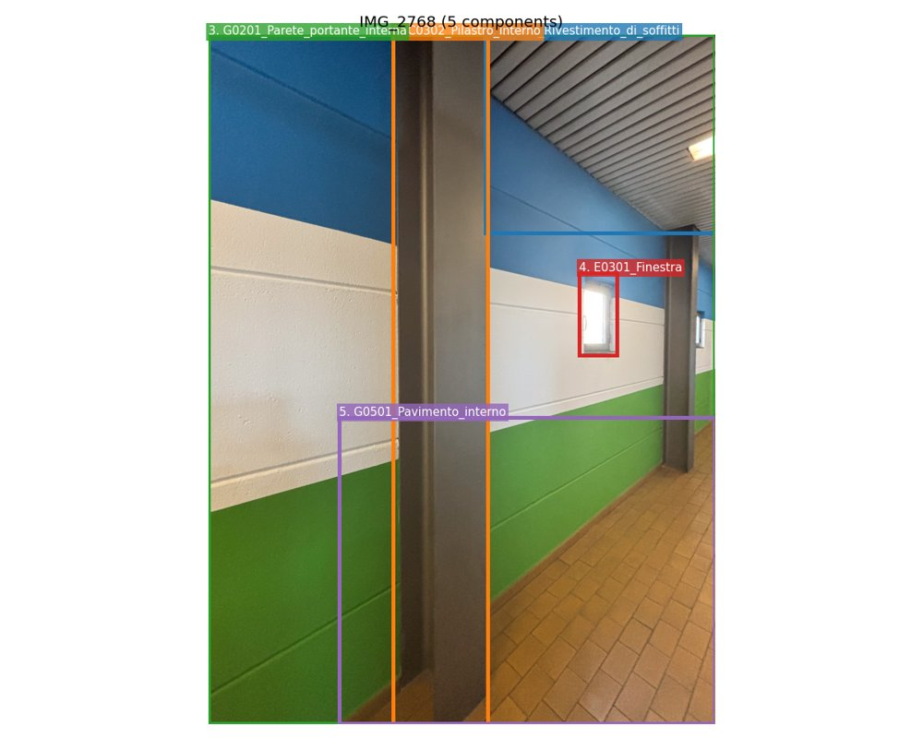 | 1. Linear metal ceiling panel system  Class (level 1): G_Finitura_interna_edificio  Class (level 2): G04_Rivestimento_di_soffitti  Class (level 3): G0402_Rivestimento_di_soffitti  Geometry: approx. 3.00 m x 0.15 m (per panel), installed in continuous run  Aesthetics: Minor signs of deterioration/wear  Functionality: Functionality does not appear to be compromised  Pollutants: Unlikely  Connection: Connection with added elements (mechanical fasteners)  Disassembly: Simple  Anomalies: minor surface dust accumulation -> Deterioramento generico (Minor); slight discoloration along panel edges -> Deterioramento generico (Minor)  2. Internal steel structural column  Class (level 1): C_Costruzione_grezza_edificio  Class (level 2): C03_Pilastro_interno  Class (level 3): C0302_Pilastro_interno  Geometry: 0.20 m x 0.20 m x 3.00 m (approx.)  Aesthetics: Minor signs of deterioration/wear  Functionality: Functionality does not appear to be compromised  Pollutants: Unlikely  Connection: Direct integral connection  Disassembly: Complex  Anomalies: light surface oxidation on edges -> Deterioramento generico (Minor); minor paint chipping at base -> Deterioramento generico (Minor)  3. Painted concrete block wall (three-color finish)  Class (level 1): G_Finitura_interna_edificio  Class (level 2): G02_Parete_portante_interna  Class (level 3): G0201_Parete_portante_interna  Geometry: approx. 3.00 m x 2.50 m (per visible section)  Aesthetics: Minor signs of deterioration/wear  Functionality: Functionality does not appear to be compromised  Pollutants: Likely  Connection: Direct integral connection  Disassembly: Complex  Anomalies: minor paint peeling at joints -> Deterioramento generico (Minor); surface abrasion near base -> Deterioramento generico (Minor); small water stain near floor level -> Deterioramento generico (Minor)  4. Small fixed window in concrete wall  Class (level 1): E_Facciata_edificio  Class (level 2): E03_Infisso_in_facciata  Class (level 3): E0301_Finestra  Geometry: 0.60 m x 0.60 m  Aesthetics: Minor signs of deterioration/wear  Functionality: Functionality does not appear to be compromised  Pollutants: Unlikely  Connection: Connection with added elements (mechanical fasteners)  Disassembly: Simple  Anomalies: minor surface dirt on glass -> Deterioramento generico (Minor); slight frame discoloration -> Deterioramento generico (Minor)  5. Terracotta brick flooring in herringbone pattern  Class (level 1): G_Finitura_interna_edificio  Class (level 2): G05_Pavimento_interno  Class (level 3): G0501_Pavimento_interno  Geometry: approx. 3.00 m x 1.50 m (visible section)  Aesthetics: Minor signs of deterioration/wear  Functionality: Functionality does not appear to be compromised  Pollutants: Unlikely  Connection: Soft chemical connection  Disassembly: Simple  Anomalies: minor surface staining -> Deterioramento generico (Minor); some loose grout joints -> Deterioramento generico (Minor)

