**Decision Tree**

**Explain the advantages and disadvantages of writing a program on your own vs using a pre-created suite such as WEKA.**

One of the advantages of creating or developing you own program instead of using programs such as WEKA, is that in the process of implementing you are able to understand and clarify all the concepts of the ID3 algorithm. Also, when you write your program you can do some changes in the output to make it more understandable that can match certain needs, in the other hand in programs such as WEKA the output is defined and even though you can choose between different options, but this is also an advantage of using this type of tools, as it has more than one option and gives more information of the tree like schema, attributes, number of leaves, size of the tree, etc.

**Explain what criteria you followed to choose the datasets for your tree and the WEKA tests.**

We follow the given tutorial, and it suggested to use the weather.nominal.arff. We used that set to compare the output of Weka and out program. We obtained the same results.

After that we checked the different data set in WEKA, but some of them the output given by the tool was different as it contains <= , >=, >, <. This is because the data set had numeric values. So, the ones we used were the ones that does not include numeric values.

**Include the graphics of the trees or part of the trees you generated in WEKA and your own program. Are they different, and if so, why?**

The output of our program and the output of WEKA are different, this is not because one of them is wrong but because of the different presentation of the output. We included two different trees generated by WEKA and our program to compare the output, even though the presentation of them is different we get the same result.

We think that the output of our program is clearer than WEKA’s output, because as our has indentation this helps to understand more the tree.

.

WEKA

OUR PROGRAM

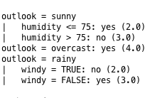

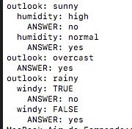

../../../../../Desktop/Captura%20de%20pantalla%202017-03-24%20a%20la(s)%2023.07.2../../../../../Desktop/Captura%20de%20pantalla%202017-03-24%20a%20la(s)%2023.07.2

**Based in what you have learned so far where would you use decision trees?**

Decision trees are useful for predictive analysis as they are a good tool to choose between different options or to predict the result given certain inputs. For predictive analysis that returns the possible outcomes and this will help to balance the possible risks or benefits related with the possible option or input.

*The second data set was recover from : https://archive.ics.uci.edu/ml/datasets/Balloons