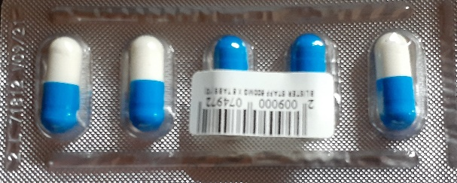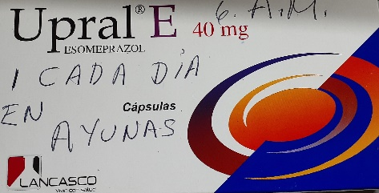

UPRAL E **6:00 A.M. UNICA DOSIS**  STAFF **6:A.M. – 12:P.M. - 6:00 `P.M. – EN AYUNA 12:00 AM Por 7 DIAS**

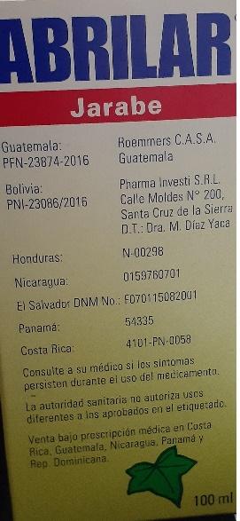

ABRILAR **6:00 A.M. – 2:00 P.M. - 10:00 PM**

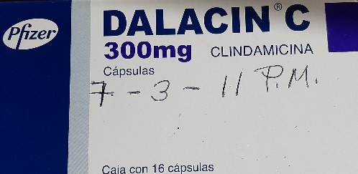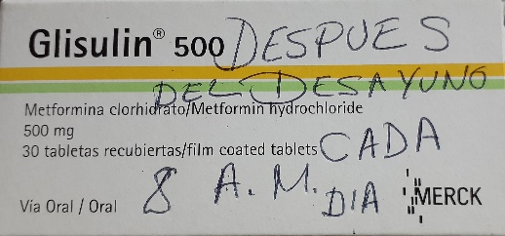

DALACIN C **7:00 A.M. – 3:00 P.M. - 11:00 PM** GLISULIN 8:00 **A.M. UNICA DOSIS**

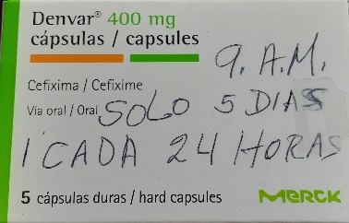

DENVAR **9:A.M. UNICA DOSIS POR 5 DIAS**