1. LKMs give you the ability to modify the kernel without having to restart the computer, or recompile the entire kernel.

2 . ### Makefile
obj-m := rkit.o
KDIR := /lib/modules/3.13.0-35-generic/build
PWD := $(shell pwd)

all:
$(MAKE) -C $(KDIR) M=$(PWD) modules

clean:
rm -rf *.o *.ko *.mod *.sysmvers *.order
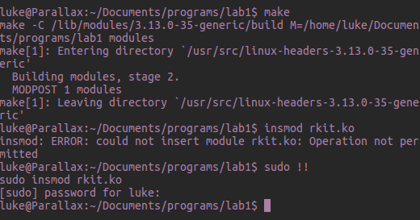
3. a. ssize_t is a defined size type. It differs from size_t in that ssize_t is signed and size_t is unsigned.
b. asmlinkage tells the cpu that it won't have any function parameters in it's registers and that they will instead be on the stack.
c. copy_from_user() is a kernel function that allows the copying of data from user-space to the kernel
d. The sys_call_table is the table where the kernel calls are defined, ie echo. Because we cannot just access it in the newer kernel versions we must scan through memory to find the start of it.
e. we cannon use user-space functions in the kernel, we must use kernel specific versions of them such as kmalloc. One major difference is that kmalloc returns physically contiguous memory whereas malloc does not guarantee this
f. Similar to the last question we must use the kernel-space version of the printf, whos output goes to /var/log/syslog
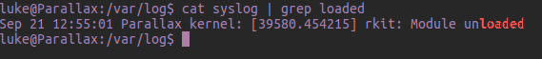
g. The first call disables protected mode so we can write to the read-only section containing the sys_call_table and the second re enables it

h. rkit_init() finds the sys_call_table and replaces the appropriate entry with the addr function of rkit_write
I. rkit_write() is the malicious function whose address has been inserted into the sys_call_table. When the sys_call is called this code will be executed instead of the default code. If h1dd3n is in the buffer you clear it otherwise you so the write.

4. Because the special sting h1dd3n is there the buffer gets deleted.
5. A rootkit is supposed to give you a backdoor to a machine. Because it shows up in the list a user can easily see a rootkit is running on their system and can remove it.
6. When remove the module you restore the sys_call_table to its default state. Our “malicious” code no longer gets pointed to and so it doesn't run. Because of this there is no hook to remove h1dd3n.
7. The rootkit has removed itself from the list of modules.
8. Rebooting, some 3rd party programs may be able to find/remove it as well.

