Luke Woodruff & Annie Kelly
CSCI 3753
Programming Assignment 3
11/4/2014

Linux Scheduler Experiment

Abstract
In this report we will be benchmarking three different scheduling algorithms: normal, round robin, and first in-first out. We will be testing these schedulers across three different program types: IO-Bound, CPU-Bound, and Mixed. In addition, we will run these programs and fork off a different number of processes each time: Low (5 processes), Medium (50 processes), High (200 processes). We will record our results using time to record the Wall, User, System, CPU, i-switched, and v-switched.

Introduction
The purpose of this investigation is to probe into the behavior of the Linux scheduler. We looked at the performance of three schedulers. The first-in-first-out (FIFO) scheduler maintains a queue and picks processes from the front of the queue, that is those having been in the queue the longest, and does not preempt any process. Round Robin (RR) gives each process a quantum of runtime, then preemptively switches to the next process until all have gotten a turn. The Completely Fair Scheduler (CFS) is the default scheduler in Linux and, at a high level, is similar to the Round Robin scheduling, but it adjusts the time quantum based on the amount of CPU it previously used.

Method
This experiment determines the runtime of the three schedulers a CPU bound, IO bound, and a mixed program. The CPU bound program statistically computes pi over 1000000 iterations. The IO bound copies 102400 bytes from an input file to an output file. The mixed statistically computes pi over 1000000 iterations and writes the result to an output file. Each test is run with each scheduler and with 5, 50 and 200 simultaneous forked processes. The testing machine was natively running Ubuntu 14.10 on an SSD with an Intel i5 3570k, a quad-core CPU with hyper-threading, with 8gb of main memory.

Results
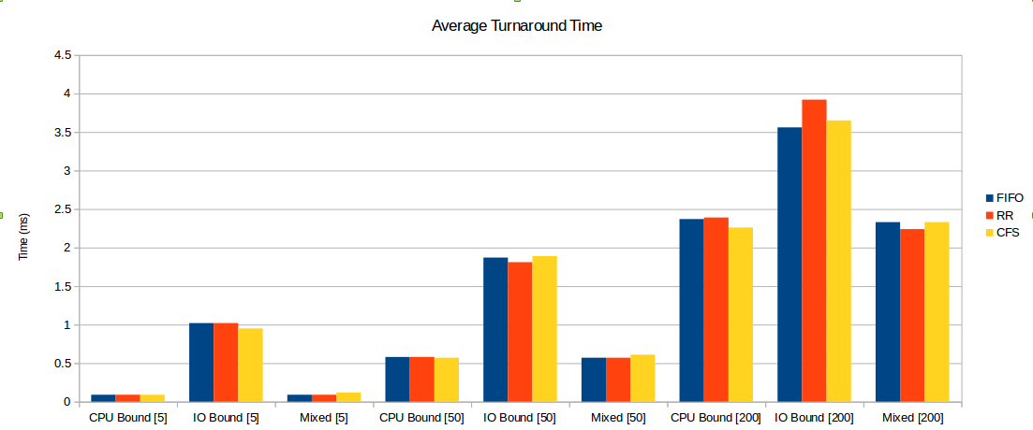
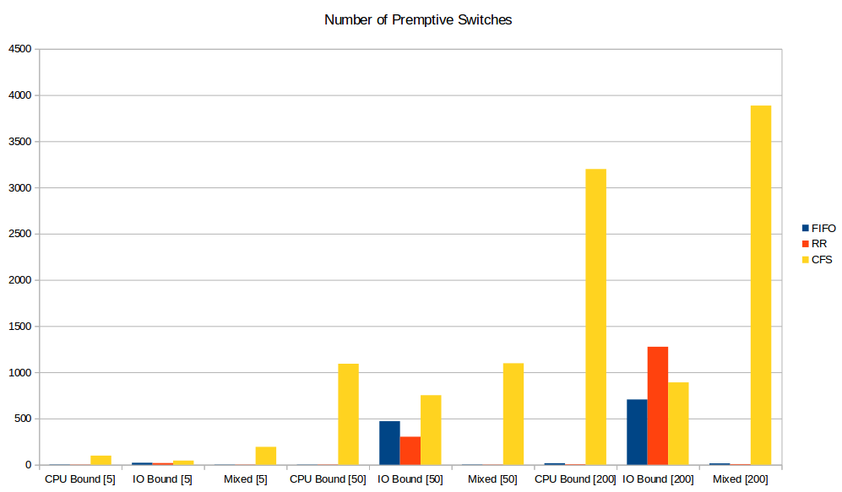

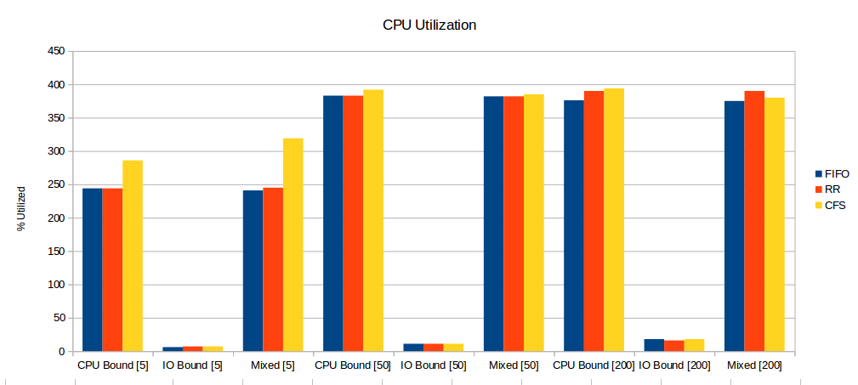
First In First Out
 | # Processes | Wall | User | System | CPU | i-switched | v-switched
CPU Bound | 5 | 0.09 | 0.22 | 0.00 | 244% | 3 | 13
IO Bound | 5 | 1.02 | 0.00 | 0.06 | 6% | 21 | 1553
Mixed | 5 | 0.09 | 0.21 | 0.00 | 241% | 2 | 12
CPU Bound | 50 | 0.58 | 2.22 | 0.00 | 383% | 2 | 57
IO Bound | 50 | 1.87 | 0.00 | 0.20 | 11% | 471 | 16498
Mixed | 50 | 0.57 | 2.18 | 0.00 | 382% | 3 | 58
CPU Bound | 200 | 2.37 | 8.92 | 0.02 | 376% | 16 | 207
IO Bound | 200 | 3.56 | 0.02 | 0.64 | 18% | 706 | 63797
Mixed | 200 | 2.33 | 8.73 | 0.02 | 375% | 14 | 208

Round Robin
 | # Processes | Wall | User | System | CPU | i-switched | v-switched
CPU Bound | 5 | 0.09 | 0.22 | 0.00 | 244% | 2 | 12
IO Bound | 5 | 1.02 | 0.00 | 0.06 | 7% | 18 | 1981
Mixed | 5 | 0.09 | 0.21 | 0.00 | 245% | 2 | 11
CPU Bound | 50 | 0.58 | 2.22 | 0.00 | 383% | 3 | 58
IO Bound | 50 | 1.81 | 0.01 | 0.18 | 11% | 303 | 15507
Mixed | 50 | 0.57 | 2.17 | 0.01 | 382% | 2 | 57
CPU Bound | 200 | 2.39 | 8.92 | 0.02 | 390% | 5 | 207
IO Bound | 200 | 3.92 | 0.02 | 0.64 | 16% | 1276 | 66643
Mixed | 200 | 2.24 | 8.73 | 0.01 | 390% | 6 | 208

Normal Scheduler
 | # Processes | Wall | User | System | CPU | i-switched | v-switched
CPU Bound | 5 | 0.09 | 0.26 | 0.00 | 286% | 98 | 14
IO Bound | 5 | 0.95 | 0.00 | 0.06 | 7% | 45 | 1946
Mixed | 5 | 0.12 | 0.38 | 0.00 | 319% | 193 | 13
CPU Bound | 50 | 0.57 | 2.23 | 0.00 | 392% | 1092 | 103
IO Bound | 50 | 1.89 | 0.00 | 0.22 | 11% | 752 | 16418
Mixed | 50 | 0.61 | 2.34 | 0.01 | 385% | 1098 | 103
CPU Bound | 200 | 2.26 | 8.91 | 0.03 | 394% | 3199 | 403
IO Bound | 200 | 3.65 | 0.00 | 0.66 | 18% | 891 | 64777
Mixed | 200 | 2.33 | 8.73 | 0.02 | 375% | 14 | 208

Analysis
The fastest turnaround time provides the “best” user experience as programs will respond quickly. Unfortunately this data does not consistently point to one scheduler as being best. In general the CFS scheduler, the default scheduler in Linux, seems to be best for CPU bounded tasks. CFS performs worse in cases with a small amount of simultaneous processes, due to the overhead from more context switches. From this limited set of data preemptive switches appears to increase linearly with number of simultaneous processes.
For systems running primarily or exclusively CPU intensive programs First-in-First-out or Round Robin would be a better scheduling choice than CFS, due to the fact that you don't want these programs getting switched out until they are complete. These schedulers also scale better than CFS and so in systems with a large number of running processes may be better suited.

Conclusion
Although it's hard to definitively say any scheduler is best for normal computer use CFS seems to be better than first-in-first-out or round robin. However in non-typical environments, such as those in server back-ends or super computers FIFO or Round Robin would be more optimal due to their lower overhead.

References
Andy Sayler
Modern Operating Systems

Appendix A – Raw Data
Doing CPUBound 5 times using SCHED_OTHER
wall, user, system, CPU, i-switched, v-switched
0.09 0.26 0.00 286% 98 14
0.07 0.22 0.00 289% 72 14
0.07 0.22 0.00 313% 71 14
0.07 0.22 0.00 301% 82 14
0.07 0.22 0.00 309% 90 14
Doing CPUBound 5 times using SCHED_RR
wall, user, system, CPU, i-switched, v-switched
0.09 0.22 0.00 244% 2 12
0.09 0.21 0.01 246% 3 12
0.09 0.22 0.00 244% 3 13
0.09 0.22 0.00 245% 4 13
0.09 0.22 0.00 247% 3 13
Doing CPUBound 5 times using SCHED_FIFO
wall, user, system, CPU, i-switched, v-switched
0.09 0.22 0.00 244% 3 13
0.09 0.22 0.00 244% 2 12
0.09 0.22 0.00 241% 5 13
0.09 0.22 0.00 247% 4 13
0.09 0.22 0.00 247% 2 12
Doing IOBound 5 times using SCHED_OTHER
wall, user, system, CPU, i-switched, v-switched
0.95 0.00 0.06 7% 45 1946
1.04 0.00 0.06 7% 30 1954
0.99 0.01 0.06 7% 41 1959
0.97 0.00 0.06 7% 40 1970
1.02 0.00 0.07 7% 24 1975
Doing IOBound 5 times using SCHED_RR
wall, user, system, CPU, i-switched, v-switched
1.02 0.00 0.06 7% 18 1981
1.00 0.00 0.05 5% 20 1884
0.97 0.00 0.06 6% 40 1887
1.03 0.00 0.07 7% 22 1967
0.97 0.00 0.07 7% 22 1964
Doing IOBound 5 times using SCHED_FIFO
wall, user, system, CPU, i-switched, v-switched
1.02 0.00 0.06 6% 21 1553
1.04 0.00 0.06 6% 41 1961
1.00 0.00 0.06 6% 32 1967
0.94 0.00 0.06 7% 88 1754
1.05 0.00 0.07 7% 14 1966
Doing Mixed 5 times using SCHED_OTHER
wall, user, system, CPU, i-switched, v-switched
0.12 0.38 0.00 319% 193 13
0.08 0.24 0.00 306% 77 13
0.07 0.21 0.00 306% 76 14
0.07 0.22 0.00 315% 126 14
0.06 0.22 0.00 341% 155 14
Doing Mixed 5 times using SCHED_RR
wall, user, system, CPU, i-switched, v-switched
0.09 0.21 0.00 245% 2 11
0.09 0.21 0.00 245% 2 13
0.08 0.22 0.00 248% 3 12
0.09 0.21 0.00 244% 3 12
0.09 0.22 0.00 245% 3 15
Doing Mixed 5 times using SCHED_FIFO
wall, user, system, CPU, i-switched, v-switched
0.09 0.21 0.00 241% 2 12
0.09 0.22 0.00 246% 4 13
0.09 0.21 0.00 245% 4 12
0.09 0.22 0.00 245% 3 12
0.09 0.21 0.00 245% 2 13
Doing CPUBound 50 times using SCHED_OTHER
wall, user, system, CPU, i-switched, v-switched
0.57 2.23 0.00 392% 1092 103
0.57 2.22 0.01 391% 893 103
0.57 2.23 0.00 390% 762 104
0.57 2.22 0.01 389% 1031 104
0.57 2.23 0.00 390% 781 102
Doing CPUBound 50 times using SCHED_RR
wall, user, system, CPU, i-switched, v-switched
0.58 2.22 0.00 383% 3 58
0.58 2.22 0.00 383% 3 57
0.60 2.22 0.00 366% 7 58
0.58 2.21 0.01 383% 2 57
0.58 2.22 0.00 383% 4 58
Doing CPUBound 50 times using SCHED_FIFO
wall, user, system, CPU, i-switched, v-switched
0.58 2.22 0.00 383% 2 57
0.58 2.22 0.00 383% 3 59
0.58 2.22 0.01 382% 4 58
0.58 2.21 0.02 383% 2 58
0.60 2.22 0.00 368% 7 58
Doing IOBound 50 times using SCHED_OTHER
wall, user, system, CPU, i-switched, v-switched
1.89 0.00 0.22 11% 752 16418
1.91 0.00 0.22 12% 375 16777
1.89 0.00 0.20 10% 444 16823
1.81 0.00 0.21 11% 388 16502
1.88 0.00 0.19 10% 423 17635
Doing IOBound 50 times using SCHED_RR
wall, user, system, CPU, i-switched, v-switched
1.81 0.01 0.18 11% 303 15507
1.93 0.00 0.22 11% 567 16184
1.73 0.00 0.17 10% 411 15286
1.95 0.00 0.20 10% 571 18937
1.84 0.01 0.19 11% 508 16977
Doing IOBound 50 times using SCHED_FIFO
wall, user, system, CPU, i-switched, v-switched
1.87 0.00 0.20 11% 471 16498
1.81 0.00 0.18 10% 319 15399
1.81 0.00 0.21 11% 352 15918
1.84 0.00 0.20 11% 429 17217
1.81 0.00 0.17 10% 451 15811
Doing Mixed 50 times using SCHED_OTHER
wall, user, system, CPU, i-switched, v-switched
0.61 2.34 0.01 385% 1098 103
0.59 2.19 0.00 366% 1002 104
0.58 2.19 0.00 375% 862 104
0.59 2.18 0.01 367% 856 102
0.56 2.18 0.00 386% 857 124
Doing Mixed 50 times using SCHED_RR
wall, user, system, CPU, i-switched, v-switched
0.57 2.17 0.01 382% 2 57
0.59 2.17 0.01 369% 7 58
0.57 2.18 0.00 382% 2 56
0.57 2.18 0.00 382% 2 58
0.57 2.17 0.01 382% 4 57
Doing Mixed 50 times using SCHED_FIFO
wall, user, system, CPU, i-switched, v-switched
0.57 2.18 0.00 382% 3 58
0.59 2.18 0.00 367% 7 58
0.57 2.17 0.01 382% 3 60
0.57 2.17 0.01 383% 2 57
0.57 2.18 0.00 383% 3 57
Doing CPUBound 200 times using SCHED_OTHER
wall, user, system, CPU, i-switched, v-switched
2.26 8.91 0.03 394% 3199 403
2.27 8.90 0.03 393% 3513 407
2.26 8.92 0.00 394% 3257 402
2.26 8.90 0.03 394% 3265 403
2.26 8.92 0.01 394% 3344 399
Doing CPUBound 200 times using SCHED_RR
wall, user, system, CPU, i-switched, v-switched
2.29 8.92 0.02 390% 5 207
2.32 8.91 0.01 383% 11 208
2.38 8.92 0.02 375% 14 207
2.33 8.93 0.02 383% 10 208
2.32 8.91 0.01 383% 11 207
Doing CPUBound 200 times using SCHED_FIFO
wall, user, system, CPU, i-switched, v-switched
2.37 8.92 0.02 376% 16 207
2.33 8.92 0.01 382% 11 207
2.32 8.91 0.01 384% 11 207
2.37 8.91 0.02 375% 13 207
2.32 8.90 0.03 383% 11 207
Doing IOBound 200 times using SCHED_OTHER
wall, user, system, CPU, i-switched, v-switched
3.65 0.00 0.66 18% 891 64777
3.93 0.02 0.62 16% 1615 64562
3.61 0.01 0.57 16% 839 64391
3.91 0.01 0.59 15% 1786 63880
3.65 0.01 0.62 17% 788 65053
Doing IOBound 200 times using SCHED_RR
wall, user, system, CPU, i-switched, v-switched
3.92 0.02 0.64 16% 1456 65063
3.64 0.02 0.62 17% 779 64484
3.58 0.01 0.58 16% 993 64585
3.94 0.01 0.64 16% 1276 66643
3.89 0.01 0.59 15% 1761 64731
Doing IOBound 200 times using SCHED_FIFO
wall, user, system, CPU, i-switched, v-switched
3.56 0.02 0.64 18% 706 63797
3.83 0.02 0.60 16% 1428 64822
3.65 0.00 0.60 16% 642 65493
3.72 0.01 0.60 16% 874 64500
3.84 0.01 0.65 17% 1144 66412
Doing Mixed 200 times using SCHED_OTHER
wall, user, system, CPU, i-switched, v-switched
2.25 8.73 0.03 388% 4019 467
2.25 8.74 0.02 388% 3258 445
2.32 8.75 0.02 378% 3886 595
2.25 8.74 0.02 388% 3571 433
2.25 8.71 0.05 389% 3459 422
Doing Mixed 200 times using SCHED_RR
wall, user, system, CPU, i-switched, v-switched
2.24 8.73 0.01 390% 6 208
2.28 8.73 0.02 383% 11 209
2.33 8.72 0.02 375% 13 209
2.29 8.74 0.01 382% 11 208
2.27 8.73 0.02 384% 11 209
Doing Mixed 200 times using SCHED_FIFO
wall, user, system, CPU, i-switched, v-switched
2.33 8.73 0.02 375% 14 208
2.28 8.71 0.03 383% 10 209
2.28 8.72 0.02 383% 11 207
2.28 8.72 0.03 383% 10 207
2.34 8.76 0.03 374% 14 209

Appendix B – Code
Testscript
ITERATIONS=100000000
BYTESTOCOPY=102400
BLOCKSIZE=1024
TIMEFORMAT="wall=%e user=%U system=%S CPU=%P i-switched=%c v-switched=%w"
MAKE="make -s"
NUMPROC="5 50 200"
TESTS="CPUBound IOBound Mixed"
PRIORITIES="SCHED_OTHER SCHED_RR SCHED_FIFO"
echo Building code...
$MAKE clean
$MAKE
echo Starting test runs...
for num in $NUMPROC
do
for test in $TESTS
do
for priority in $PRIORITIES
do
echo Doing $test $num times using $priority
echo wall, user, system, CPU, i-switched, v-switched
for i in {1..5}
do
/usr/bin/time -f "$TIMEFORMAT" sudo ./$test $num $priority > /dev/null
done
done
done
done

benchmark.h
#include <sys/types.h>
#include <unistd.h>
#include <sys/wait.h>
#include <errno.h>
#include <string.h>
#include <sched.h>
#include <stdio.h>
#include <stdlib.h> /* atoi */

int forkMe(int numOfFork)
{
pid_t pid;
int ii;
for(ii = 0; ii < numOfFork; ii++)
{
pid = fork();
if(pid == 0)
{
break;
}
}
if(pid == 0)
{
printf("New Process %d\n", getpid());
return getpid();
}
else
{
printf("Parent Process\n");
while ((pid = waitpid(-1, NULL, 0))) {
if (errno == ECHILD) {
break;
}
}
printf("Done with all processes\n");
return 0;
}
return 0;
}
CPUBound.c
#include <stdlib.h>
#include <stdio.h>
#include <string.h>
#include <math.h>
#include <errno.h>
#include <sched.h>
#include "benchmark.h"

#define DEFAULT_ITERATIONS 1000000
#define RADIUS (RAND_MAX / 2)

inline double dist(double x0, double y0, double x1, double y1){
return sqrt(pow((x1-x0),2) + pow((y1-y0),2));
}

inline double zeroDist(double x, double y){
return dist(0, 0, x, y);
}

int main(int argc, char* argv[]){

long i;
long iterations;
int processes;
struct sched_param param;
int policy;
double x, y;
double inCircle = 0.0;
double inSquare = 0.0;
double pCircle = 0.0;
double piCalc = 0.0;
iterations = DEFAULT_ITERATIONS;
/* Set default policy if not supplied */
if(argc < 3){
policy = SCHED_OTHER;
}
/* Set default number of processes */
if(argc < 2){
processes = 1;
}
if(argc > 1){
processes = atol(argv[1]);
if(iterations < 1){
fprintf(stderr, "Bad number of processes\n");
exit(EXIT_FAILURE);
}
}
/* Set policy if supplied */
if(argc > 2){
if(!strcmp(argv[2], "SCHED_OTHER")){
policy = SCHED_OTHER;
}
else if(!strcmp(argv[2], "SCHED_FIFO")){
policy = SCHED_FIFO;
}
else if(!strcmp(argv[2], "SCHED_RR")){
policy = SCHED_RR;
}
else{
fprintf(stderr, "Unhandeled scheduling policy\n");
exit(EXIT_FAILURE);
}
}
/* Set process to max prioty for given scheduler */
param.sched_priority = sched_get_priority_max(policy);

/* Set new scheduler policy */
fprintf(stdout, "Current Scheduling Policy: %d\n", sched_getscheduler(0));
fprintf(stdout, "Setting Scheduling Policy to: %d\n", policy);
if(sched_setscheduler(0, policy, &param)){
perror("Error setting scheduler policy");
exit(EXIT_FAILURE);
}
fprintf(stdout, "New Scheduling Policy: %d\n", sched_getscheduler(0));

int pid = forkMe(processes);
if(pid != 0){

/* Calculate pi using statistical methode across all iterations*/
for(i=0; i<iterations; i++){
x = (random() % (RADIUS * 2)) - RADIUS;
y = (random() % (RADIUS * 2)) - RADIUS;
if(zeroDist(x,y) < RADIUS){
inCircle++;
}
inSquare++;
}

/* Finish calculation */
pCircle = inCircle/inSquare;
piCalc = pCircle * 4.0;

/* Print result */
fprintf(stdout, "pi = %f\n", piCalc);
}
return 0;
}
IOBound.c
#define _GNU_SOURCE

/* System Includes */
#include <stdlib.h>
#include <stdio.h>
#include <unistd.h>
#include <errno.h>
#include <fcntl.h>
#include <string.h>
#include <sys/types.h>
#include <sys/stat.h>
#include "benchmark.h"

/* Local Defines */
#define MAXFILENAMELENGTH 80
#define DEFAULT_INPUTFILENAME "rwinput"
#define DEFAULT_OUTPUTFILENAMEBASE "rwoutput"
#define DEFAULT_BLOCKSIZE 1024
#define DEFAULT_TRANSFERSIZE 1024*100

int main(int argc, char* argv[]){

int rv;
int inputFD;
int outputFD;
char inputFilename[MAXFILENAMELENGTH];
char outputFilename[MAXFILENAMELENGTH];
char outputFilenameBase[MAXFILENAMELENGTH];

ssize_t transfersize = 0;
ssize_t blocksize = 0;
char* transferBuffer = NULL;
ssize_t buffersize;

ssize_t bytesRead = 0;
ssize_t totalBytesRead = 0;
int totalReads = 0;
ssize_t bytesWritten = 0;
ssize_t totalBytesWritten = 0;
int totalWrites = 0;
int inputFileResets = 0;
int processes;

transfersize = DEFAULT_TRANSFERSIZE;

blocksize = DEFAULT_BLOCKSIZE;

/* Set default number of processes */
if(argc < 2){
processes = 1;
}
if(argc > 1){
processes = atol(argv[1]);
if(processes < 1){
fprintf(stderr, "Bad number of processes\n");
exit(EXIT_FAILURE);
}
}

/* Set supplied input filename or default if not supplied */

if(strnlen(DEFAULT_INPUTFILENAME, MAXFILENAMELENGTH) >= MAXFILENAMELENGTH){
fprintf(stderr, "Default input filename too long\n");
exit(EXIT_FAILURE);
}
strncpy(inputFilename, DEFAULT_INPUTFILENAME, MAXFILENAMELENGTH);

/* Set supplied output filename base or default if not supplied */
if(strnlen(DEFAULT_OUTPUTFILENAMEBASE, MAXFILENAMELENGTH) >= MAXFILENAMELENGTH){
fprintf(stderr, "Default output filename base too long\n");
exit(EXIT_FAILURE);
}
strncpy(outputFilenameBase, DEFAULT_OUTPUTFILENAMEBASE, MAXFILENAMELENGTH);

/* Confirm blocksize is multiple of and less than transfersize*/
if(blocksize > transfersize){
fprintf(stderr, "blocksize can not exceed transfersize\n");
exit(EXIT_FAILURE);
}
if(transfersize % blocksize){
fprintf(stderr, "blocksize must be multiple of transfersize\n");
exit(EXIT_FAILURE);
}

int pid = forkMe(processes);
if(pid != 0){
/* Allocate buffer space */
buffersize = blocksize;
if(!(transferBuffer = malloc(buffersize*sizeof(*transferBuffer)))){
perror("Failed to allocate transfer buffer");
exit(EXIT_FAILURE);
}

/* Open Input File Descriptor in Read Only mode */
if((inputFD = open(inputFilename, O_RDONLY | O_SYNC)) < 0){
perror("Failed to open input file");
exit(EXIT_FAILURE);
}

/* Open Output File Descriptor in Write Only mode with standard permissions*/
rv = snprintf(outputFilename, MAXFILENAMELENGTH, "%s-%d",
outputFilenameBase, getpid());
if(rv > MAXFILENAMELENGTH){
fprintf(stderr, "Output filenmae length exceeds limit of %d characters.\n",
MAXFILENAMELENGTH);
exit(EXIT_FAILURE);
}
else if(rv < 0){
perror("Failed to generate output filename");
exit(EXIT_FAILURE);
}
if((outputFD =
open(outputFilename,
O_WRONLY | O_CREAT | O_TRUNC | O_SYNC,
S_IRUSR | S_IWUSR | S_IRGRP | S_IWGRP | S_IROTH)) < 0){
perror("Failed to open output file");
exit(EXIT_FAILURE);
}

/* Print Status */
fprintf(stdout, "Reading from %s and writing to %s\n",
inputFilename, outputFilename);

/* Read from input file and write to output file*/
do{
/* Read transfersize bytes from input file*/
bytesRead = read(inputFD, transferBuffer, buffersize);
if(bytesRead < 0){
perror("Error reading input file");
exit(EXIT_FAILURE);
}
else{
totalBytesRead += bytesRead;
totalReads++;
}

/* If all bytes were read, write to output file*/
if(bytesRead == blocksize){
bytesWritten = write(outputFD, transferBuffer, bytesRead);
if(bytesWritten < 0){
perror("Error writing output file");
exit(EXIT_FAILURE);
}
else{
totalBytesWritten += bytesWritten;
totalWrites++;
}
}
/* Otherwise assume we have reached the end of the input file and reset */
else{
if(lseek(inputFD, 0, SEEK_SET)){
perror("Error resetting to beginning of file");
exit(EXIT_FAILURE);
}
inputFileResets++;
}

}while(totalBytesWritten < transfersize);

/* Output some possibly helpfull info to make it seem like we were doing stuff */
fprintf(stdout, "Read: %zd bytes in %d reads\n",
totalBytesRead, totalReads);
fprintf(stdout, "Written: %zd bytes in %d writes\n",
totalBytesWritten, totalWrites);
fprintf(stdout, "Read input file in %d pass%s\n",
(inputFileResets + 1), (inputFileResets ? "es" : ""));
fprintf(stdout, "Processed %zd bytes in blocks of %zd bytes\n",
transfersize, blocksize);

/* Free Buffer */
free(transferBuffer);

/* Close Output File Descriptor */
if(close(outputFD)){
perror("Failed to close output file");
exit(EXIT_FAILURE);
}

/* Close Input File Descriptor */
if(close(inputFD)){
perror("Failed to close input file");
exit(EXIT_FAILURE);
}
}
return EXIT_SUCCESS;
}
Mixed.c
#include <stdio.h>
#include <stdlib.h> /* atoi */
#include "benchmark.h"

/* Local Includes */
#include <stdlib.h>
#include <stdio.h>
#include <math.h>
#include <errno.h>

#include <stdlib.h>
#include <stdio.h>
#include <unistd.h>
#include <errno.h>
#include <fcntl.h>
#include <string.h>
#include <sys/types.h>
#include <sys/stat.h>

/* Local Defines */

#define RADIUS (RAND_MAX / 2)

char resultStr[500];

/* Local Functions */
inline double dist(double x0, double y0, double x1, double y1){
return sqrt(pow((x1-x0),2) + pow((y1-y0),2));
}

inline double zeroDist(double x, double y){
return dist(0, 0, x, y);
}

int pi(long iterations, int fd){
long i;
double x, y;
double inCircle = 0.0;
double inSquare = 0.0;
double pCircle = 0.0;
double result = 0.0;

/* Calculate pi using statistical methode across all iterations*/
for(i=0; i<iterations; i++){
x = (random() % (RADIUS * 2)) - RADIUS;
y = (random() % (RADIUS * 2)) - RADIUS;
if(zeroDist(x,y) < RADIUS){
inCircle++;
}
inSquare++;
}

/* Finish calculation */
pCircle = inCircle/inSquare;
result = pCircle * 4.0;

//sprintf(resultStr, "%d\n", result);
write(fd, resultStr, strlen(resultStr)*sizeof(char));
return result;
}

int main(int argc, char *argv[])
{
if(argc < 2)
{
perror("Not enough Argument");
exit(1);
}
int processNum = atoi(argv[1]);
int fd;
int policy;
struct sched_param param;
if(argc > 2){
if(!strcmp(argv[2], "SCHED_OTHER")){
policy = SCHED_OTHER;
}
else if(!strcmp(argv[2], "SCHED_FIFO")){
policy = SCHED_FIFO;
}
else if(!strcmp(argv[2], "SCHED_RR")){
policy = SCHED_RR;
}
else{
fprintf(stderr, "Unhandeled scheduling policy\n");
exit(EXIT_FAILURE);
}
}
/* Set process to max prioty for given scheduler */
param.sched_priority = sched_get_priority_max(policy);

/* Set new scheduler policy */
fprintf(stdout, "Current Scheduling Policy: %d\n", sched_getscheduler(0));
fprintf(stdout, "Setting Scheduling Policy to: %d\n", policy);
if(sched_setscheduler(0, policy, &param)){
perror("Error setting scheduler policy");
exit(EXIT_FAILURE);
}
fprintf(stdout, "New Scheduling Policy: %d\n", sched_getscheduler(0));
//setScheduler(argv[2]);
int pid = forkMe(processNum);

if(pid == 0)
{
return 0;
}

char filename[20];
sprintf(filename, "test%d.txt", pid);
fd = open(filename,O_WRONLY | O_CREAT | O_TRUNC | O_SYNC, S_IRUSR | S_IWUSR | S_IRGRP | S_IWGRP | S_IROTH);
pi(1000000, fd);
close(fd);
remove( filename );
return 0;
}

