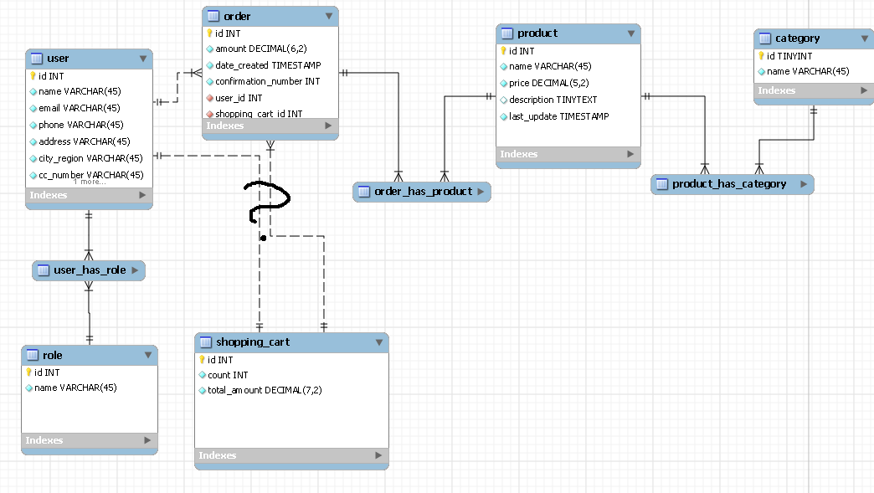

From this schema the following tables will be implemented:

1. User
2. Role
3. ShoppingCart
4. Product
5. Order
6. OrderProduct

The application will have the following components:

1. Login
2. ProductList
3. Order