PACKAGE

This document gives an overview of the package and the classes, and also a description of the most vital classes.

SLEEP APP PACKAGE

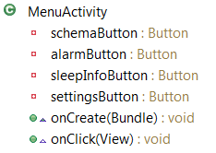
Menu Activity:
This class gives the start menu with buttons to the major functionalities.
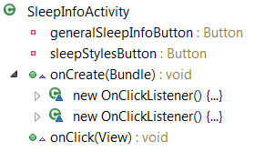
SleepInfoActivity:
This class gives the information on sleep and sleepstyles with dialogue-windows.

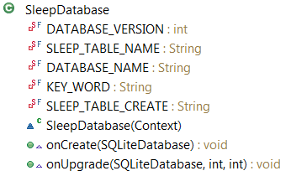
SleepDatabase:
This class stores the values from Schema and gives them to Alarms.

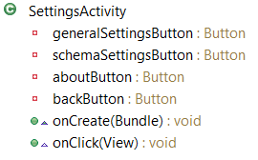
Settings Activity:
This class gives the possibility to change application settings and get to the about window.

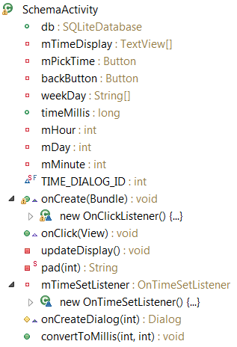
Schema Activity:
This class gives the sleep and wake periods through calculations.

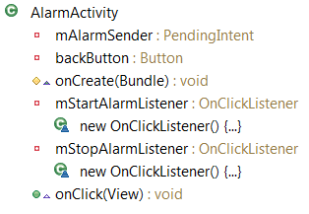
Alarm Activity:
This class starts the alarm activity-service and gives the visual alarms.

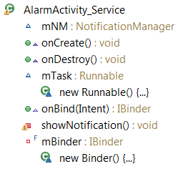
Menu Activity:
This class takes the wake and sleep times and makes alarms from them.

