- (+1) Pick up a stock symbol and get your own API key from Alpha Vantage
from google.colab import userdata
from datetime import datetime, timedelta
alpha_api_key=userdata.get('alpha_api_key')

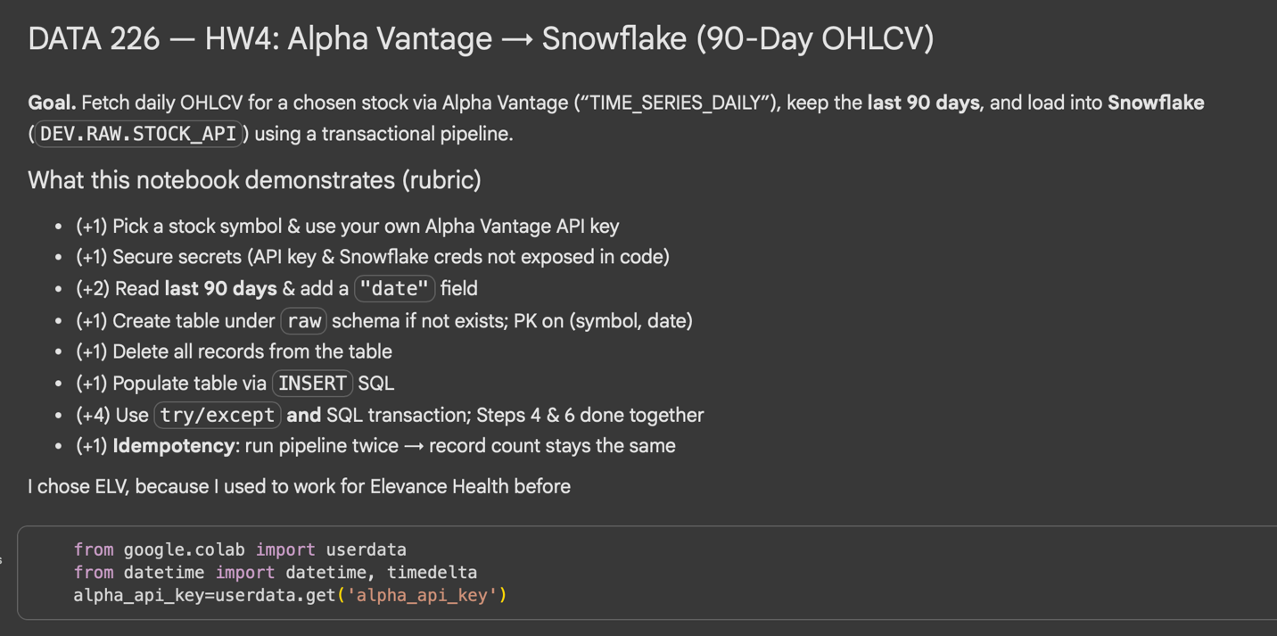

- (+1) Secure your Snowflake credentials and Alpha Vantage API key (don't expose them in the code)
user_id = userdata.get('snowflake_userid')
password = userdata.get('snowflake_password')
account = userdata.get('snowflake_account')
database = userdata.get('snowflake_database')
vwh = userdata.get('snowflake_vwh')

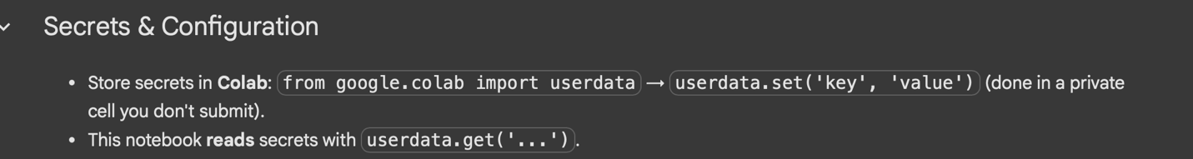
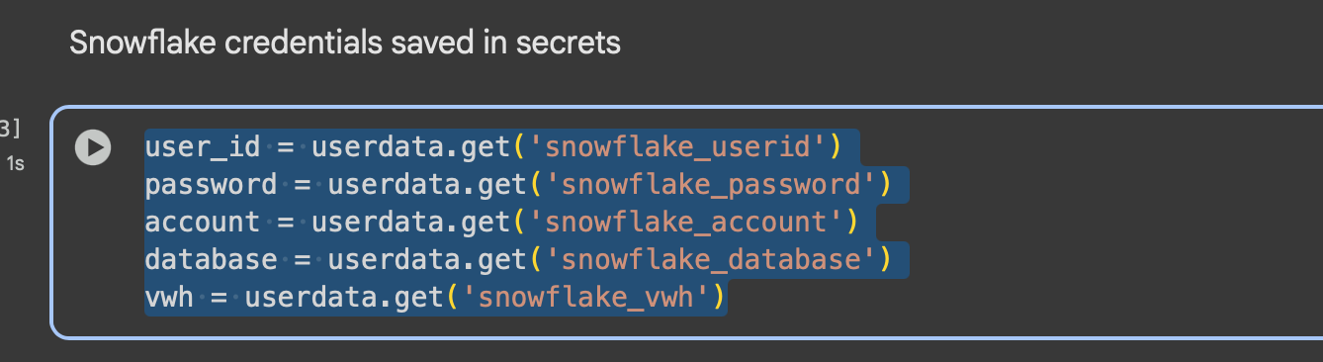
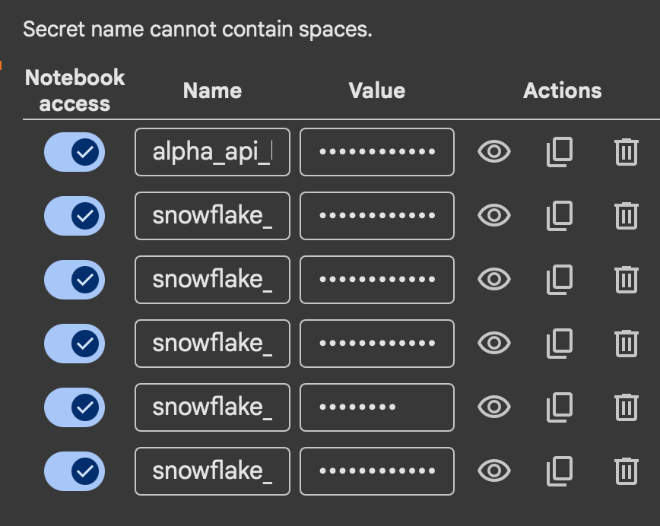
- (+2) Read the last 90 days of the price info via the API (refer to the code snippetLinks to an external site.& you need to add "date”)
def return_last_90d_price(symbol):
vantage_api_key = userdata.get('alpha_api_key')
url = f'https://www.alphavantage.co/query?function=TIME_SERIES_DAILY&symbol={symbol}&apikey={vantage_api_key}'
r = requests.get(url)
data = r.json()

cutoff = datetime.today().date() - timedelta(days=90)
results = []

for d in data["Time Series (Daily)"]:
# Parse date string into a date object
trade_date = datetime.strptime(d, "%Y-%m-%d").date()
if trade_date >= cutoff:
stock_info = data["Time Series (Daily)"][d]
stock_info["date"] = d
results.append(stock_info)

return results
- (+1) Create a table under “raw” schema if it doesn’t exist to capture the info from the API
  - symbol, date, open, close, high, low, volume: symbol and date should be primary keys
- (+1) Delete all records from the table
- (+1) Populate the table with the records from step 2 using INSERT SQL (refer tothe relevant code snippetLinks to an external site. as a starting point)
- (+4) Steps 4 and 6 need to be done together
  - Use try/except along with SQL transaction. (use the code hereLinks to an external site. as reference)
ef load(con, records,symbol):
target_table = "user_db_hedgehog.raw.stock_api"
try:
con.execute("BEGIN;")
con.execute(f"""CREATE TABLE IF NOT EXISTS {target_table} (
symbol VARCHAR NOT NULL,
trade_date DATE NOT NULL,
open NUMBER(18,4),
close NUMBER(18,4),
high NUMBER(18,4),
low NUMBER(18,4),
volume NUMBER(38,0),
CONSTRAINT pk_symbol_date PRIMARY KEY (symbol, trade_date) NOT ENFORCED);;""")
con.execute(f"""DELETE FROM {target_table}""")
for r in records:
trade_date = r["date"]
open = r["1. open"]
high = r["2. high"]
low = r["3. low"]
close = r["4. close"]
volume = r["5. volume"]
insert_sql = f"INSERT INTO {target_table} (symbol, trade_date, open, close, high,low, volume) VALUES ('{symbol}',TO_DATE('{trade_date}','YYYY-MM-DD'),{open}, {close}, {high},{low}, {volume})"
con.execute(insert_sql)
con.execute("COMMIT;")
except Exception as e:
con.execute("ROLLBACK;")
print(e)
raise e

- (+1) Demonstrate your work ensures Idempotency by running your pipeline (from extract to load) twice in a row and checking the number of records (the number needs to remain the same)
def check_table_stats(table,con):
result = con.execute(f"SELECT * FROM {table} order by symbol, trade_date")
df = con.fetch_pandas_all()
print(df.head())
print(df.tail())
print("The count is ",len(df))
def stock_api(symbol):
con = return_snowflake_conn()
data = return_last_90d_price(symbol)
load(con, data,symbol)
check_table_stats("user_db_hedgehog.raw.stock_api",con)
con.close()
def check_idempotency(symbol):
con = return_snowflake_conn()
data = return_last_90d_price(symbol)
load(con, data,symbol)
check_table_stats("user_db_hedgehog.raw.stock_api",con)
con.close()

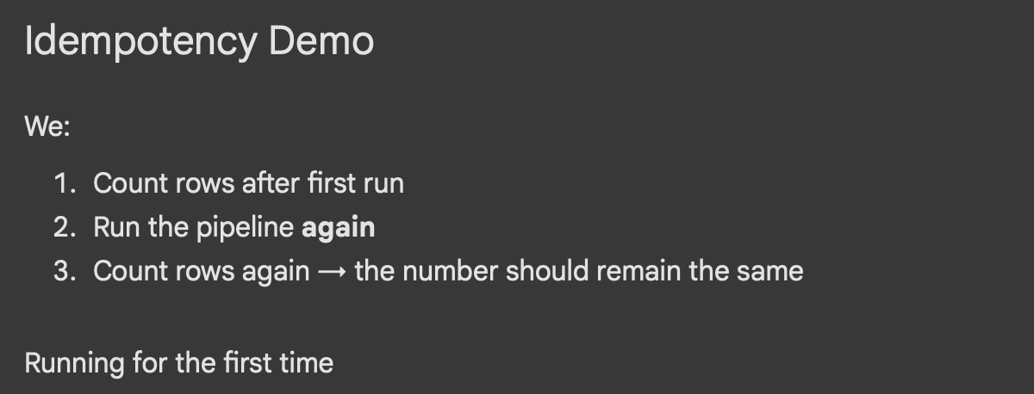
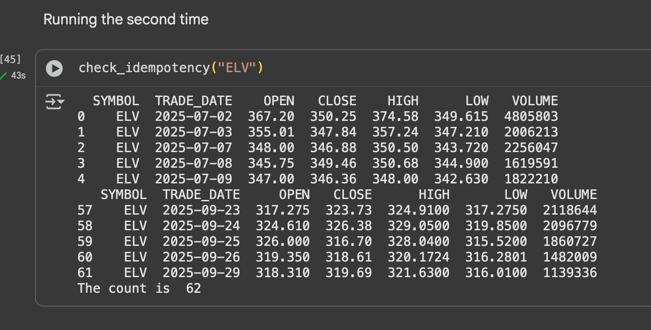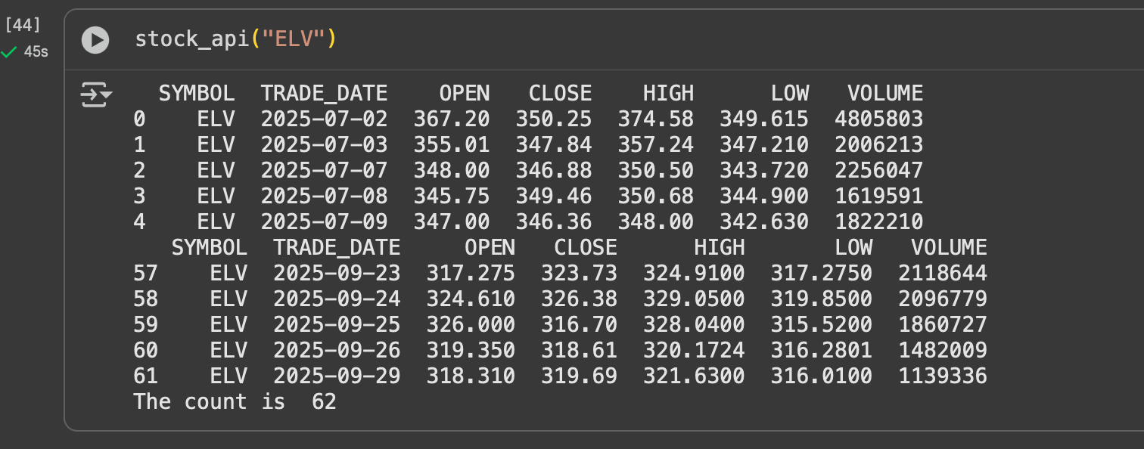

- (+2) Follow today’s demo and capture Docker Desktop screen showing Airflow

