- (+2) Create tasks using @task decorator.
- You can use as many tasks as you want
- Schedule the tasks properly (task dependency)
@task
def fetch_last_90d(symbol):
# Get the API key securely from Airflow Variables
api_key = Variable.get('alpha_api_key')

# Alpha Vantage endpoint for daily time series
url = f"https://www.alphavantage.co/query?function=TIME_SERIES_DAILY&symbol={symbol}&apikey={api_key}"

# Make GET request to the API
r = requests.get(url)
data = r.json()

# Calculate the cutoff date (90 days ago from today)
cutoff = datetime.today().date() - timedelta(days=90)
results = []

# Parse the API JSON response
for d in data["Time Series (Daily)"]:
trade_date = datetime.strptime(d, "%Y-%m-%d").date()
if trade_date >= cutoff:
stock_info = data["Time Series (Daily)"][d]
stock_info["date"] = d # add date key for reference
results.append(stock_info)

return results

@task
def load_to_snowflake(cur, records, symbol):
target_table = "RAW.STOCK_API" # destination table in Snowflake

try:
# Begin SQL transaction
cur.execute("BEGIN;")

# Create table if it does not already exist
cur.execute(f"""
CREATE TABLE IF NOT EXISTS {target_table} (
symbol VARCHAR NOT NULL,
trade_date DATE NOT NULL,
open NUMBER(18,4),
close NUMBER(18,4),
high NUMBER(18,4),
low NUMBER(18,4),
volume NUMBER(38,0),
CONSTRAINT pk_symbol_date PRIMARY KEY (symbol, trade_date) NOT ENFORCED
);
""")

# Delete existing records to refresh dataset (optional)
cur.execute(f"DELETE FROM {target_table}")

# Insert each record individually
for r in records:
trade_date = r["date"]
open_ = r["1. open"]
high_ = r["2. high"]
low_ = r["3. low"]
close_ = r["4. close"]
volume_ = r["5. volume"]

# Build INSERT SQL command
insert_sql = f"""
INSERT INTO {target_table}
(symbol, trade_date, open, close, high, low, volume)
VALUES (
'{symbol}',
TO_DATE('{trade_date}','YYYY-MM-DD'),
{open_}, {close_}, {high_}, {low_}, {volume_}
);
"""
cur.execute(insert_sql)

# Commit the transaction if all inserts succeed
cur.execute("COMMIT;")
print(f"[SUCCESS] Loaded {len(records)} records for {symbol} into {target_table}")

except Exception as e:
# Roll back in case of any failure
cur.execute("ROLLBACK;")
print(f"[ERROR] Failed to load data for {symbol}: {e}")
raise

with DAG(
dag_id='AlphaVantage_to_Snowflake',
start_date=datetime(2025, 9, 29),
catchup=False,
tags=['ETL', 'StockAPI'],
schedule='30 2 * * *' # cron format (02:30 UTC)
) as dag:

# Stock symbol to load
symbol = "ELV"

# Get a Snowflake connection cursor
cur = return_snowflake_conn()

# Define the Airflow task flow
fetch_task = fetch_last_90d(symbol)
load_task = load_to_snowflake(cur, fetch_task, symbol)

# Task dependency chain
fetch_task >> load_task

- (+1) Set up a variable for Alpha Vantage API key
- Use the variable in your code (Variable.get)
- Capture the Admin -> Variables screenshot
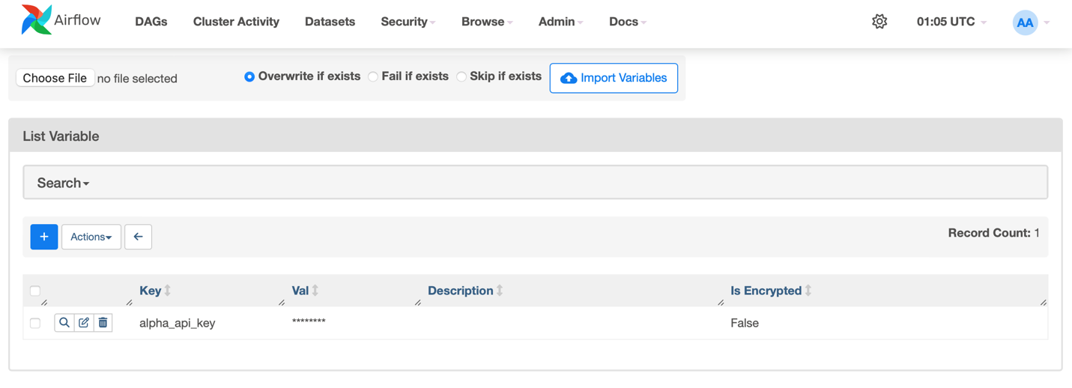
- (+2) Set up Snowflake Connection (refer to GitHub link Links to an external site.)
- Use the connection in your code
- Capture the Connection detail page screenshot (an example will be provided ②)
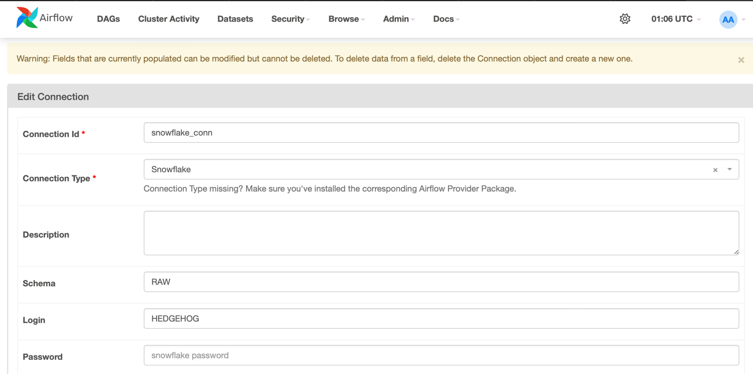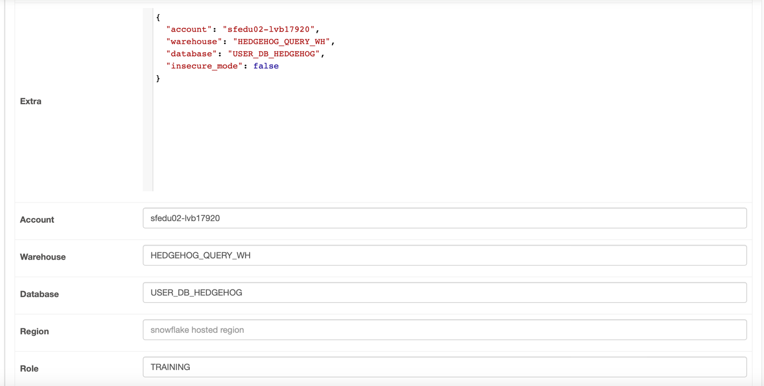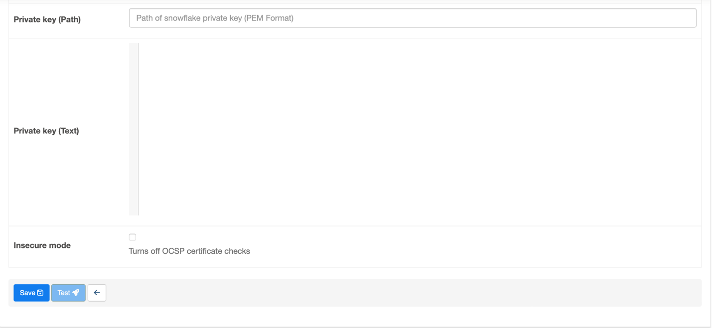
- (+5) Ensure the overall DAG is implemented properly and runs successfully
- A github link with the entire code needs to be submitted (2 pts)
- Implement the same full refresh using SQL transaction (3 pts)
Code Link: https://github.com/danwaseem/SJSU-DATA226/blob/main/HW5/hw5_final.py
Airflow Link: https://github.com/danwaseem/SJSU-DATA226/tree/main/Airflow
- (+2) Capture two screenshot of your Airflow Web UI (examples to follow)
- One with the Airlow homepage showing the DAG (③)
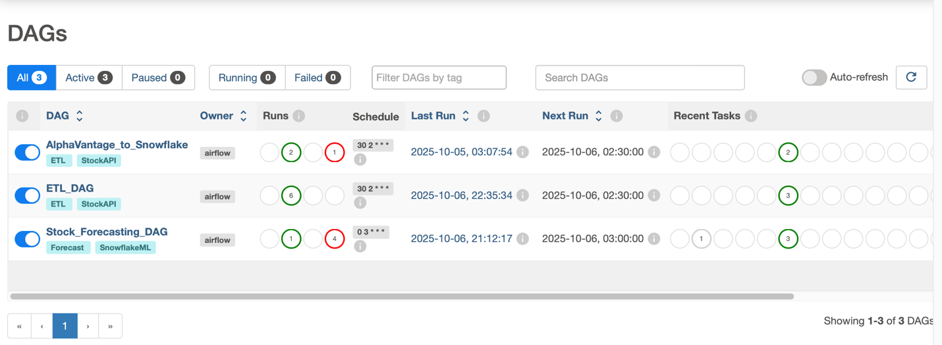
- The other with the log screen of the DAG (④)
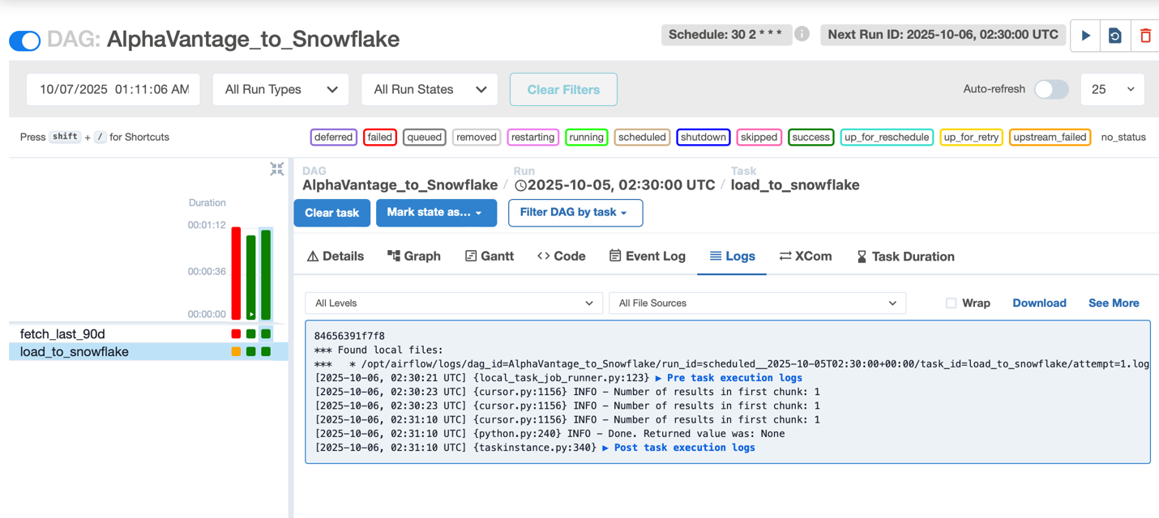
- (+1) Overall formatting

