I am a former educator and a recent grad from Bitmaker Labs’ demanding 9-week web development boot camp. In addition to HTML and CSS, I’ve now added Ruby on Rails and more advanced Javascript to my skill set. I am an enthusiastic coder with a knack for problem solving and an acumen to integrate the technical and design aspects of web development.

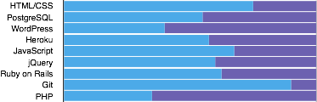

- Bitmaker Labs - Nine week immersive web course, January 2015 to April 2015
- Canisius College - Masters in Childhood Education, August 2009 to May 2010
- York University - Bachelor of Science, September 1995 - April 1998

Substitute Teacher, LEO BAECK DAY SCHOOL – 2012 to 2015
- Taught more than 1,000 students over the span of 4 years, adapting to a variety of age levels and curriculum as needed.
DANIEL WEINSTOCK
Twitter: @danweinstock1
GitHub: danweinstock
LinkedIn: /danweinstock
Full Stack Web Developer
Profile
Experience
Education
Skills
- Wrote daily reports to the classroom teacher to update them about student progress and student behaviour.
- Worked with English as a Second Language and Special Needs students, adapting lessons and expectations to suit their unique needs.

Medical and Administrative Assistant, WEINSTOCK EYE CONSULTANTS – 2011 to 2014
- Managed patient flow to maximize efficiency within a busy practice.
- Learned various new technologies and patient care tools as systems were regularly improved and replaced.
- Spearheaded troubleshooting efforts on these new technologies to ensure systems operated correctly on a daily basis.
- Managed invoicing and receivables for all patients.

