COS 116
The Computational Universe
Laboratory 8: Internet Structure and Congestion Control

You saw in lecture that the Internet is a loose, decentralized network of computers that communicate with each other using TCP/IP (Transmission Control Protocol / Internet Protocol). We also saw that IP breaks data transmissions into packets. The Internet predated the World Wide Web (WWW) by almost two decades. Informally, WWW is the term for useful content that resides on the Internet. It consists of web pages that were all created using languages such as HTML (subject of Lab 1, and used for your course blog). These languages allow web pages to have hyperlinks to each other, thus giving rise to a conceptual network or graph (as opposed to a physical network like the Internet) which we thought about earlier in the context of web search (lecture 5). Web pages reside on server computers (such as www.princeton.edu), which communicate with each other using the HTTP protocol (also invented by Sir Tim). Like everything else on the Internet, the HTTP protocol itself uses IP.
Today we’ll get some insight into the Internet. Of special interest will be the phenomenon described in the lecture as “dependence on the kindness of strangers.” There is no centralized control or predetermined limit on the amount of data communication allowed to a particular user or computer. Nobody can stop all of us from going online at the same time and start downloading our favorite files. However, it is clear that this could result in chaos: the Internet would get overloaded with packets and, unable to deliver them all, would drop most of them; our files would never arrive. This used to happen a lot in the 1980s. Ultimately, most makers of Internet software agreed upon an informal convention for sharing the resources of the network that has so far kept the internet running smoothly. It is interesting to speculate—from political, social, and technological viewpoints—how long this informal agreement will continue to last. In the meantime, it provides us with a good case study of congestion issues in society and their solutions.

For this lab you’ll be using Clack, a powerful network simulator tool created by Dan Wendlandt of Stanford (and now at Carnegie Mellon), who also helped tremendously with this lab. The reason for using a simulator is that the decentralized nature of the Internet makes it almost impossible to run controlled experiments. Clack creates a virtual world that merges seamlessly with the real internet. Your browser thinks it is communicating with a server on the real Internet, but the requests from your browser are actually directed into a virtual world. Do not try to think too hard about where the real ends and the virtual begins as that is not the point of this lab. (But, we are happy to answer any questions.) As usual, feel free to discuss with other students or a TA. However, you are not allowed to copy another student’s answers.

Hand in your lab report at the beginning of lecture on Tuesday, April 25. Include responses to questions printed in bold. (Number them by Part and Step.)
Part 1: Entering the “Matrix”

Let us enter the virtual world of Clack.

- Start Internet Explorer and visit the following web page to launch Clack:
http://www.clackrouter.net/princeton/demo_loss.html

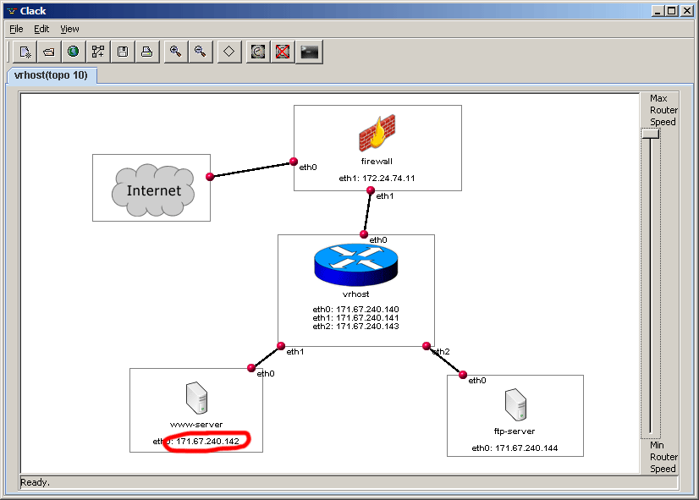

- You should see the Clack application window, as pictured above. Clack is set up to simulate a small network consisting of two servers (www-server and ftp-server) connected to the Internet through a router (vrhost) and a firewall. In this picture, you and your lab mates are in the cloud labeled “Internet.” We will refer to this picture as your virtual world.
- IP addresses: Like all Internet devices, the ones in this virtual world are identified by numeric IP addresses consisting of four numbers separated by periods. As mentioned in lecture, each of the four numbers lies between 0 and 255. In the above picture we’ve circled the IP address of the virtual web server, 171.67.240.142. This address changes each time you restart Clack. Also, your neighbor is likely seeing a different IP address in his/her virtual world.

- Write down the IP address of www-server in your virtual world (It probably will not be the same as the address in the picture.) In the instructions that follow, whenever we write [www-server] you should replace that with the IP address you wrote down in this step.
- Open a new Internet Explorer window and enter the address http://[www-server]/. If you watch the Clack window while the page loads, you should see some of the virtual network links flash green as data moves across them. Each flash corresponds to a single packet traversing the network.

- Tell your neighbor your [www-server] address and ask him/her to open this address in their browser. Report what you see. (In fact, this IP address is 100% real; feel free to call up your mom on the cell phone and asking her to open this address in her browser. Do you see her request in your virtual world?)

- The web page you loaded from http://[www-server]/ contains hyperlinks to several large files. Download one of these files such as “Dan’s Magnum Opus” (let windows save the file in your directory). Watch the download window for a minute, specifically, the transfer rate in kilobytes per second (kb/s). How does that number change? Stop the download and go on to Part 2, which will give you a glimpse into what is really going on.

Part 2: Data flow and congestion
- Return to the web page at http://[www-server]/ and click on the link labeled “Dan’s Magnum Opus”. This will begin a large download that will take several minutes to complete. You will use Clack to observe TCP’s congestion control behavior while this file is downloading.

- In the Clack window, click the open the View menu and click Zoom In to enter the detailed view of the virtual world shown below:

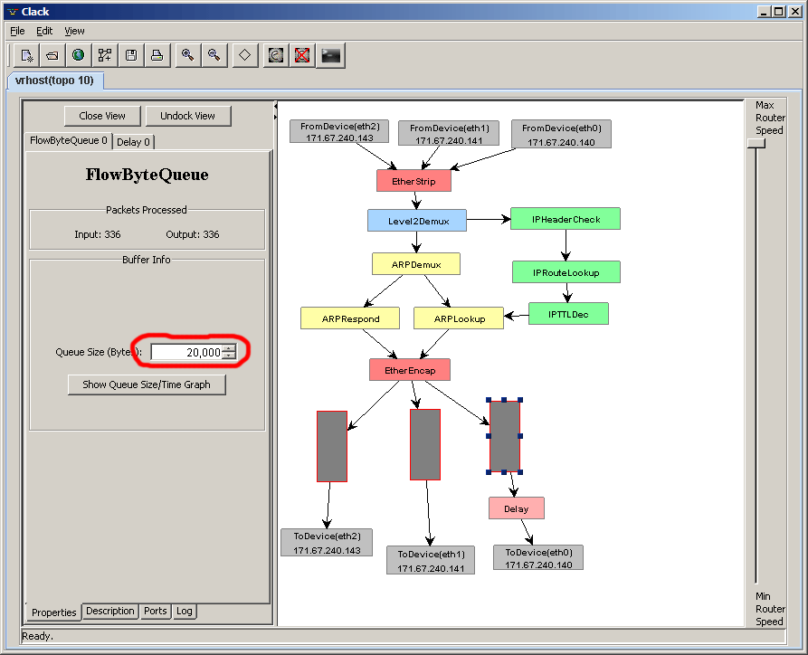

This screen shows a detailed view of how data moves through the simulated network. The window has more information than we will need, so ignore most of it. The important thing is that there are three entities attached to the network—a web server (eth1), an ftp server (eth2), and the “Internet” (eth0), which refers to you (and your mom, if she is participating in this). Data from these connections comes in at the gray boxes at the top of the screen and is directed to the appropriate destination gray box at the bottom of the screen. The file download that is currently underway is happening in the form of packets from the web server going from the gray box marked eth1 at the top to the gray box marked eth0 at the bottom.

- Find the vertical gray rectangles outlined in red near the bottom of the Clack display. These represent the queues on the network links leading to the three devices. If packets come in on a link faster than the device on the other end can receive them, these excess packets are temporarily stored in a queue. The queue has finite capacity, and once it fills up the packets will be discarded (“dropped”).

The rectangles are colored green to represent how much of the queues is occupied by data. The rightmost queue is on the network link leading to the Internet; it may flash green periodically as packets sent by the web server temporarily back up.

- Double click the rightmost queue. Using the controls that appear on the left side of the screen, set the Queue Size to 10,000 bytes.

- Click the “Show Queue Size/Time Graph” button to display a graph of the queue’s occupancy over time. Bandwidth ////

- Back in the Clack window, double click the pink box labeled “Delay.” This lets you slow down the link between the web server and the Internet so that packets build up in the queue. Reduce the rate to 15%.

Return to the Queue Graph window and observe the behavior of the queue over time. When the queue is completely filled, packets start to be dropped. (When this happens, the queue in the main Clack window flashes red.) The sender detects this condition and rapidly decreases its transmission rate until packets stop being dropped. Then it begins to slowly increase its transmission rate until packets are dropped again. This behavior results in a characteristic “saw tooth” pattern in the queue graph.

- Take a screenshot of the graph showing the saw tooth pattern and include it in your report. To do so, right click on the white area of the graph and select Save As or Print.
In your report, explain in a line or two why the curve is a saw tooth and stays that way. (After all, the flow has the link all to itself.)

- Think for a moment what will happen if a second flow now tries to use the link. The link is being fully used by a pre-existing flow. How will the two flows “share” this link? Note that the second flow has no idea who else is using the link nor how many of its packets will get through. It has to figure out the “right” amount. Try to predict the behavior. To experimentally verify your guess, return to the page at http://[www-server]/ again and start a second download, the link labeled “Dan’s Magnum Opus 2”.
- With both files downloading simultaneously, return to the Queue Graph window. Observe the behavior of the two downloads for a couple of minutes. Save a characteristic screenshot and include it with your report. Explain in a line or two what happened and why. Did the two flows settle into a fair sharing arrangement?

Part 3: Congestion and Fairness in Other Protocols

Unfortunately, today’s applications cannot always afford to behave as “good citizens.” This experiment explores why this is so and what the consequences are.

- Cancel any downloads remaining from Part 1 and set the rate back up to 100% in the Delay control panel. (In other words, no delay.)

- Recall from Lab 4 that an audio stream must have a minimal bit rate (determined by the sampling frequency), below which the sound becomes severely degraded. Suppose you are listening to a streaming MP3. If the stream has a bit rate of 16,000 bytes/second and it is transmitted using 1500 byte packets, on average, how many packets must be transferred every second to play the stream? What if a packet gets dropped? The player could request a retransmission but that packet may take a while to arrive. What do you think the player would do?

- Launch QuickTime Player from the Start menu. On the File menu, select Open URL and enter the following location:
rtsp://[www-server]/criminal.mp4

- Wait for the music to begin playing and listen to it for a few seconds. Verify that it plays without skipping.

- In the Clack window, double click the pink box labeled “Loss.” In the control panel on the left, click the “Drop Next Packet” button a few times. Each time you click the button, a packet of the audio stream will be discarded on its way to your PC. Mention in your report what you heard.
Experiment a bit and report how many packets had to be dropped and in how short an interval to hear this effect reliably.

- Throttle the packet rate down to 15% using the Delay control (this may cause the music to stop playing, though the server should keep transmitting the stream).

- Open the Queue Graph and compare what you see to the graph of a single TCP download from Part 2. Save a representative screenshot and include it in your report. How does the streaming server behave when it encounters congestion?
While web servers use the HTTP protocol, which operates on top of the TCP protocol, the music file in this experiment is transmitted using a different protocol called RTSP (real-time streaming protocol), which operates on top of an alternative protocol called UDP. You may see this acronym in the graph. UDP isn’t always a “good citizen.” When a UDP application detects dropped packets, it can choose whether to reduce its transmission rate or whether to keep transmitting at the same rate.

- With the stream playing in QuickTime Player, open a web browser window and begin downloading the “Dan’s Magnum Opus” file again.

- Return to the Queue Graph and observe the behaviors of the two flows. The download is marked “TCP” and the audio stream “UDP.” Save a representative screenshot and include it in your report. How does the behavior you see differ from the behavior of two simultaneous TCP downloads that you observed in Part 2? Explain the observation in a line or two.

- Change the throttle setting back to 100% and observe the behavior of the graph. Why is it possible in practice to surf the web while listening to an audio stream?

Part 4: Detective work

Now we use a program called traceroute (which you also saw in lecture) to do some sleuthing and discover the physical location of this virtual world. Recall that packets travel over the Internet by following a succession of intermediate links. Traceroute prints out this path.

- Open the Windows Start menu and click Run. Enter the filename “cmd” and click OK to open a command prompt.

- At the command prompt, type “tracert cs.princeton.edu” and press Enter. Each line in the trace lists one intermediary link that packets cross to get from your PC to the Princeton computer science department’s network.

- Usually there will be more links in a trace to a distant network than to a nearby one, though this is not always the case. Trace the path to “cs.yale.edu” and “cs.stanford.edu” and compare these to the Princeton trace.

- The names of the intermediary links may appear cryptic, but they often contain useful hints about the physical location of the links. Looking closely at the Yale trace, we can guess that the data travels through the Philadelphia area, since one of the links is called “phl-09-02.backbone.magpi.net.” Do you notice any major cities on the packets’ path to Stanford?

- Type “tracert [www-server]” at the command prompt and report what you saw. Where do you think the Clack virtual world physically resides?

Further Questions

- Name a few Internet applications which you think might use UDP and briefly explain why.

- A server can’t control who sends it packets, it can only filter them out after they arrive over its Internet connection. Imagine you are a malicious attacker and want to prevent anyone from reaching Yahoo.com. Based on what you know about congestion control, how would you try to bring down the site? You can assume that the attacker has thousands of computers at his disposal. (This is called a denial of service attack. An upcoming lecture will discuss it more together with other Internet security issues, such as how attackers gain control of thousands or millions of computers.)

- Why might Internet traffic from Princeton to Yale travel by way of Philadelphia? Speculate based upon what you saw in lecture.

