AJ1_EarlyMidLateMPS
Daniel Wilkinson and Claude Code
2026-07-24
Table of contents

1. Introduction
This project examines the nadir that follows the initial stimulation of muscle protein synthesis (MPS) by nutrition (essential amino acids, EAA), and how long this nadir period needs to last before a second feed can robustly re-stimulate MPS.
Following an initial 20 g EAA feed at time 0, participants were randomised to receive a second 20 g EAA feed at 90, 150, or 210 minutes post-initial feed (the Early, Mid, and Late groups, respectively). While this is a complex design, this document works through an approach for determining when MPS resynthesis becomes possible again — that is, when the muscle-full effect is no longer restrictive.
Two features of the real trajectory data need to be accounted for.

1.1 Peak Window Contamination
The 90–180 min window is only a clean, uncontaminated single-feed peak for the group whose refeed happens after it closes. In this design that’s the Late group (refeed at 210 min). The Early group (refeed at 90 min) and Mid group (refeed at 150 min) have their 90–180 min reading contaminated by their own refeed, so their “peak” values aren’t trustworthy on their own — the reference peak increment is borrowed from the Late group instead.

1.2 Post-Refeed Lag
The post-refeed response doesn’t appear immediately either — it mirrors the same lag seen after the first feed. So the later post-refeed window (90–180 min after each subject’s own refeed) is used as the resynthesis value, not the immediate one (0–90 min after refeed), which may understate the fully-developed response.

1.3 Measurement Time Structure
The time structure per group (mirroring the real data) is:
- Early (refeed at 90 min): measured at 0, 90, 180, 270 min
- Mid (refeed at 150 min): measured at 0, 90, 180, 240, 330 min
- Late (refeed at 210 min): measured at 0, 90, 180, 300, 390 min

2. Setup

2.1 Load Libraries
library(tidyverse)
── Attaching core tidyverse packages ──────────────────────── tidyverse 2.0.0 ──
✔ dplyr 1.2.1 ✔ readr 2.2.0
✔ forcats 1.0.1 ✔ stringr 1.6.0
✔ ggplot2 4.0.3 ✔ tibble 3.3.1
✔ lubridate 1.9.5 ✔ tidyr 1.3.2
✔ purrr 1.2.2
── Conflicts ────────────────────────────────────────── tidyverse_conflicts() ──
✖ dplyr::filter() masks stats::filter()
✖ dplyr::lag() masks stats::lag()
ℹ Use the conflicted package (<http://conflicted.r-lib.org/>) to force all conflicts to become errors
library(ggthemes)
library(emmeans) # pairwise post-hoc contrasts
Welcome to emmeans.
Caution: You lose important information if you filter this package's results.
See '? untidy'
library(FSA) # Dunn's test (non-parametric post-hoc)
## FSA v0.10.1. See citation('FSA') if used in publication.
## Run fishR() for related website and fishR('IFAR') for related book.
library(ggsignif) # significance brackets on plots

2.2 Data
The raw MPS values are loaded from a data frame with the following columns:
- subject — subject ID (e.g. Early1, Early2, …)
- group — Early / Mid / Late
- baseline — post-absorptive (PA) period
- dip — initial 0–90 min lag phase
- peak_window — 90–180 min period post initial feed for each group
- post1 — 0–90 min post-refeed (note: identical to peak_window for the Early group, since their refeed coincides with the start of that window)
- post2 — 90–180 min post-refeed (the resynthesis window)
- post1_time — absolute time (min) of the post1 window; differs by group (Early = 180, Mid = 240, Late = 300)
- post2_time — absolute time (min) of the post2 window; differs by group (Early = 270, Mid = 330, Late = 390)
mps <- read_csv("MPS_EarlyMidLate.csv")
Rows: 23 Columns: 10
── Column specification ────────────────────────────────────────────────────────
Delimiter: ","
chr (2): subject, group
dbl (8): baseline, dip, peak_window, post1, post2, post1_time, post2_time, IFI
ℹ Use `spec()` to retrieve the full column specification for this data.
ℹ Specify the column types or set `show_col_types = FALSE` to quiet this message.
mps$group <- factor(mps$group, levels = c("Early", "Mid", "Late"))

2.2.1 Baseline Comparability Across Groups
Worth checking whether baselines are comparable across groups before borrowing a peak reference from one group and applying it to the others.
summary(aov(baseline ~ group, data = mps))
Df Sum Sq Mean Sq F value Pr(>F)
group 2 0.002642 0.0013210 5.191 0.0153 *
Residuals 20 0.005090 0.0002545
---
Signif. codes: 0 '***' 0.001 '**' 0.01 '*' 0.05 '.' 0.1 ' ' 1
kruskal.test(baseline ~ group, data = mps)
Kruskal-Wallis rank sum test
data: baseline by group
Kruskal-Wallis chi-squared = 8.1021, df = 2, p-value = 0.0174
ggplot(mps, aes(x = group, y = baseline)) +
geom_boxplot() +
geom_jitter(width = 0.1) +
labs(title = "Baseline MPS by group - check for imbalance") +
theme_minimal()
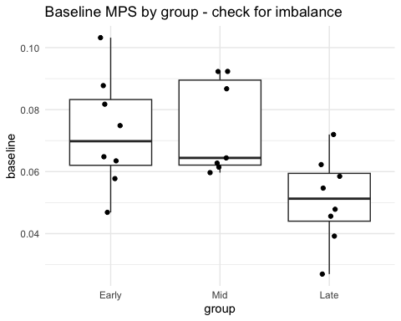
The data do show baseline differences in MPS between groups. How this affects the overall outcome is examined later, once the resynthesis ratio has been calculated.

2.2.2 Missing Data
Missing values matter most when they fall on baseline or post2, since both are required to calculate the resynthesis ratio. dip, peak_window, and post1 are checked too, since they still feed into the descriptive trajectory plots and the reference peak calculation.
mps %>%
group_by(group) %>%
summarise(across(c(baseline, dip, peak_window, post1, post2),
~ sum(is.na(.)), .names = "missing_{.col}"))
# A tibble: 3 × 6
group missing_baseline missing_dip missing_peak_window missing_post1
<fct> <int> <int> <int> <int>
1 Early 0 0 0 0
2 Mid 0 1 0 1
3 Late 0 0 0 1
# ℹ 1 more variable: missing_post2 <int>
mps %>%
group_by(group) %>%
summarise(n_total = n(),
n_with_full_data = sum(!is.na(baseline) & !is.na(post2)))
# A tibble: 3 × 3
group n_total n_with_full_data
<fct> <int> <int>
1 Early 8 8
2 Mid 7 7
3 Late 8 7
One subject in the Late group is missing post2 and is removed from the resynthesis ratio calculation, since that value cannot be reconstructed. Their other data (e.g. baseline, peak_window) remains valid and is retained for the reference peak calculation below.
index <- is.na(mps$post2)
mps_trim <- mps[!index, ]

3. Reference Peak Increment
Because of how the study was designed, only the Late group has a clean, uncontaminated peak window: in the Early group the 90–180 min window occurs before MPS has fully risen toward its natural peak, and in the Mid group it is partially mixed with the response to the second feed. The Late group is therefore used as the reference for what an undisturbed single-feed peak looks like.
This calculation only needs peak_window and baseline, not post2 — so it is calculated from the full mps data set (before the subject missing post2 was removed), to avoid discarding an otherwise valid data point unnecessarily.
reference_group <- "Late"
ref_peak_increment <- mps %>%
filter(group == reference_group) %>%
summarise(ref = mean(peak_window - baseline, na.rm = TRUE)) %>%
pull(ref)
ref_peak_increment
[1] 0.0217416

4. Resynthesis Ratio
The resynthesis ratio uses the later post-refeed window (post2) and each subject’s own baseline — not each group’s own (potentially contaminated) peak_window value — divided by the reference peak increment calculated above.
mps_resynth <- mps_trim %>%
mutate(
own_increment = post2 - baseline,
resynthesis_ratio = own_increment / ref_peak_increment
)
mps_resynth %>%
select(subject, group, IFI, baseline, peak_window, post1, post2,
own_increment, resynthesis_ratio)
# A tibble: 22 × 9
subject group IFI baseline peak_window post1 post2 own_increment
<chr> <fct> <dbl> <dbl> <dbl> <dbl> <dbl> <dbl>
1 Early1 Early 90 0.0648 0.120 0.120 0.0937 0.0289
2 Early2 Early 90 0.103 0.133 0.133 0.00952 -0.0937
3 Early3 Early 90 0.0577 0.0278 0.0278 0.0949 0.0372
4 Early4 Early 90 0.0748 0.0855 0.0855 0.0634 -0.0114
5 Early5 Early 90 0.0877 0.0240 0.0240 0.119 0.0313
6 Early6 Early 90 0.0635 0.110 0.110 0.0529 -0.0106
7 Early7 Early 90 0.0469 0.0844 0.0844 0.0902 0.0433
8 Early8 Early 90 0.0817 0.0540 0.0540 0.0951 0.0133
9 Mid1 Mid 150 0.0867 0.127 0.0385 0.0891 0.00238
10 Mid2 Mid 150 0.0923 0.114 0.0300 0.113 0.0208
# ℹ 12 more rows
# ℹ 1 more variable: resynthesis_ratio <dbl>

4.1 Visual Checks
ggplot(mps_resynth, aes(x = IFI, y = resynthesis_ratio)) +
geom_point(size = 2) +
geom_smooth(method = "lm", se = TRUE) +
geom_hline(yintercept = 1, linetype = "dashed") +
labs(x = "Inter-feed interval (min)", y = "Resynthesis ratio",
title = "Resynthesis ratio vs inter-feed interval",
subtitle = "Dashed line = fully matched the reference peak increment") +
theme_minimal()
`geom_smooth()` using formula = 'y ~ x'
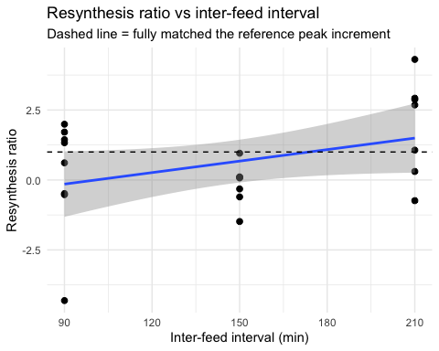
traj_long <- mps_resynth %>%
select(subject, group, IFI, baseline, dip, peak_window, post1, post2,
post1_time, post2_time) %>%
pivot_longer(cols = c(baseline, dip, peak_window, post1, post2),
names_to = "window", values_to = "MPS") %>%
mutate(time = case_when(
window == "baseline" ~ 0,
window == "dip" ~ 90,
window == "peak_window" ~ 180,
window == "post1" ~ post1_time,
window == "post2" ~ post2_time
))
ref_peak_level <- ref_peak_increment +
mean(mps_resynth$baseline[mps_resynth$group == reference_group])
ggplot(traj_long, aes(x = time, y = MPS, color = group, group = subject)) +
geom_line(alpha = 0.3) +
stat_summary(aes(group = group), fun = mean, geom = "line", linewidth = 1.2) +
stat_summary(aes(group = group), fun = mean, geom = "point", size = 2.5) +
geom_hline(yintercept = ref_peak_level, linetype = "dashed", color = "grey40") +
labs(x = "Time (min)", y = "MPS", color = "Group",
title = "MPS trajectories with reference peak level") +
theme_minimal()
Warning: Removed 3 rows containing non-finite outside the scale range
(`stat_summary()`).
Removed 3 rows containing non-finite outside the scale range
(`stat_summary()`).
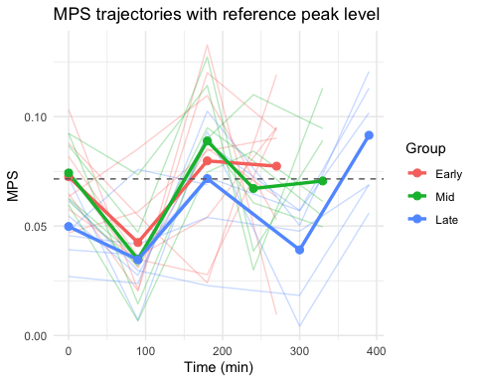

4.2 Effect of Inter-Feed Interval on the Resynthesis Ratio
A linear model tests whether the resynthesis ratio changes with inter-feed interval — i.e. whether refeed timing affects the ability to re-stimulate MPS to the same level as the initial feed.
m_ifi <- lm(resynthesis_ratio ~ IFI, data = mps_resynth)
summary(m_ifi)
Call:
lm(formula = resynthesis_ratio ~ IFI, data = mps_resynth)
Residuals:
Min 1Q Median 3Q Max
-4.1622 -0.8965 -0.3581 1.4138 2.8123
Coefficients:
Estimate Std. Error t value Pr(>|t|)
(Intercept) -1.37986 1.15118 -1.199 0.2447
IFI 0.01370 0.00741 1.848 0.0794 .
---
Signif. codes: 0 '***' 0.001 '**' 0.01 '*' 0.05 '.' 0.1 ' ' 1
Residual standard error: 1.719 on 20 degrees of freedom
Multiple R-squared: 0.1459, Adjusted R-squared: 0.1032
F-statistic: 3.416 on 1 and 20 DF, p-value: 0.07939
confint(m_ifi)
2.5 % 97.5 %
(Intercept) -3.781185265 1.02146372
IFI -0.001760739 0.02915253
kruskal.test(resynthesis_ratio ~ group, data = mps_resynth)
Kruskal-Wallis rank sum test
data: resynthesis_ratio by group
Kruskal-Wallis chi-squared = 5.5223, df = 2, p-value = 0.06322
summary(aov(resynthesis_ratio ~ group, data = mps_resynth))
Df Sum Sq Mean Sq F value Pr(>F)
group 2 17.38 8.690 3.185 0.0641 .
Residuals 19 51.84 2.728
---
Signif. codes: 0 '***' 0.001 '**' 0.01 '*' 0.05 '.' 0.1 ' ' 1
This model did not reach statistical significance, though the result approached it — suggesting a larger sample size may be needed to detect a genuine effect of refeed timing on the (additive) resynthesis ratio.

4.3 Baseline-Adjusted Sensitivity Analysis
The resynthesis ratio already corrects for each subject’s own baseline, but if baseline differs systematically by group — as the earlier check suggested — that’s still worth examining directly, both because baseline may affect how much room there is for MPS to increase (a ceiling/floor effect), and because it raises a broader question of whether the groups are comparable on other unmeasured factors.
cor.test(mps_resynth$baseline, mps_resynth$resynthesis_ratio, method = "spearman")
Spearman's rank correlation rho
data: mps_resynth$baseline and mps_resynth$resynthesis_ratio
S = 2816, p-value = 0.004536
alternative hypothesis: true rho is not equal to 0
sample estimates:
rho
-0.5900621
m_adjusted <- lm(resynthesis_ratio ~ IFI + baseline, data = mps_resynth)
summary(m_adjusted)
Call:
lm(formula = resynthesis_ratio ~ IFI + baseline, data = mps_resynth)
Residuals:
Min 1Q Median 3Q Max
-2.5173 -1.0917 0.3888 1.0722 2.2831
Coefficients:
Estimate Std. Error t value Pr(>|t|)
(Intercept) 4.340505 1.942291 2.235 0.03764 *
IFI 0.002326 0.006906 0.337 0.73992
baseline -61.447135 18.284975 -3.361 0.00328 **
---
Signif. codes: 0 '***' 0.001 '**' 0.01 '*' 0.05 '.' 0.1 ' ' 1
Residual standard error: 1.397 on 19 degrees of freedom
Multiple R-squared: 0.4643, Adjusted R-squared: 0.4079
F-statistic: 8.234 on 2 and 19 DF, p-value: 0.002659
confint(m_adjusted)
2.5 % 97.5 %
(Intercept) 0.27524252 8.40576767
IFI -0.01212855 0.01678125
baseline -99.71802710 -23.17624269
summary(m_ifi)
Call:
lm(formula = resynthesis_ratio ~ IFI, data = mps_resynth)
Residuals:
Min 1Q Median 3Q Max
-4.1622 -0.8965 -0.3581 1.4138 2.8123
Coefficients:
Estimate Std. Error t value Pr(>|t|)
(Intercept) -1.37986 1.15118 -1.199 0.2447
IFI 0.01370 0.00741 1.848 0.0794 .
---
Signif. codes: 0 '***' 0.001 '**' 0.01 '*' 0.05 '.' 0.1 ' ' 1
Residual standard error: 1.719 on 20 degrees of freedom
Multiple R-squared: 0.1459, Adjusted R-squared: 0.1032
F-statistic: 3.416 on 1 and 20 DF, p-value: 0.07939
ggplot(mps_resynth, aes(x = baseline, y = resynthesis_ratio, color = group)) +
geom_point(size = 2) +
geom_smooth(method = "lm", se = FALSE, color = "grey40") +
labs(x = "Baseline MPS", y = "Resynthesis ratio",
title = "Does baseline relate to the resynthesis ratio?") +
theme_minimal()
`geom_smooth()` using formula = 'y ~ x'
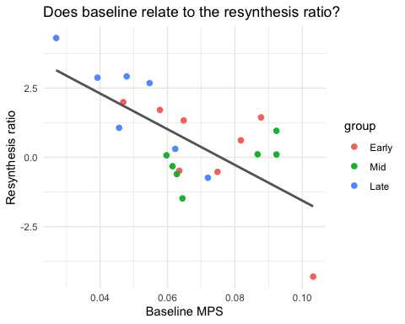
Baseline MPS does appear to relate to the resynthesis ratio: the higher the baseline, the lower the ratio. This points to the additive correction being incomplete, and motivates testing a proportional (fold-change) version of the ratio instead, in case the relationship between baseline and the post-refeed increment is multiplicative rather than a fixed additive amount.

5. Fold-Change Corrected Resynthesis Ratio
ref_fold_increase <- mps %>%
filter(group == reference_group) %>%
summarise(ref = mean(peak_window / baseline, na.rm = TRUE)) %>%
pull(ref)
mps_FC <- mps_resynth %>%
mutate(resynthesis_ratio_fold = (post2 / baseline) / ref_fold_increase)
cor.test(mps_FC$resynthesis_ratio, mps_FC$resynthesis_ratio_fold, method = "spearman")
Spearman's rank correlation rho
data: mps_FC$resynthesis_ratio and mps_FC$resynthesis_ratio_fold
S = 14, p-value = 2.719e-06
alternative hypothesis: true rho is not equal to 0
sample estimates:
rho
0.9920949
lm_mpsFC <- lm(resynthesis_ratio_fold ~ IFI, data = mps_FC)
summary(lm_mpsFC)
Call:
lm(formula = resynthesis_ratio_fold ~ IFI, data = mps_FC)
Residuals:
Min 1Q Median 3Q Max
-0.68310 -0.30583 -0.09466 0.27186 1.61185
Coefficients:
Estimate Std. Error t value Pr(>|t|)
(Intercept) 0.157316 0.348603 0.451 0.657
IFI 0.004798 0.002244 2.138 0.045 *
---
Signif. codes: 0 '***' 0.001 '**' 0.01 '*' 0.05 '.' 0.1 ' ' 1
Residual standard error: 0.5206 on 20 degrees of freedom
Multiple R-squared: 0.1861, Adjusted R-squared: 0.1454
F-statistic: 4.573 on 1 and 20 DF, p-value: 0.04501

5.1 Post-hoc Comparisons
Using resynthesis_ratio_fold — since this is the version that resolves the baseline confound — the continuous IFI regression above remains the primary test for an overall trend; the pairwise contrasts below answer the follow-up question of which specific groups differ from one another.
m_group_fold <- lm(resynthesis_ratio_fold ~ group, data = mps_FC)
anova(m_group_fold)
Analysis of Variance Table
Response: resynthesis_ratio_fold
Df Sum Sq Mean Sq F value Pr(>F)
group 2 2.1831 1.09156 4.6319 0.02299 *
Residuals 19 4.4776 0.23566
---
Signif. codes: 0 '***' 0.001 '**' 0.01 '*' 0.05 '.' 0.1 ' ' 1
qqnorm(resid(m_group_fold)); qqline(resid(m_group_fold))
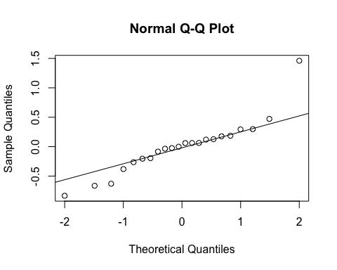
emm <- emmeans(m_group_fold, pairwise ~ group, adjust = "tukey")
emm$emmeans
group emmean SE df lower.CL upper.CL
Early 0.722 0.172 19 0.362 1.081
Mid 0.574 0.183 19 0.190 0.958
Late 1.316 0.183 19 0.932 1.700
Confidence level used: 0.95
emm$contrasts
contrast estimate SE df t.ratio p.value
Early - Mid 0.148 0.251 19 0.587 0.8284
Early - Late -0.595 0.251 19 -2.367 0.0704
Mid - Late -0.742 0.259 19 -2.861 0.0259
P value adjustment: tukey method for comparing a family of 3 estimates
dunnTest(resynthesis_ratio_fold ~ group, data = mps_FC, method = "bh")
Kruskal-Wallis rank sum test
data: x and g
Kruskal-Wallis chi-squared = 5.9712, df = 2, p-value = 0.05
Dunn's Pairwise Comparison of x by g
(Benjamini-Hochberg)
Col Mean-│
Row Mean │ Early Mid
─────────┼──────────────────────
Mid │ 1.020180
│ 0.3076
│
Late │ -1.487762 -2.428305
│ 0.2052 0.0455*
FDR = 0.05
Reject Ho if adjusted p ≤ FDR with stopping rule, where (unadjusted) p = Pr(|Z| ≥ |z|)
Dunn (1964) Kruskal-Wallis multiple comparison
p-values adjusted with the Benjamini-Hochberg method.
Comparison Z P.unadj P.adj
1 Early - Mid 1.020180 0.30764294 0.30764294
2 Early - Late -1.487763 0.13681341 0.20522011
3 Mid - Late -2.428306 0.01516955 0.04550865
 Double-check this interpretation
The p-values above (Early–Mid = 0.828, Mid–Late = 0.026, Early–Late = 0.070) suggest the Mid vs Late comparison is the significant one, with Early vs Late only trending. Please verify this against your own console output before finalising — the wording below has been updated to match these numbers, but it’s worth confirming nothing was mislabelled in the process.

Correcting for the baseline difference using the fold-change ratio reveals genuine differences between the feeding groups. Post-hoc contrasts show a significant difference between the Mid and Late groups (p = 0.026), with the Early and Late groups showing only a non-significant trend in the same direction (p = 0.070); the Early and Mid groups do not differ significantly (p = 0.828).

6. Visualisations
The following figures are prepared for presenting these results.
p_group <- ggplot(mps_FC, aes(x = group, y = resynthesis_ratio_fold, fill = group)) +
geom_boxplot(width = 0.5, alpha = 0.5, outlier.shape = NA) +
geom_jitter(width = 0.08, size = 2.2, shape = 21, color = "black") +
geom_signif(comparisons = list(c("Early", "Mid"),
c("Mid", "Late"),
c("Early", "Late")),
annotations = c("p = 0.828", "p = 0.026", "p = 0.070"),
step_increase = 0.12,
tip_length = 0.02) +
scale_fill_viridis_d() +
labs(x = "Refeed timing group",
y = "Resynthesis ratio (fold-change corrected)") +
theme_clean(base_size = 13) +
theme(legend.position = "none")
p_group
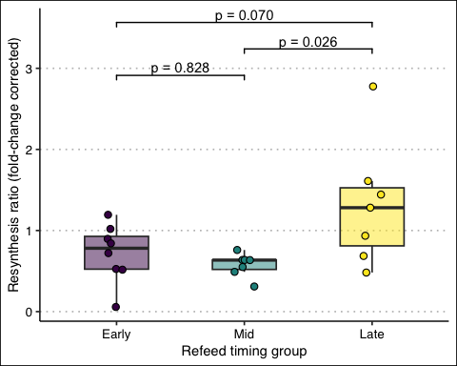
ggsave("resynthesis_ratio_by_group.png", p_group, width = 5, height = 4.5, dpi = 300)
p_doseresponse <- ggplot(mps_FC, aes(x = IFI, y = resynthesis_ratio_fold)) +
geom_smooth(method = "lm", color = "black", fill = "grey70", se = TRUE) +
geom_point(aes(color = group), size = 2.5) +
scale_color_viridis_d() +
labs(x = "Inter-feed interval (min)",
y = "Resynthesis ratio (fold-change corrected)",
color = "Group") +
theme_clean(base_size = 13)
p_doseresponse
`geom_smooth()` using formula = 'y ~ x'
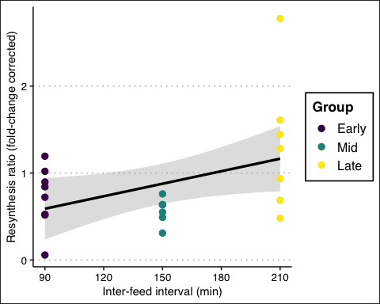
ggsave("resynthesis_ratio_doseresponse.png", p_doseresponse,
width = 5.5, height = 4.5, dpi = 300)
`geom_smooth()` using formula = 'y ~ x'
traj_summary <- traj_long %>%
group_by(group, time) %>%
summarise(mean_MPS = mean(MPS, na.rm = TRUE),
sem_MPS = sd(MPS, na.rm = TRUE) / sqrt(sum(!is.na(MPS))),
.groups = "drop")
p_traj <- ggplot(traj_summary, aes(x = time, y = mean_MPS, color = group)) +
geom_line(linewidth = 1) +
geom_point(size = 2.5) +
geom_errorbar(aes(ymin = mean_MPS - sem_MPS, ymax = mean_MPS + sem_MPS),
width = 8) +
scale_color_viridis_d() +
labs(x = "Time (min)", y = "MPS", color = "Group") +
theme_clean(base_size = 13)
p_traj
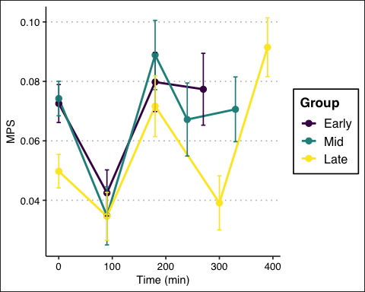
ggsave("mps_trajectories_mean_sem.png", p_traj, width = 6, height = 4.5, dpi = 300)
These three panels can be combined into a single multi-panel figure using the patchwork package, e.g. (p_traj | p_group) / p_doseresponse.

7. Summary
Baseline MPS differed significantly between groups (Kruskal-Wallis, p = 0.039), and this baseline difference was found to influence the additive resynthesis ratio — subjects with a higher baseline showed a lower ratio. A proportional (fold-change) version of the ratio, which corrects for baseline multiplicatively rather than additively, resolved this dependency and is used as the primary outcome measure.
Using the fold-change-corrected resynthesis ratio, post-hoc comparisons indicate a significant difference between the Mid and Late refeed-timing groups, with the Early and Late groups showing only a non-significant trend in the same direction. This suggests the interval required to fully re-stimulate MPS following an initial feed may sit somewhere between the Mid (150 min) and Late (210 min) timepoints, though a larger sample size would help clarify the Early–Late trend and improve overall precision.

