Semi-Tomographic Gamma Scanning Technique for non-destructive assay of radioactive waste drums
GU Weiguo, RAO Kaiyuan, WANG Dezhong, XIONG Jiemei
Abstract
Segmented gamma scanning (SGS) and tomographic gamma scanning (TGS) are two traditional detection techniques for the low and intermediate level radioactive waste drums. This paper proposes one detection method named semi-tomographic gamma scanning (STGS) to avoid the poor detection accuracy of SGS and very long detection time of TGS. This method and its algorithm synthesize the principles of SGS and TGS where annual voxels are divided in each segment and tomography is used in the radiation reconstruction. The accuracy of STGS is verified by experiments and simulations aiming at the 200 liter standard waste drums containing three types of nuclides, point source or multipoint sources, and uniform or nonuniform materials. The results show that STGS exhibits a large improvement in the detection performance for the reconstruction error decreasing greatly in most cases by compared with SGS. The detection time of STGS is longer than SGS, but shorter than TGS, which indicates that STGS has the good overall performances for non-destructive assay of radioactive waste drums.

Keywords
Semi tomography, gamma scanning techniques, radioactive wastes, non-destructive assay

1. Introduction
Radioactive wastes have to be detected before the intermediate treatment and final storage because they should meet the acceptance criteria defined by national regulatory and management authorities. In order to estimate the amount and categories of the radioactive nuclides inside the waste packages, non-destructive assay (NDA) techniques, especially gamma scanning techniques including segmented gamma scanning (SGS) and tomographic gamma scanning (TGS) are widely used (IAEA, 2007).
The first SGS and TGS system were both established by Los Alamos National Laboratory respectively in early 1970s (Parker,1977 ) and 1990s (Estep,1991 ). SGS divides the waste drum into several axial segments and assumes that the filling materials and radioactive sources are uniformly distributed in each segment, but large systematic errors normally appear in the case of nonuniform distribution. TGS further divides the segments into several voxels and then reconstructs the distribution of radioactive sources using tomographic method. The detection accuracy of TGS is improved greatly, but the detection process becomes complicated and the time-consuming problem restricts its wide application.
In last two decades, some efforts have been made in order to improve the detection accuracy of SGS and reduce detection time of TGS. In real waste drum, the radioactive sources with high activities usually only appear somewhere in the waste drum, which is called hotspot. In this situation, rotating the waste drum during the measurement is one method to reduce the nonuniformity. If the rotation is at a constant speed within a long time, the point source can approximate the ring source. Then some researchers studied the method to reconstruct the ring source in one segment, but the filling materials are still assumed uniform (Anh, 2005). Another method is to reconstruct the radius of the ring source directly and calibrate the detection efficiency according to the ring radius (Liu, 2010), but the accuracy is not good in the case of multi-point sources. In addition, there were some studies using statistical method of analyzing angular dependent count rate distribution to improve the accuracy of SGS (Bai, 2009, Thomas, 2011), however the results were also not ideal when there were more than three same point isotopes simultaneously in one segment. As to TGS, reducing the number of voxels divided in the segment is the effective way to shorten the detection time. In order to avoid voxels reduction leading to the decrease of detection accuracy, adaptive dynamic voxels were applied in the reconstruction calculation where the voxels were refined around the radioactive sources (Liu, 2012, Gu, 2013). By this method, the detection time of TGS was shortened by half by compared with the fixed voxels, but the reliability of the algorithm was not studied absolutely. Until now, these problems of SGS and TGS have not be solved absolutely, and accordingly the business equipment is still less than satisfactory.
This paper presents one method and its algorithm which combines the principles of SGS and TGS. In this method, the waste drum is rotated and the point source is regarded as the ring source. In the reconstruction, the segment is divided into several annular voxels, then tomography is used in reconstructing the radial distribution of activities in these annular voxels. Because the voxel division in the segment is one-dimensional instead of the two-dimensional of TGS, this method is called as semi-tomographic gamma scanning (STGS).

2. Detection principle
For the low and intermediate level gamma-contaminated 200 liter waste drums, gamma scanning is a widely used technique detecting the category and amount of the radionuclides. Normally, the instrument employs a single shielded and collimated high purity germanium (HPGe) detector. As seen in figure 1, transmission source, typically Eu-152 is used to measure the attenuation coefficients and then calculate densities of the filling materials.

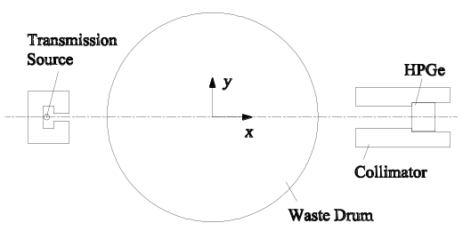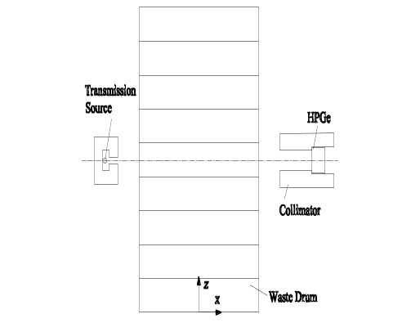
(a) layout in x-y plane (b) layout in x-z plane
Figure 1. The schematic of gamma scanning detection system

Conventional SGS measurement is performed by rotating the drum and measuring vertical segments in sequence. The waste drum is divided normally 9 segments where the dimension is limited by the detector collimator. During the measurement, the detector is positioned toward to the center of the segment, the transmission gamma rays penetrate the waste drum and the track length is the diameter (D). According to Beer’s law, this transmission measurement is described by
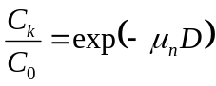 (1)
Where, C₀ is the count rates from the transmission source without attenuation, C_{k} is the count rates after the filler attenuation when the detector is positioned vertically toward the k-th segment, μ is the linear attenuation coefficient of the k-th segmental filling material.
In the emission measurement of SGS, the detection efficiency (E’) of the segmental volume source is calculated comprehensively considering the parameters of geometric size, position, density (ρ) and radionuclide energy (e). It is described by
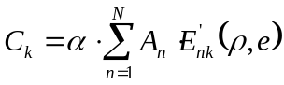 (2)
Where, C_{k} is the count rates from emission source where the detector is positioned toward the k-th segment, A_{n} is the activity of one radionuclide in the n-th voxel, α is the branching ratio of gamma line whose characteristic energy is e. When the whole measurements are finished, a group of linear equations are constructed consisting of K equations and N unknowns where K is the total detector positions number and N is the total segments number. Solving the linear equations, the activities in each segment can be obtained.

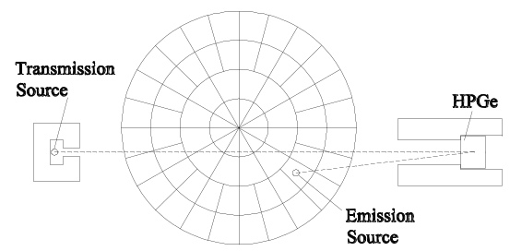
Figure 2. The layout of TGS detection system

The uniformity assumption in each segment will lead to the low detection accuracy of SGS. For TGS as seen in figure 2, the segment is further divided into several voxels. Because of the large number of these voxels, at least the same number of the detector positions is required in order to satisfy the requirement in solving linear equations. Accordingly, TGS detection process demands the waste drum rotating step by step instead of continuously. Moreover, the detector and transmission source will both be moved eccentrically in y direction. Consequently, dozens of detector positions are needed in one segment for TGS, whereas SGS just needs one position.

The transmission measurement of TGS is described by
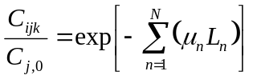 (3)

Where, i, j, k denote the number of detector positions in circumferential, eccentric and vertical directions respectively, n denotes the serial number of the voxels in the waste drum and the total number is N, μ_{n} and L_{n} are the linear attenuation coefficient and gamma ray track length in the n-th voxel. It is worth noting that the group of measurements should insure that each voxel is needed to be penetrated by transmission gamma rays at least once.

In TGS emission measurement, the point source is supposed to be positioned in the geometric center of the small voxel, the measurement is described by
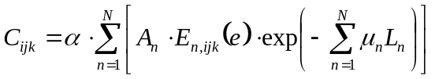 (4)
Where, C_{ijk} is the count rate of the detector in the i-th circumferential, j-th eccentric and k-th vertical position, α is the branching ratio of gamma line. A_{n} is the activity of one radionuclide in the n-th voxel. E_{n,ijk} is the geometric detection efficiency of the point source in n-th voxel to the detector in the No. i, j, k position, and the energy of the radionuclide is e. L_{n} is the track length of the gamma ray in the n-th voxel from the point source to the detector.
STGS integrates the two principles of SGS and TGS, where the waste drum is rotated at a constant speed and divided into vertical segments and annular voxels as seen in figure 3. The point source is assumed to be the ring source. The filling material and radioactive sources are assumed to be distributed uniformly in the annular voxels. Referring to the transmission and emission reconstruction of TGS, the measurement of STGS is described by
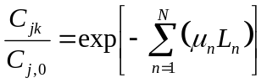 (5)
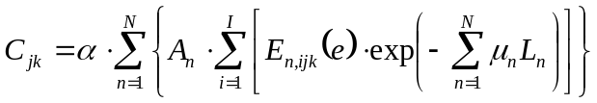 (6)
Where, j, k respectively denote the number of detector position in eccentric and vertical directions, n denotes the serial number of the annular voxels in the waste drum and the total number is N. A_{n} is the activity of one radionuclide in the n-th annular voxel. The detection efficiency of STGS is calculated integrally to all circumferential voxels which are divided in reference of TGS. E_{n,ijk} is the geometric detection efficiency of the n-th annual voxel to the detector. I is the total number of circumferential voxels used in STGS calibration. The geometric detection efficiency is corrected by the filling material attenuation. And μ_{n} and L_{n} are the linear attenuation coefficient and track length through the n-th annular voxel.


(a) two voxels by ER (b) two voxels by EA (c) four voxels by ER (d) four voxels by EA
Figure 3. The division of the annular voxels in the segment where ER, EA denote the division methods according to equal radius or equal area in the segment

3 Simulation and Experiments
Simulation and experiments are both performed in order to verify the characteristics of STGS in detecting 200 liter radioactive waste drum. Monte-carlo method is used in simulation. Considering the attenuation of the filling materials being relating with the energy of radioactive nuclides, the nuclides of Cr-51 (0.32 MeV), Cs-137 (0.6617 MeV), Co-60 (1.3325 MeV) are selected in the simulation. The experiments only use Cs-137 and Co-60 as the emission sources because there is no standard source of Cr-51. Three types of materials are used in experiment for the standard waste drum, polyurethane (0.3 g/cm³), density wood (0.7 g/cm³) and nylon (1.2 g/cm³).
The 200 liter drum is 56 cm in diameter, 90 cm in height. Figure 4 is the picture of partial experimental facilities. In order to save the detection time in experiments, the standard waste drum only uses three segments where the radioactive sources are placed in the middle segment. The detector is Canberra’s well type high-purity Germanium (HPGe) detector whose crystal has a diameter of 6.2 cm and length of 5.95 cm, is wrapped by an aluminum layer of 1.5 mm thickness. As shown in figure 1, the detector is housed by a cylindrical lead shield of 4 cm thickness and positioned at 53 cm away from the drum center. Before the detector, a lead collimator of 8 cm diameter is placed with a square hole of 6 cm side length and 15 cm long. According to the geometric dimension and position, detection efficiency (E) of ring sources is distributed as shown in figure 5 where r denotes the radius of the ring. The figure exhibits that the detection efficiency is affected by the filling material density and radioactive nuclides.
The detections of SGS and STGS methods are compared in order to analyse the detection accuracy improvement of STGS. The waste drum is divided into 9 segments whose height is 10 cm. In each segment, four types of annular voxels are adopted in STGS as seen in figure 3. Accordingly, total four eccentric positions are selected in STGS method, the offset distance (Δy) is 0, 7, 14, 21 cm respectively. Among these measurements, one position of Δy=0 cm is used for SGS, tow positions of Δy=0 and 17.5 cm are used for STGS with two voxels, and the total four positions are used for STGS with four voxels of one segment.

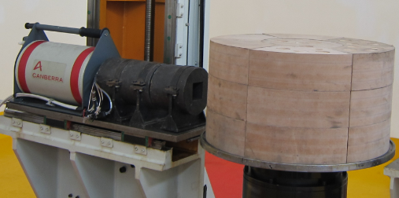
Figure 4. The picture of partial experimental facilities

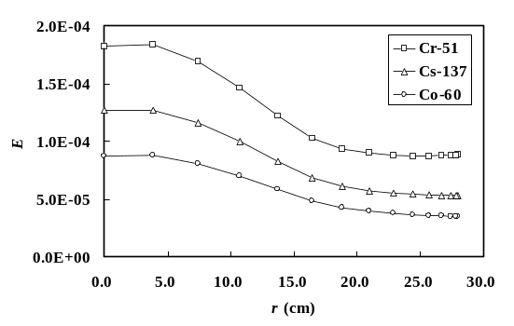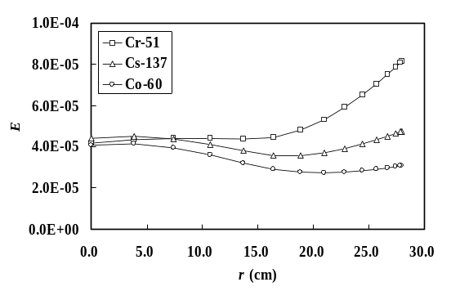
(a) material density of 0.3 g/cm³ (b) material density of 0.7 g/cm³
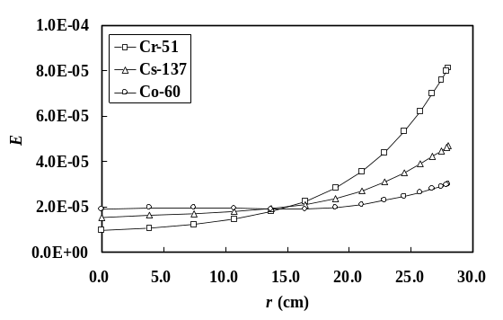
(c) material density of 1.2 g/cm³
Figure 5. The detection efficiency of the ring source versus its radius in the waste drum

4 Results and discussion
After emission measurement, total activity is calculated by summing over results in the voxels. The reconstruction error (Δ) is defined as
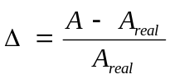 (7)
Where, A is the reconstructed activity of one nuclide from all emission sources, A_{real} is the real total activity of the similar nuclide.
Figure 6 shows the comparison of the count rate (C_{e}) between experiments and simulation for one point source of Cs-137 (6.6×10⁶Bq) located at the radius of 9 cm in the nylon filler. According to the detection setup of TGS, totally 96 positions are selected including 24 circumferential positions (step increment of 15°) and 4 eccentric positions (step increment of 7 cm). These positions are numbered consecutively as shown in the x-axis. It’s found that the simulation results are agreed well with the experimental results where the maximal deviation of peak count is only 2.8%.

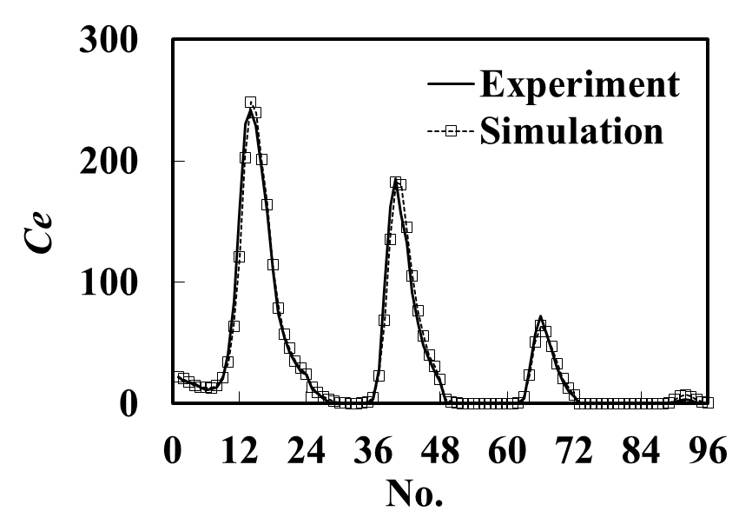
Figure 6. The comparison of point source Cs-137 (r=9 cm) between experiments and simulation

Two radioactive sources of Cs-137 and Co-60 with about one million Bq are used in the experiments. Three types of materials, polyurethane, density wood and nylon are selected in the standard waste drum. In one segment, a small vertical hole are opened for placing the emission source with the distance of 0, 10, 24 cm from the drum center. Figure 7 shows the reconstruction error in the cases of the point emission source in the experiments. STGS includes four reconstruction methods according to the different voxel division as shown in Figure 3. In the figure, the symbol of 2 or 4 denotes the voxel number in each segment, ER or EA denotes the voxel being divided according to equal radius or equal area.
As shown in figure 7, the absolute maximal reconstruction error of SGS reaches 100% in the case of the nuclide of Cs-137 placed in the polyurethane filler. However, these reconstruction error displays a different variation trend versus the geometric position of the emission source in different filling materials. This characteristics has the corresponding relation to the detection efficiency as shown in figure 5. According to the principle of SGS, the detection efficiency of one segment is the weighted average of the efficiencies at different ring radius. Being influenced by the attenuation of the filling material and the collimator, the efficiency of the ring source is changed with the radius. If the variation is large, these efficiencies will depart from the average efficiency obviously. If using the average efficiency in SGS emission reconstruction, the large error is probably produced. The figures show that the reconstruction error of SGS is generally large in polyurethane and nylon materials. At the same time, STGS exhibits the comparatively low reconstruction error which is less than about 25%. As to the four division methods of STGS, the differences are not obvious.
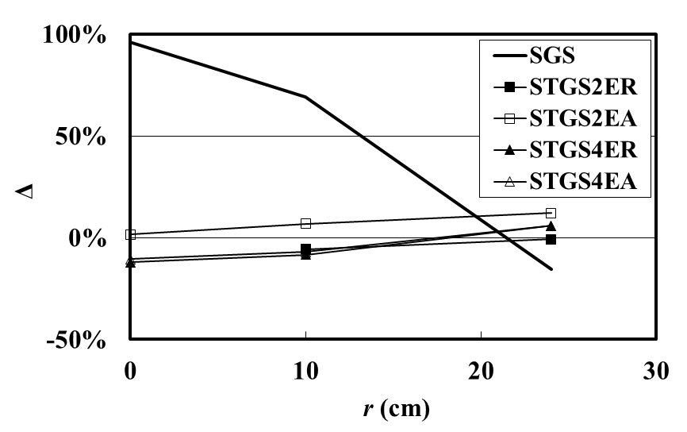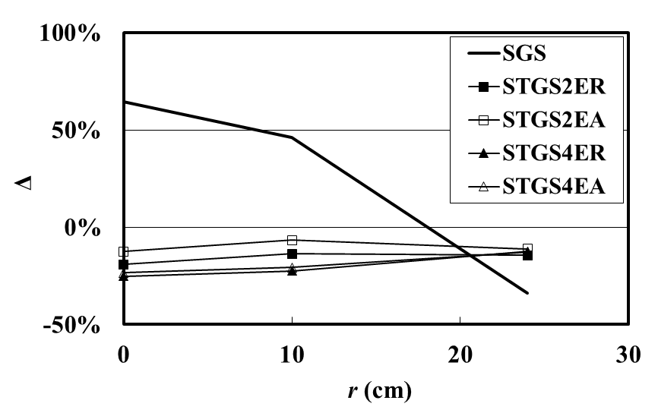
(a) Cs-137 in the polyurethane material (b) Co-60 in the polyurethane material
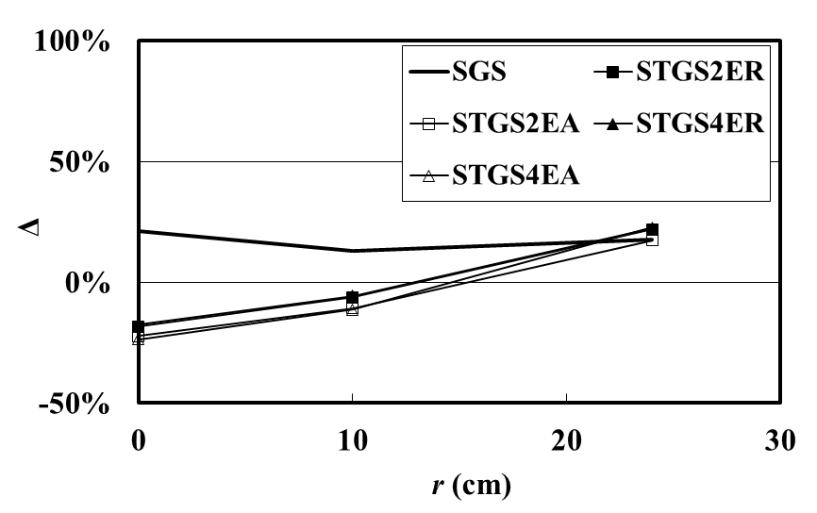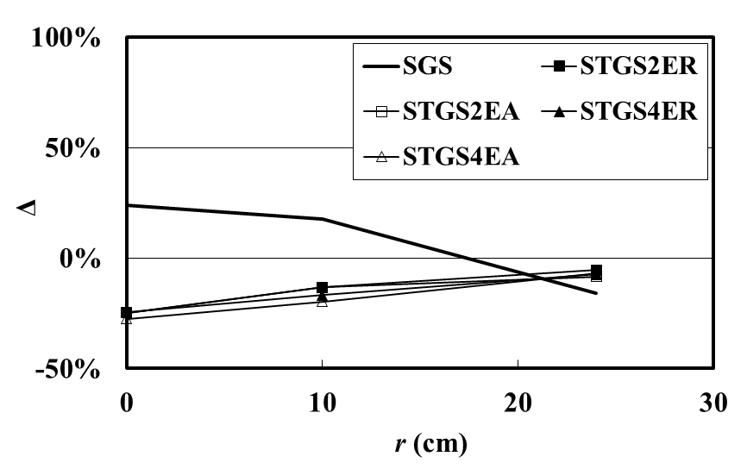
(c) Cs-137 in the density wood material (d) Co-60 in the density wood material
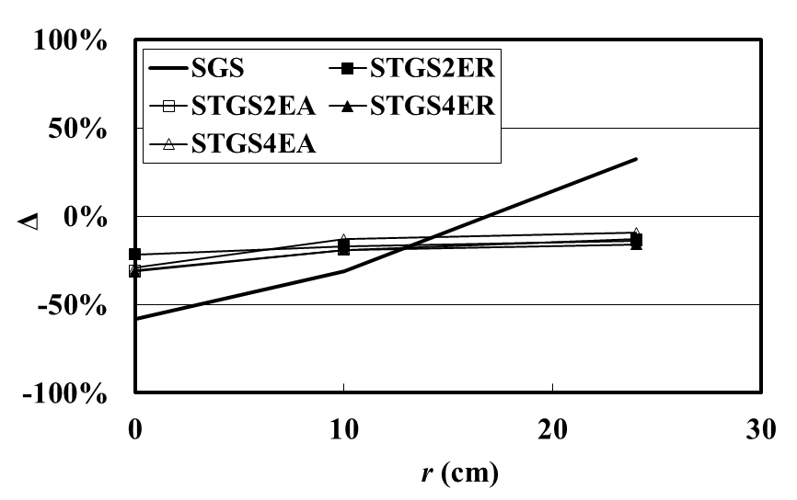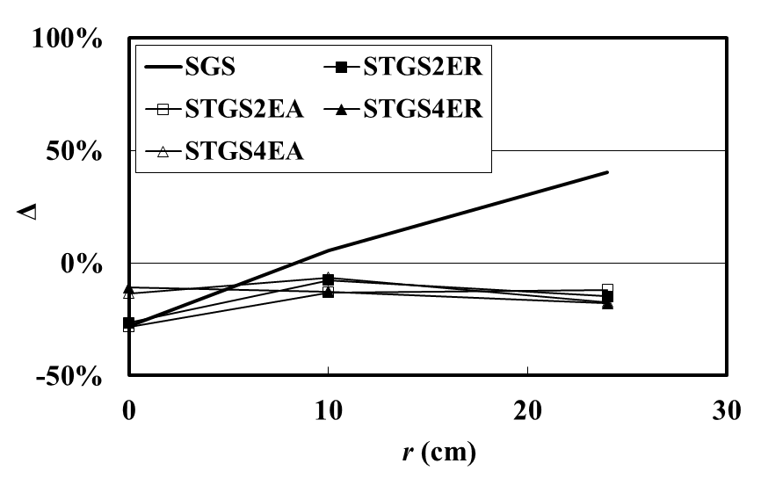
(e) Cs-137 in the nylon material (f) Co-60 in the nylon material
Figure 7. The reconstruction results of one point emission source in experiments

At the same time, 14 positions of point source with increment of 2cm are simulated by Monte-Carlo method respectively. The construction results are shown in figure 8. Three nuclides of Cr-51, Cs-137 and Co-60 are used as emission sources. In the figure, the distribution of the reconstruction errors of simulation results is similar with the experimental results. The error of SGS method is large and varied at different positions, especially in 0.3 g/cm³ and 1.2 g/cm³ materials. Comparatively, the error of STGS method is significantly reduced. Comparing figure 7 and figure 8, the error of simulation case is overall smaller than that of experiments probably because that the emission source in experiments has low activity and the detection uncertainty is accordingly high.

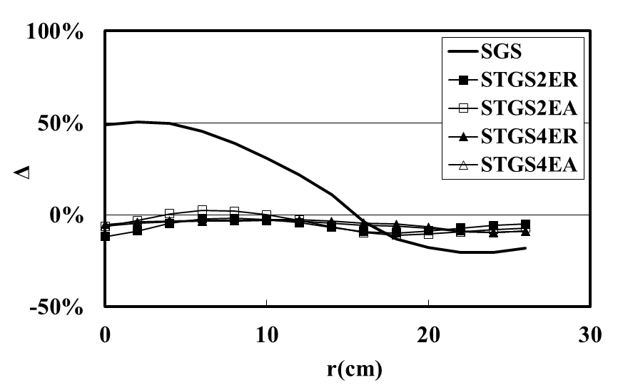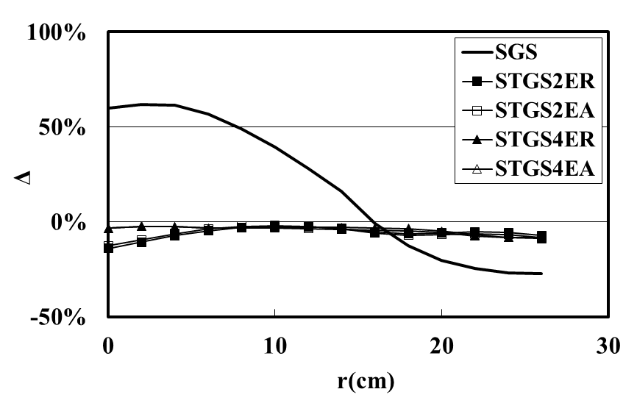
(a) Cr-51 in the material of 0.3g/cm³ (b) Cs-137 in the material of 0.3g/cm³
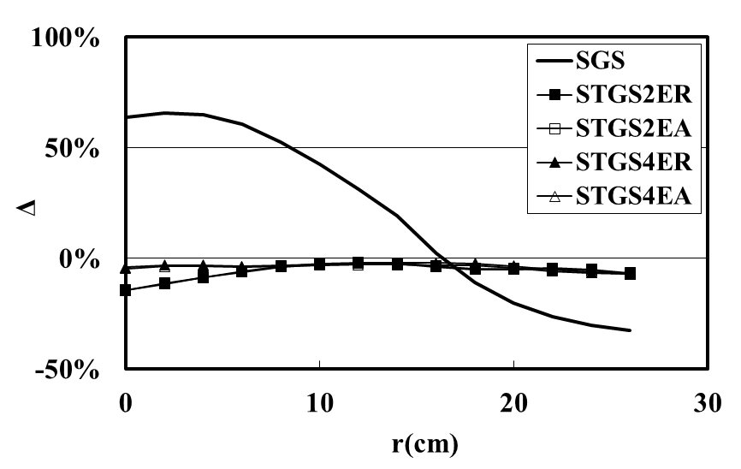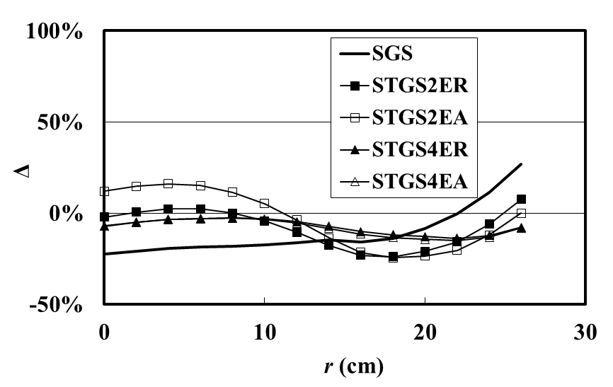
(c) Co-60 in the material of 0.3g/cm³ (d) Cr-51 in the material of 0.7g/cm³
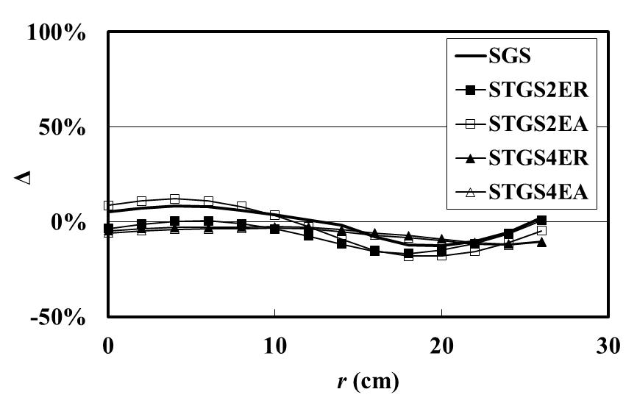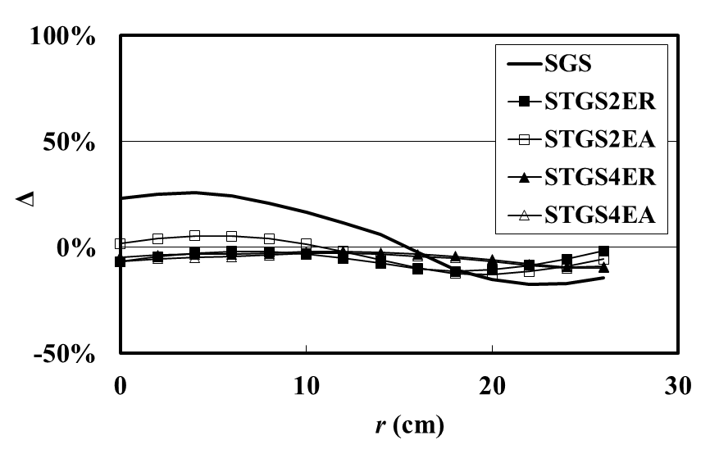
(e) Cs-137 in the material of 0.7g/cm³ (f) Co-60 in the material of 0.7g/cm³
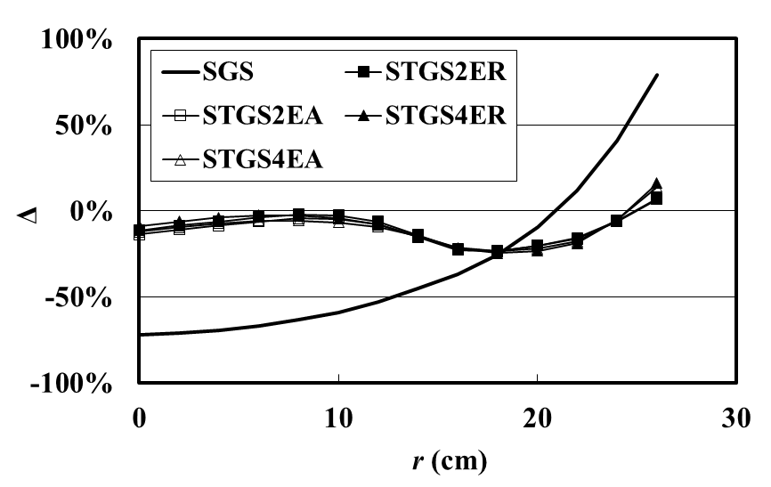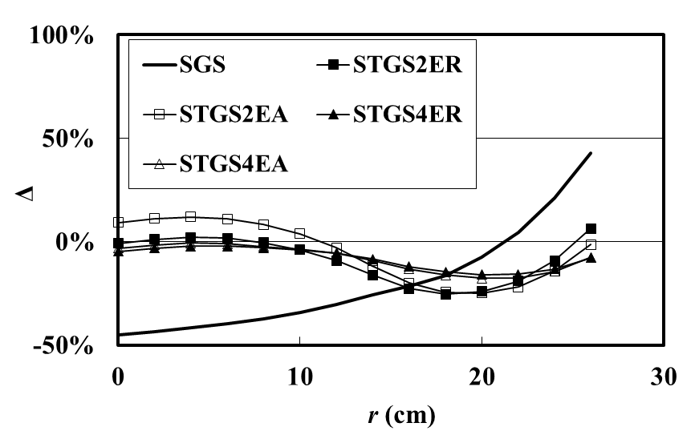
(g) Cr-51 in the material of 1.2g/cm³ (h) Cs-137 in the material of 1.2g/cm³
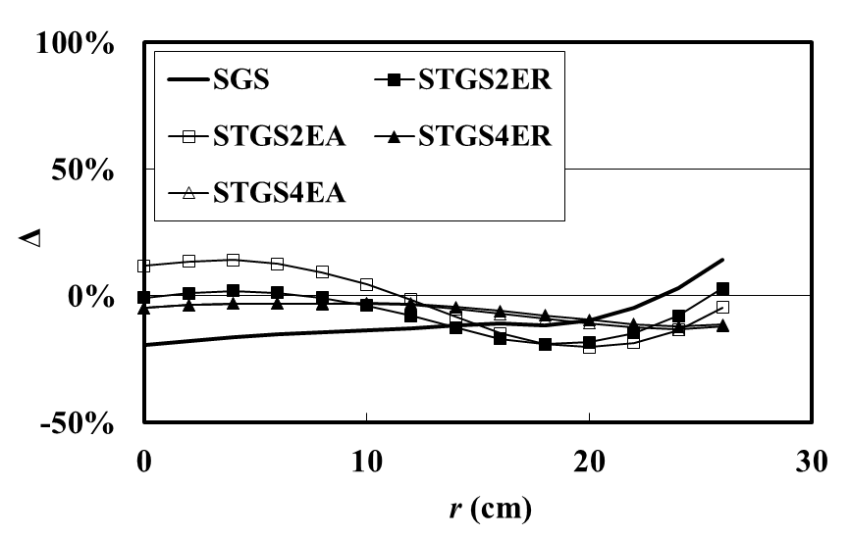
(i) Co-60 in the material of 1.2g/cm³
Figure 8. The reconstruction results of one point emission source in simulation

Statistical analysis is performed for the large number of reconstruction results. Table 1 gives the maximal and minimal reconstruction error in different cases. Moreover, in order to get the overall deviation of the reconstruction results, root mean square (RMS) of the error is defined as
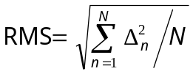 (8)
where N is the number of reconstruction error (Δ) which is adopted in statistical calculation.
As shown in table 1, the reconstruction error of SGS method at the middle level density (0.7 g/cm³) material is relatively small with absolute value less than 30%. If the density increases to 1.2 g/cm³, reconstruction error will depend on the type of nuclides. For example, reconstruction error appears relatively low for the nuclide of Co-60 and high for the nuclide Cr-51. It can be concluded that if the detection efficiency curve is flat distributed, the overall detection error is low in SGS. The distribution of the detection efficiency versus the ring radius depends on the attenuation of the filling material, penetrability of the gamma ray emitted from the source, the dimension of the collimator and position of the detector. In the present experimental conditions, the material density of 0.7 g/cm³ seems to the appropriate case for SGS with the relatively high detection accuracy, especially for the nuclide of Cs-137. However, the unknown nuclides or inhomogeneous materials filled in the real waste drum will lead to the uncertainty of SGS detection.
If compared with SGS, the new method of STGS has improved the detection accuracy effectively, the absolute maximal reconstruction error of all cases is less than that of SGS. As to the four divisions of STGS, the simulation results shows that the division of four voxels in one segments exhibits the highest accuracy, including RMS less than 10% in most cases. Moreover, the division of voxels according to equal radius (ER) also displace the slightly better performance than that of EA division.

Table 1. The statistical results for the point emission source in uniform filling material
Density  (g/cm³) | Detection Type | Cr-51 |  |  | Cs-137 |  |  | Co-60
Density  (g/cm³) | Detection Type | Max. | Min. | RMS | Max. | Min. | RMS | Max. | Min. | RMS
0.3 | SGS | 50.41% | -20.51% | 31.83% | 61.74% | -27.29% | 39.69% | 65.57% | -32.36% | 42.58%
0.3 | STGS2ER | -2.00% | -11.97% | 7.07% | -2.39% | -13.93% | 6.72% | -1.89% | -14.25% | 6.54%
0.3 | STGS2EA | 2.45% | -11.11% | 6.80% | -2.06% | -12.74% | 6.63% | -2.18% | -14.49% | 6.82%
0.3 | STGS4ER | -2.65% | -9.56% | 5.62% | -2.43% | -8.75% | 4.68% | -2.07% | -7.09% | 3.91%
0.3 | STGS4EA | -3.10% | -9.82% | 6.19% | -2.47% | -8.43% | 5.04% | -2.81% | -7.02% | 4.31%
0.7 | SGS | 26.73% | -22.47% | 17.18% | 8.31% | -12.56% | 7.44% | 25.85% | -17.23% | 17.84%
0.7 | STGS2ER | 7.49% | -23.87% | 12.94% | 0.67% | -16.78% | 9.05% | -1.63% | -11.40% | 6.66%
0.7 | STGS2EA | 16.13% | -24.55% | 15.58% | 12.04% | -18.15% | 11.65% | 5.41% | -12.61% | 7.47%
0.7 | STGS4ER | -2.84% | -13.78% | 8.46% | -2.52% | -11.61% | 6.63% | -1.95% | -9.14% | 5.11%
0.7 | STGS4EA | -2.87% | -15.24% | 9.30% | -0.74% | -17.66% | 10.28% | -2.57% | -9.71% | 5.95%
1.2 | SGS | 79.21% | -72.20% | 54.82% | 42.81% | -45.07% | 32.15% | 14.10% | -19.48% | 13.25%
1.2 | STGS2ER | 6.68% | -23.24% | 12.81% | 6.32% | -25.42% | 13.63% | 2.97% | -19.05% | 10.39%
1.2 | STGS2EA | 7.19% | -23.50% | 13.59% | 11.97% | -24.84% | 14.66% | 14.10% | -20.20% | 13.09%
1.2 | STGS4ER | 16.09% | -24.62% | 13.95% | -2.16% | -15.86% | 9.52% | -2.77% | -12.18% | 6.96%
1.2 | STGS4EA | 13.86% | -23.46% | 14.01% | -0.74% | -17.66% | 10.28% | -3.00% | -13.25% | 7.71%

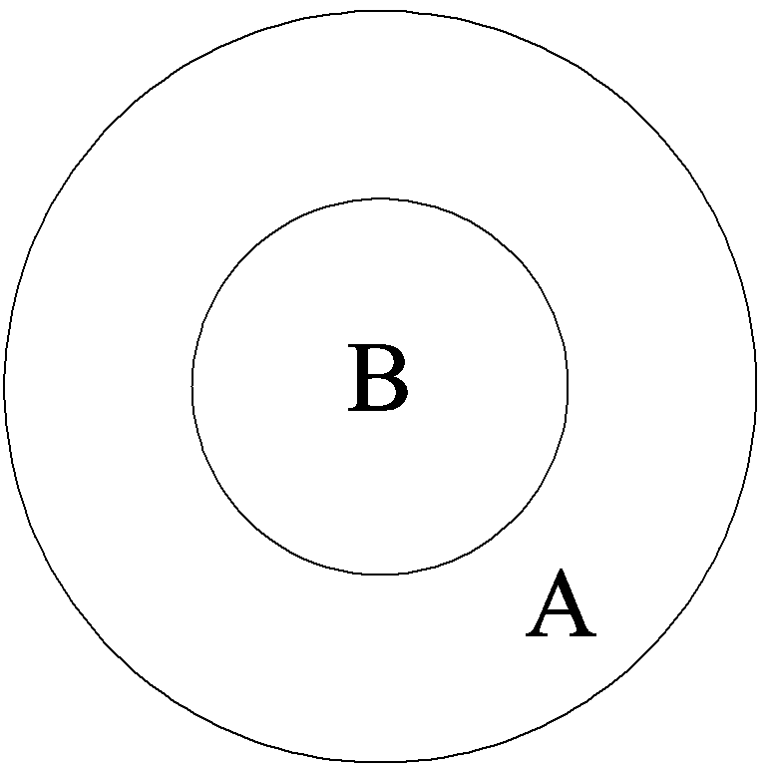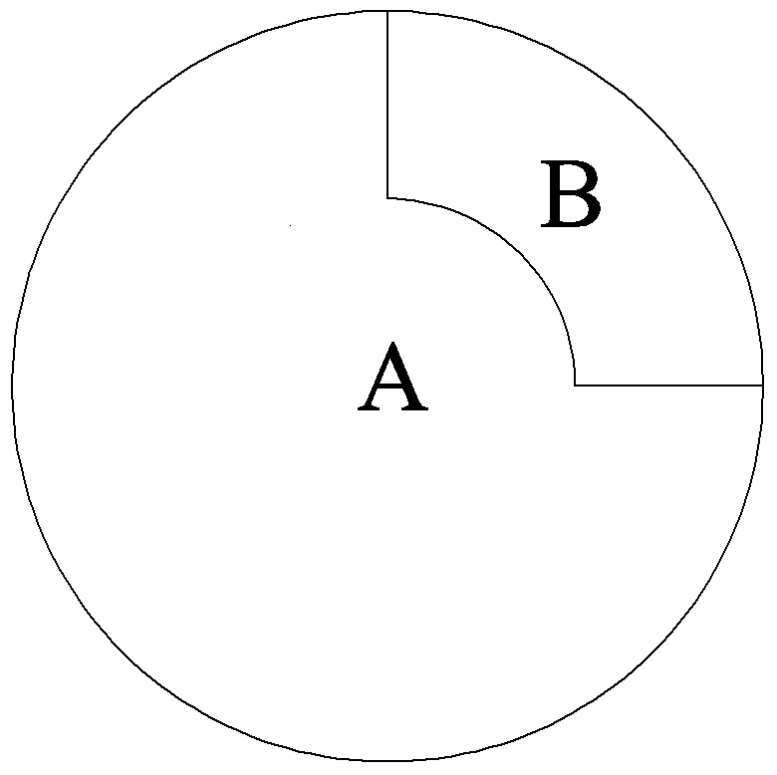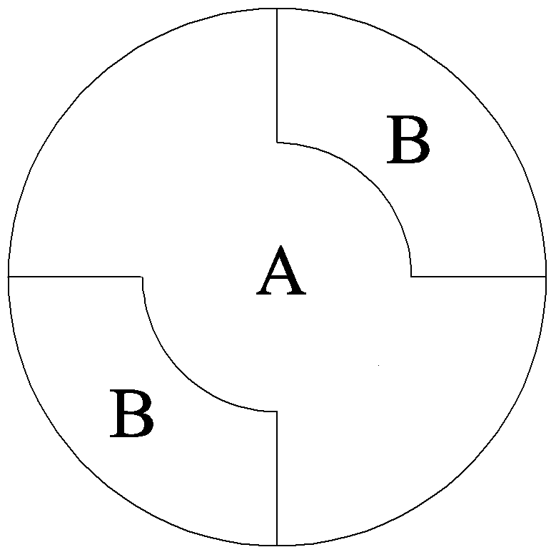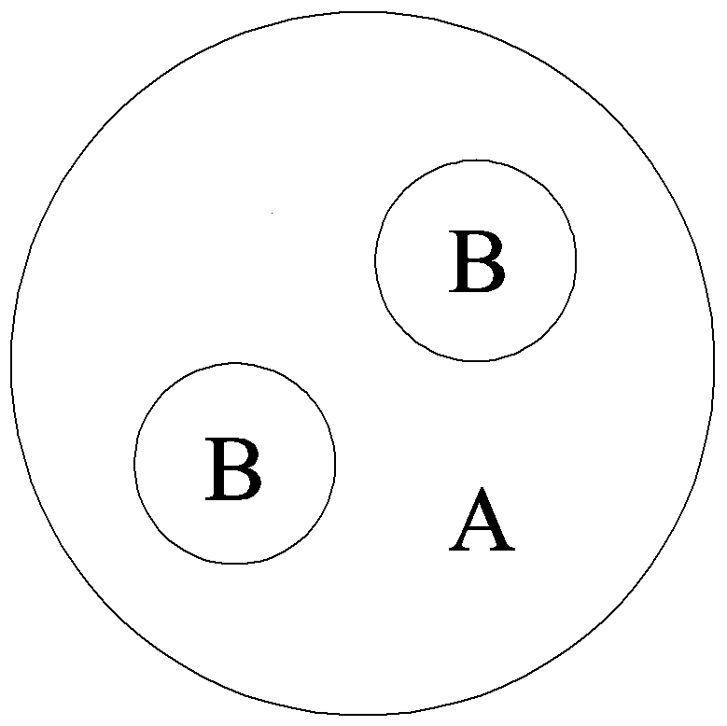
(a) form 1 (b) form 2 (c) form 3 (d) form 4
Figure 9. The sectional layout of the filler with two materials in the segment where A represents the density of 0.7g/cm³ and B represents the density of 1.2g/cm³

In order to simulate the nonuniform material in the waste drum, two materials of 0.7 and 1.2 g/cm³ are selected to coexist in the segment with four combination forms as shown in figure 9. Table 2 lists the statistical results, where only the case of 4 voxels divided according to ER is selected for STGS because this case exhibits the best performance in the uniform material. In SGS, the reconstruction error of the nuclide Cr-51 is relatively large especially in the nonuniform material of form 1, and the error of Cs-137 is the lowest between the three nuclides. At the same time, STGS also improves the detection accuracy in the nonuniform materials. For example, the absolute maximal reconstruction error of Cr-51 is less than 25%, and is almost less than 15% for both Cs-137 and Co-60, whereas the error of SGS is several times larger than that of STGS. RMS of STGS is also smaller, which indicates STGS has the better overall detection accuracy than SGS.

Table 2. The statistical results for the point emission source b in nonuniform filling material
Density  Comb. | Detection Type | Cr-51 |  |  | CS-137 |  |  | Co-60
Density  Comb. | Detection Type | Max. | Min. | RMS | Max. | Min. | RMS | Max. | Min. | RMS
Form 1 | SGS | 70.71% | -47.50% | 36.06% | 38.17% | -12.55% | 15.39% | 19.99% | 5.12% | 15.15%
Form 1 | STGS4ER | 23.72% | -34.04% | 20.54% | 17.90% | -24.75% | 14.16% | 13.18% | -18.02% | 10.16%
Form 2 | SGS | 32.23% | -32.82% | 25.05% | 12.52% | -19.86% | 12.40% | 34.53% | -15.66% | 20.23%
Form 2 | STGS4ER | 16.44% | -9.03% | 6.70% | 12.97% | -3.07% | 4.24% | 9.75% | -0.91% | 3.15%
Form 3 | SGS | 36.31% | -33.83% | 27.93% | 14.56% | -20.86% | 11.65% | 27.04% | -15.42% | 16.91%
Form 3 | STGS4ER | 21.30% | -2.57% | 12.12% | 16.65% | 0.43% | 9.09% | 12.50% | 1.82% | 6.95%
Form 4 | SGS | 44.39% | -26.18% | 21.33% | 19.19% | -4.99% | 7.86% | 31.17% | -5.93% | 18.90%
Form 4 | STGS4ER | 20.64% | -6.26% | 11.20% | 15.55% | -4.38% | 7.32% | 11.49% | -3.10% | 5.13%

In addition to the case of only one point emission source in the waste drum, multipoint sources, 54 point sources simultaneously in the waste drum is also simulated. The 54 point sources, on average 6 sources in one segment, include three nuclides of Cr-51, Cs-137 and Co-60 with random activities by the range from 0.5 to 1 times of the maximal value. The positions of all point sources are also randomly located in the waste drum. The reconstruction results are listed in table 3. Compared with the case of one point source, the overall reconstruction error of multi-point sources is obviously reduced. STGS also improves the detection accuracy with its absolute maximal error and RMS are both smaller than that of SGS. The amount of improvement depends on the type of nuclide and materials, such as the improvement is very obvious in the material of 0.3 g/cm³ for all nuclides, and 0.7 g/cm³ for Cs-137 and Co-60. Anyway, multi-point sources will make the uniformity to be improved, which causes the detection error of SGS and STGS become reduced. In real waste drum, the number of hotspots is uncertain, the present results of 54 point sources show that STGS has the good performance while the absolute maximal error is less than 10% in most cases.

Table 3. The statistical results for the multi-point emission sources in uniform filling material
Density  (g/cm³) | Detection Type | Cr-51 |  |  | CS-137 |  |  | Co-60
Density  (g/cm³) | Detection Type | Max. | Min. | RMS | Max. | Min. | RMS | Max. | Min. | RMS
0.3 | SGS | 21.48% | -24.22% | 9.56% | 24.81% | -25.96% | 10.53% | 25.32% | -25.04% | 10.37%
0.3 | STGS2ER | 3.40% | -5.63% | 2.29% | 3.20% | -5.23% | 2.05% | 2.77% | -4.84% | 1.78%
0.3 | STGS2EB | 4.03% | -6.22% | 2.42% | 3.40% | -5.47% | 2.12% | 3.01% | -4.86% | 1.81%
0.3 | STGS4ER | 3.61% | -5.68% | 2.26% | 3.47% | -5.70% | 2.10% | 3.23% | -5.13% | 1.84%
0.3 | STGS4EB | 3.46% | -5.73% | 2.27% | 3.40% | -5.57% | 2.10% | 3.33% | -5.40% | 2.06%
0.7 | SGS | 6.80% | -10.21% | 3.59% | 12.16% | -16.33% | 5.84% | 17.84% | -19.15% | 7.43%
0.7 | STGS2ER | 6.51% | -10.49% | 3.70% | 4.31% | -7.64% | 3.00% | 3.52% | -6.14% | 2.34%
0.7 | STGS2EB | 6.44% | -10.31% | 3.64% | 5.36% | -8.84% | 3.11% | 4.31% | -7.03% | 2.46%
0.7 | STGS4ER | 5.03% | -8.15% | 3.00% | 4.20% | -6.34% | 2.58% | 3.83% | -5.56% | 2.18%
0.7 | STGS4EB | 4.96% | -7.88% | 2.98% | 3.91% | -6.31% | 2.60% | 3.52% | -5.57% | 2.20%
1.2 | SGS | 21.84% | -23.31% | 10.25% | 9.50% | -10.76% | 4.65% | 6.95% | -10.02% | 3.49%
1.2 | STGS2ER | 10.80% | -17.21% | 5.50% | 7.99% | -9.77% | 3.63% | 4.93% | -8.47% | 3.23%
1.2 | STGS2EB | 9.47% | -14.67% | 5.20% | 7.38% | -9.06% | 3.51% | 5.64% | -9.33% | 3.18%
1.2 | STGS4ER | 14.49% | -16.00% | 5.59% | 6.18% | -9.51% | 3.28% | 4.33% | -6.45% | 2.64%
1.2 | STGS4EB | 11.62% | -14.24% | 5.07% | 6.15% | -8.96% | 3.20% | 4.03% | -6.44% | 2.65%

After the comparison between SGS and STGS, the above results show that STGS will improve the detection accuracy to the radioactive waste drum. The improvement is caused by the STGS method which more annular voxels are divided in one segment instead of SGS assuming that emission sources are distributed homogeneously in the segment. Then STGS uses tomographic method to position the emission source and reconstruct its activity. However, more detector positions are necessary in STGS, which will cause the detection time longer than SGS. At the same time, it is still shorter several times than that of TGS. It is included that STGS is an effective method having good overall performances with relatively high detection accuracy and short detection time.

5 Conclusion
One gamma scanning method and its algorithm, namely semi-tomographic gamma scanning (STGS) are proposed aiming at the low and intermediate level radioactive waste drum in order to improve the detection performance. Experiments and simulation are performed to verify the accuracy of this method where three types of nuclides, point source and multipoint sources, uniform and nonuniform filling materials are adopted.
As to one point source in the uniform material, experimental and simulation results are consistent and proved that STGS has a very low reconstruction error by compared with SGS. Although the reconstruction error depends on the type of nuclides or filling materials, the absolute maximal error of STGS is less than 10% in most cases, which is similar with the results when multipoint resources are applied. In the nonuniform materials, both SGS and STGS exhibit the increasing reconstruction error, but the performance of STGS is better than SGS where the absolute maximal reconstruction error aiming at Cr-51 is less than 25%, and is almost less than 15% for both Cs-137 and Co-60.
The assumption of uniform distribution of emission sources in the segment is the core reason to cause SGS has a very large reconstruction error because the detection efficiency will be varied versus the radius of the ring source. STGS uses tomographic method to position and reconstruct the emission ring source, which leads to the improvement of detection accuracy. Although the detection time will be longer than SGS, STGS has a good overall performance that detection accuracy is better than SGS and detection time is shorter than TGS.

6 Acknowledgment
This research is supported by China Postdoctoral Science Foundation (No.20110490717).

7 References
IAEA, 2007. Strategy and Methodology for Radioactive Waste Characterization. IAEA-TECDOC-1537, IAEA, Vienna.
Martin E.R., Jones D.F., and Parker J.L., Gamma-ray measurements with the segmented gamma scan. Technical Report LA-7059-M, Los Alamos Scientiﬁc Laboratory, 1977
R.J. Estep, K. Sherwood. A prototype tomographic gamma scanner for assaying 208-liter drums, Los Alamos National Laboratory, LA-UR-91-61, 1991
Tran Ha Anh, Nguyen Duc Thanh, Tran Quoc Dung, Evaluation of performance of a new gamma technique for assay of radioactive waste, Annals of Nuclear Energy, 32 (2005): 1516–1523
LIU Cheng, WANG Dezhong, BAI Yunfei, QIAN Nan. An improved segmented gamma scanning for radioactive waste drums[J]. Nuclear Science and Techniques, 2010, 21(4): 204-208
Y.F. Bai, E. Mauerhofer, D.Z. Wang, R. Odoj, An improved method for the non-destructive characterization of radioactive waste by gamma scanning, Applied Radiation and Isotopes, 67 (2009): 1897–1903;
Thomas Krings, Eric Mauerhofer, Reconstruction of the activity of point sources for the accurate characterization of nuclear waste drums by segmented gamma scanning, Applied Radiation and Isotopes, 69 (2011): 880–889
LIU Cheng, GU Weiguo, QIAN Nan, WANG Dezhong. Study of Image Reconstruction Using Dynamic Grids in Tomographic Gamma Scanning[J]. Nuclear Science and Techniques, 2012, 23(5): 277-283
Weiguo GU，Cheng LIU，Nan QIAN，Dezhong WANG. Study on detection simplification of tomographic gamma scanning using dynamic grids applied in the emission reconstruction, Annual of Nuclear Energy, 58 (2013) 113–123

