An improved method of gamma scanning assay for 400L highly compressed radioactive wastes drum basing on equivalent ring source assumption

1. Introduction
For the purpose of volume reduction, the compaction of solid radioactive wastes in 400 liter drum is adopted presently in the waste treatment in the nuclear power plant. The widely used method to detect the amount and categories of radioactive nuclides within the waste drum is segmented gamma scanning (SGS) ^{[1]}, one method of non-destructive assay techniques. Due to the assumption of both drum matrix and radionuclides being homogeneously distributed within the drum, large assay errors will be resulted in when the distribution is not homogeneous in the practical condition ^{[2]}. As a result, tomographic gamma scanning (TGS) is proposed by using a lot of small voxels to reconstruct and obtan the distribution of matrix and radioactivities ^{[3]}. However, when the radioactive wastes are compressed with more than two times density as high as water and the geometry increases from widely used 200 liter waste drum to 400 liter drum, the large attenuation to gamma rays by the matrix will cause the quick change of detection efficiency versus radionuclide’s position and lead to the assay error of SGS further increasing. Meanwhile, TGS will meet the limitation of low counting statistics when matrix densities become high and the transmission gamma rays difficult to penetrate the matrix ^{[4]}. Especially, due to the high attenuation, the large difference of detection efficiency between the small voxels will amplify the iteration residual during the image reconstruction.
In order to improve the detection accuracy, some new and improved approaches were proposed in gamma-ray scanning presently mainly aiming at 200 liter waste drum. Although dynamic grids ^{[5][6]} and semi-TGS ^{[7]} techniques were applided in tomographic gamma scanning method in order to reduce voxels’ number and shew the good accuracy, the assay error would increase quickly when the density was larger than 2.5 g/cc in 400 liter drum, which was found by present numerical measurements. The original purpose of TGS was to resolve the problems caused by the heterogeneous matrix and activity distribution, but some studies proved that reasonable results in the measurement of waste drums could be obtained for heterogeneous mass distributions ^{[8]}. In the condition of relatively homogeneous matrix and heterogeneous activity distribution, the point source will be equal to the ring source by integral gamma scanning method when the waste drum is rotated continuously. An improved SGS method proposed the reconstruction algorithm basing on the assumption of one ring souce which was obtained by weighted average technique to all ring sources ^{[9]}. If the location of the ring source was known, the detection efficiency could be calibrated accuratedly. However, the results shew that small assay error depended on the less source number and small matrix density. Another complicated method to position the source location is using the techniques combining gamma emission tomography with the SGS based on a NaI(Tl) detector ^{[10]}.
It is clear that the difficulty to identify the radiosources positions within the waste drum leads to the assay error which will be enhanced especially for the wasts drum with large volume and high density. This paper aims at heterogeneous activity distribution in the highly compressed radioactive wastes drum, and proposes an improved gamma scanning method basing on equivalent ring source. The new technique to identify the location of equivalent ring source is suggested, and radioactive sources are projected into one segment in order to avoiding the iteration of souce locations in each segment.

2. Principles
The detection process is similar to SGS as shown in figure 1, the high purity germanium (HPGe) spectrometer employing a lead collimator is used to record gamma rays, and the waste drum is divided into several axial segments. The waste drum is rotated at a constant speed, every point nuclide source can be regarded as a ring source after several whole circles’ integral. During the detection, the detector is lifted toward each segment. When the detector is in the k-th segment, the gamma count rate (C_{k}) of one energy will consist of all contributions from the segments which can be seen by sensitive germanium through the collimator.
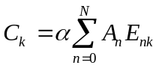 （1）
In above equation, C_{k} is concluded by the net area of full-energy peak of one nuclide, α is the branching ratio of gamma line, A_{n} is the activity of one nuclide with the position serial number of n, N is the total number of identical nuclides, E_{nk} is the detection efficiency of the n-th nuclide to the detector which is left in k-th segment.

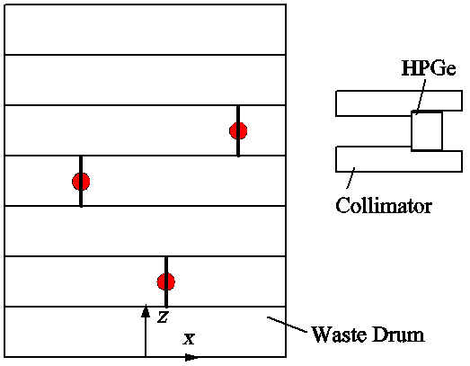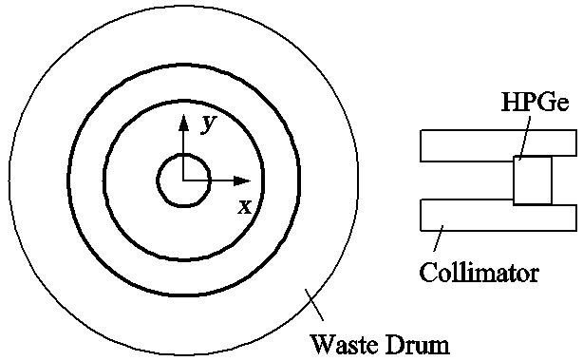
(a) Layout in x-z plane (b) Layout in x-y plane
Fig. 1. The schematic of gamma scanning method

In the efficiency calibration, the ring source with one segment is assumed to a cylinder source with the same radius. Figure 2 shows the detection efficiency curves of cylinder sources distributed versus the cylinder radius for Cs-137 when the density is 2.5 g/cc. In the figure, the label “Segment +0” denotes the segment with the similar height with the detector, and “Segment +1” denotes the segment above or below the detector by one segment height, and so on. It is found that the detection efficiency by two segments drop is too small to be ignored.

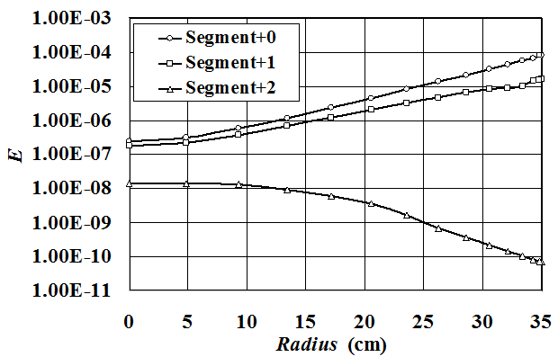
Fig2. The detection efficiency curves of Cs-137 cylinder source versus cylindrical radius when the waste density is 2.5g/cc

If three neighbouring segments are considered, equation (1) is changed as follows.
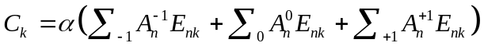 （2）
In the above equation, A_{n}⁻¹, A_{n}⁰, A_{n}⁺¹ are activities which are distributed in the three neighbouring segments. The detection efficiency (E_{nk}) depends on nuclide’s energy, waste’s density and relative position between radioactive sources to the detector. If the matrix in the waste drum is supposed to be uniformly distributed, the detection efficiency of one nuclide in a segment is identical. When all radioactive sources are projected into one segment, the total count rate (C) is the sum of all segmental count rates.
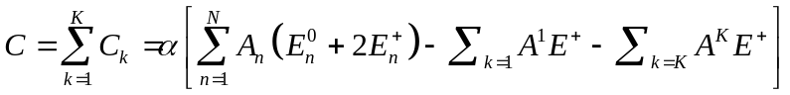 （3）
In above equation, E_{n}⁰, E_{n}⁺ are detection efficiencies of the n-th nuclide to the detector which is positioned in the “0” or “±1” segment. Because the detector starts the detection from the 1st segment and ends it at the K-th segment, the detector losses two assay positions which are below the 1st segment and above the K-th segment. K is the total number of segments. This is called "end loss", so equation (3) excludes the two lost parts. To resolve this problem, one method is to complete the two detections, the other method is to estimate the activities in the 1st or K-th segment according to the mean activity in the whole waste drum. In normal circumstances when multiple sources exist, the second method will not cause large error because the detection efficiency of E⁺ is smaller than E⁰. Consequently, equation (3) is changed as follows.
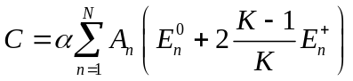 （4）
The synthetical detection efficiency (E’) is defined as
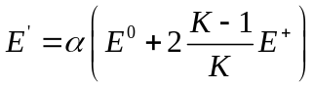
which can be calculated directly by calibrations. Then the total count (C) is simplified as follows.
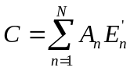 （5）
The synthetical detection efficiency (E’) depends on the radius of cylinder source, and figure 2 can conclude that it will monotonically increases versus the radius, so all sources in one segment can be approximated into one ring source with a particular radius of r which is called “equivalent radius”. Then the total count rate is given by
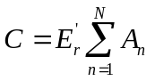 (6)
here E’_{r} is the synthetical detection efficiency of the equivalent cylinder source with radius of r. So far, the total activities (A) can be concluded accurately if the equivalent radius is determined.
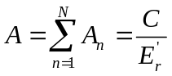 (7)
Using two detectors simultaneously to scan the waste drum or one detector in two positions is the method to identify the equivalent radius. The schematic of detector layout is shown in figure 3, where the offset of position B to position A is △y. Count rates in position A and B are respectively given by
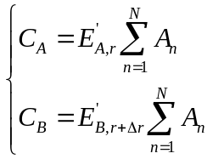 (8)
here E’_{A} and E’_{B} are the synthetical detection efficiencies of cylinder source to the detector which is located at position A and B. Figure 4 (a) exhibits the curves of E’_{A} and E’_{B} versus source radius where the nuclide is Cs-137, wastes density is 2.5 g/cc and △y is 24.5 cm. For multiple sources existing in the waste drum, the equivalent radiuses will be different for position A and B, △r is the equivalent radius bias between the two positions. Of course, if there is only one cylinder source in the segment, the radius bias will be zero (△r=0). Otherwise, △r will be larger than zero because the growth rate of E’_{B} is larger than that of E’_{A} which can be found in figure 4(a).

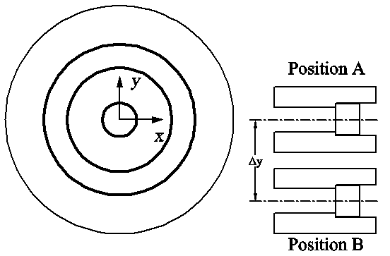
Fig. 3 The schematic of two detectors layout

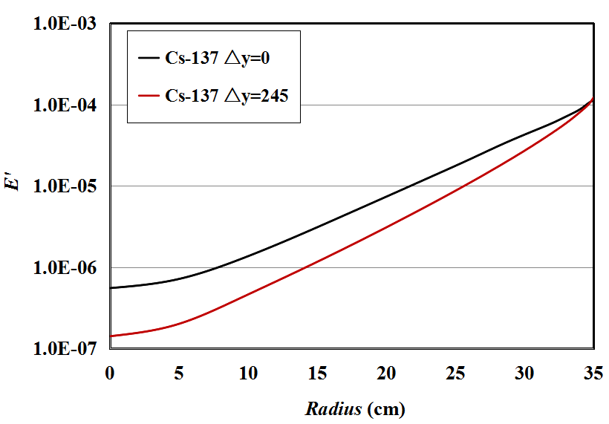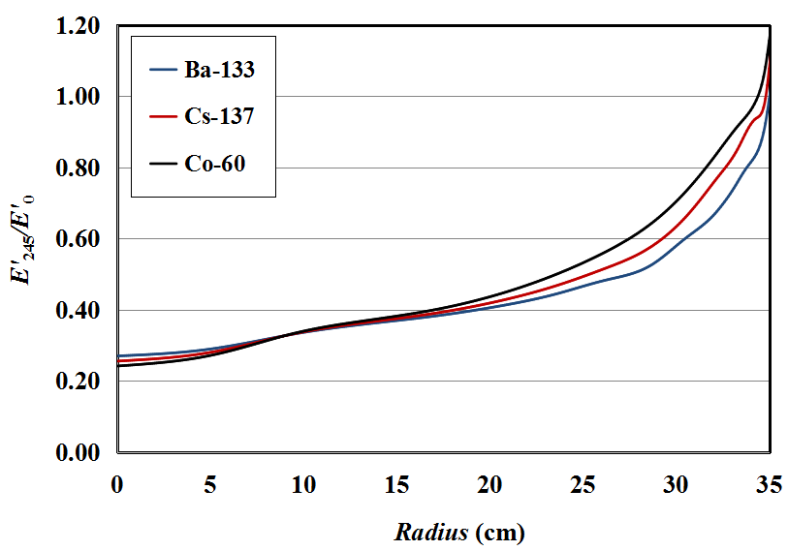
Fig. 4 The synthetical detection efficiencies

Basing on the statistic analysis of 200 groups of randomly distributed sources, the mean value of △r is shown in table 1. It is found that △r is in the range between 0.5 to 2 cm and depends on nuclide's type, sources number and waste’s density. However, when sources number is 21, △r will not grow in a large degree. The mean value is used in this paper.

Tab.1 The equivalent radius bias (△r, cm) between position A and B for different nuclides and sources number where the wastes density is 1.5 and 2.5 g/cc
Density |  | 1.5 g/cc |  |  | 2.5 g/cc
Nuclide |  | Ba-133 | Cs-137 | Co-60 | Ba-133 | Cs-137 | Co-60
Sources number | 2 | 0.5 | 0.7 | 0.9 | 0.3 | 0.4 | 0.6
Sources number | 7 | 1.3 | 1.6 | 2.0 | 0.7 | 1.1 | 1.4
Sources number | 14 | 1.4 | 1.7 | 2.1 | 0.9 | 1.2 | 1.5
Sources number | 21 | 1.4 | 1.7 | 2.2 | 0.9 | 1.2 | 1.5

If the two count rates in equation (8) are compared, the relative counting rate (C_{B/A}) is only related with the ratio of two synthetical detection efficiencies.
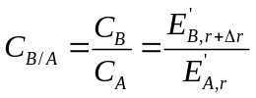 (9)
A function (F) is defined as follows.
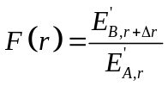 (10)
The distribution of F versus source radius where △r=0 is shown in figure 4 (b) which contains three nuclides, Ba-133, Cs-137 and Co-60 whose energies are 0.356, 0.662 and 1.333MeV respectively. The figure shows that the function of F monotonically increases with source radius, so the equivalent radius (r) can be concluded basing on the relative counting rate (C_{B/A}) according to equation (9). So far, the accurate detection efficiency can be calibrated if the equivalent radius is known, and the total activity will be calculated by equation (7).

3. Results and discussion
The standard 400 liter radioactive wastes drum is detected by numerical methods which applies GEANT4. The diameter and height of the waste drum are 70 and 105 cm. One Canberra’s pin coaxial high-purity Germanium (HPGe) detector with the efficiency of 40% is adopted to scan the gamma emissions. The diameter and length of the crystal is 6.2 and 5.95 cm. The crystal is housed in a lead collimator whose thickness is 8 cm. The rectangular collimation mouth has a width of 22 cm, height of 12 cm and depth of 15 cm, which is placed with a distance of 10 cm to the drum surface. Three common nuclides, Ba-133 (0.356 MeV), Cs-137 (0.662 MeV) and Co-60 (1.333 MeV) are selected to compare the accuracy of radioactivity reconstruction. The waste drum is assumed to be contained by highly compressed materials except metal wastes whose mass attenuation coefficients are set to 0.11, 0.075 and 0.054 cm²/g for the gamma rays emitted by above three nuclides. Two densities of 1.5 and 2.5 g/cc are considered. The waste drum is divided into 7 segments, and the segmental height is 15cm.
In order to verify the effectiveness of the new improved method identifying equivalent radius, only a line source with length of 105 cm is set in the waste drum. The reconstructed results are shown in figure 5, where A_{rc} is the reconstructed radioactivity of one nuclide, A_{real} is the preset activity in simulation, R_{source} is the radial coordinate of the line source. If the ratio between A_{rc} and A_{real} is equal to 1, it is indicated that the reconstructed activity well agrees with the real activity. It is found that when traditional SGS is applied, the ratio markedly deviates from 1 especially when the source is located near the drum axis or near the wall. With the density increases from 1.5 to 2.5 g/cc, the extreme value of A_{rc}/A_{real} will increase to 0.1 (e.g. Co-60), which means the reconstructed activity is only 10% of the real activity. The error is even larger for the other two nuclides whose characteristic apex energy is comparatively smaller than that of Co-60. At the same time, the ratio by the improved method (IM for short) very approaches to 1 wherever the source is located. The extreme value of A_{rc}/A_{real} by IM is 1.65, 1.21 and 1.08 for Ba-133, Cs-137 and Co-60 respectively when the density is 2.5 g/cc. Figure 6 displays the source radius identified by the improved method which is proved to very agree with the value of R_{source}. The positions having comparatively large difference is the center area in the waste drum, for example where the radius is less than 10 cm as shown in figure 6 (b), which is probably caused by that the ratio of detection efficiencies as shown in figure 4 (b) is distributed comparatively flat leading to the increasing error when the equivalent radius is identified.

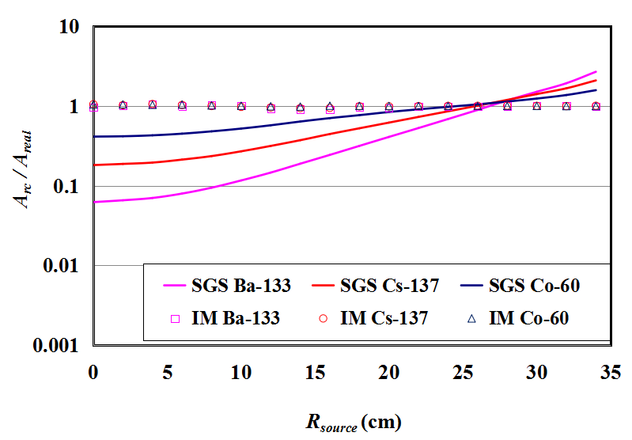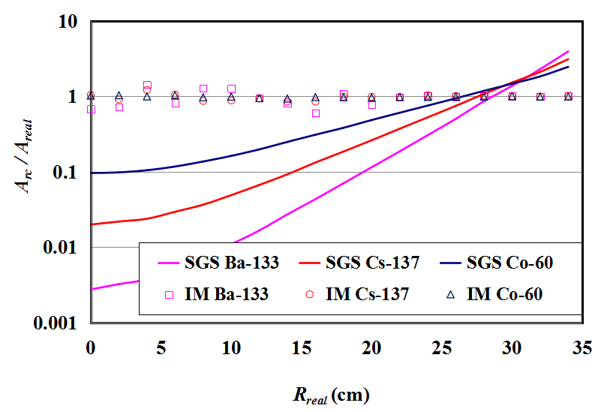
(a) Density=1.5 g/cc (b) Density=2.5 g/cc
Fig. 5
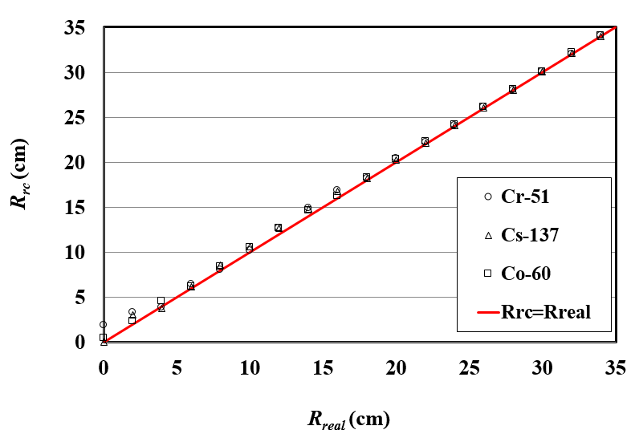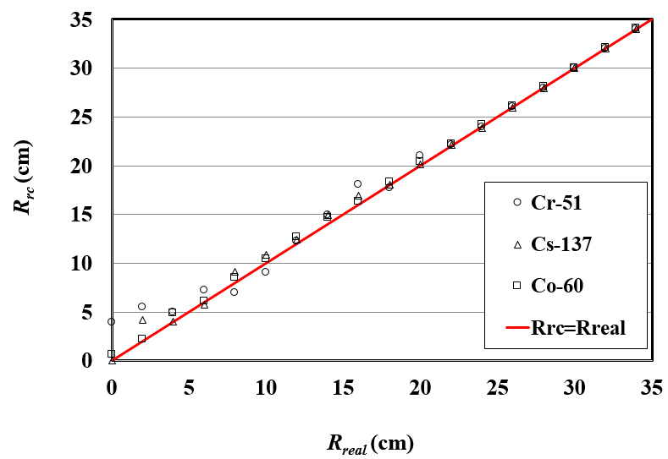
Fig. 6

In the real waste drum, multiple radioactive sources will exist and be complicatedly distributed. Accordingly, 7 and 14 identical nuclides with random activity are simultaneously set in one drum with uniform random positions. Totally 100 waste drums are statistically analysed.
The geometric mean of A_{rc}/A_{real} is used to compare the detection accuracy. In order to avoid the neutralization of values which are lower than 1 and higher than 1, the ratio between the reconstructed activity and real activity (Δ) is defined as follows.
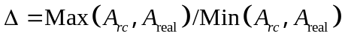
Here, Max and Min denote the large and small value by comparing the two data within brackets.
The geometric mean is calculated by
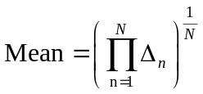
where N is the total number of samples.
Table 2 and 3 exhibit the statistical results of maximal and geometric mean of Δ for the waste drums whose density includes 1.5 and 2.5 g/cc containing 7 and 14 nuclides respectively. In the table, SGS represents the results obtained by traditional segmented gamma scanning method, and IM represents that obtained by the improved method.
The tables show that the detection accuracy will be improved when the nuclide becomes from the low energy to high energy, which indicates that the enhancement of gamma penetrating will reduce the quick decline of detection efficiency distribution and accordingly the fluctuations of reconstructed activities depending on source positions. Especially when the density is 2.5 g/cc as shown in table 2, the maximal Δ of Ba-133, Cs-137 and Co-60 is 8.06, 4.13 and 2.56 respectively, which means that the reconstructed activity will probably be about 8, 4 and 2.6 times lager or smaller than the real activity. At the same time, the improved method distinctly reduces the detection error by comparing both the maximal and mean Δ. When the density is 1.5 g/cc in table 2, the mean Δ of Co-60, for example, is 1.14 for SGS and 1.05 for IM, which indicates the relative error of reconstructed activities is reduced between 14% to 5% of the real activities. Similarly, they are reduced nearly in half for Ba-133 and Cs-137. When the density increases to 2.5 g/cc, the increasing attenuation to gamma rays leads to the relative errors for both SGS and IM becoming nearly double. However, the comparatively small relative error appears in the improved methods, 43% for Ba-133, 29% for Cs-137 and 15% for Co-60 which are between two thirds and a half of SGS.

Tab.2 The maximal and mean reconstructed errors for 7 radioactive sources in the waste drum
Nuclide | Δ | Desnsity=1.5g/cc |  | Desnsity=2.5g/cc
Nuclide | Δ | SGS | IM | SGS | IM
Ba-133 | Max. | 2.96 | 2.01 | 8.06 | 3.11
Ba-133 | Mean | 1.34 | 1.19 | 1.66 | 1.43
Cs-137 | Max. | 2.03 | 1.58 | 4.13 | 2.53
Cs-137 | Mean | 1.23 | 1.10 | 1.46 | 1.29
Co-60 | Max. | 1.51 | 1.40 | 2.56 | 1.91
Co-60 | Mean | 1.14 | 1.05 | 1.30 | 1.15

When the sources number increases, the improved uniformity of the sources distribution will result in the detection error being further reduced especially for SGS as shown in table 3. The mean relative error of SGS is almost less than 20% when density is 1.5 g/cc, and is less than 40% when density is 2.5 g/cc for all nuclides. Meanwhile, the mean relative error of IM is reduced about by 5% and 7% when density is 1.5 and 2.5 g/cc respectively. It can be foreseen that when more sources exist in the waste drum, the assumption of radioactive source uniformly distributed will be more approximate, the detection error of SGS will accordingly be extremely reduced. Even so, the equivalent radius in the improved method also can be concluded according to the average of the whole detection efficiency curves, so the radioactivity will also be reconstructed accurately.

Tab.3 The maximal and mean reconstructed errors for 14 radioactive sources in the waste drum
Nuclide | Δ | Desnsity=1.5g/cc |  | Desnsity=2.5g/cc
Nuclide | Δ | SGS | IM | SGS | IM
Ba-133 | Max. | 2.05 | 1.67 | 3.29 | 2.64
Ba-133 | Mean | 1.21 | 1.16 | 1.39 | 1.32
Cs-137 | Max. | 1.64 | 1.30 | 2.48 | 1.87
Cs-137 | Mean | 1.14 | 1.08 | 1.28 | 1.21
Co-60 | Max. | 1.32 | 1.15 | 1.89 | 1.45
Co-60 | Mean | 1.08 | 1.04 | 1.19 | 1.12

4. Conclusions
One improved gamma scanning assay and its algorithm are proposed aiming at 400 liter drum with low and intermediate level radioactive waste which are highly compressed. In the improved method, the nuclides in the waste drum are supposed to be projected into one segment and approximated to a ring source. The equivalent radius of the ring source is estimated by applying two detectors, so that the detection accuracy is markedly improved by accurate calibration basing on the equivalent radius.
Three common nuclides (Ba-133, Cs-137, Co-60) and two waste densities (1.5, 2.5 g/cc) are selected for contrastive analysis. The reconstructed results show that the improved method distinctly exhibits the very good performance in detecting the large and highly compressed radioactive wastes drum. The performance depends on the waste's density, nuclide's type and sources' number, but on the whole the maximal error of the improved method decreases several times for comparison with SGS, and the mean error is reduced nearly in half for all nuclides.
With the increase of sources number, the detection accuracy of SGS is gradually improved and increasingly close to that of the improved method. However, due to the difficulty in judging the sources distribution in practical waste drums, the proposed method is efficient and promising especially for the compressed waste drums whose radioactive sources will be finite and more probably nonuniform.

References
[1] Martin E.R., Jones D.F., and Parker J.L., Gamma-ray measurements with the segmented gamma scanner. Technical Report LA-7059-M, Los Alamos Scientiﬁc Laboratory, 1977
[2] Bronson F., Atrashkevich V., Geurkov G., Young B., Probabilistic uncertainty estimator for gamma-spectroscopy measurements. J. Radioanal. Nucl. Chem. 2008, 276(3), 589–594.
[3] Estep R.J., Prettyman T.H., Sheppard G.A., Tomographic gamma scanning to assay heterogeneous radioactive waste, Nuclear science and engineering, 1994, 118: 145-152.
[4] Ramkumar Venkataraman, Marcel Villani, et al., An integrated Tomographic Gamma Scanning system for non-destructive assay of radioactive waste, Nuclear Instruments and Methods in Physics Research A, 2007, 579: 375-379
[5] LIU Cheng, GU Weiguo, QIAN Nan, WANG Dezhong. Study of Image Reconstruction Using Dynamic Grids in Tomographic Gamma Scanning[J]. Nuclear Science and Techniques, 2012, 23(5): 277-283
[6] Weiguo GU，Cheng LIU，Nan QIAN，Dezhong WANG. Study on detection simplification of tomographic gamma scanning using dynamic grids applied in the emission reconstruction, Annual of Nuclear Energy, 58 (2013) 113–123
[7]
[8] Stanga D., Gurau D., A new approach in gamma-ray scanning of rotating drums containing radioactive waste, Applied Radiation and Nuclides, 2012, 70: 2149-C2153.
[9] LIU Cheng, WANG Dezhong, BAI Yunfei, QIAN Nan. An improved segmented gamma scanning for radioactive waste drums[J]. Nuclear Science and Techniques, 2010, 21(4): 204-208
[10] TranThienThanh, HoangThiKieuTrang, et al., A prototype of radioactive waste drum monitor by non-destructive assays using gamma spectrometry, Applied Radiation and Nuclides, 2016, 109 :544-546

