F

F1

Game Design Document

Table of Contents

Game description 1

Game mechanics 1

Player Experience 1

Core Game Mechanics 1

Game Flow and Screens 2

Screen Mock-ups 2

# Game description

F1 Is an educational 3D “endless runner” platformer game where the player must travel the most distance possible while evading obstacles.

# Game mechanics

# Player Experience

Like Temple Run but simple.

# Core Game Mechanics

* The player has one attempt to finish the track
* The player slides through the level until they reach the end.
* If the player falls or crashes with an obstacle, a random question will be asked
* If the player’s answer is right, he will continue playing
* If the player’s answer is wrong, its game over

# Game Flow and Screens

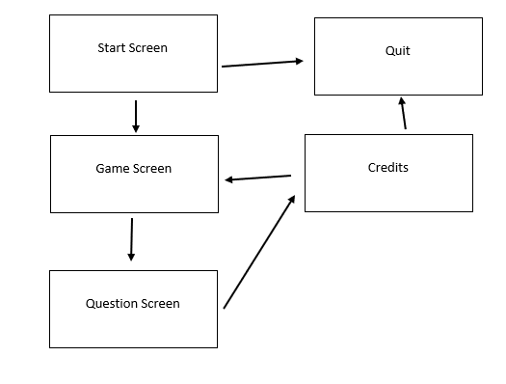

# Screen Mock-ups





