F1

Software Engineering Document

Table of Contents

Game Mechanics 1

Game Scenes 1

Game Flow 1

Classes and Scripts 2

# Game Mechanics

## Game Scenes

The game will have four basic scenes:

* The “Menu” scene which server as the welcoming scene for the player, in here the player is welcomed with a simplistic splash screen with the game title and a button to start playing.
* A game scene “Level01” where the player will adapt to the role of a red cube, and begin moving forward constantly on an infinite track where gray rectangular prism will spawn throughout the track and act as obstacles that the player has to avoid, as well as avoiding falling to the sides of the track.
* A “Questions” scene, where the player will get to whenever they fall from the track or collide with one of the obstacles in the Level01 scene, the player will be asked a truth or false question that in turn decides if the player can continue playing or not.
* A “Credits” scene, where the player will get to if they get wrong an answer in the Questions scene. The leaderboards and final score of the player will be presented, as well as an input field and a button to submit the obtained score to the leaderboards. The leaderboard shows the first five players with the highest scores. This scene also presents the player two more buttons which in turn will let the player quit the game or to retry altogether from the beginning.

## Game Flow

* “Menu” scene will lead to the Level01 scene, the scene where the actual gameplay experience for the player occurs.
* The “Level01” scene will lead to the “Questions” scene when the player collides with an obstacle on the track, or when the player falls from the sides of the track.
* The “Questions” scenes will lead to:
  + The “Level01” scene when and if the player responds correctly to the trivia question shown in the present scene.
  + The “Credits” scene when and if the player responds incorrectly to the trivia question shown in the present scene.
* The “Credits” scene will allow the player to quit the game altogether or to retry which in turn will lead them back to the Menu scene.

# Classes and Scripts

We handle a set of scripts throughout the game:

* A Cam, that allows the camera to move alongside the player trough the scene.
* Credits, allows us to quit the application.
* Highscores, it contains methods to add, download and give format to the highscores.
  + Also included is a Highscore struct which lets us give an object structure to the username and the score.
* DisplayHighscores, allows the presentation of the highscores in the UI of the game.
* LevelComplete, let us change the level by the index of the scenes.
* LevelManager, lets us move from one scene to another.
* LoadLevel, allows us to change to alevel when a collision is detected.
* MusicPlayer, allows us play different music throughout the scenes.
* PlayerCollision, allows us to detect when the player collisions with obstacles.
* PlayerMovement, allows us to define the behaviours of the player by its inputs or conditions.
* ScoreDisplay, allows us to represent in the UI the total final score the player achieved.
* ScoreKeeper, keeps track of the overall score the player obtains.
* SpawnObjects, obstacles will appear throughout the track with the help of this script.
* Trivia, allows us to add the trivia like behavior to our game, reads the text file where the questions are stored, sets the questions to be presented, and checks if the user answered correctly.

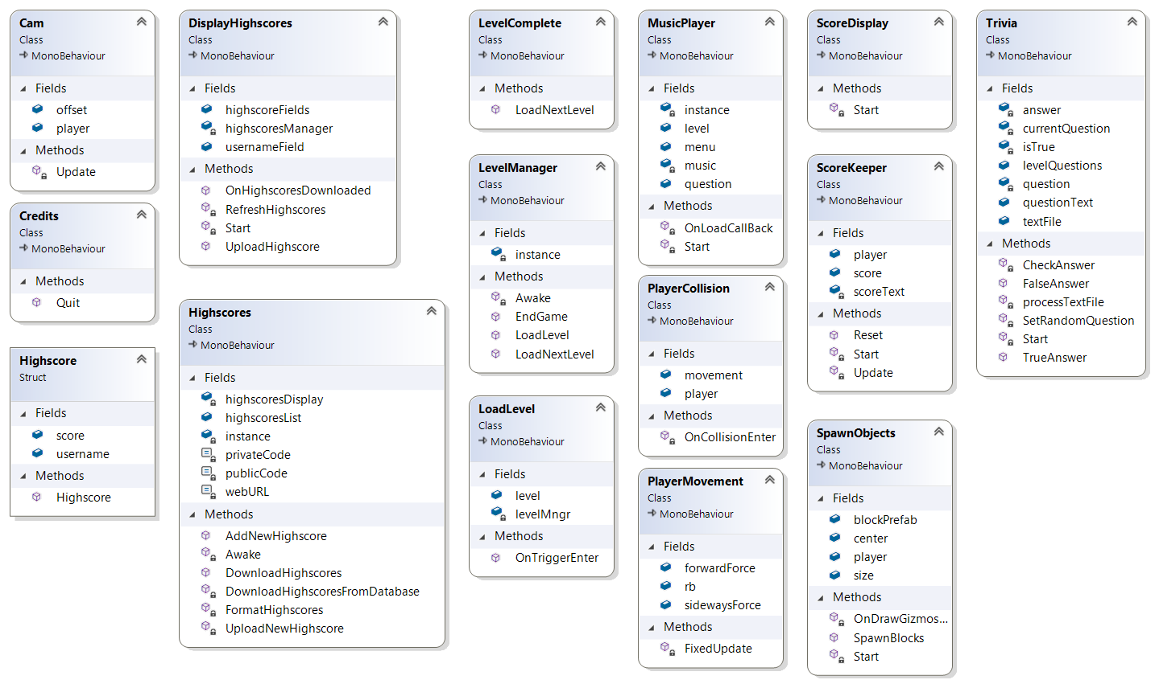

Cam

Attributes:

Methods:

Credits

Attributes:

Methods:

Highscores

Attributes:

Methods:

DisplayHighscores

Attributes:

Methods:

LevelComplete

Attributes:

Methods:

LevelManager

Attributes:

Methods:

LoadLevel

Attributes:

Methods:

MusicPlayer

Attributes:

Methods:

PlayerCollision

Attributes:

Methods:

PlayerMovement

Attributes:

Methods:

ScoreDisplay

Attributes:

Methods:

ScoreKeeper

Attributes:

Methods:

SpawnObjects

Attributes:

Methods:

Trivia

Attributes:

Methods: