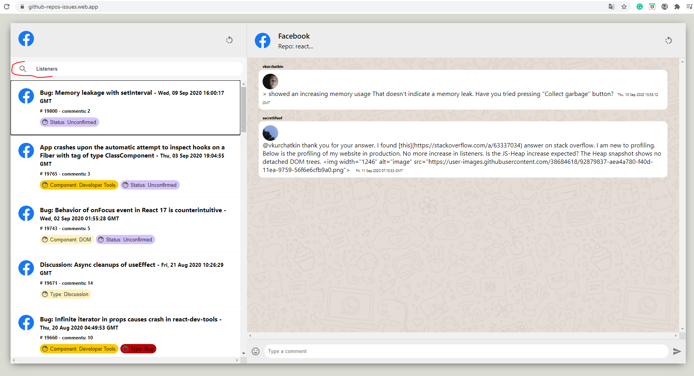

By means of the search bar, you can visualize different issues about repot react. on the right side, the comments made by users on a particular issue are displayed.

Field: search any text, number etc.

Commands: KEY_UP,

  KEY_DOWN,

  KEY_RETURN,

  KEY_ENTER,

  KEY_ESCAPE,

  KEY_TAB

Mouseover & clicked for visualize the comments associate to issue

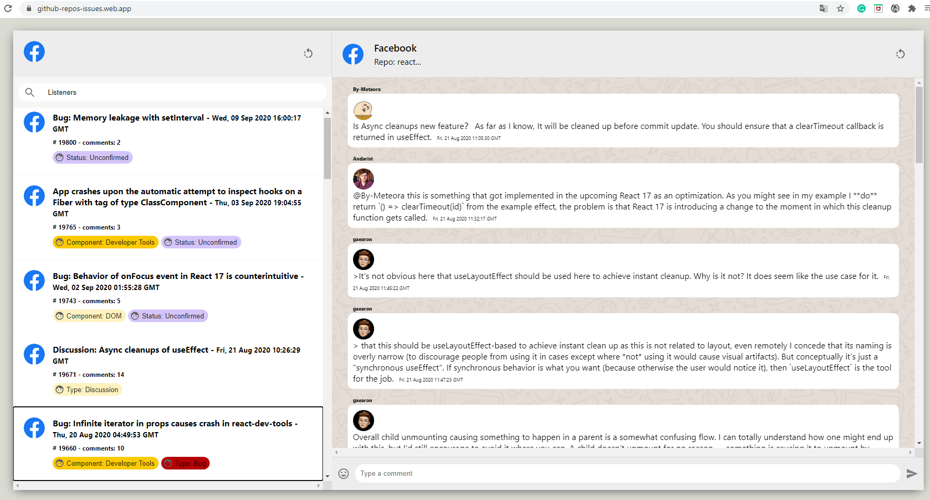

Navigating with the following keys you can scroll through the list of occurrences, changing with the tab key, navigating within the different issues, and with the enter key in each issue the comments associated with it are displayed on the right side.