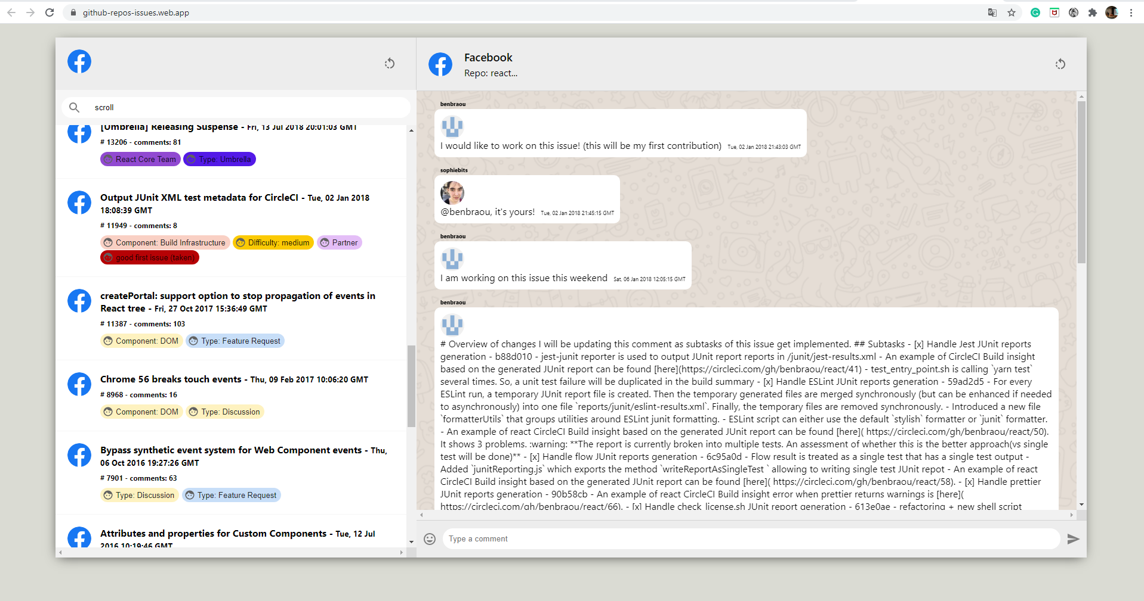

Field: search any text, number etc.

Commands: KEY_UP,

  KEY_DOWN,

  KEY_RETURN,

  KEY_ENTER,

  KEY_ESCAPE,

  KEY_TAB

Mouseover & clicked for visualize the comments associate to issue