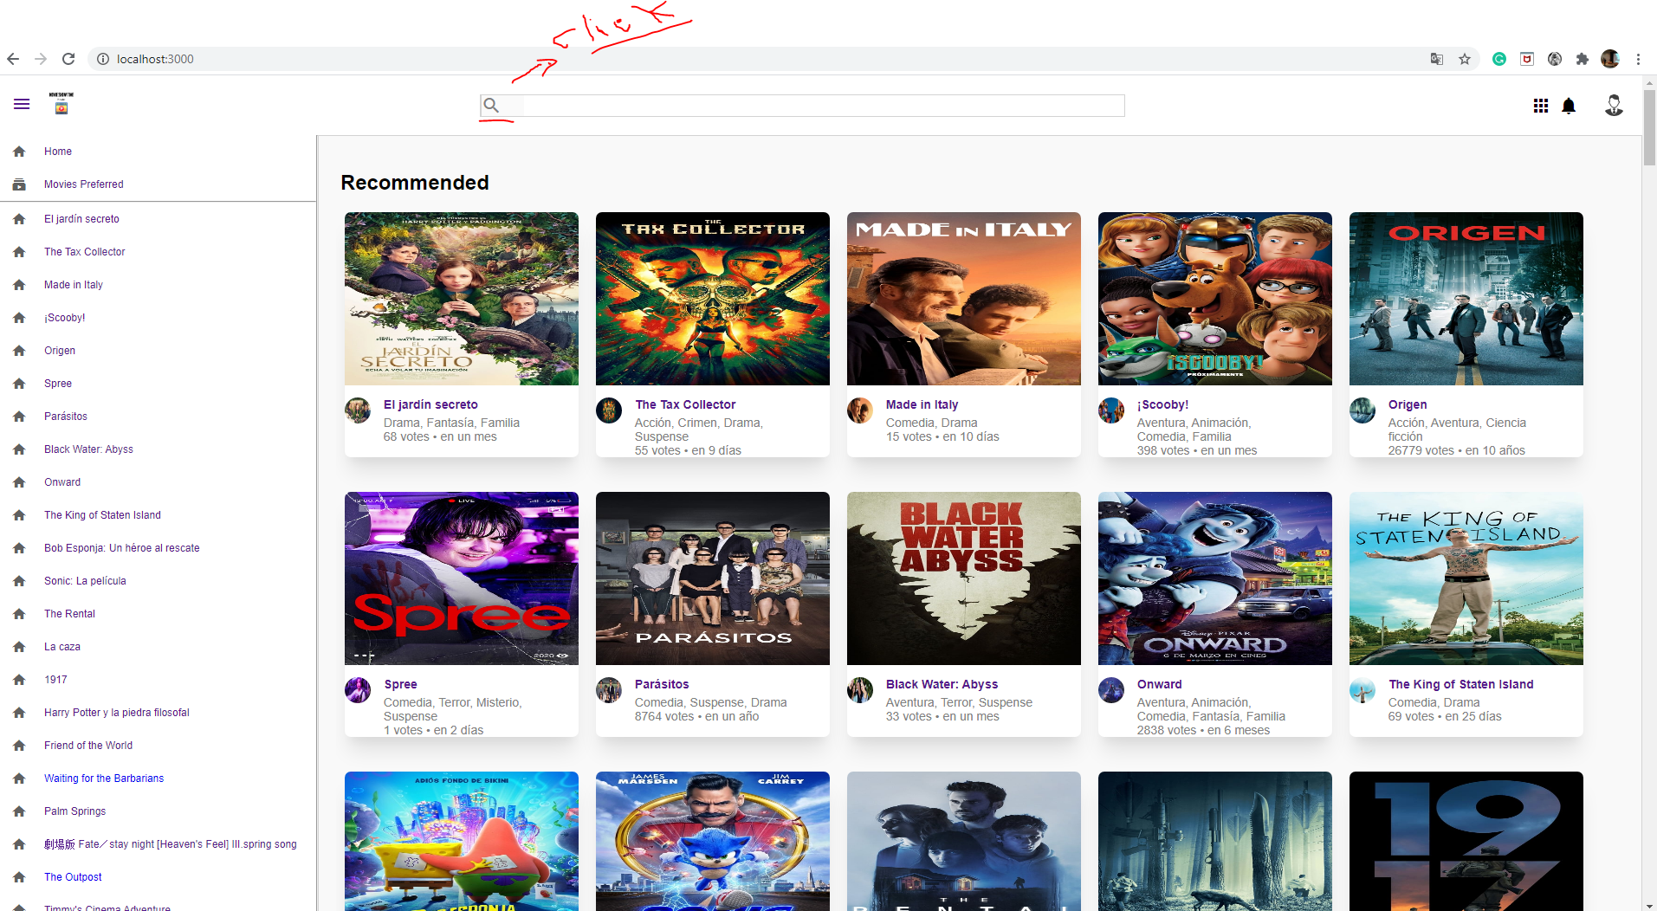

Clicked in the bottom active input and next the user put different letters, words for the search.

Sidebar left put the different results according to the search or new movies,

Click in the card movie enter in the movie detail

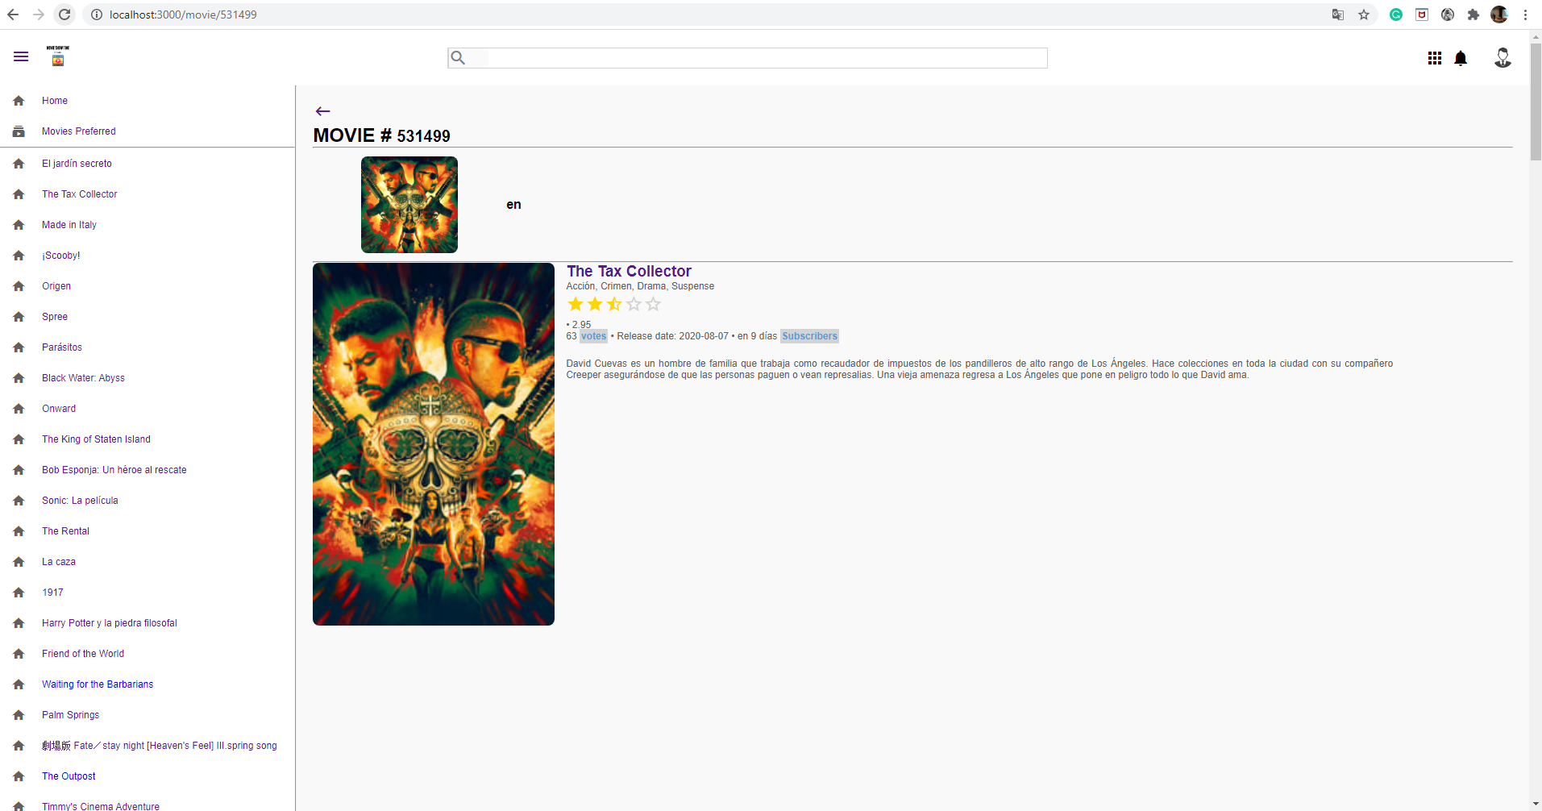

Roll over in the card appear the information related to stars

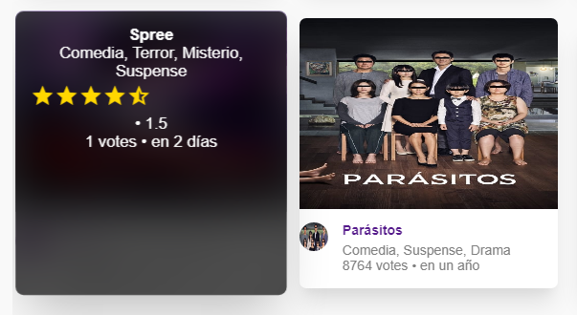

App create with react js using hooks

Responsive degin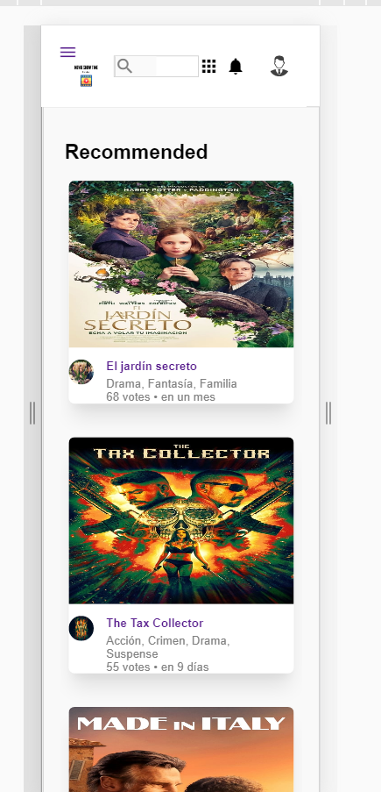

Saving searchs into firebase database, for historical