
Certification Services Division
Newton Building, St. George’s Avenue
Northampton, NN2 6JB
United Kingdom
Tel : +44(0)1604-893-811.
Fax : +44(0)1604-893-868.
E-mail: pcn@bindt.org

The European Pressure Equipment Directive (PED)
Electronic application for approval by BINDT of NDT personnel certificated under AS 3998 / EN ISO 9712 : 2012 criteria by the Australian Institute for NDT

Introduction
For pressure equipment, non-destructive tests of permanent joints must be carried out by suitably qualified personnel. For pressure equipment in categories III and IV, NDT and welding personnel must be approved by a ‘Third Party Organisation’ recognised by a member state pursuant to Article 24.
This document describes arrangements under which BINDT, a Recognised Third Party Organisation, will issue a certificate of approval in compliance with The Directive to NDT personnel certified competent under AS 3998 / EN ISO 9712:2012 criteria in specific NDT methods, as applied in relevant industry or product sectors, by the Australian Institute for NDT (hereinafter referred to as AINDT).
Eligibility
To be eligible for approval by BINDT, the applicant will hold current valid MT/PT/RT/UT Level 2 or Level 3 AS 3998 / EN ISO 9712:2012 certificate(s) of competence issued by AINDT which cover the testing of permanent joints (welds) in pressure equipment.
Applications (only electronic applications are accepted)
Application forms may be downloaded from www.bindt.org or from http://www.aindt.com.au/certification/certification-forms-guide.html. Completed applications, which include separate credit card authorisations for the debit of an application fee (payable to AINDT) and approval fees (payable to BINDT) for each NDT method for which approval is sought, are to be submitted by email to ndtcertification@aindt.com.au
Issue of approval(s)
Upon receipt of evidence, provided by AINDT of success in a qualification examination satisfying AS 3998 / EN ISO 9712:2012 criteria covering the testing of permanent joints (welds) in pressure equipment, BINDT will issue approval(s) by Email to the applicant.
Validity of approval(s)
Approvals, which will not state a level since the related certificate of competence defines this, will expire five years from date of issue.
Renewal of approval(s)
Approval(s) will be renewed by BINDT for a further term upon receipt of evidence from AINDT of renewal or recertification of the certificate(s) related to the approval(s). Application and approval fees at the prevailing rate will be payable before the issue of the renewed approval(s).
Further Information
Further information may be obtained from www.bindt.org or www.aindt.com.au, or by Email: pcn@bindt.org

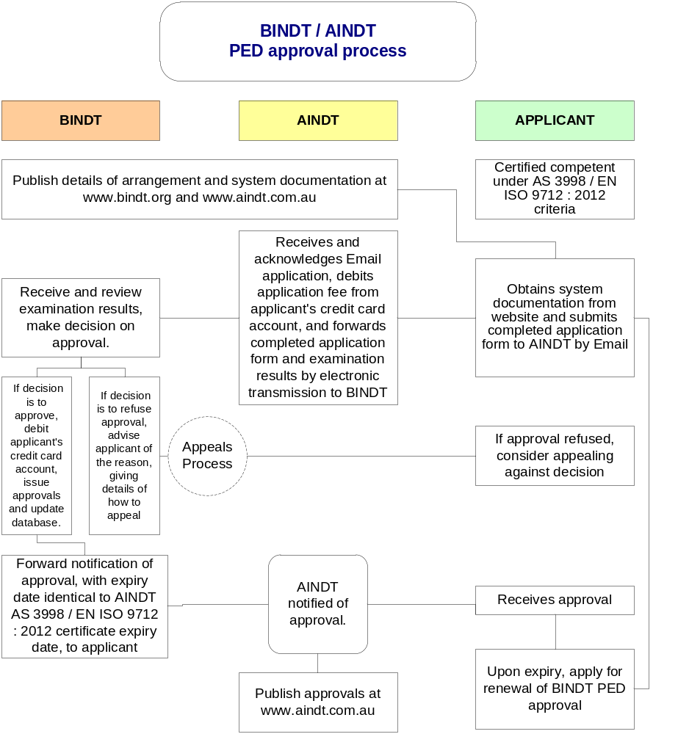
Certification Services Division
Newton Building, St. George’s Avenue
Northampton, NN2 6JB
United Kingdom
Tel : +44(0)1604-893-811.
Fax : +44(0)1604-893-868.
E-mail: pcn@bindt.org

ANNEX A – ELECTRONIC APPLICATION FOR BINDT Approval of NDT personnel under the PRESSURE EQUIPMENT directive
Part 1. Applicant’s personal Information
Family name
Given name(s)
Full postal address
Email:
Telephone

Part 2. Approval applied for (you must hold valid AINDT certification at level 2 or 3 covering the testing of welds). Please check applicable boxes
Magnetic particle testing of welds | Radiographic testing of welds
Liquid penetrant testing of welds | Ultrasonic testing of welds

Part 3. AINDT EN ISO 9712:2012 certification details
MT certificate number | RT certificate number
PT certificate number | UT certificate number
Remarks (any endorsements held)

Part 4. Applicant’s declaration
By checking the box below, I certify that I am regularly employed to non-destructively test welds using the above NDT method(s), and I agree to abide by the Code of Ethics in Annex B to this document.
By checking the box below, I authorise AINDT to provide BINDT with qualification and certification data related to this application for BINDT NDT approvals.
I understand that this data will be used only for the purpose of applying for NDT approval(s) under the European Pressure Equipment Directive (2014/68/EU).
Part 5. Credit card payment.
A non-refundable application fee is payable to AINDT, and an approval fee is payable to BINDT for each NDT method approval sought.

Name of applicant for BINDT PED approvals | Family name  Forenames
Address to which approvals will be sent (if different for applicant’s address given in Part 1).
Credit/Debit Card (provide details below)
Please tick the appropriate boxes:

For payment by credit card  (tick relevant box): |  | Visa |  |  | MasterCard |  |  | Amex |  |  | Switch
 |  |  |  |  |  |  |  |  |  |  | Issue No.
Corporate/  company card |  |  |  |  |  | Personal Card
Name as shown on the card:
Card Number
Signature of above named individual:
Security code:
(Last 3 digits on the security strip on reverse of the card)
Card valid from:
Card expiry:
Billing address:
(Address the invoice will be sent to, if Corporate card then address of company and name of whom the invoice should be sent to)
Please debit the above credit/debit card for the amount shown (right) in respect of a non-refundable application fee payable to AINDT |  |  |  |  |  |  | $100.00 (Australian)
Please debit the above credit/debit card for the total amount shown (right) in respect of approval fees payable to BINDT |  |  |  |  |  |  | £60.00 x #  see note 1
By checking the following box I hereby authorise AINDT and BINDT respectively to debit my credit card account for the amounts shown (above-right) |  |  |  |  |  |  |  |  |  |  |  | Date:

Notes
- £60.00 x #, where # is the number of PED approvals applied for, i.e., one approval per NDT method (this will not be debited from the credit card account in the event that BINDT PED approvals cannot, for whatever reason, be issued).
- Incorrectly completed applications will be returned. If in doubt about how to complete the application, please email ndtcertification@aindt.com.au or pcn@bindt.org for advice.
- Please remember, only electronic applications are accepted.
- Forward completed applications by email to ndtcertification@aindt.com.au

ANNEX B – cODE OF ETHICS
Individuals approved by BINDT to inspect permanent joints in pressure equipment must recognise that personal integrity and professional competence are the fundamental principles on which their testing activities are founded. Accordingly, it is a condition of approval that approved persons shall undertake to:
- comply with this code of ethics;
- undertake only those non-destructive testing assignments for which they are competent by virtue of their training, qualification and experience;
- only sign documents for work of which they have personal professional knowledge and/or direct supervisory control;
- engage, or advise the engagement of, such specialists as are required to enable assignments to be properly completed;
- conduct themselves in a responsible manner and utilize fair and equitable business practices in dealing with colleagues, clients and associates;
- at all times, be aware of and uphold the provisions/ requirements of codes, regulations and standards under which they are working;
- immediately report to their supervisor/employer any perceived violation(s) of codes, regulations or standards. In the event that their supervisor/employer provides no satisfactory explanation or takes no corrective action, the certified individual shall report the situation direct to The British Institute of NDT;
- perform their professional duties with proper regard for the physical environment and the safety, health and well-being of the public;
- protect to the fullest extent possible, consistent with the well being of the public and the provisions of this code of ethics, any information given to them in confidence by an employer, colleague or member of the public;
- avoid conflicts of interest with the employer or client, but when unavoidable, forthwith disclose the circumstances to the employer or client;
- strive to maintain their proficiency by updating their technical knowledge as required to properly practice NDT in the certified methods and levels.
- indicate to the employer or client any adverse consequences which may result from an overruling of their technical judgment by a non-technical authority;
- not falsify nor permit misrepresentation of their own or their associate’s academic or professional qualifications, training, experience or work responsibilities;
- refrain from making unjustified statements or from performing unethical acts which would discredit the British Institute of NDT;
- immediately report to the British Institute of NDT any perceived violation(s) of this code of ethics;
- immediately report to the British Institute of NDT any attempt to pressure or force an approved individual to violate this code of ethics.
Failure to comply with the above code of ethics will be dealt with under arrangements for handling complaints and appeals (PCN document CP21 refers).

ANNEX C – FOR AINDT USE ONLY
This form is for use by AINDT in providing assessment information related to an individual certified to the AS 3998/EN ISO 9712:2012 standard who is applying for BINDT PED Approvals under the Agreement between AINDT and BINDT.
AINDT will provide such information only with the consent of the applicant, and BINDT undertakes to hold confidential to AINDT and BINDT any information provided by the applicant or by AINDT.
When completed, please forward this electronic file by email to pcn@bindt.org

Family name of applicant
Given name(s) of applicant
NDT Method | MT | PT | RT |  | UT
Certificate number
Certificate expiry date
Industry or product sector
NDT Level
Date of initial certification
General written grade Level 2 | (%) | (%) | (%) |  | (%)
Specific written grade Level 2 | (%) | (%) | (%) |  | (%)
Specific practical grade Level 2 | (%) | (%) | (%) |  | (%)
Basic written grade Level 3 | (%) | (%) | (%) |  | (%)
Main method written grade Level 3 | (%) | (%) | (%) |  | (%)
Recent renewal date
Recent recertification date
Recertification grade (%) | (%) | (%) | (%) |  | (%)
Remarks (details of any suspensions, endorsements, statement of continuity at renewal, vision tests, etc.).
Name of authorised representative of AINDT verifying information provided |  |  |  | Date:

