Supporting information for
Substituting the End for the Whole:
Why Voters Respond Primarily to the Election-Year Economy

I. Voters’ Intended Behavior: Additional Studies 3
A. Histograms for Respondents' Intended Weights 3
B. Eliciting intended weights from the main experimental subjects 4
C. Eliminating the easy 4 × 25% answer 5
D. Question with predefined weights — internet sample 7
E. Question with predefined weights — student sample 9
F. Question without referring to weights 10
G. How far do you look back with George Bush? 12
II. Memory-based Explanations for End Bias 13
A. Replication of Table 3’s historical-data study with a separate sample of 64 participants. 13
B. Experiments changing the order of the bars and the orientation of the plots 14
C. Replication of Table 3: Additional hypothetical income growth studies 16
III. How Informative is the Election-Year Economy? 17
A. Additional information for simple survey question 17
B. Replication of Study C1 18
C. Predicting future growth when seeing the change for a single year 19
D. Importance of each year when predicting the future economy (YouGov/Polimetrics) 20
E. Hypothetically paying for growth information to predict the future 21
F. Example of growth plot without political context (Study C2) 22
G. Trends and Peaks 23
1. Do trends matter? Pooled analysis of randomly drawn experiments on yearly income growth 23
2. Do peaks matter? Pooled analysis of randomly drawn experiments on yearly growth 24
H. Is the election-year economy actually more informative about future growth? 25
I. Is election-year growth more informative about earlier growth? 27
IV. Aligning Voters’ Actions with Their Intentions 28
A. Testing whether voters act in accordance with their stated intentions 28
B. Addressing concerns about demand with the cumulative growth experiments 29
C. Addressing concerns about demand with cumulative experiments (minimal instructions) 30
D. Addressing concerns about demand with the level experiment 31
E. Level experiment using text instead of plots 33
F. Income-in-levels experiment where participants saw only one term (SSI sample) 34
G. Simple income-in-levels experiment 36
H. Average-in-plot experiment 38
G. Twenty-year study 40
V. Additional Analysis and Robustness Checks 41
A. Media coverage of the economy: Content analysis 41
B. Replication with Indian subjects 43
C. Accounting for potential repeat takers on Mechanical Turk 44
1. Excluding repeat IP addresses across studies 44
2. Excluding repeat IP addresses within study 45
VI. Experimental Instructions and Related Information 46
A. Recruitment language for Mechanical Turk studies 46
B. Description of task for Mechanical Turk studies 47
C. Mechanical Turk validation 51
1. Published validation studies 51
2. Citations for MTurk validation studies and selected MTurk publications 52
3. Mechanical Turk demographics 53
4. Attention to task and screener questions 53

I. Voters’ Intended Behavior: Additional Studies
In the paper, we report on a survey question that elicited participants’ intended weights for economic conditions during years 1 through 4 of presidential terms. In this section, we present additional analyses, as well as a series of additional studies we conducted that elicited intentions in other ways and in other samples. These findings further confirm that voters apparently do not intend to place so much weight on the election-year economy.

A. Histograms for Respondents' Intended Weights
The figure below graphically displays voters’ intended behavior on the survey question by presenting the distributions of respondents’ reported weights for each of the four years (for study A1). It shows that only a small percentage of the 1602 respondents reported intentions consistent with voters’ behavior. That is, very few reported intending to put 75% of the weight or more on the election-year economy.

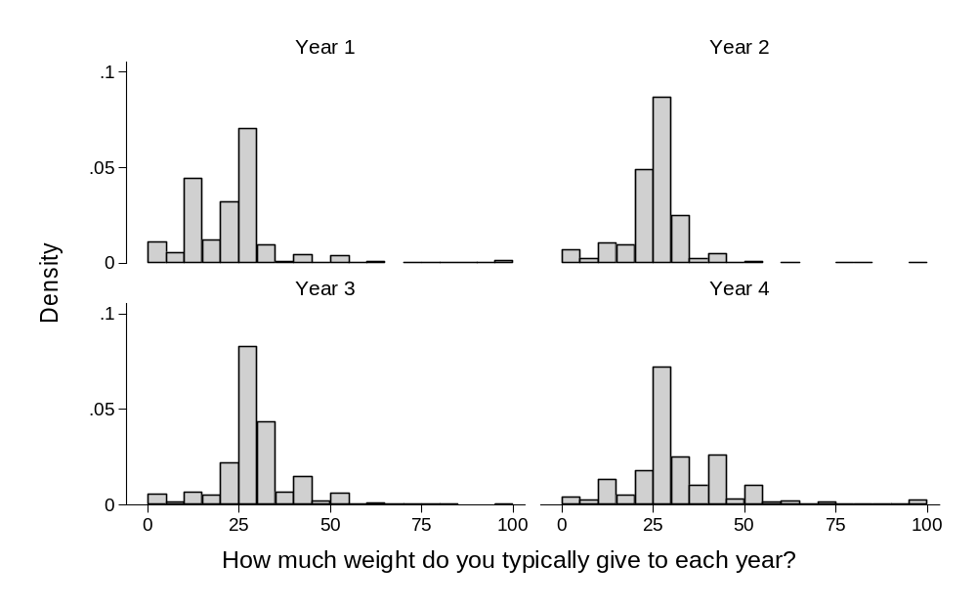
Note: This figure shows that almost no one reported weights consistent with voters' actual weights (0%, 0%, 25%, 75% for years 1-4, respectively). Means, medians, and question wording shown in Table 2 (Source: Study A1).

B. Eliciting intended weights from the main experimental subjects
As described in the paper in footnote 6, we asked the simple survey question about intended weights to the subjects in our experiments in addition to the large internet sample that we described in the paper (Study A1). We obtained very similar results across the different experimental studies, and very similar results to those shown for our SSI sample in Table 2. In the table below, we repeat the weights that we obtained for the SSI sample (Study A1) and compare them to the weights we obtained for one of our experimental samples.

Intended Weights for Large-Scale Internet Sample and Experimental Subjects
 |  | Large-scale internet sample | Experimental subjects
 |  | (1) | (2)
Year 1 Growth |  | 20.6% | 19.3%
 |  | (0.3%) | (0.9%)
Year 2 Growth |  | 22.9% | 23.9%
 |  | (0.2%) | (0.9%)
Year 3 Growth |  | 27.0% | 27.4%
 |  | (0.3%) | (0.7%)
Year 4 Growth |  | 29.6% | 29.3%
 |  | (0.4%) | (1.3%)
Number of participants |  | 1602 | 64
Study |  | A1 | Replication of historical income plots study (see below)
Notes: The question asked was: "When evaluating the economy during presidents' terms, how much weight did you typically give to each year? (Please enter a percent for each year, with the total equaling 100%.)" Respondents' answers were constrained to sum to 100%. Standard errors are in parentheses (unstandardized coefficients).

C. Eliminating the easy 4 × 25% answer
To further assess the possibility that respondents answered 25% for each year because it was easy, we asked a sample of students to state their intentions but required that their weights sum to 70% instead of 100%. Even though participants could no longer break down their answers easily into four equal numbers, their responses were similar to the nationally representative sample.
The sample consisted of 75 undergraduates from a west coast institution. To make sure participants understood the question, we first showed them anonymized plots of income growth from presidents’ terms. We asked two versions of the question about the weights they wanted to assign. In the first, 55 participants reported their weights for the four years vertically, one on top of the other, with year 4 at the bottom. In the second, 20 participants reported their weights horizontally. We included the latter treatment to avoid greater physical proximity between the Year 4 weight and the sum of the weights, in comparison to the other weights (see the questionnaire on the next page).
For the first condition, rescaling subjects’ 70-point responses to a 100-point scale, the average weights for years 1-4 were 20.4%, 19.0%, 26.2%, and 34.3%, respectively. In the second condition, the respective weights were 18.3%, 26.0%, 28.4%, and 27.4%.
The results are summarized in the table below. The survey questionnaire for the horizontal condition that subjects answered can be found on the following page.

Options | Reported weights vertically | Reported weights  horizontally
Year 1 | 20.4% | 18.3%
Year 2 | 19.0 | 26.0
Year 3 | 26.2 | 28.4
Year 4 | 34.3 | 27.4
Survey of 75 undergraduate students at a west coast university.

Questionnaire for the survey where weights added to 70 instead of 100:
We would like to ask you about how you evaluate the economy during presidents’ terms.
To make our question clear, consider the four plots below, which show the percent change in personal income during presidents’ terms. We picked these at random from the historical record. Each bar shows a year from a term.
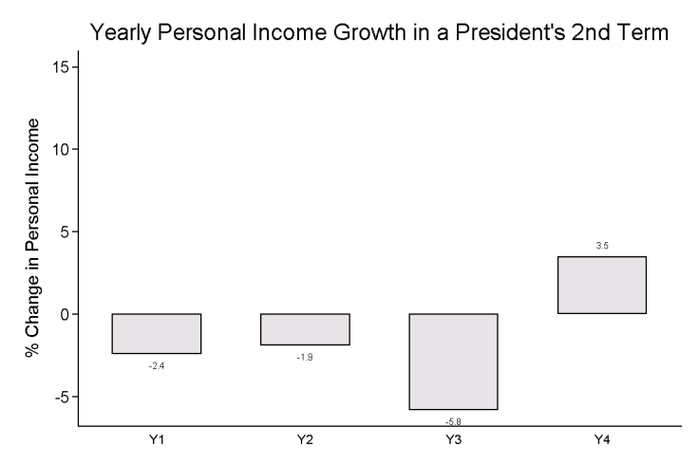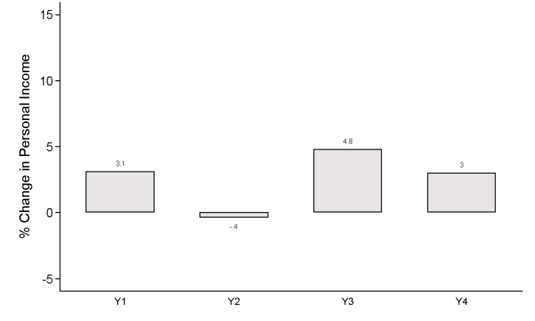
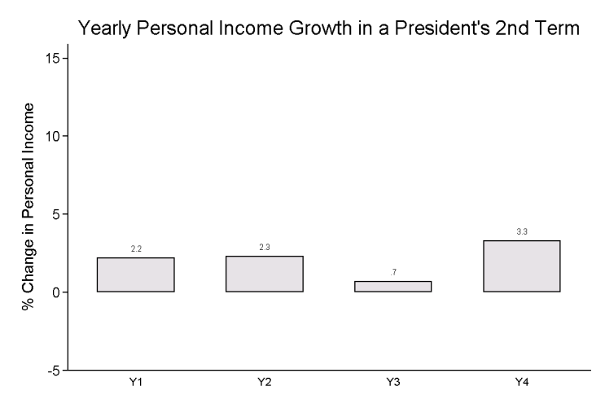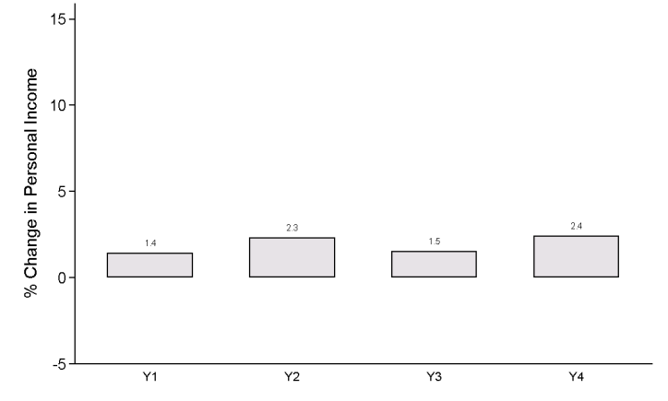

Our question is not about these terms in particular, but a more general question:
When evaluating the economy during presidents' terms, how much weight do you typically give to each year?
We would like you to allocate a total of 70 points across the four years, allocating whole numbers to each year. Please indicate your choices below:
Year 1 ______ Year 2 ______ Year 3 ______ Year 4 ______
Total (must add up to 70)

Thank you!

D. Question with predefined weights — internet sample
Another approach we took was to ask about predefined weights, with the goal of making all choices—with equal weights for all years and weights similar to actual voter behavior as two of those choices—equally available. We interviewed 484 participants on Mechanical Turk, gave participants examples of the economy under actual unnamed presidents, explained the idea of yearly weights, and tested their understanding. We then asked:
When evaluating how the President is handling the national economy, how much weight do you typically give to each year of the President's four-year term? Please choose the weights in % for years 1, 2, 3, and 4.
Participants were then asked to choose between the weight options in the table below.
One aspect of this condition to note is that we did not specify the president’s term, potentially pushing people more towards higher weights for later years in comparison to the condition where we specify that it is a president’s second term. Nevertheless, we find little evidence to suggest that people generally intend to put much more weight on the election year. As we report in the paper, only 17.8% choose to place a great deal of weight on the last year, that is, option e). More than twice as many respondents choose the option that puts just slightly more weight on Year 4 than the earlier years. That modal response also matches up with the results from the simple survey question reported in the paper and on the previous page.

Options  Years  1 2 3 4 | Choices
a) 75%, 25%, 0%, 0% | 2.1%
b) 30%, 27%, 23%, 20% | 11.8
c) 25%, 25%, 25 %, 25% | 24.2
d) 20%, 23%, 27%, 30% | 44.2
e) 0%, 0%, 25%, 75% | 17.8
Survey of 484 participants on Mechanical Turk
For 113 of the 484 participants in this survey, we added a follow-up question. This follow-up question was designed to see what weights these subjects would choose if not restricted to the five choices they were originally given.

We would like to ask you to answer the same question again, but this time you can set the weights yourself.
When evaluating how the President has handled the national economy, how much weight do you typically give to each year of the President's four-year term?
(Feel free to give the same answer you gave to the previous question.)
Please enter a percent for each year, with the total summing to 100%.

For all respondents pooled together, the results look very similar to the other ways we have asked this question (see the first column of the table below). Those who chose to place considerably more weight on year four, however, report considerably more moderate Year 4 weights on the follow-up question (see third column).

 | How much weight do you typically give to each year? (means)
 | All respondents | Respondents who previously chose  20%, 23%, 27%, 30% | Respondents who previously chose  0%, 0%, 25%, 75%
Year 1 | 17.1% | 16.5% | 5.7%
Year 2 | 21.5 | 22.2 | 14.3
Year 3 | 28.3 | 29.4 | 31.5
Year 4 | 33.0 | 31.8 | 48.5
N | 113 | 49 | 26
Survey of 484 participants on Mechanical Turk

E. Question with predefined weights — student sample
We replicated this predefined weight question with a small student sample. The results are similar.
When evaluating how the President is handling the national economy, how much weight do you typically give to each year of the President's four-year term? Please choose the weights in % for years 1, 2, 3, and 4.

Options  Years  1 2 3 4 | Choices
a) 75%, 25%, 0%, 0% | 6%
b) 30%, 27%, 23%, 20% | 35
c) 25%, 25%, 25 %, 25% | 12
d) 20%, 23%, 27%, 30% | 35
e) 0%, 0%, 25%, 75% | 12
Survey of 17 undergraduate students at a west coast university.

F. Question without referring to weights
To avoid asking about weights entirely, we asked the question below to 572 Mechanical Turk respondents, randomly assigning them to be asked about years 1-4 (Study A2 in the paper). The most important aspect of this study is the fact that individual subjects saw a change for only a single year. In other words, this condition mitigates the chance that any subject perceived demand to equalize the importance of the years since each subject considered only a single year. We describe the results of this study in the paper and provide complete results here.

Question wording (with random assignment to years 1, 2, 3, or 4):
Suppose that we took any one president’s second term (not necessarily one of those shown above) and asked you to evaluate the economy on a scale from 1 to 10. In general, by how much would your rating change if growth in Year [1,2 ,3, or 4] was 3 percentage points higher?
The results in the table below show that participants saw higher growth as roughly equally important across the years.

 | Year 1 | Year 2 | Year 3 | Year 4
Does not change | 18.67% | 4.44% | 10.88% | 7.86%
Goes up a small amount | 44.67 | 52.59 | 56.46 | 46.43
Goes up moderately | 32.00 | 31.85 | 28.57 | 37.14
Goes up substantially | 4.67 | 11.11 | 4.08 | 8.57
Total | 150 | 135 | 147 | 140
Survey of 572 participants on Mechanical Turk, January 2012.

To test how differently subjects responded to better growth in each of the four different conditions, we ran a simple regression where we define a respondent to be a 1 if they responded either “Goes up substantially” or “Goes up moderately” and a 0 otherwise. Below, we consider two regressions (estimated with a linear probability model) where this variable is the dependent variable. First, we regress this variable on the different years that subjects could have observed, using Year 1 as the omitted category. Second, we regress this variable on a Year 4 dummy, to compare how subjects respond in this condition compared to all the other years.
The results from the first regression show that people are about 9.0% more likely to respond to Year 4 than to Year 1 (p = 0.115). The results from the second regression estimate that people are about 8.4% more likely to respond to the changes in economic conditions in Year 4 in comparison to all other years. Similar to our results for the simple survey question, these results suggest that changes in Year 4 impact economic evaluations a little more than do changes in other years, but not substantially or significantly more.

Regression Results for Between-Subjects Experiment for Eliciting Intentions
Dependent variable: Did the change for Year X moderately or substantially
 | affect the subject's evaluation?
 |  | (1) | (2)
Condition
Year 2 |  | .063
 |  | (.058)
Year 3 |  | -.040
 |  | (.057)
Year 4 |  | .090 | .084
 |  | (.057) | (.047)
R-squared |  | .006 | .011
N |  | 572 | 572
Notes: Regression standard errors are in parentheses (unstandardized coefficients). In column 1, Year 1 is the omitted category. The constants are not shown.

G. How far do you look back with George Bush?
Finally, we asked a very different question to get at voters’ intentions when evaluating the economy, one explicitly about a president who had recently left office.
When considering your approval or disapproval of the way George W. Bush has handled the economy, how far do you look back?
Past year
Past two years
Past three years
Past four years
Past five years
Past six years
Past seven years
Past eight years
The sample was 200 Mechanical Turk respondents in October 2009.

The figure below shows the histogram of respondents’ answers.
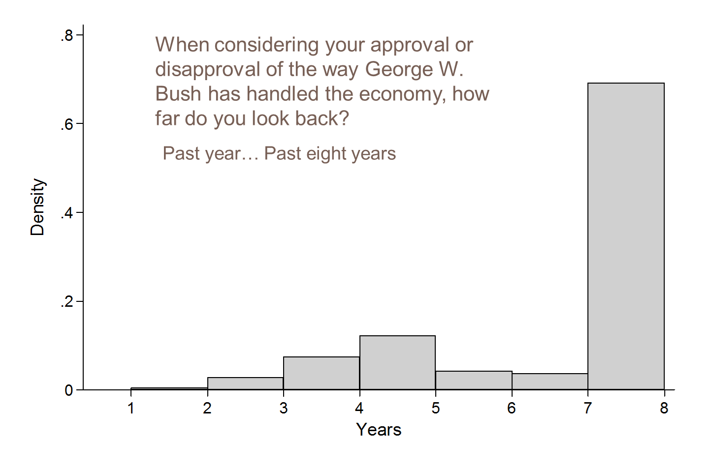

II. Memory-based Explanations for End Bias

A. Replication of Table 3’s historical-data study with a separate sample of 64 participants.

In addition to the sample reported in the paper, we replicated the study with historical income data with a separate sample collected at a different time. The results with this sample are similar to those from Study B1 in the paper.

Participants Respond to Historical Economic Growth in the Same Way Voters Did
 | DV: | Participants' Economic Evaluations | Rescale dependent variable to be in (0,1)
 | DV: | Participants' Economic Evaluations | Actual election results (1944-2008) | Participants' Economic Evaluations
 |  | (1) | (2) | (3)
Year 1 Growth |  | -0.065 | -0.0009 | -0.0098
 |  | (0.063) | (0.021) | (0.0095)
Year 2 Growth |  | 0.24 | -0.013 | 0.036
 |  | (0.063) | (0.021) | (0.0095)
Year 3 Growth |  | 0.47 | 0.044 | 0.071
 |  | (0.084) | (0.028) | (0.013)
Year 4 Growth |  | 0.77 | 0.13 | 0.12
 |  | (0.096) | (0.032) | (0.015)
R-squared |  | 0.92 | 0.64 | 0.92
Number of terms |  | 17 | 17 | 17
Number of participants |  | 64 |  | 64
Notes: Regression standard errors are in parentheses (unstandardized coefficients). The constants are not shown. MTurk sample.

B. Experiments changing the order of the bars and the orientation of the plots
One concern is that, despite having all the information in front of them, participants may focus on the final year due to simple laziness. People may rush through the plots and only remember what they saw last, which might be fourth-year growth. To address this concern, we conducted an additional experiment where we displayed the income growth with horizontal bars, instead of vertical bars. The study had two conditions. In the first condition, the bars were in descending order, with Year 1 at the top and Year 4 at the bottom. In the second condition, we flipped the bars, so participants saw Year 4 at the top and Year 1 at the bottom.
The figure below displays examples of the plots that participants observed. The plots showed growth data from the 15 presidential terms from 1949-2008.
Examples of Horizontal Plots (Left: Year 4 on bottom, Right: Year 4 on top)
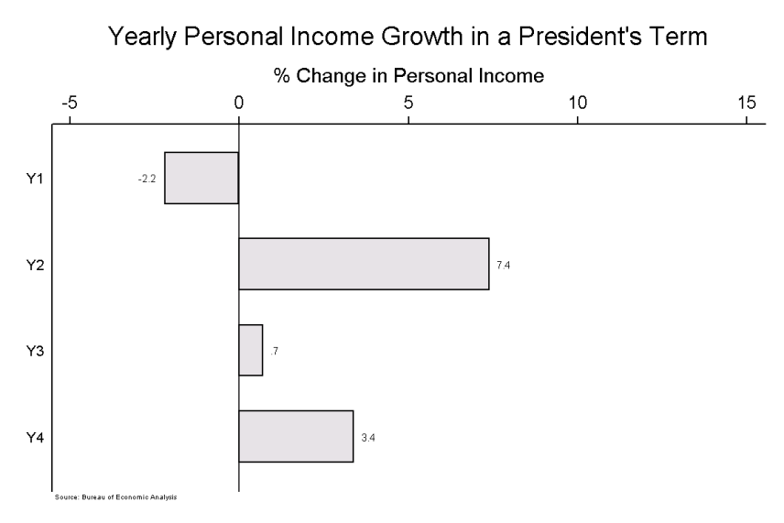
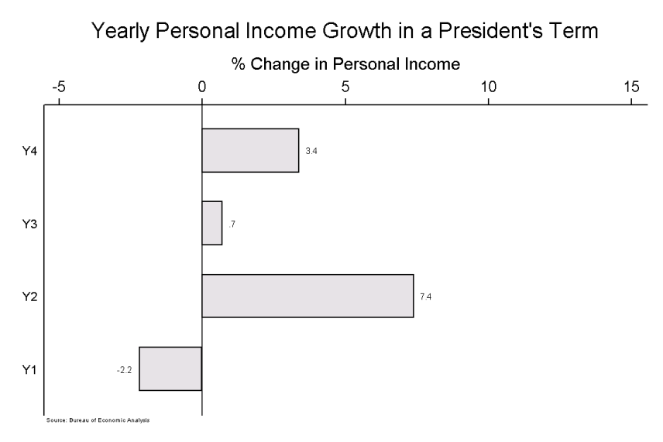

These two conditions yield similar estimates of yearly weights. In the first column of the table below, we report the weights that participants applied when they saw horizontal bars with Year 4 on the bottom. The estimates in the second column refer to participants who saw horizontal plots with Year 4 on the top rather than the bottom. Year 4 is strongest in both conditions, with its estimate being roughly three times larger than the estimate for Year 3, although Year 2 is weighed somewhat more heavily than in other studies. The results therefore show that participants treat the different years similarly when they see it displayed horizontally, and that they put significantly more weight on Year 4 whether the years are ordered from top to bottom or bottom to top.
Weights with Horizontal Bars
 |  | Year 4 on bottom | Year 4 on top
 |  | (1) | (2)
Year 1 Growth |  | 0.16 | 0.20
 |  | (0.031) | (0.039)
Year 2 Growth |  | 0.29 | 0.35
 |  | (0.042) | (0.039)
Year 3 Growth |  | 0.17 | 0.19
 |  | (0.038) | (0.053)
Year 4 Growth |  | 0.47 | 0.49
 |  | (0.060) | (0.073)
R-squared |  | 0.95 | 0.93
Number of terms |  | 15 | 15
Number of participants |  | 63 | 79
Notes: The dependent variable is the average evaluation of the economy shown in the income-growth plots (see the note to Table 3 for details). Regression standard errors are in parentheses (unstandardized coefficients).

C. Replication of Table 3: Additional hypothetical income growth studies

Similarly, we replicated the experiments using hypothetical data in several ways, which are reported in the table below. In addition to varying whether the president’s term was specified, we also implemented a study where we relabeled the plots as about governors rather than presidents and about crime rather than the economy.

Weights for Hypothetical Growth Data in Three Additional Experiments
 | Office: | President | President | Governor
 | Term: | Second | Not specified | Not specified
 | Domain: | Income growth | Income growth | Murder growth
DV: Evaluations of |  | Economy |  | Crime prevention
 |  | (1) | (2) | (3)
Year 1 Growth |  | 0.28 | 0.22 | -0.050
 |  | (0.097) | (0.083) | (0.068)
Year 2 Growth |  | 0.47 | 0.39 | 0.12
 |  | (0.081) | (0.078) | (0.054)
Year 3 Growth |  | 0.37 | 0.31 | 0.35
 |  | (0.066) | (0.060) | (0.062)
Year 4 Growth |  | 0.61 | 0.66 | 0.76
 |  | (0.058) | (0.058) | (0.069)
R-squared |  | 0.93 | 0.92 | 0.91
Number of terms |  | 25 | 25 | 25
Number of participants |  | 64 | 47 | 36
Notes: Regression standard errors are in parentheses (unstandardized coefficients). The constants are not shown. MTurk samples.

III. How Informative is the Election-Year Economy?

A. Additional information for simple survey question
To assess further whether voters perceive the election-year economy to be particularly informative, we first simply asked participants whether they saw income growth from particular years as more informative about income growth in future years (Study C1). After 232 participants rated 17 real-world economies for an experiment we present in the article (Study B1), we asked, “Say you were trying to forecast the average economy in the four years following these periods. Would all years during these terms be equally predictive of the future? Would later years matter a little more or a little less than earlier years? Tell us what you think by assigning percentage weights to each year. The higher the weights you give to each year, the more predictive you think that year will be.” Based on their responses, shown in the table below, participants did not appear to see later years as much more informative: the average weights they reported are 19.8%, 22.8%, 26.5%, and 30.9%, respectively. On the next page, we show a replication of this study.

How Useful is Previous Growth for Predicting Future Growth?
 |  | Means | Medians
 |  | (1) | (2)
Year 1 Growth |  | 19.8 | 20
 |  | (0.69)
Year 2 Growth |  | 22.8 | 24
 |  | (0.51)
Year 3 Growth |  | 26.5 | 25
 |  | (0.53)
Year 4 Growth |  | 30.9 | 30
 |  | (0.83)
Number of participants |  | 232 | 232
Study |  | C1 | C1
Note: Standard errors in parentheses.

B. Replication of Study C1
After participants rated 25 hypothetical economies for an experiment we present in the article (Study D2), we asked a question similar to the one from Study C1 to that sample: “Say you were trying to forecast the average economy in the four years following these periods. Would all years during these terms be equally predictive of the future? Would later years matter a little more or quite a bit more? Tell us what you think by assigning percentage weights to each year. The higher the weights you give to each year, the more predictive you think that year will be.” Based on their responses, described in the table below, participants did not appear to see later years as much more informative: the average weights they reported are 20.4%, 21.5%, 25.5%, and 32.6%, respectively, similar to the results we observed in Study C1.

How Useful is Previous Growth for Predicting Future Growth?
 |  | Means | Medians
 |  | (1) | (2)
Year 1 Growth |  | 20.4 | 20
 |  | (0.84)
Year 2 Growth |  | 21.5 | 20
 |  | (0.48)
Year 3 Growth |  | 25.5 | 25
 |  | (0.47)
Year 4 Growth |  | 32.6 | 30
 |  | (0.91)
Number of participants |  | 243 | 243
Study |  | D2 | D2
Note: Standard errors in parentheses.

C. Predicting future growth when seeing the change for a single year

To address concerns about experimenter demand potentially leading subjects to give equal weight to each year when predicting future growth, we implemented some additional studies. Here, we describe the first of these. Similar to the study where we used a between-subjects treatment so that any one subject only responded to the change in a single year (Study A2), we also implemented a study where any given subject only responded to a hypothetical shock in a single year.

In this study, we asked participants to guess the income growth rate in a governor’s third term based on one year in his second term. We first showed them some graphs of income growth rate over a four-year period. Then we asked them, “In general, how much would your prediction of average growth change if growth in Year X was 3 percentage points higher?” They could choose: does not change, goes up a small amount, goes up moderately, or goes up substantially.

As shown in the table below, we found that respondents generally assigned a similar weight to all four years, suggesting that respondents think all four years of politicians’ previous terms are equally predictive of the following term’s income growth.

We also checked for comprehension of the question by asking respondents what we had asked them to do in the previous question. We ran the results for only those participants who answered the question correctly and found no substantial shift in the results.

 | Year 1 | Year 2 | Year 3 | Year 4
Does not change | 9.84% | 10.29% | 7.46% | 4.92%
Goes up a small amount | 54.10% | 58.82% | 55.22% | 55.74%
Goes up moderately | 29.51% | 23.53% | 35.82% | 31.15%
Goes up substantially | 6.56% | 7.35% | 1.49% | 8.20%
Moderate or Substantial | 36.07 | 30.87 | 37.31 | 39.35
Total | 61 | 68 | 67 | 61
Survey of 257 participants on Mechanical Turk.

D. Importance of each year when predicting the future economy (YouGov/Polimetrics)
To further examine whether participants see later years as more predictive of the future, we conducted a between-subjects experiment with a nationally representative sample. We asked 987 respondents on an August 2012 YouGov/Polimetrics poll the following question:
When thinking about how the economy will perform over the next four years, how important is the performance of the economy ["this year," “last year," "two years ago," "three years ago”]?
We randomly assigned them with equal probability to see one of the four periods (e.g., "this year"). Since we asked this question in August of an election year, "this year" refers to the election year. As shown in the table below, respondents saw the current year as being somewhat more informative than other years. When we combine the very important and somewhat important categories, we find that 82.6% saw "this year" as important, which falls only to 76.4% for “three years ago.” (Given the ongoing financial crisis in 2009 (three years ago), placing so much importance on three years ago is surprising.)
These results help confirm our other survey findings that people do not see the election-year as especially more informative than previous years, certainly not enough to explain why voters put 75% of the weight on the election year. By using a between-subjects design, they also help eliminate the possibility that experimental demand and the desire to treat all years equally gives rise to this tendency.

When thinking about how the economy will perform over the next four years, how important is the performance of the economy ["this year," “last year," "two years ago," "three years ago”]?
 | This year | Last year | Two years ago | Three years ago
Very important in predicting the next four years | 38.9% | 32.6% | 30.6% | 25.2%
Somewhat important in predicting the next four years | 43.7 | 46.1 | 45.7 | 51.2
Somewhat unimportant in predicting the next four years | 12.6 | 16.3 | 14.7 | 17.6
Very unimportant in predicting the next four years | 4.9 | 5.0 | 9.1 | 6.0
Important combined | 82.6 | 78.6 | 76.3 | 76.4
Unimportant combined | 17.4 | 21.3 | 23.7 | 23.6
N | 247 | 248 | 232 | 250
Note: YouGov poll of 987 respondents conducted in the first week of August 2012.

E. Hypothetically paying for growth information to predict the future
In another study to assess how predictive participants think the election-year economy is of future growth, we elicited how much participants would be willing to pay for information in different years of a term if they were attempting to predict future growth. In this study, we asked respondents to predict the third-term income growth under a governor. We asked them to imagine that if they were within one percent of the answer they would win $30. Respondents then had the option of “purchasing” the income growth rate in one of the years of the second term for a randomly generated amount—ranging from $1 to $10. The idea behind this experiment was to elicit in as simple a way as possible how valuable subjects perceived the growth rates for a given year to be for predicting future growth. The key instructions were as follows:
“Suppose that you have the option to purchase the income growth rate in one of the four years of the governor’s second term. Specifically, we're going to ask you whether you would purchase the income growth rate in Year X [randomized to be 1, 2, 3, or 4] of the governor’s second term.”

The results generally mirrored our past findings, with respondents placing slightly more weight on later years. Overall they believed all years were fairly predictive, less so for the first year (see the first column of the table below). By chance, year 2 was priced slightly lower on average ($5 vs $5.20 for year 1 and 4) and year 3 was valued slightly higher ($5.30), which may explain why people bought year 2 at higher rates and bought year three at lower rates. Since the instructions were somewhat complicated, we asked participants about their level of confusion and we also had them pass an attention test. The table below shows that the results are similar when we exclude respondents who reported being somewhat or very confused or who failed the attention test.

Percentage of people who choose buy the information
 | All | Excluding very confused | Excluding very & somewhat confused | Passed Attention test
Year 1 | 54.0% | 50.0% | 58.8% | 53.6%
Year 2 | 81.0% | 79.6% | 88.2% | 82.7%
Year 3 | 68.3% | 64.7% | 72.7% | 68.6%
Year 4 | 78.6% | 80.7% | 85.0% | 78.6%
N | 251 | 204 | 76 | 230

Purchasing by year
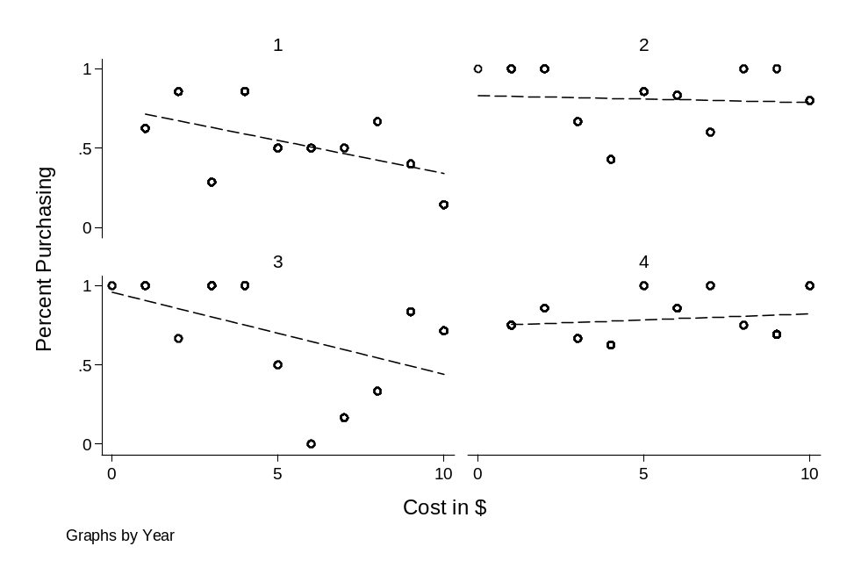

F. Example of growth plot without political context (Study C2)
In the paper, we described Study C2, where we removed all political context (see Table 5 for the results). Asking subjects only to evaluate the economy without any reference to politics should minimize the chance that people essentially answer the question about the economy’s performance as a referendum on a president’s performance. In other words, since voters are evaluating only the economy, we are minimizing the chance that subjects put extra weight on Year 4 because they see it as more informative about the president’s performance.
Below, we show an example of the plots in that study.

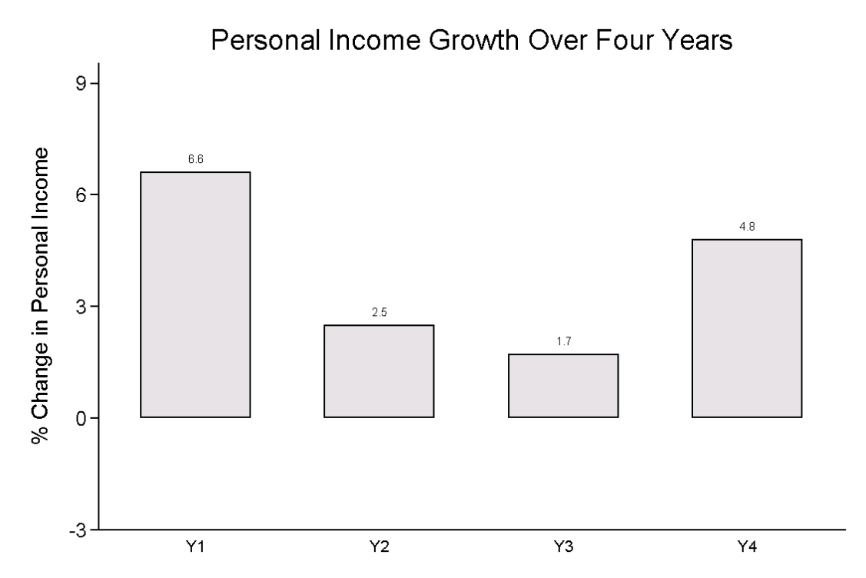

G. Trends and Peaks

1. Do trends matter? Pooled analysis of randomly drawn experiments on yearly income growth
The table below searches for evidence that trends matter. Economies with strong Year 4 growth are, of course, more likely to display an upward trend over the term, and the regressions in the table examine the possibility that the high weight for Year 4 growth comes from these trends. The regressions in the table combine five experiments that showed participants randomly-drawn income growth. The unit of analysis is the average economic evaluation (on a 0-10 scale) for each economy plot from each experiment (N = 5 studies*25 economies per study = 125). We include study fixed effects (not shown). The results suggest that voters do not focus much on upward trends and that they focus somewhat more on downward trends. The coefficients for the effects of the individual years remain nearly the same when the trend terms are included, indicating that the high weight for Year 4 growth is not primarily driven by trends.
Column 1 shows the baseline pooled model, replicating the general finding from the article. Column 2 adds indicator variables for whether there is a consistent upwards trend or downward trend (coded one if every year had a higher growth than the previous year, and zero otherwise, reversed for downward trend). The coefficients on these indicator variables suggest some effect of consistent trends, with the coefficients for the individual years remaining similar. Column 3 adds controls for an indicator of whether the last year was the highest and whether the last year was the lowest.
We also tried a number of other plausible specifications, such as including a variable for the change in growth between the first and last years, but continued to find little evidence that controlling for them reduces the focus on the last year.

 | (1) | (2) | (3)
DV: Economic evaluations
Year 1 Growth | 0.21 | 0.24 | 0.24
 | (0.031) | (0.031) | (0.034)
Year 2 Growth | 0.39 | 0.39 | 0.40
 | (0.028) | (0.027) | (0.028)
Year 3 Growth | 0.40 | 0.40 | 0.40
 | (0.028) | (0.027) | (0.033)
Year 4 Growth | 0.64 | 0.60 | 0.58
 | (0.025) | (0.027) | (0.043)
Consistent upward trend |  | 0.46 | 0.35
 |  | (0.24) | (0.26)
Consistent downward trend |  | -0.79 | -0.85
 |  | (0.27) | (0.30)
Last year highest |  |  | 0.24
 |  |  | (0.20)
Last year lowest |  |  | 0.079
 |  |  | (0.20)
Observations | 125 | 125 | 125
R-squared | 0.913 | 0.921 | 0.923
SER | 0.62 | 0.60 | 0.60
Notes: Fixed effects for study included but not shown. Regression standard errors in parentheses (unstandardized). Constant not shown.

2. Do peaks matter? Pooled analysis of randomly drawn experiments on yearly growth
The table below searches for evidence that peaks matter. As in the analysis above on trends, it combines five experiments that showed participants randomly-drawn income growth. The unit of analysis is the average economic evaluation (on a 0-10 scale) for each economy plot for each experiment (N = 5 studies * 25 economies per study = 125). We include study fixed effects (not shown). The results reveal that people do not appear to focus much on peaks.
Column 1 shows that, without other controls, the maximum growth and minimum growth occurring during the terms influences economic evaluations in the correct direction. Column 2 adds a control for Year 4 growth , which substantially cuts the effects the maximum and minimum coefficients. Column 3 adds a control for average growth in years 1-3, which reduces the minimum and maximum growth coefficients to essentially zero.
In another analysis, we tried including the average of Year 4 and the maximum (the peak-end specification used in the colonoscopy experiments), but it did not contribute to the models below. Peaks (and troughs) may not matter here for several reasons, including the salience of memories being the mechanism behind peaks. Our findings are consistent with psychology studies finding that peak effects happen less frequently than end effects.

DV: Economic evaluations | (1) | (2) | (3)
Maximum growth during term | 0.64 | 0.37 | -0.13
 | (0.066) | (0.076) | (0.11)
Minimum growth during term | -0.81 | -0.52 | -0.020
 | (0.091) | (0.097) | (0.13)
Year 4 Growth |  | 0.37 | 0.68
 |  | (0.068) | (0.083)
Average Growth Years 1-3 |  |  | 0.66
 |  |  | (0.12)
Observations | 125 | 125 | 125
R-squared | 0.640 | 0.713 | 0.772
SER | 1.26 | 1.13 | 1.01

Notes: Fixed effects for study included but not shown. Regression standard errors in
parentheses (unstandardized). Constant not shown.

H. Is the election-year economy actually more informative about future growth?
In the next two sections, we present some suggestive evidence regarding whether the election year actually is particularly informative either about the incumbent’s capability to generate growth in the future or about his past performance. These results are only meant to provide some background related to arguments often made to explain voters’ election-year emphasis. As such, they are only tangentially related to the main arguments we make in the paper.
First, we consider the actual relationship between post-election growth and pre-election growth since the 1944 election to see if Year 4 growth actually is more informative about future growth than growth in Years 1-3. First, we look at all elections. The second table subsets on the cases where the incumbent president won reelection. We include George H.W. Bush’s term in this group. Earlier we showed that our participants perceive Year 4 growth to be only slightly more informative in this regard. The results indeed show that Year 4 is not particularly informative about post-election growth.
These results confirm, in a less sophisticated way, the results of Achen and Bartels (2004) and Alesina, Londregan, and Rosenthal (1993), as we discuss in footnote 12 in the main text.
Real Disposable Income Growth Pre- and Post-Election Since 1944: All Elections
 | (1) | (2) | (3) | (4)
 | Percent change in Real Disposable Income (RDI)
 | Year 5 | Year 6 | Year 7 | Year 8
Percent change in RDI
Year 1 | -0.37 | -0.055 | -0.61 | -0.16
 | (0.15) | (0.18) | (0.14) | (0.18)
Year 2 | 0.042 | -0.28 | -0.031 | 0.21
 | (0.15) | (0.18) | (0.14) | (0.17)
Year 3 | 0.52 | -0.47 | 0.42 | 0.16
 | (0.20) | (0.24) | (0.19) | (0.23)
Year 4 | 0.39 | 0.22 | -0.13 | -0.34
 | (0.23) | (0.30) | (0.24) | (0.29)
Observations | 17 | 16 | 16 | 16
R-squared | 0.508 | 0.560 | 0.688 | 0.253
Regression standard errors are in parentheses (unstandardized coefficients). Constant not shown.

Real Disposable Income Growth Pre- and Post-Election Since 1944: Reelected Incumbents
 | (1) | (2) | (3) | (4)
 | Percent change in Real Disposable Income (RDI)
 | Year 5 | Year 6 | Year 7 | Year 8
Percent change in RDI
Year 1 | -1.04 | -0.59 | -0.60 | 0.00
 | (0.34) | (0.50) | (0.27) | (0.28)
Year 2 | 0.82 | 0.35 | -0.09 | 0.18
 | (0.38) | (0.56) | (0.30) | (0.24)
Year 3 | 0.63 | -0.51 | 0.44 | 0.02
 | (0.22) | (0.32) | (0.17) | (0.25)
Year 4 | 0.54 | 0.11 | 0.12 | 0.49
 | (0.40) | (0.59) | (0.32) | (0.44)
Observations | 9 | 9 | 9 | 9
R-squared | 0.826 | 0.734 | 0.898 | 0.331
Regression standard errors are in parentheses (unstandardized coefficients). Constant not shown.

I. Is election-year growth more informative about earlier growth?
Although election-year growth appears not to be predictive of future growth (see the tables on the previous page), it could be correlated with earlier growth (years 1-3), making it an efficient heuristic to assess growth throughout the term under a sanctioning model. In the correlation matrix below, however, we find little relationship between income growth (RDI) in the election-year (RDI_4) and growth in years 1-3. In fact, election-year growth seems less related to other years than the average year.

Correlation matrix, percent change in real disposable income (RDI), 1941-2008
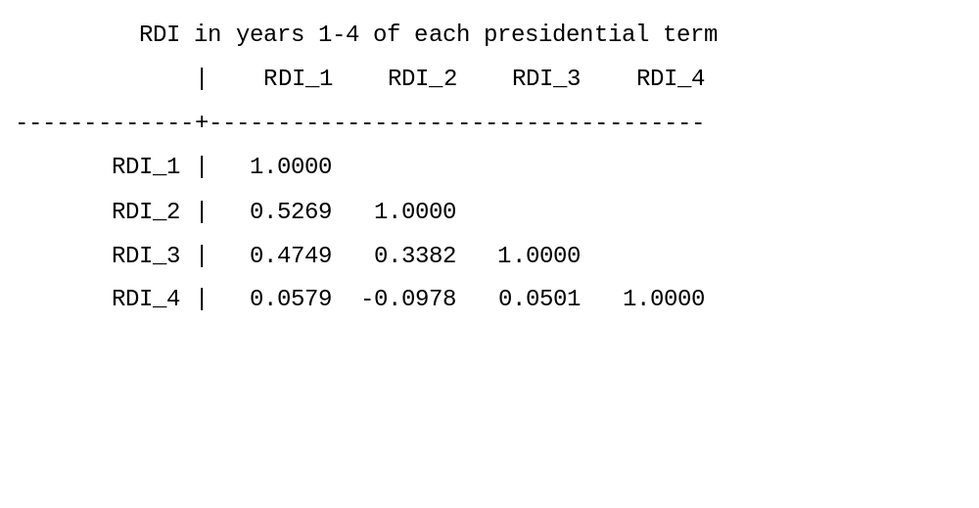

IV. Aligning Voters’ Actions with Their Intentions

A. Testing whether voters act in accordance with their stated intentions
To test whether participants’ weights accord on average with their intentions, we compared how subjects actually behaved in the growth experiments with how they stated they intended to behave. Each subject first gave their evaluation of the 25 economies before stating the weights that they intended to apply to growth in each year. We use their intended weights to construct intended weight ratios between each of Year 1, Year 2, and Year 3 relative to Year 4. Given any coefficient that subjects actually assigned to Year 4, we can then estimate the coefficients that subjects intend to use for Years 1, 2, and 3. We then ran the regression of evaluations on the growth rates in each of the four years, and tested the hypothesis that the Year 1, 2, and 3 coefficients are equal to their intended values as determined by the three ratios from participants’ intended weights.
The results of this test give a p-value less than 0.001 for the case where participants observe only yearly growth and a p-value of 0.156 for the case where participants observe both cumulative and yearly growth. In this case, participants actually put somewhat less weight on Year 4 relative to other years that they intend, although the difference is not significant.

B. Addressing concerns about demand with the cumulative growth experiments
Another potential demand concern with our finding that cumulative income growth plots reduce participants' focus on later years is that our cumulative condition contained a sentence that explained cumulative income growth. Since we did not include a sentence explaining yearly income growth, our instructions might have signaled participants to focus on cumulative growth. We therefore conducted two replications to ensure yearly growth and cumulative growth were explained in the same amount of detail. In the first, we added a sentence explaining yearly growth (see below). In the second replication, we eliminated both sentences explaining the plots (see the next section).

For the first replication, the instructions in the cumulative condition were as follows:

Evaluate the economy under 25 hypothetical presidents who are serving in their second terms.
On the following pages, you will see figures with measurements of how much better off people are during hypothetical U.S. presidents' terms. The figures only show the economy for presidents in their second terms.
We show percent change in personal income growth in two ways: yearly and cumulatively.
- The yearly growth plots show the percent change in income over the previous year. For example, if personal income grew 2% in a year, that means personal income is two percentage points higher than the previous year.
- The cumulative growth figures simply add together the yearly income growth. For example, if personal income growth grew 2% in each year of a presidents four-year term, cumulative growth would be (4*2% = 8%).
After looking at each figure, evaluate the president's handling of the economy.

Here, we have 232 respondents in the sample who passed the attention screeners. As shown in the table below, the results are similar to those seen in Study D1. The cumulative growth plots reduce participants’ focus on later years.

 | (1) | (2)
 | Yearly growth | Cumulative and yearly growth
DV: | Participants' Economic Evaluations
Year 1 Growth | 0.16 | 0.40
 | (0.072) | (0.065)
Year 2 Growth | 0.28 | 0.45
 | (0.079) | (0.071)
Year 3 Growth | 0.48 | 0.54
 | (0.063) | (0.057)
Year 4 Growth | 0.92 | 0.64
 | (0.086) | (0.078)
Observations | 25 | 25
R-squared | 0.891 | 0.901
Rmse | 0.64 | 0.58
Number of participants | 122 | 110

Notes: Regression standard errors are in parentheses (unstandardized coefficients). The constants are not shown.

C. Addressing concerns about demand with cumulative experiments (minimal instructions)
To further address demand concerns in the cumulative experiments (as explained in the previous section), we replicated the cumulative experiment a second time but with minimal instructions. We cut the sentences about yearly growth and cumulative growth.

The minimal instructions were as follows:

Evaluate the economy under 25 hypothetical presidents who are serving in their second terms.
On the following pages, you will see figures with measurements of how much better off people are during hypothetical U.S. presidents' terms. The figures only show the economy for presidents in their second terms.
After looking at each figure, evaluate the president's handling of the economy.

For this study, we have a sample of 229 participants who passed the screeners. As shown in the table below, the results are essentially the same. The cumulative income plots substantially reduce participants’ focus on later years.

 | (1) | (2)
 | Yearly growth | Cumulative and yearly growth
DV: | Participants' Economic Evaluations
Year 1 Growth | 0.13 | 0.40
 | (0.067) | (0.070)
Year 2 Growth | 0.29 | 0.44
 | (0.073) | (0.076)
Year 3 Growth | 0.48 | 0.52
 | (0.059) | (0.061)
Year 4 Growth | 0.85 | 0.59
 | (0.080) | (0.083)
Observations | 25 | 25
R-squared | 0.896 | 0.880
rmse | 0.59 | 0.62
Number of participants | 113 | 116

Notes: Regression standard errors are in parentheses (unstandardized coefficients). The constants are not shown.

D. Addressing concerns about demand with the level experiment
As we describe in the text, there are several reasons we might be concerned that experimenter demand could lead people to weigh all years equally in either the cumulative income treatments or the income-in-levels treatments. It is important to note that most of these concerns would also operate in the yearly income growth conditions, where we found not that people put equal weights on all years, but instead a substantially greater weight on the last year.

One possible concern is that, since we tell participants that growth “provides a good measure of the strength of the national economy” and that they were asked to “evaluate the economy during this period,” we signaled them to put more weight on measures of the economy stretching over the whole period. (Again, however, we used the same language in the growth treatments where people put more weight on Year 4 than earlier years.)

To determine whether the instructions could be driving the equal weights that subjects assigned to the different years, we replicated Study D1, where we showed participants either yearly income growth or income in levels. We made two key changes. First, we eliminated the language about income growth providing a good measure of the national economy. Second, more importantly, we asked participants to evaluate, not the economy during the period, but the president's handling of the economy.

Here are the new instructions used for this study:
Evaluate the economy under 25 hypothetical presidents who are serving in their second terms.
On the following pages, you will see figures with measurements of how much better off people are during hypothetical U.S. presidents' terms. The figures only show the economy for presidents in their second terms.
After looking at each figure, evaluate the president's handling of the economy.
Thank you so much for your time. Your responses are very important to us.

Here is the new question respondents answered below each four-year term, which we adapted from the ANES:

Do you approve or disapprove of the way the president handled the economy?

Respondents could answer: disapprove strongly, disapprove not strongly, approve not strongly, and approve strongly (the ANES response options)

231 respondents passed the attention screener and constitute our sample in this study.

These changes to the instructions in question wordings leave the main findings unchanged (see the table on the following page). When individuals saw yearly income growth (control condition), they placed a great deal more weight on the end. In contrast, when they saw a level growth (treatment condition), they did not.

Eliminating the Election-Year Emphasis: Level Income Plots
 |  | Yearly growth | Levels
 | DV: | Participants' Economic Evaluations
 |  | (1) | (2)
Year 1 Growth |  | -0.029
 |  | (0.094)
Year 2 Growth |  | 0.20 | 0.30
 |  | (0.068) | (0.052)
Year 3 Growth |  | 0.39 | 0.55
 |  | (0.088) | (0.064)
Year 4 Growth |  | 0.64 | 0.39
 |  | (0.058) | (0.044)
R-squared |  | 0.89 | 0.91
Number of terms |  | 25 | 25
Number of participants |  | 114 | 117
Notes: Regression standard errors are in parentheses (unstandardized coefficients). The constants are not shown.

E. Level experiment using text instead of plots
In addition, we replicated the level experiment with text taking the place of plots. We gave the control group data on the income growth rate for each year in a president’s second term written with text, e.g., 3% in year 1, 4% in year 2, etc. The treatment group instead observed the income data in levels for each year of the second term, e.g. $32,000 in year 1, $33,000 in year 2, etc. Below the text, participants rated the economy.
Again, we found that respondents who observed income in levels focused less on later years. When they read the yearly growth rate data, respondents placed the greatest emphasis on the fourth year and placed the least weight on the first year. In contrast, when they observed income in levels, respondents valued early growth more in later growth less.
With the income data presented in text, participants must actually read the numbers. This study therefore confirms that income in levels do not eliminate end bias due to a visual aspect to those plots. Since voters are more likely to hear about economic data on the radio or read them in newspapers than they are to see plots, this finding also suggests that the level cure may be more likely to work in the real world.

 | (1) | (2)
 | Yearly growth in text | Income levels in text
DV: | Participants' Economic Evaluations
Year 1 Growth | 0.13
 | (0.061)
Year 2 Growth | 0.39 | 0.49
 | (0.056) | (0.054)
Year 3 Growth | 0.29 | 0.45
 | (0.062) | (0.066)
Year 4 Growth | 0.58 | 0.32
 | (0.052) | (0.054)
Observations | 25 | 25
R-squared | 0.912 | 0.868
rmse | 0.54 | 0.57
Number of participants | 50 | 52

Notes: Regression standard errors are in parentheses (unstandardized coefficients). The constants are not shown. Mechanical Turk sample of 102 respondents.

F. Income-in-levels experiment where participants saw only one term (SSI sample)
We used the income-in-levels experiments along with the cumulative growth conditions to test the end heuristic hypothesis. In the level and cumulative growth experiments described in the paper, participants evaluated multiple terms in short succession. In real-world elections, of course, people only evaluate one term. To see whether our findings regarding both the causes and the cure of voters’ election-year emphasis hold when participants evaluate only one term, we ran a version of the income-in-levels study with a representative sample of 1602 respondents. We showed them the income plots in a 20-minute survey that primarily focused on other topics (the same survey used for the survey results in Table 1, Study A1). Midway through the survey, participants saw one of 25 yearly percentage growth plots for a president’s second term, and recorded their evaluation of the economy for the term. After answering a battery of unrelated questions, participants then evaluated one of 25 plots of income in levels. On average, then, 64 participants rated each of the 25 terms. We again told respondents that the plot showed hypothetical, second-term presidents. To analyze the results, we followed the procedures above, taking the average economic evaluation for each plot across all participants who rated it.
As shown in the table on the next page, the results remain similar to those when subjects observed 25 terms when participants only saw one term. Participants placed more weight on the fourth year than earlier years when they saw a yearly percentage growth plot, but did not do so when they saw a level plot. Compared to the within-subject studies, the coefficients are generally smaller in both conditions, indicating a somewhat muted reaction to the data when seeing only one term, but the main findings remain the same.
Income in levels experiment (between subject)
Eliminating the Election-Year Emphasis: Income in Levels
 |  | Participants see one of 25 terms
 |  | Yearly growth | Income in levels
 | DV: | Participants' Economic Evaluations
 |  | (1) | (2)
Year 1 Growth |  | -0.13
 |  | (0.085)
Year 2 Growth |  | 0.0043 | 0.12
 |  | (0.075) | (0.060)
Year 3 Growth |  | 0.18 | 0.13
 |  | (0.087) | (0.070)
Year 4 Growth |  | 0.31 | 0.075
 |  | (0.079) | (0.063)
R-squared |  | 0.496 | 0.309
Number of terms |  | 25 | 25
Number of participants |  | 1602 | 1602
Study |  | A1 | A1
Notes: Regression standard errors are in parentheses (unstandardized coefficients). The constants are not shown.

G. Simple income-in-levels experiment
In the paper, we report a study where we showed participants income in levels and yearly growth in income in the same plot (Study D2). We also ran a pilot study where participants only observed income in levels. We picked the previous income growth experiment with the strongest end bias (highest weight for Year 4 growth), which was in a gubernatorial study (Study C3). We then tried to cure it by using its randomly drawn income growth data to generate level data. The figure presents an example of a level plot. For the first year of each term, we drew an initial value from a normal distribution with a mean of about $32,000 (the average RDI since 2000) and a standard deviation of 100.
As shown in the table below, presenting income in levels appears to eliminate end bias. This result therefore confirms the finding in the article that respondents in our national sample did not display end bias when they observed a single plot on income in level terms, as described on the previous two pages.
Screen shot for income-in-levels experiment
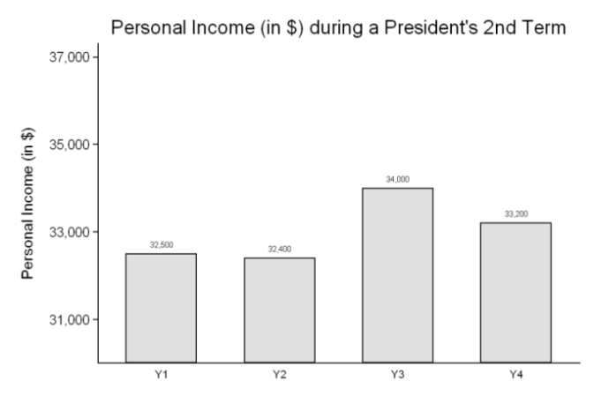
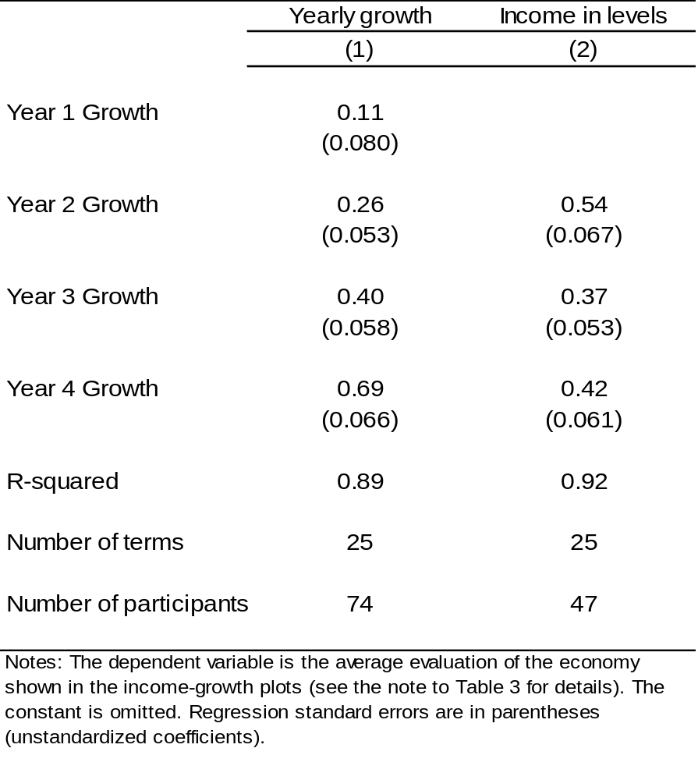

H. Average-in-plot experiment
We also attempted to cure end bias by including the average growth in the plots (see the example below). Given that the average essentially conveys the same information as cumulative growth, we might expect these plots to cure end bias. As shown in the table on the next page, they do reduce end bias somewhat, but not substantially. Simply stating the average growth rate has a small effect, we think, because people respond to the information that is clearly the focus of the plots: the growth bars. In contrast to the cumulative growth and income-in-levels plots described earlier that did substantially reduce end bias by making total growth equally available to participants, the average displayed here was not as prominent as the growth information.
Screen shot for average-in-plot experiment

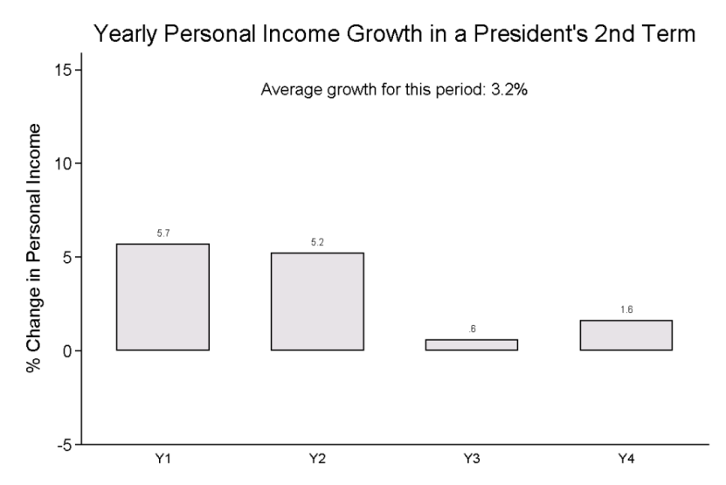

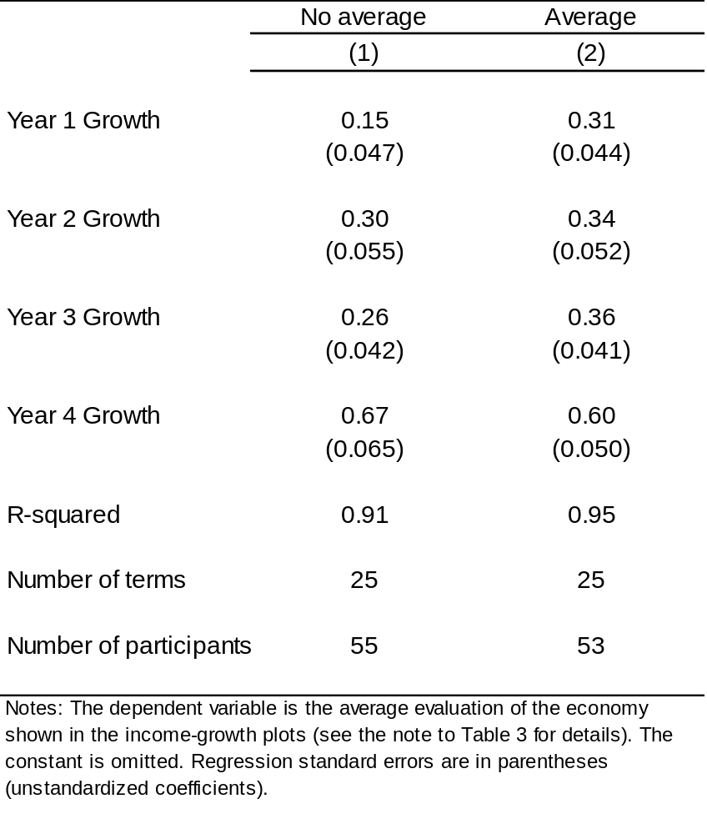

G. Twenty-year study
In another study, we showed yearly income growth for a hypothetical unusually long serving governors, who served 20 years, (i.e., five four-year terms). Below, we show two plots from the study. In contrast with our other studies involving yearly growth plots, we found no evidence of end bias with this one. The average growth over the 20 years best predicted participants evaluations of the economies, with little evidence that year 20 mattered more, or that the last four years mattered more. This result is obviously inconsistent with our finding for the four-term governors (each term’s income growth was represented by just one bar), which we present in the article. In that four-term study, participants did place extra weight on term four — the weights were essentially the same as the weights applied to the one-term studies. The 20-year study result, we think, is an exception that proves the rule. As is evident in the two figures below, showing people 20 bars gives them much more data. As participants flipped through the 25 randomly-drawn plots, they can readily see average differences across them. With more data, they no longer fall back on the end heuristic. This finding, therefore, suggests another cure for and substitution.

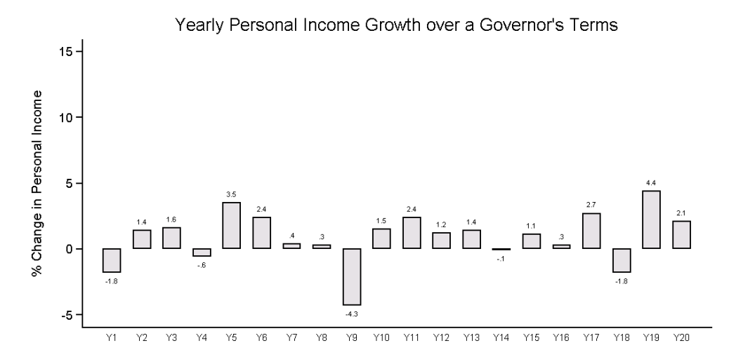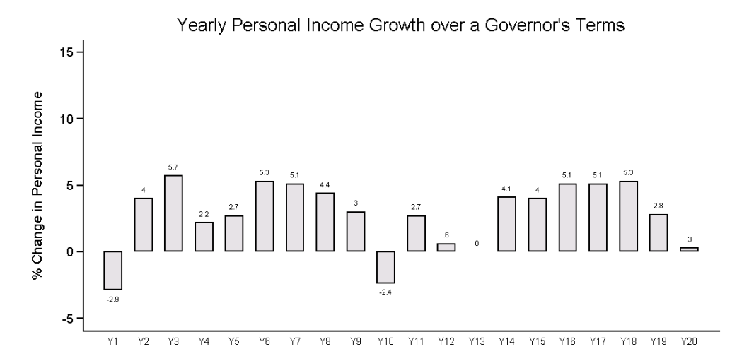

V. Additional Analysis and Robustness Checks

A. Media coverage of the economy: Content analysis
We asked our research assistant to use a database (EBSCOhost) to search for news transcripts (radio or TV) that covered the economy in September and October of 2000 as 2004, as well as in October of 2008. The search that we implemented—“(‘GDP growth’ or ‘income growth’ or ‘economic growth’ or jobs) and election”—was chosen specifically to get as many hits with a longer time horizon as possible. Below are the instructions given to our research assistant.
Our assistant classified each hit according to whether it gave substantial attention to the economy within the (1) last year, (2) more than one year ago but within the last four years, (3) more than four years ago but within the last eight, and (4) more than eight years ago. A transcript could be classified in more than one category or none if it was either about another country or not about the economy. Of the 156 articles classified as in at least one category (many articles referred to other countries or were not actually about the economy), our assistant found 96.6%, 20.7%, 10.3%, and 10.3% for the four respective categories.

We had a second research assistant classify a random subset of 50 of these articles to verify the accuracy of the classification. The average correspondence between the ratings was about two-thirds across the categories (average Cronbach’s alpha = 0.663).

The content analysis thus indicates that, even around elections when we might expect economic coverage to discuss performance over an entire term, most of the coverage concerns recent economic conditions. In fact, around 96% of the articles in the sample cover recent economic performance with a much smaller share of the articles covering economic performance over the longer term in any significant way.

Instructions for Content Analysis
We are asking you to read through news transcripts from three time periods: September-October 2000, September-October 2004, and October 2008. You will find these articles by going to the database “Newspaper Source” that is hosted by EBSCOhost and conducting the following search:
(“economic growth” OR “income growth” OR “GDP growth” OR jobs) AND election
You will also need to select the time period that you want to search for, as well as the kind of source from which you want to search. So, below the search box, you just need to: 1) click “Also search within the full text of the articles,” 2) select the time period for which you want to search, and 3) choose “transcript” in the box that says “publication type.”
For 2000, I have gotten 116 hits with this search (68 hits for 2004 and 358 hits for 2008). For 2008, please just consider the first 150 hits rather than the entire group.
We would like you to classify each article that you read according to several criteria in the Excel spreadsheet. First, please record the date and source of each article. You can enter the date as month/day. The source can just be the news organization. For example, if it says “CNN Morning News,” you can enter just “CNN” into the spreadsheet.
Second, you need to classify whether the part of the transcript that is describing the economy is substantially about the US economy. If the transcript is mainly about the economy in another country, enter an “N” in the column that says “About US”. If the transcript focuses more on the US economy than that in any other country, enter a “Y” in the column. For any article where you enter an “N,” you can simply move on to the next article.
Third, for the transcript that are mainly about the US economy, we want you to read more carefully to see what kind of coverage is given to the US economy. In particular, your job is to determine whether the coverage focused on economic performance: 1) within one year preceding the report, 2) more than one year preceding the report but less than four years preceding the report, 3) more than four years preceding the report but less than eight years preceding the report, and/or 4) more than eight years preceding the report.
If the transcript covers any of these areas, you should enter a 1 in the appropriate column. If it covers more than one of these, please enter a 1 in each relevant column. If it covers none of these—if it only talks about predictions of future economic growth, for example— then please enter a zero in each column for that transcript.
There should be one line per transcript. You should enter each article in the order in which it appears in your searches. Please do the three searches in chronological order. So the first 116 entries should refer to articles written in 2000, the next 68 should refer to articles written in 2004, and the last 150 entries should refer to articles written in 2008.
Thank you very much for your help with this.

B. Replication with Indian subjects
For studies conducted on Mechanical Turk, we restricted the eligibility to those residing in the United States (Amazon.com does not reveal how it determines where workers reside, but presumably through bank accounts and IP addresses.) Inadvertently, however, we did not restrict the location for the study where we showed participants historical income growth data (Study B, see Table 3). For that study, we therefore excluded 41 of 115 participants with IP addresses outside of the United States before conducting the analyses.
The data from Indian participants give us the opportunity to examine how people from another country evaluate yearly growth information. Of the non-US respondents, 17 from India passed the screener test of attention. The table below shows that we find a very similar pattern of weights among the Indian participants (Column 1). It also presents the results for all non-US participants who passed the screener test, which adds four more participants (Column 2).
Replication of experiment in Table 3 among participants from India
 | (1) |  | (2)
DV: Economic evaluations | Indians |  | All non-US
Year 1 Growth | -0.12 |  | -0.082
 | (0.072) |  | (0.064)
Year 2 Growth | 0.094 |  | 0.14
 | (0.072) |  | (0.064)
Year 3 Growth | 0.16 |  | 0.26
 | (0.096) |  | (0.086)
Year 4 Growth | 0.83 |  | 0.81
 | (0.11) |  | (0.098)
Participants | 17 |  | 21
Observations | 17 |  | 17
R-squared | 0.839 |  | 0.875
SER | 0.75 |  | 0.67
Notes: Fixed effects for study included but not Regression standard shown. Regression standard errors in parentheses
(unstandardized). The constant is omitted.

C. Accounting for potential repeat takers on Mechanical Turk

1. Excluding repeat IP addresses across studies
Given our usage of online samples over a considerable period of time, it was possible that some participants might have participated in more than one study, and so may have responded differently because of learning from past studies. Since we conducted the studies over the course of more than a year, and they typically took only about 4 minutes, we doubt participants remembered much about past studies. We also see no evidence of change in results for the yearly-growth version of the study over the course of the year.
Nevertheless, we use IP addresses to investigate this potential concern, focusing on the five studies that showed participants yearly-income growth, the same studies we use for the trends and peak analysis earlier in the supporting materials. These analyses suggest that repeat taking is not a problem. Out of 283 participants, only 17 IP addresses appear more than once across these five studies (and these may not necessarily represent the same individuals). In the table below, we first show the regression coefficients pooling across all five studies, the same results we show above for the analysis of trends. In column 2, we show the nearly identical results we obtain when we exclude those IP addresses. In column 3, we show the results obtained by considering only the repeaters.

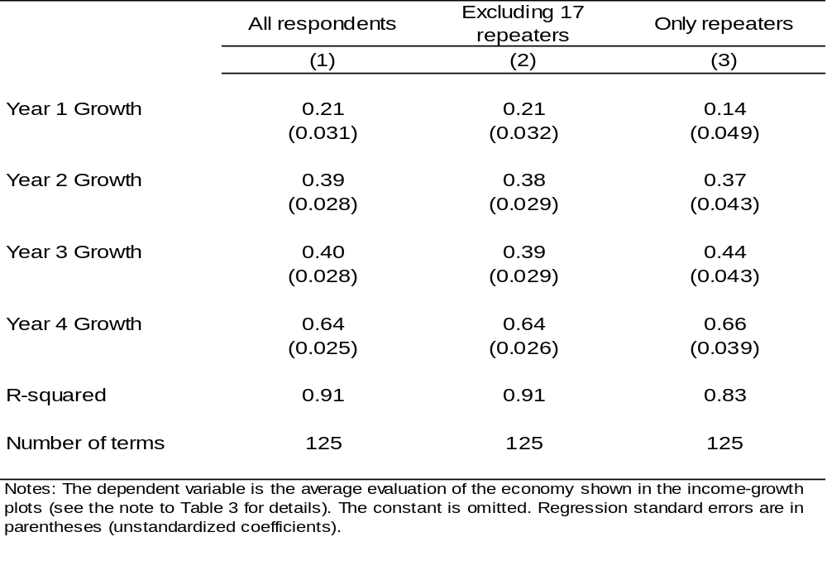
Notes: Pooled analysis of the five experiments that showed participants randomly drawn yearly income growth. The dependent variable is the average valuation of the economy shown in the income-growth plots (rescaled to vary between 0-10). Constant not shown. Fixed effects for study included but not shown. Regression standard errors in parentheses (unstandardized coefficients).

2. Excluding repeat IP addresses within study
Another potential concern with Mechanical Turk is with the same people taking the same study more than once. Although Mechanical Turk workers are not permitted to do so, they could create multiple worker accounts, and then take the study once from each account. Doing so violates Amazon.com's user agreement, but it is nevertheless a potential concern. Across the five yearly-growth studies we have pooled above for the trends and peaks analysis, we searched for possible repeat takers by checking for duplicate IP addresses within studies. Although distinct workers could have the same IP address for innocent reasons — because they are from the same household, workplace, or even Internet provider — they could also reflect repeat takers. This analysis suggests that repeat taking within study is again not a problem. Across the five studies (283 participants), six IP addresses total were repeated twice within the same study, and one IP address was repeated three times. Column 1 in the table below shows the results for all participants. Column 2 shows that the results remain the same when we exclude these within-study repeat IP addresses.

 | (1) | (2)
DV: Economic evaluations | All participants | Excluding the seven, within-study, repeat IP addresses
Year 1 Growth | 0.21 | 0.21
 | (0.031) | (0.032)
Year 2 Growth | 0.39 | 0.38
 | (0.028) | (0.028)
Year 3 Growth | 0.40 | 0.39
 | (0.028) | (0.028)
Year 4 Growth | 0.64 | 0.64
 | (0.025) | (0.025)
Observations | 125 | 125
R-squared | 0.913 | 0.912
SER | 0.62 | 0.63
Notes: Pooled analysis of the five experiments that showed participants randomly drawn yearly income growth. The dependent variable is the average valuation of the economy shown in the income-growth plots (rescaled to vary between 0-10). Fixed effects for study included but not shown. Regression standard errors in parentheses (unstandardized coefficients).

VI. Experimental Instructions and Related Information

A. Recruitment language for Mechanical Turk studies
For all Mechanical Turk studies except for the one that eliminated any mention of politics (Study C2), the recruitment language was as follows:
Title: Answer questions about the economy under US presidents! Usually takes less than 4 minutes.
Description: | Contribute to research!
Keywords: | survey, economy, quick, easy
Qualification Requirement: | Location is UNITED STATES (Required for preview)  HIT approval rate (%) greater than or equal to 95 (Required for preview)

Answer questions about the economy under US presidents! Usually takes less than 4 minutes.
You can find the survey here:
Click here to take a survey.
At the end of the survey, you'll find a code. To get paid, please enter the code below:

For Study C2, the recruitment language was slightly modified in the sentence following the qualification requirement. The language for that study is below:
Title: Answer questions about the economy! Usually takes less than 4 minutes.
Description: | Contribute to research!
Keywords: | survey, economy, quick, easy
Qualification Requirement: | Location is UNITED STATES (Required for preview)  HIT approval rate (%) greater than or equal to 95 (Required for preview)
Answer questions about the economy! Usually takes less than 4 minutes.
You can find the survey here:
Click here to take a survey.
At the end of the survey, you'll find a code. To get paid, please enter the code below:

B. Description of task for Mechanical Turk studies

Description of the task in historical income growth study (B1):
Evaluate the economy under 17 hypothetical presidents who are serving in their second terms.
On the following pages, you will see figures with measurements of how much better off people are during hypothetical U.S. presidents' terms. The figures only show the economy for presidents in their second terms.
After looking at each figure, evaluate the economy.
Thank you so much for your time. Your responses are very important to us.

Description of the task in hypothetical income growth study (B2):
Evaluate the economy under 25 hypothetical presidents who are serving in their second terms.
On the following pages, you will see figures with measurements of how much better off people are during hypothetical U.S. presidents' terms. The figures only show the economy for presidents in their second terms.
After looking at each figure, evaluate the economy.
Thank you so much for your time. Your responses are very important to us.

Description of task when there was no mention of politics (Study C2):
Now, we would like you to evaluate the economy during four-year periods.
On the following page, you will see figures showing measurements of how much better off people were during 25 four-year periods. The measurements shown are percent change in personal income growth for each year. They provide a good measure of the strength of the national economy.
After looking at the figure, evaluate the economy during this period. Would you say it is very good, fairly good, fairly bad, or very bad?

Description of task for the percent change and cumulative percent change condition (Study D1):
In the percent change condition (the control condition), the language was the same as on the one shown two pages later where presidents were labeled as being in their second terms.
Evaluate the economy under hypothetical presidents who are serving in their second terms.
On the following pages, you will see figures with measurements of how much better off people are during hypothetical U.S. presidents' four-year terms. The figures only show the economy for presidents in their second terms.
The measurements shown are percent change in personal income growth, which provides a good measure of the strength of the national economy.
We show percent change in personal income growth in two ways: yearly and cumulatively. The cumulative growth figures simply add together the yearly income growth. For example, if personal income growth grew 2% in each year of a presidents four-year term, cumulative growth would be (4*2% = 8%).
After looking at each figure, evaluate the economy during this period. Would you say it was very good, fairly good, fairly bad, or very bad?
Thank you so much for your time, your responses are very important to us.

Please note: As we describe earlier in the SI, we replicated this study with more instructions for yearly income growth and with minimal instructions (no explanation of yearly or cumulative growth). The replication study also asked about the president's handling of the economy, not “evaluating the economy during this period.”

Description of task for the percent change and level condition (Study D2):
In the percent change condition (the control condition), the language was the same as on the one shown on the next page where presidents were labeled as being in their second terms.
Evaluate the economy under hypothetical presidents who are serving in their second terms.
On the following pages, you will see figures with measurements of how much better off people are during hypothetical U.S. presidents' four-year terms. The figures only show the economy for presidents in their second terms.
Each figure presents measurements of personal income, which provides a good measure of the strength of the national economy. It presents the information on personal income in two ways.
First, it shows percent change in personal income growth, calculated on a yearly basis.
Next, it shows per capita personal income at the end of each year (after taxes and government transfers, and adjusting for inflation). During periods shown, yearly personal income ranges from about $31,000 to about $37,000.
After looking at each figure, evaluate the economy during this period. Would you say it was very good, fairly good, fairly bad, or very bad?
Thank you so much for your time, your responses are very important to us.

Please note: As we describe earlier in the SI, we replicated this study with minimal instructions. The replication study also asked about the president's handling of the economy, not “evaluating the economy during this period.”

Description of the task with the president’s term unspecified (for replication studies):
On the following pages, you will see figures with measurements of how much better off people are during hypothetical U.S. presidents' four-year terms.
The measurements shown are percent change in personal income growth, calculated on a yearly basis. They provide a good measure of the strength of the national economy.
After looking at each figure, evaluate the economy during this period. Would you say it was very good, fairly good, fairly bad, or very bad?
Thank you so much for your time. Your responses are very important to us.
Wording was changed for studies about governors and about crime.

Description of task for studies where presidents were labeled as second term (for replication studies):
Evaluate the economy under hypothetical presidents who are serving in their second terms.
On the following pages, you will see figures with measurements of how much better off people are during hypothetical U.S. presidents' four-year terms. The figures only show the economy for presidents in their second terms.
The measurements shown are percent change in personal income growth, calculated on a yearly basis. They provide a good measure of the strength of the national economy.
After looking at each figure, evaluate the economy during this period. Would you say it was very good, fairly good, fairly bad, or very bad?
Thank you so much for your time, your responses are very important to us.

C. Mechanical Turk validation

1. Published validation studies
Mechanical Turk (MTurk) allows researchers to recruit and pay participants for participating in web-based studies. Although initially set up by Amazon.com to collect data for basic tasks such as recognizing products in pictures, it has expanded and people now post jobs of numerous sorts, including social science experiments. As we describe below, MTurk samples are more diverse than typical experimental samples, not that different on many demographic and political variables from nationally representative samples, and appear to be more attentive than other samples. Researchers have successfully replicated many experiments and published MTurk validation studies in several fields, including political science.
Berinsky, Huber, and Lenz (published in Political Analysis), attempts to validate MTurk samples on external and internal validity grounds. To assess external validity, it compares MTurk samples to typical convenience samples used in experiments (other Internet panels, undergrad volunteers, recruits off the street) as well as nationally representative Internet surveys (e.g. Knowledge Networks) and face-to-face surveys (ANES and CPS). On demographics and political attitudes, we find that MTurk samples are often more representative than the convenience samples. Although obviously not as nationally representative as the ANES or CPS, MTurk samples are not that different from Knowledge Networks on these variables (the principal exception is age and variables related to age such as income). To further assess external validity, Berinsky, Huber, and Lenz also replicated three well-known experiments with MTurk samples. Finally, they examined the potential problem of "habitual customers"—participants who take part in numerous social science studies and so could become unrepresentative of citizens. Examining seven large MTurk samples conducted over five months, we found that only about 2% of participants fell in this category.
Berinsky, Huber, and Lenz also examines attentiveness, which is a concern not just with MTurk but with most experimental subject pools. Compared with other samples, however, MTurk participants appear to be more attentive, not less so. Since individuals requesting workers ("Requesters") often specify at least a 95% prior "approval rate" – that is, Requesters accepted 95% or more of the work previously submitted by an individual—MTurk workers have an incentive to read instructions carefully and consider their responses. As Berinsky, Huber, and Lenz report, our own experiences are consistent with this expectation. In one study, the authors asked participants to identify the political office held by a person mentioned in a story they had just read. The format of this question was multiple choice with five possible responses. On the MTurk study, 60% of the respondents answered the question correctly. An identical question concerning the same article was also included on experiments run through Polimetrix/YouGov and Survey Sampling International (SSI). The correct answer rates on these platforms were markedly lower than in the MTurk sample – 49% on Polimetrix/YouGov and 46% on SSI.
The attentiveness of MTurk participants is also evident in direct tests of attention. To ensure that participants were reading instructions, we included trick questions in all our studies. Here is a typical example:
We are interested in learning about your preferences on a variety of topics, including colors. To demonstrate that you've read this much,
just go ahead and select both green and yellow among the alternatives below, no matter what your favorite color is. Yes, ignore the question below and select both of those options.
What is your favorite color?
- pink
- red
- green
- white
- yellow
- blue

MTurk participants pass these tests at substantially higher rates than do participants in other samples. In an MTurk experiment just conducted by the authors, 93% passed the color test. On a harder attention test, which asked about which of many news media sources individuals read (but deep in the question told them to demonstrate their attention by selecting two in particular) 81% passed. When the same questions were included on a recent SSI survey by Berinsky, Margolis, and Sances, however, the proportion passing was more than 20 percentage points lower: only 69% passed the color test and only 59% passed the news test.
In addition to the Berinsky, Huber, and Lenz article, several articles now validate MTurk in other fields, reaching similar conclusions. In a paper published in Perspectives on Psychological Science, Buhrmester, Kwang, and Gosling conclude:
(a) MTurk participants are slightly more representative of the U.S. population than are standard Internet samples and are significantly more diverse than typical American college samples;
(b) participation is affected by compensation rate and task length but participants can still be recruited rapidly and inexpensively;
(c) realistic compensation rates do not affect data quality; and
(d) the data obtained are at least as reliable as those obtained via traditional methods.

Largely the same conclusions are reached in a paper recently published in Judgment and Decision Making . Finally, the journal of Experimental Economics has published an evaluation of MTurk for economic experiments that also successfully replicates previous studies and reaches similar conclusions about the strengths of MTurk.
In part because four validation studies have now been published or are forthcoming, MTurk appears to be rapidly gaining acceptance. Quantifying the number of published social sciences articles using MTurk is hard, but Google scholar now lists 981 social science papers that refer to Mechanical Turk. Political science journals publishing with MTurk samples include World Politics and Political Psychology . In psychology, where time to publication is quicker, JPSP and Psych Science (arguably the top two journals) have now published 15 article using MTurk . The prestigious journal PNAS has just published two papers with experiments using MTurk samples . .

2. Citations for MTurk validation studies and selected MTurk publications
Alter, Adam L., Daniel M. Oppenheimer, and Jeffrey C. Zemla. 2010. "Missing the Trees for the Forest: A Construal Level Account of the Illusion of Explanatory Depth." Journal of Personality and Social Psychology 99(3): 436-51.
Berinsky, Adam J., Gregory A. Huber, and Gabriel S. Lenz. 2012. "Evaluating Online Labor Markets for Experimental Research: Amazon.Com's Mechanical Turk." Political Analysis. 20(3): 351-68.
Brady, Timothy F., and George A. Alvarez. 2011. "Hierarchical Encoding in Visual Working Memory: Ensemble Statistics Bias Memory for Individual Items." Psychological Science 22(3): 384-92.
Buhrmester, Michael D., Tracy Kwang, and Samuel D. Gosling. 2011. "Amazon's Mechanical Turk: A New Source of Inexpensive, yet High-Quality, Data?" Perspectives on Psychological Science 6(1): 3-5.
Fausey, Caitlin M., and Teenie Matlock. 2011. "Can Grammar Win Elections?" Political Psychology 32(4): 563-74.
Gómez, Ángel, Matthew L. Brooks, Michael D. Buhrmester, Alexandra Vázquez, Jolanda Jetten, and William B. Swann, Jr. 2011. "On the Nature of Identity Fusion: Insights into the Construct and a New Measure." Journal of Personality and Social Psychology 100(5): 918-33.
Horton, John J., David G. Rand, and Richard J. Zeckhauser. 2010. "The Online Laboratory: Conducting Experiments in a Real Labor Market." Experimental Economics 14(3): 399-425.
Lawson, Chappell, Gabriel S. Lenz, Michael Myers, and Andy Baker. 2010. "Looking Like a Winner: Candidate Appearance and Electoral Success in New Democracies." World Politics 62(4): 561-93.
Mason, Winter, and Duncan J. Watts. 2011. "Collaborative Learning in Networks." Proceedings of the National Academy of Sciences.
Norton, Michael I., Lalin Anik, Lara B. Aknin, and Elizabeth W. Dunn. 2011. "Is Life Nasty, Brutish, and Short? Philosophies of Life and Well-Being." Social Psychological and Personality Science 2(6): 570-75.
Paolacci, G., J. Chandler, and P.G. Ipeirotis. 2010. "Running Experiments on Amazon Mechanical Turk." Judgment and Decision Making 5(5).
Rand, David G., Samuel Arbesman, and Nicholas A. Christakis. 2011. "Dynamic Social Networks Promote Cooperation in Experiments with Humans." Proceedings of the National Academy of Sciences 108(48): 19193-98.

3. Mechanical Turk demographics
We did not collect demographics for our studies on Mechanical Turk (MTurk), but have done so for other studies. As we noted above, Berinsky, Huber, and Lenz (forthcoming) compare MTurk demographics and standard political questions to the Current Population Study (CPS) and the American National Election Study (ANES). They summarize the results as follows:
All told, these comparisons reinforce the conclusion that the MTurk sample does not perfectly match the demographic and attitudinal characteristics of the U.S. population, but does not present a wildly distorted view of the U.S. population either. Statistically significant differences exist between the MTurk sample and the benchmark surveys, but these differences are substantively small. MTurk samples will often be more diverse than convenience samples and will always be more diverse than student samples .

4. Attention to task and screener questions
Since Mechanical Turk workers become increasingly ineligible for tasks when their work is rejected, they are incentivized and selected to be attentive, which is evident in their high rates of success on manipulation checks . Neither the students used in experimental work, nor respondents in Internet panels face similar incentives or selection processes.
To screen out Mechanical Turk workers who were not paying attention, we asked one of the following questions during the studies. About 10% of participants failed to pass these tests. We excluded these respondents before conducting the analysis (though the results are essentially unchanged if we include them).
Favorite number test
I understand that this survey will test my reading comprehension (really whether I'm reading at all). I understand that the questions will be a bit tricky. To demonstrate that you've read this much, just go ahead and select both one and two among the alternatives below, no matter what the question asks. Yes, ignore the question below and select both of those options.
Which number is the largest?
1.
2.
3.

Favorite color test (already noted above)
We are interested in learning about your preferences on a variety of topics, including colors. To demonstrate that you've read this much, just go ahead and select both green and yellow among the alternatives below, no matter what your favorite color is. Yes, ignore the question below and select both of those options.
What is your favorite color?
pink
red
green
white
yellow
blue

We chose to show the income-in-levels plots after showing the yearly-percent-change plots because the former are unusual, not what people typically see in the news, and might prompt people to react differently to the yearly growth plots. The level plots showed only income in levels. With an even larger sample, it could make sense to randomize the order.
We also estimated regressions with subject fixed effects and found similar results: the same people who put relatively more weight on the last year in the yearly growth plots did not do so when, just several minutes later, they evaluated the level plots.
As we mentioned in the article, we calculate growth with natural logs, so that cumulative growth is the sum of yearly growth. Of course, we did not explain this technicality to participants. One might be concerned that mathematically sophisticated participants would have been confused on this point. In open-ended responses at the end of the study, however, no participants mentioned this point and almost all passed a test where they had to calculate cumulative growth at the end of the study.

