CHAPTER 2
REVIEW OF RELATED LITERATURE

This chapter presents various related works, articles, journals, and studies related to this study entitled "Learning style and academic performance of Social Studies major students in Mabini Colleges Inc." These are conducted by various proponents of such related literary works that can support the study for further findings and development.

The first part presents the related literature and related studies; the second part presents the synthesis of the state-of-the-art; the third part presents the conceptual framework, and the fourth part presents the theoretical framework. This study focuses on one theories: Vark Theory, and Multiple Intelligences Theory. The last part provides the definition of terms.

Review of Related Literature
Foreign
It is vital to identify the learning styles of the students, make them aware of their learning preferences, and design the activities accordingly to facilitate a positive and effective learning process aimed at improving academic achievement (Kubat et al.,2020). In this regard, learning style, which is termed Learning Preferences (LP), is the way in which individuals begin to focus, process, internalize, and retain new and complex information. Thus, this study aims to identify LP among students of middle secondary school and examine the relationship between LP and study. Approaches (SA) and their academic performance.

According to James & Blank (2007), learning style is the way in which learners perceive, process, store and recall information efficiently and effectively and a wide range of learning influenced by factors such as time of day, temperature or lighting, and structural options, including learning individually, with adults, peers, or in mixed groups (Fleming,2012). These variations point towards the importance of the use of flexible and learner-centered principles in modern education systems.

Learning styles help learners to be aware of their preferred ways of learning and integrate those learning styles during the learning process (Awla, 2014). This approach makes learning more efficient and effective, enabling students to grasp concepts faster and solve problems more effectively. The traditional learning process is ineffective and does not take into account the diverse learners and their learning styles (Faryadi, 2018). These limitations in traditional methods indicate
the need for instructional strategies that cater to different student profiles.

In the Bhutanese education system, too, the traditional system was claimed to be passive and static, while the current system is secular, innovative, creative, and progressive (Phuntsho, 2000). This shift illustrates Bhutan's efforts to maintain its education practices, aligning with the global trends stressing student interaction and creativity. To enhance student learning, teachers need to take into account individual learning styles. There should be communication with the students before the lesson delivery, and take note of their needs and interests during the process of teaching and learning.

As stated by Fleming & Mills (1992), visual learners learn best through the use of visual aids like maps, charts, and diagrams. Aural learners learn best when they explain ideas and discuss and listen to the explanations. Read/write learners prefer to learn through note-taking, printed handouts, or web pages. Kinesthetic learners learn through hands-on experience and activities like field trips or laboratory experiments. Students may have one dominant preference or may exhibit multiple modes of learning (Fleming, 1995). Being aware of these preferences can help teachers design instruction that works best for how students learn.

Individual learning preferences significantly differentiated the achievement of the students in Mathematics (Bosman et al. 2019). Similarly, the preferred learning styles of students are aural and kinesthetic. With the smallest preference given to visual, while higher achievers preferred Kinesthetic mode of learning (Md. Zain, et al. 2021). This suggests that active and experiential learning approaches may have beneficial impacts on academic achievement among certain students.

According to Md. Zain et al. (2019), students who preferred Visual (V) and Kinesthetic (K) learning styles positively and significantly influenced students’ academic performance. Hence, it is recommended that teachers and educators adopt the use of differentiated instruction during the teaching and learning process (Kado et al., 2021). This can help teachers create inclusive settings to meet diverse learning needs and enhance overall student achievement.

In the deep approach, the students actively relate their ideas to the learning principles (Pask,1988), use evidence and examine its logic, and continue to monitor their own level of understanding (Entwistle, 2000). In the strategic approach, students aim to achieve the highest scores possible. This involves good time management and study organization (Liew, 2015). Hence, they pay more attention to the content as well as assessment requirements. In the surface approach, the learning of the students is restricted to rote learning, as their intention is merely to complete the task. This type of learning is not typically followed by long-term retention and critical engagement with the course materials. The deep and strategic approach has been reported to be associated with better academic outcomes as compared to those with the surface approach (Entwistle, 2000).

The study of Rabgay (2015) revealed that Bhutanese learners are aware of the learning strategies, but they are not consistently applying them in their learning, which may have an influence on their academic performance. Thus, it is suggested that students are to be guided to understand their study attitude and study habits, and identify their weaknesses and strengths, so as to adopt better learning habits strategies for a positive outcome.

Assessment is a goal-oriented approach that affects the way students learn and
subsequently determines the learning outcomes (OECD, 2008). Students often modify their learning approaches as per the demands of the assessment. Brown et al. (2015) found that students had three learning styles (Deep, Strategic, and Surface) with a surface approach as the dominant approach. However, males had higher means for the strategic approach compared to females, with no differences gender-wise for deep and surface approaches.

For instance, Bunce et al. (2017) surveyed the respondents using M-ASSIST (Modified Approaches and Study Skills Inventory), in which the deep approach was adopted by A/B graded students and the surface approach was adopted by D/F achievement, while C groups were reported to have SA intermediate between higher and lower grade groups. Welch (2013) revealed that deep and strategic approaches to study were more inclined towards achieving academic success, whereas a surface approach to study was inclined towards poorer performance.

On the contrary, Liew et al. (2015) revealed that most of the high achievers had unimodal learning, with the majority of them having a Kinesthetic type of LP and were strategic/deep learners. Neither the LP nor the SA was significantly associated with academic performance. This means that while there may often be observed LP and SA among successful students, these do not predict outcomes on a statistically significant scale.

Local
Education plays a vital role in contributing greatly to society’s economic prosperity and harmony. United Nations Educational, Scientific, and CulturalOrganization (UNESCO, 2014) focuses on how to promote different approaches tolearning and claims that education transformation is required at large, which caters to all learners’ needs, abilities, expectations, and styles.
Academic performance remains a significant concern in the Philippines, where many students struggle to meet curriculum expectations, particularly in comparison to international standards. Recent data from UNESCO sheds light on a troubling gap: the top 25% of Filipino students perform similarly to the lowest quarter of students in Singapore (EDCOM II, 2024). This disparity aligns with findings from the World Bank (2021), which reveal that approximately 91% of Filipino secondary students do not achieve the expected proficiency in essential macro-skills, resulting in the lowest academic outcomes in Southeast Asia.

Further compounding these issues, results from the Program for International Student Assessment (PISA) indicate that nearly 72% of Filipino students exhibit low academic performance in reading, mathematics, and science (Gutiérrez et al., 2019). Therefore, it is crucial to address these deficiencies to enhance educational quality and produce competent graduates who can contribute meaningfully to society (Magpily & Mercado, 2018; Albarico et al., 2023).

Review of Related Studies
Foreign
Individual preferences and tendencies that impact how students perceive, process, and retain knowledge are learning styles. Educators can customize their educational approaches to better meet the requirements of diverse learners by identifying and accommodating these preferences. Each student has an individual predisposition toward certain learning styles, techniques, and degrees of learning (Ariastuti & Wahyudin, 2022).
Students' success in the learning process and achieving high academic results can also be influenced by their predominant learning style or the combination of two of the learning styles. Some students may have a predominantly visual learning style and learn through diagrams, pictures, and graphs, while others may have an auditory style and learn through lectures (Hagart et al., 2022).

Shamsuddin, and Kaur (2020) define learning style as a distinctive way of acquiring knowledge, skills, or attitudes through study. For a teacher, learning styles can help identify and solve students’ learning problems (Shah et al., 2022). This will encourage students to learn more effectively, and the teacher will be able to choose educational material that resonates with their learning style.

It is plausible that the root of the issue lies in the misalignment between teachers' instructional methods and the students' preferred learning styles and study approaches. Although teachers are trained by the two training colleges on the latest teaching strategies, and further enhanced through the provision of in-service professional development programs. (Ministry of Education,2020)

However, it is crucial to focus that learning styles are only one component of the complicated learning process, and their impact on student results is currently being debated and researched (Akbar, et al., 2020). Therefore, it is essential to find more efficient ways of teaching and accommodating different styles of students through a learning environment that they prefer. The learning styles model acknowledges that students learn in various ways, even though there are a variety of general concerns connected to learning styles.

Nevertheless, students may encounter learning difficulties when they lack a suitable learning style. Students find it more challenging to understand the subject or course when there is no alignment between their preferred learning style and the instructional activities and techniques that lecturers utilize, which may lead to difficulties in the learning process (Lingua, 2021).

While learning style may not directly affect academic achievement, some researchers argue that it can still influence student engagement and motivation. Liu et. al. (2024) found that students felt more satisfied and engaged when their learning preferences were acknowledged, potentially supporting better long-term learning outcomes. Thus, while grades may not immediately improve, motivation and interest may increase with preferred instructional approaches.

Other scholars, such as Migdadiy, et.al. (2023), caution against dismissing learning styles entirely based on a single p-value. They argue the relationship between learning style and performance is complex and context-dependent, influenced by factors like teaching methods, content type, and student background. This suggests that learning styles may still play a role in specific educational settings, even if not broadly evident in performance metrics.
Local
The alignment of teaching styles with pupils' learning styles is a critical factor in determining academic performance. Carbonel (2021) highlights, when there is a disconnect between how a teacher imparts knowledge and how a student absorbs it, it can lead to a range of challenges.

Similarly, Anderson et al. (2022) found that auditory tools, such as podcasts, improve understanding of complex subjects. However, Fleming and Baume (2020) argue that relying solely on auditory methods is less effective than using a variety of strategies. Despite this, a significant portion of students still prefer learning through listening, suggesting that educators should include verbal instruction and audio materials in teaching practices.

Davidson et al. (2023) stated that advocates for including kinesthetic strategies, especially for learners in vocational or applied subjects. Nevertheless, critics such as Fallace (2023) argue that kinesthetic learning has a limited impact in traditional academic settings. Sauro (2022) also found that a preference for kinesthetic learning does not necessarily lead to better academic outcomes. These findings suggest that while kinesthetic learning is effective for some, it is best used as part of a broader, integrated instructional approach.

Moreover, Ariem and Cabal (2021) argue that misalignment between teaching styles and pupils’ learning styles can result in difficulties in comprehension and retention, as the teaching approach may not resonate with every student's cognitive preference.

As stated by Ariem and Cabal (2021), findings, it becomes evident that the dynamics between teaching styles and academic success are not only significant but extend across various subject areas, including science. This underscores the broader relevance of adapting teaching approaches to enhance student understanding and performance. The correlation observed in these studies emphasizes the need for educators to be cognizant of their teaching styles, ensuring alignment with students’ learning preferences and subject-specific demands.

The study of Edwards (2024) highlights that UDL improves student performance by offering multiple ways of engagement, representation, and expression, benefiting all students regardless of learning style preference.

A study analyzed the impact of learning styles on nursing students' academic achievement, revealing that converging learning styles were linked to better academic performance. This suggests that teaching strategies that align with students' learning preferences can enhance educational outcomes (Goltash et al., 2021).

Theoretical framework
This study is anchored and supported by the following theories and principles.
VARK theory is a learning preference model which indicates that "students have different preferences in the assimilation and processing of information". The VARK learning style model introduced by Fleming includes a questionnaire that identifies a person's sensory modality preference in learning. This model classifies students into four different learning modes; visual (V), aural (A), read/write (R), and kinesthetic(K).
Howard Gardner Multiple Intelligences Theory (MI) is highly significant and relevant to the concept of learning styles because it proposes a much broader view of human intelligence. Gardner’s Theory of Multiple Intelligences proposes that intelligence is not a single ability but a collection of distinct types. He identified eight intelligences, including linguistic, logical-mathematical, spatial, musical, bodily-kinesthetic, interpersonal, intrapersonal, and naturalistic. Gardner’s theory suggests that everyone has different strengths and learning styles across these areas. VARK highlights the diversity in sensory modalities, classifying learning preferences into Visual, Aural, Read/Write, and Kinesthetic. Gardner’s MI theory broadens this scope by proposing that intelligence is not singular, but a collection of distinct strengths—such as linguistic, spatial, and bodily-kinesthetic—across which individuals naturally vary. These theories establish a crucial theoretical foundation.

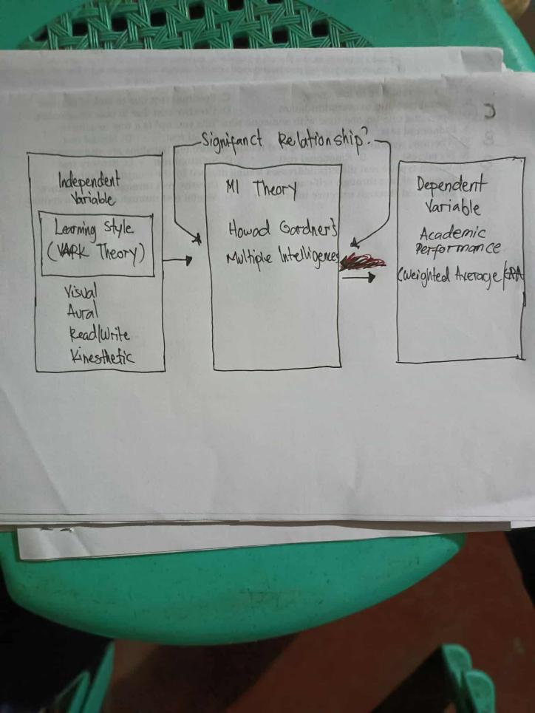
Definition of terms
For a better understanding of their usage in the context of this study, key terminology connected to the study were specified.
Visual. Students predisposing with this style are likely to be provided with demonstration and can learn through description. These students prefer to use list to maintain their advance rate in learning as well as arranging their ideas and mind. Apart from that, visual students are easy to be disturbed or change in focus by movements or actions, where as, noise, usually do not bother them (Drago & Wagner 2004).
Aural. Students learn something by listening. These students give more attention to the words delivered by teachers. They prefer to listen than writing lecture notes. After lectures end, they choose to discuss topics which were taught with classmates, as a way to clarify their understanding. (Drago & Wagner 2004).
Kinesthetic. Although measured as a separate category in VARK, learning through kinesthetic is a measurement mode, regarded to the combination of various sense functions. Priority kinesthetic referring to learning achieved using experience and practice. In other words, kinesthetic students should go through experience to learn something (Murphy et al. 2004).
Reading and Writing. This emphasized text-based input and output – reading and writing in all its form but especially manuals, reports, essays, and assignments. (Neil Fleming 1987.)

NOTES

Combong, J. L., & Napil, M. C. (2025). Writing apprehension and learning style as predictors of academic performance in Filipino students. American Journal of Education & Technology, 4(2). https://doi.org/10.54536/ajet.v4i2.4484

Pradhan, S., Wangmo, C., Dorji T., S., Wangdi, N., & Lhendup, U. (2025). Learning Preferences (VARK) and Study Approaches (ASSIST) of Middle Secondary School Students in Relation to their Academic Performance in Science. Bhutan Journal of Research and Development, 14(1). https://doi.org/10.17102/bjrd.rub.14.1.007

Subramaniam, G., Jaafar, M. S. bin, & Sapri, R. binti. (2023). Exploring learning style and learning outcome of students at Polytechnic Sultan Idris Shah. International Journal of Academic Research in Progressive Education and Development, 12(3), 1874-1885. https://doi.org/10.6007/IJARPED/v12-i3/19287

Lincă, F. I., & Matei, L. (2024). Learning styles and academic performance among students. RA – Theory and Practice in Action (RAFT), 9, Article 0006. https://doi.org/10.2478/raft-2024-0006

Pradhan, S., Wangmo, C., Dorji, T. S., Wangdi, N., & Lhendup, U. (2025). Learning Preferences (VARK) and Study Approaches (ASSIST) of Middle Secondary School Students in Relation to their Academic Performance in Science. Bhutan Journal of Research and Development, 14(1). https://doi.org/10.17102/bjrd.rub.14.1.007
Subramaniam, G., Jaafar, M. S. bin, & Sapri, R. binti. (2023). Exploring learning style and learning outcome of students at Polytechnic Sultan Idris Shah. International Journal of Academic Research in Progressive Education and Development, 12(3), 1874-1885. https://doi.org/10.6007/IJARPED/v12-i3/19287

Clavido, G., & Macalisang, D. S. (2024). Teaching styles and pupils’ learning styles: Their relationship with pupils’ academic performance. Spring Journal of Arts, Humanities and Social Sciences, 3(2), 11-15. https://doi.org/10.55559/sjahss.v3i2.221

De Jesus, D. A. D. (2024). The benefits of effective teaching style for HUMSS students at Liceo De Pulilan Colleges: A quantitative study. NPRC Journal of Multidisciplinary Research, 1(4), 159-171. https://doi.org/10.3126/nprcjmr.v1i4.70963

Chapter3
RESEARCH METHODOLOGY
This chapter describes the method of research, research design, the respondents of the study, the instrument used, data gathering procedures, and statistical treatment of data.
Method of Research
This study employs a quantitative approach using a correlational research design to examine the learning style and academic performance of Social Studies major students in Mabini Colleges Inc.The research aims to assess how the frequency and nature of learning style and academic performance of Social studies students.By collecting data and using statistical analysis, the study seeks to identify whether a significant relationship exists between learning style and academic performance. The correlational design allows the researchers to determine the strength and direction of this relationship, providing valuable insights into how learning style affects their academic performance.
The correlational research design allows the researchers to explore the strength and direction of the learning styles and academic performance of Social studies students, without manipulating either of the variables. By observing these variables in their natural setting, the study will identify whether the different learning styles contribute in the better academic outcomes of Social studies students.This design is appropriate because it enables the measurement of the degree of correlation between two naturally occurring variables (learning style and academic performance).
The data for this study will be collected through a structured survey questionnaire that includes sections designed to measure students' frequency of learning style, academic performance, and their relationship with each other. The questionnaire will assess both the students' learning style ( what learning style are more oftenly used) and their academic performance. Statistical methods such as Pearson correlation analysis will be used to determine the strength and direction of the relationship between the variables.
In addition, a review of relevant literature will be conducted to contextualize the study. Previous research, such as (Fleming & Mills, 1992) visual learners learn best through the use of visual aids like maps, charts, diagrams. Aural learners learn best when they explain ideas and discuss and listen to the explanations. Read/write learners prefer to learn through note-taking, printed handouts, or web pages. Kinesthetic learners learn through hands-on experience and activities like field trips, or laboratory experiments. Students may have one dominant preference or may exhibit multiple modes of learning (Fleming, 1995). Being aware of these preferences can help teachers design instruction that works best for how students learn best. This findings support the rationale for exploring the learning style and academic performance of students in this study.
Data Gathering Procedure
For this study, data were gathered using a structured questionnaire designed to assess the learning style and academic performance of Social Studies major students in Mabini Colleges Inc. The questionnaire consisted of 30 items, which were carefully developed to measure various aspects of learning style and academic performance of social studies major students.
The questionnaire was administered in person by the researchers to ensure that participants understood the instructions and had the opportunity to seek clarification if needed. The items in the questionnaire were divided into two sections: the first focused on the frequency and nature of learning styles (e.g., audio, visual, kinesthetic and reading and writing ), and the second assessed the participants' academic performance.
The responses were collected using a Likert scale, with options ranging from "Strongly Disagree" to "Strongly Agree," allowing the researchers to quantify the data and identify patterns in the learning style and academic performance of social studies students.
To ensure the reliability and validity of the data, the researchers provided clear instructions on how to complete the questionnaire and ensured that all responses were confidential and for academic purposes only. The completed questionnaires were then retrieved, and the data were compiled for subsequent analysis.
Research Instrument
The primary data collection tool used in this study was a structured questionnaire consisting of 30 questions, which served as the main method for data collection to evaluate the association between learning styles and academic performance of Social Studies majors at Mabini Colleges.
The first part of the survey asked questions about the participants' learning style and academic performance,…………..

