**Stock market analyst**

**INSTRUCTIONS :**

1. Create a script that will loop through all the stocks for one year and output the following information.

* The ticker symbols.
* Yearly change from opening price at the beginning of a given year to the closing price at the end of that year.
* The percent change from opening price at the beginning of a given year to the closing price at the end of that year.
* The total stock volume of the stock.

1. You should also have conditional formatting that will highlight positive change in green and negative change in red.

**CHALLENGE:**

1. Your solution will also be able to return the stock with the "Greatest % increase", "Greatest % decrease" and "Greatest total volume".
2. Make the appropriate adjustments to your VBA script that will allow it to run on every worksheet, i.e., every year, just by running the VBA script once.

* 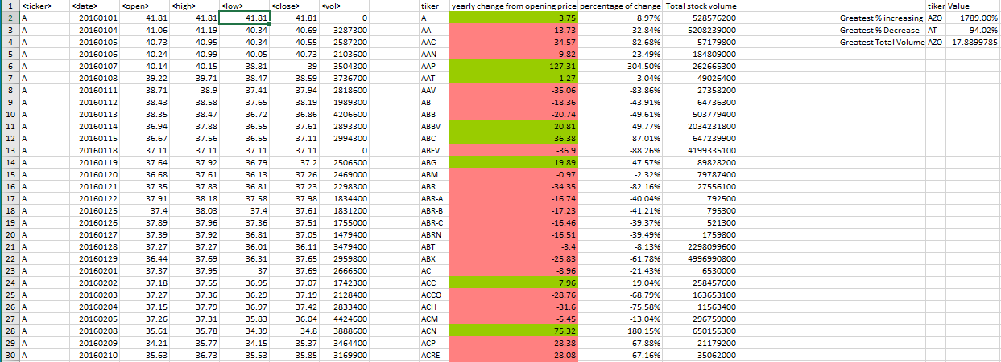Stock Market Analysis screenshot:

