Steps to host on AWS

Please upload the entire payment code folder to AWS EC2 instance with the following configuration:

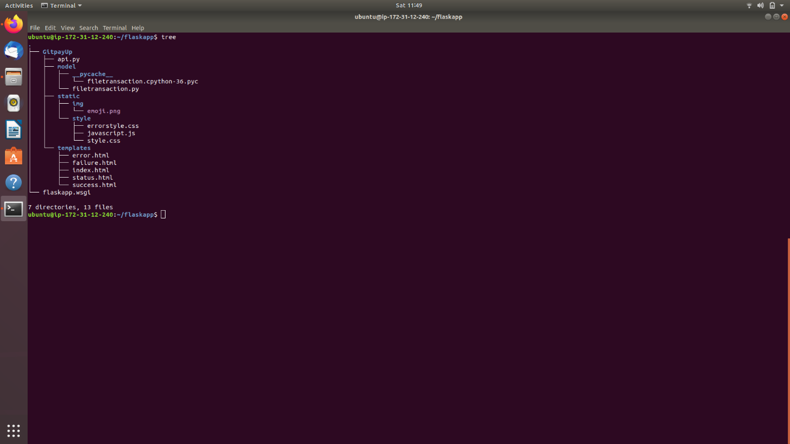

Add the following code to /etc/apache2/sites-enabled/000-default.config in the EC2

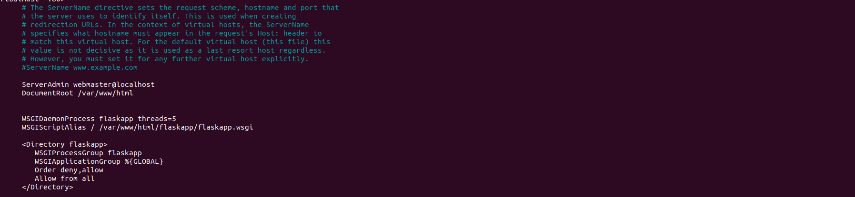

Payments Page Screen

1)Payment page

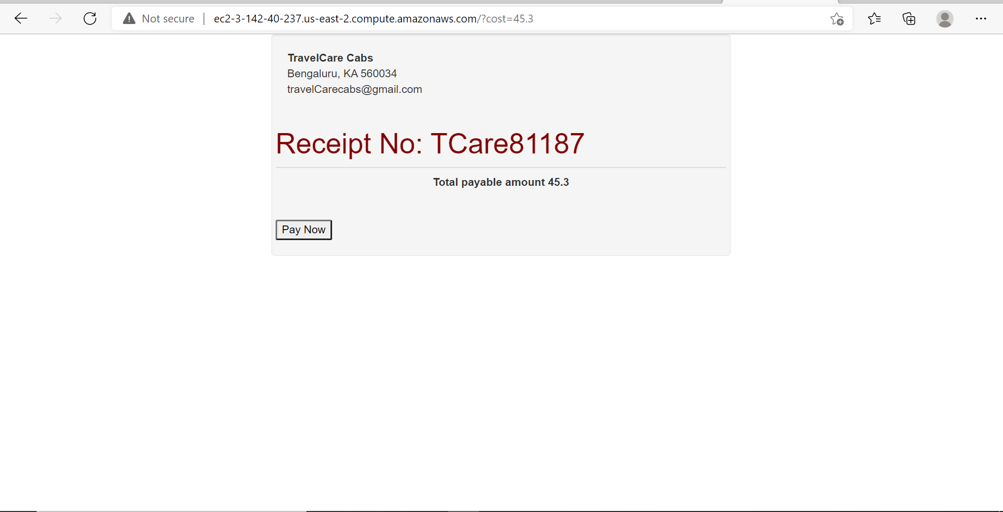

2)Redirecting to PayUbiz portal

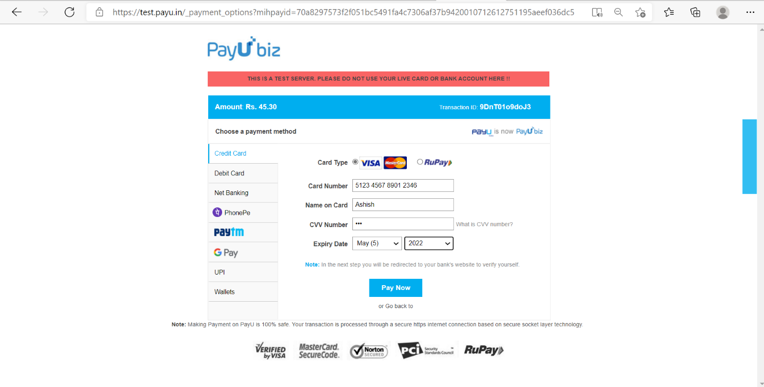

3)Status Page

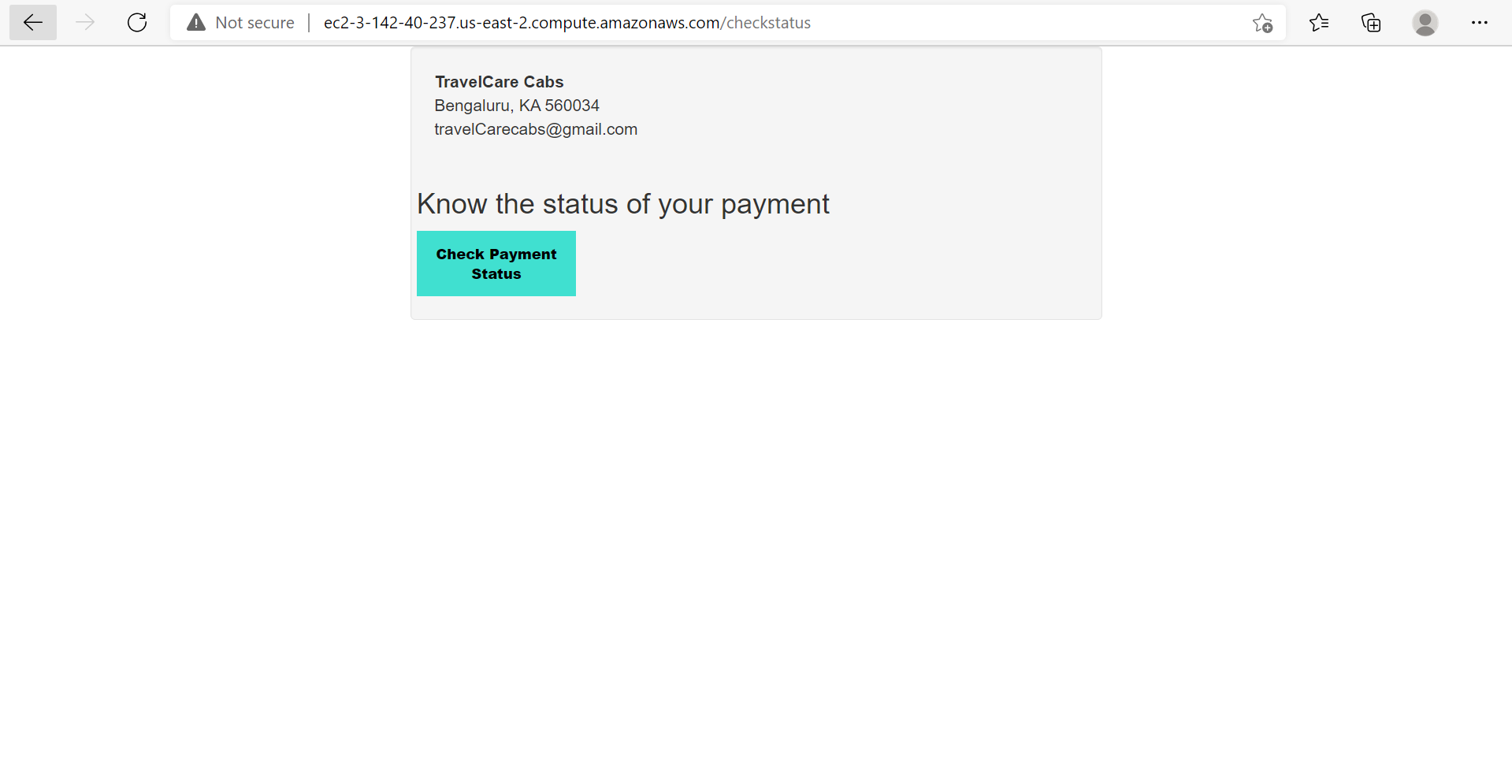

4) Success Page

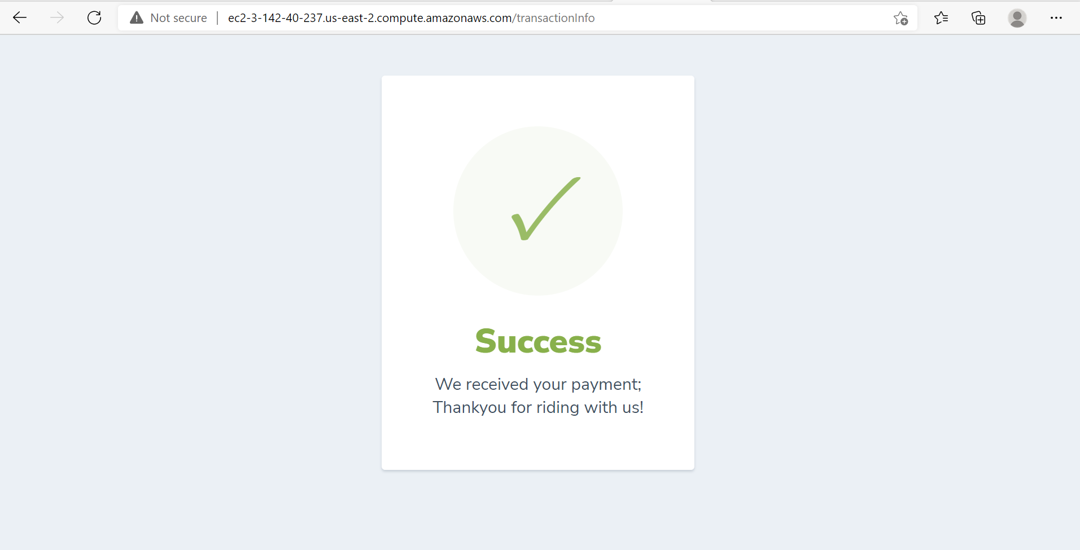

4) Retries payment on wrong entry of credentials

