1) Cloud Formation template to setup Taxi simulator environment in AWS

Note – Please add code.zip in s3 bucket to download it while running EC2 instance. Lambda will automatic take code zip from s3 bucket. Provide name of your bucket and code zip file in cloud Formation template

All Create EC2 Appropriate role before executing cloud formation template and add this role name in Template file or in parameter of CF template

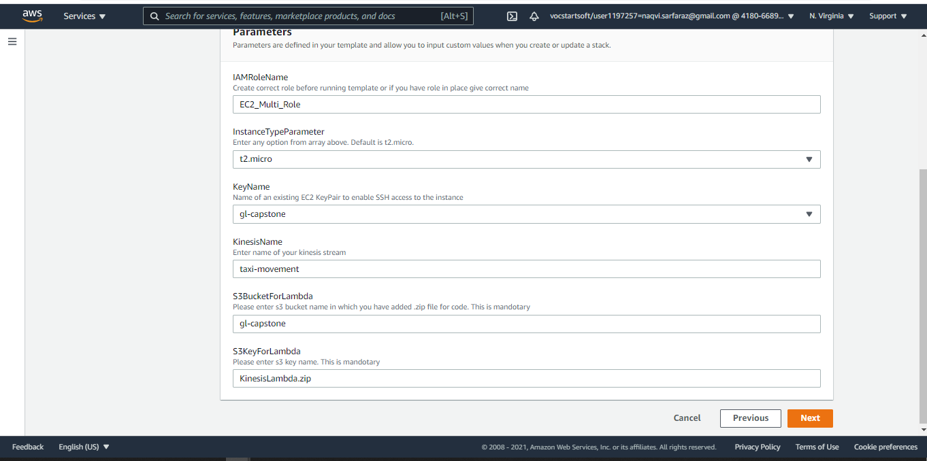

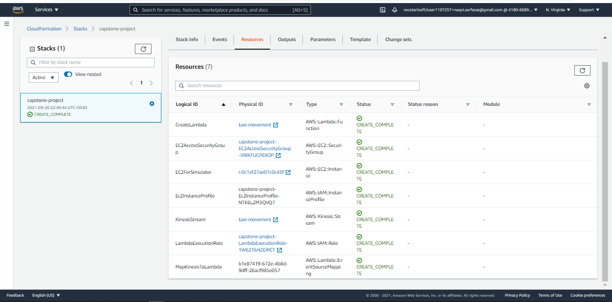

2) Taxi simulator in ec2 instance

- Initial location for taxi pushed to kinesis

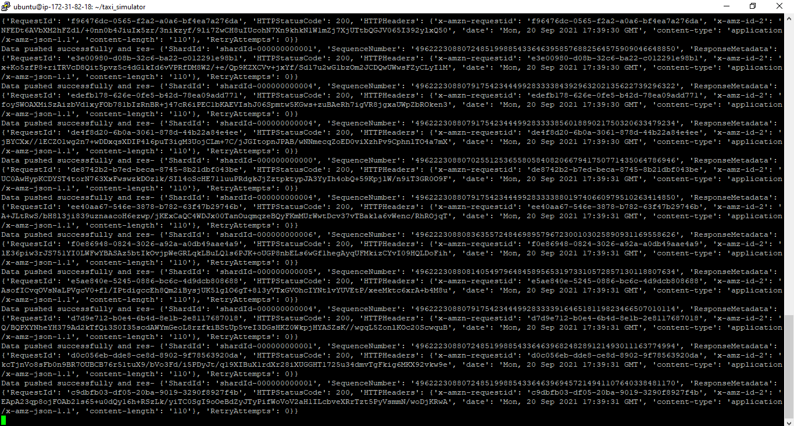

- Every one minute movement

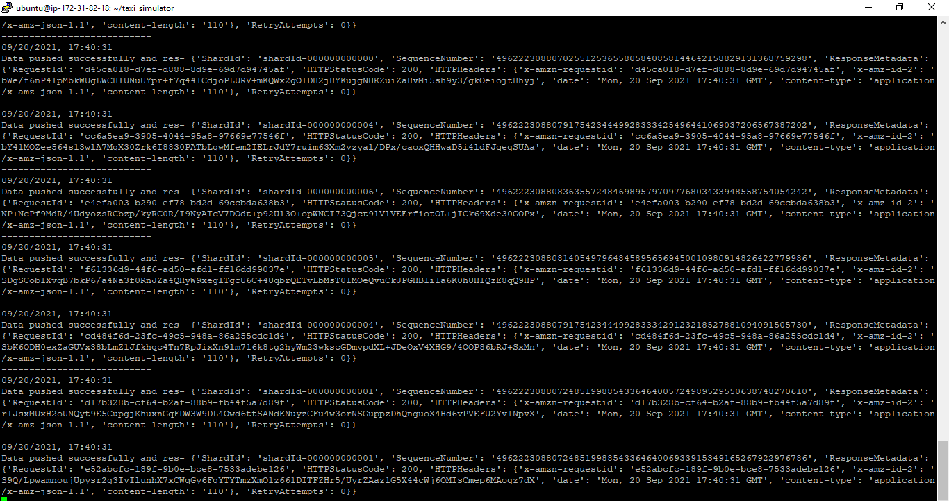

- Lambda function that will pick data from kinesis and push that to database.

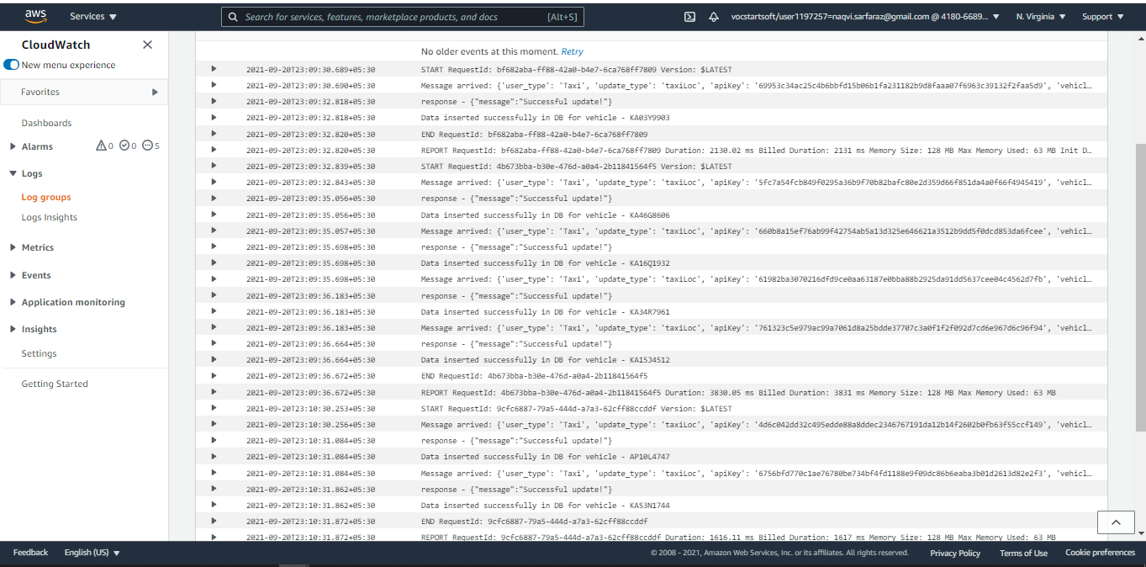

- Lambda code

