1. Create Multiple EC2 instances (existing key pairs used):

Run below cloud formation template to create 5 EC2 Instances



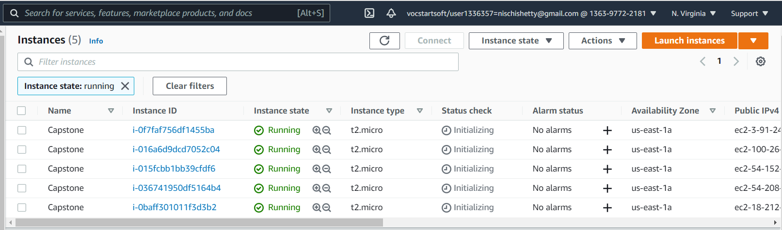

1. Once instructions in readme.md are followed. Run the main.py from AWS CLI command window.

**Application flow:**



**SignUp/Sign In:** User have option to sign Up or Sign In

**Sign Up:** Option 1

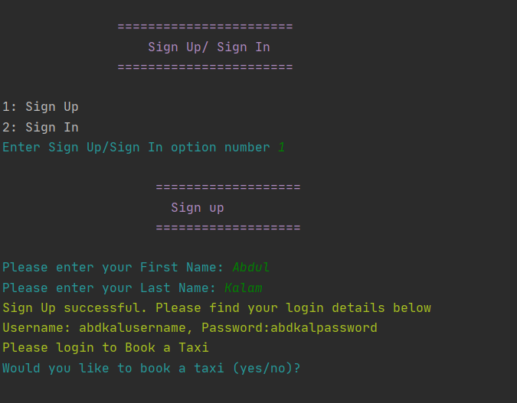

1. **Sign In –** option 2

After sign in enter **taxi type number** to book a taxi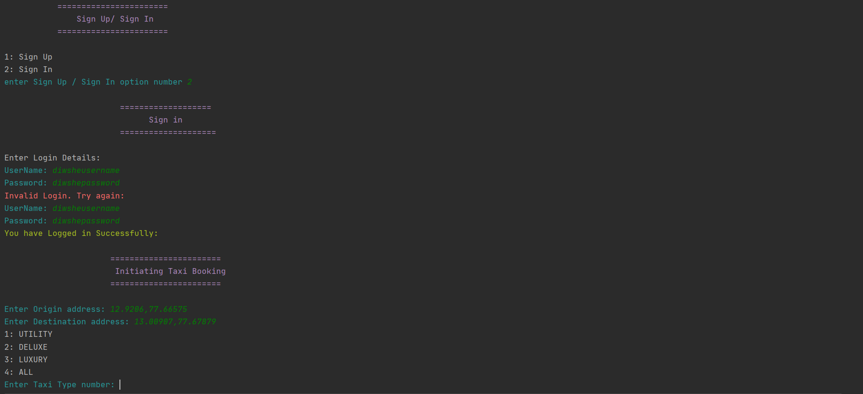

1. Cost for closest taxi for the requested taxi type is displayed which user can either confirm or deny.

**Deny:**

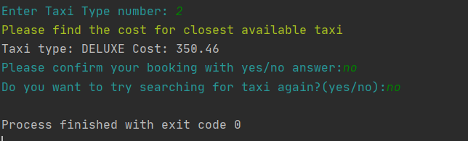

**Confirm:**

OTP is displayed and taxi starts moving towards passenger. Every 1 min taxi location will be checked.

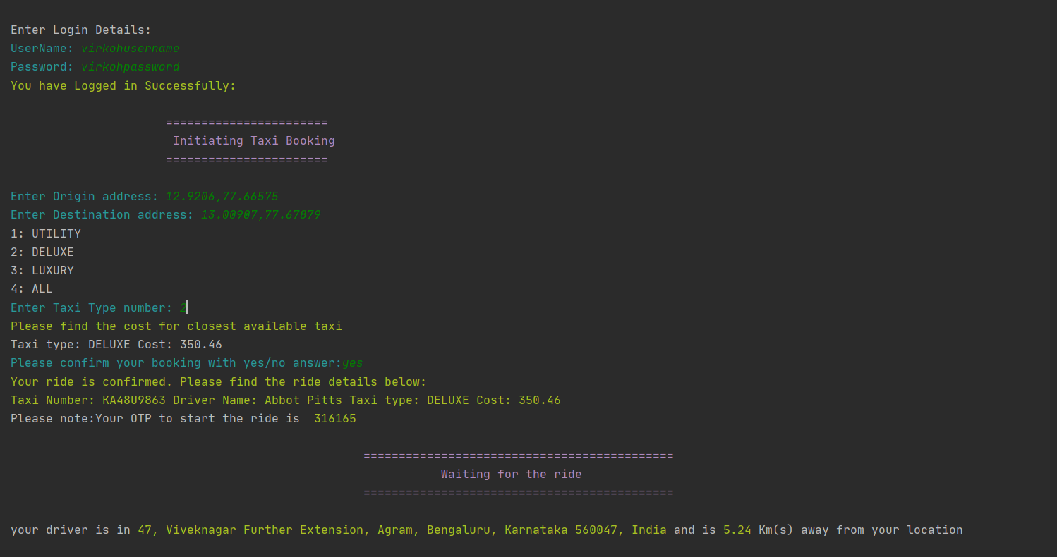

1. Once user enters the OTP ride starts and every 1 min distance of taxi from destination will be checked.

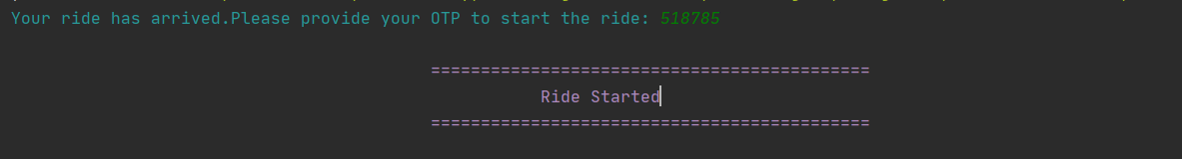

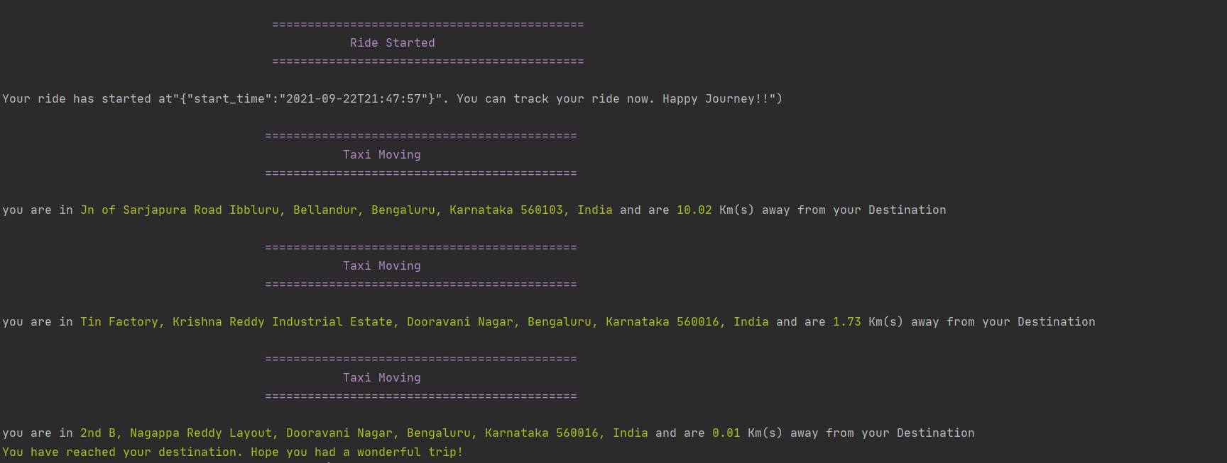

1. Once taxi reaches to a location less than 0.5 kms from the destination , ride ends.Passenger can either provide the feed back or close the application.

